

Student Learning Log

Student Name: Dumitru Alin Popa
Student ID: 2132755
Module: Managing Hotel Administration
Module code: BMIH6004
Lecture: Lisa Bassler

Table of Contents
Introduction 3
Section 1: Reflection on the investment experience 4
Description 4
Feelings 4
Evaluation 4
Analysis 4
Conclusion 5
Action plan 5
Section 2: Work-based Skills and technical knowledge related to the Department 6
Section 3: Reflection on the Organisational issue of Ashford International Hotel 7
Action Plan 8
Conclusion 9
References 10

List of Table
Table 1: Action plan to develop the skills of HR management 8
List of Figure
Figure 1: Related skills and technological knowledge for HR department 6

Introduction
Ashford International Hotel is well known among consumers in the hospitality industry for achieving higher customer satisfaction and brand loyalty. The organisation operates its business with the best employees and the HR department is responsible for recruiting, training, and developing staff (Szende et al, 2020). This will discuss the human resource management of Ashford International Hotel and its related skills and knowledge. The learning objectives of HR placement in this hotel are understanding the HR practices in hotel management and developing its related skills. The placement has also helped to analyse the management performance in the workplace and examine the issue of workforce management and their training.

Section 1: Reflection on the investment experience
My placement was in the HR department at Ashford International Hotel. This has helped me understand the tasks related to human resource management and HR functions. The reflection is provided below through the Gibbs reflective cycle model,

Description
During my placement at the human resource department at Ashford International Hotel, I was supervised by the senior HR manager. I had to complete different tasks like assisting in recruiting employees, taking their exams, sometimes checking the exam copies, helping colleagues with onboarding steps, hosting the orientation and training programs, payroll management, handling staff queries, and compensation, and benefits management through checking their performance (Mbaya, 2019). I had to prepare their joining letter, an appointment letter, and the proposal for the organisational purpose which was the most significant task in the HR department.

Feelings
During my first day at placement, I was very excited and nervous as I was in a new place. After a week with the help of my colleagues and supervisor, I was able to understand the real-world scenario of HR management. In the case of complex tasks like payroll or handling employee matters, my supervisor helped me a lot to become more comfortable and gain the necessary skills related to the HR department (Hasnat, 2021).

Evaluation
I have learned to handle the candidates and employ them effectively. Moreover, I have observed the interviews which have helped me to develop my knowledge about the customer-focused environment, HR-related skills, and challenges (Wilton, 2022). The wage structure, tax calculation, benefit and bonus management, merit pay, gain sharing, etc. are complex for me. There was the application of different legal aspects which were sensitive and diplomatic. These areas have significant importance in the HR department as well as I have found my weaknesses in these.

Analysis
To work in the HR department interpersonal and professional skills are necessary (Sparrow et al, 2016). Besides that, effective theoretical and technical knowledge can help to fit with the culture of the hotel. Communication, teamwork, leadership skills, and technical knowledge are important in dealing with HR matters.

Conclusion
The opportunity to work at Ashford International Hotel in the HR department has opened the door to gaining skills and knowledge in this sector. I can understand the technology related to HRM which has developed my technical knowledge. There is more room to work to understand the payroll and legal system in the HR department.

Action plan
I will develop my technical knowledge in this area by attending offline and online training sessions. Additionally, I will engage in training programs to improve the idea of performance management and legal areas (Griggs et al, 2018). Seeking feedback from my mentors and colleagues will help to address these areas of improvement.

Section 2: Work-based Skills and technical knowledge related to the Department
To write in the HR department effective communication skills are necessary. Handling the candidates during the recruitment process, managing sensitive employee matters, providing performance feedback, ensuring employee relationships, and in other aspects communication skill has a significant role. Teamwork is another essential aspect of HR as all the departments collaborate with this for recruiting and employee management practices (McLeish and Snowden, 2017). Effective alignment is necessary with all the departments which can only be possible through teamwork skills. There are many departments in Ashford International Hotel so the HR department is very busy (Cunningham and Dawes, 2016).
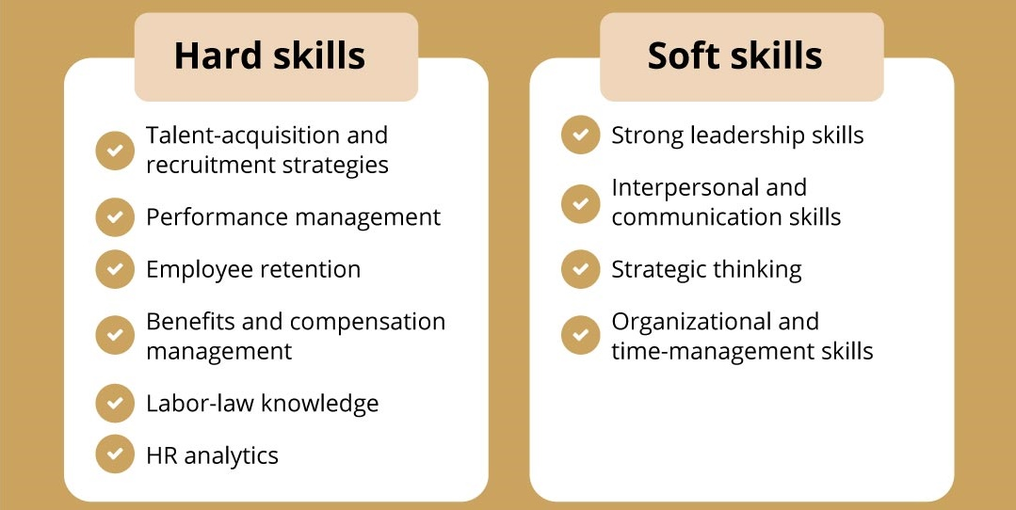
Figure 1: Related skills and technological knowledge for the HR department
Source: (Wall, 2017)
To manage time effectively according to priority task management is urgent. The employees use the Gantt chart diary method and other scheduling techniques to ensure task management. To recruit employees HRIS has significant importance (Dogara et al, 2020). This software helps to select the most eligible candidate automatically and perform other tasks like performance management, payroll management, leave and training management. So effective technological knowledge is also necessary for the HR operations in Ashford International Hotel.

Section 3: Reflection on the organisational issue of Ashford International Hotel
In the Ashford International Hotel, there is a communication gap between the employees and the HR department which creates confusion and inconsistency across the departments. This issue has impacted the performance and operations. Many employees don't provide the necessary documents and disrupt the workflow. This increases the understaffing problems and hampers the guest services (Jackson et al, 2022). Moreover, the overall operation is also hampered due to the lack of synchronisation, coordination, and scheduling which leads to different confusion and administrative backtracking. Shannon Weaver's communication model can describe this where the sender often fails to convey information from the receivers which creates misunderstanding, confusion, lack of performance, and operational inefficiency in different departments of the hotel (Salleh and Sulaiman, 2015). The organisation can take the strategy of making a centralised communication platform by using HRIS, clear communication protocol, and provide training on communication and leadership to ensure cross-departmental collaboration, better communication, and performance within the organization.

Action Plan
The strategies for personal development in the HR department are necessary. The action plan to improve the skills is provided below:
Objective | Specific step | Strategy | Timeline
Enhance professional hotel- HR-related skills. | Pursue a CIPD (Chartered Institute of Personnel and Development) certification course | Attend CIPD training and workshops to have up-to-date knowledge. | 6 months
Enhance technological knowledge | Attend technological training in HRIS from Workday, BambooHR, or SAP SuccessFactors | I will participate in online tutorials or vendor-led certification programs | 6 months
Enhance knowledge about employment law. | Studying and practising UK employment laws | Enroll in short courses related to UK employment law and engage in case studies | 4 months
Table 1: Action plan to develop the skills of HR management
Source: (Author)

Conclusion
Ashford International Hotel operates its business encompassing different departments like human resources, front office, back office, sales office, or revenue management that help to operate the business smoothly ensuring higher profitability and market positioning (Wall, 2017). The placement at the HR department at Ashford International Hotel has provided several knowledge skills about the real-world application of workforce management including recruitment, staff training, performance evaluation, payroll management, orientation, conflict resolution, and legal aspects. Communication skills, teamwork skill collaboration skills, problem-solving skills, leadership skills, and technical skills are necessary to work proactively in the human resource department. They should have enough expertise in employment law before conflict resolution and monitor their performance.

References
Cunningham, I., and Dawes, G. (2016). The handbook of work-based learning. Routledge.
Dogara, G., Saud, M. S. B., and Kamin, Y. B. (2020). Work-based learning conceptual framework for effective incorporation of soft skills among students of vocational and technical institutions. IEEE Access, 8, 211642-211652.
Griggs, V., Holden, R., Lawless, A., and Rae, J. (2018). From reflective learning to reflective practice: Assessing transfer. Studies in Higher Education, 43(7), 1172-1183.
Hasnat, Q. (2021). An exploration of employee engagement and employee commitment in the London hotel sector: the perspectives of migrant housekeeping workers and their managers (Doctoral dissertation, University of Brighton).
Jackson, D., Shan, H., and Meek, S. (2022). Employer development of professional capabilities among early career workers and implications for the design of work-based learning. The International Journal of Management Education, 20(3), 100692.
Mbaya, C. G. (2019). Human Resource Management Practices and Organizational Commitment in Five Star Hotels in Nairobi, Kenya (Doctoral dissertation, University of Nairobi).
McLeish, L., and Snowden, A. (2017). Reflection on practice: Consultation skills. Nurse Prescribing, 15(12), 600-604.
Salleh, K. M., and Sulaiman, N. L. (2015). Technical skills evaluation based on competency model for human resources development in technical and vocational education. Asian Social Science, 11(16), 74.
Sparrow, P., Brewster, C., and Chung, C. (2016). Globalizing human resource management. Routledge.
Szende, P., Bagnera, S. M., and Cole, D. C. (2020). Human resource management in hospitality cases. Routledge.
Wall, T. (2017). A manifesto for higher education, skills and work-based learning: through the lens of the manifesto for work. Higher Education, Skills and Work-Based Learning, 7(3), 304-314.
Wilton, N. (2022). An introduction to human resource management.

