University of Wales Trinity Saint David
Motorsport Engineering
Engineering Skills Technical Report
Harri Evans
2500728
07/12/2025
Engineering Skills - ACHA4022A
Word Count - 2045

Contents Page
- Introduction……………………………………………...….………3
- Health and Safety with Risk Assessments………………….………3-4
- Security Risk Matrix……………………………………….……….4-5
- Engineers Role in Society………………………………….……….6
- Problem Solving………………………………………….…………7
- Team Structure………………………………………….…………..8-9
- Conclusion………………………………………………………….10
- References…………………………………………………………..11-13
1.Introduction
1.1. This report will examine several key points that shape the responsibilities of engineers within professional environments. Beginning with the importance of health and safety in the workplace through following Uk legislation and risk assessments. The report then covers the security risks that are facing the modern automotive industry whilst using a risk matrix to evaluate the risk and implement appropriate responses to the threats. The ethical expectations placed on engineers are explored through codes of conduct with a view on sustainability in the automotive industry. Also, the practical problem-solving methods used by engineering teams when technical problems occur during the development of a component, supported with researched flow diagrams to demonstrate the process. The final section will outline team structures whilst reflecting on past experiences with supporting images and concluding with brief conclusion of findings and concluding with an overview conclusion.
2.Health and Safety with Risk Assessments
2.1. Whilst undertaking the Engineering degree you may be tasked with raising a vehicle in the air using a trolley jack to access the components under the car or to replace the wheels, this comes with many risks which are considered with safety precautions and regulations from HSE to minimise the likelihood of an incident. The specific legislation that will apply to this would be the Lifting Operations and Lifting Equipment Regulations (LOLER) (HSE, 2023), this outlines the safe lifting checks that should be carried out, such as planning and organising lifting operations and thorough examination of lifting equipment before use to ensure no equipment collapses or overturns during operation (Harraway, 2002). When planning to lift a vehicle you should check the equipment for any signs of damage such as oil leaks or damage from excessive use, you should also ensure the safe working load (SWL) of the lifting equipment must not be exceeded. Before lifting you should check the surrounding environment for any hazards such as components on the ground, trailing cables, soft ground which may cause the jack to lean/overturn or people near the vehicle, if any hazards are found they need to be attended to accordingly to ensure a safe environment. Once the vehicle has been raised safely axle stands that have been inspected should be used to support the weight of the vehicle instead of the jack whilst maintenance work is being carried out.

Hazard | Likelihood | Impact | Risk level | PPE
Jack failure | Low | High | Medium | Steel toe cap boots
Jack slipping off the pad | Medium | High | High | Steel toe cap boots
Unstable ground | Medium | High | High | Steel toe cap boots
Oil leak | Low | Medium | Low | Steel toe cap boots, overalls
Pinch points | Medium | Medium | Medium | Steel toe cap boots, protective gloves, overalls
Over jack SWL capacity | Low | High | High | Steel toe cap boots
Poor visibility | Low | High | High | Steel toe cap boots, safety glasses
Figure 1 Risk Assessment (Author, 2025)
3.Security Risk Matrix
3.1. Modern vehicles are moving further towards high levels of connectivity and autonomy through complex networks which introduce potential security risks if they are not properly secured. A usual form of threat that faces the public is unauthorised remote access using keyless entry from an enhanced signal from the key fob to unlock and start the vehicle. The UK government reported around 40% of vehicle thefts are carried out by criminals with sophisticated electronic devices in England and Wales, which under new legislation will be banned with the aim to reduce car thefts. (Office, 2025)
CAN (Controller Area Network) bus injection attacks are also a prominent way of vehicle theft through using external wiring such as in the wheel arch or headlight connectors or through OBD ports. CAN bus is used to send messages throughout the vehicles electrical system but only the intended ECU will receive and read the data with a specific ID number (Duan et al., 2021). False CAN messages can be sent to the ECU to unlock and start the vehicle without the key, allowing criminals to steal the vehicle. Safety functions like the braking, Steering, instrument cluster and ECU’s can also be disabled which could result in life threating accidents, endangering the public.
Data breaches are also another security threat due to the large amount of data that is stored by automotive companies about personal and sensitive operational data. This can be caused by inadequate encryption and poor access control, exposing sensitive company information such as location histories and customer profiles which may have privacy and fraud implications. According to research conducted by (ENISA, 2019) smart cars and autonomous vehicles are the main targets for criminals as they have such a high level of connectivity with an inadequate level of security whilst collecting a large amount of data.
Remote access cyber-attacks also pose a threat to the automotive industry due to the number of electrical components such as ECU’s installed on modern vehicles. Although some security guidance measures have been implemented, for example the ones outlined by the NHTSA. (Cybersecurity Best Practices for the Safety of Modern Vehicles (2022) To improve vehicle cyber security such as guidance on how to control wireless paths into vehicles, despite that a large threat still remains as criminals find new ways to infiltrate electronic systems.
 |  |  | Impact
 |  |  | 1 - Insignificant | 2 - Minor | 3 - Moderate | 4 - Severe | 5 – Catastrophic
Likelihood | 1- Rare
Likelihood | 2 - Unlikely |  |  |  | Data Breach
Likelihood | 3 - Possible |  |  |  |  | CAN Bus | Remote Attack
Likelihood | 4 - Likely
Likelihood | 5 – Almost certain |  |  |  |  | Keyless Entry
Figure 2 - Risk Matrix (Author 2025)
Remote Attack is the highest rated threat due to its high consequences if criminals gain access to vehicle electronic systems. A holistic and proportional response would be to increase security by utilizing encrypted communication, 2 step authentication for wireless interfaces and segregation from important safety ECUs. Regular security updates must also be implemented to ensure the system is up to date with the latest software, along with threat monitoring and supplier management. These safety measures will reduce the likelihood of any remote attacks to an acceptable level if the safety measures mentioned are implemented with active support.
4.Engineers Role in Society
4.1. IMechE expects engineers in the UK to follow codes of conduct on how they conduct themselves whether it be in a professional or a personal capacity. A large portion placing a strong emphasis on sustainability, environmental responsibility and health and safety which is particularly relevant in the motorsport industry. “Balancing the needs of the present with needs for future generations”. (Institution of Mechanical Engineers, 2023)
The Engineering Council and Royal Academy of Engineering have published a statement of ethical principles which underpins the four fundamental principles, Honesty and integrity, Respect for life, law, the environment and public good, Accuracy and rigor, Leadership and communication. (Engineering Council, 2017) These principles require engineers to protect and where possible minimise the environmental impact on current and future generations. The Engineering council further backs they’re principles by implementing guidance on sustainability which expects engineers to go beyond standard regulations and challenges them to integrate sustainable development into they’re design and decision making. (Engineering Council, 2021)
From both codes of conduct we can see that a driving factor is environmental impact and how we can prevent damage and maintain balance between engineering advancements and sustainability. From a motorsport engineers point of view this means that careful consideration needs to be given when making decisions on power train, materials, aero dynamic efficiency and product life cycle to minimise waste. Environmental options have already been created such as biofuels and electric motors with minimal carbon footprint. By following these codes set out by each council and institution each engineer will contribute to the sustainability of the motorsport industry whilst delivering competitive vehicles.

5. Problem Solving
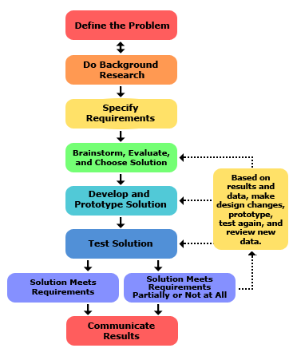
5.1. The design process is a series of steps that engineers follow to develop and solve problems whilst creating a part. If an issue is found whilst developing a new part the engineering team could follow a step by step process such as define the problem, this is done by asking questions such as what is the problem, this allows engineers to specifically pinpoint the problem in the design. Next research could be conducted to explore existing solutions to similar problems which will also prevent you from making past mistakes. Specific requirements will also need to be set out to ensure the solution meets specific parameters such as safety rating, weight restrictions, material and space limitations. Once the previous steps have been covered the engineers will have a rough design in their head and can begin brainstorming different solutions. Once you have many different designs you can single out the designs that fit your design requirements the best and continue to develop that design and create prototypes out of different materials. Doing this will allow you to test multiple iterations and identify if your requirements are met, if they are not you will need to go back and develop new designs to solve the problem. Once a design has been found that meet all of the criteria you can implement it into the assembly and observe if the design works. (Science Buddies, n.d.)

Figure 3 – Problem Solving Flow Chart (Science Buddies, n.d.)
6. Team Structure
6.1. I am have recently worked in a team of 4 people on a project for Morgan Motor Company, this project required us to remove a bracket from a hinge assembly in a CAD FEA simulation whilst recreating the displacement caused by the forces on the bracket using a remote force of 1000N. Whilst working on this project we used a Teams group to share images of our results and share ideas to further improve our simulation testing, whilst this was an effective way of sending images and text it didn’t always notify me when a message had come through which would result in me seeing the message a day later which may have delayed the process. To improve this, we could have used another messaging platform such as WhatsApp to ensure we received the notifications when they were sent.
During our meetings with our Lecturer one of our team members went up to present and explain what we had done and what result we had received and how accurate the results were to what we were trying to achieve, areas we needed to improve were also covered as the displacement wasn’t identical to the original simulation. In my opinion I thought this style of presenting was effective as the person that was presenting knew exactly what we had discovered and could talk the audience through the presentation step by step without covering topics twice which might happen if there are two presenters. To send the best result we had found we used the folder function in Fusion which allowed us to open the simulation results in the presentation which would give the audience a better understanding of the results with a 3D image.
Although different team structures such as a main leader with sub teams may work effectively for other projects as only the most important information can be forwarded to the leader, this may be much quicker as each team can cover a large amount of information on different topics. I think the way our team was constructed worked best for our type of presentation as the simple communication techniques we used proved effective and adequate. (Singh, Dong and Gero, 2025)

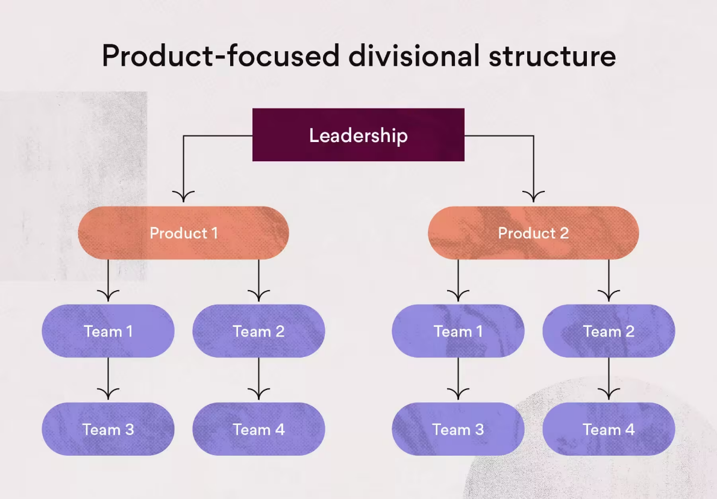

Figure 4 – Team Structure (Team Asana, 2021)

7. Conclusion
7.1. This report has covered the importance of UK health and safety legislation such as LOLER when conducting workshop tasks with a risk assessment on the potential danger which may occur. Next I created a security matrix which covered 4 potential security risks, through risk matrix evaluation I then identified the most significant threat and outlined safety precautions required the reduce the risk. Engineers role from various professional bodies are covered with an overview of what they both cover in terms of environmental and ethical responsibilities to protect future generations. Problem solving techniques are then covered with a clear laid out plan of what process to follow when designing a part to ensure engineers overcome technical standards whilst maintaining performance and safety standards Lastly teamwork and communication are recognised as an important part for project delivery through a practical CAD simulation task where teamwork was required to deliver effective solutions and results.
References
HSE (2023). Lifting Operations and Lifting Equipment Regulations 1998 (LOLER) - Work equipment and machinery. [online] Hse.gov.uk. Available at: https://www.hse.gov.uk/work-equipment-machinery/loler.htm [Accessed 30 Nov. 2025].

Harraway, J. (2002). TAKING THE STRAIN OUT OF LIFTING: LOLER AND PUWER REGULATIONS EXPLAINED. Arboricultural Journal, 26(2), p.105. doi:https://doi.org/10.1080/03071375.2002.9747326.

Office, H. (2025). Vehicle theft equipment to be banned under new government law. [online] GOV.UK. Available at: https://www.gov.uk/government/news/vehicle-theft-equipment-to-be-banned-under-new-government-law [Accessed 1 Dec. 2025].

Duan, X., Yan, H., Tian, D., Zhou, J., Su, J. and Hao, W. (2021). In-Vehicle CAN Bus Tampering Attacks Detection for Connected and Autonomous Vehicles Using an Improved Isolation Forest Method. IEEE Transactions on Intelligent Transportation Systems, 24(2), pp.1–13. doi:https://doi.org/10.1109/tits.2021.3128634.

ENISA (2019). ENISA GOOD PRACTICES FOR SECURITY OF SMART CARS Security and Resilience for Smart Health Service and Infrastructures ENISA GOOD PRACTICES FOR SECURITY OF SMART CARS ABOUT ENISA. [online] Available at: https://www.enisa.europa.eu/sites/default/files/publications/Good%20practices%20for%20security%20of%20Smart%20Cars.pdf [Accessed 5 Dec. 2025].

Cybersecurity Best Practices for the Safety of Modern Vehicles. (2022). Available at: https://www.nhtsa.gov/sites/nhtsa.gov/files/2022-09/cybersecurity-best-practices-safety-modern-vehicles-2022-pre-final-tag_0_0.pdf [Accessed 5 Dec. 2025].

Institution of Mechanical Engineers (2023). Code of Conduct explained - IMechE. [online] www.imeche.org. Available at: https://www.imeche.org/about-us/imeche-governance/governance-and-finance-reviews/code-of-conduct-explained [Accessed 5 Dec. 2025].

Engineering Council (2017). Guidance on ethical practices. [online] Engc.org.uk. Available at: https://www.engc.org.uk/resources-and-guidance/guidance-for-the-profession/ethical-principles [Accessed 6 Dec. 2025].

Engineering Council (2021). GUIDANCE ON SUSTAINABILITY for the engineering profession. [online] Available at: https://www.engc.org.uk/media/f15gswox/guidance-on-sustainability.pdf [Accessed 6 Dec. 2025].

Science Buddies. (n.d.). The Engineering Design Process. [online] Available at: https://www.sciencebuddies.org/science-fair-projects/engineering-design-process/engineering-design-process-steps#requirements [Accessed 6 Dec. 2025].

Singh, V., Dong, A. and Gero, J.S. (2025). www.designsociety.org. DS 68-7: Proceedings of the 18th International Conference on Engineering Design (ICED 11), Impacting Society through Engineering Design, Vol. 7: Human Behaviour in Design, Lyngby/Copenhagen, Denmark, 15.-19.08.2011, [online] 7, pp.117–126. Available at: https://www.designsociety.org/publication/30668/how_important_is_team_structure_to_team_performance [Accessed 6 Dec. 2025].

Team Asana (2021). Team Structure: 10 Effective Ways to Organize Your Team • Asana. [online] Asana. Available at: https://asana.com/resources/team-structure [Accessed 6 Dec. 2025].

Figure 1 - Risk Assessment (Author, 2025)
Figure 2 - Risk Matrix (Author 2025)
Figure 3 - Problem Solving Flow Chart (Science Buddies, n.d.)
Figure 4 - Team Structure (Team Asana, 2021)

