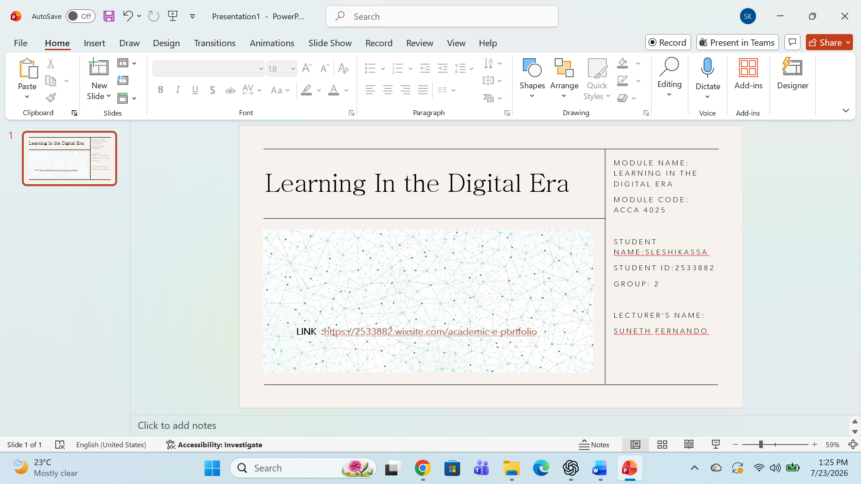

Contents
Task 1: Academic and Professional Skills for Future Career Development 3.1 Report on Key Academic and Employability Skills 4
3.2 Evaluation of the Report Based on the Similarity Analysis 4
3.3 self-evaluation 5
Task 2: Team Mind Map and Individual Poster Design 5
4.1 Collaborative Mind Map 5
4.2 Individual Poster Presentation 6
Task 3: Online Collaboration and Reference Management 6
5.1 Report on Virtual Team Collaboration 6
5.2 Guide to Using RefWorks with Supporting Screenshots 8
Task 4: E-Portfolio Development and Critical Evaluation 11
6.1 Development of an E-Portfolio 11
Conclusion 12
Acknowledgement 12

LINK : https://2533882.wixsite.com/academic-e-portfolio

Introduction
Developing the right academic and professional skills is essential for achieving success in both higher education and future employment. This report presents a series of activities designed to strengthen key competencies such as academic writing, teamwork, digital literacy, communication, and reflective practice. Each task focuses on a different aspect of personal and professional development while encouraging the practical application of knowledge in real-world and academic contexts.
The report begins by exploring the academic and employability skills that are important for future career development and includes an evaluation based on a similarity report to highlight the importance of academic integrity. It then presents a collaborative mind map and an individual poster that demonstrates teamwork, creativity, and effective communication. The report also examines the experience of virtual collaboration and provides a step-by-step overview of using RefWorks as a reference management tool. Finally, it discusses the creation of an e-portfolio and critically evaluates the selected platform, highlighting its role in showcasing skills, achievements, and professional growth.
Overall, this report reflects the learning journey undertaken throughout these activities and demonstrates how the knowledge and skills gained can contribute to academic success and long-term career development.
Main Discussion
The main discussion of this report brings together the key learning activities completed throughout the module and explains how each one has contributed to developing important academic and professional skills. It covers topics such as employability skills, teamwork, digital collaboration, reference management, and e-portfolio development. Each section not only describes the task completed but also reflects on the knowledge and experience gained, showing how these skills can be applied in both academic studies and future career opportunities.

Task 1: Academic and Professional Skills for Future Career Development
3.1 Report on Key Academic and Employability Skills
Essential academic and employment skills

Skills play an essential role in both professional employment and everyday life, and the variety of skills required in modern society continues to expand. Among these, academic and employability skills are particularly important, as they involve a range of abilities including critical thinking, effective communication, digital literacy, time management, and other transferable competencies. [1]
Academic and employment skills are valuable transferable abilities that can be developed throughout a person’s lifetime. These skills can be acquired and improved through various methods, including formal education and practical experiences gained through everyday life. The importance of developing specific skills may vary depending on individual circumstances, career goals, and personal interests.
However, the value of certain skills can change depending on the time period and social context. For example, some artistic skills, such as painting, were highly valued during certain historical periods. Geographic location is also an important factor, as a skill that is highly valued in one country may have less relevance in another. For instance, being a skilled sumo wrestler in Japan may not provide the same employment opportunities or value in the UK. Therefore, for individuals to succeed in the workforce, their skills need to align with the demands of the current job market. [2]
Nevertheless, digital literacy has become a significant skill regardless of geographical location, and its importance continues to increase as technology becomes more integrated into society. Digital literacy involves a range of abilities, including basic computer skills, information literacy, effective communication and collaboration, critical thinking, digital citizenship, adaptability to technological changes, and the ability to create and innovate using digital tools.
Research shows that digital literacy is one of the most demanded skills in today’s world. The job market related to digital technologies has continued to expand as these technologies have been introduced to the general public and have become an integral part of modern society. Digital skills are increasingly important because many industries now rely on technology in their daily operations. [3]
In my view, having strong academic and employment skills, especially digital literacy, is essential for success in both personal and professional life.
[1] | v. masterson, "Future of jobs 2023: These are the most in-demand skills now - and beyond," may1 ,2023.
[2] | "Skills for the Digital Transition," OECD, 19 October 2022.
[3] | "Skills for the Digital Transition," OECD, 19 October 2022.

3.2 Evaluation of the Report Based on the Similarity Analysis
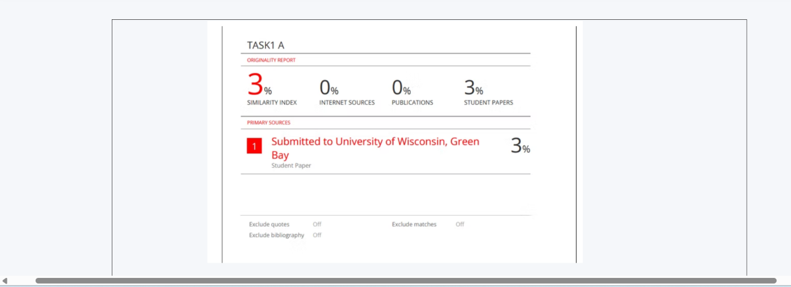

3.3 self-evaluation
According to the originality report, my assignment received a low similarity score of 3%, indicating that the work is largely original and written in my own words. This reflects my effort to maintain academic integrity by avoiding unnecessary copying and properly expressing ideas independently. However, the report also highlighted that I relied on a limited number of academic and online sources. Using a wider range of credible references would have strengthened my arguments and provided more evidence to support my discussion. In future assignments, I will continue to produce original work while incorporating more high-quality academic sources to improve the depth, credibility, and overall quality of my research

Task 2: Team Mind Map and Individual Poster Design

4.1 Collaborative Mind Map
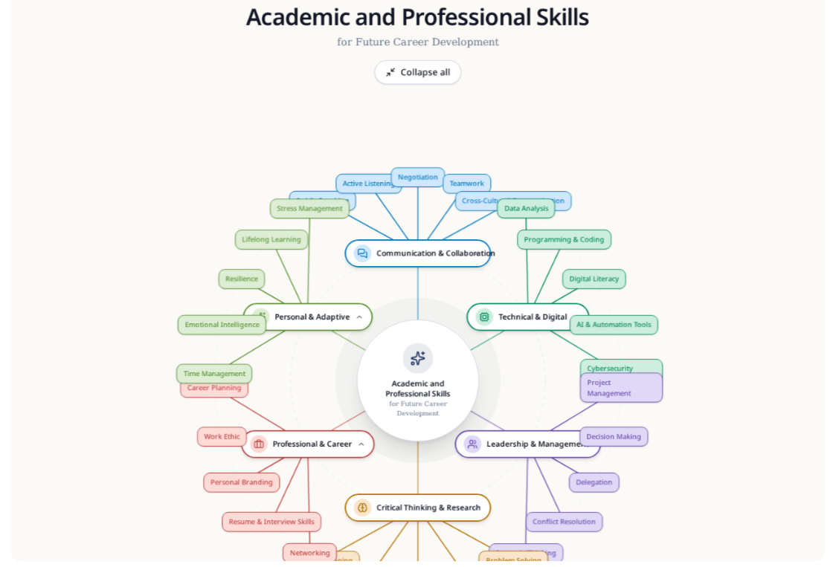

4.2 Individual Poster Presentation
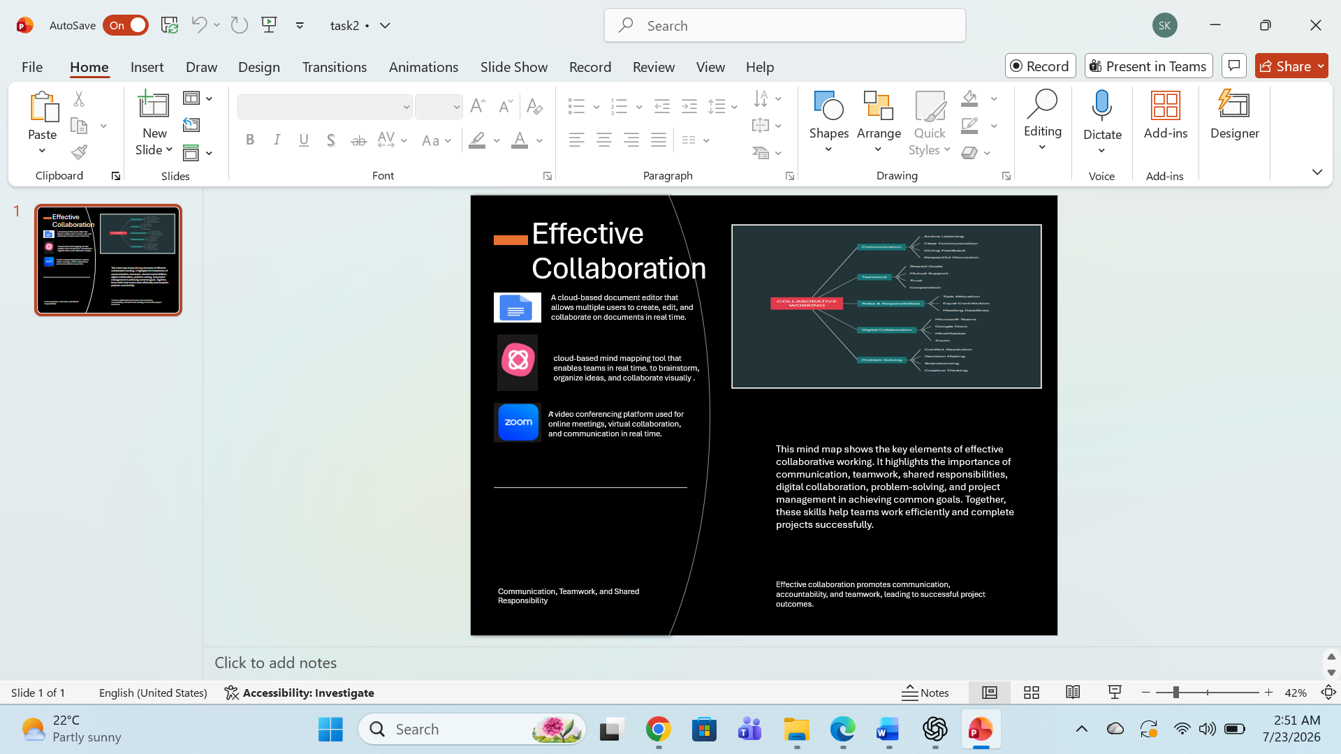

Task 3: Online Collaboration and Reference Management

5.1 Report on Virtual Team Collaboration
The Storming Stage of Team Development and Its Relevance according to Bruce W. Tuckman
Bruce W. Tuckman (1965) proposed that teams develop through a series of stages before they become effective [1]. He identified four main stages of team development: forming, storming, norming, and performing [1]. Later, Tuckman and Jensen (1977) added a fifth stage called adjourning, which describes the completion and separation of a team after achieving its objectives [2]. In this assignment, the focus will be on the storming stage, which is an important phase where teams experience conflicts and challenges while developing their working relationships.
According to Tuckman (1965), the storming stage occurs when team members begin to express different opinions, ideas, and expectations [1]. During this stage, individuals adjust to their roles and responsibilities, which may create disagreements and tension. The storming stage is considered as one of the most crucial stages of team development because the way conflicts are managed determines whether the team can build trust and progress effectively. Some characteristics of the storming stage include:
- Conflicts over roles, responsibilities, and priorities.
- Differences in opinions, ideas, and working styles.
- Competition for leadership or influence.
- Communication difficulties and misunderstandings.
- Resistance to decisions or changes.
- Challenges in developing trust among team members.
- The need for effective leadership and conflict resolution. [1]
There are several ways to solve problems during the storming stage and help teams overcome conflicts. These include:
- Encouraging open and honest communication between team members.
- Clearly defining roles, responsibilities, and expectations.
- Respecting different opinions and encouraging collaboration.
- Using negotiation and compromise to resolve disagreements.
- Providing strong leadership and guidance.
- Building trust through teamwork and shared goals.
- Giving constructive feedback to improve team performance.
Although Tuckman’s evaluation and classification of team development remain valuable, they have some limitations when applied to modern teams. Today’s team-building environment is different from the 1970s, especially with the rise of virtual collaboration, which has become a common and expanding method of working. Virtual teams face unique challenges, such as digital communication barriers, reduced personal interaction, and difficulties in building trust[1]. Therefore, while Tuckman’s model provides a useful foundation for understanding team behaviors, modern teams may require additional approaches to address the challenges of virtual collaboration.

References
[1] Bruce W. Tuckman, "Developmental Sequence in Small Groups," no. 6, pp.384–399, 1965, [Online]. Available: https://doi.org/10.1037/h0022100
[2] B. W. Tuckman and M. A. C. Jensen, "Stages of Small-Group Development Revisited," no. 4, pp.419–427, doi: 10.1177/105960117700200404.

5.2 Guide to Using RefWorks with Supporting Screenshots

Screenshot 1: Creating a RefWorks account

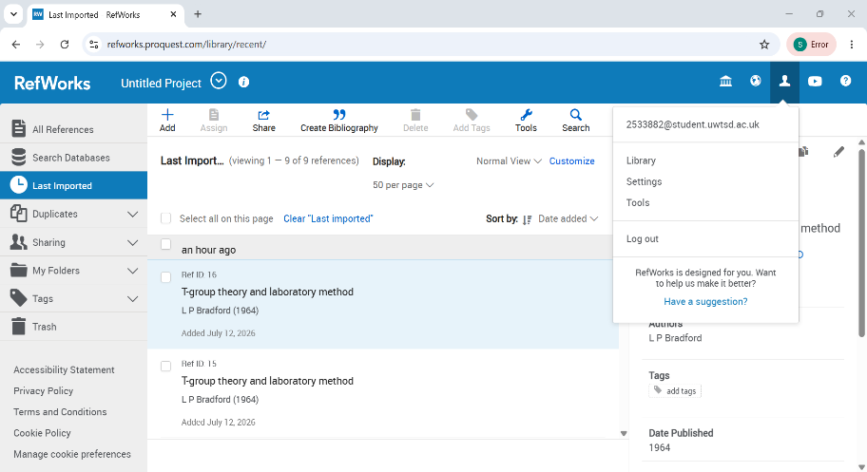
Tips for creating a RefWorks account
Use your university email address and use your real academic details
Screenshot 3: Adding references using RefWorks
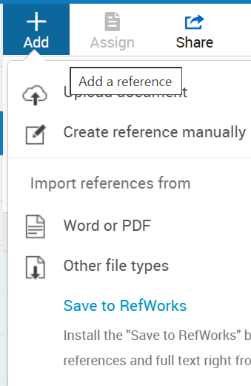
Screenshot 4: Adding references using RefWorks

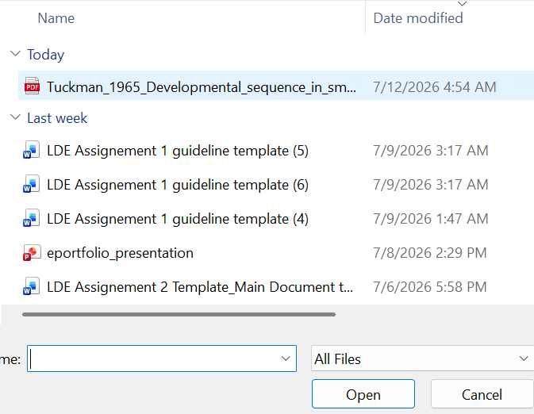
Tip for uploading a file to RefWorks: Check the file format before uploading. Make sure your document or reference file is in a format supported by RefWorks (pdf)
Screenshot 5: Adding references using RefWorks
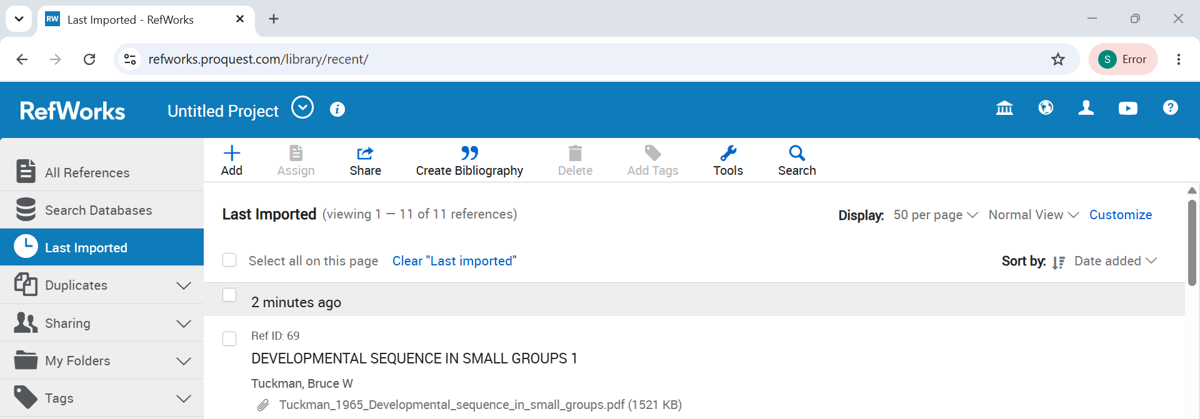

Screenshot 6: Adding references using RefWorks
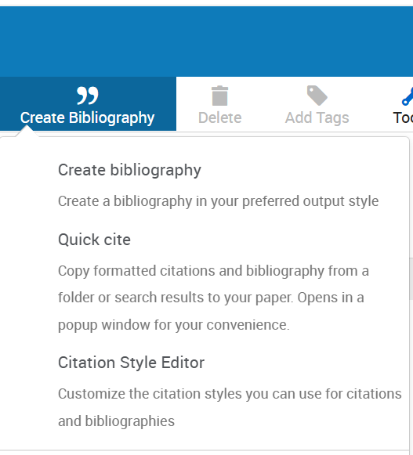
Screenshot 7: Adding references using RefWorks
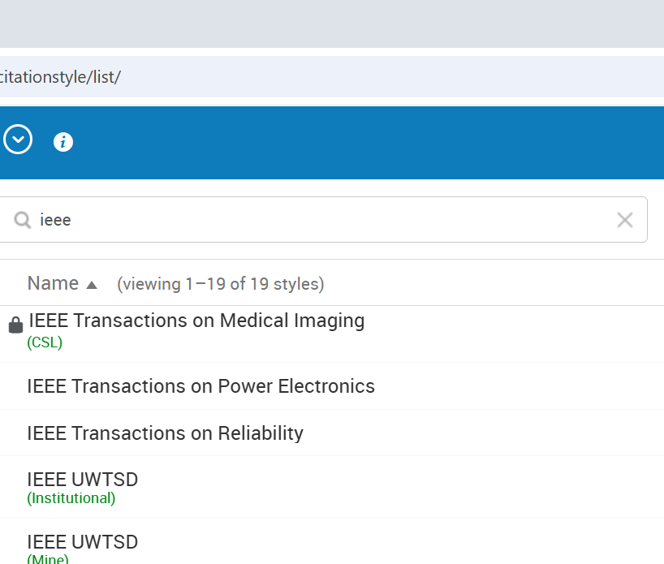

Screenshot 8: Adding references using RefWorks
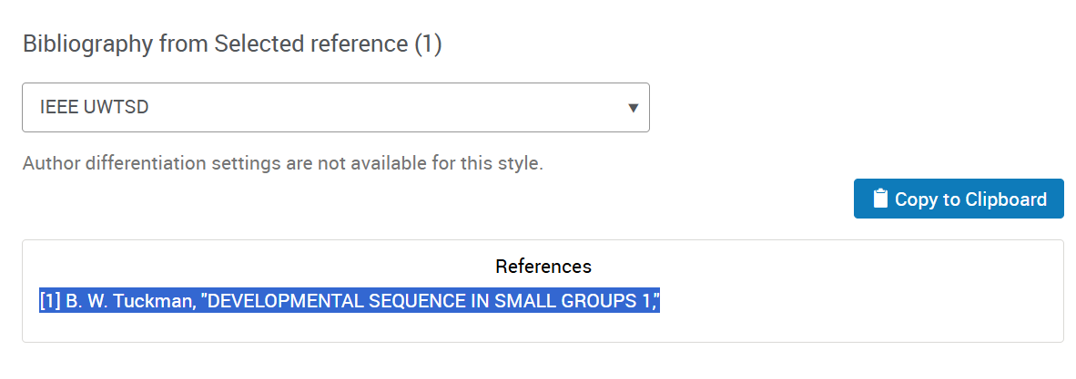

Task 4: E-Portfolio Development and Critical Evaluation

6.1 Development of an E-Portfolio
I developed my e-portfolio using Wix because it is easy to use and does not require any coding skills. I selected a simple and professional template and created separate pages for each assessment task. I added my reports, reflections, screenshots, mind maps, and other supporting evidence to show the work I completed throughout the module. I also used clear headings, images, and consistent formatting to make the portfolio easy to read and navigate. Before publishing, I checked that all the pages worked correctly and made any necessary improvements. Creating the e-portfolio helped me improve my digital skills and provided a professional way to present my learning journey and achievements.
6.2 Critical Review and Justification of the Selected E-Portfolio Platform
I chose Wix to create my e-portfolio because I found it simple to use and suitable for presenting my academic work in a professional way. Its drag-and-drop features made it easy to create pages, organize my content, upload images and documents, and customise the overall design without needing any technical or coding skills. I was able to choose a layout that suited my work and made the portfolio easy to navigate, which improved the overall presentation. Although the free version includes Wix branding and has some limitations compared to the paid version, it still provided all the features I needed to complete this assignment successfully. Overall, Wix was a good choice because it helped me create a well-organized and visually appealing e-portfolio while also improving my digital skills. I can continue to update and use this portfolio in the future to showcase my academic achievements and professional development

Conclusion
Completing this report has helped me develop a better understanding of the academic and professional skills that are important for success at university and in the workplace. Through the different tasks, I improved my skills in academic writing, teamwork, communication, digital collaboration, and referencing. I also learned how to use RefWorks to organise and manage references correctly, and I created my own e-portfolio using Wix, which allowed me to present my work in a clear and professional way. Reflecting on each activity has helped me identify my strengths as well as the areas where I can continue to improve, such as using a wider range of academic sources in future assignments. Overall, this module has increased my confidence, strengthened my digital and academic skills, and better prepared me for my future studies and career.

Acknowledgement
I would like to thank my lecturers for their guidance, support, and valuable feedback throughout this module. Their teaching helped me develop my academic and digital skills. I also acknowledge the use of ChatGPT, in accordance with the assignment guidance, to support editing, improve the clarity of my writing, and organise ideas. The final work reflects my own understanding and learning. In addition, I used Grammarly to check grammar, spelling, and punctuation to improve the quality of my writing. I am grateful for the support and tools that helped me complete this e-portfolio successfully.
LINK : https://2533882.wixsite.com/academic-e-portfolio

