

Programme: BSc Health and Social Care
BMHP5019_BIRM – Introduction to Independent Research Skills
Component 2:
Written Assignment (Research Report)
Lecture: Philip Jones
Student Name: Bernice TAKYI
Student Number:2330845

Title
A Scoping Review of the Impact of Social Media on Adolescent Mental Health in the UK: Identifying Key Themes Using Aveyard's Simplified Thematic Analysis

Abstract
Mental health concerns among UK adolescents, aged 11-19, are rising significantly as SM creates room for comparisons, leading to social anxiety, body image concerns and feelings of exclusion. SM entails both positive and negative impacts on the mental health of adolescents, as SM can offer social support and a form of self-expression while contributing to social comparison, sleep disruption, and cyberbullying. It signifies the need to investigate the impact of SM on the mental health and well-being of adolescents.
The current scoping review explores existing evidence on the impact of social media use on the mental health and wellbeing of adolescents in the UK. 5 peer-reviewed primary journal articles have been selected to conduct the scoping review using inclusion-exclusion criteria and search strategy.
The reviewed studies indicate that SM has a multifaceted and complex relationship with mental health outcomes among adolescents. It entails both positive and negative effects. Psychological distress, depressive symptoms, and anxiety are major health issues reported among adolescents due to their excessive exposure to social media. Social media engagement pattern and time, sleep disruption and cyber bullying are major factors that influence the relationship between SM and mental health impact.

Table of Contents
1.0 Introduction 4
1.1 Introduction to Social Media and Popularity among Adolescents 4
1.2 Adolescents' Mental Health Concerns in the UK 4
1.3 Rationale 4
1.4 Research Aim and Objectives 4
2.0 Background 5
2.1 Social Media Usage among UK Adolescents 5
2.2 Adolescents' Mental Health Concerns Due to Long-term Exposure to Digital Platforms 5
2.3 UK Strategies and Policies to Support Adolescents' Mental Health 6
2.4 Need for a Scoping Review 6
3.0 Methods 6
3.1 Research Design 6
3.2 Search Strategy and Databases 7
3.3 Inclusion and Exclusion Criteria 7
3.4 Study Selection and Extraction Process 7
3.5 Ethical Considerations 8
4.0 Results 9
5.0 Discussion 11
Theme 1: Social Media Use and Psychological Distress 11
Theme 2: Positive and Negative Experiences of Social Media Usage 11
Theme 3: Sleep Disruption, Physical Activity, and Cyberbullying Contributing to Negative Mental Health 12
Theme 4: Intensity and Patterns of Social Media Engagement and their Effects on Mental Health 13
Theme 5: The Dynamics of Relationship between Mental Health and Social Media Among Adolescents 13
6.0 Conclusion and Recommendations 14
6.1 Conclusion 14
6.2 Recommendations 14
References 16

1.0 Introduction

1.1 Introduction to Social Media and Popularity among Adolescents
The term “social media” (SM) emerged in the online media scenario of Tokyo in 1994, and its implications and meaning have grown ever since (Aichner et al., 2021). Social media has been defined as internet-based, persistent and decentralised platforms of mass personal communication that promote interactions among users (Aichner et al., 2021). There are numerous SM platforms available on the internet, and they can be categorised into “microblogging sites”, “social networking”, “content sharing”, “collaborative knowledge sharing”, “product and service review sites” and others (Gong and Yang, 2020).
These SM platforms have gained significant popularity in the UK, shaping the daily lives of individuals, as there are about 55.5 million active SM users, accounting for about 80% of the whole population, with WhatsApp being the most used SM service (Slotta, 2026). The use of SM platforms among UK adolescents is specifically prevalent, as about 93% of adolescents aged 12-15 in the UK in 2023 have reported using SM platforms like TikTok, Instagram, Twitter and Snapchat regularly, highlighting the need to assess their mental health implications on children (Sisters Hospitallers, 2026).

1.2 Adolescents' Mental Health Concerns in the UK
Mental health concerns among UK adolescents, aged 11-19, are rising significantly, as surveyed adolescents reported experiencing sadness (7.8%), although they have excluded non-school-going adolescents and school/college dropouts (Al-Zawaadi et al., 2021). Sisters Hospitallers (2026) have linked SM use to mental health conditions like low self-esteem, depression, and anxiety, as SM creates room for comparisons, leading to social anxiety, body image concerns and feelings of exclusion. It signifies the need to investigate the impact of SM on the mental health and well-being of adolescents.

1.3 Rationale
Literature indicates that SM entails both positive and negative impacts on the mental health of adolescents, as SM can offer social support and a form of self-expression while also contributing to social comparison, sleep disruption, and cyberbullying (Keles et al., 2020). Thus, it is important to determine the major factors of SM usage that might have a significant impact on the mental well-being of adolescents.

1.4 Research Aim and Objectives
Aim: To explore existing evidence on the impact of social media use on the mental health and wellbeing of adolescents in the UK.
Objectives
- To identify the main mental health outcomes associated with social media use among adolescents in the UK.
- To examine both positive and negative effects of social media on adolescent psychological well-being.
- To explore factors influencing the relationship between social media use and mental health.
- To identify gaps within the current evidence base and provide recommendations for future research and practice.

2.0 Background

2.1 Social Media Usage among UK Adolescents
The use of SM among young people, specifically adolescents in the UK, is extremely high, as Davies et al. (2025) observed that SM use among 12-15-year-olds has increased from 16% in 2018 to 93% by 2022, indicating the growing influence of social media in the lives of adolescents. The growing influence of SM among UK adolescents has been acknowledged by the World Economic Forum, which observed that SM sites are a major news source for UK teens, with TikTok, Instagram and YouTube being the most widely used SM platforms among 12-15-year-olds (Masterson, 2022). It highlights the need for controlling misinformation and bullying content on SM, specifically following the advent of “deepfake” technology.
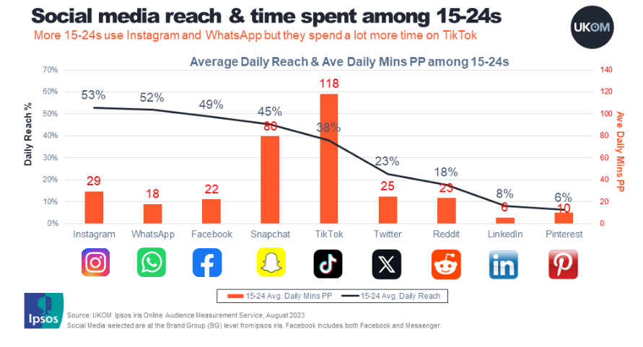
Figure 1: Social Media Usage and Time Spent Among 15-24s in the UK
(Source: UKOM, 2024)
Looking into the online activity of young people (15-24s), Instagram (53%), WhatsApp (52%), and Facebook (49%) are found to be the most used SM platforms, but in terms of time spent, TikTok (118 minutes) and Snapchat (80 minutes) secure first and second position, respectively [see Figure 1]. Such a usage pattern has significant consequences on the mental health of users, highlighting the need for further investigations.

2.2 Adolescents' Mental Health Concerns Due to Long-term Exposure to Digital Platforms
Concerns regarding SM usage and the mental health of adolescents are growing because Fassi et al. (2025) observed that adolescents suffering from mental health issues, specifically internalising issues, tend to stay on SM longer and feel negatively about number of friends they have on SM as compared to adolescents without mental health issues. They tend to engage in social comparisons and have a higher impact on mood from feedback, highlighting the negative impact of SM on mental health. The UK “Royal Society for Public Health” acknowledged that excessive SM usage is linked to higher rates of cyberbullying, which can enhance mental health conditions, along with developing sleep deprivation, overstimulation and isolation, leading to impaired cognitive development, affecting their ability to connect with people outside (Sisters Hospitallers, 2026).
Davies et al. (2025) found SM usage to be negative for adolescents from the evaluation of UK newspapers between 2014 and 2024, as 58% of headlines were framed negatively and 98% of articles discussed potential risks, including harmful content, mental health issues, inappropriate adult contact, online conflict and suicide risks (24%). In contrast, only 16% of articles refer to the benefits of SM on adolescents, increasing public anxiety. Marciano and Viswanath (2023) argued that although SM presents both positive and negative associations with the well-being of adolescents, SM has great potential in promoting good habits that facilitate the development of adolescents via inspirational content.

2.3 UK Strategies and Policies to Support Adolescents' Mental Health
Taking into account the potential impact of SM on adolescents, 9 out of 10 parents have demanded a ban on SM usage for adolescents under 16 years old, prompting the UK government to develop a new plan banning SM companies that offer services to adolescents under 16 by 2017 (DSIandT, 2026). The “Online Safety Act 2023” also helps in protecting adolescents under 16 by preventing their access to SM. Additionally, to address mental health concerns among adolescents, the UK government introduced the “Children and young people’s mental health services” (CYPMHS) offered by a range of institutions, including local authorities, community trusts, the NHS mental health and the voluntary sectors, which play a critical role in ensuring the mental wellness of UK adolescents (Garratt et al., 2024).

2.4 Need for a Scoping Review
Past studies mainly indicate contradictory findings referring to both positive and negative impacts of SM on mental health; however, they lack focus on mental health outcomes in UK adolescents, depending on the nature of SM usage. It highlights the need to carry out thematic synthesis to recognise factors influencing the relationship between SM use and the mental health of adolescents.

3.0 Methods

3.1 Research Design
The current study carried out a scoping review as per the brief requirement, which is a secondary research approach and helped in recognising the knowledge gap in terms of SM use and mental health concerns of adolescents (Munn et al., 2018). The five-phase scoping review framework by Arksey and O'Malley (2005) has been used in this research, which involves identifying the research question, recognising, selecting and charting the literature, and lastly, extracting the review results. Recognition of the research question is a key requirement of conducting a scoping review to ensure relevant studies are included (Mak and Thomas, 2022).
Research Question: What are the key themes identified in the literature regarding the impact of social media use on adolescent mental health in the UK?

3.2 Search Strategy and Databases
An effective search strategy has been developed, which means the selection of appropriate databases and applying relevant search terms to collect the research-relevant studies (Carrera-Rivera et al., 2022). For the current scoping review, PubMed, CINAHL, PsycINFO and UWTSD Library are considered along with the Google Scholar search platform. The key search terms used in this research are “social media”, “adolescent mental health”, “psychological wellbeing”, “anxiety”, and “depression”.

3.3 Inclusion and Exclusion Criteria
 | Inclusion criteria | Exclusion criteria
Project Background | Researching social media use and mental health outcomes, relevant to UK practice | Articles unrelated to mental health outcomes
Target Population | Studies involving adolescents aged 10–19 years. | Studies focused exclusively on adults
Publication Type | Peer-reviewed studies. | Non-peer-reviewed literature.
Publication Period | Published between 2015 and 2026. | Before 2015
Language | English-language publications. | Non-English publications.
Table 1: Inclusion and exclusion criteria

3.4 Study Selection and Extraction Process
Initially, 148 studies were selected from predetermined databases, and then 32 were removed following title and abstract screening. Then, further studies have been removed following the inclusion-exclusion criteria, such as a lack of peer-reviewed studies, and studies that did not focus on SM and mental health outcomes in the UK [see Figure 2]. Lastly, 5 peer-reviewed primary journal articles have been selected to conduct the scoping review.
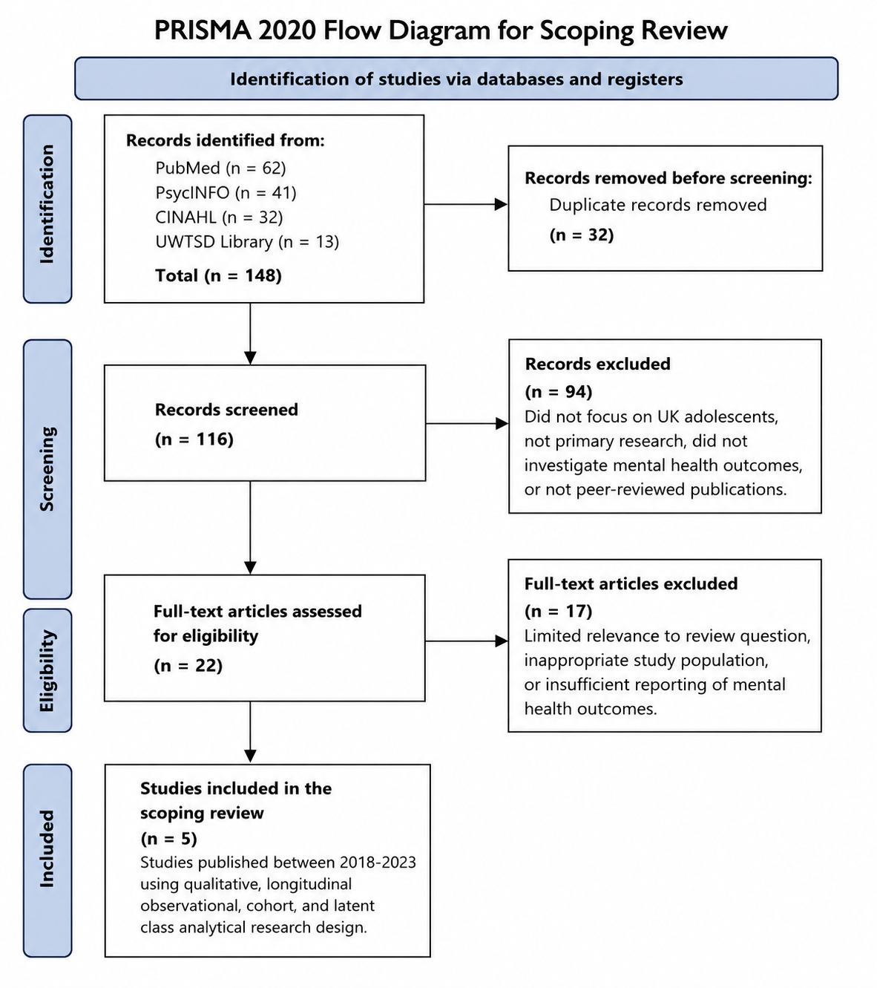
Figure 2: PRISMA Flow for Scoping Review

3.5 Ethical Considerations
The study has followed the ethics requirements of the UWTSD University and ensured the research outcome accurately represents the reviewed articles. Proper citations and references have been used to avoid the issue of plagiarism and maintain academic integrity.

4.0 Results
Author (Year) | Country | Aim | Research Design | Sample | Main Findings | Quality/Strength
Kelly et al. (2018) | UK | Evaluating associations between SM use and mental health conditions like depressive symptoms among adolescents. | UK Millennium Cohort Study (Longitudinal) | 10,904 adolescents aged 14 years | - Heavy social media usage is linked to depressive symptoms, particularly among girls,  - Cyberbullying, poor sleep, low self-esteem and body image partially influence this relationship. | - Large nationally representative cohort  - Validated mental health measures,  - Robust statistical analyses
O'Reilly et al. (2018) | UK | To investigate the perception of adolescents on SM and its relevance to emotional well-being and mental health. | Qualitative study using focus groups | 54 adolescents aged 11–18 years | - Perceived SM as a mental wellbeing threat  - Cause mood and anxiety disorders  - Cyberbullying, peer pressure and addiction  - Potential risks rather than actual experienced harms | - Deeper insights from adolescents' own experiences provided a contextual understanding
Plackett et al. (2023) | UK | To evaluate the longitudinal associations between SM use and adolescent mental health with social connectedness and self-esteem as potential mediators | Longitudinal observational study | 3,228 adolescents from the “UK Longitudinal Household Survey” | - Little evidence to indicate that higher time spent on SM indicates poorer mental conditions 2 years later  - Self-esteem has a moderate impact and can be used in prevention strategies  - Social connectedness does not influence the relationship | - Longitudinal design  - Adjustment for multiple confounders
Viner et al. (2019) | England | To explore mediating pathways linking SM use with the mental health and wellbeing of adolescents | Secondary analysis of longitudinal cohort data, “Our Futures” | (Wave 1= 12,866; Wave 2= 10,866; Wave3= 9797)  adolescents aged 14 years | - Associations between SM use and poorer mental health were largely mediated via cyberbullying, inadequate sleep and reduced physical activity  - SM exposure alone does not influence mental health outcomes | - A large, nationally representative longitudinal dataset  - Mediation analysis
Winstone et al. (2022) | UK | To identify adolescent SM user profiles and evaluate associations with mental health and wellbeing. | Longitudinal survey with latent class analysis | 2,459 adolescents aged 13–14 years | - 4-class model of SM user  - Adolescents recognised as “Broadcasters” have reported poorer wellbeing  - Moderate users showed comparatively better mental health outcomes. | - An innovative person-centred analytical approach
Table 2: Results

5.0 Discussion

Theme 1: Social Media Use and Psychological Distress
From the review of five selected studies, one major theme that emerges is SM usage and related psychological distress or depression symptoms that also align with the research objectives of the current scoping review. Kelly et al. (2018), in a longitudinal study, find that SM use and login depressive symptoms increase among girls, with the highest depressive symptoms being noticed in girls reporting 3 or more hours of usage of SM. According to the study, girls generally spend more time online and are likely to be more exposed to online harassment. They might also face psychological distress due to exposure to SM for having low self-esteem and dissatisfaction regarding bodyweight and appearance. All these factors contribute to a higher mental health concern among adolescent girls due to higher SM exposure compared to boys. Viner et al. (2019) observed a similar outcome to that of Kelly et al. (2018), in terms of SM usage and mental health outcomes and found that adolescent girls in the UK are more vulnerable to mental health issues due to cyberbullying. UK adolescents believe that SM directly contributes to mental health issues like suicidal ideation and depression, and exposes them to cyberbullying, which negatively affects mental health (O'Reilly et al., 2018).
Looking into the mixed evidence on SM use impact on mental health, Winstone et al. (2022) carried out a longitudinal study, which indicates that adolescents characterised as “Broadcasters” have reflected poorer wellbeing after 1 year of SM exposure. This is because broadcasters tend to frequently share content online along with consistently socialising, messaging and browsing, referring to higher SM usage. In contrast, Viner et al. (2019) and Plackett et al. (2023), in longitudinal studies, noticed that there is little to no evidence that longer time spent on SM was linked to mental health issues later on among UK adolescents, creating difficulty in ascertaining the clinical effects on mental health of adolescents from SM. The findings address the scoping review objective to identify the main mental health outcomes associated with social media use among adolescents in the UK.

Theme 2: Positive and Negative Experiences of Social Media Usage
The five reviewed studies indicate that SM usage entails both negative and positive experiences as SM offers all adolescents the opportunity to share their feelings and experiences with others and helps in social interactions, but it can also lead to several negative mental outcomes like anxiety and depression due to online harassment, loss of sleep quality, and quantity and impaired cognitive development (Kelly et al. 2018; O'Reilly et al. 2018). O'Reilly et al. (2018) has been extremely critical in offering perspectives of adolescents on SM usage, as it revealed that UK adolescents perceived SM as a threat to their mental well-being, as SM promotes addiction and cyberbullying, which can cause low self-esteem, depression, stress, and suicide ideation. However, they also believed that these perspectives of adolescents are influenced by societal representation of social media usage rather than negative experiences by adolescents themselves in most cases. It means that SM related discussed harms are potential risks rather than experienced harms by adolescents, undermining the realisation of actual negative effects of SM on the mental health of young people.
Winstone et al. (2022) observed that Broadcasters with higher SM usage have the poorest mental health outcomes, while moderate communicators have better well-being. However, Winstone et al. (2022) noticed the absence of positive outcomes among minimal users as compared to moderate users. It indicates that moderate SM use might be beneficial for adolescents to maintain peer-connectedness. Kim (2017) and Webster et al. (2021), as part of wider literature, have found that SM use entails both positive and negative effects on adolescent psychological well-being, but it depends on usage patterns. The findings help in addressing the objective of examining both positive and negative effects of social media on adolescent psychological well-being.

Theme 3: Sleep Disruption, Physical Activity, and Cyberbullying Contributing to Negative Mental Health
The relationship between SM and mental health conditions is influenced by several factors, including sleep disruption, cyberbullying, and physical activity, and this has been evidenced by reviewed studies. Online harassment and poor sleep (less than 7 hours) due to SM related disruptions contribute to higher depression scores among surveyed adolescents (Kelly et al. 2018). Viner et al. (2019) argued that very frequent SM usage is not likely to have harmful effects among adolescents unless they are exposed to harmful content like cyberbullying or their sleep is affected. They also argued that physical activity and frequent SM use have no significant impact on mental health outcomes. Cyberbullying has the most significant mediating impact on mental health outcomes following SM exposure (Kelly et al. 2018; Viner et al. 2019).
Wider literature analysis has similarly conveyed that cyberbullying via SM has a significant negative impact on mental health, as it contributes to psychosomatic conditions among adolescents (Peprah et al., 2024). Suprapto et al. (2025), on the other hand, argued that SM usage for over 4 hours/day (sedentary lifestyle) and exposure to fast food advertisements increase risks of obesity, which puts an additional burden on the mental health of adolescents. The finding addresses the objective to explore factors that influence the relationship between social media use and mental health.

Theme 4: Intensity and Patterns of Social Media Engagement and their Effects on Mental Health
Reviewed literature denotes that SM exposure alone does not contribute to mental health; usage patterns and intensity largely influence the mental health outcomes of adolescent users. Kelly et al. (2018), for instance, found that two-fifths of adolescent girls use SM for 3 (43.1%) or more hours as compared to one-fifth of boys (21.9%), thus, face higher online harassment and depressive symptoms. It aligns with the assumption that excessive SM usage contributes to negative mental health conditions. The more time spent on SM, the more adolescent girls reported experiencing dissatisfaction regarding body weight and appearance, which directly connects to the depressive symptoms (Kelly et al., 2018). Winstone et al. (2022) acknowledged that SM usage patterns influence mental health outcomes after categorising users into 4 models- “High Communicators, Moderate Communicators, Broadcasters and Minimal users” and found that Broadcasters with higher SM usage have the poorest mental health performance, whereas Moderate Communicators experience better well-being by reducing self-harm potential. Plackett et al. (2023), in contrast, did not find higher SM usage linked with mental health issues. These findings help in addressing research objectives 1 and 3.

Theme 5: The Dynamics of Relationship between Mental Health and Social Media Among Adolescents
The reviewed literature observed a bidirectional relationship between mental health and SM usage, which means excessive SM usage can contribute to mental health conditions, including depressive symptoms among adolescents. Similarly, adolescents with mental health issues are likely to use SM more to feel validated or even gain help (Kelly et al. 2018; Winstone et al. 2022). Kelly et al. (2018), however, noted that online harassment and poor sleep contribute to depressive symptoms among adolescents due to SM usage, addressing the third research objective in this scoping review. Viner et al. (2019) and Plackett et al. (2023), in contrast, observed that there was little evidence to indicate that the longer time spent on SM contributes to mental health issues later on among UK adolescents. They further noticed that self-esteem and social connectedness do not influence or mediate the relationship anymore.
However, the bidirectional relationship has been acknowledged by wider literature since Heffer et al. (2019), and Fassi et al. (2025) observed that adolescents with mental issues like internalising tend to stay on SM longer and feel negatively about number of friends, feedback on posts, and engage in social comparisons more than adolescents without mental health issues.
Based on research findings, there are several gaps in current evidence base as adolescents, similar to adults, consider SM as faulty for negative effects rather than taking accountability themselves, highlighting the need to investigate accountability and awareness of the negative sides of SM and offer recommendations for future research and practice to address all research objectives (O'Reilly et al. 2018).

6.0 Conclusion and Recommendations

6.1 Conclusion
The scoping review evaluated existing evidence on the impact of social media use on the mental health and wellbeing of adolescents in the UK, focusing on 5 primary peer-reviewed journal articles. The review denotes that the SM has a multifaceted and complex relationship with mental health among adolescents, as it entails both positive and negative effects, and these negative effects are mostly societal representations learned by adolescents rather than experiencing any negative impact themselves. Nevertheless, psychological distress, depressive symptoms, and anxiety are major health issues reported among adolescents due to their excessive exposure to social media. Social media engagement pattern and time, sleep disruption and cyberbullying are major factors that influence the relationship between SM and mental health impact. This relationship, therefore, depends on the context in which SM is used to indicate mental health conditions, but moderate usage seems to have a positive impact rather than a negative one.

6.2 Recommendations

6.2.1 Recommendations for UK Education and Mental Health Care Services and Policy Recommendations
Digital literature should be a key requirement for UK schools to assist adolescents in navigating social media by learning safe usage, recognising harmful behaviour and determining the accuracy of misleading online content. Both caregivers at home and mental health professionals should encourage adolescents to talk about social media usage and their experiences with adolescents to offer guidance and even implement restrictions on usage where required. Policymakers, on the other hand, can contribute to the implementation and viewing of the Online Safety Act of the UK to minimise exposure of adolescents to cyberbullying, inappropriate adult contact and other harmful content.

6.2.2 Recommendations for Future Research
The future studies must focus on evaluating the directional relationship between SM use and mental health conditions among UK adolescents via longitudinal studies by applying standardised measures to them to compare and contrast the study findings over time. Additionally, future studies can focus on evaluating online accountability on the adverse impacts of SM usage, as very few studies have evaluated matters of accountability and resilience development.

References
Aichner, T., Grünfelder, M., Maurer, O., and Jegeni, D. (2021). ‘Twenty-five years of social media: a review of social media applications and definitions from 1994 to 2019’. Cyberpsychology, behavior, and social networking, 24(4), 215-222. DOI: 10.1089/cyber.2020.0134
Al-Zawaadi, A., Hesso, I., and Kayyali, R. (2021). Mental health among school-going adolescents in Greater London: a cross-sectional study. Frontiers in psychiatry, 12, 592624. doi: 10.3389/fpsyt.2021.592624
Arksey, H. and O'Malley, L. (2005) 'Scoping studies: Towards a methodological framework', International Journal of Social Research Methodology, 8(1), pp. 19–32.https://eprints.whiterose.ac.uk/id/eprint/1618/1/Scopingstudies.pdf
Carrera-Rivera, A., Ochoa, W., Larrinaga, F., and Lasa, G. (2022). ‘How-to conduct a systematic literature review: A quick guide for computer science research’. MethodsX, 9, 101895. https://doi.org/10.1016/j.mex.2022.101895
Davies, J., Cadwallader, S., Black, L., Hickman Dunne, J., and Panayiotou, M. (2025). The representation of adolescent social media use: a systematic review and content analysis of UK newspaper articles. BMC Public Health, 25(1), 3067. https://doi.org/10.1186/s12889-025-23897-5
DSIandT, (2026). Consultation outcome Growing up in the online world: a national consultation. Department for Science, Innovation and Technology. [Online]. Available at: https://www.gov.uk/government/consultations/growing-up-in-the-online-world-a-national-consultation [Accessed on 26/06/2026]
Fassi, L., Ferguson, A. M., Przybylski, A. K., Ford, T. J., and Orben, A. (2025). Social media use in adolescents with and without mental health conditions. Nature human behaviour, 9(6), 1283-1299. https://doi.org/10.1038/s41562-025-02134-4
Garratt, K., Kirk-Wade, E., and Long, R. (2024). Children and young people's mental health: Policy and services (England). House of Commons Library. https://commonslibrary.parliament.uk/research-briefings/cbp-7196/
Gong and Yang, (July 2020). ‘Social Media Platforms. Geographic Information Science and Technology Body of Knowledge 2020(Q3)’. DOI:10.22224/gistbok/2020.3.2
Heffer, T., Good, M., Daly, O., MacDonell, E., and Willoughby, T. (2019). The longitudinal association between social-media use and depressive symptoms among adolescents and young adults: An empirical reply to Twenge et al.(2018). Clinical Psychological Science, 7(3), 462-470. https://doi.org/10.1177/2167702618812727
Keles, B., McCrae, N. and Grealish, A. (2020) 'A systematic review: The influence of social media on depression, anxiety and psychological distress in adolescents', International Journal of Adolescence and Youth, 25(1), pp. 79–93.https://www.tandfonline.com/doi/pdf/10.1080/02673843.2019.1590851
Kelly, Y., Zilanawala, A., Booker, C., and Sacker, A. (2018). Social media use and adolescent mental health: Findings from the UK Millennium Cohort Study. EClinicalMedicine, 6, 59-68. https://doi.org/10.1016/j.eclinm.2018.12.005
Kim, H. H. S. (2017). The impact of online social networking on adolescent psychological well-being (WB): a population-level analysis of Korean school-aged children. International Journal of Adolescence and Youth, 22(3), 364-376. https://doi.org/10.1080/02673843.2016.1197135
Mak, S., and Thomas, A. (2022). Steps for conducting a scoping review. Journal of graduate medical education, 14(5), 565-567. doi: 10.4300/JGME-D-22-00621.1
Marciano, L., and Viswanath, K. (2023). Social media use and adolescents’ well-being: A note on flourishing. Frontiers in Psychology, 14, 1092109. doi: 10.3389/fpsyg.2023.1092109
Masterson V., (2022). These social media channels are where UK teens get their news. [Online]. Available at: https://www.weforum.org/stories/2022/08/social-media-news-uk-instagram-tiktok-youtube/ [Accessed on 26/06/2026]
Munn, Z., Peters, M. D., Stern, C., Tufanaru, C., McArthur, A., and Aromataris, E. (2018). Systematic review or scoping review? Guidance for authors when choosing between a systematic or scoping review approach. BMC medical research methodology, 18(1), 143. https://doi.org/10.1186/s12874-018-0611-x
O’reilly, M., Dogra, N., Whiteman, N., Hughes, J., Eruyar, S., and Reilly, P. (2018). Is social media bad for mental health and wellbeing? Exploring the perspectives of adolescents. Clinical child psychology and psychiatry, 23(4), 601-613.
Peprah, P., Oduro, M. S., Atta-Osei, G., Addo, I. Y., Morgan, A. K., and Gyasi, R. M. (2024). Problematic social media use mediates the effect of cyberbullying victimisation on psychosomatic complaints in adolescents. Scientific reports, 14(1), 9773. https://doi.org/10.1038/s41598-024-59509-2
Plackett, R., Sheringham, J., and Dykxhoorn, J. (2023). The longitudinal impact of social media use on UK adolescents' mental health: longitudinal observational study. Journal of medical Internet research, 25, e43213. https://www.jmir.org/2023/1/e47678
Sisters Hospitallers, (2026). Almost half of British teenagers feel addicted to social media. [Online]. Available at: https://www.sistershospitallers.org/social-media-teenagers-addiction-in-the-uk/ [Accessed on 26/06/2026]
Slotta D., (2026). ‘Social media usage in the United Kingdom (UK) - statistics and facts’. Statista [Online]. Available at: https://www.statista.com/topics/3236/social-media-usage-in-the-uk/?srsltid=AfmBOopXFf5qU0vSCUFzREh0S1668Q9GuNo20qdGFwL3_Wimt2k56BBC#topicOverview. [Accessed on 26/06/2026]
Suprapto, A., PM, M. A. P., and Jurini, A. T. (2025). Cyberbullying and Its Impact on Adolescent Mental Health on Social Media. International Journal of Multidisciplinary Research and Creative Innovation Ideas, 1(2), 104-114. https://journal.bizscript-studio.co.id/the-mir-journal
UKOM, (2024). Social media use by age. [Online]. Available at: https://ukom.uk.net/snapshots/269-social-media-use-by-age.php [Accessed on 26/06/2026]
Viner, R. M., Gireesh, A., Stiglic, N., Hudson, L. D., Goddings, A. L., Ward, J. L., and Nicholls, D. E. (2019). Roles of cyberbullying, sleep, and physical activity in mediating the effects of social media use on mental health and wellbeing among young people in England: a secondary analysis of longitudinal data. The Lancet Child and Adolescent Health, 3(10), 685-696. https://discovery.ucl.ac.uk/id/eprint/10081099/3/Viner_Resubmission%20Social%20media%20mentalhealth%20LSYPE2%20%20Lancet%20CAH%200519.pdf
Webster, D., Dunne, L., and Hunter, R. (2021). Association between social networks and subjective well-being in adolescents: A systematic review. Youth and Society, 53(2), 175-210. https://doi.org/10.1177/0044118X20919589
Winstone, L., Mars, B., Haworth, C. M., Heron, J., and Kidger, J. (2022). ‘Adolescent social media user types and their mental health and well‐being: Results from a longitudinal survey of 13–14‐year‐olds in the United Kingdom’. JCPP advances, 2(2), e12071. DOI: 10.1002/jcv2.12071

