Rowan Patey (2317629)
2317629@student.uwtsd.ac.uk
Abstract
Exploring the behaviour of parallel RLC circuits using simulation and practical circuits.
parallel RLC circuits
EEP Assignment

Abstract

To explore A.C. theory and the principles of inductance, capacitance, resistance and reactance in A.C. voltage source circuits, a modified parallel LC circuit, with a resistor placed in series (parallel RLC circuit) was designed. Set up both as a simulation in Proteus 8 and real components on a breadboard, frequency response graphs were plotted and used to find the quality factor and bandwidth of each circuit’s response. Having discovered that the quality factor of the simulated circuit was greater than that of the practical circuit, reasoning was theorised and applied to the simulation, causing the characteristic response curve to drop into the same pattern after adding a single primitive resistor in series with the inductor, bringing the Q factor much closer and showing the variable of greatest explanatory value was the parasitic series resistance of the inductor.

Introduction

LC circuits, are simple circuits consisting of an inductor and a capacitor. Displayed characteristics of the circuit change depending on whether these two reactive components are placed in series or parallel [1]. The behaviour observed is due to elements of A.C. voltage source circuits: Capacitors store charge on the plates across the dielectric, inductors store charge in their magnetic field. Ideal parallel LC circuits act as electrical resonators, ideal here being no resistance to dissipate energy. The energy would theoretically continue to bounce between the two reactive elements like a pendulum swinging with no other forces acting against it. In reality, internal resistances [2] will act upon this oscillating and eventually bring it to a stop without any further current input. The oscillating, or resonance, is a product of reactance in the A.C. circuit: Reactance is opposition to the change of flow of current and consists of both an inductive reactance element and a capacitive reactance element. Capacitive reactance occurs due to the work done while charging producing a resistance in the circuit, and is modelled using Equation 1. [3]:

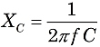

Inductive reactance instead arises due to the magnetic field they generate, where a voltage is induced across the inductor’s coil and acts as a resistive ‘back electromotive force (EMF)’. It is modelled using Equation 2. [3]:

When one or the other is larger, a phase shift is induced between current and voltage. Impedance is then the collective reactance and resistance in the A.C. circuit with respect to phase. However it is when the two reactance values are the same that resonance occurs. The energy

By placing the resistor in series with the parallel LC circuit, then placing a load in series, a bandstop filter is made; the series resistor acts to dampen the system [1]. This RLC circuit can be modelled as the combined effects of an RC circuit and an RL circuit: RC circuits act as 1st order passive low pass filters, generating attenuation depending on input frequency where the resistor and following capacitor (due to internal resistance) behave like a voltage divider. RL circuits on the other hand behave more like LC circuits, however the present resistor dissipates energy, making them far less elastic in the energy transfer occurring. Function wise they behave like high pass filters [1] and as such, combining RL and RC circuits into RLC parallel circuits combines the functions, creating a circuit that increases the gain of signals up to the point where the two reactances become equal, then attenuates the output signal past this point.

Resonance has many industrial uses:

LC circuits, or Tank circuits see use across telecommunications, where in they resonant at the desired frequency [4], with the ability to then edit the frequency using a series resistor in front of the inductor (hence creating a potential divider) [1].

Audio mixing equipment/circuits utilise the resonant behaviour of tank circuits to remove noise and other undesirable distortion like echo [4].

Parallel RLC circuits are vital for impedance matching, a crucial part of RF engineering to match impedance, ensuring maximum power transfer [5].

Methods

First a suitable range of values must be determined, based upon the intended component values:
Resistor – 1kΩ
Capacitor – 1µF
Inductor – 1mH

Due to the inductor and capacitor being two reactance forces in parallel, the product rule can be used similarly to calculating parallel resistance in a D.C. circuit. This value will therefore be the impedance (Z) of the RLC circuit at a given frequency, Equation 3. [6]:

$$Z= \frac{jX_{L}(-jX_{c})}{jX_{L}-jX_{c}}$$

Where j is the imaginary component to account for phase. Using equations 1. and 2. the two reactance values can be found for a given frequency. As established, the ‘cutoff’, or resonance frequency of the combined RLC circuit will be the frequency at which X_{L} = X_{C} which is where the total impedance is 1/0, theoretically infinite. Therefore subbing the component values into equations 1. and 2. as an equivalence, it can be rearranged with respect to f, to find the resonant frequency, Equation 4. [6]:

$$f= \frac{1}{2π-\sqrt{C x L}}$$

With the component values, f_{res} is therefore 5032.92 Hz. Z_{lc} at this frequency is 1/0. Therefore suitable values must be selected around this centralising frequency in order to explore the resonant behaviour. Appropriate values start well below the resonant frequency to observe behaviour below resonant frequency, tighten around the resonant frequency to better see what is occurring, then go well beyond this frequency to explore what happens above. See Table 1. for the selected range.

To explore the behaviour of the parallel RLC circuit, Proteus 8 cad software was used to design the circuit. The following component types and values were used:
Generic resistor – 1kΩ
Generic none polarised capacitor – 1µF
Primitive inductor – 1mH

The physical equivalent components selected for the practical circuit were as follows:
Metal film resistor – 1% tolerance
Metal film capacitor – 1k63 rated 10% tolerance
Primitive inductor
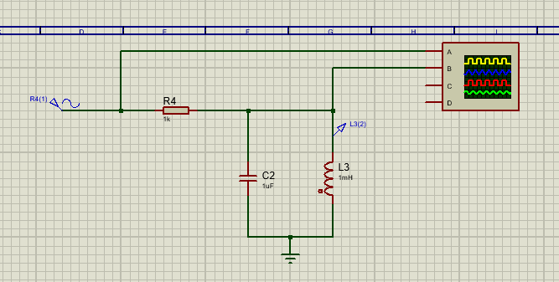
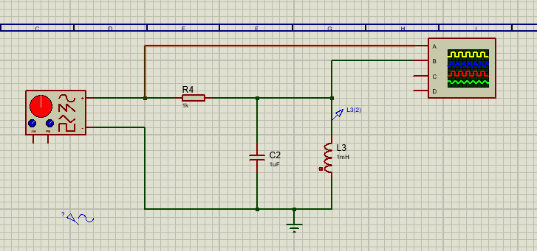
Figure 2. Proteus schematic for the RLC circuit with R = 1k, C = 1uF and L = 1mH. A sine wave generator is modelled inputting an A.C. sine wave into the RLC circuit at 2Vpk-pk, with the load being an oscilloscope.
Figure 1. Proteus schematic for the RLC circuit with R = 1kΩ, C = 1µF and L = 1mH. A signal generator is modelled in this version to generate an A.C. sine wave function, with the load being an oscilloscope.
Then, the practical version of the same circuit was set up using comparatively rated components on a breadboard, connected to a wave generator set to output a sine wave at a consistent amplitude of 2Vpk-pk, with an oscilloscope probe attached at the input line in to measure the input voltage and a probe on the leading arm of the resistor to observe the output wave function, see Figure 3. 4. and 5.
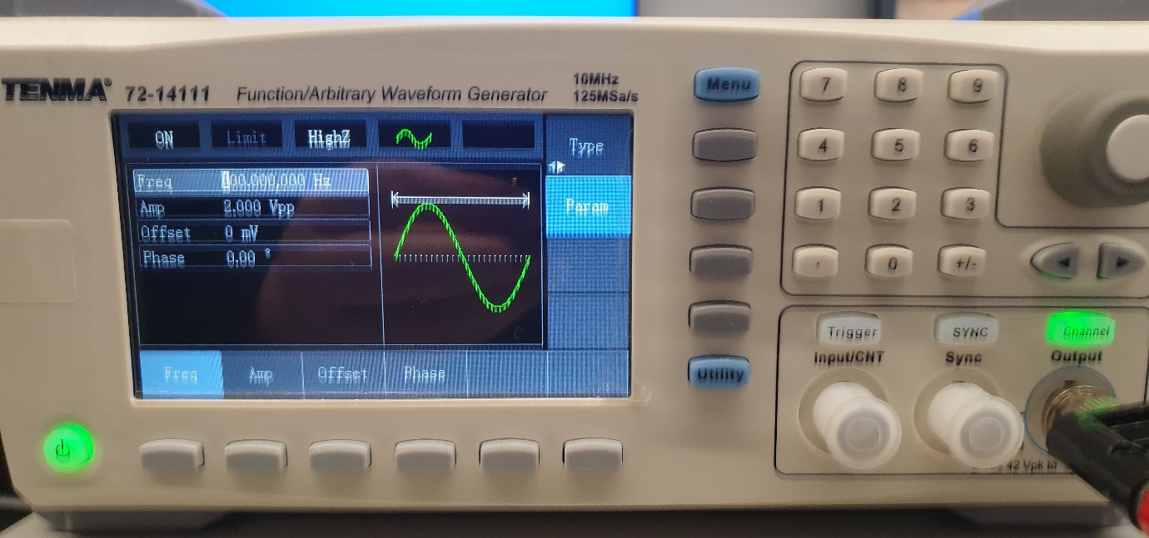
Figure 3. Signal generator set to produce a sine wave at whatever set frequency, at a consistent amplitude of 2Vpk-pk.

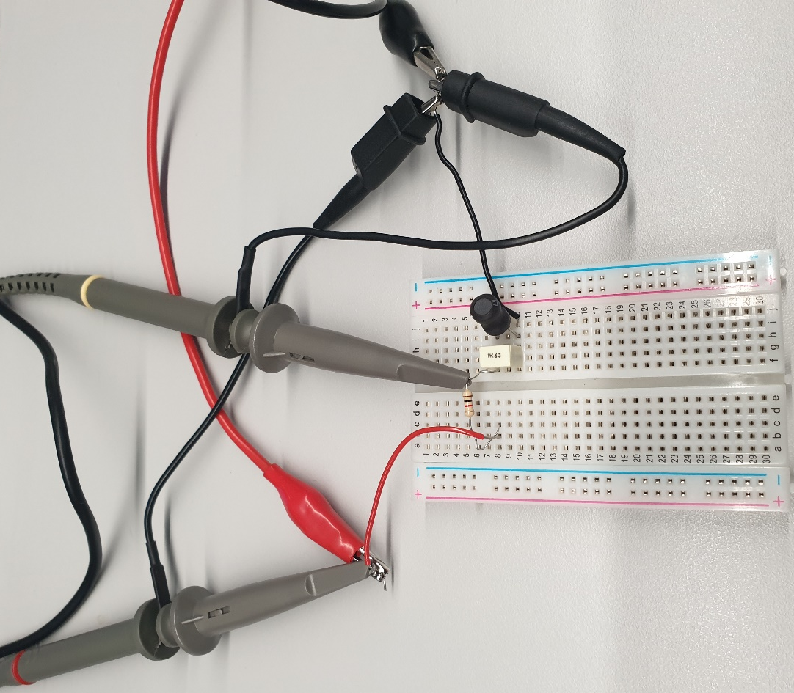

Figure 4. Breadboard version of the RLC circuit using components of the same claimed values as set out, a 1kΩ resistor, a 1µF capacitor and a 1mH inductor.
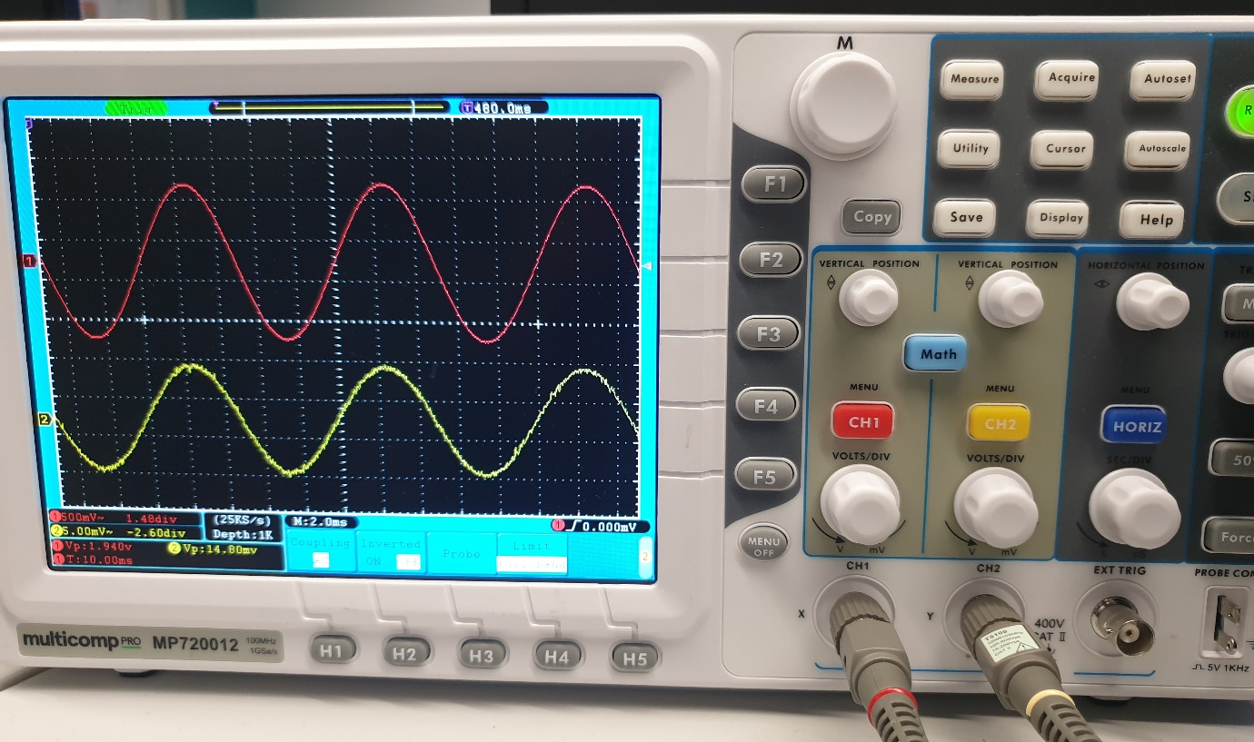
When values were obtained for output voltage against frequency change, a frequency response curve could be generated for both of the circuits by calculating attenuation (dB) and plotting this against the frequency on a logarithmic scale, using the Equation 5.:
Figure 5. Oscilloscope showing the red input signal and yellow output signal. The pk-pk voltage of the output signal was measured using this.
$$Att \left(dB\right)=20*Log10 \frac{Vout}{Vin}$$
Finally, these results could be used to determine the Q factor of both circuits. First the bandwidth at both -3db points of the curve is found using a tool provided by Professor Steven Mosey, followed by Equation 6.:
$$Qfactor= \frac{fres}{BW}$$

Results
f (Hz) | Vin | Vout (Gen) | Vout (Sine) | Att (dB)
100 | 2 | 0.0013 | 0.0013 | -63.74173
200 | 2 | 0.0025 | 0.0025 | -58.0618
500 | 2 | 0.0064 | 0.0063 | -50.03379
1000 | 2 | 0.0132 | 0.0131 | -43.67517
2000 | 2 | 0.0304 | 0.0299 | -36.50718
4000 | 2 | 0.145 | 0.14 | -23.09804
4800 | 2 | 0.8375 | 0.8375 | -7.560904
4900 | 2 | 1.435 | 1.315 | -3.642085
5000 | 2 | 1.605 | 1.795 | -0.939311
5032.92 | 2 | N/A | 1.57 | -2.102607
5100 | 2 | 0.96 | 1.07 | -5.432924
5200 | 2 | 0.63 | 0.67 | -9.499104
6000 | 2 | 0.164 | 0.165 | -21.67092
10000 | 2 | 0.0415 | 0.0415 | -33.65964
15000 | 2 | 0.0235 | 0.0235 | -38.59924
20000 | 2 | 0.0167 | 0.0167 | -41.56627
Table 1. Simulated RLC circuit in Proteus 8 using R = 1kΩ, C = 1µF and L = 1mH. Gen denotes results obtained using the wave generator, however attenuation is calculated using the results for the sine generator to keep results consistent, due to noted differences in values close to resonant frequency across the two methods.
Table 2. Practical RLC circuit in Fig. 4 results showing the output voltage at each input frequency, followed by attenuation calculated using Equation 5.
f (Hz) | Vin | Vout | Att (dB)
100 | 1.96 | 0.016 | -41.76272
200 | 1.96 | 0.0164 | -41.54824
500 | 1.96 | 0.0176 | -40.93487
1000 | 1.96 | 0.0212 | -39.3184
2000 | 1.96 | 0.0348 | -35.01354
4000 | 1.96 | 0.12 | -24.2615
4900 | 2 | 0.22 | -19.17215
5000 | 2 | 0.224 | -19.01564
5032.92 | 2 | 0.225 | -18.97695
5100 | 2 | 0.222 | -19.09354
5200 | 2 | 0.218 | -19.25147
6000 | 2 | 0.14 | -23.09804
10000 | 2 | 0.044 | -33.15155
15000 | 1.96 | 0.024 | -38.2409
20000 | 1.96 | 0.018 | -40.73967

Graph 1. Attenuation against frequency logarithmically plotted to generate a frequency response graph for the RLC circuit simulated in proteus
Immediately obvious, the frequency response ‘sharpness’ for the simulated RLC circuit is much greater than for the experimental RLC circuit, implying a much greater Q factor value to come. The simulated RLC circuit attenuates the voltage ouput/signal more drastically at lower frequencies and attenuates far less at the expected resonant frequency predicted. This is further examplified in Graph 3. wherein the experimental resonance peak is seen to be roughly -18dB lower than the simulated circuit.

Graph 2. Attenuation against frequency logarithmically plotted to generate a frequency response graph for the RLC circuit designed on breadboard.

Graph 3. Direct comparison of the resonance peaks seen in Graphs 1. and 2.
Graph 4. Model provided by Professor Stephen Mosey used to estimate the bandwidth of the simulated RLC circuit.

The bandwidth estimated at the -3dB points of the simulated RLC circuit Graph 4. is 180Hz, therefore through Equation 6. the Q factor of the simulated circuit is 27.9607 (still using the calculated resonant frequency).

The bandwidth estimated at the -3dB points of the practical RLC circuit Graph 5. is 1375Hz, therefore through Equation 6. the Q factor of the simulated circuit is 3.66031, roughly 9 times lower than that of the simulated circuit.

Graph 5. Model provided by Professor Stephen Mosey used to estimate the bandwidth of the practical RLC circuit.

Discussion
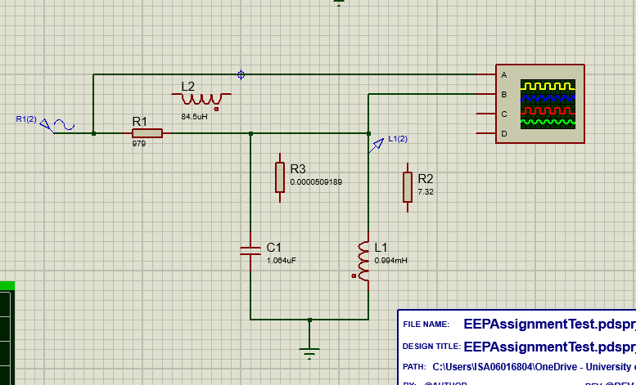
As is obvious immediately upon viewing the results, the quality factor of the practical breadboard circuit was drastically lower than the comparative result for the Proteus simulated frequency response. This would first call into question whether the component values of the real passive devices are accurate, as this would affect every recorded value given they are all determined by the inductance, capacitance and dampening resistance of the circuit [1]. Professor Stephen Mosey recorded more accurate values for the passive devices used, revealing small differences in the real world component values alongside previously not modelled parasitic effects [2]. The slightly adjusted values were simulated in Proteus (Fig. 6) to see if the slight inaccuracies were causing the noticeable shift in Q factor. The new values were:
Figure 6. Adjusted values to match the measured component values from the batch of components used.
R - 979Ω
C – 1.064µF
L – 0.994mH
This specific capacitor, marked 1K63, has a tolerance of up to 10%, denoted by the K. These metal film capacitors therefore can differ in their actual capacitance rating, seen in the new value measured.
After simulating the edited circuit, the results however were nearly identical to the original simulated circuit frequency response, strongly implying that the explanatory variable is elsewhere (Appendix 1 for results).
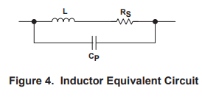
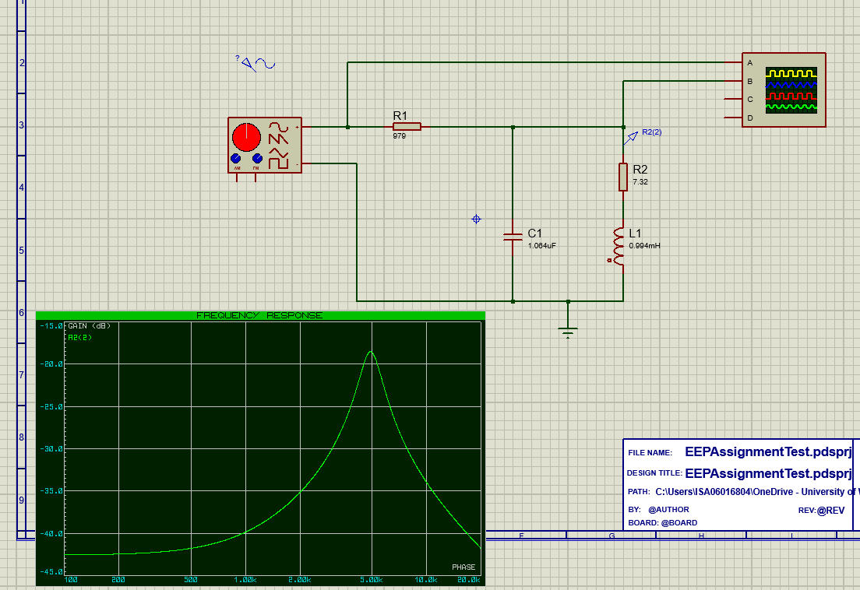
Mentioned in the introduction, tank circuits are parallel LC resonant circuits with a resistor placed intentionally to lower the Q factor, called Q-spoiling resistors [1]. These are typically placed in front of the inductor of the tank circuit with the intention of lowering the resonant peak. However, there is not a resistor placed in front of the inductor in the practical RLC circuit seen arranged in Fig. 4, implying that there maybe parasitic resistance occurring that’s lowering the Q factor here. “Understanding basic analog devices” [2] shows how passive components actually behave, modelling equivalent circuits that convey true behaviour of the three RLC components. Referring back to tank circuits and the drastic effect a resistor has on Q factor, the inductor modelled demonstrates that real world inductors have a series resistance type of parasitic effect that would behave just like a resistor placed in front of the RLC inductor, alongside some parallel capacitance; it is even highlighted in [2] that this series resistance within the inductor lowers quality factor. To test whether it was a failure to model this series resistance that caused the simulated RLC resonance peak to have a smaller BW and greater Q factor, the Rs measured by Professor Mosey for the inductor units was modelled on the RLC circuit (of adjusted values):
Figure 7. Equivalent circuit modelling the parasitic effects inductor devices undergo due to the intended behaviour of storing charge in a magnetic field.
Figure 8. Proteus simulated RLC parallel circuit with adjusted component values and parasitic inductor series resistance modelled.
Table 3. Results of adding recorded parasitic inductor series resistance measured at 7.38Ω, modelled with generic resistor device to the primitive inductor of the RLC simulated circuit. Another parasitic effect, the frequency dependent ‘effective series resistance’ of the film capacitor was also modelled at the two provided values to test whether it would noticeably change the results.
f (Hz) | Vin | Vout (Gen) | Vout (Sine) | ESR | Att (dB)
100 | 2 | 0.01476 | 0.0149 | N/A | -42.55687
200 | 2 | 0.015 | 0.0151 | N/A | -42.44106
500 | 2 | 0.01626 | 0.0163 | N/A | -41.77685
1000 | 2 | 0.0205 | 0.0203 | 0.0203 | -39.87068
2000 | 2 | 0.0355 | 0.035 | N/A | -35.13924
4000 | 2 | 0.1365 | 0.134 | N/A | -23.4785
4800 | 2 | 0.2325 | 0.2325 | N/A | -18.69214
4893.91 | 2 | N/A | 0.2375 | N/A | -18.50733
4900 | 2 | 0.231 | 0.234 | N/A | -18.63628
5000 | 2 | 0.227 | 0.23 | N/A | -18.78604
5100 | 2 | 0.217 | 0.221 | N/A | -19.13275
5200 | 2 | 0.206 | 0.208 | N/A | -19.65933
6000 | 2 | 0.124 | 0.124 | N/A | -24.15217
10000 | 2 | 0.039 | 0.039 | 0.039 | -34.19931
15000 | 2 | 0.0225 | 0.0224 | N/A | -39.01564
20000 | 2 | 0.016 | 0.016 | N/A | -41.9382

Graph 6. Frequency response comparing all 5 tested conditions, indicating that modelling the inductor’s parasitic series resistance explains almost all of the Q factor drop observed between the experimental and simulated circuits. Trying to model the recorded parasitic inductance of the resistor made no difference to the frequency response, see Appendix 2.

Graph 7. Closer demonstration of the resonance peaks for each of the newly tested conditions. Of note, the newly simulated frequency response peaks each have a resonance frequency slightly lower than the unmodified simulated RLC circuit, due to the modified component values.

Demonstrated through graphs 6 and 7, adding parasitic resistance brings the resonance peak into line with the practical RLC circuit’s results. Graph 8 further confirms this by with a now similar estimated BW and Q factor calculated: BW = 1215Hz, Q factor = 4.027. Results now match the practical circuit within a far smaller tolerance. The analysis of the author is that the importance of modelling inductor parasitic series resistance is the magnitude of the resistance here. Both of the reactive elements of the parallel RLC circuit can behave like potential dividers to the output signal with respect to the 1k resistor. However, the capacitor frequency dependent ESR is negligible in this circuit, even at the greatest value recorded for 10kHz, capacitor ESR for this film capacitor only experienced parasitic series resistance of 7.63784 x 10⁻⁴ Ω, compared to 7.38Ω in the inductor. The potential divider ratio created by the inductor therefore lowers the Vout of the signal noticeably.

Graph 8. Compiling all of the attempted adjustments, with inductor series resistance being the only explanatory variable changed, to estimate the bandwidth at -3dB points and therefore the Q factor, now 4.027.

Conclusion
Parallel RLC circuits were used to explore A.C. theory concepts such as inductive and capacitive reactance and how they can create resonance within a circuit, alongside the behaviour of that resonance. It was discovered that simulated circuits carry a number of assumptions and effects that occur because they replicate near perfect/ideal component behaviour. For RLC parallel circuits, parasitic series resistance generated within the inductor was found to be the most influential parasitic effect in the low frequency circuit that was designed and tested.

References

[1] | P. Horowitz and W. Hill, The Art of Electronics 3rd Edition, Cambridge University Press., 2015.
[2] | Texas Instruments, “Understanding Basic Analog - Passive Devices,” Texas Instruments, 1999.
[3] | Sparks, “Calculating Reactance,” [Online]. Available: https://sparks-activities.concord.org/sparks-content/tutorials/tutorial-24.html. [Accessed 01 05 2024].
[4] | eTechnoG, “The amazing facts about LC TANK CIRCUIT | Working, Applications,” 03 11 2023. [Online]. Available: https://www.etechnog.com/2020/09/the-amazing-facts-about-lc-tank-circuit.html. [Accessed 01 05 2024].
[5] | Cadence PCB Solutions, “What Is the Impedance of an RLC Circuit?,” Cadence, [Online]. Available: https://resources.pcb.cadence.com/blog/2022-advanced-pcb-design-blog-what-is-the-impedance-of-an-rlc-circuit. [Accessed 01 05 2024].
[6] | J. Bird, Electronic and Electrical Engineering Principles and Practice Third Edition, palgrave macmillan, 2003.

