Reflective Report: Principles of Health and Social Care Practice
Anisa karim

Table of Contents
Introduction 3
Task 1: Reflection on the Importance of Principles 3
Task 2: Practical Examples of Concepts in Practice 4
Task 3: Self-Reflection as a Health and Social Care Professional 6
Reference List 10

Introduction
Providing quality health and social care in the United Kingdom is supported by a series of fundamental principles which are aimed at safeguarding the service users and the attainment of professional excellence. In this report, a critical reflection approach will be used to consider three main pillars including person-centred care, partnership working and ethical practice. Discussing these notions in theoretical terms, practical contexts, and self-reflection, the given assignment aims at proving how they improve the results of care and form the image of the contemporary healthcare professional.

Task 1: Reflection on the Importance of Principles
The importance of person-centred practice, collaboration and teamwork, and ethics cannot be overemphasised in the framework of the National Health Service (NHS) of the UK and the sphere of social care. These principles, however, are not just plain social constructs but are ingrained in the law and professional codes of conduct in order to safeguard the safety and human dignity of people.

Person-Centred Care
Person-centred care in its simplest form can simply be described as a move away of the one-sise-fits-all model of medical care and to instead a holistic approach that takes into consideration the values and preference of the person. Rogers (1951) listed empathy, congruence, and unconditional positive regard as the needed humanistic care components. This in practice entails the consulting of service user in all decisions in respect to treatment. The significance of such a principle is emphasised by the Care Quality Commission (CQC, 2023), which states that person-centredness is one of the markers of outstanding rating of a service. Placing the patient at the center will allow care providers to minimise health disparities and enhance patient satisfaction.

Partnership Working
Partnership working This is the teamwork approach between the various professionals (multidisciplinary teams), organisations, and even the service users. Health and Social Care Act (2022) underlines the importance of the duty to collaborate as complex health needs may involve the involvement of social workers, GPs, nurses, and therapists at the same time. The partnership working helps to avoid the silo effect, which is the loss of information between the departments and may result in the failure of care. Glasby (2017) believes that integrated care is the key to the long-term management of the long-term diseases that are widespread amongst the aging population.

Ethical Decision-Making
Ethics offers the moral of the medical context. Biomedical ethics have four pillars that include autonomy, beneficence, non-maleficence, and justice; these help professionals to make challenging decisions (Beauchamp and Childress, 2019). The autonomy is extremely critical, because it provides the right of a patient to refuse to be treated with the assistance of Mental Capacity Act (2005). Ethics make sure the provision of care to a person is just (justice) and the results of an intervention at all times outnumber the risks (beneficence and non-maleficence). The lack of solid ethical background would damage the trust between the people and the healthcare system.
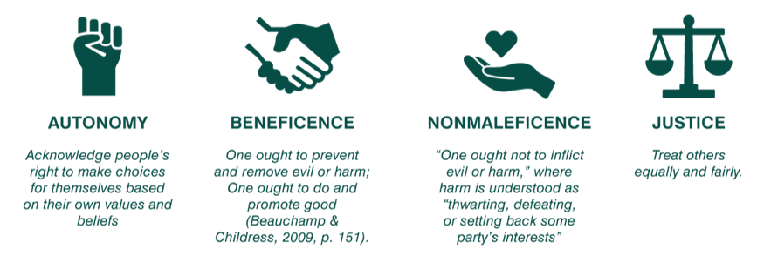
Figure 1: 4Pillars

Task 2: Practical Examples of Concepts in Practice
In order to demonstrate how healthcare principles can be put in practice, we can consider the example of a woman, Robyn who has a spinal injury and has switched the agency care to the Personal Health Budget (PHB). Her story outlines the role that person-centred care, partnership working and ethics plays in the UK health and social care framework.

Application of Person-Centred Care
Firstly, Robyn had an institutionalised care; in one year alone, she experienced 36 different personal assistants (PAs) and many of them were allergic or scared of animals to have them participate in the interest she had, which was being with the horses. This clinical only thinking did not support her well-being as required by the Care Act 2014 that requires local authorities to combine well-being of individuals though risk-taking that is positive. Moving to PHB, Robyn re-gained independence, and the PAs she has could assist her business of animals in a holistic approach and in her competitive carriage driving. Such a change is based on the humanistic theory which emphasises the individual values and preferences of a person in order to achieve positive psychological and physical results.

Partnership Working in Action
The multidisciplinary team (MDT) that included her Continuing Health Care (CHC) nurse and social care teams and Personal Budget Support Service (PBSS) was critical to a successful transition of Robyn. This cooperation made sure that Robyn was not merely receiving care but being involved in her support planning. This is a collaboration that is in line with the Health and Social Care Act 2022 and the philosophy of no decision about me, without me since Robyn eventually created her own care plan to reflect her identity and needs more. This inter-relationship of health and financial support services helps eliminate the silo mentality whereby services tend to break down.

Addressing Ethical Challenges
The case involving Robyn had a major conflict of ethics between beneficence (making sure she is not killed) and autonomy (that she has a right to decide who stays in her house). Her basic needs were fulfilled under the former model of an agency but her quality of living was not considered. Applying the Mental Capacity Act 2005 model, Robyn was given the mandate to determine her own choices concerning her care staffs; her autonomy right was not interfered with. Moreover, the concept of justice has been fulfilled by efficient distribution of her PHB, decreasing her dependence on the costly community-based nursing services by assigning her health activities to her qualified PAs. In the end, these principles not only changed her care to become less of a daunting bureaucratic procedure, but she actually was provided with her life back, and this was the model of independence.
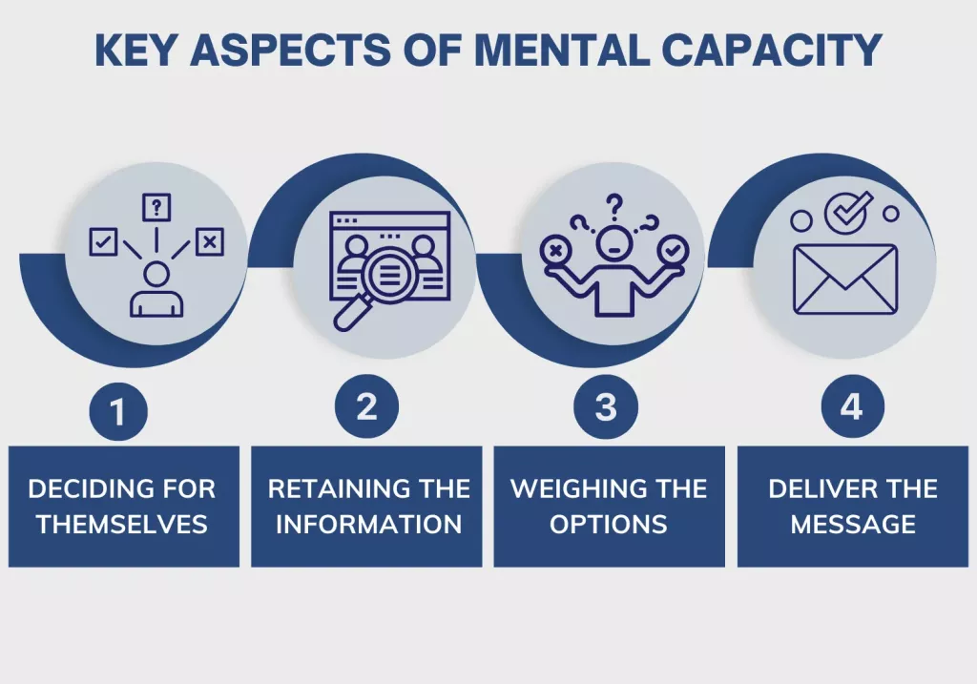
Figure 2: the Mental Capacity Act (2005) "best interests" framework

Task 3: Self-Reflection as a Health and Social Care Professional
I have used the reflection to critically reflect on who I am and my development as a professional using the Gibbs Reflective Cycle (1988). Having explored my experiences in the framework of six stages, I will fill the gap between theory and practice, paying attention to person-centred care, partnership, and ethical maturity.

1. Description
Being a future health and social care professional, I perceive my everyday activities in the context of person-centreedness and teamwork. In my practice nowadays, I also use communication as a therapy tool, because with the help of active listening I can confirm the lived experience of the service users. As an illustration, I will make sure that the first few minutes of any interaction would be devoted to the concerns of the user before I review clinical notes.
I am also legally and ethically directed by Data Protection Act (2018) and Mental Capacity Act (2005). I used these principles recently to defend the right of a service user to an unwise decision about his treatment as I was able to resist the paternalistic instinct and make sure that the autonomy of this person was not deprived of. Nevertheless, I have also found areas of weaknesses. My SWOT analysis shows that I have a weak point in handling the moral principle of Justice versus Beneficence, namely, the emotional problem of giving priority to patients during the situation of limited resources. What is more, I occasionally experience the bureaucracy of inter-agency communication, which tends to make me prone to the silo mentality that is triggered when I am focused on my own tasks as opposed to the whole Multi-Disciplinary Team (MDT).

2. Feelings
I also experience professional congruence when I can make positive contributions towards a holistic social model of care. Listening to a patient and making them feel respected satisfies their needs of Esteem (Maslow, 1943) which makes me feel that I am actually treating the person behind the diagnosis. Nonetheless, I become highly affected in cases of bureaucratic challenges or lack of resources, which results in a high level of moral distress. Having experience of inter-agency communication breakdown, it makes me struggle to feel isolated and nervous since I know that failure in inter-agency communication can result in disaster, as it has been underscored in the Laming Report (2003). Moreover, the existing situation of massive staff turnover and burnout in the UK care industry is a source of significant concern that I consider a "threat" to my ability to sustain high-quality care.

3. Evaluation
My skill to form swift rapport and create trust with a variety of service users has been learning effectively. I am also determined to promote Shared Decision-Making (NHS England, 2019), which entails having a tight-knit web of care. I would also trust my documentation because it would be objective and show dignity to an individual following the NMC (2018) and HCPC (2016) codes of conduct.
Negatively, my, so-called siloed approach in stressful situations is an important impediment to successful collaboration. I am also weak in technical terms and have little understanding of how the local authority funding processes work and therefore, therefore this hinders my effectiveness in complicated systems. I have assessed that, the emotional intelligence is high; however, my ethical sensitivity in the fast-paced settings remains prone to substitutions by the task-centred care.

4. Analysis
Professional accountability is based on the relationship between theory and practice. The way that I have been prioritising psychological comfort (warmth, food, and security) over medical intervention is an immediate application of the Hierarchy of Needs (1943). A patient is unable to give his/her attention to self-actualisation, or even elaborate healing in case his/her basic needs are not met: such as safety and belongingness.
Moreover, the conflict that I experience in connection with the distribution of resources is connected with such ethical principle as Justice. I am skilled in shielding the individual autonomy (Mental Capacity Act 2005), which I find difficult to fulfill the macro-ethical issue of fair distribution. To continue, I will have to learn to apply the Ethics of Care (Gilligan, 2023), which emphasises a relationship and obligation instead of a set of rules. This theoretical change will contribute to assisting me to leave a clinical-only perspective behind with a more sustainable, relationship-oriented approach towards care. Moreover, the Health and Social Care Act (2022) and the emergence of these organisations as Integrated Care Boards (ICBs) have offered me a strategic framework that will help me shake the silt of my so-called silo mentality and enter into large-scale partnership working.

5. Conclusion
This reflection has made me understand that being a professional is a process of becoming and not a destination. I am well-versed in empathy and legal expertise especially the Care Act (2014). Nevertheless, I have decided that I should be more forceful in my adoption of digital integration tools and inter-professional communication. I cannot also allow the stress of the surrounding to divert my attention out of person-centredness to task-centredness. In order to be ethically mature, I need to build a more solid legal and moral agenda which will enable me to make tough choices free of crippling effect of the moral distress.

6. Action Plan
In order to improve my professional competency in the next twelve months, I have worked on the following strategic plan:
- Specialist Ethical Training (CPD): I will go through a qualified course regarding the Mental Capacity Act (2005) and Deprivation of Liberty Safeguards (DoLS). This will solve my ethical decision making weakness that will give me the legal courage in approaching dilemmas without fear of handling them.
- Multidisciplinary Immersion: In a bid to enhance partnership working, I will organise the shadowing days with Occupational Therapists, Social Workers, and Dieticians. This will assist me to familiarise myself with the professional languages of various departments to make sure that I can contribute to the MDT meetings and prevent a communication break down.
- Person-Centred Tools: I will receive training in Motivational Interviewing (Miller and Rollnick, 2012). This will enable me to promote health-affirming choices (quitting smoking) in a manner that will resonate the inner motivation of the user instead of dictating what he or she wants to achieve or accomplish.
- Legislative and Strategic Updates: I will subscribe to CQC update bulletins to stay informed on the Health and Social Care Act (2022). This will ensure my practice remains compliant with the new "one-sise-fits-all" Framework and help me understand local authority funding processes.
- Ongoing Reflection I will use the Gibbs (1988) cycle officially when using complex cases to transform difficult experiences into ongoing evidence-based learning.

Conclusion
The UK health and social care is governed by the principles of person-centred care, partnership working and ethics which form the core. This reflection has made me understand that they are not rules but dynamic practices that should always be taken care of, involving emotional work and self-criticism. Following these rules, utilising legislative provisions such as the Care Act (2014), and being targeted on the well-being of each person, I will be able to make contributions to a healthcare system that will not only be efficient but also highly caring and fair.

Reference List
Beauchamp, T.L. and Childress, J.F. (2019) Principles of Biomedical Ethics. 8th edn. Oxford: Oxford University Press.
Care Act 2014, c. 23. Available at: https://www.legislation.gov.uk/ukpga/2014/23/contents
Care Quality Commission (CQC) (2023) The State of Health Care and Adult Social Care in England 2022/23. London: CQC. Available at: https://www.gov.uk/government/publications/state-of-health-and-adult-social-care-in-england-2023-to-2024
Data Protection Act 2018, c. 12. Available at: https://www.legislation.gov.uk/ukpga/2018/12/contents
Gibbs, G. (1988) Learning by Doing: A Guide to Teaching and Learning Methods. Oxford: Further Education Unit.
Glasby, J. (2017) Evidence-Based Practice in Health and Social Care. 2nd edn. Bristol: Policy Press.
Health and Care Professions Council (HCPC) (2016) Standards of Conduct, Performance and Ethics. London: HCPC. Available at: https://www.hcpc-uk.org/standards/standards-of-conduct-performance-and-ethics/
Health and Social Care Act 2022, c. 31. Available at: https://www.legislation.gov.uk/ukpga/2022/31/contents
Maslow, A.H. (1943) ‘A theory of human motivation’, Psychological Review, 50(4), pp. 370–396.
Mental Capacity Act 2005, c. 9. Available at: https://www.legislation.gov.uk/ukpga/2005/9/contents
National Institute for Health and Care Excellence (NICE) (2018) People’s experience in adult social care services: improving the experience of care and support for people using adult social care services. London: NICE. Available at: https://www.nice.org.uk/guidance/ng86
Nursing and Midwifery Council (NMC) (2018) The Code: Professional standards of practice and behaviour for nurses, midwives and nursing associates. London: NMC. Available at: https://www.nmc.org.uk/standards/code/
Rogers, C.R. (1951) Client-Centered Therapy: Its Current Practice, Implications and Theory. London: Constable.
Thompson, N. (2021) Anti-Discriminatory Practice: Equality, Diversity and Social Justice. 7th edn. London: Red Globe Press.
World Health Organisation (WHO) (2015) WHO Global Strategy on People-Centred and Integrated Health Services. Geneva: WHO. Available at: https://www.who.int/health-topics/integrated-people-centered-care

