becca owen
[Company name] [Company address]
Should the Government enact more laws to curb Domestic Violence and how Does domestic violence impact the police?

Declarations
This work has not previously been accepted in substance for any degree and is not being concurrently submitted in candidature for any degree.
STATEMENT 1
This dissertation is being submitted in partial fulfilment of the requirements for the degree of BA/BSc.
STATEMENT 2
This dissertation is the result of my own independent work/investigation, except where otherwise stated.
Other sources are acknowledged in the Reference Section.
STATEMENT 3
I hereby give consent for my dissertation, if accepted, to be available for photocopying and for interlibrary loan, and for the title and summary to be made available to outside organisations.
STATEMENT 4
I hereby give consent for my dissertation, if accepted, to be available on the university’s IT system to those who have consent to use the system.

Student’s Name: Rebecca Sarah Owen

Signed: R.Owen

Date:06/05/2022

Acknowledgments
I would like to thank Rhiannon Lloyd my dissertation advisor for the support writing this dissertation during my final year. I would also like to thank my family and friends during my time at university for keeping me focused and determined to complete my course.

Abstract
The purpose of this research project is to establish whether or not the Government should enact more Laws to curb Domestic Violence and how does Domestic Violence impact the Police. This will be conducted using primary and secondary research by using a literature review and questionnaire. The findings underline that domestic violence is an issue within the UK and more knowledge is needed within the topic area. Domestic violence is both a problem for the government and the police, showing improvement need to be made.

Contents
Acknowledgments 2
Abstract 3
Chapter One - Introduction 6
1.1 Research Objectives 6
1.2 Research content 6
1.3 Background 7
1.4 Conclusion 10
Chapter Two - Literature Review 12
2.1 Introduction 12
2.2 Establishing what legislation, orders and procedures have been enacted by the government to help curb domestic violence for victims 13
2.3 Does the police apply these procedures when convicting an offender? 15
2.4 Establishing whether the UK government and the police could do more to prevent future victims of domestic violence. 17
2.5 Conclusion 19
Chapter Three - Methodology 21
3.1 Introduction 21
3.2 Research onion 22
3.2.1 Philosophy 22
3.2.2 Approach and strategy 23
3.2.3 Choice 23
3.2.4 Time horizon 24
3.2.5 Techniques: data collection and analysis 24
4.3 Limitations 26
4.4 Ethical considerations 27
4.5 Conclusion 27
Chapter Four – Findings 28
4.1 Introduction 28
4.2 Research Data Analysis 28
4.3 Questionnaire Feedback 28
4.4 Conclusion 35
Chapter Five – Conclusion 35
5.1 Introduction 35
5.2 Main Findings 36
5.3 Implications 37
5.4 Recommendations 37
5.5 Limitations 38
5.6 Completed aims and objectives 38
5.7 Conclusion 38
Reference List 40
Appendix 1 47

Chapter One - Introduction
This research is to develop an understanding of why domestic violence is under reported and whether this is more to do with a lack of legislation or the police (Dyfed Powys) in general. This will be done by looking at the laws that have been enacted and to see if the government could do more to prevent domestic violence victims in the future and if the police (Dyfed Powys) is using these procedures in place and how domestic violence crimes affect them.

1.1 Research Objectives
- Establishing what legislation, orders and procedures have been enacted by the government to help curb domestic violence for victims
- Does the police apply these procedures when convicting an offender?
- Should more laws be made to prevent future victims of domestic violence.

1.2 Research content
To explore both primary and secondary research in order to understand the full nature of domestic violence crimes surrounding victims. For primary research, the aim is to investigate using questionnaires for the public’s response and viewpoint surrounding the procedures in place for domestic violence victims and how the police deal with victims. And secondary research to identify the strengths and weaknesses of these enacted laws and whether more should be introduced and how this has impacted the police.
The Questionnaire will be spilt into two parts:
- Part 1 (Publics viewpoint on existing laws for domestic violence and whether more laws should be enacted)
- Part 2 (Public viewpoint on how the police procedures are when dealing with domestic violence victims)

1.3 Background
The definition of Domestic Violence is “any incident or pattern of incidents of controlling, coercive or threatening behaviour, violence or abuse between those aged 16 or over who are or have been intimate partners or family members regardless of gender or sexuality” (Home Office et al, 2012). There are many types of abuse:
- Emotional
- Sexual
- Physical
- Financial
- Psychological
(Home Office et al, 2012).
Domestic Violence does not always mean a physical act and can be coercive, meaning acts of assaults, intimidation, threats and other forms of abused aimed to harm, terrify or discipline the victims. This behaviour is used by abusers to isolate the victim from independence and to be solely be dependent on them (Women’s Aid, 2021).
A few examples of this behaviour:
- Isolating the victim from their family/friends
- Depriving the victim from basic needs (food, water, sleep etc)
- Monitoring the victim’s communication online
- Controlling the victims’ finances
(Women’s Aid, 2021).
During march 2019/20, around 2.3 million adults (757,000 men and 1.6 million women) had experienced domestic violence (Home Office, 2022). In the year ending of march 2021 from march 2020, 1,459,663 victims of domestic violence were recorded within England and Wales. Domestic violence is not always reported to the police for a number of reasons and therefore is only a partial picture of the levels of data collected, meaning figures are only a rough representation of the number of victims that deal with domestic violence every day, many of these cases will never enter the criminal justice process due to the fact not many victims will report their crimes (Elkin, 2021). Although, during 2020 figures showed on the crime survey for England and Wales, 758,941 domestic abuse crimes were recorded by the police, showing an increase of 9% from the year before and rose by 845,734 (6%) by 2021 (Elkin, 2021) proving this is a reoccurring trend, providing evidence that victims are coming forward demonstrating victim confidence within the police is increasing more and more each year (Stripe, 2020).
Coronavirus also caused a concern for domestic violence victims as from the 17th of march, face to face reporting was suspended leaving many victims feeling vulnerable over concerns of safeguarding and confidentiality due to the police using a telephone operated crime survey (Elkin, 2021). However, Oppenheim (2021) argued that more women came forward during the coronavirus pandemic, stating that many of the victims would not necessarily have come forward pre lockdown but due to being stuck at home the patterns of violence would have been on a more regular basis, leaving many of the victims no option than to ask for help for their own safety and fear of their partner.
Domestic violence destroys victims’ lives, the government is working hard in order to be able to provide tools for the police to use in order to keep these victims safe. Victim’s need to be informed about these procedures in place and what escape methods are available for them. From 2014 may changes have been made to the laws in order to protect victims of domestic violence. Then again, although new schemes, orders and acts have been introduced for victim protection, there is still so many cases every year, which can be complex and difficult to deal with, leaving many victims vulnerable and let down (Home Office and May, 2014).
Before the new Domestic Abuse Act (2021) came out victims of domestic violence only had a time limit of 6 months to report their crime, leaving many of these victims to feel portrayed by the police after gathering courage and the strength to report their abuser, to only be told that they cannot do anything to help due to the time limit of their incident. Figures have shown that more than 13,000 cases were dropped over the past five years from this time limit in place in England and Wales. There are countless reasons why domestic violence victims need more time to report their crimes:
- Physical danger
- Feeling ashamed
- No place to go
- No money
- Children
And for these victims to be told nothing can be done, leaves them feeling more defenceless to their abuser (Cooper, 2021).
The new Domestic Abuse Act 2021 has now created a statutory definition, accentuating that the evidence of domestic violence does not need to be physical, but also involves emotional and economic abuse (Home Office, 2022). Domestic violence tends to become more and more recurrent the longer it can continue, possibly resulting in a death. The main aim of this act is to get more victims to come forward in order to prevent this from happening but these cases can be problematic to prosecute, as many factors have to be taken into consideration. The support and safety of the victim needs to be the main priority and should be identified from when the report was made and throughout the trail. The police need to be able to give the victims the special measures, support requirements and work closely with the victim to be able to gather the best evidence (Crown Prosecution Service, 2020).
Evidence has shown many victims of domestic violence are not always passive and will stay in the relationship, due to many reasons:
- Fear of the abuser retaliating
- Lack of economic support
- Children
- No support from family/friends
- Losing custody of the children
- Hoping the abuser will change
(World Health Organization, 2012).

1.4 Conclusion
This chapter has given a brief background of the topic being discussed and identified the objective being intensely explored to answer the question. The next chapter will look more deeply into the topic to understand whether the UK is able to be curb domestic violence.

Chapter Two - Literature Review
To establish the history of the legislation in place for domestic abuse and reviewing the changes made in order to reduce crime statistics, looking into the weaknesses and successes of the UK government and police to see if enough has been done to curb domestic violence. This chapter will aim to answer the following main objectives:
Establishing what legislation, orders and procedures have been enacted by the government to help curb domestic violence for victims
Does the police apply these procedures when convicting an offender?
Establishing whether the UK government and the police could do more to prevent future victims of domestic violence.

2.1 Introduction
Domestic violence victims need to be addressed by the government as it is effectively a basic breech of a person’s human rights. Individuals have a right to life, to be free from torture and inhumane/degrading treatment, this has been a gap within law for years (Hilder and Bettinson, 2016). The Council of Europe (2022) in 2012 introduced the Istanbul Convention and the aim is understanding the true nature of violence in all of its forms, by introducing prevention, protection and prosecution implementations of polices within this field. The aim is for all countries to introduce new criminal offences that criminalise stalking, forced marriage and genital damage to be able to adapt to the new convention requirements. However, the UK did sign to have this implemented but it was notified that the domestic laws in place could not fit the requirements needed. The UK is still to this day trying to update the laws in place in order to proceed with this convention (Horne, 2021).

2.2 Establishing what legislation, orders and procedures have been enacted by the government to help curb domestic violence for victims
Domestic violence can be very complex and difficult cases to solve, especially when it comes to supporting, preventing and protecting victims, the government has over the years made legislation to make victims of domestic violence feel more protected and supported (Crown Prosecution Service, 2021). Domestic violence is a serious crime and can devastate the lives of the victims or even lead to a tragic death. Since 2013 the main priority of the government is to improve the response for these victims, by introducing tools available for the police to use, from rolling out new schemes and orders in order to fill the gap in the law for domestic violence victims (Home Office, 2015).
The Domestic Violence Disclosure Scheme (DVDS) allows victims/potential victims to gain information on their partner’s past, allowing them access to any past violent/abusive offences done by their partner, also known as Clare’s Law (Home Office, 2022). This new scheme has been a major success, even from the year it was introduced, in 2014 after it was rolled out to all 43 police forces within England and Wales (Home Office, 2016), 1,300 victims from abusive partners came forward to find out information and police are keen for people to use this scheme, the more people that hear about it, the more likely many more will be saved from this awful situation. In 2014, it proved to the UK that there is a serious domestic violence problem and by introducing Clare’s Law, it has help to empower victims to gain information that is potentially lifesaving for them and enables the police to help people before they become a victim (Grierson, 2015).
However, although this scheme has shown results of being a great success many of the public feel that the police have let them down due to the requests made for background checks have not been answered in time, leaving many victims vulnerable during this time. The police are supposed to get back to victims within 35 days, in 2020 police forces were taking well over the time frame to get back to victims with information on their partner, during this time of year it could have been vital for victims during the coronavirus pandemic, as the public was confined to staying home (Lowe, 2021). Domestic Violence Protection Orders (DVPOs) and Domestic Violence Protection Notices (DVPNs) were rolled out in 2014 to fill the gap within the law on providing protection for the victims of domestic abuse. DVPOs and DVPNs provide victims with an emergency protection from the offender, given them a protected space in order to seek out the option available to them and help to make a decision for their safety without being impacted by the abuser (Home Office, 2020).
DVPOs have shown to have mixed reviews, research has shown that they have reduced psychological and physical abuse but no research has been done to see if it is more effective than other methods. Also, many victims may not have reported violations of the DVPOs, due to feeling embarrassed, blamed, fear of the perpetrator retaliating or from dissatisfaction from the police forces response in the past. Evidence has shown that if the victim has a continuing relationship with the abuser this decreases the amount of effect a DVPOs will have, also it is shown that they do not completely stop the continuation of violence towards the victim. However, to some extend there is evidence of them reducing the amount of violence for some victims (Cordier et al, 2019). On the other hand, DVPOs and DVPNs have been proven to be a helpful tool for victims when it comes to safeguarding as it gives the victim the time to explore the options available and to access any support services, as many are not strong enough to take it any further and it offers them a chance to see what it is like out of a toxic relationship. Although, Victim Support data showed in 2017 nearly a quarter of the DVPOs given out (4,878) were later recorded to being breached (Moroz and Maynes, 2019).
The new Domestic Abuse Act 2021 has added a new civil Domestic Abuse Protection Notice (DAPN) and civil Domestic Abuse Protection Order (DAPO) in order to provide a longer and flexible protection for DV victims. The Act allows DAPOs to impose positive and prohibitions on the perpetrator, for example not being allowed within the distance of the victim or being required to attend a behaviour change programmes. Also, due to previous data of these orders/notices being breached quite regularly, the courts will be allowed to use electronic monitoring in order to keep the perpetrator away from the victim (Home Office, 2022).

2.3 Does the police apply these procedures when convicting an offender?
In 2017, the levels of domestic violence being reported had increased dramatically, taking to note that this is seen as a positive. More reporting of this type of crime can mean the public is more confident within the police as they feel the crime will be taken seriously and forces are prioritising domestic violence crimes. However, there is still a concern that police officers can be slow when arriving at the scene of a domestic violence incident, this tended to be due to the forces not having enough officers available. Most forces are investing in domestic violence guidance and training to help officers identify and understand victim’s needs. Although, there was a concern that officers did not fully understand certain types of domestic violence (controlling and coercive behaviour) (HMICFRS, 2019).
Another concern is the level of confidence among female victims within the police is considerably low, this is due to the support available for victims not being good enough, leaving them feeling vulnerable and not taken seriously. The reasons for this are that officers have not been made aware of the powers available to use and processing can be confusing (College of Policing, 2021). The response of the police has been portrayed very negatively over the years and despite the improvements, dedication and commitment of police forces there is still weaknesses when it comes to the services that is provided for victims. Domestic violence is seen as a priority on paper but has not been seen to put into practice. There is a concern of police officers’ poor attitudes towards victims of domestic violence and this has stemmed from a lack of understanding. The police need to use the victim’s feedback in order to improve the way they deal with victims; it can also help them assess how well the forces performances levels are (HMIC, 2014).
However, it needs to be considered that keeping victims safe when tackling domestic violence can be extremely difficult, Dyfed Powys police force has been seen to have a respectable response to domestic violence victims, taking positive actions to improve the victims experience and taking robust action against the perpetrator from training. Although, this force is still experiencing the same problems (HMIC, 2014) inspectors had raised a concern after it was estimated around 4,000 crimes had not been recorded with roughly 2,400 being violent and domestic abuse crimes, with Dyfed Powys police force being told previously that improvements needed to be made. The force has expressed that the main aim of officers is to safeguard the victims and has put plans in place to improve crime recording and supporting victims (Rees, 2021).
On the other hand, the Crown Prosecution Service in Wessex has decided to introduce a three-year action plan to improve the outcome for victims of domestic violence around three policing agencies. The aim is gain public confidence within the police when reporting domestic violence by building a strong case and making sure offenders are being brought to justice or put into programmes in order to reduce further reoffending. Officers have been running community events to raise awareness to the different forms of abuse and to help encourage victims to come forward. Demonstrating officers do have an understanding of the devasting impact this type of crime has on a person life (Crown Prosecution Service, 2021). Also, During Covid-19 the police proactively took action to help victims of domestic violence, targeting known offenders and putting safeguards in place for victims. Using web based/ online services to allow victims to reach and report offences safely, making sure to monitor and pursue DVPO’s if needed (Home Office, 2021).
The way police forces respond to domestic abuse has been seen in a negative spotlight for over 30 years and scholars have highlighted the weaknesses of policing not only in the UK but worldwide showing domestic abuse is impiously in need of changes to the policies and practice of policing. The UK uses a risk led approach to deal with domestic violence victims, although this has demonstrated to being a challenge and a concern that officers perception of risks differ from uneven training (Robinson, Pinchevsky, and Guthrie, 2018).

2.4 Establishing whether the UK government and the police could do more to prevent future victims of domestic violence.
From 2010 the UK published the first disclosure of ending violence against women and girls, understanding that women should not have to live in the fear of any violence and feel safe in the hands of the police and criminal justice system. The UK has started to strengthen the legislation for domestic violence and introduced new offences to tackle coercive and controlling behaviour, as well as stalking. One of the main aims of the government is to improve the first response for these victims by improving the response by the police. A national oversight group will be developed in order to ensure the police put the HMIC’s recommendations into force (Home Office, 2021). However, many are concerned that the UK had signed the Istanbul Convention in 2012 and still are failing to ratify it. This convention is to combat and prevent violence against women and the UK is still not able to meet the requirements from the convention especially with the uprise in domestic violence this is a major concern (UK Parliament, 2021).
Police forces around Wales and England have improved; more risk assessments, safeguarding and support, body worn cameras, improved identification and responses for victims just to name a few, showing evidence that the UK is taking the increasing amount of domestic violence cases seriously and attempting to slowly curb the problem. With victims identifying the positive changes within the police’s response to domestic violence, stating that the police took action in order to make the victim feel safe during and after the offence was reported (HMICFRS, 2021). Overall, the response of the police has improved but it not consistent across the 43 forces within England and Wales, one recommendation was for police officers need to consider the powers available to them (DBPNs/DVPOs) especially when a charge cannot be made (HMICFRS, 2017). Police officers have a low knowledge as why a risk assessment is important and what to do after the completion of the form, especially when it comes to updating the laws surrounding domestic abuse (College of Policing, 2021).
From the 14th January the UK government backed the ask for ANI codeword scheme which allows domestic abuse victims to access support from pharmacies around the UK, it gives victims a chance to come forward discreetly and access support. This will allow for a trained pharmacist to talk to the victim and provide them with support services or help them to contact the police, especially if the victim is isolated at home with the abuser and is the only way for them to ask for help (Home Office et al, 2021). North Yorkshire Police has launched a scheme to share information between prisons in order to stop the offender of domestic abuse contacting the victim, stating that this should have been a standard practice. This is regularly seen within prisons as the offender wants the victim to retract the statement made against them and victims feel that they are still being abused while the offender is behind bars (BBC News, 2021).
2.3 million people have experience domestic abuse from 2021 to 2022 and 1 in 5 have ended in a homicide. The Government has proved it is taking steps in order to curb domestic abuse, by introducing the updated Domestic abuse Act and making it easier for the public to access DVDs by allowing online applications. However, the government still has a lot more to do in order to reduce the amount of domestic abuse crimes in England and Wales and is working hard to expand police forces response for victims and improve the criminal justice system to make sure prosecutions are pursued to safeguard victims (Home Office and Patel, 2022).

2.5 Conclusion
Since 2013 the government has implemented new scheme and orders to improve the police response for victims and is on the role of attempting to curb domestic violence, especially since 2014. Especially since domestic violence is effectively a basic breech of a person’s human rights. The UK currently has the Domestic Abuse Act 2021, DVPOs, DVPNs, DVDs and schemes such as the ANI codeword in place to help support victims. Showing the government is on the move to lower the rates of domestic violence victims. However, there is a concern that the UK is unable to meet the requirements of the Istanbul convention to combat and prevent violence against women especially with the statistic as high as they are. This proves that the gap within the law needs to be strengthen in order to curb domestic violence. The government has produced reports on the police forces around the UK showing that some are not up to par when it comes to domestic violence cases. The concern is that often than most cases are being dropped and police officer are not using the powers available to them. Although, over the years through all report improvements are being made slowly every time, showing that it is taken seriously. This shows that the police are impacted by domestic violence cases and adjustments need to be.

Chapter Three - Methodology
Chapter three is to establish and identify the approach on getting primary research by using the public’s opinion on domestic violence in the UK. The aim is to investigate using a questionnaire to gain the public’s response and viewpoint surrounding the legislation in place for domestic violence victims and how the police respond in order to collect research data to evaluate the public response in chapter four.

Introduction
Primary research is a vital part of increasing the knowledge about a certain topic area, giving an individual new ideas and insight into the public’s opinion on the subject matter. Primary research is collected first hand and provides the reader with opinions from the public rather than being limited to research that has already been gained. The three main ways primary research can be collected is through; observations, interviews or surveys (Lowe and Zemliansky, 2011, p.153 - 154).
The aim of the primary research is to identify whether the public viewpoint will establish if the police is impacted by domestic violence and whether the government is in the right direction or could do more to curb domestic violence by conducting a survey. Chapter two looked at secondary research, showing that the UK government has done a lot of improvement for domestic violence victims since 2014 but came to the conclusion that more needs to be done in order to lower crime statistics within the UK. The police have regular reports done to see how effectively officers are dealing with victims and whether the powers available to them are use efficiently, however, there has shown to be a concern that some forces are inconsistent when dealing with victims but overall positive changes are being made. The primary research will help to support and provide new opinions and ideas to strengthen this thesis, in order to determine if the Government should enact more laws to curb domestic violence and how this would impact the police.

Research onion
In order for the research to have a maximum credibility the researcher needs to go through all the stages to develop a strong methodology.
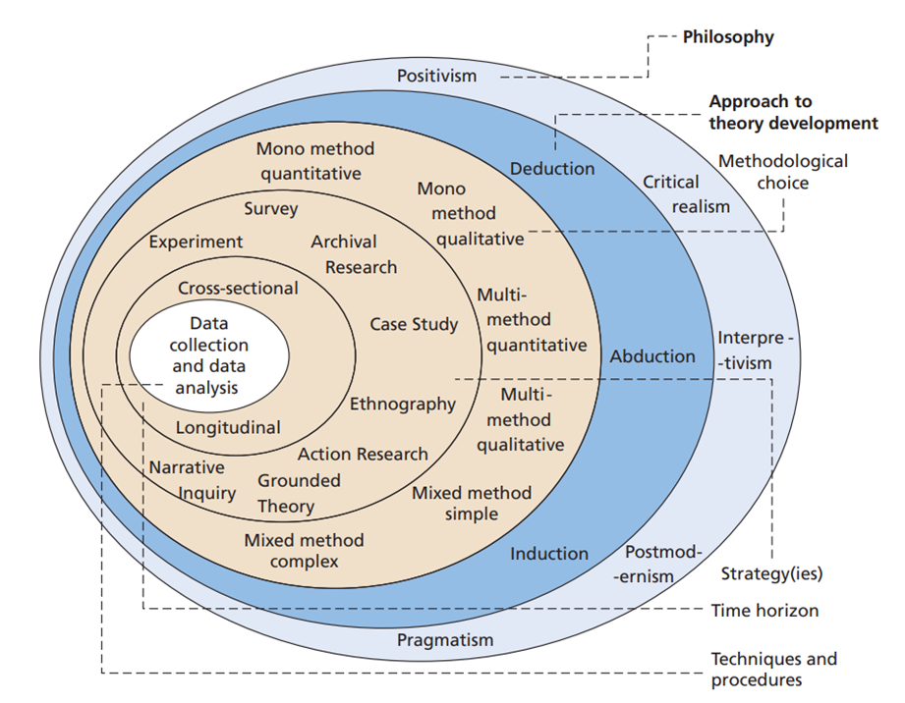
(Saunders et al, 2019).

3.2.1 Philosophy
Research Philosophy is a system of beliefs and assumptions in order to develop knowledge into the subject area. The key research philosophy that has been considered when it comes to conducting this research is the interpretivism approach (Saunders et al, 2019).

3.2.2 Approach and strategy
The approach chosen to conduct this research is the deductive approach. All methods that can use used to collect data will have strengths and weaknesses. The research method being used to collect primary research data is a questionnaire, this is a fast and quick response which can be done/sent out online. Also, it can be administered anonymously and this is seen as a positive as people will tend to be more truthful (Patten, 2014, p1-2). Questionnaires offers both quantitative and qualitative data, through open or closed questions.
The reason why this method has been selected to collect data is due to the current times with Covid 19, at this time it is not possible to conduct other methods of collecting data as it has been implemented by the government to minimize contact with other individuals if not necessary. The sampling method being used for this research is convivence sampling, this questionnaire has been released online to platforms, such as Facebook and student forums. This means it will not target all members of the general population, as it will be limited to those who have seen it. This method of sampling has been chosen as it a quick and efficient way to get data collection with minimal effort (Simkus, 2022).

3.2.3 Choice
This research is taking on the mono method to allow for both qualitative and quantitative approach. Quantitative data is numbers and measurements and qualitative data is an in-depth exploration to answer the question. So qualitative data answers the why questions and quantitative data answers the how questions (Biggam, 2021, p.142).

3.2.4 Time horizon
This is the time frame it takes for the research to gain all the information that is needed, however due to the short time frame for the research to be conducted in. The research was done under the cross-sectional time horizon.

3.2.5 Techniques: data collection and analysis
Data collection will be done through a questionnaire to gain the public understand, opinions and viewpoint on the thesis.

Table 3.2.5.1: Questionnaire and Literature Review
Question 1 - Do you agree to Participate in this Study? | This is to make sure the participant is given their consent to be involved within this research
Question 2 - What age category do you fall Under? | This was to see if the participants involved would meet the general population in order to make this study more reliable.
Question 3 - Do you feel that there is a gap in the United Kingdom’s Law for Domestic Violence victims, at current (2022)? | This was to establish the participants opinions on the legislation for domestic violence victims to identify if more laws should be enacted.
Question 4 - If you stated 'yes' to there being a gap in the Law for Domestic Violence Victims, please give reasoning why? | This question was optional, to make sure nobody felt uncomfortable answering. This was to gain the public insight for the option that was chosen in question 3.
Question 5 - Do you believe that the Police respond to domestic violence victims effectively? | This was to understand how the public felt when it comes to the police dealing with domestic violence victims, as the literature review only reflected on official reports.
Question 6 - Do you think that the Police need more training when it comes to the powers and support in place for domestic violence victims? | Question 6 was to establish whether the public agreed with official reports that police training needs to be improved.
Question 7 - From the knowledge that you have on Domestic violence victims do you think that the Government could do more? | This question was also optional, this was just to gain an insight on whether the public thought the UK could do more when it comes to domestic violence
Question 8 - What number of Victims do you think suffered from Domestic Violence within the United Kingdom over past year alone? | Question 8 was to see if the public was aware of the statistics surrounding domestic violence.
Question 9 - Do you think that the Police provide enough safeguarding for Victims during and after they have reported the crime? | To understand whether or not the public’s feedback agreed or disagreed with the safeguarding being enough victims by comparing it to the secondary research conducted in chapter two.
Question 10 - Do you think that the British Government should push for the ANI code word scheme to be adopted in all organisations throughout the UK, to give more victims the chance to access support in a disclosed manner? | This question was to see if the public agreed that more schemes like this should be introduced in all organisation not just pharmacies.

To analysis the data from the questionnaire, the research was conducted using google forms and this gives the researcher a simple and accessible way to write up the data as it has analysis the data and put the information received into pie charts. For the open questions, as this was optional there is not as many responses so these questions will be used to give more insight in to the public opinion on the subject matter.

4.3 Limitations
One limitation that has affected the way the research can be conducted in covid 19, due to the restrictions in place the university requested that data was collected in a form of a survey. This has prevented the use of using face to face interviews which could have given more insight to this thesis.
The second limitation is the sampling may not represent the general population, due to the survey being conducted online anyone over the age of 70 is less likely to participate meaning this research will not represent that age groups opinions. However, this has been avoided by asking friends and families to present the questionnaire to this age group to make the information more reliable.
Also, the time frame allowed for the dissertation is consuming and problems can arise if this is not kept on time. One way to avoid this is to keep a detailed planner to keep on tract and manage each section so this can be avoided.

4.4 Ethical considerations
All participants were given background information on the research being done, also all participants were asked to confirm that they were willing to participate within the study. No participant was asked anything that would breech confidentiality but were asked to identify the age category they fit into. None of the questions were harmful or could cause any risk to the participant and the reader would have been made aware what the research was about before they participated, also were given the right to withdraw at any time.

4.5 Conclusion
This chapter has shown the research onion to successfully pick the research approach needed to complete the survey. Limitations were highlighted to show the concerns that may arise and ethical issues were disclosed in order to avoid anymore problems.

Chapter Four – Findings

4.1 Introduction
This chapter is to present the findings the researcher has collected from the survey, to provide the reader with the public’s opinion into the on existing laws for domestic violence and whether more laws should be enacted and how the police procedures are when dealing with domestic violence victims. The primary research will expand and present new opinions to the research that has already been identified in the literature review.

4.2 Research Data Analysis
The data will be reviewed on google forms, providing the researcher with pie charts and percentages to analysis the data collected in order to conclude the findings received from the survey on the public response. Questions four and seven were optional questions but provide the researcher with qualitative data on the public’s opinion.

4.3 Questionnaire Feedback
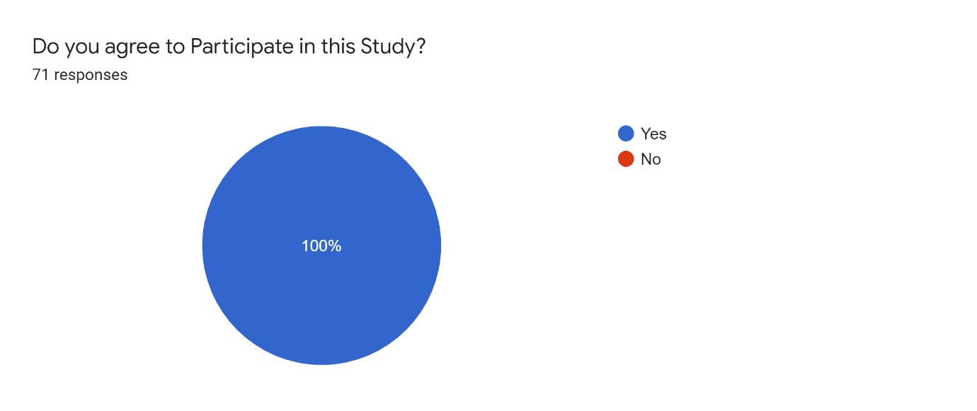
Question one was to make sure the participants were happy to be apart of this research survey. Consent is needed in order not to breech the ethical issues within this study. All 71 respondents had agreed to participate in the research.
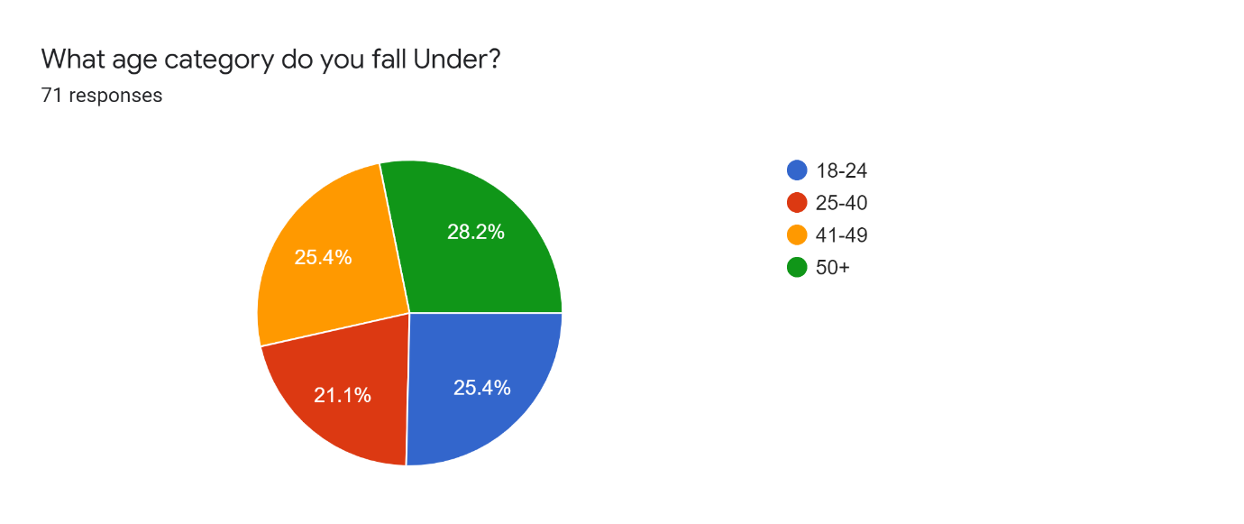
Question two was used to establish whether all age group had participated in order to see if the survey had responses that would represent the general population. The results below show that the 71 respondents that took part are well represented showing that the general population is met.
Question three was to see if the public thought there was a gap in the law for domestic violence victims. The results showed that out of the 71 respondents 40.8% said yes there is a gap within the law, 9.9% no and 49.3% were unsure. This shows that the majority of the public is not clear on the laws in place for domestic violence victims, a small amount feels that the government has done enough and many believe more could be done. Looking at research from chapter two, the UK has started to strengthen the legislation for domestic violence and introduced new offences to tackle coercive and controlling behaviour, as well as stalking (Home Office, 2021). However, there is a concern with crime statistics increasing that the government could do more especially for the movement of violence against women.
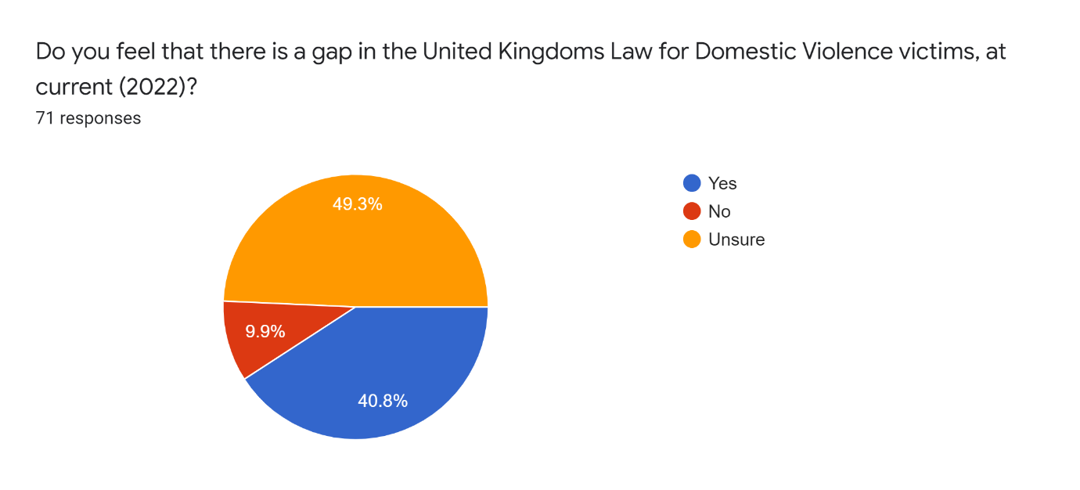
Question 4 is a follow-on question to 3 and ask the participant if they were will to give an insight to why they felt there was a gap within the law.
If you stated 'yes' to there being a gap in the Law for Domestic Violence Victims, please give reasoning why?
Altogether, 38 out of the 71 participants took part in this question. This was probably due to that fact that a lot of them said they were unsure in the question above. However, some of the responses made were:
“Too many victims”
“There’s not enough protection in place for victims or safe secure spaces for victims”
“Cases are pushed a side and sometimes not picked up”
“The crime statistics show that there is a high percentage of domestic violence victims within the UK”
“Many cases show when there isn't enough evidence, they will say there's nothing they can do”
“No, I feel the government keeps improving”
“There is a large problem within the UK for domestic violence victims often cases go un- noticed and abuse continues for months often years.”
This shows that the people who agreed that there is a gap within the law feel the government need to tighten down on crime statistics, stop cases being dropped and allow for more safe guarding for victims during and after the offence. Going back to chapter two cases in the Dyfed Powys police force alone, 4,000 cases were dropped last year and 2,400 of those were domestic abuse offences, showing that victims are not always supported (Rees, 2021). However, other forces have taken on board the need for better safeguarding for victims with three policing agencies around Wessex area introducing an action plan to improve the outcome for domestic violence victims (Crown Prosecution Service, 2021).
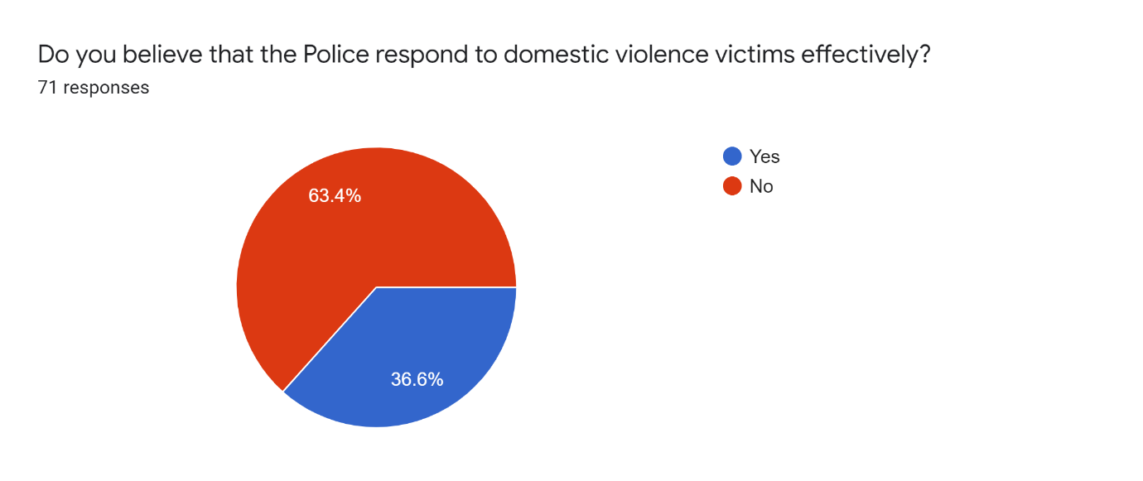
Question five shows in the pie chart below that out of the 71 respondents, 63.4% stated that the police do not respond to domestic violence victims effectively with only 36.6% agreeing that they do. This shows that from the evidence received in chapter two the police need to improve the way victims are dealt with and this is also agreed upon within the public’s viewpoint.
Question six demonstrates that the participants involved have more knowledge on how the police deals with domestic violence victims and the legislation, orders and schemes in place. In the pie chart below shows that 60.6% believe that the UK police forces need to invest more in the training given, provide more support and use the powers available to keep offender away from victims.
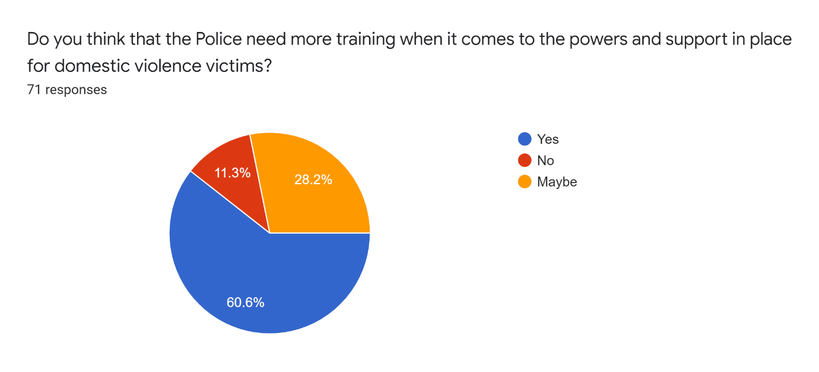
Question seven was to gain insight into what the public thought the UK’s government could do to help domestic violence victims.
From the knowledge that you have on Domestic violence victims do you think that the Government could do more?
One response given by a participant “Yes, they could do more, more funding needs to be given to charities and other domestic violence organisation to help victims after they have suffered from abuse” Also another participant stated that “Victims need more security and peace of mind for their safety from abusers”.
Few other responses given:
“Too many cases are being dropped and the governments should do more to make sure every victim is taken seriously”
“Yes, improve safeguarding for victims”
“Not enough funding for them to do more”
“Victims need more security and peace of mind for their safety from abusers”
“Put more action into violence against women”
These reviews show that the participants involved felt that the UK government could do more. Altogether 65 out of the 71 respondents had answered this question, yes some did feel that the government is doing enough but the majority felt that more could be done.

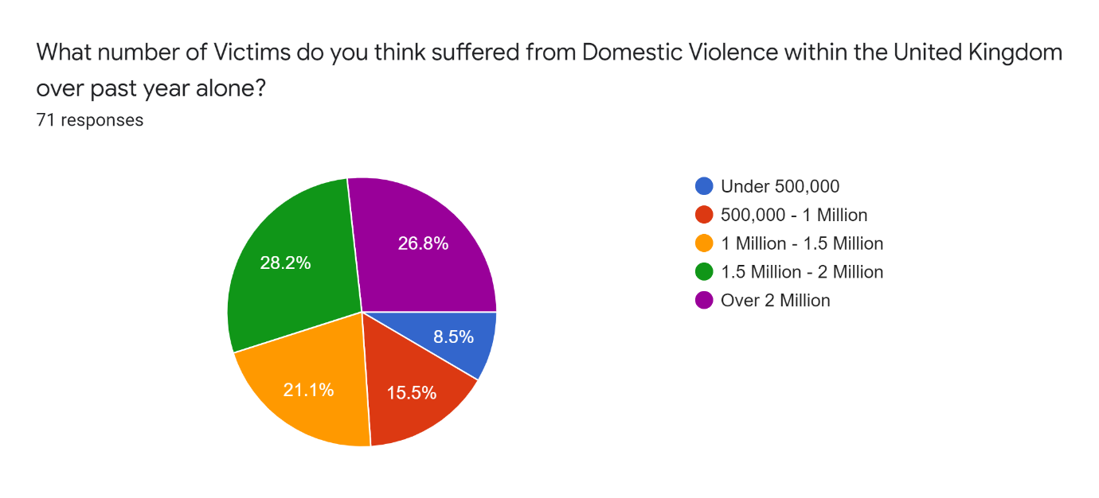
Question eight was to see how many participants knew the amount of domestic violence victims over the past year alone, 8.5% thought it was under 500,000, 15.5% believed it was between 500,000 and 1 million, 21.1% chose between 1 million and 1.5 million, 28.2% had thought it was between 1.5 million and 2 million and 26.8% got it right with over 2 million, this shows that a lot of the public are not aware of the amount of domestic violence victims are affected each year. However, most people did agree that the number of victims each year are a high amount. Looking back at the research done in chapter two, 2.3 million people have experience domestic abuse from 2021 to 2022 and 1 in 5 have ended in a homicide (Home Office and Patel, 2022).

Question nine was to see if the public thought there was enough safeguarding available to victims by the police. 15.5% agreed that there was enough, 49.3% believed there is not enough safeguarding in place and 35.2% were unsure. This suggests that the public does feel that the police could do more for victims’ safety. However, being that a high number of correspondents were unsure implies that the public are uneducated about the procedures and protocols that take place in relation to the prevention and post case safeguarding that the police have in the UK. Chapter two show evidence stated from College of Policing (2021) that the support available for victims is not being good enough, leaving them feeling vulnerable and not taken seriously. The reasons for this are that officers have not been made aware of the powers available to use and processing can be confusing.
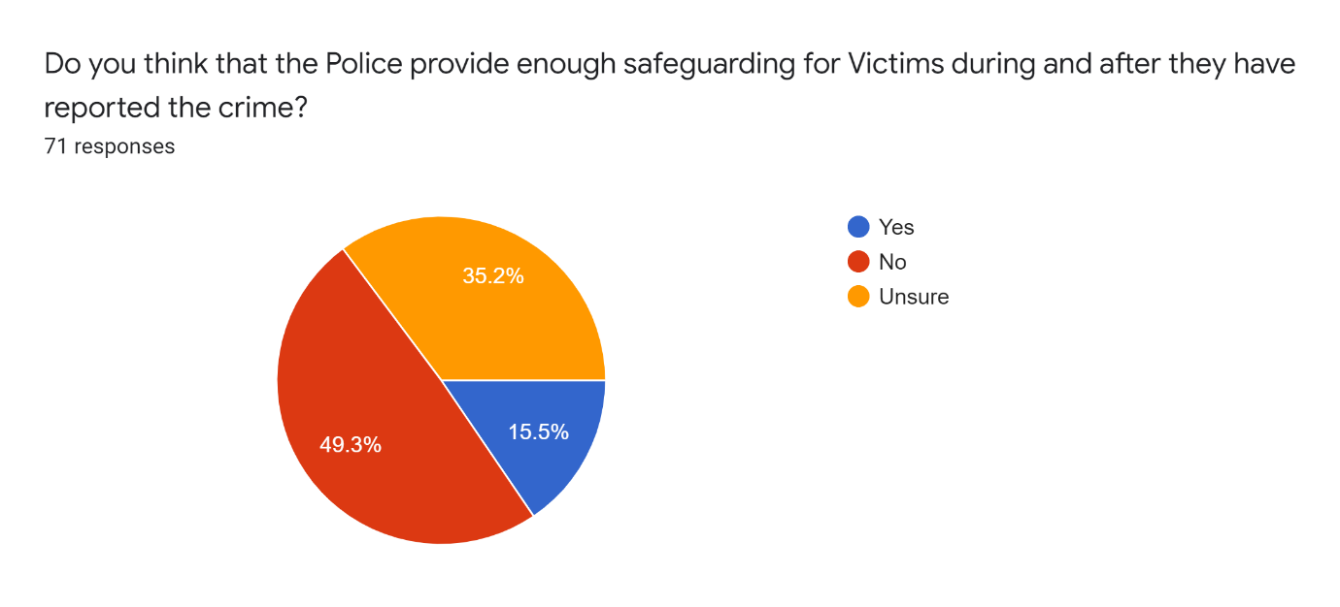
Also, there is a concern of police officers’ poor attitudes towards victims of domestic violence and this has stemmed from a lack of understanding. The police need to use the victim’s feedback in order to improve the way they deal with victims; it can also help them assess how well the forces performances levels are (HMIC, 2014).

Question ten was to gain insight into one of the schemes which the government has in place at current (2022) within the united kingdom the public was asked whether or not the ANI code word scheme should be rolled out as a mandatory protocol for all organisation to curb domestic violence, in response 70 participants felt that it should be, with only one participant saying no, this should be noted as the wider view of the public is that the government should be doing more in relation to providing schemes which provide safeguarding for victims of domestic violence.

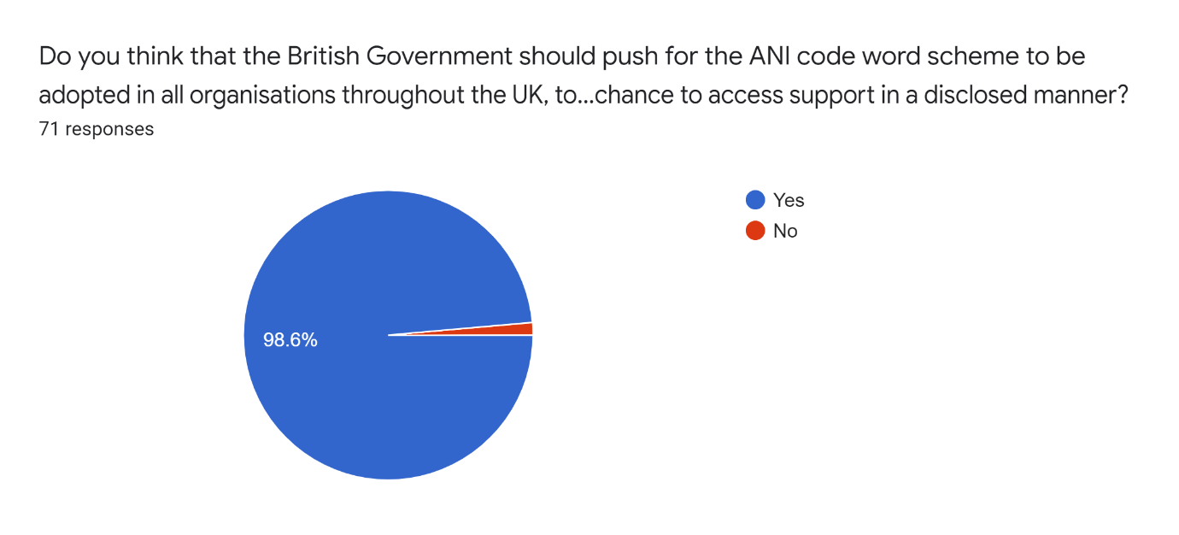

4.4 Conclusion
To concluded chapter four has establish the public’s opinion surrounding whether the government should enact more law for domestic abuse and if domestic abuse impacts the police.

Chapter Five – Conclusion

5.1 Introduction
Chapter five brings forward the research data collected in order to answer the question of whether the government should enact more laws to curb domestic violence and how the police is impacted by domestic violence.

5.2 Main Findings
Domestic violence victims need to be addressed by the government as it is effectively a basic breech of a person’s human rights. Individuals have a right to life, to be free from torture and inhumane/degrading treatment, this has been a gap within law for years (Hilder and Bettinson, 2016). Domestic violence can be very complex and difficult cases to solve, especially when it comes to supporting, preventing and protecting victims, the government has over the years made legislation to make victims of domestic violence feel more protected and supported (Crown Prosecution Service, 2021). Since 2013 the main priority of the government is to improve the response for these victims, by introducing tools available for the police to use, from rolling out new schemes and orders in order to fill the gap in the law for domestic violence victims (Home Office, 2015). The UK government has the Domestic Abuse Act 2021, Domestic Violence Protection Orders (DVPOs), Domestic Violence Protection Notices (DVPNs), Also the police have the power to use The Domestic Violence Disclosure Scheme (DVDS) and schemes in place (ANI code word scheme) for victims which allows them access to support in order to help curb domestic violence to lower statistics.
Findings have shown that since the UK has introduced new legislation, orders, procedures and schemes victims have started to come forward, meaning the government is on track for supporting, preventing and protecting victims. However, post domestic violence cases being reported victims feel that the police fall short in utilising the powers that they have from government legislations as training and procedures that police forces use across the UK are inconsistent leaving victims feel that safeguarding is not appropriate. Although, most forces are investing in domestic violence guidance and training to help officers identify and understand victim’s needs. Although, there was a concern that officers did not fully understand certain types of domestic violence (controlling and coercive behaviour) (HMICFRS, 2019).
However, question six demonstrated that 60.6% out of the 71 respondents from the primary research survey, believed that the UK police forces need to invest more in the training and provide more support for victims. Also, 49.3% believed there is not enough safeguarding in place and 35.2% were unsure. This suggests that the public does feel that the police could do more for victims’ safety. The results from the primary research also showed that out of the 71 respondents 40.8% said yes there is a gap within the law, 9.9% no and 49.3% were unsure. This shows that the majority of the public is not clear on the laws in place for domestic violence victims, a small amount feels that the government has done enough and many believe more could be done.

5.3 Implications
Due to some of the questions being optional, quite a lot of people left them unanswered and resulted in finding falling short of a clear picture into the insight of the general population standpoint of the subject matter.
Also, due to covid 19 the primary research was only able to be done through a survey method, which has limited the amount of information that could be gathered.

5.4 Recommendations
The government should provide the UK police forces with more in depth compulsory training when using the powers available to them and more insight into definition of domestic violence, as this will effectively stop domestic violence crimes impacting the police.

5.5 Limitations
Using face to face interviews could have allowed for professional bodies from the police and the government to give insight on how they might curb domestic violence.
The questionnaire was only responded by 71 participants showing that this does not really reflect the general population.

5.6 Completed aims and objectives
The aim of this research was to answer the question:
Should the government enact more laws to curb domestic violence and how is the police impacted by domestic violence affect the police?
This has been reflected throughout all sections of the chapters
The three main objectives:
- Establishing what legislation, orders and procedures have been enacted by the government to help curb domestic violence for victims
- Does the police apply these procedures when convicting an offender?
- Should more laws be made to prevent future victims of domestic violence.
These objects have also been reflected throughout the completion of all chapters.

5.7 Conclusion
This study has met the aim and objectives of the project, it has identified the limitations that has arose. This chapter has also evaluated all the evidence found surrounding the subject area and recommendation have been made.

Reference List
- Biggam, J. (2021) Succeeding with your master’s dissertation a step-by-step handbook. London: Open University Press
- BBC News. (2021) Domestic violence: Scheme stops abusers writing to victims from jail. Available at: https://www.bbc.co.uk/news/uk-england-york-north-yorkshire-58802284 (Accessed: 26 April 2022).
- Council of Europe. (2022) Key facts about the Istanbul Convention. Available at: https://www.coe.int/en/web/istanbul-convention/key-facts (Accessed: 1 February 2022).
- Crown Prosecution Service. (2021) Domestic Abuse. Available at: https://www.cps.gov.uk/legal-guidance/domestic-abuse (Accessed: 1 February 2022).
- Crown Prosecution Service. (2021) CPS Wessex and three police forces commit to joint three year action plan to improve outcomes for all victims of domestic abuse. Available at: https://www.cps.gov.uk/wessex/news/cps-wessex-and-three-police-forces-commit-joint-three-year-action-plan-improve-outcomes (Accessed: 20 April 2022).
- Cooper, Y. (2021) The law is failing domestic abuse victims in England and Wales. But we can change it. Available at: https://www.theguardian.com/commentisfree/2021/nov/19/law-uk-domestic-abuse-victims-assaults-justice (Accessed: 1 February 2022).
- Crown Prosecution Service. (2020) Domestic Abuse. Available at: https://www.cps.gov.uk/legal-guidance/domestic-abuse (Accessed: 1 February 2022).
- College of Policing. et al (2021) A duty to protect: Police use of protective measures in cases involving violence against women and girls. Available at: https://www.gov.uk/government/publications/police-use-of-protective-measures-in-cases-of-violence-against-women-and-girls/a-duty-to-protect-police-use-of-protective-measures-in-cases-involving-violence-against-women-and-girls (Accessed: 11 April 2022).
- College of Policing. (2021) Recognising and responding to vulnerability related risks. Available at: Recognising and responding to vulnerability related risks: Scope of practice (college.police.uk) (Accessed: 25 April 2022).
- Cordier R. et al. (2019) The Effectiveness of Protection Orders in Reducing Recidivism in Domestic Violence: A Systematic Review and Meta-Analysis. Trauma, Violence, & Abuse. 22(4) pp:804-828. doi:10.1177/1524838019882361
- Elkin, M. (2021) Domestic abuse prevalence and trends, England and Wales: year ending March 2021. Available at: https://www.ons.gov.uk/peoplepopulationandcommunity/crimeandjustice/articles/domesticabuseprevalenceandtrendsenglandandwales/yearendingmarch2021 (Accessed: 1 February 2022).
- Elkin, M. (2021) Domestic abuse in England and Wales overview: November 2021. Available at: https://www.ons.gov.uk/peoplepopulationandcommunity/crimeandjustice/bulletins/domesticabuseinenglandandwalesoverview/november2021 (Accessed: 15 March 2022).
- Forsyth, A. (2021) Victims to get more time to report domestic abuse in England and Wales. Available at: Victims to get more time to report domestic abuse in England and Wales - BBC News (Accessed: 2 February 2022).
- Grierson, J. (2015) 'Clare's Law' saves 1,300 women from violent partners in first year. Available at: https://www.independent.co.uk/news/uk/crime/clare-s-law-saves-1-300-women-from-violent-partners-in-first-year-10001781.html (Accessed: 2 February 2022).
- Home Office. And Patel, P. (2022) Home Secretary launches new Tackling Domestic Abuse Plan. Available at: https://www.gov.uk/government/news/home-secretary-launches-new-tackling-domestic-abuse-plan (Accessed: 2 May 2022).
- Home Office. (2022) Domestic Abuse Protection Notices / Orders factsheet. Available at: https://www.gov.uk/government/publications/domestic-abuse-bill-2020-factsheets/domestic-abuse-protection-notices-orders-factsheet (Accessed: 15 March 2022).
- Home Office. (2022) Domestic Violence Disclosure Scheme factsheet. Available at: https://www.gov.uk/government/publications/domestic-abuse-bill-2020-factsheets/domestic-violence-disclosure-scheme-factsheet (Accessed: 2 February 2022).
- Home Office. (2022) Domestic Abuse Act 2021: overarching factsheet. Available at: https://www.gov.uk/government/publications/domestic-abuse-bill-2020-factsheets/domestic-abuse-bill-2020-overarching-factsheet (Accessed: 1 February 2022).
- Home Office. (2021) Ending violence against women and girls strategy: 2016 to 2020 (accessible version). Available at: https://www.gov.uk/government/publications/strategy-to-end-violence-against-women-and-girls-2016-to-2020/ending-violence-against-women-and-girls-strategy-2016-to-2020-accessible-version (Accessed: 24 April 2022).
- Home Office. (2021) Istanbul Convention: 5th progress report 2021 (accessible web version). Available at: https://www.gov.uk/government/publications/istanbul-convention-implementation-progress-report-2021/istanbul-convention-5th-progress-report-2021-accessible-web-version (Accessed: 24 April 2022).
- Home Office. Et al. (2021) Pharmacies launch codeword scheme to offer ‘lifeline’ to domestic abuse victims. Available at: https://www.gov.uk/government/news/pharmacies-launch-codeword-scheme-to-offer-lifeline-to-domestic-abuse-victims (Accessed: 24 April 2022).
- Home Office. (2020) Domestic Violence Protection Notices (DVPNs) and Domestic Violence Protection Orders (DVPOs) guidance. Available at: https://www.gov.uk/government/publications/domestic-violence-protection-orders/domestic-violence-protection-notices-dvpns-and-domestic-violence-protection-orders-dvpos-guidance-sections-24-33-crime-and-security-act-2010 (Accessed: 2 February 2022).
- HMICFRS. (2019) The police response to domestic abuse. Available at: https://www.justiceinspectorates.gov.uk/hmicfrs/wp-content/uploads/the-police-response-to-domestic-abuse-an-update-report.pdf (Accessed: 7 April 2022).
- HMICFRS. (2017) A progress report on the police response to domestic abuse. Available at: progress-report-on-the-police-response-to-domestic-abuse.pdf (justiceinspectorates.gov.uk) (Accessed: 27 April 2022).
- Hilder, S. and Bettinson, V. (2016) Domestic Violence Interdisciplinary Perspectives on Protection, Prevention and Intervention. 1st ed. London: Palgrave Macmillan UK. doi:10.1057/978-1-137-52452-2.
- Home Office. (2016) Domestic Violence Disclosure Scheme (DVDS). Available at: https://assets.publishing.service.gov.uk/government/uploads/system/uploads/attachment_data/file/505434/2016-03-08_DVDS_report__final_.pdf (Accessed: 2 February 2022).
- Home Office. (2015) Serious Crime Act 2015 Fact sheet: Domestic Abuse Offence. Available at: https://assets.publishing.service.gov.uk/government/uploads/system/uploads/attachment_data/file/416011/Fact_sheet_-_Domestic_Abuse_Offence_-_Act.pdf (Accessed: 2 February 2022).
- Home Office. And May, T. (2014) Clare’s Law rolled out nationally on International Women’s Day. Available at: Clare’s Law rolled out nationally on International Women’s Day - GOV.UK (www.gov.uk) (Accessed: 1 February 2022).
- HMIC. (2014) Everyone’s business: Improving the police response to domestic abuse. Available at: https://www.justiceinspectorates.gov.uk/hmicfrs/wp-content/uploads/2014/04/improving-the-police-response-to-domestic-abuse.pdf (Accessed: 12 April 2022).
- HMIC. (2014) Dyfed-Powys Police’s approach to tackling domestic abuse. Available at:https://www.justiceinspectorates.gov.uk/hmicfrs/wp-content/uploads/2014/03/dyfed-powys-approach-to-tackling-domestic-abuse.pdf (Accessed: 15 April 2022).
- Home Office. Et al. (2012) New definition of domestic violence. Available at: https://www.gov.uk/government/news/new-definition-of-domestic-violence (Accessed: 1 February 2022).
- Lowe, C. and Zemliansky, P. (2011) Writing Spaces 2: Readings on Writing. South Carolina: Parlor Press LLC
- Moroz, A. and Mayes, A. (2019) Learnings from the London Domestic Violence Protection Order Caseworker Project. Available at: https://www.victimsupport.org.uk/wp-content/uploads/2021/04/VS-London-DVPO-Report.pdf (Accessed: 11 March 2022).
- Oppenheim, M. (2021) Domestic abuse rose in London by up to 40% in first lockdown, study finds. Available at: https://www.independent.co.uk/news/uk/home-news/domestic-abuse-london-lockdown-rise-algorithm-b1975764.html (Accessed: 1 February 2022).
- Patten, M. (2014) Questionnaire Research: A Practical Guide. 4th ed. New York: Routledge.
- Rees, J. (2021) Dyfed-Powys Police commissioner defends force over 'service failure'. Available at: https://www.bbc.co.uk/news/uk-wales-57074861 (Accessed: 7 April 2022).
- Robinson, A. Pinchevsky, G. and Guthrie, J. (2018) ‘A small constellation: risk factors informing police perceptions of domestic abuse’, Policing & society, 28(2), pp. 189–204. doi:10.1080/10439463.2016.1151881.
- Simkus, J. (2022) Convenience Sampling: Definition, Method and Examples. Available at: https://www.simplypsychology.org/convenience-sampling.html (Accessed: 4 May 2022).
- Stripe, N. (2020) Domestic abuse in England and Wales overview: November 2020. Available at: https://www.ons.gov.uk/peoplepopulationandcommunity/crimeandjustice/bulletins/domesticabuseinenglandandwalesoverview/november2020 (Accessed: 14 March 2022).
- Saunders, M. Lewis, P. and Thornhill, A. (2019) Research methods for business students. 8th ed. Harlow: Pearson.
- UK Parliament. (2021) Are the Government failing to address violence against women and girls?. Available at: https://www.parliament.uk/business/lords/media-centre/house-of-lords-media-notices/2021/january-2021/are-the-government-failing-to-address-violence-against-women-and-girls/ (Accessed: 24 April 2022).
- Women’s Aid. (2021) What is coercive control?. Available at: https://www.womensaid.org.uk/information-support/what-is-domestic-abuse/coercive-control/ (Accessed: 1 February 2022).
- World Health Organization. (2012) Understanding and addressing violence against women. Available at: WHO_RHR_12.36_eng.pdf (Accessed: 17 March 2022).

Appendix 1


