

LEVEL 4

SEMESTER 2

MODULE CODE: SHSS4086
INTRODUCTION TO SPORT AND EXERCISE PSYCHOLOGY
aSSESSMENT TYPE: REPORT
Assessment/Component: 2

COMPONENT WEIGHTING: 50%

WORD COUNT: 1500 WORDS

MODULE TUTOR: ALISON CONNAUGHTON

SUBMISSION DETAILS:
Assignments should be submitted via Turnitin (Moodle) by 3pm on Friday 26th of April, 2019.

TASK:
Write a report on the following topic:
As a group, you will gather data using the measure provided for at least 20 team sport participants and 20 individual sport participants from the student population at UWTSD.

Motivation to take part in Team vs. Individual Sports

Aim: To undertake a comparison of the motives for taking part in team and individual sports. Participants will be gathered from the School of Sport, Health and Outdoor Education.
Introduction – Review of relevant literature relating to motivation for taking part in sport (approx. 500 words).
This should include research relating to differences found between team and individual sports participants.

Method – Briefly outline the participants, procedures and design of the study (approx. 200 words).

Results – Using the data provided, present the results in an appropriate format. This should include descriptive statistics, table, figure and associated narrative (approx. 250 words).

Discussion – Discussion of your findings in relation to previous motivation research (approx. 550 words).
In this section you will need to relate your findings to the research discussed in the introduction and either support or reject previous research findings. Briefly explain the practical implications of research your findings.

The format required for the different section of the report will be discussed during lectures, with further guidance placed on Moodle.

Word count – 1500 Words

Submission Date: Friday 26th of April, 2019.

School of Sport, Health & Outdoor Education

Assessment Feedback Sheet

Student No./Name: 1801011 / Jessica Tee
Module: Introduction to Sport and Exercise Psychology

Module Code: SHSS4086

Personal Evaluation – to support your academic progress please complete the section below BEFORE submitting your work.
What do you consider to be the best aspects of this work? |  |  | I think the best aspects would be the research at the beginning of the report as I found some really interesting studies regarding motivation.
Which aspects do you consider could have been improved in this piece of work? |  |  | I could have improved my discussion potentially by choosing articles that relate specifically to the study rather than motivation in general also having more data could have improved the overall study.
What have you found most satisfying whilst undertaking this submission? |  |  | Comparing results against another.
ASSESSMENT CRITERIA | Learning  Outcomes |  | GRADE
ASSESSMENT CRITERIA |  |  | Poor  < 20% | Weak  20-29% | Unsatisfactory  30-39% |  | Satisfactory  40 – 49% | Good  50 – 59% | Very Good  60 – 69% | Excellent  70 – 84% |  | Exceptional  85– 100% | %
1. Introduction:  Review of relevant literature relating to motives for taking part in team and individual sports.  (approx. 500 words) | 1,2 |  |  |  |  |  |  |  |  |  |  |  | 30%
2. Method:  Outline the participants, procedures and design of the study (approx. 200 words) | 1,2 |  |  |  |  |  |  |  |  |  |  |  | 15%
2. Results:  Descriptive statistics, use of tables, figures and associated narrative (approx. 250 words) | 1,2 |  |  |  |  |  |  |  |  |  |  |  | 25%
3. Discussion:  Discussion of your findings in light of previous research & Practical implications.  Use of appropriate resources (approx. 550 words) | 1,2 |  |  |  |  |  |  |  |  |  |  |  | 30%
It is expected that students will present work that is proof read, correctly referenced and adheres to the Assessment Checklist. Therefore a range of 0 – 10 marks will be deducted for non-completion of any of the points on the checklist below.
TUTOR COMMENTS:

Submission date: 26/4/19  via Turnitin |  | Return date:  (at least within 4 weeks) |  |  |  | Tutor: Alison Connaughton |  |  |  |  | Mark:

Assignment Checklist

- Please complete the Personal Evaluation section of the Assessment Feedback sheet, add your name and details, and paste the whole of this assignment document into the front of your assignment

- Submission is a single word file, clearly labelled with your name and module code
- Font style - Times New Roman, size -12 for text and 14 for headings
- Ink colour – black only
- Line spacing – 1.5 line spacing and 2cm- 2.5cm page margins
- Quotations more than three lines to be indented 1 line spacing
- One line space between paragraphs, paragraphs must be left aligned
- Pagination (your assignment should have page numbers)
- All tables and figures are internally referenced and have a title
- Word count checked and written at end of text (before references and any appendix)
- Assignment is within 10% of the word limit (excluding references and any appendices)
- All references in the text are included in the reference list
- Correct referencing following the Harvard style, as described in the UWTSD referencing guide.
- Correct spelling using UK English
- Correct use of punctuation
- Grammar and syntax correct- double check anything that has a green line under it
- I have read my assignment out loud to myself and it makes sense and is easy to read
- Somebody else has read my work and it makes sense to him or her!
- I have checked and I have not plagiarised

The introduction of sports into children’s lives is important for many reasons, some of which include general health upkeep but also socialising with others. Allender, Cowburn and Foster (2012) state that fun, enjoyment and social support for aspects of identity were reported more often as reasons for participation in sport as opposed to health benefits. This is supported by research which suggests that an important motivating factor for participation in sport is social interaction as it encourages working together, making friendships and meeting new people (Smith, Balaguer and Duda, 2006). Dismore and Bailey (2010) found that younger children defined fun as playing games which provides them with hedonic pleasure. This study also demonstrated how activities can affect fun and enjoyment levels. Another motivation for taking part in sport is learning new skills. According to a study by Light and Lemonie (2010) motivations for joining and remaining in a swimming club found that the majority of children stated that their primary motive for participating was to learn a new skill, to make them better swimmers. This can be seen to increase enjoyment as they enjoy the challenge that learning new skills presents.

The AFA report shows that participation in team sports is seen to be higher within younger ages and is seen to decline between the ages of 10 and 18 years old. Also, the majority of research that is conducted within this area shows that on average 35% of teenagers and preteens involved in organised sport, drop out each year (Linda M. Petlichkoff, 1992). Another finding by the AFA report indicates that individuals have different motivations for sport participation. The report identifies three main groups, the first includes reluctant characters who took part in sport because they felt as if they had to as a result of outside pressures such as their friends doing it. The second group includes individuals who feel conscious of their image, and are concerned with the rewards or the approval of others for example being popular or looking good. The third group are considered as competence-oriented youths who are concerned mainly with improving their skills. These three categories go together with the research conducted on participation motivation as it suggests how young athletes have a number of reasons as to participate in sport. An understanding of these reasons could in fact prevent some people from dropping out of sport altogether (Gould, D., and T. Horn, 1984).

As shown in a journal article by Allen (2003) when given the choice, not many individuals would choose to participate in sport on their own, most choose physical activities that are social settings. The social context of sport makes the most noticeable difference to participants’ motivation. Researchers have also found that positive and negative affects of physical activity come from social sources such as friendship opportunities, social recognition, and parental pressure. This shows that negative influences from outside pressures can cause a negative effect on an individual’s relationship with physical activity (Scanlan & Lewthwaite, 1984; Scanlan, Carpenter, Lobel, & Simons, 1993).

Throughout this report, the different motivations concerning team sports and individual sports of university students will be discussed. The participants involved in this study include two groups of university students at UWTSD between the ages of 18 and 32, with both males and females. The sports included in this study are rugby, football, netball, cricket, hockey, and basketball for team sports, and mountain biking, cycling, swimming, tennis, squash, triathlons, athletics, marathons, and badminton for individual sports. The studies include an analysis of amotivation (a lack of motivation), external regulation (motivated due to an external acting influence such as reward), introjected regulation (doing something in order to maintain self-esteem or to avoid guilt), identified regulation (involves consciously valuing a goal so it is accepted as personally important), integrated regulation (arises when a person has fully integrated a motivation within themselves), and intrinsic motivation (striving towards a goal for personal satisfaction or accomplishment). The data was collected through a survey, however the study needed 20 participants however we only had 12 participants for the team study and 11 for the individual study. Once the surveys have been handed out, each individual completes one regarding their own motivation for sports. A score is then worked out for each section and once the results were compared against another we can see where each individual’s motivation stems from. These results will then be put into a bar chart to compare the mean, showing the average score, against the standard deviation, which shows how much the members differ from the mean value.

As we can see from the results of both surveys, of which has been put into a table shown within the appendices, stating the 6 main motivations, the mean value for amotivation, external regulation, introjected regulation, identified regulation, integrated regulation and intrinsic motivation differs between team and individual sports. Looking at each area separately, we can compare team sports to individual sports and see where people’s motivations occur. We can see that amotivation is higher within team sports but only by 0.24 compared to individual sports and so it is not a considerable amount of difference to show amotivation is certainly more prominent within team sports. External regulation is again higher within team sports compared to individual sports with 0.64 difference. Introjected regulation is higher in individual sports with a 0.68 increase. We can see identified regulation is almost the same with team sports and individual sports with only a 0.01 difference. This small a number is almost not worth considering a difference showing that this area is similar within both team and individual sports. Integrated regulation is higher in individual sports with a 0.35 difference. Lastly intrinsic motivation is higher again in individual sports with a 0.69 difference.

As we can see from the research from the beginning of the report, many find physical activity to be more motivating when the activity itself is fun and enjoyable. From the study we actually see more of an emphasis on individual goals having a stronger impact on personal intrinsic motivation. The results compared to the prior research do however indicate that physical activity has a higher adherence level with certain personal motivations. One thing found within the research, that is also shown within the study is how external pressures could cause a lack of motivation concerning physical activity. This issue is found almost equally between team sports and individual sports which just shows how it is an issue that is found across all areas of sports. Although learning a new skill might be a motivation for some, it was not part of the motivation areas within the study so cannot be comparatively discussed.

Amotivation is higher within team sports, potentially because of the pressures that could be felt through wanting to perform well for the rest of the team. This pressure could be put on an individual from an external source such as the rest of the team or from the individual themselves not wanting the let the team down. External regulation could be higher within team sports as there tends to be more of an element of reward with a bigger reputation of competition, so winning could be seen as more of a goal through team sports than with individual sports. Introjected regulation is doing something with the intention to maintain self-esteem or avoid guilt and therefore more likely to be higher within individuals whose goals are based around appearance. Identified regulation is almost the same with team sports and individual sports with only a small a difference, which is almost not worth considering a difference showing that this area is similar within both team and individual sports. This involves valuing a goal as personally important and so it would be a similar scoring as an individual who focuses on either team or individual sports would find their own sport important to them. Integrated regulation being higher in individual sports than in team sports could be as individual sports may consist of people who have found a goal within themselves to work towards. It is more common to find an individual with specific goals for themselves rather than goals for their team. Intrinsic motivation is higher in individual sports and this again is most likely because individual sports tend to be for people who have personal goals to achieve for their own feeling of accomplishment rather for a group of others.

From the results we can see that individual sports overall have a higher motivation. This is shown through the initial research and is backed up with the study.

Word Count: 1427

Appendix 1 –
Figure 1.

Figure 2.

Appendix 2 –

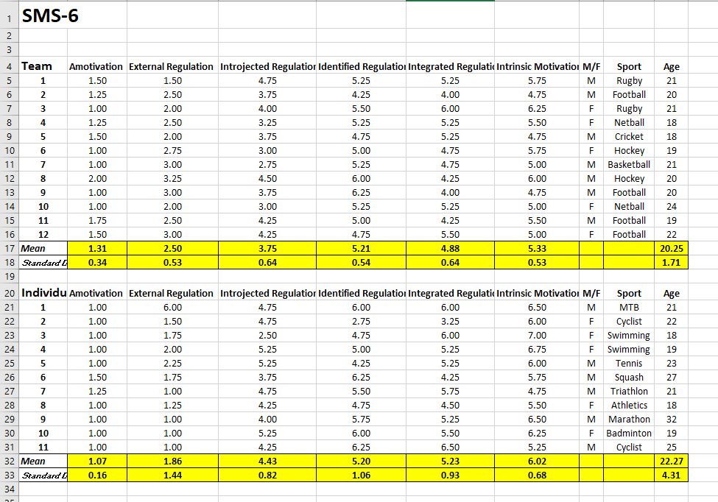
References –

Allen, J (2003) ‘Social Motivation in Youth Sport’ Journal of Sport and Exercise Psychology, 25 (25), pp 551-567.

Allender, S., Cowburn, G. and Foster, C (2012) ‘Understanding participation in sport and physical activity among children and adults: a review of qualitative studies’ Health education research, 21 (6), pp 826-835.

Dismore, H. and Bailey, R. (2010). ‘It’s been a bit of a rocky start’: attitude toward physical education following transition. Physical Education and Sport Pedagogy, 15(2), pp. 175-190.

Gould, D., and T. Horn. (1984) Participation motivation in young athletes. In: Psychological Foundations of Sport, J.M. Silva and R.S. Weinberg (Eds.). Champaign, IL: Human Kinetics, pp. 359-370

Light and Lemonie (2010) A case study on children’s reasons for joining and remaining in a French swimming club..Asian Journal of Exercise and Sports Science, 7(1), 27-33.

Linda M. Petlichkoff, 1992, ‘Youth Sport Participation and Withdrawal; Is It Simply a Matter of Fun?’ Pediatric Exercise Science

Scanlan, T.K., & Lewthwaite, R (1984). Social psychological aspects of competition for male youth sport participants: I. Predictors of competitive stress. Journal of Sport Psychology, 6, 208-226.

Scanlan, T.K., Carpenter, P.J., Lobel, M., & Simons, J.P. (1993). ‘Sources of enjoyment for youth sport athletes.’ Pediatric Exercise Science, 5, 275-285.

Smith, A. L., Balaguer, I. and Duda, J. L. (2006). ‘Goal orientation profile differences on perceived motivational climate, perceived peer relationships, and motivation related responses of youth athletes’. Journal of Sport Sciences, 24(12), pp. 1315-1327.

