Content page
Part 1 – Study Timetable ……………….................................... pages 2 – 3
Part 2 – AI activity and reference list ……………….................. pages 4 - 7
Part 3 – Poster and reference list ………………....................... page 8 – 9
Part 4 – Power point voiceover link ……………….................... page 9
AI acknowledgment
Basic Acknowledgement format of AI tool use
I acknowledge the use of Microsoft 365 Copilot [https://copilot.cloud.microsoft] on 13/09/2026 to help find information to support my work I used the
prompt(s):
- Best ways to plan how to manage time between studies work and wellbeing.
- Provide a variety of ways to use time management during my studies.
- Give me two study techniques on time management for students.
- Give me a variety of different study techniques that will support me during my degree.
- I want to know two different study techniques for time management for my level 4 degree.
- How is the pomodoro technique use full for my studies.
- Where did you find the information on these study techniques.
- How did you find the information on the pomodoro technique. Can you provide the references you used to find out the information as well.
- Can you give me the references you used for the information on smart goals.
I confirm that I have not presented any AI generated text as my own work. I confirm I have copies of my drafts, notes, and other resources I used before, and after the use of AI tools which I may be asked to provide in evidence.

Part 1 – Study Timetable
Amser /Time | Llun  Monday | Mawrth  Tuesday | Mercher  Wednesday | Iau  Thursday | Gwener  Friday | Sadwrn  Saturday | Sul  Sunday
05:00 - 05:59
06:00 - 06:59 | I will wake up at 6:30 | I will wake up at 6:30 | I will wake up at 6:30 | I will wake up at 6:30 | I will wake up at 6:30
07:00 - 07:59
08:00 - 08:59 |  |  |  |  |  | I will wake up at 8:00 | I will wake up at 8:00
09:00 - 09:59 | I start work at 9:30am | I Start work at 9:30am | I start work at 9:30am | I start work at 9:30am | I start work at 9:30am
10:00 - 10:59 | Work 9:30am till 15:00pm | Work 9:30am till 15:00pm | Work 9:30am till 15:00pm | Work :30am till 15:00pm | Work :30am till 15:00pm
11:00 - 11:59 | Go on break at 11:30am | Go on break at 11:30am | Go on break at 11:30am | Go on break at 11:30am | Go on break at 11:30am | Go for a walk with the dogs for an hour | Go for a walk with the dogs for an hour
12:00 - 12:59 | Work 9:30am till 15:00pm | Work 9:30am till 15:00pm | Work 9:30am till 15:00pm | Work 9:30am till 15:00pm | Work 9:30am till 15:00pm | Go to a Coffee shop to read or study 12:00pm till 14:00pm | Spend time with family or friends
13:00 - 13:59 | Work 9:30am till 15:00pm | Work 9:30am till 15:00pm | Work 9:30am till 15:00pm | Work 9:30am till 15:00pm | Work 9:30am till 15:00pm | Go to a Coffee shop to read or study 12:00pm till 14:00pm | Spend time with family or friends
14:00 - 14:59 | Work 9:30am till 15:00pm | Work 9:30am till 15:00pm | Work 9:30am till 15:00pm | Work 9:30am till 15:00pm | Work 9:30am till 15:00pm | Spend time with family or friends | Spend time with family or friends
15:00 - 15:59 | I Leave work at 3:00pm | I Leave work at 3:00pm | I leave work at 3:00pm | I leave work at 3:00pm | I leave work at 3:00pm | Spend time with family or friends | Spend time with family or friends
16:00 - 16:59 | Rest | Go for a walk with the dogs for an hour | Rest | Writing my Assignment  17:00pm till 18:30pm | Go for a walk with the dogs | Spend time with family or friends | Writing my Assignment  17:00pm till 18:30pm
17:00 - 17:59 | Uni 17:00pm till 20:00pm | Rest | Writing my Assignment  17:00pm till 18:30pm | Assignment 16:00pm till 18:00pm | Writing my Assignment  17:00pm till 18:30pm | Spend time with family or friends | Writing my Assignment  17:00pm till 18:30pm
18:00 - 18:59 | Uni 17:00pm till 20:00pm | Rest | Writing my assignment  17:00pm till 18:30pm | Rest | Writing my assignment  17:00pm till 18:30pm | Rest | Rest
19:00 - 19:59 | Uni 17:00pm till 20:00pm | Reading for half an hour | Rest | Rest | Rest | Rest | Reading for half an hour
20:00 - 20:59 | Rest | Rest | Rest | Reading for half an hour | Rest | Reading for half an hour | Rest
21:00 - 21:59
22:00 - 22:59
Assignment and reading
Work
Uni
Going for a walk
Spending time with family or friends
Rest

Part 2 – Using AI to explore study techniques
Initial prompts
Best ways to plan how to manage time between studies work and wellbeing.
Provide a variety of ways to use time management during my studies.
Give me two study techniques on time management for students.

Copy of original output from copilot

Pomodoro sprints — 25 minutes focus, 5 minutes rest
A proven method for staying focused and avoiding burnout. Great for days when motivation is low.

SMART goals — make goals specific and achievable
Specific, measurable, time-bound goals prevent vague sessions like “do some revision”. Instead: “summarise chapter 4”, “complete 10 flashcards”, “review two sources”.

Distraction control — protect students focus
Set session goals before students start. Remove phone distractions, use website blockers, and study in a consistent environment.

Time-blocking — assign tasks to specific time slots
Plot each study task on a planner with a clear target. This creates structure and reduces decision fatigue.

Work pattern optimisation — use your best hours wisely
If students focus best in the morning, schedule demanding tasks then. Use low-energy times for lighter tasks like organising notes.

Refined and stronger prompts
I want to know two different study techniques for time management for my level 4 degree.
Give me a variety of different study techniques that will support me during my degree.
How is the pomodoro technique use full for my studies.

Prompts to identify the sources
Where did you find the information on these study techniques.
How did you find the information on the pomodoro technique. Can you provide the references you used to find out the information as well.
Can you give me the references you used for the information on smart goals.

Discussion of the two study techniques
This discussion will be explaining two different study techniques that will support students on using time management during their studies. The two study techniques that will be used are the Pomodoro technique (Cirillo, 2025) and the smart goal technique. (Boogard, K. 2025).

Firstly, the pomodoro technique is broken down into parts where a student will set a time for 25 minutes for study time once that time will pass student will then take a break of 5 minutes. They will then repeat this in a cycle and add extra time on for both studying time and breaks. This method will support students focus.

According to (Habiya and Azeem, 2025) the Pomodoro technique decreases the amount of academic stress, it is also shown to improves mindfulness. Structuring students’ tasks and ensuring individuals make time for study breaks can have a positive effect on an individual. (Teacher Academy, 2022) Suggests when the students take a break their motivation and concentration increase to continue their studies.

Secondly, the smart goal method is said to also increase motivation and focus. This technique method is where you break down setting different goal in the word smart each letter means different things such as S – specific, M – Measurable, A – achievable, R – Relevant and T means time-bound (Buehring, 2023). (BBC Bitesize, 2022) suggests that Student make their set goals to high, so it is harder for them to reach that is why setting goals are more specific as they are broken down into parts.

In conclusion these two study techniques support students’ to be motivated and focus more on their studies. Research shows that these study techniques are best for when students are unmotivated to study and want to reduce procrastination.

reference list
BBC Bitesize (2022). SMART targets and useful examples – target setting – AQA – GCSE physical education revision – AQA. (online) BBC Bitesize. Available at: https://www.bbc.co.uk/bitesize/guides/zwr34j6/revision/3 (Accessed 23 September)

Buehring, S. (2023) SMART goals | SMART techniques | Knowledge train. (online) Knowledge train at https://www.knowledgetrain.co.uk/business-analysis/resources/business-analysis-technique-smart (Accessed 25 September 2026).

Boogard, K. (2023). How to write SMART goals. (online) Inside Atlassian. Available at: https://www.atlassian.com/blog/teamwork/how-to-write-smart-goals ( 22 September 2026)

Cirillo, F. (2025). Francesco Cirillo – Pomodoro technique. (online) Pomodoro Technique. Available at: https://www.pomodorotechnique.com/francesco-cirillo/ (Accessed 22 September).

Habiya, S.K. and Azeem, J. (2025). Role of the pomodoro technique in reducing stress and preventing burnout among college students with a focus group on neurodivergent. (Online) APHA – APHA 2025 Annual Meeting and Expo. Available at: https://apha.confex.com/apha/2025/meetingapp.cgi/Paper/578600 (Accessed 23 September 2026).

Teacher Academy (2023). Pomodoro technique: The perfect time Management tool? (online) Europass Teacher Academy. Available at: https://www.teacheracademy.eu/blog/pomodoro-technique/ (Accessed 25 September 2026).

Reflection on AI research

This reflection will show my experience of using Microsoft 365 copilot to support my studies. It will indicate the disadvantages and the advantages of using it, what worked well and how to will support me further in my studies.

When experimenting with AI, I was firstly surprised by how easy and fast it was to be able to get the answer to my questions. I felt the information was summarised information, and it helped me find information I needed from more detailed sources. Using AI made me realise how easy it was to find out more about how to study and from the prompts I put in it gave me ideas for a study and work life balance. It gave a start to my research by providing two study techniques when I asked. It provided me with direction as to what websites to look at to provide me with more in-depth information on the techniques. AI also broke down some information so I could understand it better. It was easy to access and navigate for someone who used it for the first time.

However, I felt it did not always provide me with reliable sources or references for certain prompts, so I did have to do some research of my own to find out where the sources came from. I found when typing in simple prompts it did not give me a lot of information. I then had to give AI more questions to find out more information. I did notice that some information I had to watch out for because of reliable sources and seeing if they were appropriate for my studies also some of the research can be outdated so something could change or the information about the topic could be different.

The benefits of using Microsoft 365 Copilot are that it is practical to get information quick instead of me searching for a while for research about a topic as you can ask a question and it will give you the answer. However, the disadvantages are that I feel it can impair your independence through your studies due to doing all the research for you and possibly provide you with incorrect or out of date information.

In the future I will use AI for my studies such as supporting me to summarise a text so it can make it easier to paraphrase it, also for some research I will use my critical thinking and use other sources as well as to make sure the sources AI provides are reliable.

Part 3 – Design an academic poster for two-time management study techniques
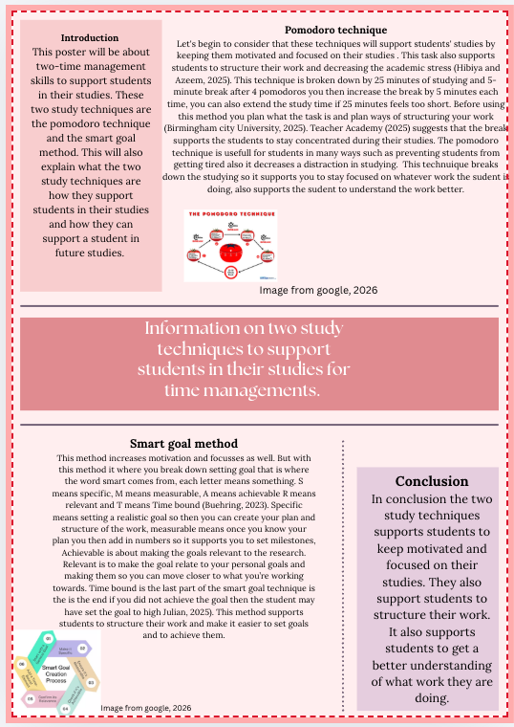

Reference list
Birmingham City University (2025). The pomodoro technique – work your wat to an A, one pomodoro session at a time. (online) Birmingham City University. Available at https://www.bcu.ac.uk/exams-and-revision/time-management-tips/pomodoro-technique (Accessed 24 September. 2026).

Buehring, S. (2023) SMART goals | SMART techniques | Knowledge train. (online) Knowledge train at https://www.knowledgetrain.co.uk/business-analysis/resources/business-analysis-technique-smart (Accessed 25 September 2026).

Habiya, S.K. and Azeem, J. (2025). Role of the pomodoro technique in reducing stress and preventing burnout among college students with a focus group on neurodivergent. (Online) APHA – APHA 2025 Annual Meeting and Expo. Available at: https://apha.confex.com/apha/2025/meetingapp.cgi/Paper/578600 (Accessed 23 September 2026).

Julian (2021). What are SMART goals and how to use them. (online) FPPT. Available at: https://www.free-power-point-templates.com/articles/smart-goals-definition-and-how-to-use/#google_vignette (Accessed 25 September 2026).

Teacher Academy (2023). Pomodoro technique: The perfect time Management tool? (online) Europass Teacher Academy. Available at: https://www.teacheracademy.eu/blog/pomodoro-technique/ (Accessed 25 September 2026).

Part 4 Poster presentation link
https://uowtsd-my.sharepoint.com/:p:/r/personal/2607193_student_uwtsd_ac_uk/Documents/poster%20presentation%20ECEY4012.pptx?d=w62b1f95ac51548dab7047e4b9a1db65b&csf=1&web=1&e=Qa6y1u

