Claire Davies 1806680

Contemporary Management Approaches (BMSP4002)


Tutor:- Davina Evans

Introduction
I have chosen Lush Cosmetics to use for my assignment for contemporary management approaches, they are a company that I work for and I have great respect for, not only for their ethical values but as a whole, to see where they started from and where and who they are today. Lush was founded back in 1995 by Mark Constantine, his wife Mo and 4 other co-founders, they started with just on shop in Poole, Dorset and now there are 104 shops in the UK and over 929 worldwide in 49 Countries. So I shall research and look at how Lush Cosmetics manage their organisational and management skills and how they put them into practice throughout their organisation. To do this I will be doing a lot of research from various sources to find out as much information as I can on the behaviour and management skills of the business.

Approaches to organisation and management
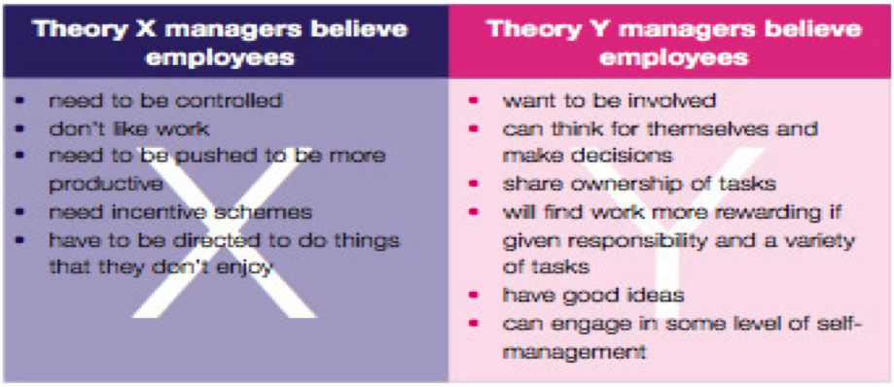
There are many organisation and management approaches with-in different businesses and organisations. Theory X and Theory Y are among some of the approaches some businesses may use, Mc Gregor believed that Theory X people were lazy and didn’t particularly want to work and were their just for the financial side of the job, this resulting in unhappy and unmotivated staff, so a stricter management approach would be needed, Theory Y he believed to be a more relaxed management approach as people wanted to work and be motivated (Gregor, The human side of enterprise, 1960). Below I have inserted an image that shows the Theory X and Y in more detail. (Gregor, n.d.)

Lush as a company seem to use Theory Y mainly and Theory X partially with their management approach. There seem to be many benefits to working for Lush Cosmetics and these benefits could been seen as a way of inspiring their work staff to enjoy their work and give the best they can with-in their job role. Management are a big part with-in the company and are there to lead by example.
“Lead from the front and demonstrate 5* Customer Experience yourself, ensure work is delegated throughout the management team, provide regular learning, feedback, coaching and reviews for your team, encourage, respect and look after one another” (Howes, 2018).
This is an approach that seems to work really well for Lush, this could possibly been seen and using Theory Y and also Theory X, feedback and coaching are a way of management ensuring staff know what they need to be doing to the best of their ability, but also leading by example is a great way for staff to see that the management team see themselves as an equal and lead by example.
Regular, updated training for management is a great way to ensure a smooth running business or organisation, this in turn can be brought back and shared with the rest of the working team.
“Create future Shop Managers by ensuring your management team have the right skill set to be able to develop the team and manage the business” (Howes, 2018).
So to ensure management have the right skills to be able to help the team develop, Lush regularly send members of the management team on training courses. Often there are also courses available for staff outside of the management team which also in turn benefits the business and helps towards a great working environment where we all work as a team. This is also a great way to encourage staff to possibly develop with-in the company, the more training given whether to management or staff members is going to benefit the company.
“Companies can reap the rewards of providing training for their employees because well-trained workers help increase productivity and profits” (Shaw, 2018).
By providing the adequate training throughout the company it is going to reflect on the business profits, by increasing productivity and profit with-in Lush Cosmetics not only benefits the company its self but it also benefits the staff employed by the company as they receive a nice monthly bonus on hitting targets and increasing profits.

Work motivation and satisfaction
As a company Lush believe in creating a supportive work place for their staff, not only do they have a close working environment provided instore but they also have a great support network outside of the work place for staff if needed. It’s a private and confidential place for their staff to reach out to if needed, not only for work related situations but also anything that they may be dealing with outside of the work place.
“Health Assured, our external Employee Assistance Programme, it has lots of useful information on their website” (Kolensikoff, 2018).
As a company Lush Cosmetics seem to be always looking after the wellbeing of their staff, this is where it seems that the Maslow’s Hierarchy of Needs Theory is put into practice, they look after their staffs wellbeing which in turn reflects on their working performance. Lush is a worldwide company and seem to show consistency throughout the company where the staffs care and wellbeing is a priority, this then in turn seems a great motivation for staff and this then could show in the performance of their work, which could then benefit the company as generally a happy and motived work force may work to the best of their ability.
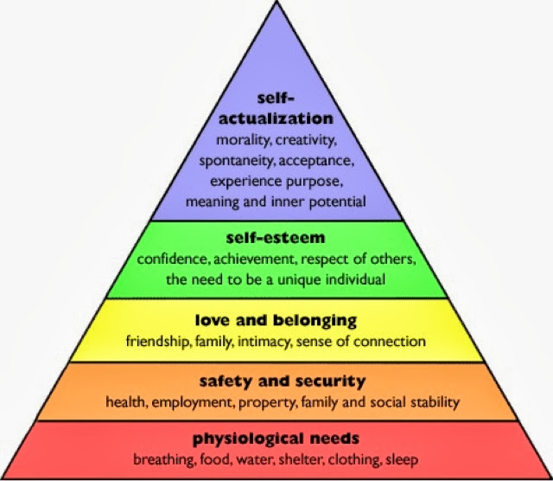

“Let There Be Light! We all need natural light. Your body uses sunlight to time various important functions, such as when you wake up, as well as promoting Vitamin D to get our bodies healthy” (Craig, 2018).
Good working conditions seem to encourage staff with-in a company or organisation, this doesn’t always mean the environment in which they are actually working in but also somewhere for staff to relax and recuperate while on break, so a nice staffroom, equipped with the necessary things needed, somewhere to sit, adequate lighting, appliances to make themselves a drink, all this may seem simple but from experience, by ensuring these small gesture are in place makes staff feel valued and this seems to help to motive people.
“Ensure your shop is well looked after. Keep the shop floor clean, tidy, & well merchandised and your stock fresh for our customers, and all back of house areas as clean, safe, and pleasant as you can for the team” (Howes, 2018).
Not only is it important to have a safe environment to work in but also to have a sense of security with-in you job, Lush provide this by giving their staff contracted hours, so they know they are guaranteed hours every week. Many companies seem to work on zero hours contracts, this doesn’t give security or guarantee hours to their staff. So looking deeper into the Maslow’s Hierarchy of Needs Theory, it appears that Lush Cosmetics puts this theory into practice in many different ways throughout its company. Communication between management and staff is a key aspect to a good working team, Lush provide this in many different ways, like daily check ins, ensuring staff know what the day ahead holds, daily targets, customer focuses etc. This is a great way for all team members to communicate amongst each other and to know what’s going on and it means no one is left out. Team building is also a great way to help motivate staff and give them a sense of satisfaction, this can be done in many ways.
“Recruitment and development are always at the forefront of our minds when we're bringing so many new staff into the business” (Devlin, 2018).
Instore training is a big part of what Lush are about, this is done as a team and is a great team building exercise where the whole team work together and train on new products. Lush provide the opportunity for all staff member to be able to go on training days, this is also a great team building exercise as you train alongside team members from other shops. As a company they encourage their staff to further their career by giving them so many opportunities, in different areas of the business and there is so much help at hand to help you to try and achieve this.
“Growth needs do not stem from a lack of something, but rather from a desire to grow as a person” (Leod, 2018)
Some people may not want to advance in their career and will be happy to stay with-in the role they have and that’s fine, but it’s nice that Lush give the opportunity for each and everyone of their staff to advance to a higher role should they want to, or even just to take a different career path, and seem to be happy to help as much as possible to enable this to happen.

Perception and communication
It seems that many people have the perception that Lush Cosmetics are all about smelly bath bombs and soaps, and in some respects they are right but the company is so much more than just that. Lush recognise that everyone is different and are trying to change peoples perception on the company. Although they have become a global business they are passionate about holding on to their grassroots and what they stand for as a company.
“We also have to be aware that you have to adapt to the growth and demand and the public’s perception of who you are and what you are so that your sustainable and your businesses survives” (Mortimer, 2015).
So over the years since the company began, it seems that perceptions have changed and Lush is now known as more than just a smelly bath bomb company, this may be due to the way they communicate and promote that as a business, they are also passionate in supporting various campaigns and the environment. Lush don’t communicate through advertising, they appear to be so passionate about their beliefs and the support they give to people and different communities that perceptions have changed.
As much as they won’t change where there they started from, as a company they are adaptable and looking to continue to making changes. As they have proved over the years they have changed so much as a company, so they are no longer just a cosmetic company, they are a company that embraces change and working everyday to continue to make changes to better the environment.

Organisational context
Organisational context is divided into different categories, private sector, public sector and social enterprise sector. Private sector is a profit driven business that can be set up by any individual, public sector is government run, like hospitals and the armed forces for instance and these are funded and the social enterprise sector can be for profit or non-profit as they have business and social goals but seems that their main purpose is to encourage, promote and to make social changes.
“Lush was started in 1995 by a close-knit team with, who have continued to work together for over 20 years, including Mark and Mo Constantine OBE. The first Lush shop opened at 29 High St, Poole in April 1995, with products being made in a small space above the shop. The business has been profitable since day one” (Barnes, 2018).
It seems that Lush Cosmetics is a private sector business and is a profit driven business, but the company also encourage, promote and make social changes across the world. In 2007 Lush Cosmetics created a body cream product called Charity Pot to help raise money for small grassroots groups and many other good causes, these included the welfare of animals, the environment and human rights.
“To date Charity Pot is sold in 35 countries and along with our other charitable giving initiatives, we have given a total of £50 million away and given money or products to at least 3500 groups across the globe” (Bagarone, 2018).
It would appear that Lush cosmetics is a company that as much as it makes a profit also thrives on giving back to the less fortune and are trying to make a different worldwide. Lush over the years have run many campaigns to raise money for causes that they have a passion about, some of these campaigns include SOSsumatra, stop the war on wildlife, world ocean day, these are only a few but they show how Lush is a company that likes to give as much as make a profit.
“Although such organisations function as companies, their main concern is with the community in general rather that with shareholder value or specific public interest. Social enterprise organisations promote the wellbeing of society but are not charities” (Mullins).
That quote seems to sum up what Lush Cosmetics is all about as a company.

Conclusion
My research into Lush Cosmetics’ contemporary management approaches has been very interesting, from what I have researched I can see that as a company their management approaches seem to work for them. I have done vast research on Lush’s own website, online searches and the use of books from the library to enable me to find all the information I needed. The majority of my findings actually came from their Lush Beta website, this is a site that shares so much information on Lush as a company, the information on there is updated regularly so most of the information I have gained is mostly current and a good representation as to who the company are and what they are about. It was nice to see how Lush have worked together as a team to create the company to make it what it is today. To grow from such a small business into a company that is recognised globally and to see the impact they have from all the changes they are making to ensure the environment is a better pplace. From my findings and from my own experience of working for the company, its nice to see how they have grown over the years and that their focus is on helping to improve the environment, the wellbeing of people as much as it is about profit. It was nice to see that unlike some companies, Lush is more than just about making a profit.

Bibliography

Bagarone, P. (2018, November 4). Lush Beta. Retrieved from https://beta.lush.com/en/article/charity-pot-&-giving-
Barnes, K. (2018, April 10). Lush Beta. Retrieved from https://beta.lush.com/en/article/best-practice-guide-5-a-company-history-and-lush-today
Craig, V. (2018, May 03). Retrieved from Lush Beta: https://beta.lush.com/en/article/wellbeing-wellness-mental-health-staffroom
Devlin, L. (2018, August 15). Lush Beta. Retrieved from https://beta.lush.com/en/article/gemma-from-cardiff-s-christmas-2018-recruitment-and-training-plan
Gregor, M. (n.d.). Retrieved from https://culcghais3.files.wordpress.com/2014/04/2.png
Gregor, M. (1960). The human side of enterprise. New York.
Gregor, M. (1960). Theory X and Theory Y.
Howes, L. (2018, July 20). Lush Beta. Retrieved from https://beta.lush.com/en/article/job-description-shop-manager-uk-ireland-1
Kolensikoff, S. (2018, April 10). Lush Beta. Retrieved from https://beta.lush.com/en/article/things-to-consider-when-supporting-team-members-wellbeing
Leod, S. M. (2018). Simply Psychology. Retrieved from https://www.simplypsychology.org/maslow.html?es=gt85mdvoqdxij7ixmoxj3rqh8suvkw2q
Mortimer, N. (2015, July 30). Retrieved from The Drum: https://www.thedrum.com/news/2015/07/31/how-lush-using-design-shift-brand-perception-away-smelly-bath-bombs
Mullins, L. J. (n.d.). Management & Organisational Behaviour. In Management & Organisational Behaviour Eleventh Edition (p. 72). Pearsons.
Parem57. (2013, October). Maslow's Humanistic Theory. Retrieved from http://psy220-ehawley.blogspot.com/
Shaw, J. (2018, June 29). Chron. Retrieved from https://smallbusiness.chron.com/effects-training-employee-performance-39737.html

