
eco bike hub case study
Database systems

January 14, 2022
University of WALES TRINITY SAINT DAVID
By Shamuel Hashan
MSC Software Engineering
Contents
0
1. Introduction 1
2. SQL vs NoSQL 1
3. Performance Tuning 2
3. Transactions 2
4. Distributed Database Solution 4
5. Appendix 5

1. Introduction
Eco bike hubs are a small chain of independent shops. At Eco Bike hubs they trade bicycles, parts, repairs and provides bicycles for hire. They aim to be a flexible service that fits most of the needs for cyclists. The main goal of these shops are to help the environment. Examples of how they achieve this by promoting recycling and using recycled frames for when selling custom builds of mountain bikes. This organisation uses medium sized buildings where their man task would be to deal with the requests of customers and booking when various customers need their bikes serviced or repaired. The customer requests will need to be logged and anything sold for customers’ needs to be tracked as well as tracking the rentals for the cycles. Eco Bike Hubs has requested for a database to be made for them to help them keep track of all their activities and data. They also requested assistance in helping the organisation on issues regarding their databases. This report will cover these issues

2. SQL vs NoSQL
One of the issues that Eco Bike Hub asked to investigate was about the debate between using a SQL database or a NoSQL database. There are a few differences with these two databases. One being that they do not share the same storage model. The SQL databases uses an ACID storage model whereas NoSQL uses a BASE storage model. The SQL data storage model has tables with fixed rows and columns whereas the NoSQL databases can be document based, graph databases or key-value pairs. NoSQL data storage model is made up of JSON documents and Key-value: key value pairs. NoSQL also consists of dynamic columns tables with rows and the graphs are nodes and edges. SQL databases are mostly known as relational databases while NoSQL databases are known as distributed databases or non-relational databases. SQL has one type but there might be little variations as opposed to NoSQL having various types that have key-value stores, graph databases and document databases included. SQL is mainly used for general use. SQL was designed for the SQL syntax and queries to used by traditional relationship databases so data can be analysed and gathered for more insights. SQL is also used by OLAP systems. NoSQL is also used for General uses. It was designed to consist of several database technologies. These databases were developed due to the demands and requirements that needed to be met for modern applications. NoSQL is used for when dealing with a lot of data. Various big companies such as Amazon that collect large number of data uses NoSQL to meet the data storage needs when it comes to the distributed data stores. Another difference between the two is that SQL has a rigid schema that has been predefined where ass NoSQL has a more flexible scheme that is used for unstructured data. One of the key differences between SQL and NoSQL is that the SQL databases can be scaled vertically whereas the NoSQL databases can be scaled horizontally. The hardware required for better performance for SQL and NoSQL are different too. A specialized DB hardware is needed to improve the performance of SQL, but NoSQL can be used with commodity hardware. When it comes to an environment that requires a lot of complex queries, SQL databases are the best suited database system whereas NoSQL might not be great to fit complex queries. However, it is more suitable when it comes to the storage of hierarchical data due the key-value pair method being supported by it while SQL does not support this method so hierarchical data storage might not be as suitable. SQL is a mixture between open source or commercial but that does depend on the language used. For example, MySQL is open source while Oracle database is commercial. NoSQL on the other hand is completely open source. Both database systems have different priorities. SQL prioritises the validity of data, but NoSQL prioritises having fast data more. It would be a good idea to use SQL where dynamic queries need supporting and to use NoSQL where the database needs to be scaled when requirements are changed. The network and storage types are more available to use with SQL as they use networks such as InfiniBand and fabric path and storage types such as SAN and RAID. NoSQL uses commodity networks such as Ethernet and commodity storage drives like Hard Disk Drives and JBOD. They each have features that are very useful. For example, SQL is cross platform, more secure and it is free. NoSQL is easily used, has a high performance and is flexible to use. Deciding on which one to use depends on various factor. SQL is the best option when it comes to communicating with relational database management systems, when data from the database needs to be gathered or stored quickly, when custom dashboards require building, when customized and behavioural related sessions need to be analysed. SQL should also be used when complex queries need to be executed. NoSQL would be good to use when there is no need for ACID support, a flexible schema is needed for data, when databases do not require the implementation constraints and validation logic. NoSQL is also used where data from distributed sources needs to be logged. It is also used where temporary data such as wish lists or shopping carts need to be stored.

3. Performance Tuning
Eco Bike Hubs have requested for the database to include performance tuning. Data queries are used to gather data from the database. There would be a few data queries that would be used by Eco bike hubs. Here are examples of data queries that were executed in the database.
One index that was added was the index for the Staff pay. One index that was created in the database was an index that would show how much each branch spends on staff.
This will display the average salary for the staff at each branch.
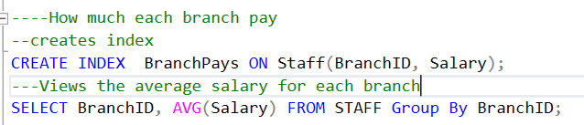
Another index that would be used Eco Bike hubs is the index to see the various bike types eco bikes hub have.
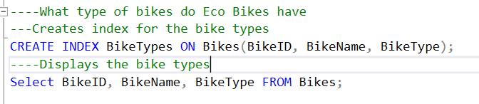
The third index that was created was the bike price index. This would be used so the organisation can execute a query where they look for the prices of the bikes in the database,
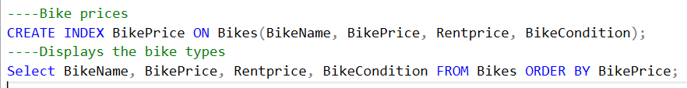

3. Transactions
One of the forms of performance tuning is done through performing transactions. These are sequences of operations that are performed on the database as a minimum of one SQL statement is used.
A transaction on ECO Bike Hubs to add a new location was used. This transaction would allow Eco Bike Hubs to add new branches to the database if they were to build another branch in another location.
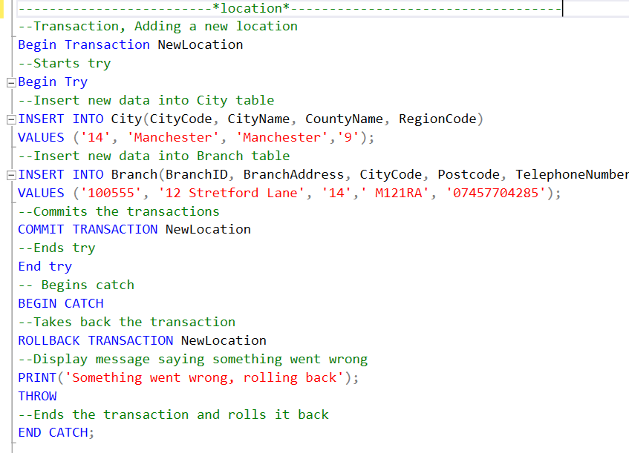
The new additions to the tables where then displayed
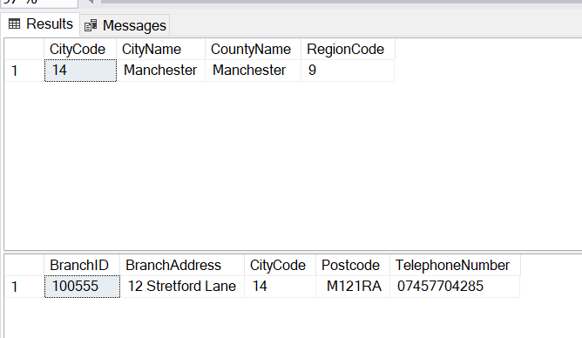
Another transaction that was performed was the transaction for adding new new customers.
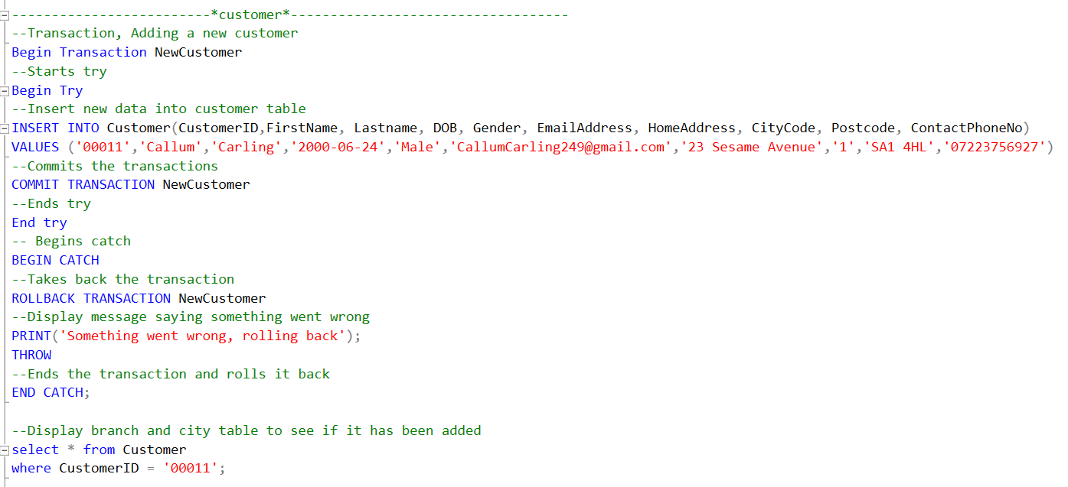
This is the new customer being displayed.
This is the transaction rollback for the customers being tested.
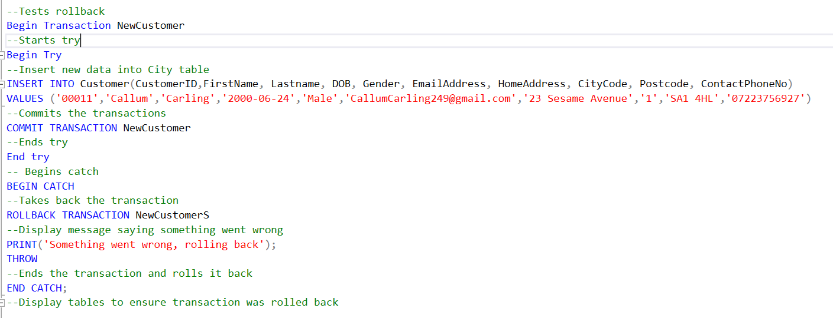

4. Distributed Database Solution
There are various distributed database solutions used to help the database.
Fragmentation is one of these. This is used to manage databases as it allows contents of a single file to be stored in a non-contiguous space. The files will not be stored in one location as it will be stored in various areas in the disk instead.

Horizontal fragmentation could be used for the branch table to see which city a branch is in. Using the horizontal fragmentation, the branch with the city it is in will be displayed.
B1 {BranchID = ‘111111 and CityCode = ‘1’}
B2 {BranchID = ‘222222’ and CityCode = ‘2’}
B3 {BranchID = ‘333333’ and CityCode = ‘3’}
B4 {BranchID = ‘444444’ and CityCode = ‘4’}
B5 {BranchID = ‘555555’ and CityCode = ‘5’}
B6 {BranchID = ‘666666’ and CityCode = ‘6’}
B7 {BranchID = ‘777777’ and CityCode = ‘7’}
B8 {BranchID = ‘888888’ and CityCode = ‘8’}
B9 {BranchID = ‘999999 and CityCode = ‘9’}
B10 {BranchID = ‘100101 and CityCode = ‘10’}
B11 {BranchID = ‘100222 and CityCode = ‘11’}
B12 {BranchID = ‘100333 and CityCode = ‘13’}
B13 {BranchID = ‘100444 and CityCode = ‘14’}
Here is one example,
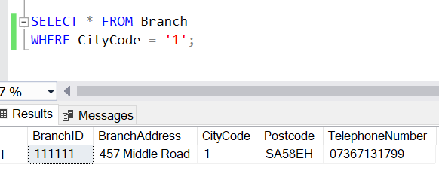

5. Appendix
[1] “SQL vs NoSQL: What’s the Difference Between SQL and NoSQL.” https://www.guru99.com/sql-vs-nosql.html (accessed Jan. 13, 2022).
[2] “NoSQL vs SQL Databases | MongoDB.” https://www.mongodb.com/nosql-explained/nosql-vs-sql (accessed Jan. 13, 2022).

