

UWTSD Rental

C o s t S h e e t

Price list………………………………02
Cameras and Kits…………………05
Lenses………………………………….20
Miscellaneous……………………….25
Audio……………………………………30
Lighting…………………………………35
Support and grip……………………42

Please note: Equipment is subject to availability. The below list may not include all items available, or kits may vary in content. Images are impressions only and may not be a true representation of an item/kit.

Price List

Cameras and Kits
Sony A7S Mark II with metabones adapter | DAILY RATE £125 + VAT
Sony A7S Mark II with lens kit | DAILY RATE £450 + VAT
C300 with lens kit | DAILY RATE £400 +VAT
Go Pro Hero 3+ Black Edition with accessories | DAILY RATE £85 +VAT
Sony FS700 | DAILY RATE £200 +VAT
Canon Mark III | DAILY RATE £80 +VAT
Canon Mark III with lens kit | DAILY RATE £170 +VAT
Canon Mark II | DAILY RATE £50 +VAT
Canon Mark II with lens kit | DAILY RATE £140 +VAT
Canon XF305 | DAILY RATE £85 +VAT
7D Canon with 35mm | DAILY RATE £60 +VAT
60D Canon with 18-55mm | DAILY RATE £50 +VAT
550D Canon with 18-55mm | DAILY RATE £40 +VAT
Infrared Night Vision Wildlife Camera | DAILY RATE £50 +VAT
RED One kit | DAILY RATE £820 +VAT
Canon XA10 | DAILY RATE £75 +VAT
Canon XF100 | DAILY RATE £100 +VAT
Lenses
75-300mm Canon | DAILY RATE £20 +VAT
28mm Canon | DAILY RATE £30 +VAT
50mm Canon | DAILY RATE £30 +VAT
35mm Canon | DAILY RATE £30 +VAT
85mm Canon | DAILY RATE £30 +VAT
100mm Canon | DAILY RATE £40 +VAT
16-35mm Canon | DAILY RATE £50 +VAT
24-70mm Canon | DAILY RATE £ 50+VAT
70-200mm Canon | DAILY RATE £60 +VAT
14mm Samyang | DAILY RATE £50+VAT
8mm Samyang | DAILY RATE £50+VAT
Vintage lens kit | DAILY RATE £60+VAT
Miscellaneous
Metabones EF > A mount adaptor | DAILY RATE £25+VAT
Monitor | DAILY RATE £40+VAT
Clapper board | DAILY RATE £5+VAT
Light meter | DAILY RATE £7+VAT
Projector | DAILY RATE £25+VAT
V lock charger and batteries | DAILY RATE £30+VAT
Gobo lens attachment | DAILY RATE £5+VAT
Media player | DAILY RATE £10+VAT
High visibility vests | DAILY RATE £2+VAT
Audio
Rode NTG 3 | DAILY RATE £15 +VAT
H4N | DAILY RATE £15 +VAT
Rode video mic pro | DAILY RATE £15 +VAT
Rode smart lav | DAILY RATE £10 +VAT
Shure SM58 | DAILY RATE £15 +VAT
Wireless Microphone | DAILY RATE £ 25+VAT
Mixer | DAILY RATE £25 +VAT
Boom pole | DAILY RATE £5+VAT
Large wind guard | DAILY RATE £25+VAT
Microphone stand | DAILY RATE £5+VAT
Headphones | DAILY RATE £5+VAT
Lighting
Dedo kit | DAILY RATE £ 50+VAT
Sola 4 LED kit | DAILY RATE £55 +VAT
Lighting panels | DAILY RATE £55 +VAT
Kino flo kit | DAILY RATE £50 +VAT
LED | DAILY RATE £15+VAT
Reflector | DAILY RATE £5 +VAT
Road rag kit | DAILY RATE £15 +VAT
Flag | DAILY RATE £5 +VAT
C-stand with arm and grips | DAILY RATE £10 +VAT
Lighting stand | DAILY RATE £5+VAT
Sand bag | DAILY RATE £2+VAT
Redhead 800W with stand | DAILY RATE £40 +VAT
Blonde 2000W with stand | DAILY RATE £50 +VAT
Support and grip
Desktop tripod | DAILY RATE £5 +VAT
Monopod | DAILY RATE £5 +VAT
Small tripod | DAILY RATE £10 +VAT
Libec tripod | DAILY RATE £20 +VAT
Large tripod (Vinten) | DAILY RATE £40 +VAT
Slider | DAILY RATE £100 +VAT
Shoulder rig | DAILY RATE £15 +VAT
Ronin S DSLR gimbal | DAILY RATE £80 +VAT
Mobile phone gimbal | DAILY RATE £20 +VAT
Cinema bundle | DAILY RATE £30 +VAT
Track and dolly | DAILY RATE £130 +VAT
Steadicam flyer kit | DAILY RATE £120 +VAT

Cameras and Kits

A7S Mark II (Sony)  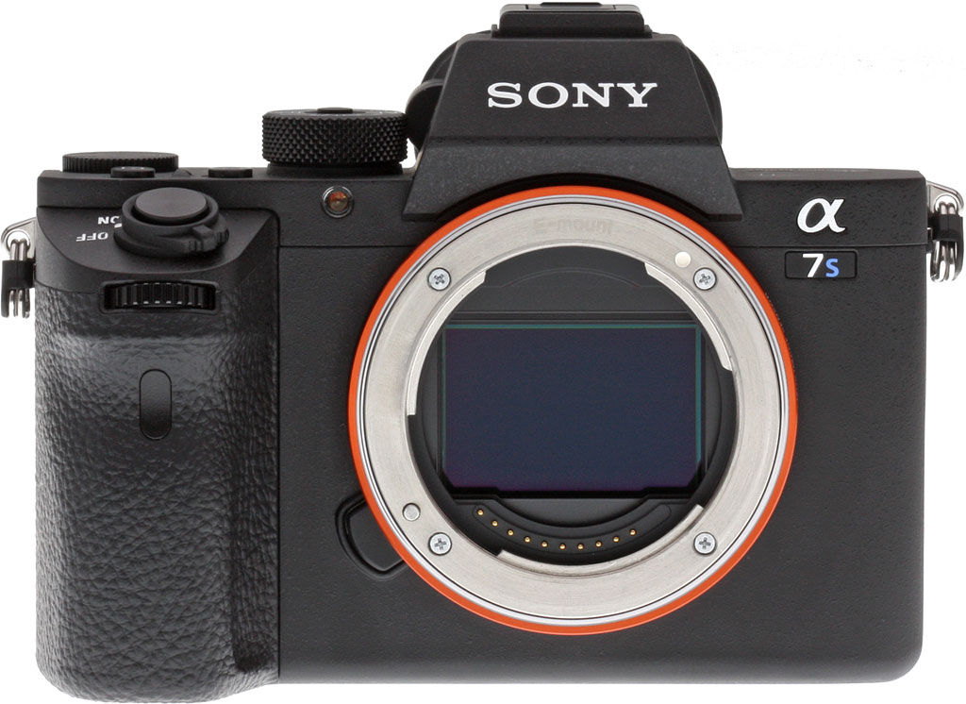 | DAILY RATE £125 + VAT
Description  Key specs:  Resolution: 12 Megapixels  Video Resolution: 4K  Card Type: SD  Format: Full Frame  Sensor Type: EXMOR CMOS  Type: Photo, Video  Weight: 500-1kg  35mm full frame (35.6 x 23.8mm), Exmor CMOS sensor  Other:  Will need your own SD card. |  | Included  2 x batteries  1 x charger  1 x adapter Canon EF to E mount

A7S Mark II (Sony) with lens kit  + 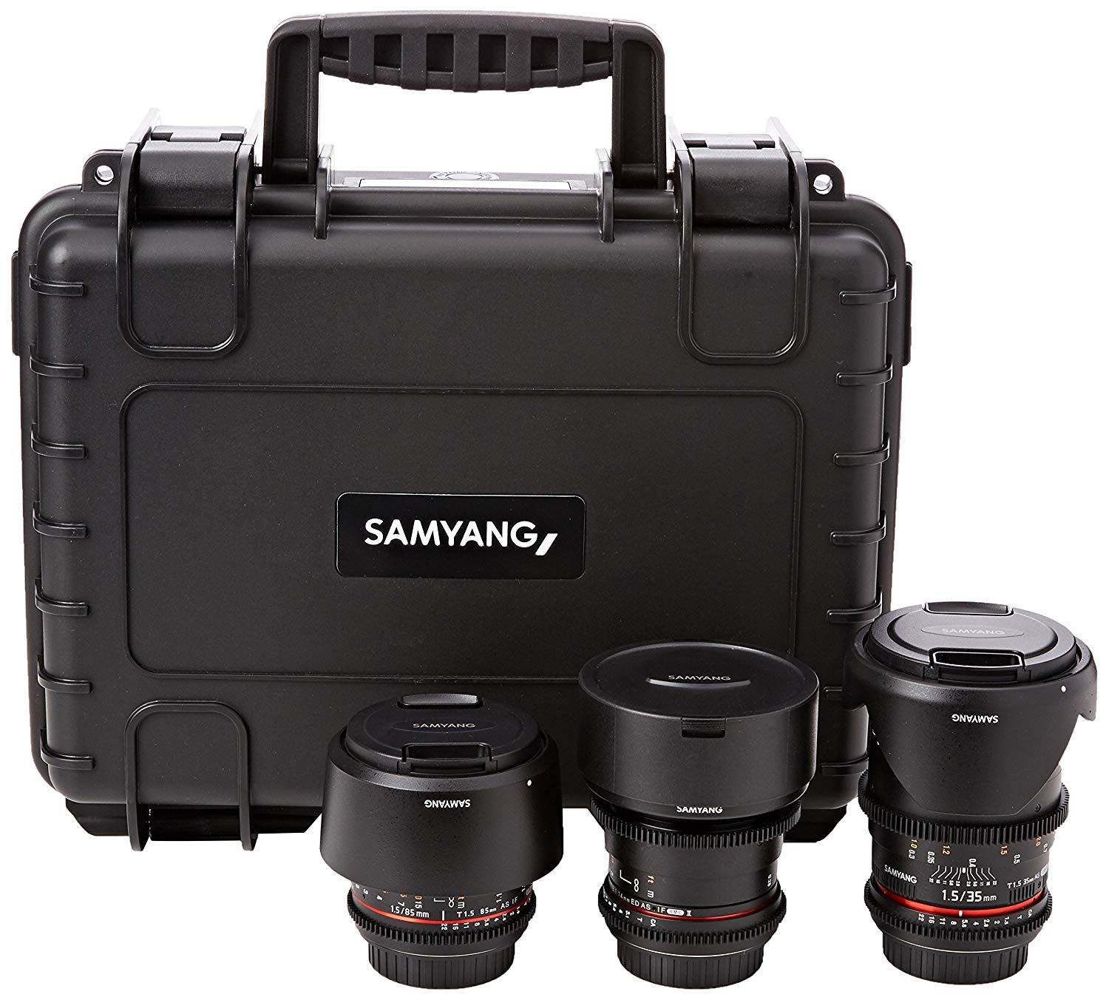 | DAILY RATE £450 + VAT
Description  Key specs:  Resolution: 12 Megapixels  Video Resolution: 4K  Card Type: SD  Format: Full Frame  Sensor Type: EXMOR CMOS  Type: Photo, Video  Weight: 500-1kg  35mm full frame (35.6 x 23.8mm), Exmor CMOS sensor  Samyang lenses  Lens Mount: Sony E  Max Aperture: T/1.5, T/2.2, T/3.1  Other:  Will need your own SD card. |  | Included  2 x batteries  1 x charger  1 x 135mm  1x 14mm  1 x 24mm  1 x 35mm  1 x 50mm  1 x 85mm

C300 kit (Canon)  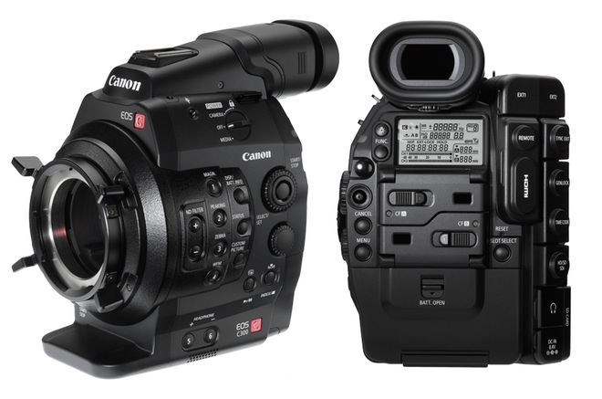+ | DAILY RATE £400 + VAT
Description  Key specs:  8.3MP Super 35mm CMOS sensor; Full HD  - Interchangeable lens  - Dual pixel CMOS AF for accurate and reliable focusing  - Compact, modular, lightweight  - 50Mbps MPEG-2 MXF  - High sensitivity, low noise  - Canon Log Gamma  - 24.00p for movie production  Other:  Interchangeable lenses give the diversity of depth of field for that sleek look.  Will need your own CF card. |  | Included  4 x batteries  1 x charger  1 x monitor  1 x handle/grip  Kit 1 lenses:  85mm Samyang  24mm Samyang  35mm Samyang  8mm Samyang  50mm Canon Cine  Kit 2 lenses:  85mm Samyang  24mm Samyang  35mm Samyang  14mm Samyang  14mm Samyang

Go Pro Hero 3+ Black Edition (Go Pro)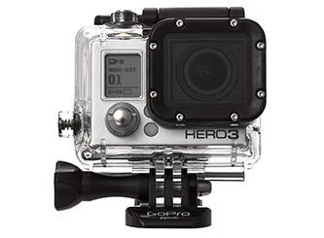 | DAILY RATE £85 + VAT
Description  Key specs:  - Supports 2.7K30, 1080p, 1440p, Video  - Capture 12MP Photos at 30 fps  - Ultra Wide Angle Glass Lens + SuperView  - Video and Photo Time-Lapse  - Protune Mode for Video and Photo  - One-Button Operation with QuikCapture  - Auto Low Light and Night Photo Modes  Other:  Will need your own micro SD card. |  | Included  2 x battery  1 x charger  1 x remote  various connector/mounts  1 x LCD monitor

FS700 (Sony)  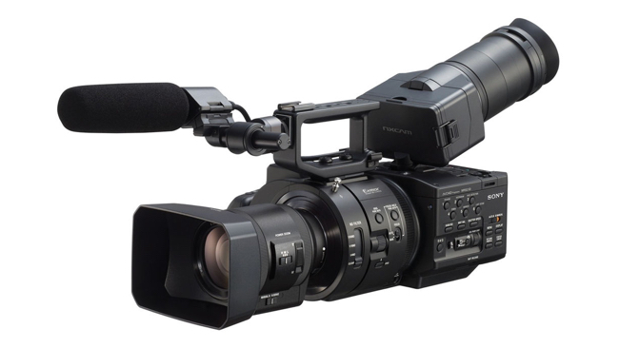 | DAILY RATE £200 + VAT
Description  - ISO 500 (0 dB) to ISO 16,000 (30 dB) sensitivity.  - Cranks from 1 to 960 fps for fast motion to super-slow motion.  - Four ND filter levels: clear, 2, 4 & 6 stops.  - Four HyperGamma settings (same as F3)  - WorldCam 50/60Hz systems.  - Exmor Super 35mm sensor 11.6-megapixles.  Other:  Will need your own micro SD card. |  | Included  1 x charger  2 x batteries  various cables

Mark III (Canon)  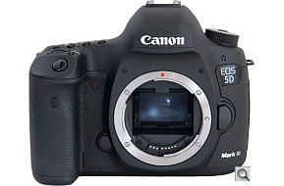 | DAILY RATE £80 + VAT
Description  The Canon 5D Mark III is a full-frame DSLR camera capable of capturing 22-megapixel images at 6fps and Full-HD movies. Delivers higher standard and expanded ISOs.  Other:  Will need your own CF card or SD card. |  | Included  1 x LP-E6 Battery  1 x charger

Mark III kit (Canon)  +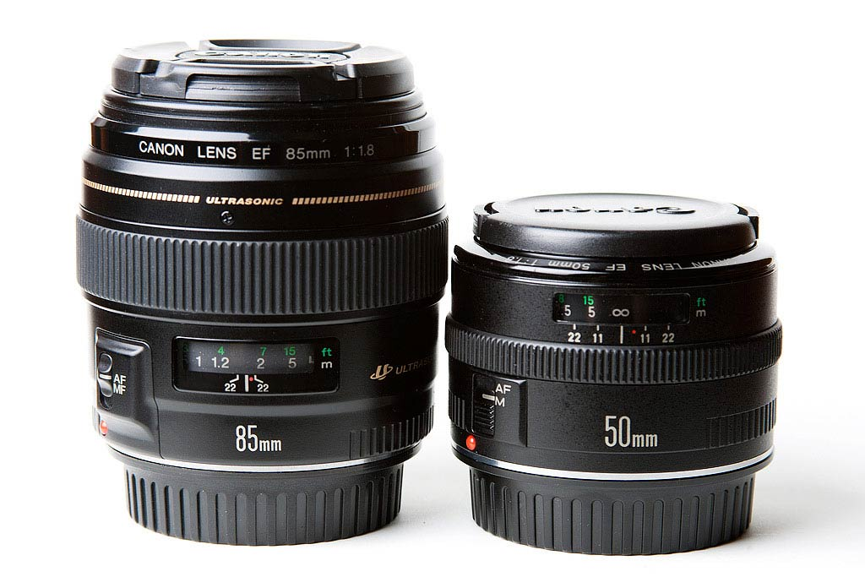 | DAILY RATE £170 + VAT
Description  The Canon 5D Mark III is a full-frame DSLR camera capable of capturing 22-megapixel images at 6fps and Full-HD movies. Delivers higher standard and expanded ISOs.  Other:  Will need your own CF card or SD card. |  | Included  1 x battery  1 x charger  85mm  28mm  50mm

Mark II (Canon)  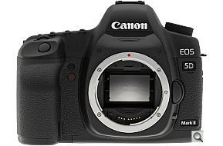 | DAILY RATE £50 + VAT
Description  The Canon 5D Mark III is a full-frame DSLR camera capable of capturing 22-megapixel images at 6fps and Full-HD movies  Other:  Will need your own micro CF card. |  | Included  1 x LP-E6 Battery  1 x charger

Mark II kit (Canon)  + | DAILY RATE £140 + VAT
Description  The Canon 5D Mark III is a full-frame DSLR camera capable of capturing 22-megapixel images at 6fps and Full-HD movies  Other:  Will need your own CF card. |  | Included  1 x battery  1 x charger  85mm  28mm  50mm

XF305 (Canon)  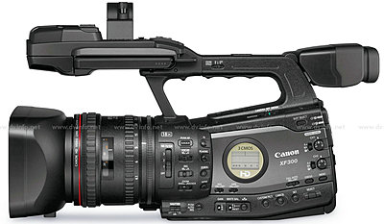 | DAILY RATE £85 + VAT
Description  Key specs:  HD Camcorder recording MPEG-2 at 50Mbps 4:2:2.  (XF-305, XF305)  Featuring 3 Full HD CMOS Sensors  Canon L-Series Fixed Lens  Records to a CF Card  Other:  Will need your own CF card. |  | Included  2 x Battery  1 x charger  various monitor cables

7D with 35mm (Canon)  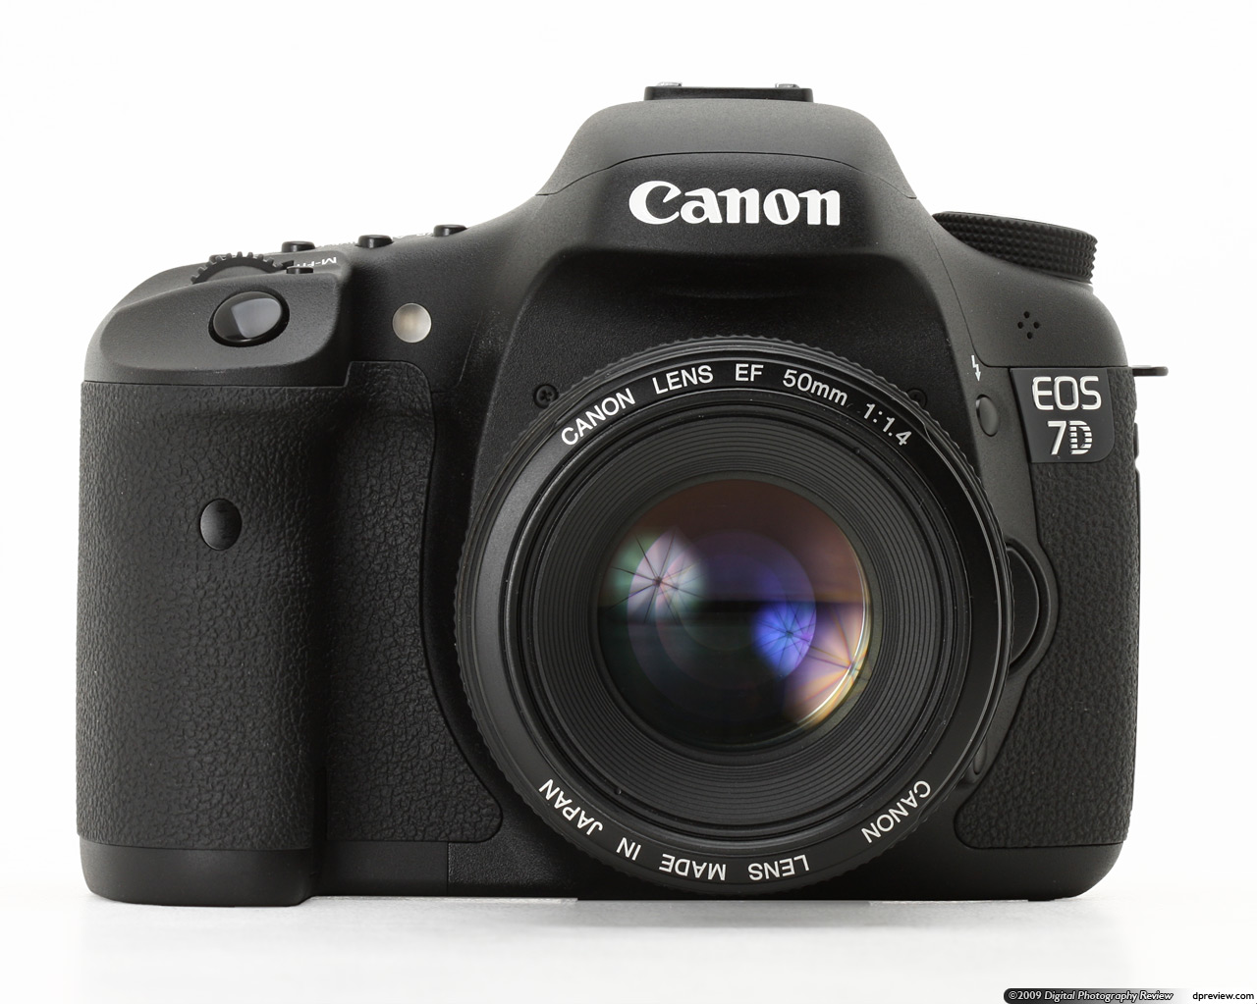 | DAILY RATE £60 + VAT
Description  The EOS 7D features a Canon-designed 18.0 Megapixel APS-C size CMOS sensor that captures such a high level of resolution it’s easy to crop images for enlargement without concern of losing detail. A major factor in reducing noise, the CMOS sensor assures that images shot at highest sensitivity will be remarkably smooth. Dual DIGIC 4 Image Processors ensure that images are captured, processed and saved with remarkable speed. The EOS 7D’s ability to capture and process data of images shot at 18.0 Megapixels at 8.0 fps, as well as Face Detection Live Mode, Full HD video recording.  Other:  Will need your own CF card. |  | Included  1 x 35mm  1 x battery  1 x charger

60D with 18-55mm (Canon)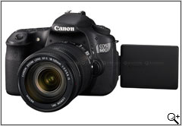 | DAILY RATE £50 + VAT
Description  Key specs:  18MP APS-C CMOS sensor  Advanced creative features  Vari-angle 7.7cm (3.0”) 3:2 ratio LCD  Full HD movies  DIGIC 4  ISO 100-6400, H:12800  Up to 5.3fps shooting for up to 58 JPEGs  Other:  Will need your own SD card. |  | Included  1 x 18-55mm  1 x battery  1 x charger

550D with 18-55mm (Canon)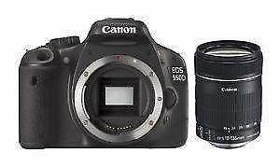 | DAILY RATE £40 + VAT
Description  18 MP APS-C CMOS sensor  DIGIC 4  ISO 100-6400, H:12800  Up to 3.7fps shooting  Full HD movies  7.7cm (3.0”) 3:2 Clear View LCE with 1,040k dots  Movie crop  Other:  Will need your own SD card. |  | Included  1 x 18-55mm  1 x battery  1 x charger

Infrared Night Vision Wildlife Camera  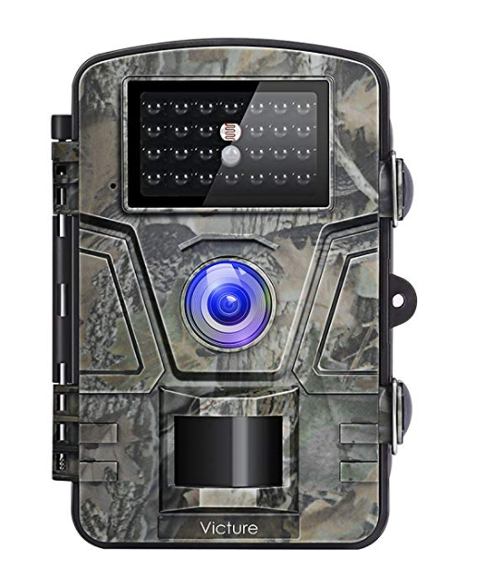 | DAILY RATE £50 + VAT
Description

0.5s trigger speed
1080p HD video
12mp images
capture at night

RED One kit  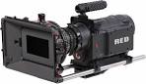 | DAILY RATE £820 + VAT
Description  Key specs:  4K capture.  Utilizing an S35mm image plane, the RED ONE displays a natural depth of field from 2K to 4.5K resolutions. Seize every moment with the ability to capture anywhere from 1-120 fps onto high-speed RED CF or SSD media. Interchangeable lens mounts.  Kit comes with full lens kit, matt box and tripod. |  | Included  1 x camera  5 x batteries  1 x chargers  1 x 640GB drive  2 x 16GB cf cards  1 x Matt box  2 x filters  1 x follow focus  1 x micro focus  5 x lenses (25mm, 35mm, 50mm, 85mm, 100mm)  1 x tripod head with plate and screws  1 x tripod legs

XA10 (Canon)  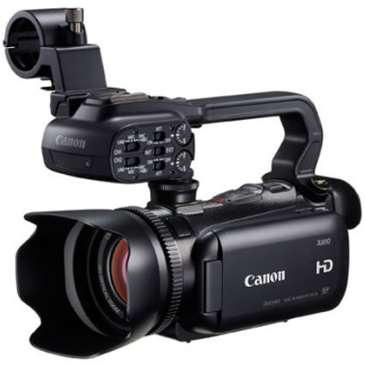 | DAILY RATE £75 + VAT
Description  - Canon HD Video Lens (10x zoom, 30.4mm, F1.8)  - Canon HD CMOS Pro sensor  - Professional audio  - AVCHD video to 64GB memory or 2x SDXC slots  - IR shooting mode  - Full manual control  - 8.8cm LCD; 0.6cm EVF  - Dynamic OIS, Powered IS, Instant AF  - Versatile and expandable  - Professional HD video in the palm of your hand  Other:  Will need your own SD card. |  | Included  1 x charger  1 x battery

XF100 (Canon)  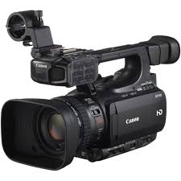 | DAILY RATE £100 + VAT
Description  - MPEG-2 recording to two CF cards at up to 50Mbps (4:2:2).  - Light, compact design; XLR inputs.  - 10x zoom Canon HD Video Lens.  - 1/3 type Full HD Canon CMOS.  - 3D Assist Functions; Infrared shooting mode.  - 8.8cm (3.5’’) 920k dot LCD; 0.6cm (0.24”), 260k dot EVF.  - Variable frame rates.  Other:  Will need your own SD card. |  | Included  1 x charger  1 x battery

Lenses

75-300mm (Canon)  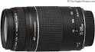 | DAILY RATE £20 + VAT
Description

Aperture range: f/4.0 - f/45

28mm (Canon)  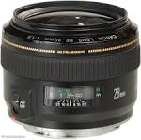 | DAILY RATE £30 + VAT
Description

Aperture range: f/1.8 - f/22

50mm (Canon)  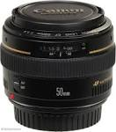 | DAILY RATE £30 + VAT
Description

Aperture range: f/1.4 - f/22

35mm (Canon)  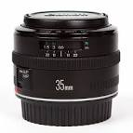 | DAILY RATE £30 + VAT
Description

f/2

85mm (Canon)  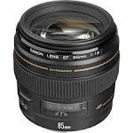 | DAILY RATE £30 + VAT
Description

Aperture range: f/1.8 - f/22

100mm (Canon)  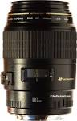 | DAILY RATE £40 + VAT
Description

Aperture range: f/2.8 - f/32

16-35mm (Canon)  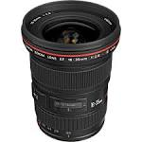 | DAILY RATE £50 + VAT
Description

Aperture range: f/2.8 - f/22

24-70mm (Canon)  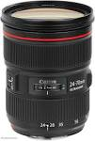 | DAILY RATE £50 + VAT
Description

f/2.8

70-200mm (Canon)  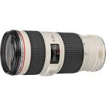 | DAILY RATE £60 + VAT
Description

Aperture range: f/2.8 - f/32

14mm (Samyang)  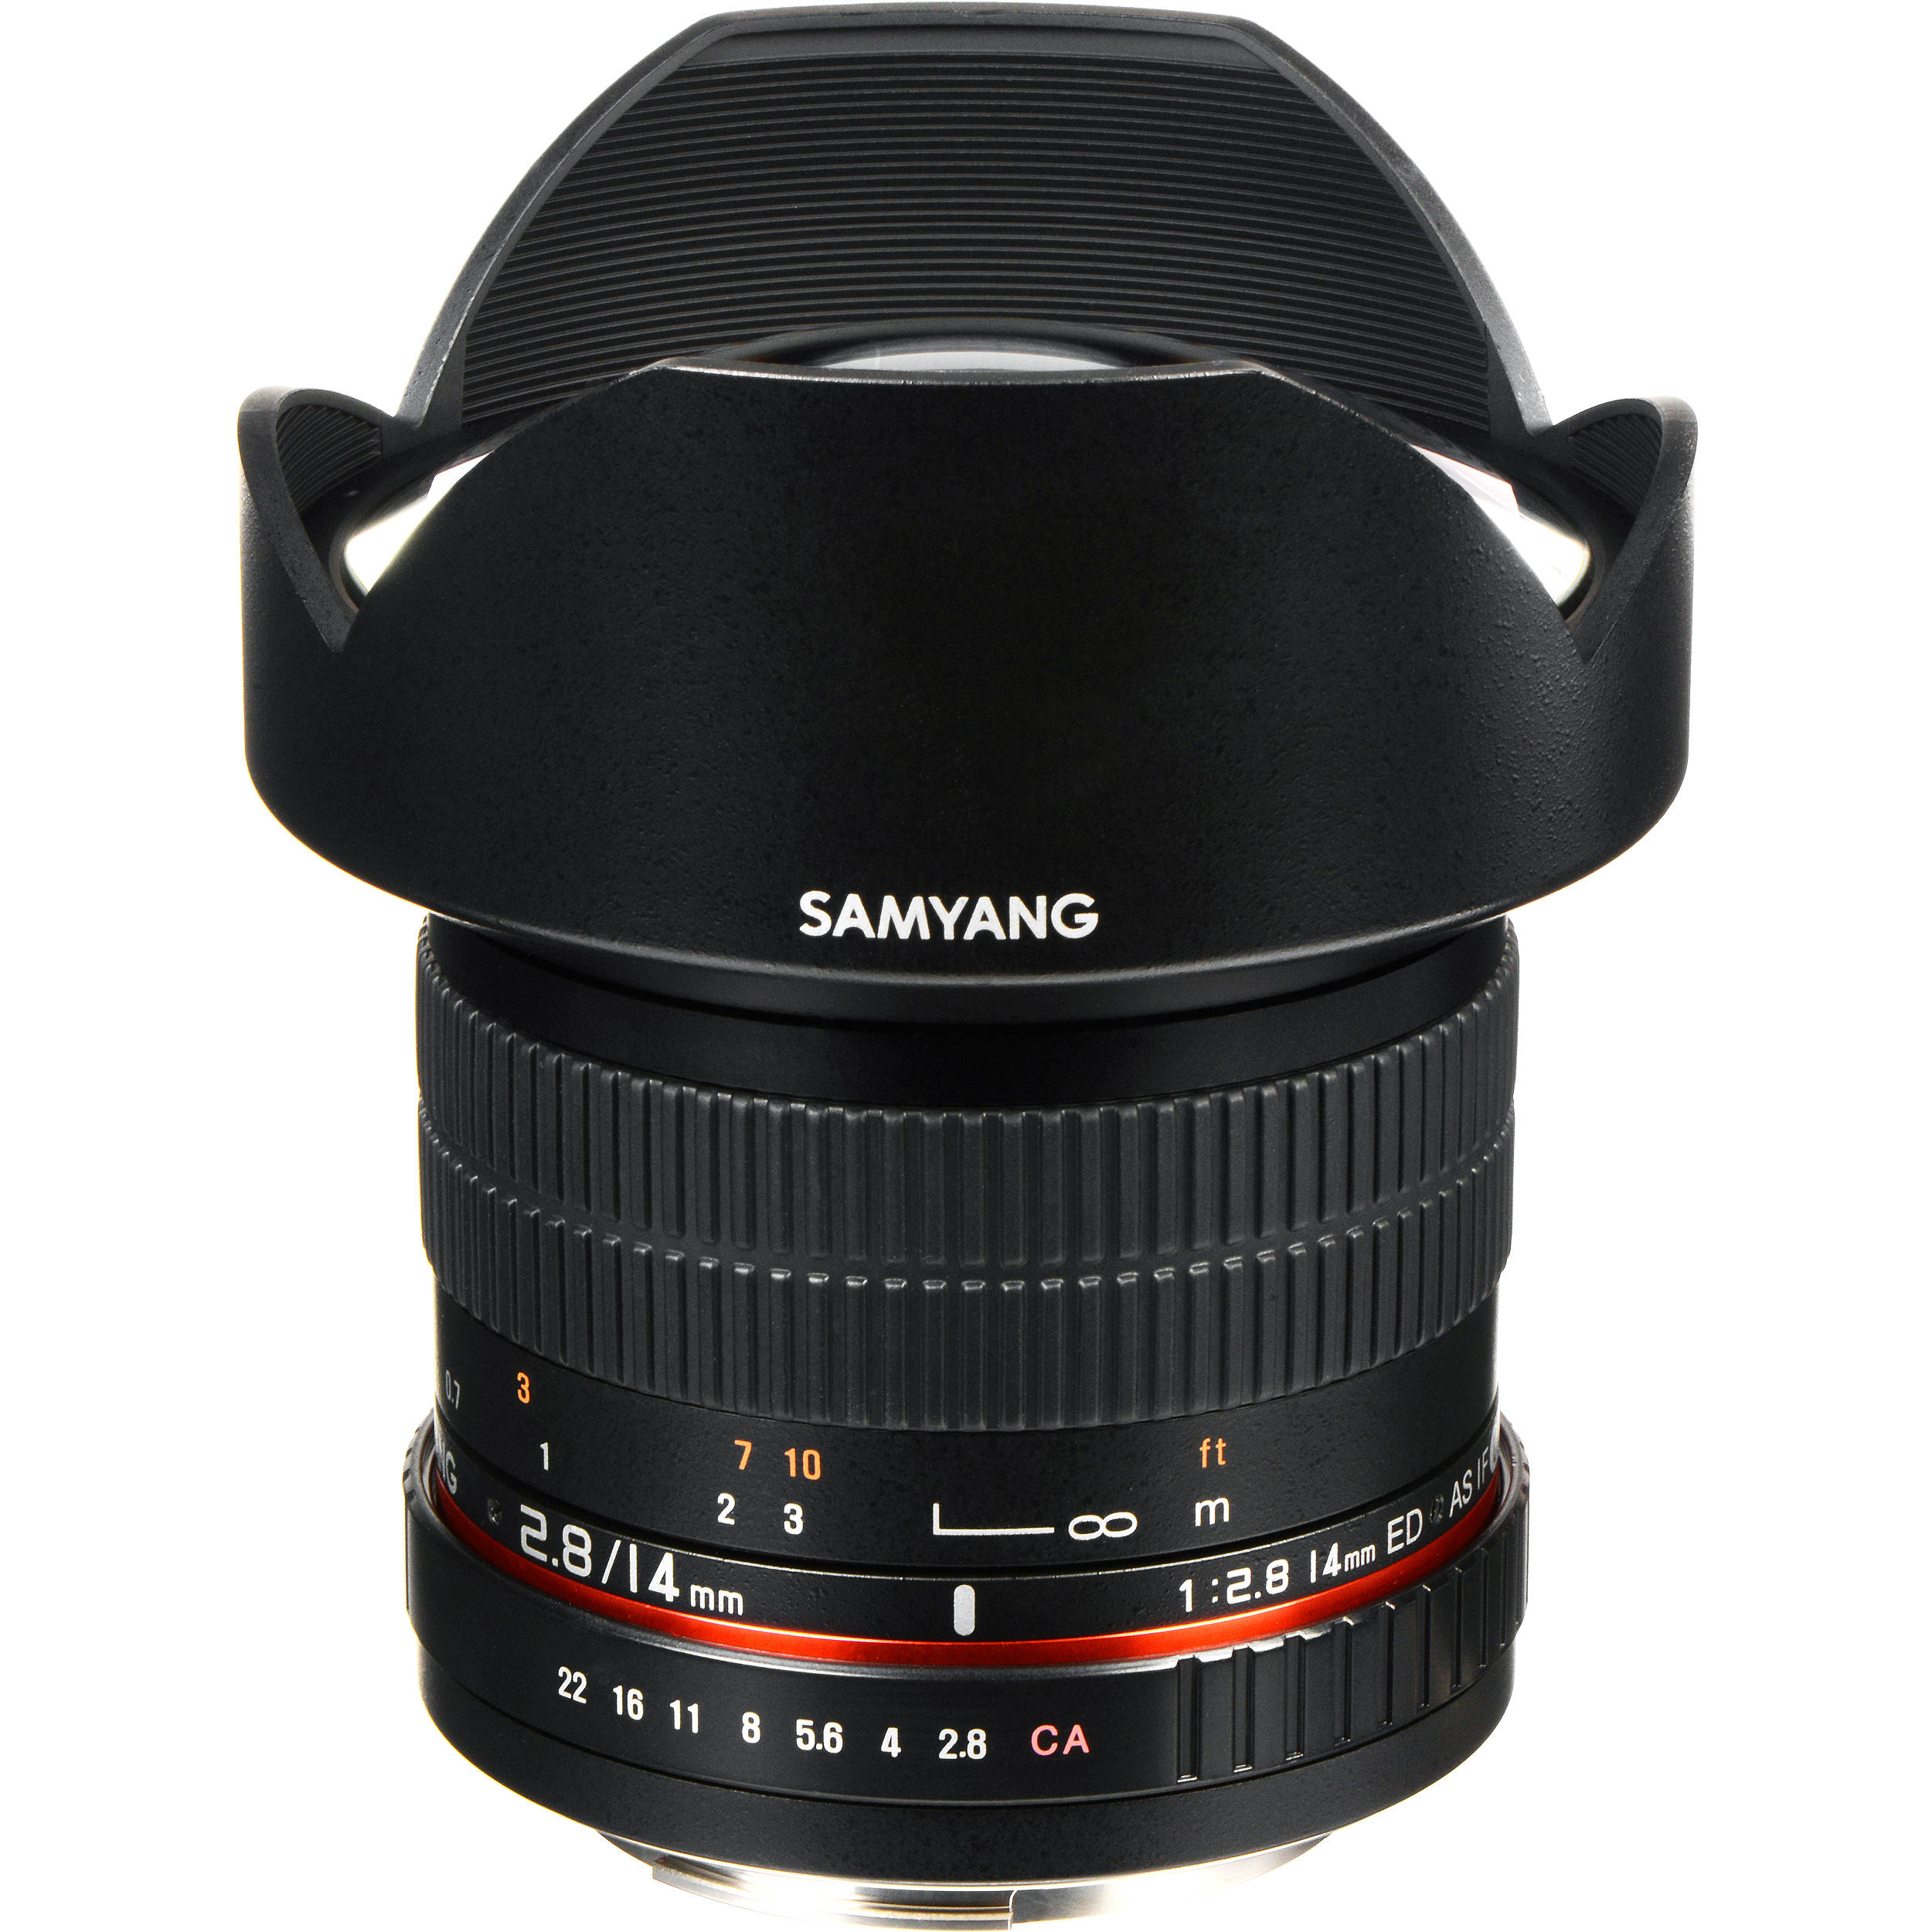 | DAILY RATE £50 + VAT
Description

Canon EF mount
T 3.1

8mm (Samyang) | DAILY RATE £50 + VAT
Description

Canon EF mount
T 3.8

Vintage lens kit  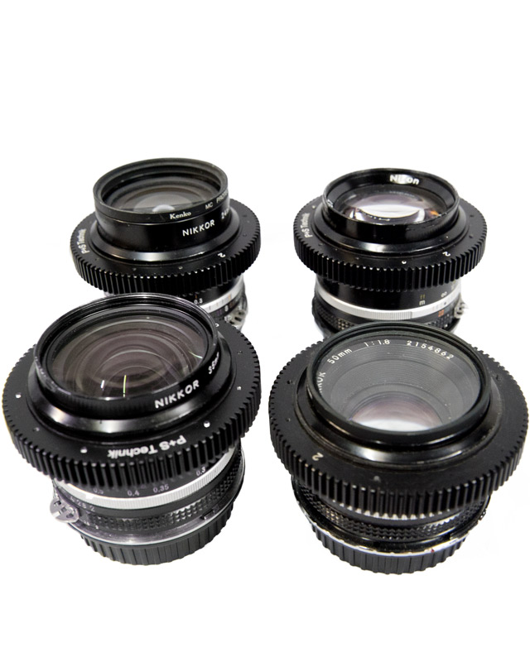 | DAILY RATE £60 + VAT
Description

Mir-1 (37mm)
Helios 44 (58mm)
Jupiter 9 (85mm)

With canon EF adapters

Miscellaneous

Metabones EF > A mount adapter  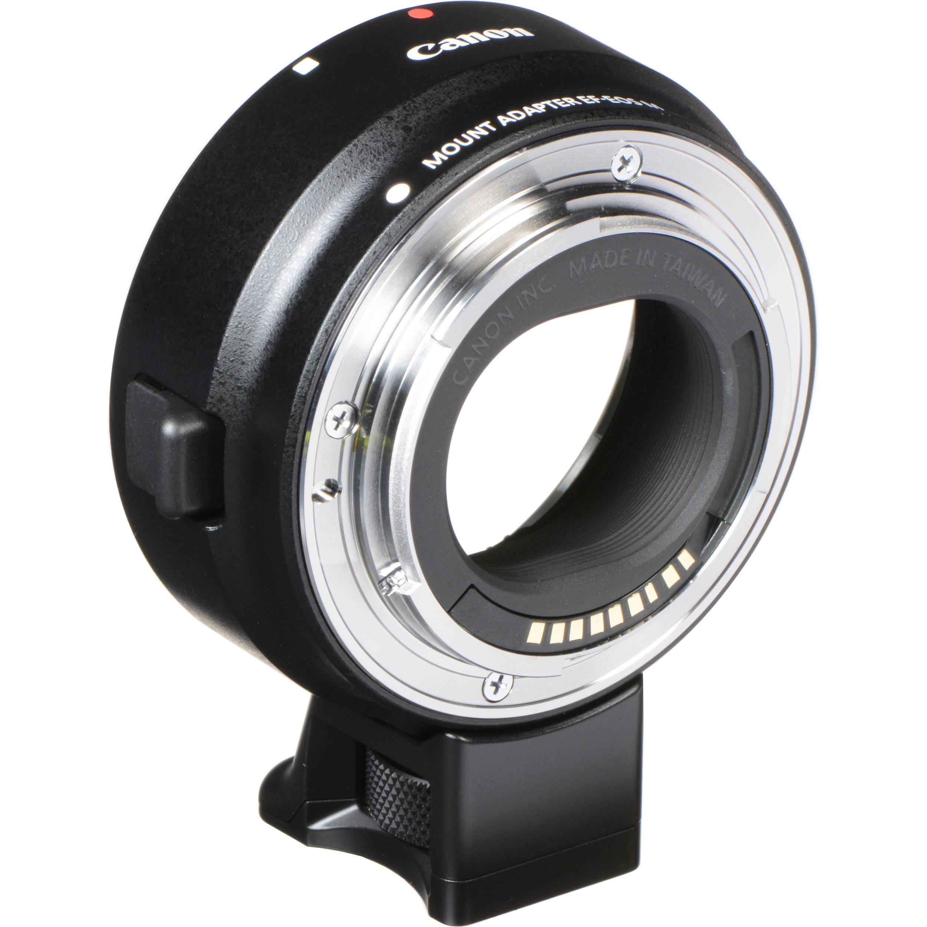 | DAILY RATE £25 + VAT
Description

To be used with FS700 so that canon lenses can be mounted.

Monitor  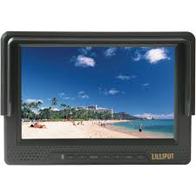 | DAILY RATE £40 + VAT

Clapper board  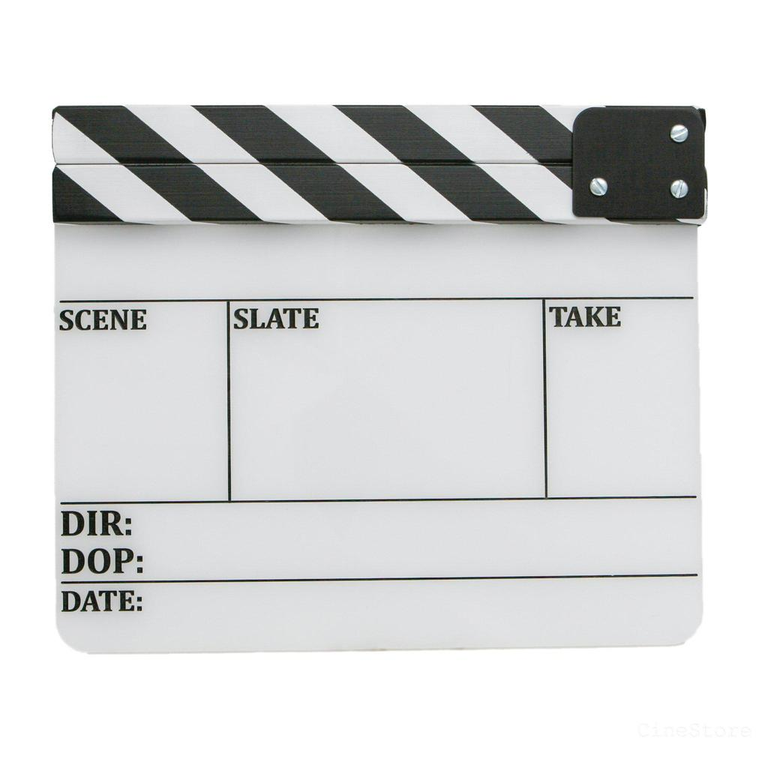 | DAILY RATE £5 + VAT
Description

Comes with white board pen.

Light meter  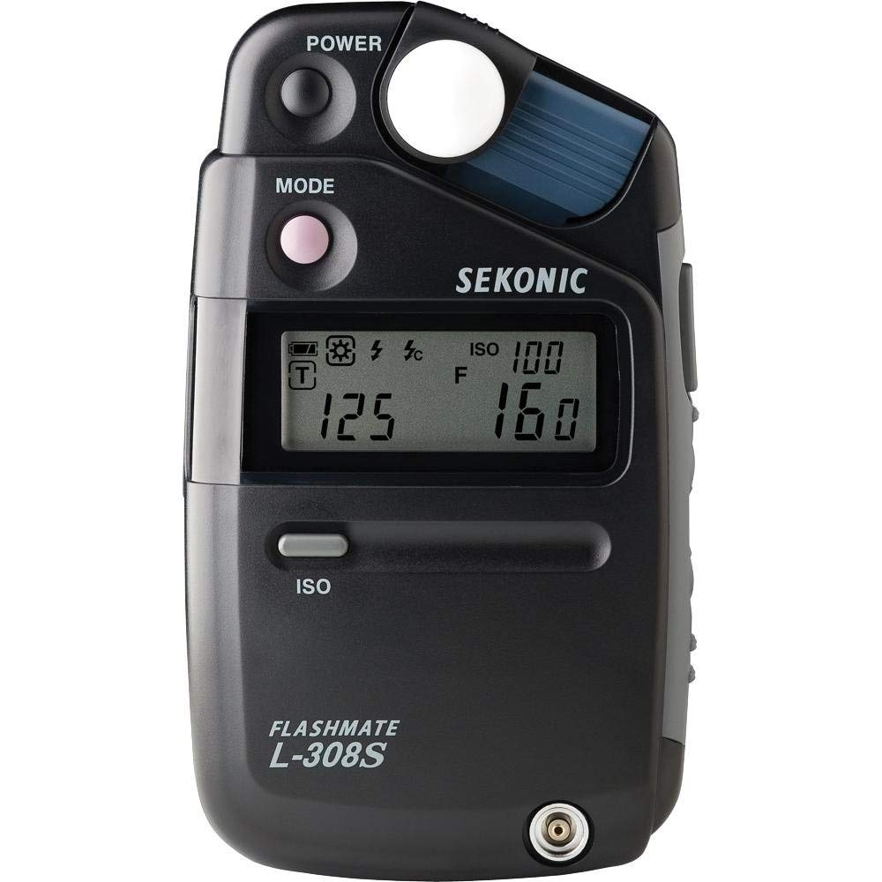 | DAILY RATE £7 + VAT

Projector  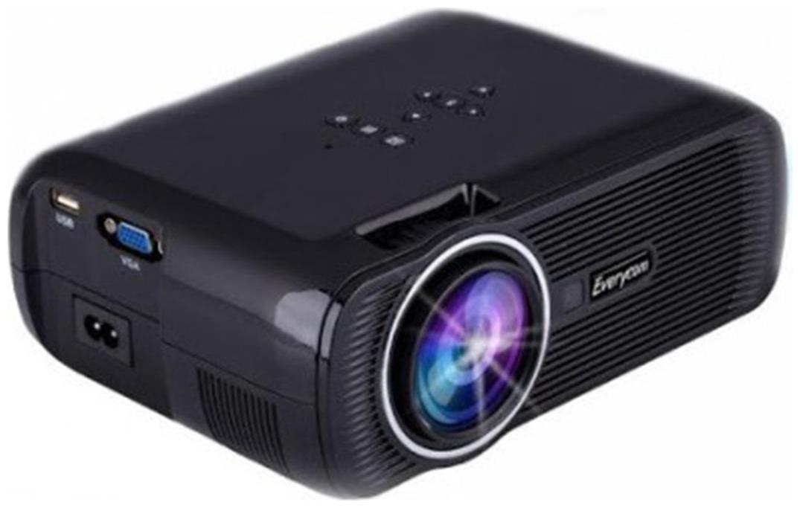 | DAILY RATE £25 + VAT
Description  AV input  HDMI input  VGA input  USB  Headphone/sound input jack |  | Included  1 x Mains cable  1 x composite cable  1 x remote  1 x hdmi cable

V lock charger and batteries  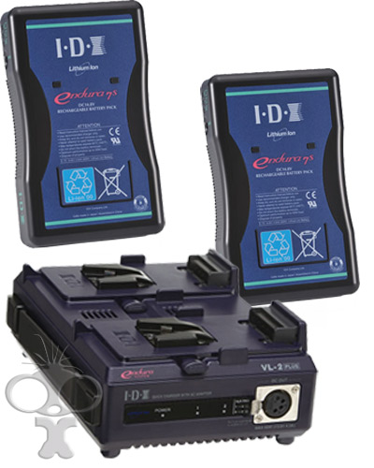 | DAILY RATE £30 + VAT
Description  Spare batteries for some lighting / camera kits |  | Included  1 x charger  1 x mains cable  2 x V Lock batteries

Gobo Lens attachment  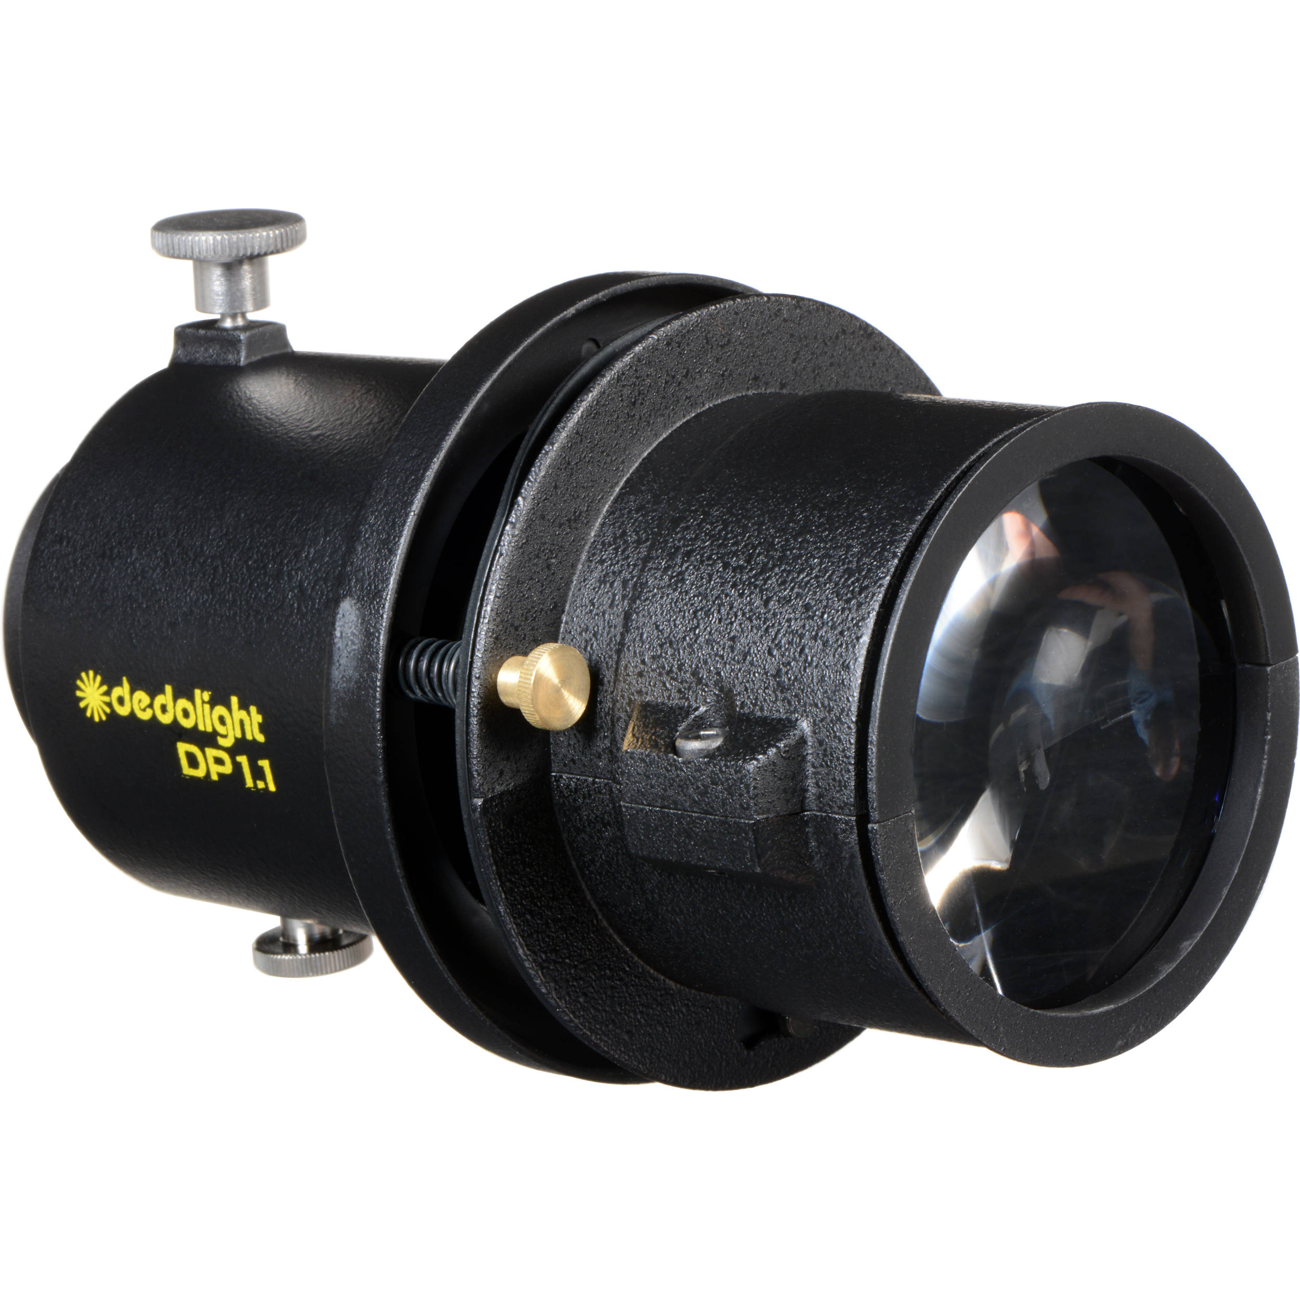 | DAILY RATE £5 + VAT
Description

To be used with Dedo lights.

Will need your own gobos.

Media Player  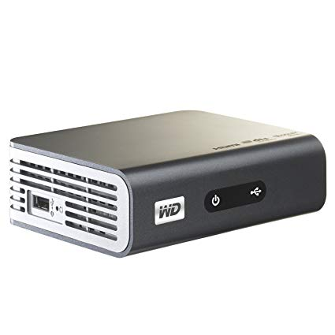 | DAILY RATE £10 + VAT
Description  HDMI  AV  Will need your own USB, and connector cables such as HDMI. |  | Included  1 X mains cable  1 x AV cable

High visibility vests   | DAILY RATE £2 + VAT

Audio

Rode NTG 3  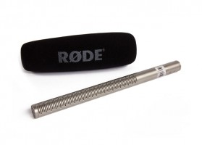 | DAILY RATE £15 + VAT
Description  Shotgun microphone.  XLR connection. |  | Included  1 x mic  1 x wind guard  1 x bag

H4N  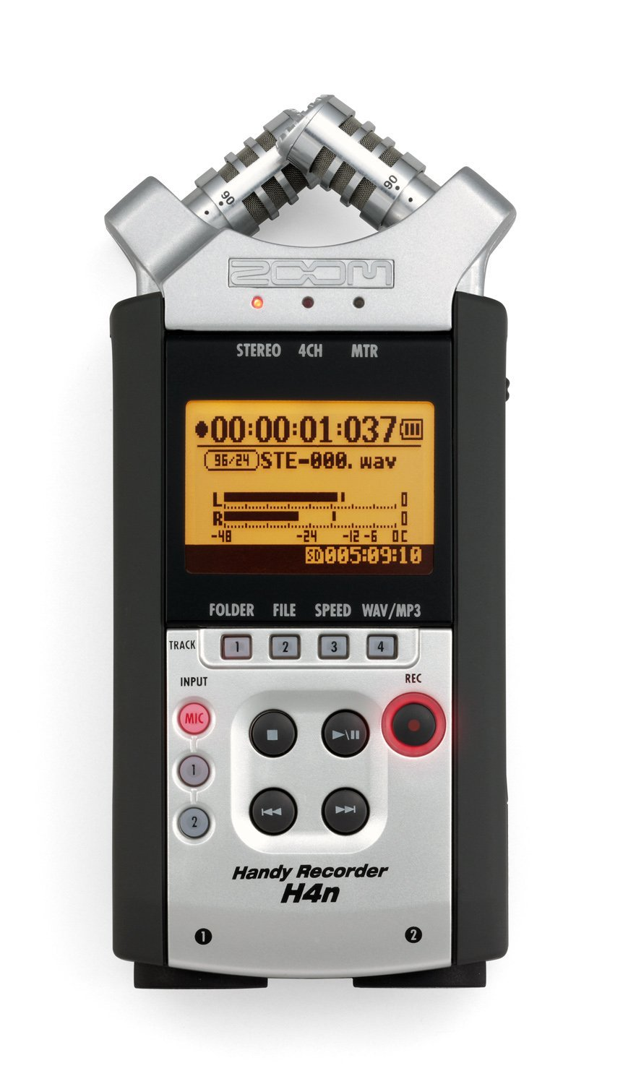 | DAILY RATE £15 + VAT
Description

The Zoom H4n is a 96 kHz/24-bit portable digital recorder that runs on two AA batteries. It comes complete with its own internal microphones, and XLR connections for external microphones.
Other:
Will need your own SD card, and AA batteries.

Rode video mic pro  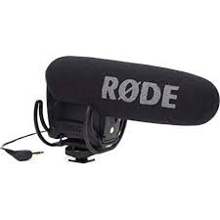 | DAILY RATE £15 + VAT
Description

- Broadcast recording quality condenser microphone
- All new capsule with lower noise and higher sensitivity
- Rycote lyre shock mounting onboard. Two step High Pass Filter (flat, 80Hz)
- This microphone is compatible with all microphones that have a TRRS plug and providing the voltage Plug-in-power (about 3V)
- Hot shoe mount

Smart lav (Rode)  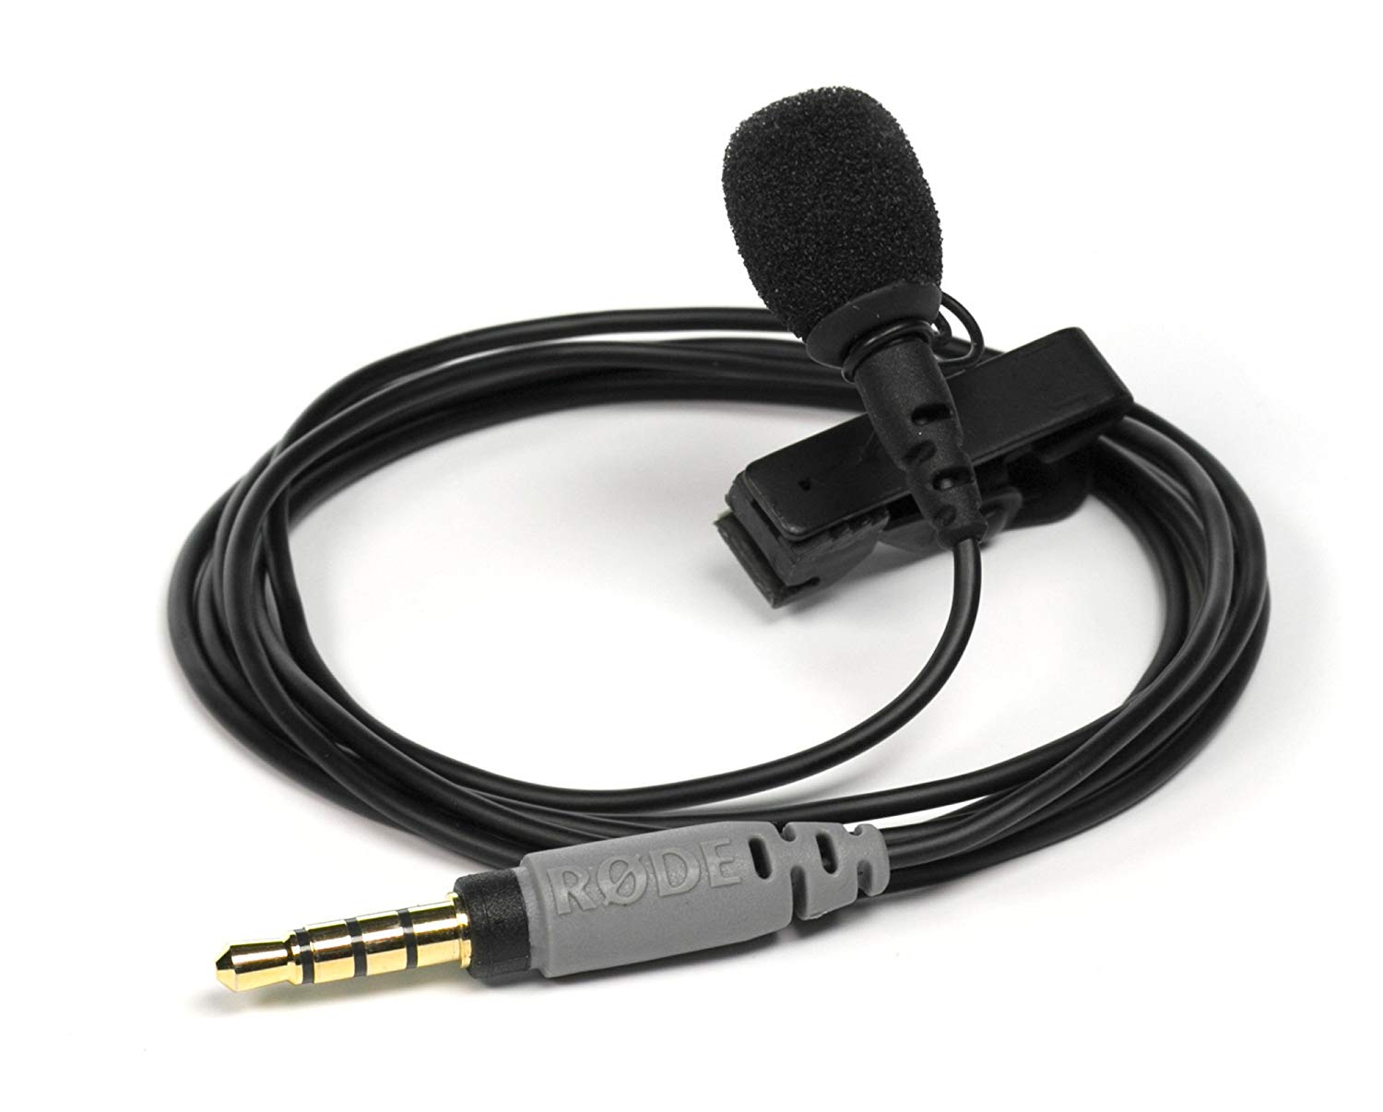 | DAILY RATE £10 + VAT
Description

With the smartlav+ the user simply mounts the microphone on the talent, connects it to a smartphone or tablet headset jack and records via the rode rec app for ios, or any other audio app of their choice. 6M extension cable available on request subject to use.

Shure SM58  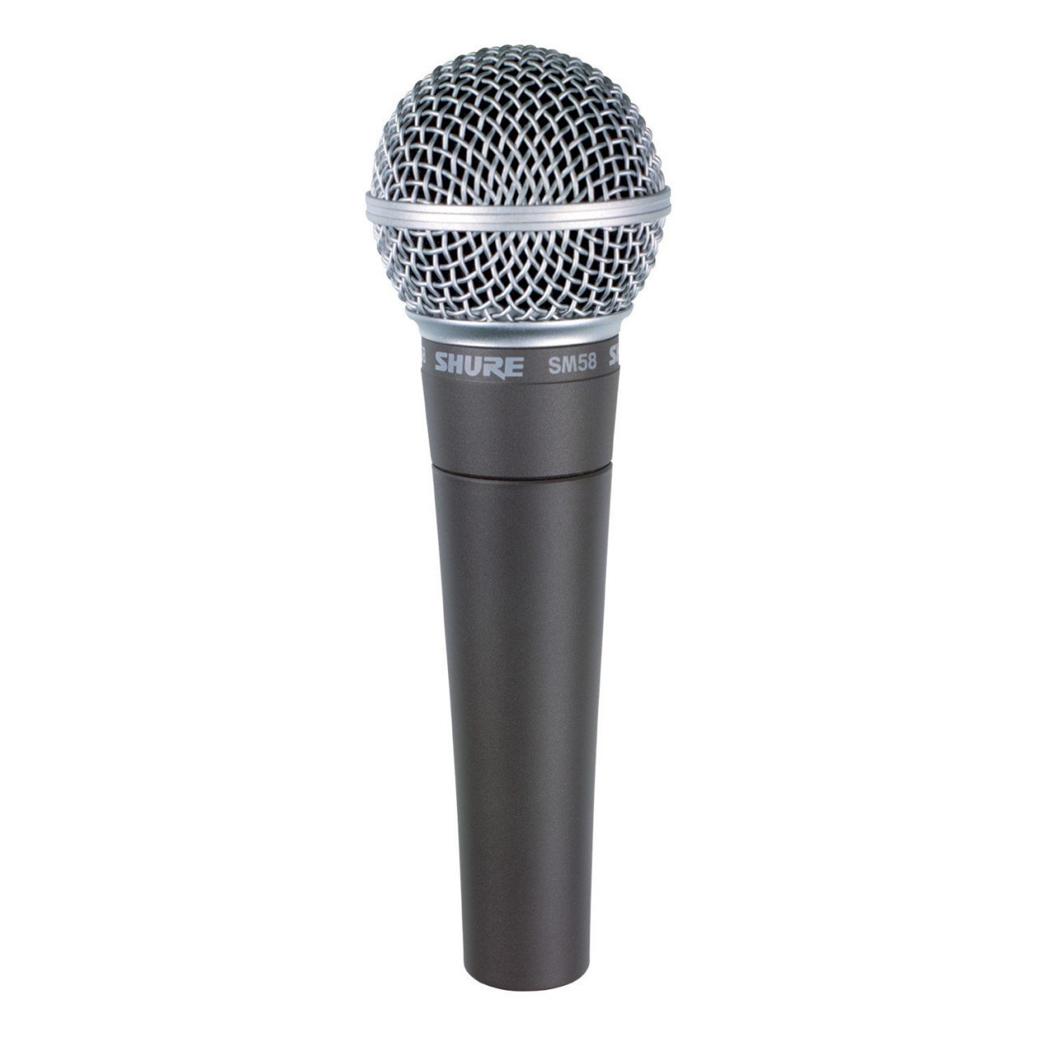 | DAILY RATE £15 + VAT
Description

The acoustic properties of the mic allow it to enhance the primary sound source whilst rejecting background noise - a valuable attribute in a live music setting.

Wireless Microphone Sennheiser G3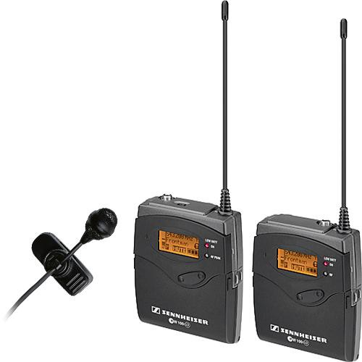 | DAILY RATE £25 + VAT
Description  This ENG set offers a great amount of flexibility for portable recording indoors or outdoors. Comes with omni-directional clip on mic and xlr cable.  Other:  Will need your own AA batteries. |  | Included  1 x omni-directional clip on microphone  1 x xlr cable

Mixer  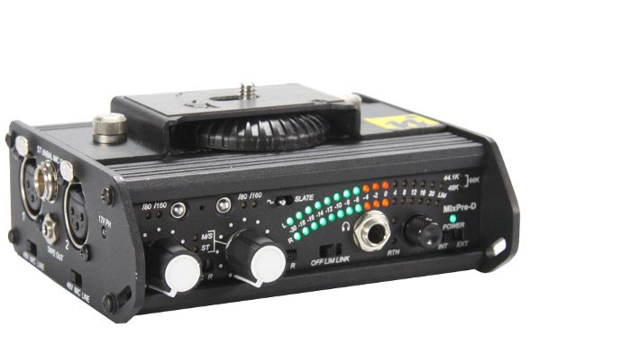 | DAILY RATE £25 + VAT
Description  Two Channel Compact Mixer (larger available)  Features two high quality mic preamps and excellent limiters and monitoring capabilities.  The MIXPRE-D can then be used as an audio interface to the camera which enables better quality audio recordings and the use of professional microphones with an XLR connector.  Other:  Will need your own AA batteries. |  | Included  1 x tape return cable

Boom pole  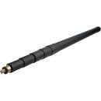 | DAILY RATE £5 + VAT

Large wind guard  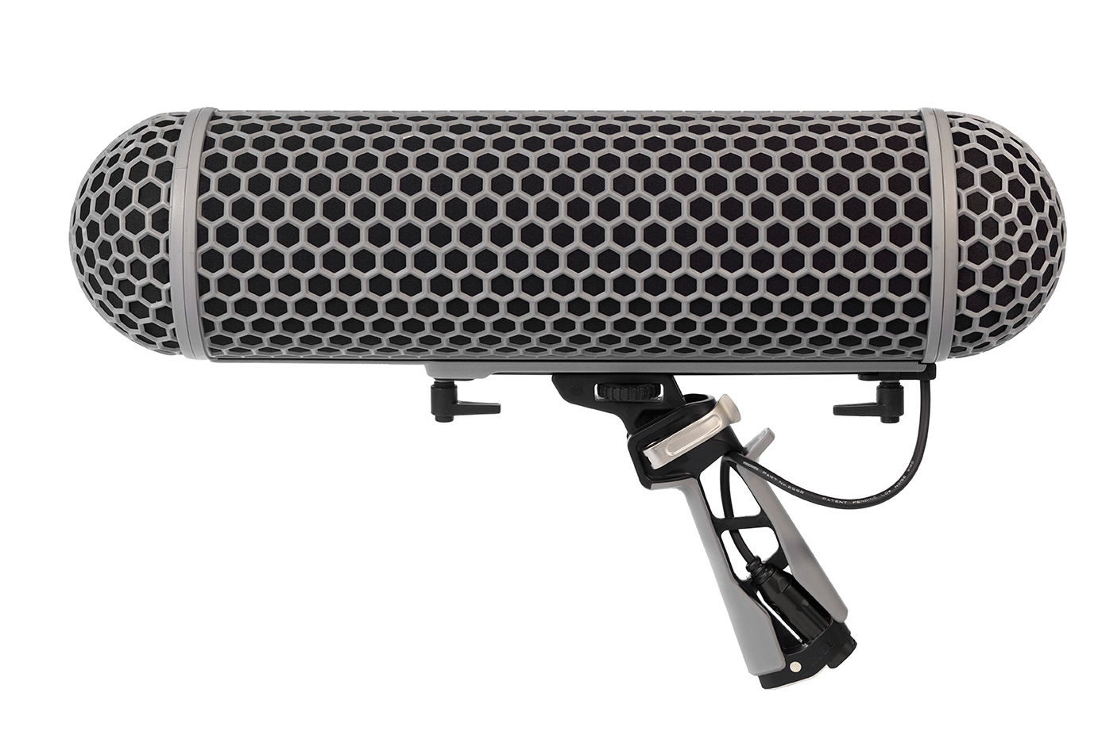 | DAILY RATE £25 + VAT

Microphone stand  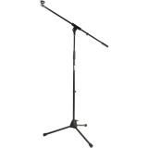 | DAILY RATE £5 + VAT

Headphones   | DAILY RATE £5 + VAT

Lighting

Dedo kit  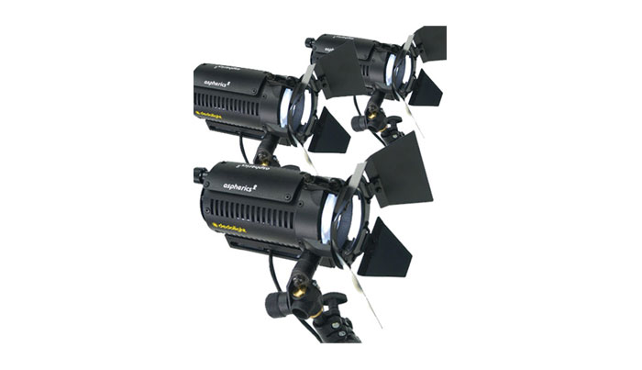 | DAILY RATE £50 + VAT
Description  Our Dedo kits go out as a 3 head kit with stands and inline dimmers. These are a great flexible lighting tool. Providing a soft light that can be focused, dimmed and fully controlled. Mains power. |  | Included  3 x dedo lights  3 x mains power cables and dimmer  3 x stands  3 x barn doors  3 x gel holders

Sola 4 LED kit  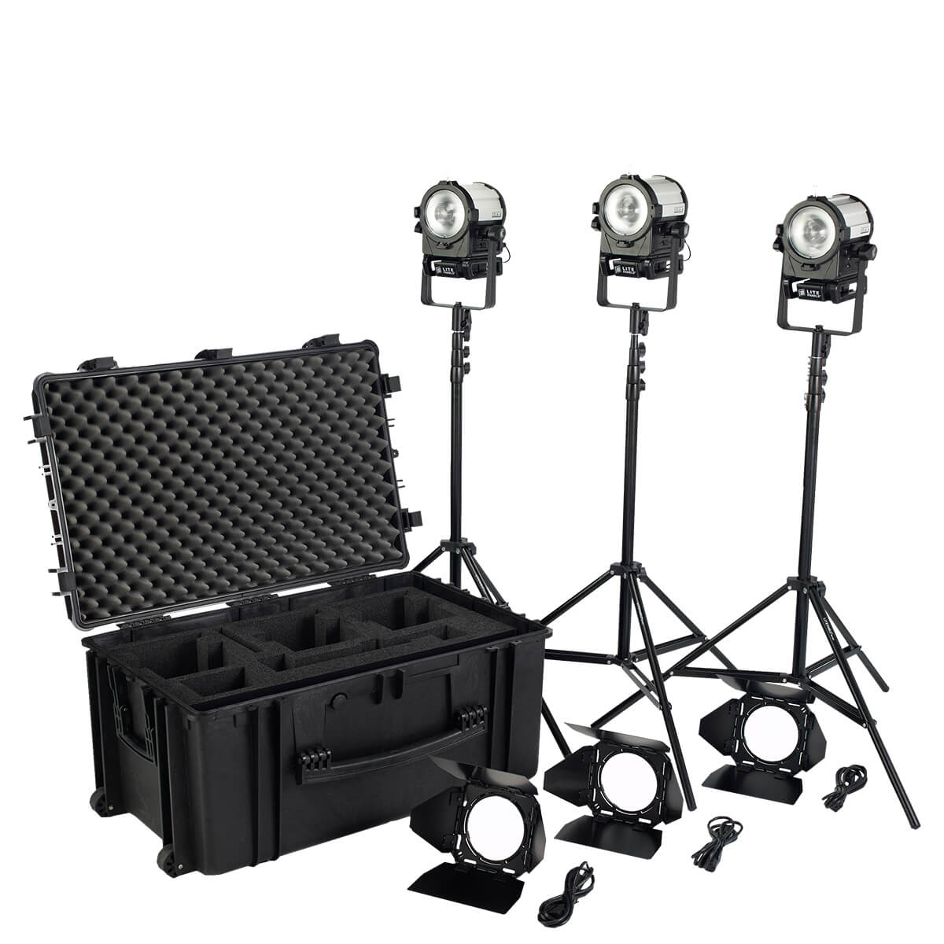 | DAILY RATE £55 + VAT
Description  Complete 3-light kit  A true Fresnel fixture that produces soft, directional illumination  Litepanels proprietary heat-free LED technology  Daylight colour balance  Mains power and battery power  100% to 0 dimming with no noticeable colour shift or flicker at any frame rate or shutter angle  Focus control  Standard yoke for easy mounting and positioning  39W power draw with output comparable to a 125W HMI |  | Included  3 x sola 4 lights  3 x stands  1 x charger  3 x batteries  3 x mains cables  3 x 4 pin cables  Velcro ties

Lighting panels  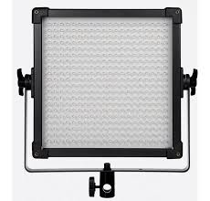 | DAILY RATE £55 + VAT
Description  - Color Temperature 5600K / Brightness: 3046lux @ 1m / Beam Angle: 50 °  - Intensity adjustable between 0 to 100% / CRI 93-97 / TLCI 95-99  - Mains power but can run off V lock batteries.  - Please request if need battery power capabilities. V lock batteries subject to availability. | Included  3 x diffuser panels  3 x stands  3 x mains cables

Kino flo kit  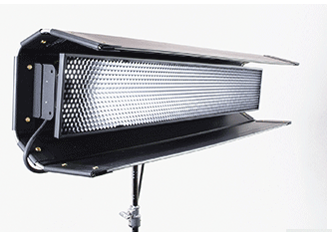 | DAILY RATE £50 + VAT
Description  Kino Flo produces a Soft Beam.  Built-in Barndoors  Twist-on Center Mount  True Match® daylight, tungsten lamps/bulbs  Mains powered |  | Included  2 x kino flo lights  2 x center mounts  2 x mains power and cables  selection of daylight and tungsten bulbs

LED  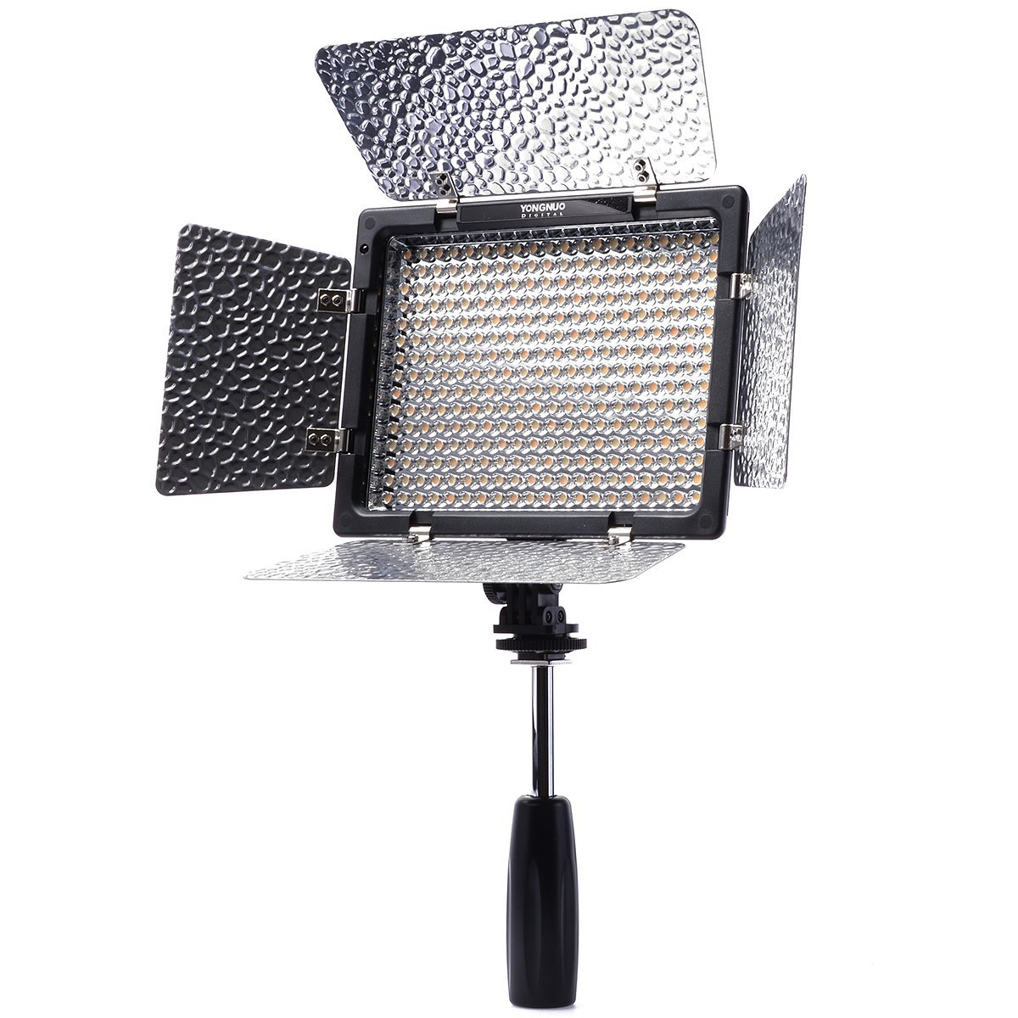 | DAILY RATE £15 + VAT
Description  Battery powered  Can be mounted to camera or stand  Dimmable |  | Included  1 x light

Reflector  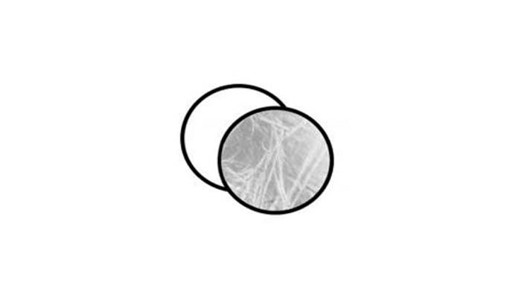 | DAILY RATE £5 + VAT
Description  A different surface on each side giving you more creative options.  In seconds the item closes down to a convenient size for portability and storage. |  | Included  1 x bag

Road rag kit   | DAILY RATE £15 + VAT
Description

Portable lighting modification system that allow the location photographer/videographer the ability to quickly and easily duplicate studio lighting effects on location using their portable lights.
Consists of two folding frames, single scrim, double scrim, artificial silk, and flag with convenient carrying bag
RoadRags are designed for use under a controlled environment. Wind and/or other weather conditions may cause damage to this product.

You may need a stand/boom arm/grip with this product.

Flag  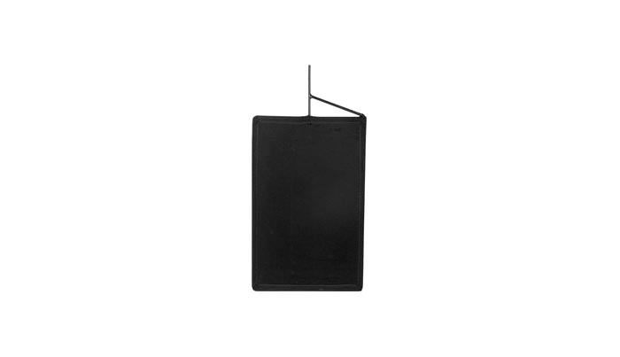 | DAILY RATE £5 + VAT
Description

Used to control natural or artificial light.
Can be used to protect the camera lens from flares, control spill light from other sources, or keep light from reaching an area on the set.

You may need a stand/boom arm/grip with this product.

C-stand with arm and grips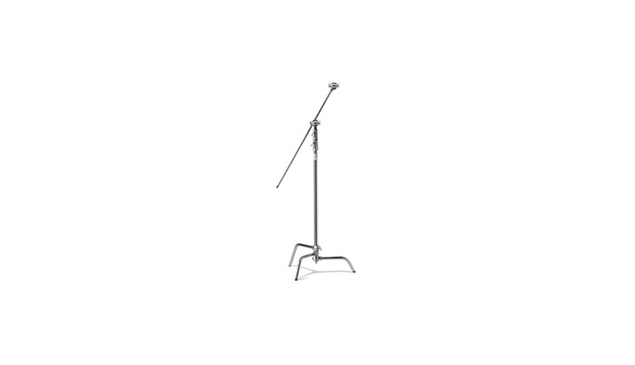 | DAILY RATE £10 + VAT
Description  Comes with arm and grip. |  | Included  1 x stand  1 x arm  2 x grips

Lighting stand  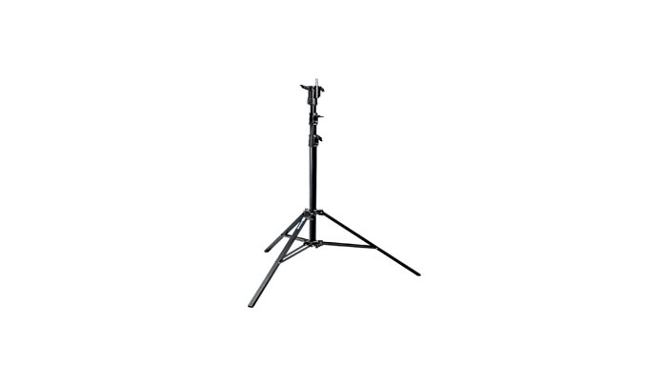 | DAILY RATE £5 + VAT

Sand bag   | DAILY RATE £2 + VAT
Description

Sandbags are used whenever you need extra weight to prevent tipping.

Redhead 800W with stand  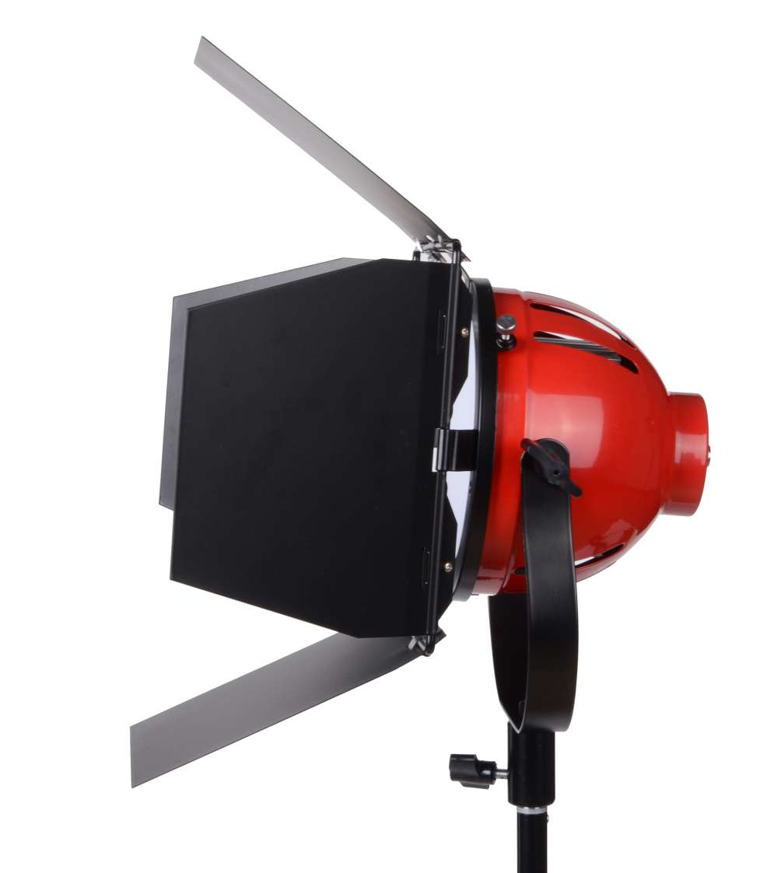 | DAILY RATE £40 + VAT

Blonde 2000W with stand  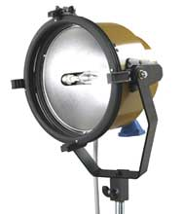 | DAILY RATE £50 + VAT

Support and Grip

Desk top tripod  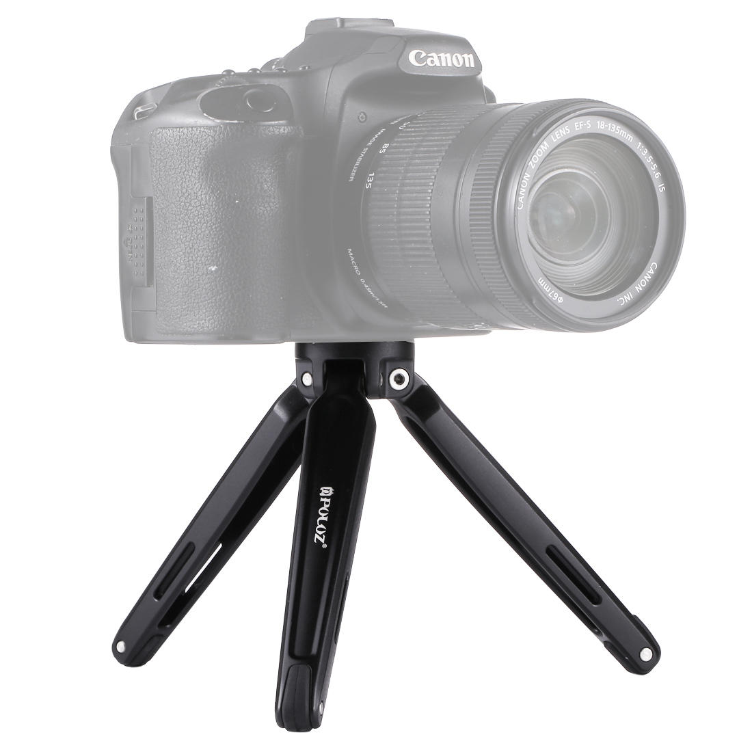 | DAILY RATE £5 + VAT
Description
Suitable for go pro, and light weight DSLRs.

Monopod  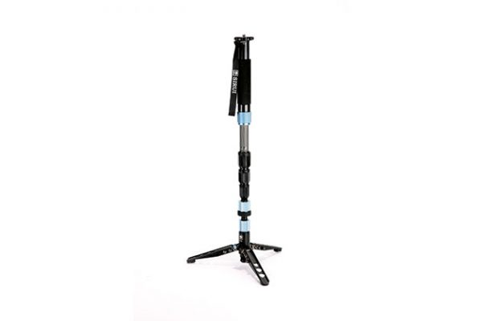 | DAILY RATE £5 + VAT
Description
Suitable for mobile phone gimbal, go pro, and light weight DSLRs.

Small tripod  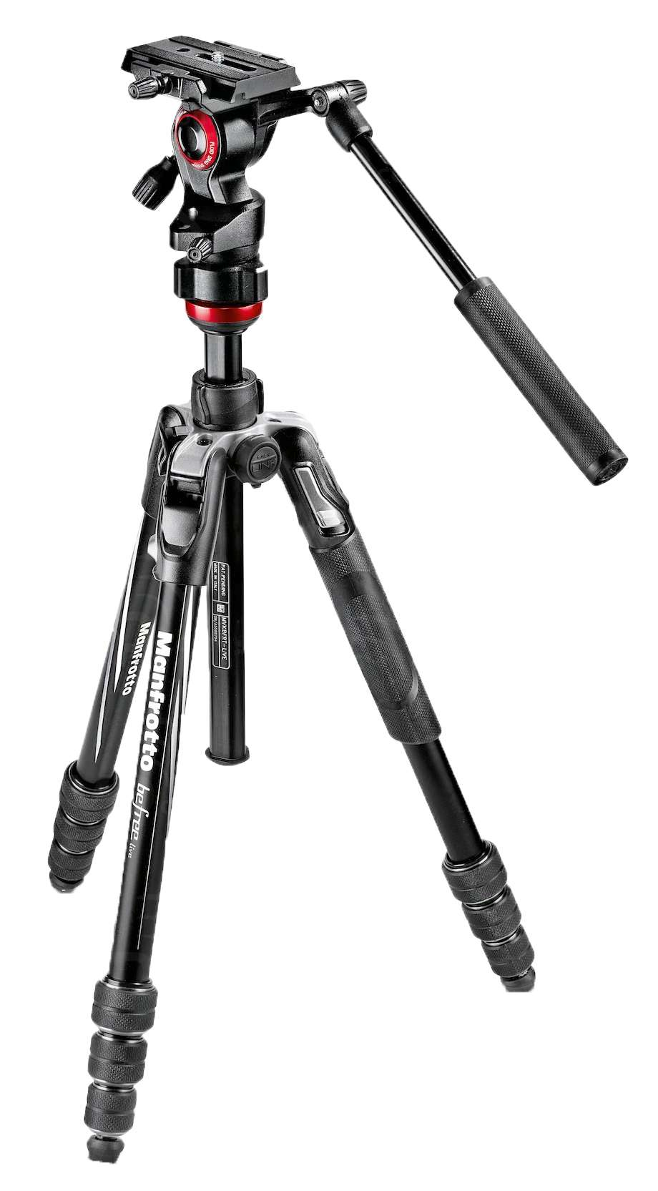 | DAILY RATE £10 + VAT
Description
Suitable for DSLRs. Fluid head dependent upon model availability.

Libec tripod  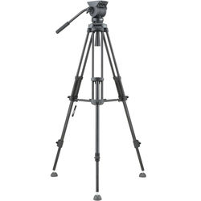 | DAILY RATE £20 + VAT
Description
Suitable for larger cameras such as C300. Fluid head.

Large tripod (Vinten)  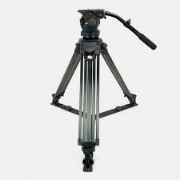 | DAILY RATE £40 + VAT
Description
Suitable for larger cameras. Fluid head.

Slider  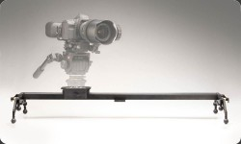 | DAILY RATE £100 + VAT
Description  Rail Length: 35" 89cm  Comes with tripod head  All terrain adjustable leg option  Comes with two stands  Possible to mount onto a tripod dependent upon weight of camera. |  | Included  1 x slider  1 x tripod head  4 x all terrain legs  2 x stands

Shoulder rig  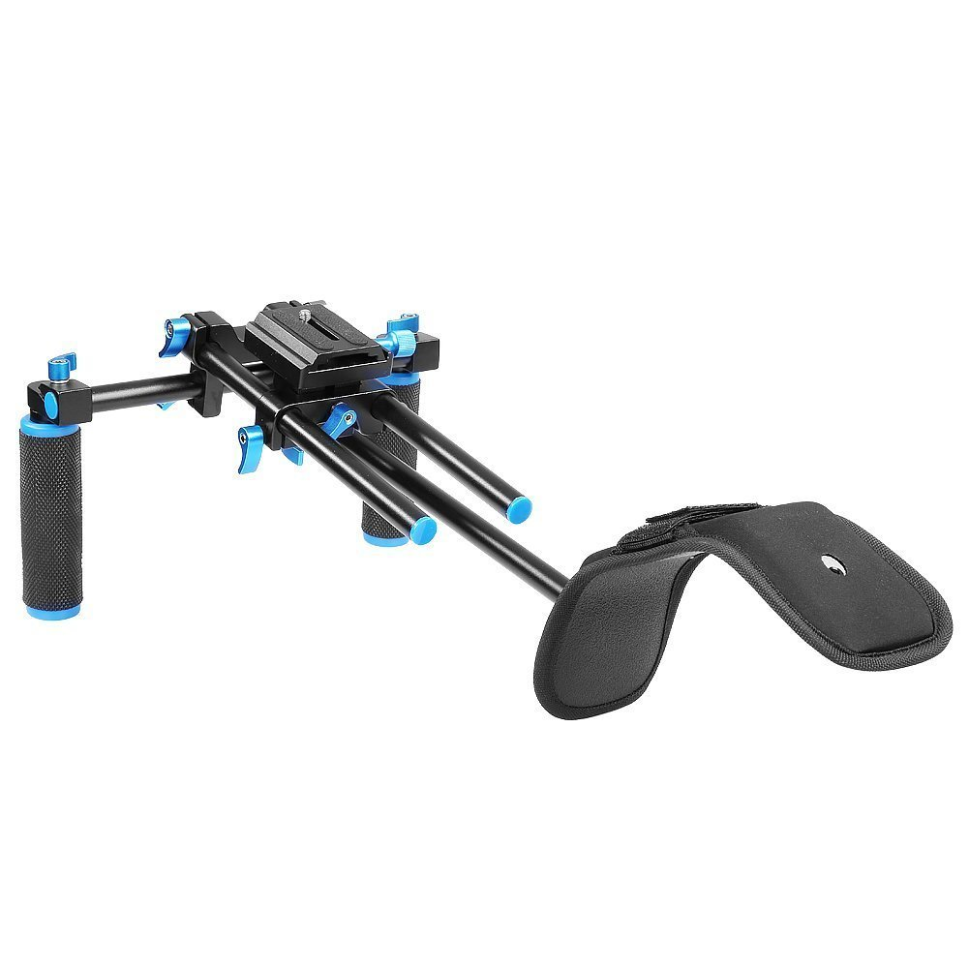 | DAILY RATE £15 + VAT
Description

- Portable film-making indoors and outdoors
Lightweight for mobile film-making.

Ronin S Gimbal (DJI)  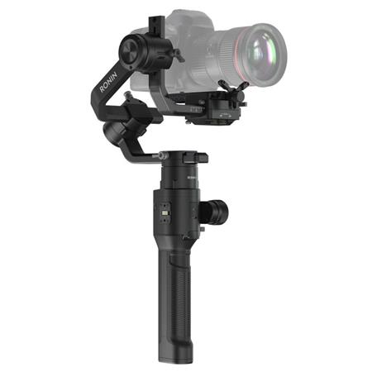 | DAILY RATE £80 + VAT
Description
Suitable for light weigh cameras such as DSLRs.
- Tested load capacity: 3.6 kg.
- 12-hour battery life.
- Three-axis stabilisation.
- Creative auto features.

Mobile phone gimbal  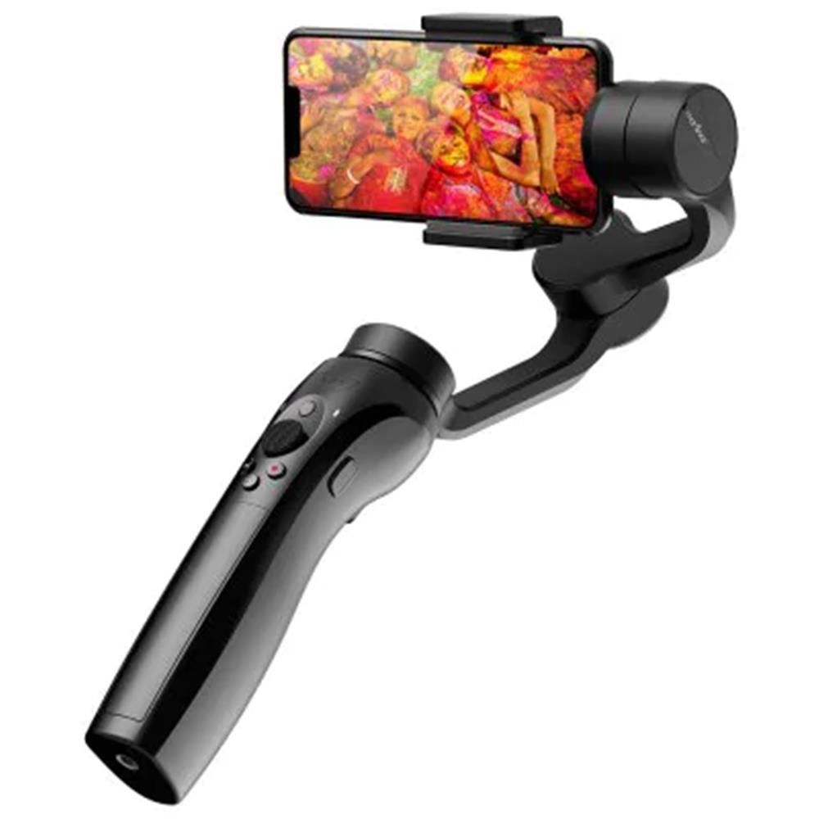 | DAILY RATE £20 + VAT
Description
Suitable for smaller phones such as iphone 4s.
Will need your own mobile phone.

Cinema bundle  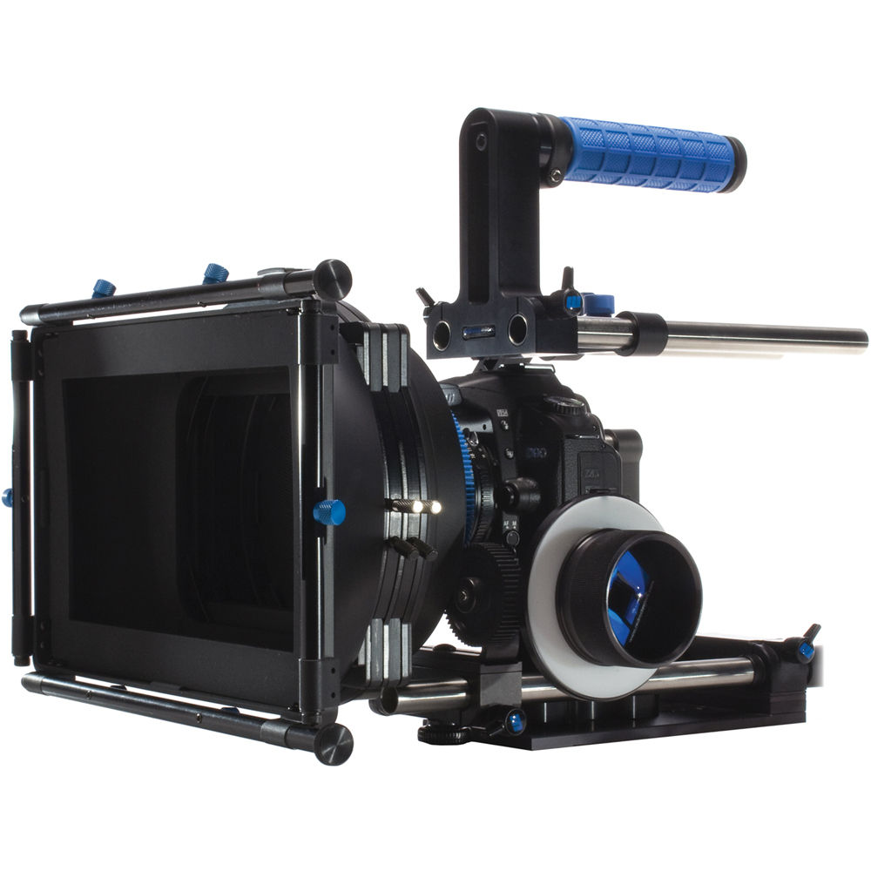 | DAILY RATE £30 + VAT
Description  Suitable for DSLRs. |  | Included  1 x matt box  various glass filters  1 x follow focus  1 x focus whip  2 x lens gears  1 x monitor

Track and Dolly  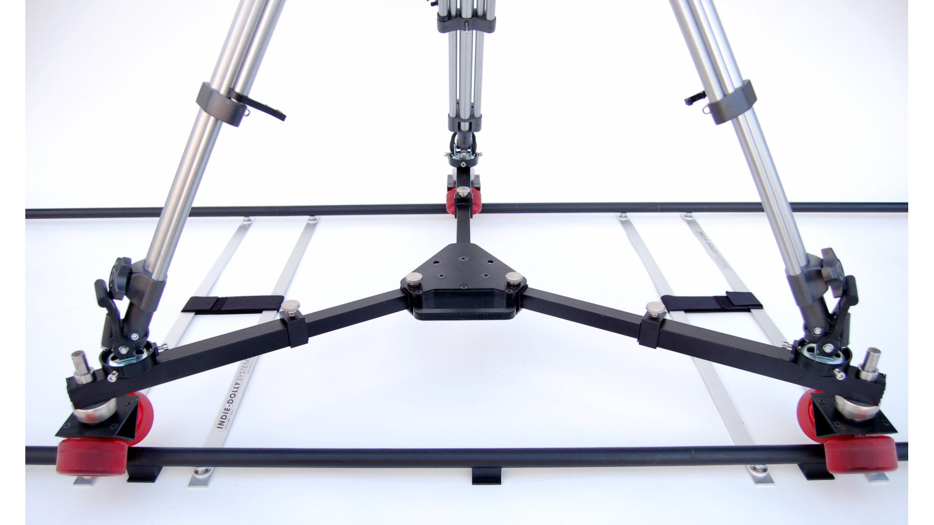 | DAILY RATE £130 + VAT
Description
Tripod mount dolly system. Will need a libec tripod.
3M straight track. Curved track available on request and subject to availability.

Steadicam kit  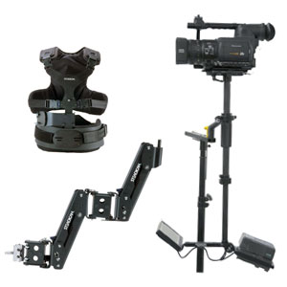 | DAILY RATE £120 + VAT
Description  The Flyer Steadicam camera stabilization system with its support for camcorders weighing from 4-15 lb (1.8 - 6.8 kg). |  | Included  1 x vest  1 x bag  1 x sled and screws  1 x stand  1 x arm  1 x docking bracket  1 x BNC adaptor  1 x charger  2 x batteries  1 x monitor

