

Usability Engineering
ACCB6017
Name: Carlos Peromo Corella
2316576

Lecture: Dr. Fahad Ahmed

User Requirements and Prototype
24/07/2026
BSc Applied Computing
Table of Contents

1. Introduction. 2
Game Understanding: 2
2. User Research. 3
Methodology 3
3. Personas. 6
4. Designing for Usability . 8
5. Experience Requirements by MoSCow criteria . 9
MoSCoW 10
6. Wireframe Storyboards. 12
App-frame screens 12
Mini Games frames screens 14
7. User Testing Feedback and Peer Review. 19
Appendix A – User Research Questionnaire: 21
Appendix B – User and Experience Requirements (MoSCoW) 22
References: 23

1. Introduction.

Game Understanding:
"Outbreak: Canary Wharf" is a single-player mobile game set on UWTSD London campus, inspired by the cooperative board game Pandemic. A virus is spreading through the campus, and the goal of the players is to contain the outbreak before it takes over.
The game is structured as six independent mini-games, each representing a different university role. The player starts at a hub menu and must complete each mini-game to unlock the next, working through all six in sequence. Only by completing every mini-game is the outbreak contained and the game won.
6 Roles:
1. Campus Security: Stand in the door and Objective is to stop the entrance to everyone not wearing mask, let in who are wearing ones. "sort the crowd" reaction game (tap people without masks, avoid the masked ones, speed rises).
2. Student: An obstacle-dodging runner (complete the course before the outbreak catches you). “Temple Run” game app idea.
3. Lecture: You must keep the students together in groups without letting them disperse and get contaminated. students keep drifting apart / wandering off, and the Lecturer must herd them back together and keep them grouped. The threat is dispersal; if they scatter too much, infection spreads between them. So it's a herding / corralling game: tap or drag to pull stray students back into the group before they wander too far.
4. IT Technician: Puzzle game , you solve a quick technical task/puzzle on a computer. Each success locks down a clean room before infected people can get in. There's pressure because infected personnel are approaching rooms, you're racing to lock rooms faster than they can reach them. Goal: keep as many rooms sealed and clean as possible. (Puzzle tasks will be like Sudoku, logic game, riddles, general culture questions…)
5. Facilities / Cleaning Staff: I need to clean as quickly as possible to try to contain the outbreak and prevent it from spreading. You are shooting and spreading sanitiser in order to contain the virus spreading.(bubble shooter version game)
6. Reception / Front Desk: Memory match game, In this role the player works at the campus front desk, where remembering who's who is part of keeping the building safe. The mini-game is a memory-matching (pairs) game: ten cards are laid out face down, made up of five different student faces, each appearing twice. The player taps a card to reveal a face, then tries to find its matching pair. If the two cards match, they stay revealed; if not, they flip back over and the player tries again, relying on memory to recall where each face was. The round is complete once all five pairs have been matched.

2. User Research.

Methodology
My research is based on Generative Research method, It basically covers and fulfils the requirements of the initial research phases for a new project, one that needs answers to begin taking meaningful shape based on user needs.
To address this initial uncertainty, qualitative interviews and background research are used to collect and analyse information about the app, its target audience and intended market.[1] (Yatsenko, 2026)

“Generative user research is qualitative research conducted with real users that helps with generating new solutions to user challenges and pain points”.[2] (Sara Fortier )
To this end, I will pose a series of questions to a diverse group of people, varying in habits, ages, lifestyles, customs, and generations, and, above all in their behavioural patterns and ways of interacting with technology. This will provide a significant advantage in gathering valuable information about the future product I intend to create, even before the design phase begins.
Participants were selected to represent a range of user types rather than a single profile, reflecting the fact that potential players differ in age, technical confidence and daily context. The group included a daily commuter who plays in short bursts while travelling, an older user with lower confidence using new apps, and a frequent mobile gamer, alongside, people not interest at all on games and technologies in general. This spread allowed me to gather needs from genuinely different perspectives, which later informed the differentiated personas presented in the following section.
A core principle of user-centred design is that design must rest on an explicit understanding of users before solutions are formed. This grounds the personas in real data rather than assumption [3] (Pruitt & Adlin, 2010). It establishes that personas should be grounded in real data gathered through interviews and surveys.
A semi-structured approach was chosen as it balances a consistent core of questions with the flexibility to probe interesting responses.[4] (Galletta, 2013).
By adopting a semi-structured interview approach, we ensure that the topic and the information sought are defined, while still allowing the user a degree of flexibility to respond in their own words, within certain limits to keep the resulting information focused and allows room for open discussion.[5] (Ryan Inglethorpe)
To conduct the interviews, I created the form using Google Forms.
Form link: https://forms.gle/VuPj2KHZ27drAqkE8

Responds and Real findings:
1. Age group:
50% aged 25–34,
50% aged 35–49.
2. Are you…
100% not students.
3. How often / where do you play:
"I stopped playing games over 2 years already"
"every day, at night"
"I don't play on mobile, but on public transport or planes."
“Usually when I am travelling to go to work”
“Every day, commuting”
4. Typical play session:
50% play 30–60 minutes.
25% play less than 15 mines.
25% play less than 30 min
5. Kinds of games enjoyed:
"Army games"
"strategy and resources management"
"RPG"
"Brain games, logic puzzles, deduction puzzles, as sudoku, murdoku, or geometrical problems as hexa sort"
“Chess”
6. What makes you stop/delete a game:
"When it became addictive"
"brain-dead games, ads everywhere, P2W"
"Because of the format"
"The continuous ads that interrupt your focus in the middle of the playgame, or if they are too easy or too difficult to solve"
“As soon as it start feeling repetitive and boring”
“Adds”
7. Games hard to use (small text, tiny buttons, fast timers, flashing, sound):
"Yes most of the times"
"no"
"Yes, I'm used to playing with a controller"
“Not really”
“Yes, of course”
8. App confidence:
57,1% fairly confident
28,6% Very confident
14,3% Not too confident
9. About the Game Idea, On first hearing the concept, what appeals / puts you off:
"First hearing it's sounds exciting and I feel the pressure to complete all of them at the same time"
"I like the cooperative side of it but that could also turn into a problem depending on the design. I love the virus outbreak setting and the quick mini-game approach so I can enjoy a little everyday"
"Sound very interesting, specially about mixing different kind games"
"The most attractive thing for me is the cooperative idea, but honestly I've never felt atracted to a virus theme, even we have lived this situation with the COVID, and for me it's a theme overdone or done to death. But maybe because I am not the kind of person who is interested in comics or this kind of things."
“Love it, but it needs to have a nice story”
“Interesting, cooperative games are always cool”
“It seems interesting.”
10. Curious to find out more?
71,4% Yes
28,6% No
11. If you could add one thing to make this game enjoyable for you, what would it be?
"Make it fun even if it is an IT specialised game"
"A Guild system where you can join and chat a group of people to coordinate games and maybe compete with other guilds"
"other platforms or from a computer "
“Relaxing mini games”
“I would make the game look cartoonish”
“The thing that would make it interesting for me would be to turning it into some kind of escape room, with kind of a mistery, a line argument that makes you want to discover more of the story of what is happening, with kind of logic deduction and some good surprises on the way. Or maybe make it as the cooking games which you have to be fast preparing all the lunches where efficiency is the queen.”

3. Personas.
This is the origin of the persona method. Cooper introduced personas as "fictitious, specific, concrete representations of target users" [6] (Cooper, 2007) built from real user research, and defined three goal (experience goals, end goals, and life goals).The questions were designed to capture the context of use and these user goals.

#1 Paul. 29 years old: “Not mobile games fa”
Identified from a response pattern: “I play with a controller”, “I don’t play on mobiles…” “Public transport, planes — but not on phone..”
Scenario: He is a console and PC gamer, not a casual mobile player; it seems he likes to play at his own pace, without the pressure of a time limit or the risk of being interrupted.
User requirements:
Feel engaged and connected with the story game.
An interface tailored to the game that ensures a comfortable experience, minimizing the feel of a mobile game as much as possible.
No adds interruptions.
#2 Athenea. 31 years old: “The commuter”
Scenario: On a packed morning train, Marcus plays one-handed with patchy signal. He might get pulled out mid-game when his stop comes. He needs the game to pause and resume cleanly, and to be playable in a couple of minutes.
User requirements:
Auto-save / resume exactly where he left off, maybe interrupting the game few times due of calls or route focus need
Mini-games completable in short bursts
Works offline / tolerant of dropped signal
One-handed playability
Design implication: justifies a clear pause/resume state and progress being saved on the role-menu. No lost progression.
#3 Linda: 56 years old: "The Returning Learner / Low Tech-Confidence"
A secondary school teacher, inspired by her students, does not want to lose touch with the modern world; she is drawn to connecting with technology and video games. Linda tries out the game after her students recommend it to her. She is cautious: she worries about "pressing the wrong thing." She needs clear buttons, simple language, and a way to undo mistakes without penalty.
After many years of study and eye strain, he wears glasses and sometimes struggles to focus and distinguish colour contrasts (especially with text, and above all in fast-paced games).
User requirements:
After many years of study and eye strain, he wears glasses and sometimes struggles to focus and distinguish colour contrasts—especially with text, and above all in fast-paced games.
Large, clearly-labelled buttons and readable text.
Plain, jargon-free instructions
Obvious "back" / "help" always visible.
Feels safe to explore without fear of breaking something.
Confident and capable, not overwhelmed.
#4 David: 28 years old: “One-Handed / Limited Dexterity”
Scenario: David enjoys strategy games but abandons any that demand rapid two-thumb input or tiny, precise taps under time pressure. He wants a fast mini-games (like Security) to be achievable without pixel-perfect speed.
Student with a motor impairment affecting one hand; plays entirely one-handed, sometimes using assistive touch settings. Sharp and experienced with games, but fast/precise tapping is a barrier.
User requirements (literature-backed accessibility):
Large touch targets, generous spacing (WCAG 2.1 / mobile accessibility guidance, target size)
No essential action requiring two hands simultaneously
Adjustable timers / difficulty so speed isn't a hard barrier
Reachable controls in the lower/thumb zone of the screen
Experience requirements:
Included, not excluded by his impairment
Same sense of achievement as any other player
Design implication: the single strongest influence on your actual button sizing and layout in the wireframes; every mini-game screen should show large, well-spaced, thumb-reachable controls.

4. Designing for Usability .
Because the game targets a deliberately diverse set of players (personas, Section 3), the interface must accommodate differences in age, technical confidence, dexterity and context of use. This section identifies the main usability challenges these differences create and explains, with reference to established literature, how the design responds to each.
Framework used. Design decisions were guided by Nielsen's ten usability heuristics, a widely used set of general principles for interaction design first developed with Molich in 1990 and refined in 1994. These heuristics remain a standard framework for identifying where users are likely to become lost, frustrated or surprised [7] (Nielsen, 1994). Accessibility decisions were additionally informed by the Web Content Accessibility Guidelines [8](WCAG 2.1). which set out criteria for making digital content usable by people with a range of disabilities.
Challenge 1: Knowing where you are in the game. Based on user research feedback, a key requirement is for users to know their current position within the game structure at all times, thereby avoiding any sense of being lost or uncertain. With six mini-games unlocked in sequence, players must see in the Menu screen what is completed , active and locked. “Nielsen visibility of system status” [7] (Nielsen 1994).
Challenge 2: Fast mini-games excluding less dexterous players. Speed based mini games would exclude a one-handed player . WCAG 2.1 recommends a minimum 44×44px touch target for users with limited dexterity [8] (WCAG 2.1). So all controls use large, spaced targets elements, which also helps the commuter users, playing on the move.
Challenge 3: Low-confidence users fearing mistakes. Applying Nielsen’s principles regarding error prevention and user control and freedom [7] (Nielsen 1994), every screen includes a “Back” option, allowing users to restart the game without issue. Simple language and clear instructions are used to avoid any sense of anxiety about making mistakes, such as accidentally logging out.
Challenge 4: Clutter and cognitive load. A busy interface overwhelms less confident players. Following “Nielsen aesthetic and minimalist design” [7] (Nielsen 1994), each screen keeps only essential elements, ideally one clear action per screen.
Challenge 5: Consistency across six mini-games. Although the structure involves various mini-games, the platform and each of the screens maintain consistency in terms of design, menus, and functions. Shared elements (score, timer, Back button, menu) remain in the same location and style throughout. Per Nielsen consistency and standards [7] (Nielsen 1994).

5. Experience Requirements by MoSCow criteria .
Based on the responses from interviews with seven potential users, and by extracting and synthesizing the key concepts from each, I have identified the main ideas needed to formulate an initial concept regarding user requirements for our game's design.
Looking across all 7 responses, clear patterns emerge:
- Ads are the main killer factor
- Repetition/shallow gameplay
- Story/meaning matters
- Touch/input difficulty
- Short-to-medium sessions
- Co-op is the main appeal
- The virus theme divides

MoSCoW
MUST HAVE : the game fails or is unusable without these.
- No intrusive/interrupting adverts during gameplay: the single most-cited drop-off trigger across responses (Question6).
- No pay-to-win (P2W) mechanics: explicitly named as a reason to delete (Q6).
- Large, well-spaced touch targets (min. 44×44px): for players who struggle with touch/prefer controllers (Q7; personas Paul, David).
- A consistently visible Back/Exit control on every screen: supports low-confidence users (persona Linda).
- Clear menu showing which mini-games are completed, active and locked: so players are never lost in the six-role sequence (Q9 "pressure to complete all"; Nielsen visibility of status).
- Readable text at default size: for users with visual strain/glasses (persona Linda; Q7).
- Plain, jargon-free language and instructions: supports low-confidence users (persona Linda).
SHOULD HAVE: important, painful to omit, but the game still works.
- Some strategic or puzzle depth in the mini-games: participants strongly favour strategy/logic/RPG over shallow reflex play (Q5; Q6 "brain-dead games").
- A light narrative/story thread: several asked for it ("needs a nice story", the mystery/escape-room idea) (Q11).
- Auto-save and resume after interruption: for commuting/interrupted play (persona Athenea; Q3 "commuting").
- Mini-games completable in short bursts: matches commute and short-session players (Q4; Q3).
- Adjustable difficulty or timer speed: so speed isn't a hard barrier (persona David; Q6 "too easy or too difficult").
- Variety across the six mini-games: the "mixing different kinds of games"(Q9).
- All sound mutable: flagged in the accessibility question (Q7).
COULD HAVE: desirable; include if time and effort allow.
- A "relaxed"/no-timer mode: one participant asked for "relaxing mini games"; supports Linda's fear of time pressure (Q11).
- Cartoonish / friendly visual style: requested by one participant (Q11)
- A social/guild feature to play or compete with others: one detailed request; also reinforces the cooperative (Q11).
- Haptic feedback on actions: supports players who rely less on precise visuals (David).
WON'T HAVE: deliberately out of scope for this iteration.
- Real-time multiplayer with six simultaneous players: out of scope; the design is single-player sequential.
- Full-colour, high-fidelity visual design.
- In-app purchases / monetisation: no user demand; participants actively dislike P2W (Q6).

6. Wireframe Storyboards.

App-frame screens
Menu page
Log in / Register page
Splash Screen

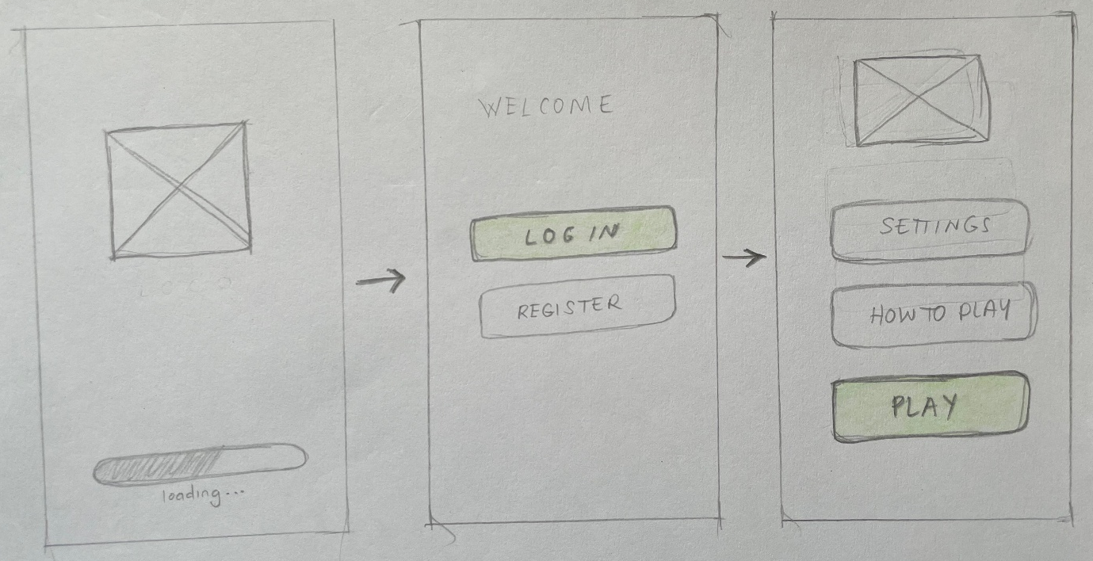
Splash Screen telling us the game is loading up.
First time: register/log in
Home page
Already logged in

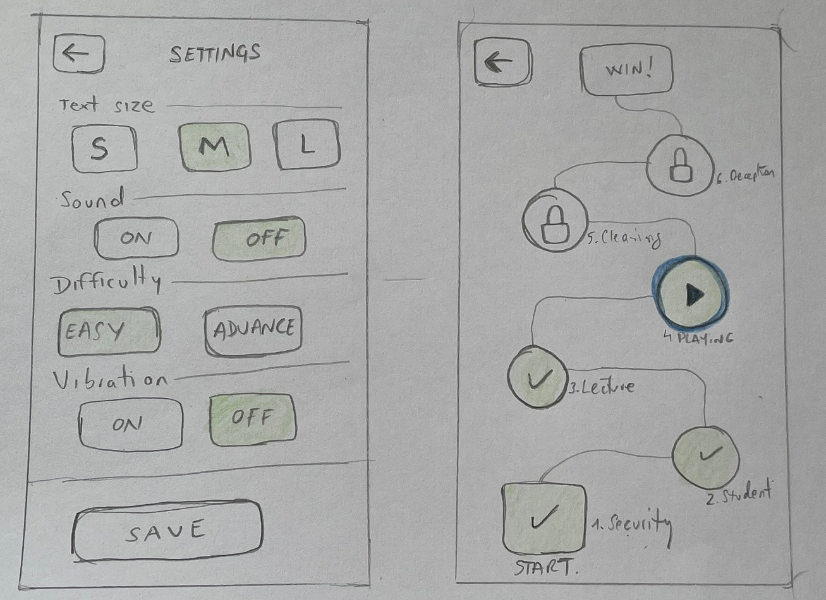
PLAY Screen
Settings Page
PLAY from the home menu will open this screen, a path progress. The three states (done / active / locked) at each level your "visibility of system status" usability point. The player always knows where they are [7] (Nielsen 1994).
Settings page, will provide a serie of options to customize the design elements to make it more fit better to each user such as : text size, Sound, Game difficulty level or vibration on/off.

Mini Games frames screens

LEVEL 1. Campus Security Game:
Its increasing pace and clear tap-targets illustrate the touch-target requirement (M3); the difficulty ramp is why adjustable difficulty (S5) matters for players like David.
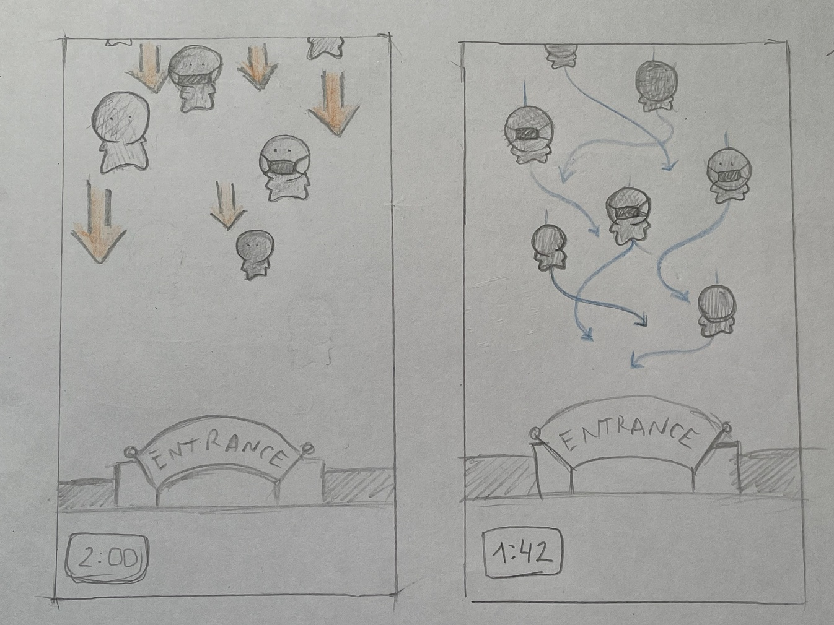

The first mini game Security, is about to control and manage the university access by taping on the characters are not wearing mask. The flow starts from top by showing up till the goal what is the entrance where will disappear once they reach the entrance. The difficulty intensity in increasing by the characters moving faster and in some point they will start to move randomly on the sides trying to skip you. A timer will show up the time reminding. Tapping on the characters without mas you getting points and you are resting more when you tapping on the mask ones.

LEVEL 2. Student Game:
As a fast reaction-based game, it demonstrates the large touch-target requirement (M3) and is another screen where adjustable difficulty (S5) supports players like David.
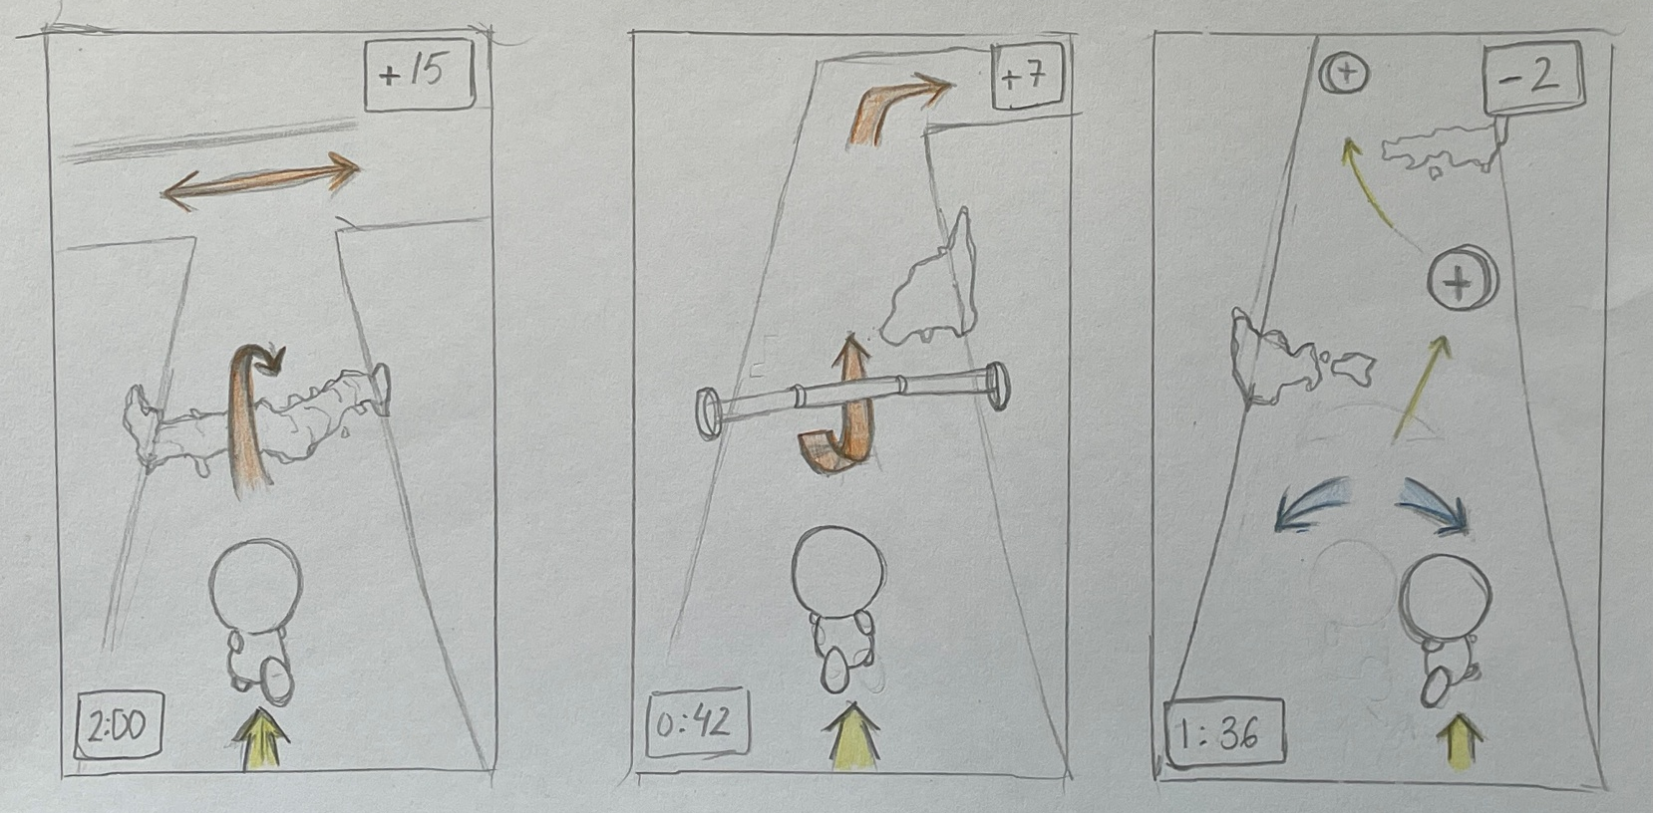
Our character starts running by default the yellow arrow shows the natural flow is performing in this game, Our main target here is to manage it to dodge and skip the obstacles, avoiding the contaminated spots. We can see in the corners of the screen a Timer and live/points counter.

By rotating the device in your hand on its own axis (as indicated by the blue arrows) and making this hand movement, you shift slightly to the right or left to dodge sources of contamination or collect medicines; the latter will determine whether points are subtracted or added.
Swapping with a single finger you will jump, turn right or left or slide down in order to dodge or react appropriately to each obstacle in the game

LEVEL 3. Lecture Game:
Because students are tapped rather than precisely swiped, the large moving targets remain accessible for one-handed players (David, M3).
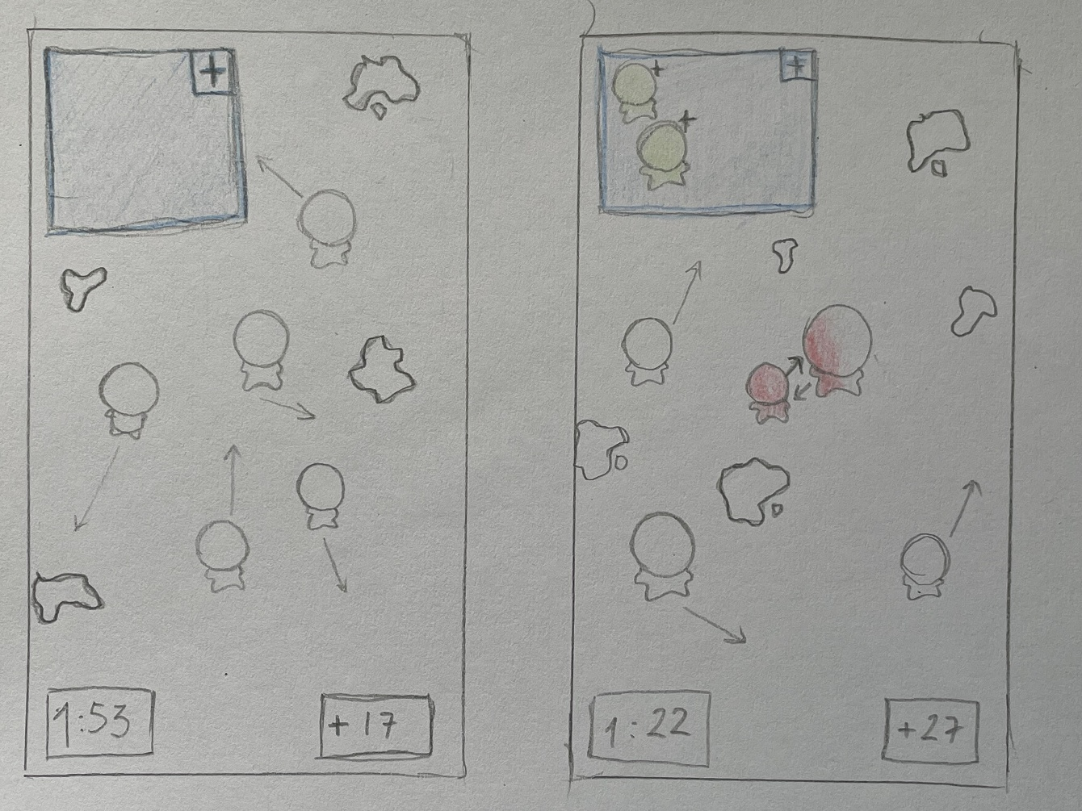
This game goal is to keep the students in the safe place (blue square in the left corner). Students are moving randomly along the screen. Every time you tap on them, they change their direction randomly.
Every time one of them gets in contact with the virus spots change their colour for a while, if in that time is touching other student this will be also contaminated so you need to avoid to them get red colour that means are contaminated, and by changing their direction take them in the safe square. But just take them here as long are green not red.

LEVEL 4. IT Technician Game:
This puzzle-based game responds to participants' preference for strategy over reflex play (Q5).
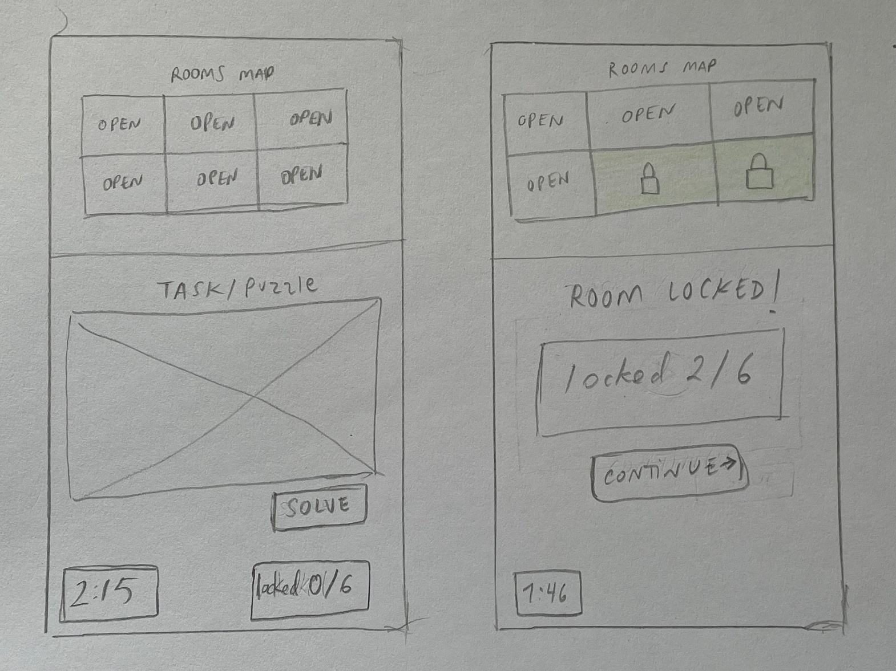
This Game about logic, to lock all the rooms and keep them safe, you may complete a task/puzzle game to lock each room, see the rooms progress status, then we see the current task to solve , the timer and the locked rooms.

LEVEL 5. Cleaning Staff game:
As the most fast-paced, swipe-heavy game, it is where the adjustable-timer option (S5) is most important for one-handed players (David).
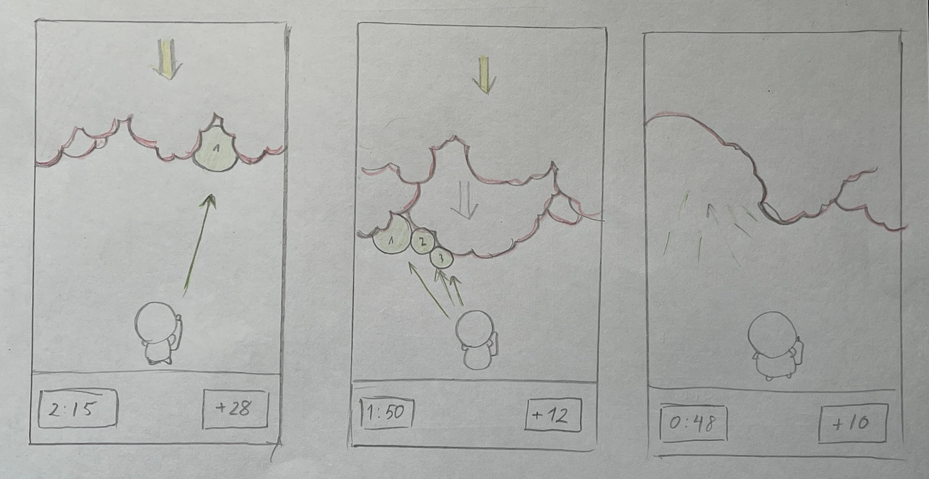
You shooting sanitiser bubbles, once you able to stick 3 together will pump to make a gap and earn space avoiding the virus spread reaching you by coming back on the screen.
From the top of the screen the virus moves downwards spreading fast growing randomly along the screen.

LEVEL 6. Receptionist game:
The Reception mini-game uses a memory-matching mechanic calm, untimed and cognitive rather than reflex-based. This directly responds to participants' preference for thinking-based over fast gameplay (Q5) and provides a low pressure, accessible option for players like Linda (C1) and David (M3).
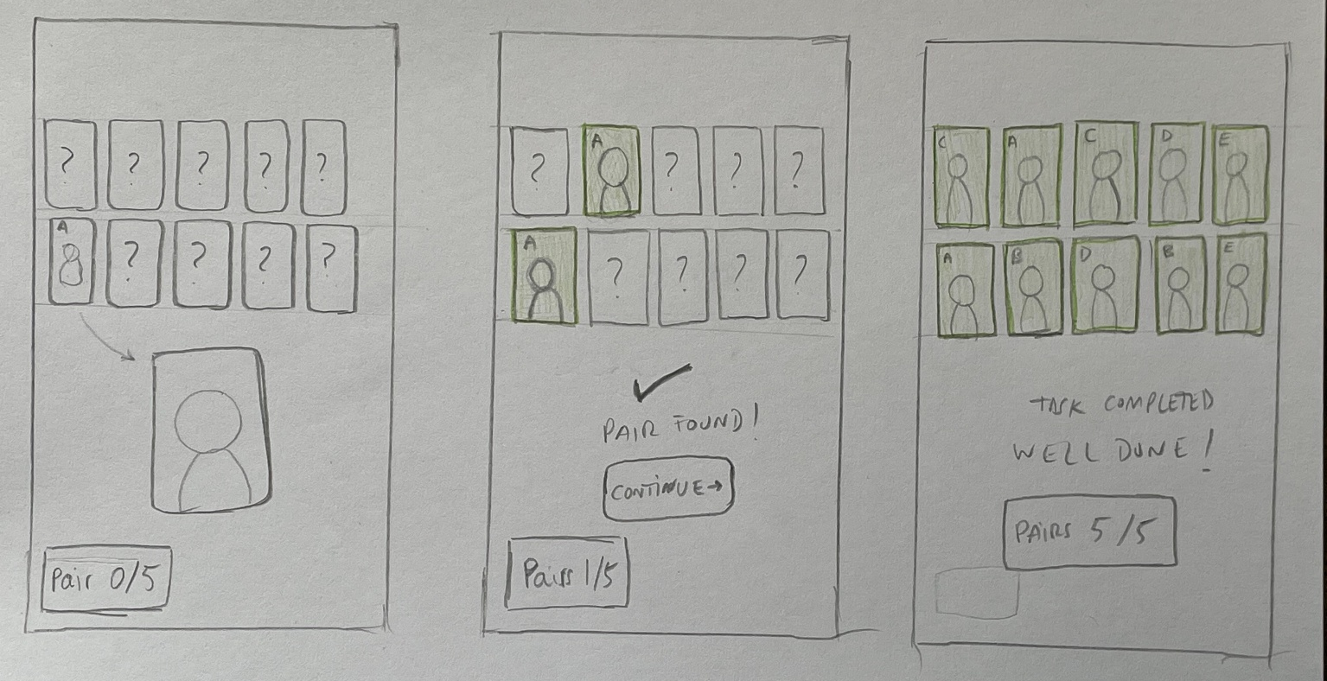
Tap a card to flip it, then try to find it pair. Memory exercise due that the cards are not changing their position
This screen game we see the 10 cards lied down. And the Score progress students pairs.(No timer due that this game will cover the calm and low pressure)

7. User Testing Feedback and Peer Review.
Providing the wareframes sketches to 3 different real users profiles I have challenge them to perform few tasks along the platform wareframes to taste the work flow of it and valuate their feedbacks.
1. Show me how you would start the game from the very first screen:
Response test: splash > login > home
2. You want to begin playing. Show me how you’d get into the first mini-game:
Response test: home > PLAY > role path > tap active role.
3. Looking at this screen, which roles have you finished and which can’t you play yet? How do you know?
Test Response: the locked / active / completed states (Visibility user status)
4. You have finished a mini game. Show me how you would get back and continue.”
Test Response: result > back to path > next unlocked
5. The text feels a bit small for you. Show me how you would make it bigger.
Test Response: finding Settings > accessibility options > Text Size > L
6. You want to stop for now. Show me how you pause the game.
Test response: back / exit control consistency

Feedback after the tasks testing:

Overall, how did using this make you feel?
- Confident: 100%

Which screen or mini-game did you like most, and which felt unclear?
- Game liked most: Student game: 2 Cleaning game:1
“The student game is with difference the most dynamic”
- Unclear game: IT tech game: “Looks the most unclear due that the 6 mini challenge are not defined yet” , “This mini game will depends on its mini tasks”

Was anything harder to find than you expected?
“Maybe the option to have faster access to certain options like fixed and constant button for mute in all the screens even in the games screen”
“Same with a gear icon for the settings don’t need to go back to home”
"Honestly the back button. On the mini-game screen I wasn't sure how to quit without losing my progress."

If you could change one thing, what would it be?
“From the previously mentioned I believe the most relevant it’s an EXIT button during the game screen playing”
“Add a mute icon in all screens, by tapping once you can mute/unmute it without the need to exit to home, settings menu ”

Appendix A – User Research Questionnaire:
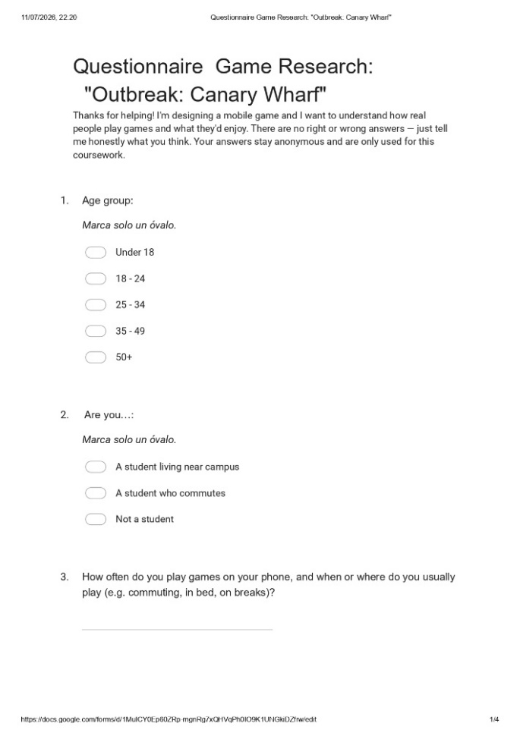 | 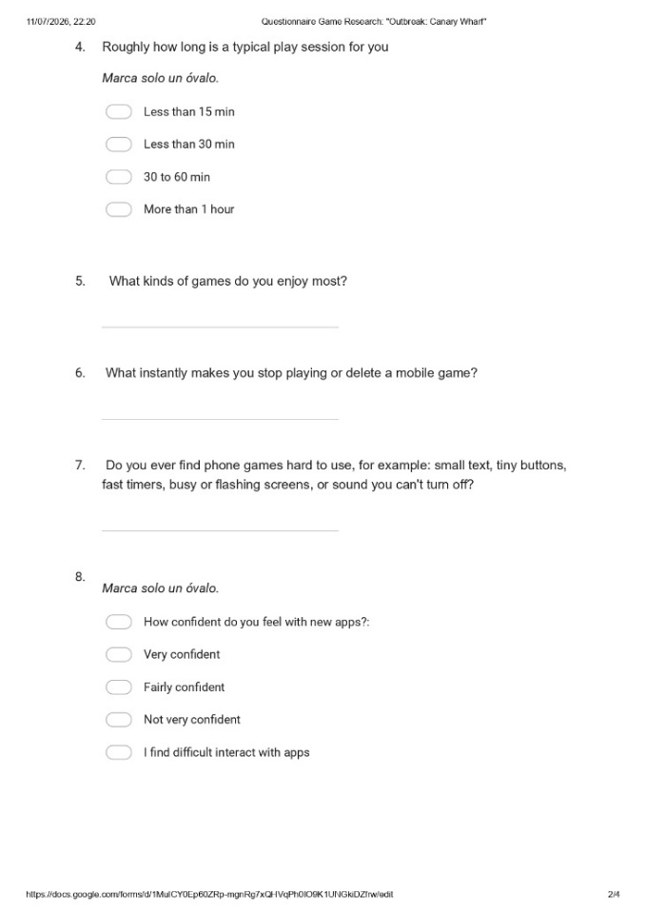
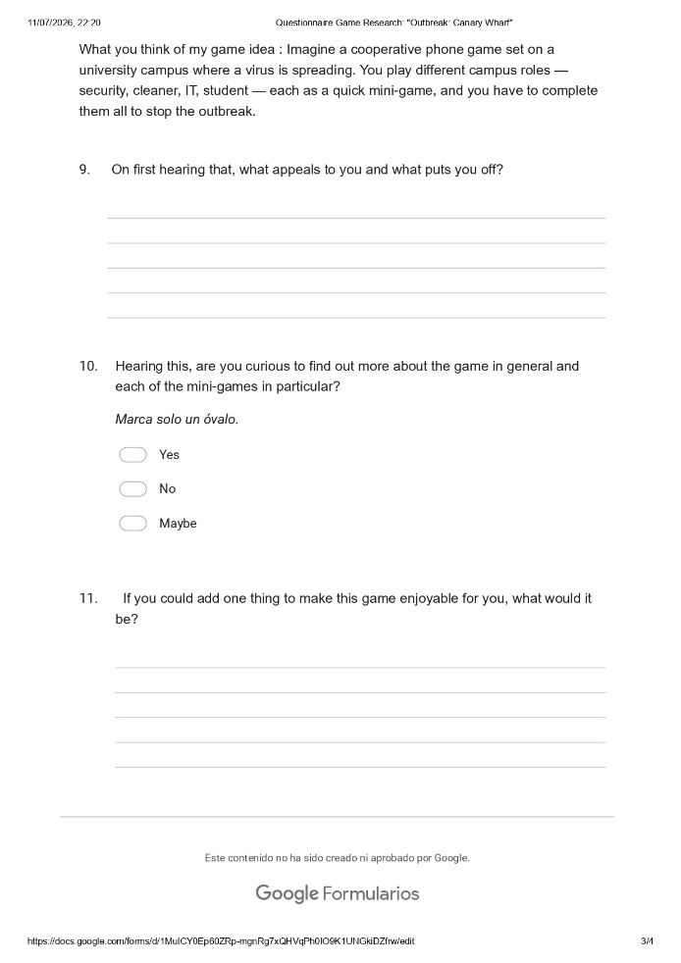 | 

Appendix B – User and Experience Requirements (MoSCoW)
ID | Requirement | Priority | Source / Justification
M1 | The game must provide an ad-free playing experience with no interrupting adverts during gameplay | Must | Most-cited reason to delete a game across responses
M2 | The game must not include pay-to-win (P2W) mechanics | Must | Explicitly named as a reason to abandon a game (Q6)
M3 | All interactive controls must use large, well-spaced touch targets (min. 44×44px) | Must | Q7 (touch difficulty); personas Paul & David; WCAG 2.1
M4 | A consistently visible Back / Exit control must appear on every screen | Must | Persona Linda (fear of mistakes); Nielsen – user control and freedom
M5 | The menu must clearly show which mini-games are completed, active and locked | Must | Q9, (Nielsen) – visibility of system status
M6 | Text must be legible at default size | Must | Q7 (visual difficulty); persona Linda (contrast)
M7 | Instructions and labels must use plain, jargon-free language | Must | Persona Linda (low app confidence); Q8 (confidence spread)
S1 | Mini-games should include some strategic or puzzle depth rather than pure reflex tasks | Should | Q5 (strategy/RPG/logic preferred); Q6 (“brain-dead games” disliked)
S2 | The game should include a light narrative / story thread | Should | Q11 (“needs a nice story”, escape-room / mystery request)
S3 | The game should auto-save and resume from the exact point after interruption | Should | Persona Athenea; Q3 (commuting, interrupted play)
S4 | Each mini-game should be completable in a short session | Should | Q4 (session length); Q3 (commuting / short bursts)
S5 | Difficulty or timer speed should be adjustable | Should | Persona David; Q6 (“too easy or too difficult”)
S6 | The six mini-games should offer genuine variety in gameplay | Should | Q9 (“mixing different kinds of games”)
S7 | All sound should be mutable; no audio essential to gameplay | Should | Q7 (accessibility / sound); WCAG 2.1
C1 | The game could offer a relaxed / no-timer mode | Could | Q11 (“relaxing mini games”); supports persona Linda
C2 | friendly visual style (The game could use a cartoonish ) | Could | Q11 (“make it look cartoonish”)
C3 | The game could include a social / guild feature to play or compete with others | Could | Q11 (guild request); reinforces the co-op appeal (Q9)
C4 | The game could provide haptic feedback on successful actions | Could | Persona David; supports players relying less on precise visuals
W1 | Real-time multiplayer with six simultaneous players | Won't | Out of scope – the design is single-player sequential (Section 1)
W2 | Full-colour, high-fidelity visual design | Won't | Explicitly deferred to the next assignment per brief
W3 | Release on other platforms (PC / console) | Won't | Requested by two participants (Q3, Q11) but outside this mobile-focused scope
W4 | In-app purchases / monetisation features | Won't | No user demand; participants actively dislike P2W (Q6)

References:
[1]. Dana Yatsenko, Unlock the Power of UX Research Process to Design With Confidence: Eleken. updated on: 27 Feb, 2026 https://www.eleken.co/blog-posts/ux-research-process
[2].Sara Fortier, Generative User Research: Why It Works, When It Works. Outwitly. December 12, 2024 https://outwitly.com/resources/generative-user-research/
[3 J. Pruitt and T. Adlin, The Persona Lifecycle: Keeping People in Mind Throughout Product Design. San Francisco, CA, USA: Morgan Kaufmann, 2006.
[4] A. Galletta, Mastering the Semi-Structured Interview and Beyond: From Research Design to Analysis and Publication. New York, NY, USA: New York University Press, 2013.
[5] Ryan Inglethorpe, Semi-structured interviews: Everything you need to know. Clevry. August 28, 2024 https://www.clevry.com/en/blog/semi-structured-interviews-everything-you-need-to-know/
[6] A. Cooper, The Inmates Are Running the Asylum: Why High-Tech Products Drive Us Crazy and How to Restore the Sanity. Indianapolis, IN, USA: Sams Publishing, 1999.
[7] J. Nielsen, "Enhancing the explanatory power of usability heuristics," in Proc. SIGCHI Conf. Human Factors in Computing Systems (CHI '94), Boston, MA, USA, 1994, pp. 152–158.
[8] Web Content Accessibility Guidelines (WCAG) 2.1, W3C Recommendation, World Wide Web Consortium, 2018. [Online]. Available: https://www.w3.org/TR/WCAG21/

