The Effect of Shallow Processing, Intermediate Processing, and Deep Processing on Word Recognition

Abstract

Craik and Lockhart’s (1972) theory regarding levels of processing argues that memory processes involve a succession of stages ranging from shallow to deep. Shallow coding may be defined as visual and acoustic whereas semantic coding is said to be deep (Craik & Lockhart, 1972). In the present study a related one-way Analysis of Variance was used to measure depth of processing and there were three conditions (shallow, intermediate and deep). Subjects were shown a series of slides before being asked to perform an incidental learning task. This was followed by a word recognition task that determined how many words had been remembered correctly by participants in each condition. Results show that more words were recognized as the depth of processing increased. This study was a partial replication of Craik and Tulving’s (1975) experiment and the results were significantly similar, therefore supporting Craik and Lockhart’s (1972) theory. These findings suggest that semantic coding may be useful to students, enabling them to remember more information and thus achieving higher grades.

Introduction

Craik and Lockhart (1972) argue that there are levels of memory processing ranging from shallow to deep and that the depth of processing impacts upon retrievable memories. The theory (Craik & Lockhart, 1972) assumes that deep levels of analysis will produce longer lasting memory traces than shallow levels of analysis. This study was a partial replication of an experiment conducted by Craik and Tulving (1975) and investigated the effects of shallow, intermediate and deep processing on word recognition. Results showed that successful word recognition rose systematically for each condition, from shallow to intermediate and from intermediate to deep (Craik & Tulving, 1975), and performance increased from 15% of words correctly recognized in the shallow condition to 81% of words correctly recognized in the deep condition. An experiment carried out by Moscovitch and Craik (1976) involved word recognition in each of the three conditions and produced similar results to those of Craik and Tulving (1975). The current study is important in attempting to demonstrate how elaboration assists memory. It has important implications for education as students may use semantic processing to study, therefore remembering more information and achieving better results. The study uses a one tailed hypothesis. It is predicted that subjects will recognize more deep processed words than intermediate processed words, which in turn will be recognized more than shallow processed words.

Methodology

Design

A related one-way Analysis of Variance (ANOVA) was used. The independent variable was the depth of processing and there were three conditions (shallow processing, intermediate processing, and deep processing). The dependant variable was the number of words recognized.

Participants

Twenty-one participants completed each condition of the study. Four participants were male and seventeen were female. The age of participants ranged from twenty to fifty-three years old. Subjects were all undergraduate students at the University of Wales, Trinity Saint David in Carmarthen and were participating in a class experiment. Participants were naïve to the purpose of the experiment.

Apparatus/Materials

- Forty-five words on a PowerPoint slide
- Words were presented on a blue background with black writing.
- See appendix 3 for PowerPoint words.
- Three yes/no trial questions and forty-five yes/no questions on a sheet of white A4 paper (fifteen for each condition).
- See appendix 4 for yes/no answer sheet.
- The text font was Helvetica Neue size thirty-six.
- One hundred and five words on a sheet of white A4 paper.
- See appendix 5 for list of one hundred and five words.
- Pen.

Procedure

Participants were requested to sit and watch a PowerPoint presentation. Subjects were informed that they would be taking part in a task answering yes or no to forty-five questions related to the presented words and were provided with an answer sheet on which to do so. Participants proceeded to watch forty-five PowerPoint slides. Each slide was presented for six seconds. The question on each slide was shown for two seconds and the answer subsequently accompanied it for a further four seconds. This task was an incidental learning test designed to manipulate the scores. Following completion of the task, subjects were provided with a list of one hundred and five words and asked to recognize as many of the forty-five words from the PowerPoint presentation as possible. The forty-five words that participants were asked to recognize consisted of fifteen words for each condition (shallow processing, intermediate processing and deep processing). Subjects were then asked how many words they correctly recognized for each condition.

Results

This section presents the results for the three conditions of shallow processing, intermediate processing and deep processing. To analyse whether the differences between the three conditions were significant, a related one-way ANOVA statistical test was conducted. The following table shows the means and standard deviations for shallow processing, intermediate processing and deep processing.

Table 1

Means and standard deviation for levels of processing scores in the shallow condition, intermediate condition and deep condition

Condition | Mean | Standard Deviation
Shallow  Intermediate  Deep | 2.8571  4.1905  11.0000 | 2.70713  2.35837  2.25832

Table 1 shows the means for each of the three conditions. There was a statistically significant difference between groups as determined by a related one-way ANOVA statistical test (N =21, (F(2,40) = 129.057, p = .000). Pairwise comparisons showed no significant difference between conditions one and two (p = .080). There were significant differences between condition one and three (p = .000), and conditions two and three (p = .000). The results of the test therefore support the hypothesis.

Discussion

The aim of this study was to explore the effect of shallow processing, intermediate processing and deep processing on word recognition. The research hypothesis was that participants would recognize more words in the deep condition than the intermediate condition, which in turn would be recognized more than words in the shallow condition. The study replicated Craik and Tulving’s (1975) experiment and the results supported the research hypothesis. Although more words were recognized in the shallow condition than the intermediate condition as predicted, the difference was not significant. As predicted more words were recognized in the deep condition than both other conditions and these differences were significant, supporting Craik and Tulving’s (1975) findings. The results also provide important empirical support for Craik and Lockhart’s (1972) initial theory. A similar experiment by Elias and Perfetti (1973), which used an incidental learning task, also found that subjects recognized significantly more words following the deep processing task than following the shallow processing task. Furthermore, Hyde and Jenkins’ (1973) levels of processing study involved participants who were provided with an incidental learning task and subjects that were asked to learn the words. Similar results were recorded for participants in each condition suggesting the depth of processing, regardless of whether learning is intentional or incidental, determines the amount of information retained (Hyde & Jenkins, 1973). This however contrasts with the findings of Tyler et al., (1979) who gave participants an easy and a difficult set of anagrams to decipher, unaware that they would be asked to recall the answers. Although the processing level was the same for both conditions, subjects recalled more difficult anagram words than easy ones leading Tyler et al., (1979) to conclude that the effort of processing is more important to the retention of information than the depth of processing. A possible limitation to the present study was the relatively small group of participants and a high female to male ratio. Furthermore, the task arguably lacks ecological validity as the experiment and setting may be unfamiliar or irrelevant to daily life. However, Lockhart and Craik (1990) argue that ecological validity in the study of memory is not dependent upon abandoning experiments but requires the use of features of memory important to daily situations. Lockhart and Craik (1990) also acknowledge the criticisms of the structural limitations of their levels of processing theory (Eysenck, 1978). Results of the present study highlight the important implications for education as students may use such semantic processing to revise, therefore retaining more information and probably achieving better grades. Challis, Velichkovsky and Craik (1996) argue that incidental learning can be as useful as intentional learning in enhancing memory performance. Furthermore, Craik (2002) argues that deeper levels of processing possess a greater capacity for retrieval. Future research may explore why the retrieval of certain types of information is difficult amongst conditions linked to memory impairment (Craik, 2002).

Conclusion

The results of the present study provide support for Craik and Lockhart’s (1972) levels of processing theory, and clearly resemble the findings of Craik and Tulving (1975). As discussed, the study has advantageous implications for education and this has been noted by numerous commentators. Results of this and other similar studies suggest that incidental learning aids the retention of information and that deeply processed information is far more likely to be remembered. There are limitations to the study as noted, and critiques of the levels of processing theory have been commented upon. Future research in the field may continue to enhance the theory and provide a deeper understanding of levels of processing.

References

Challis, B.H., Velichkovsky, B.M., & Craik, F.I.M. (1996). Levels-of-processing effects on a variety of memory tasks: New findings and theoretical implications. Consciousness and Cognition, 5, 142 – 164.
Craik, F.I.M. (2002). Levels of processing: Past, present … and future? Memory, 10 (5/6), 305 – 318.
Craik, F.I.M., & Lockhart, R.S. (1972). Levels of processing: A framework for memory research. Journal of Verbal Learning & Verbal Behaviour, 11, 671 – 684.
Craik, F.I.M., & Tulving, E. (1975). Depth of processing and the retention of words in episodic memory. Journal of Experimental Psychology: general, 104 (3), 268 – 294.
Elias, C.S., & Perfetti, C.A. (1973). Encoding task and recognition memory: The importance of semantic encoding. Journal of Experimental Psychology, 99, 151 – 156.
Eysenck, M.W. (1978). Levels of processing: A critique. British Journal of Psychology, 69, 157 – 169.
Hyde, T.S., & Jenkins, J.J., (1973). Recall for words as a function of semantic, graphic, and syntactic orienting tasks. Journal of Verbal Learning and Verbal Behavior, 12, 471 – 480.
Lockhart, R.S., & Craik, F.I.M. (1990). Levels of processing: A retrospective commentary on a framework for memory research. Canadian Journal of Psychology, 44 (1), 87 – 112.
Moscovitch, M., & Craik, F.I.M. (1976). Depth of processing, retrieval cues, and uniqueness of encoding as factors in recall. Journal of Verbal Learning and Verbal Behaviour, 15, 447 – 458.
Tyler, S.W., Hertel, P.T., McCallum, M.C., & Ellis, H.C. (1979). Cognitive effort and memory. Journal of Experimental Psychology: Human Learning and Memory, 5 (6), 607 – 617.

Appendices

Appendix 1 – Raw Data - Scores

Condition 1 (Shallow) | Condition 2 (Intermediate | Condition 3 (Deep)
1 | 5 | 12
4 | 10 | 13
3 | 5 | 12
3 | 7 | 10
2 | 5 | 10
6 | 6 | 14
2 | 3 | 9
3 | 3 | 11
0 | 2 | 10
9 | 3 | 13
1 | 2 | 11
0 | 1 | 9
4 | 3 | 6
2 | 1 | 7
0 | 2 | 12
2 | 5 | 11
10 | 8 | 13
2 | 4 | 13
4 | 5 | 13
2 | 6 | 14
0 | 2 | 8

Appendix 2 – Raw Data – Pairwise Comparisons

Levels of Processing | Levels of processing | N | Significance
1 | 2  3 | 21  21 | .080  .000
2 | 1  3 | 21  21 | .080  .000
3 | 1  2 | 21  21 | .000  .000

Appendix 3 – PowerPoint Words

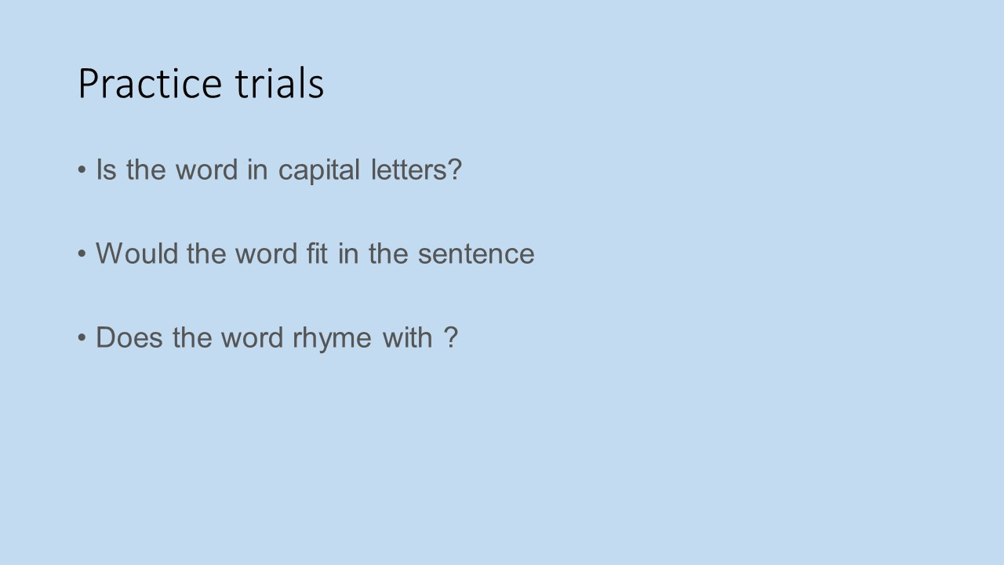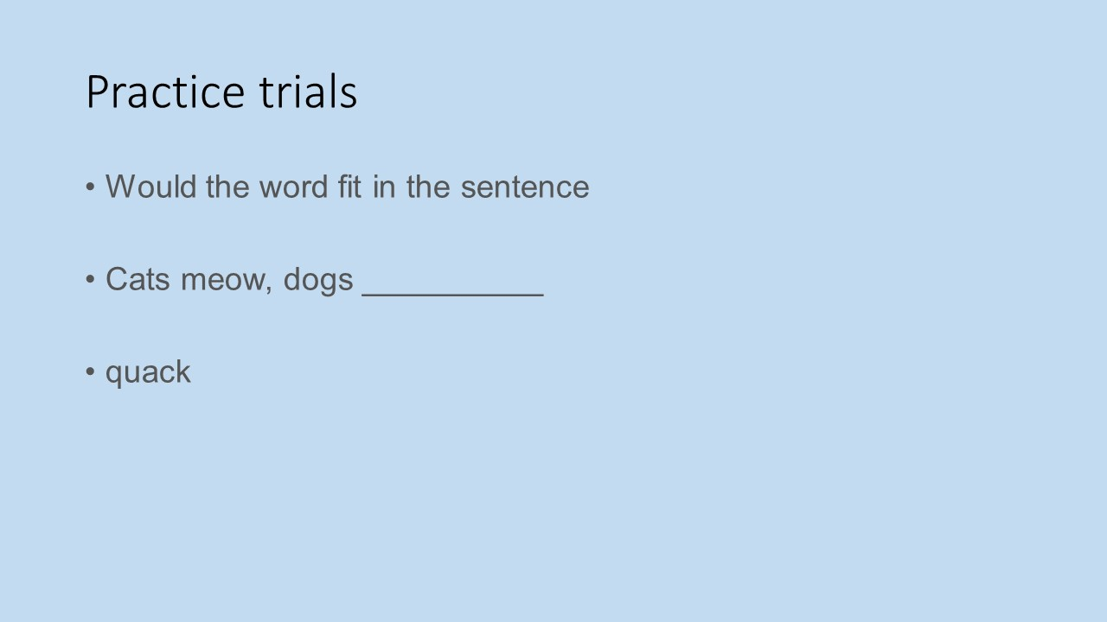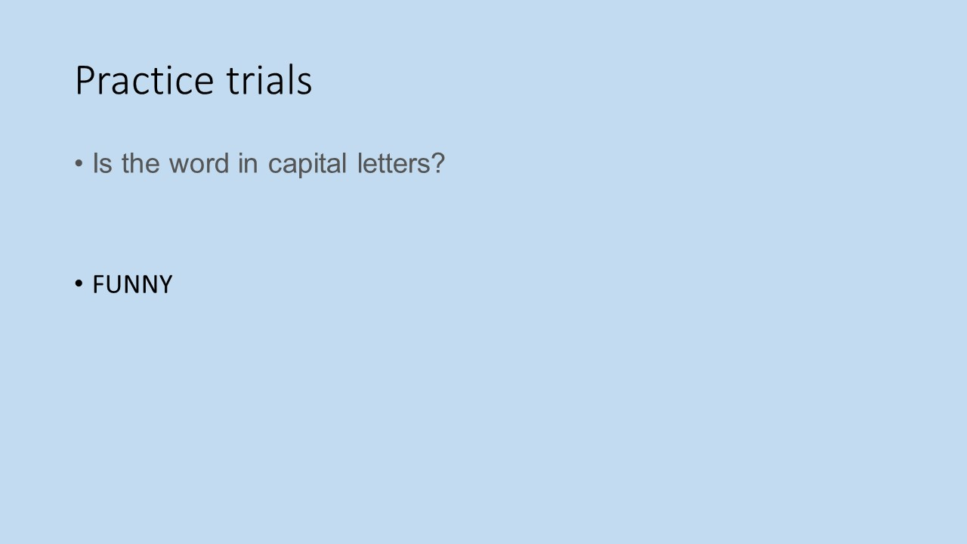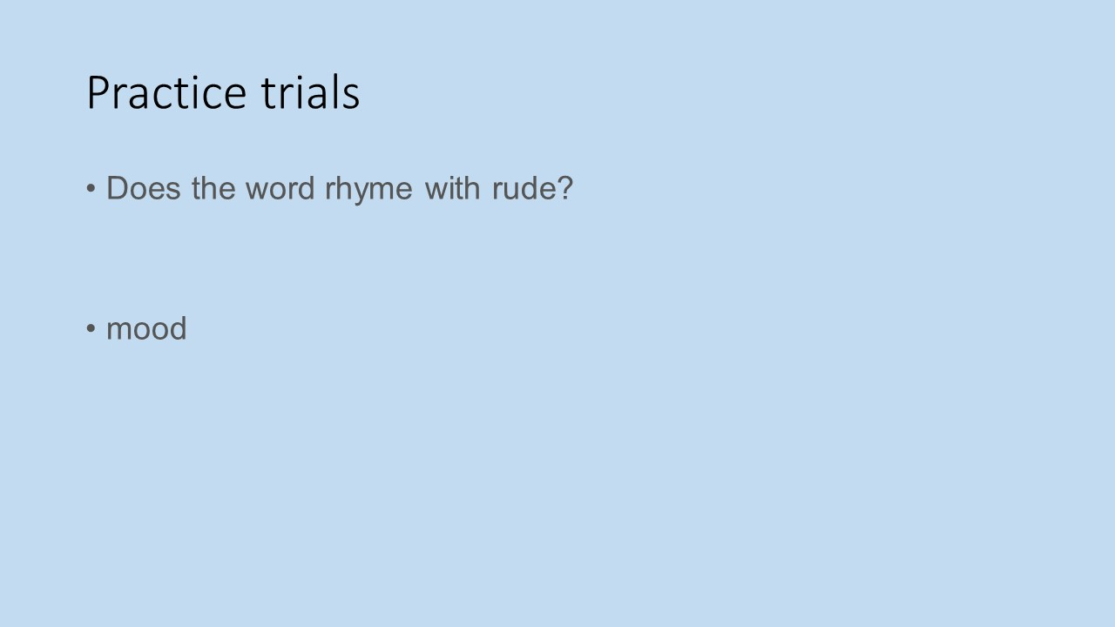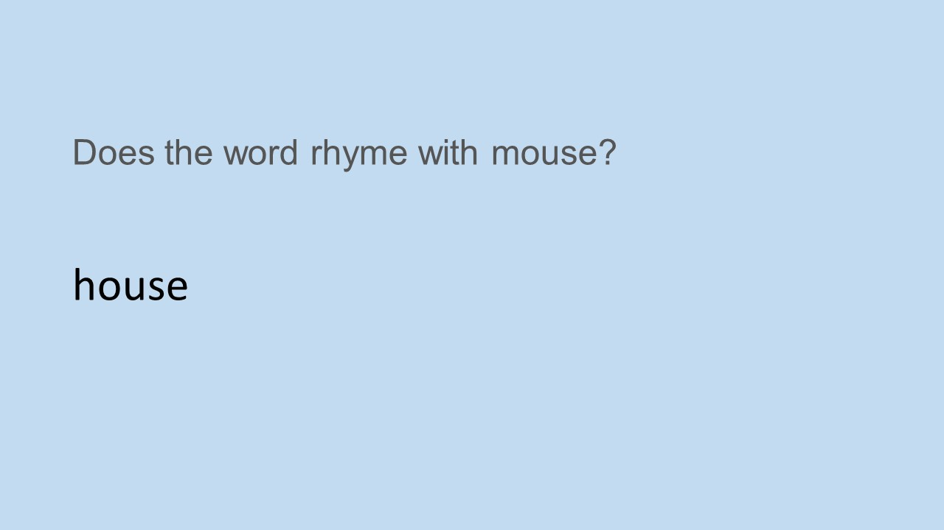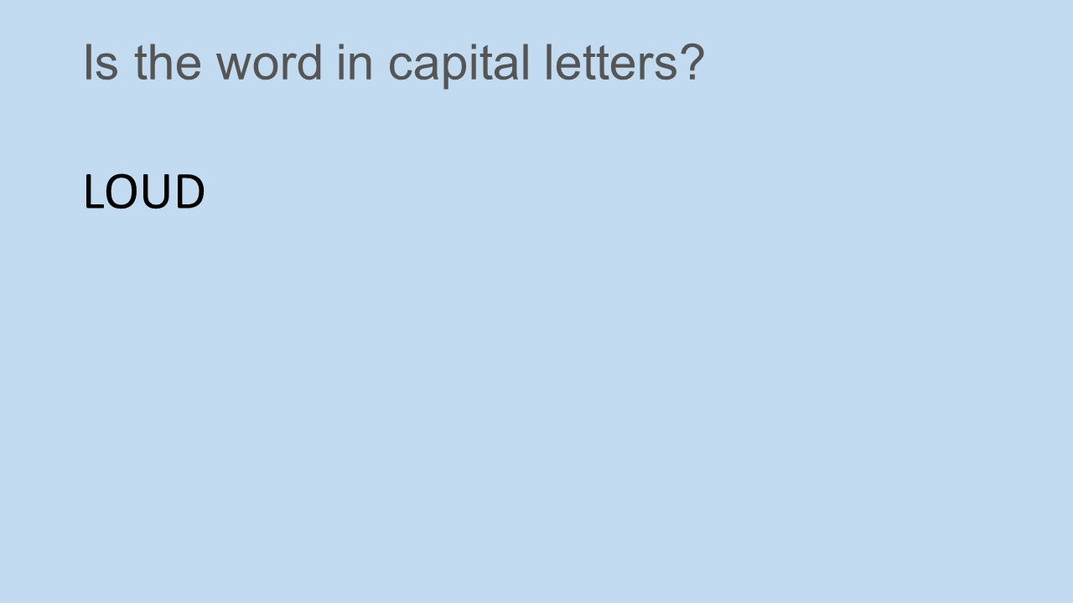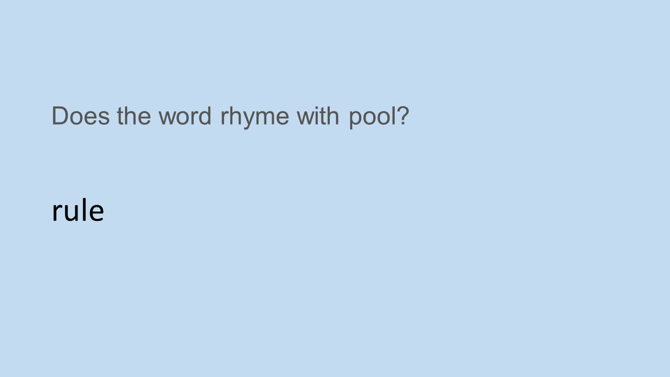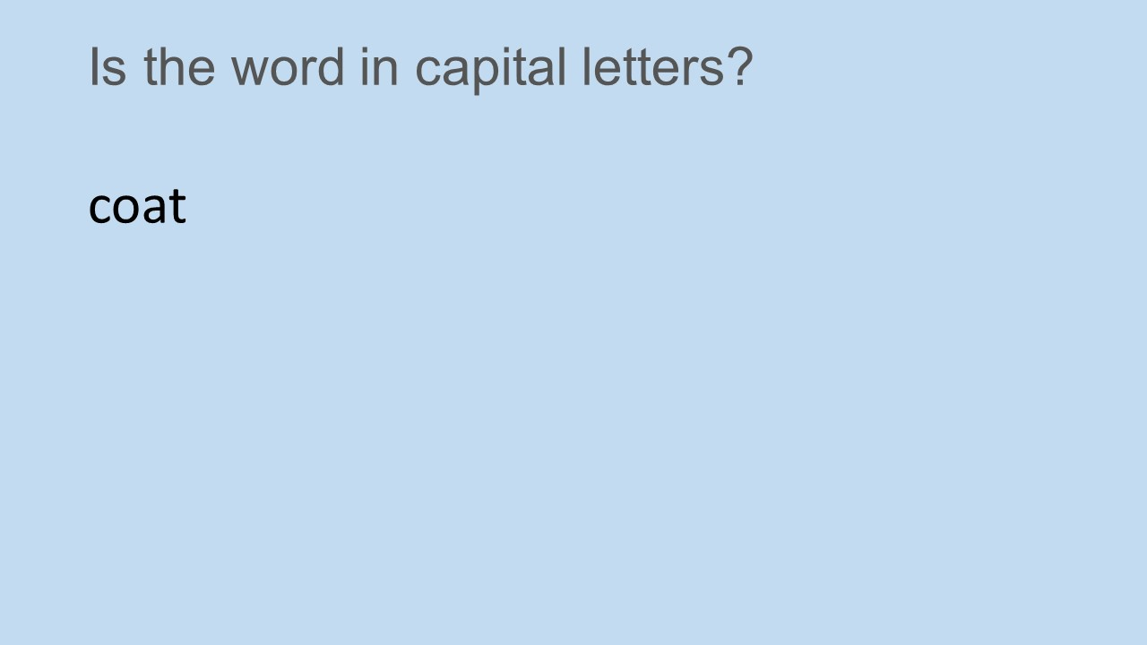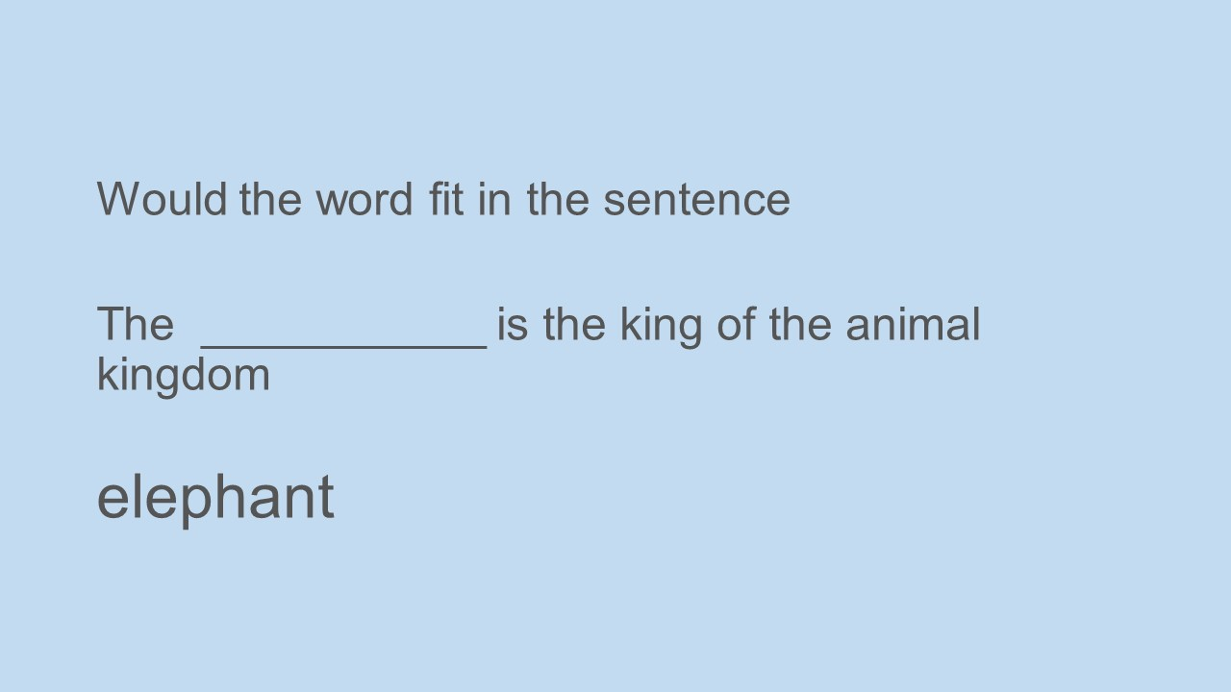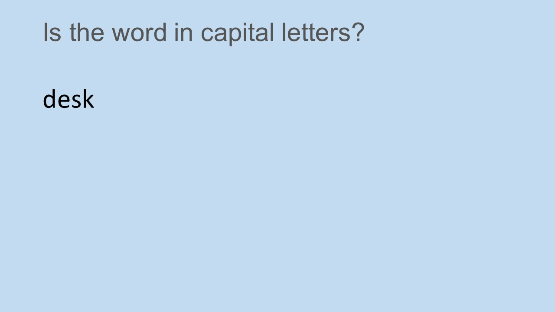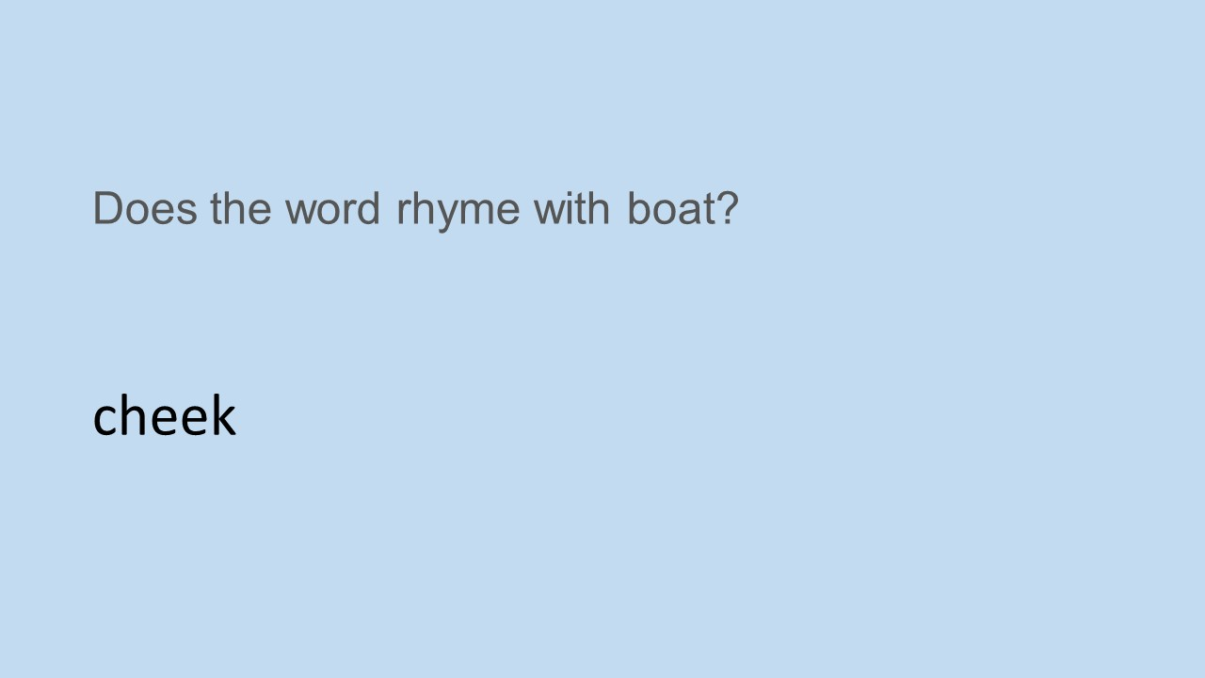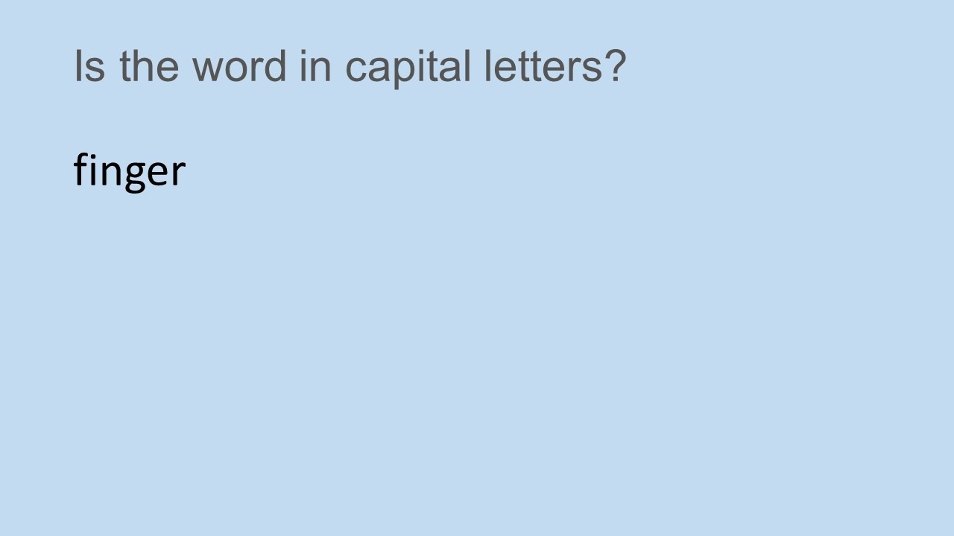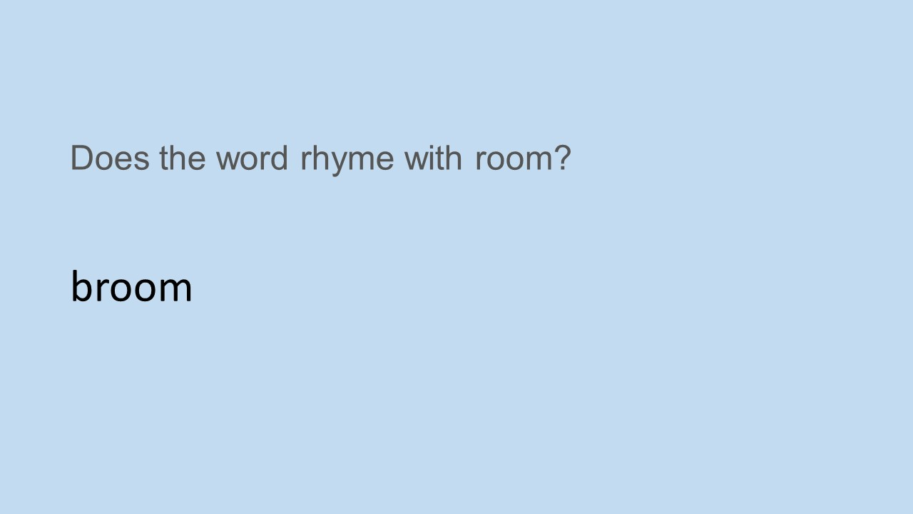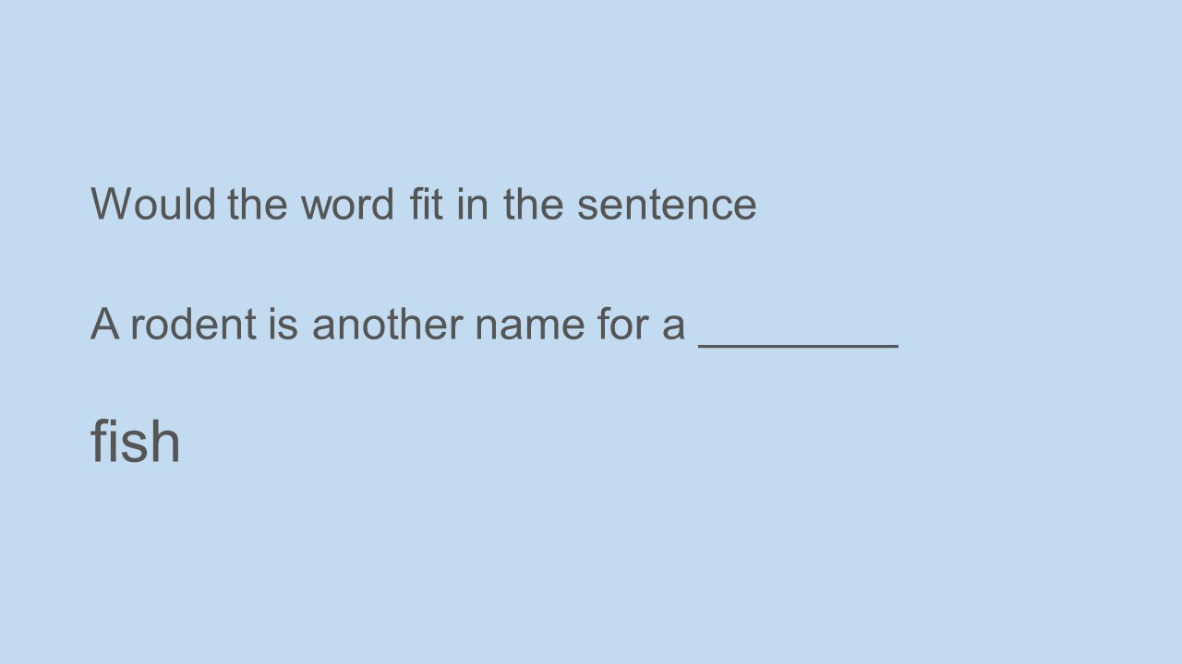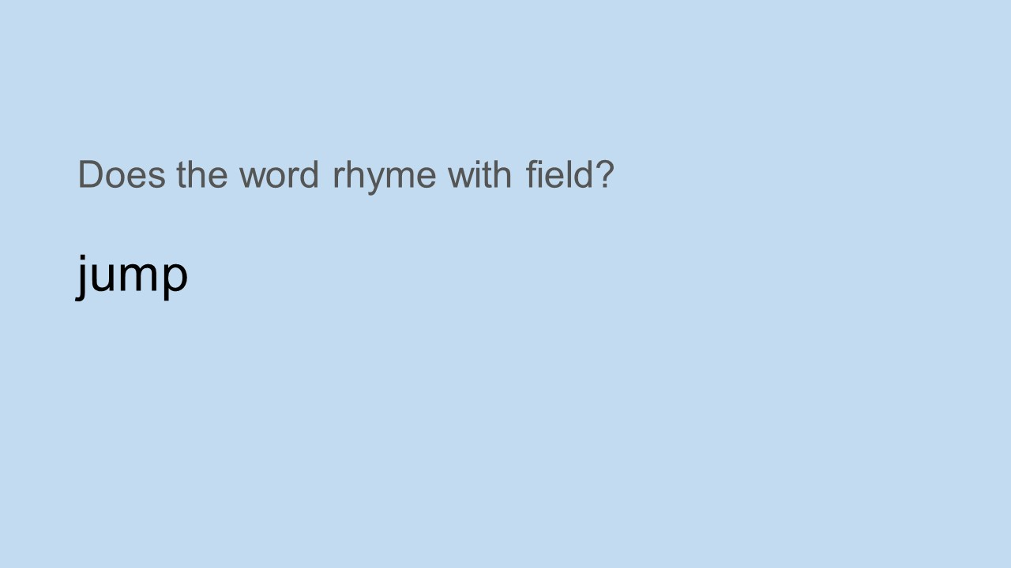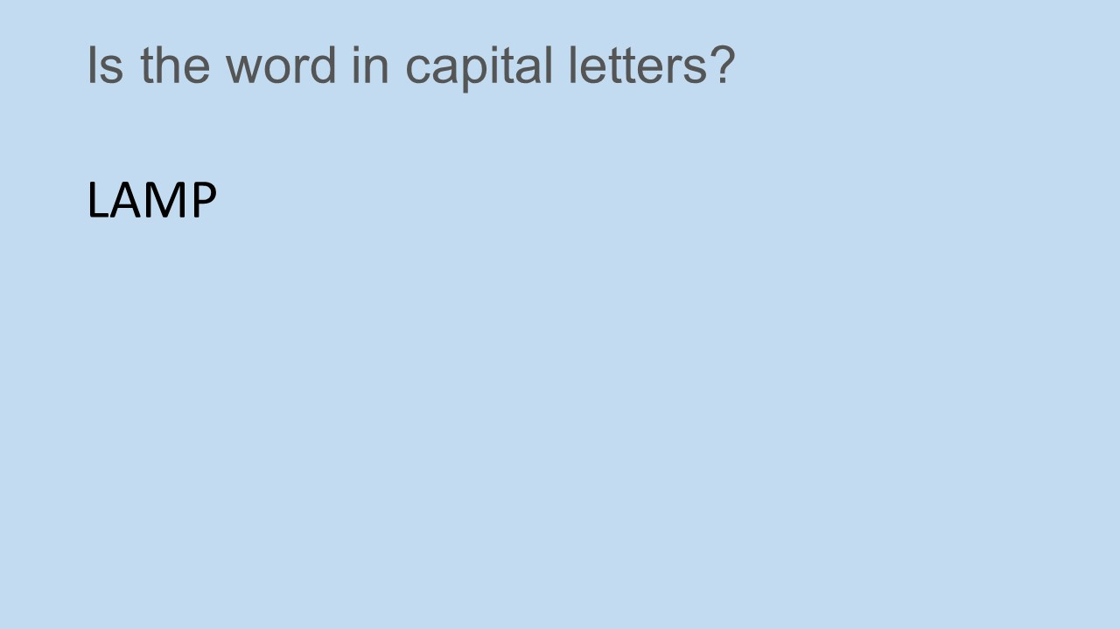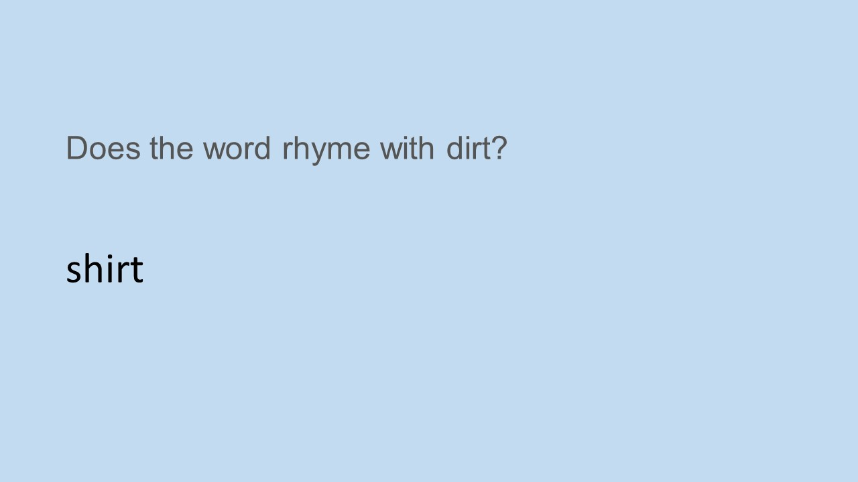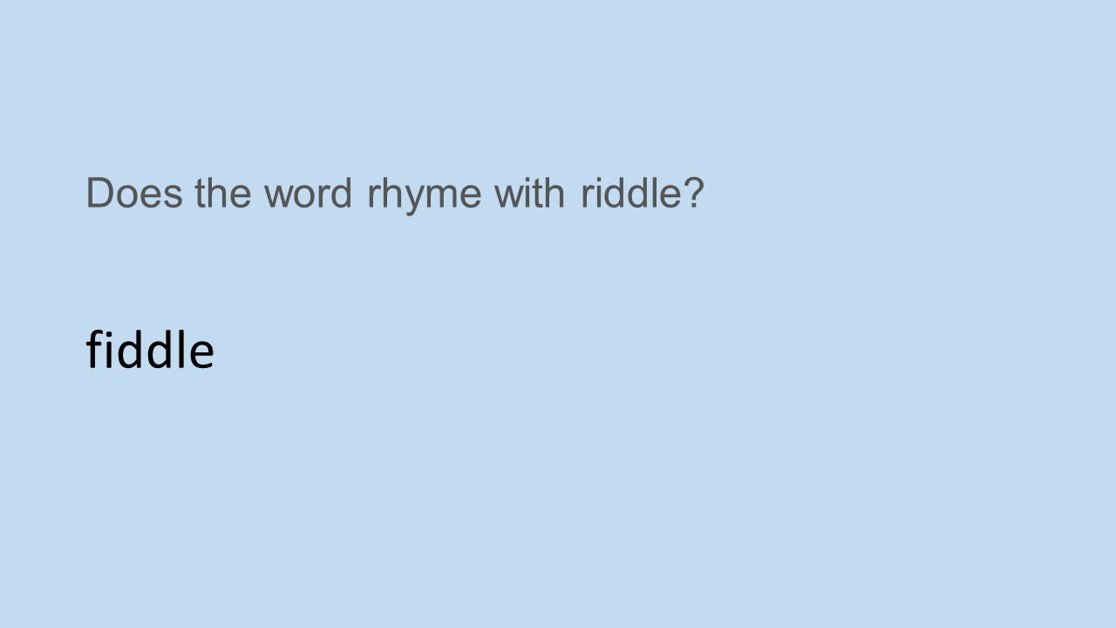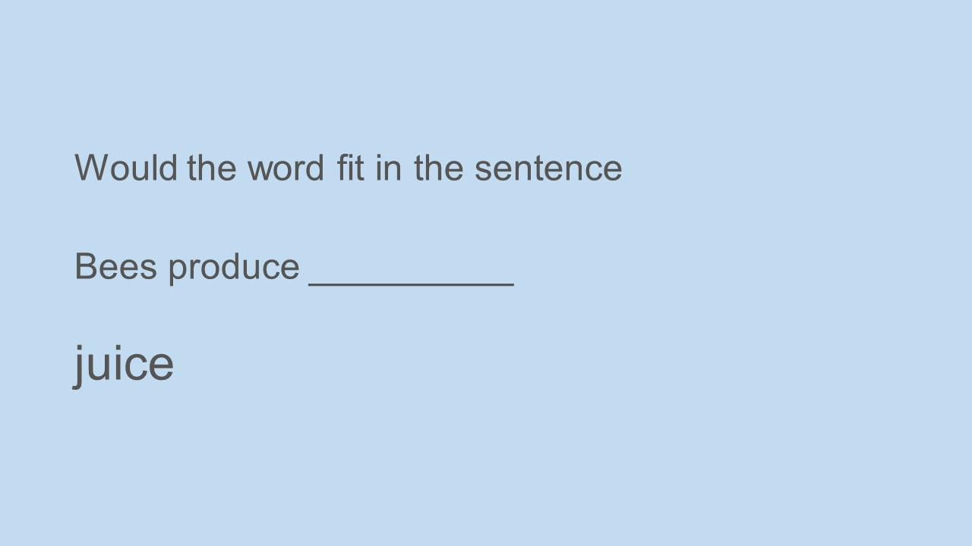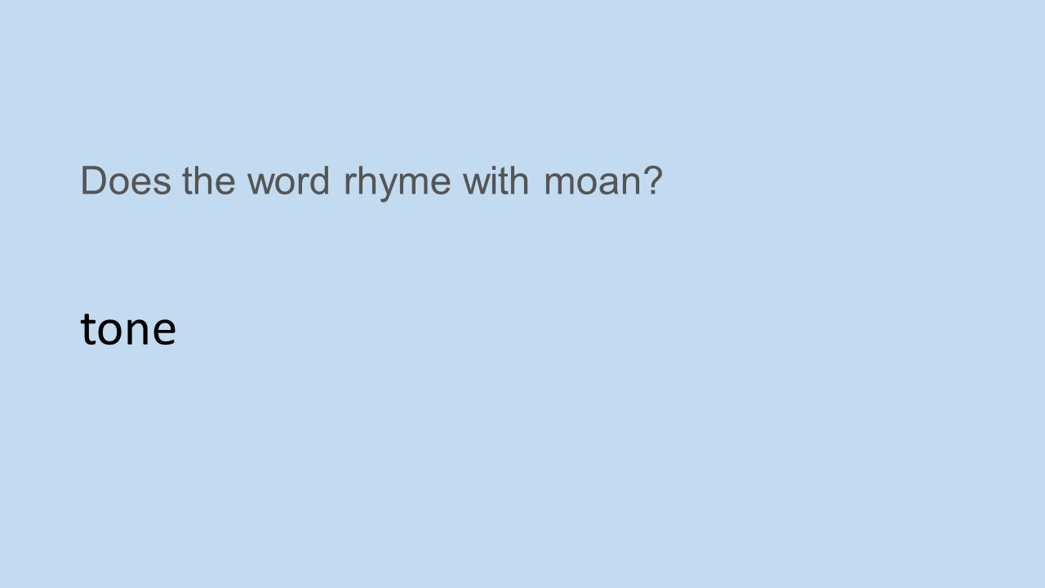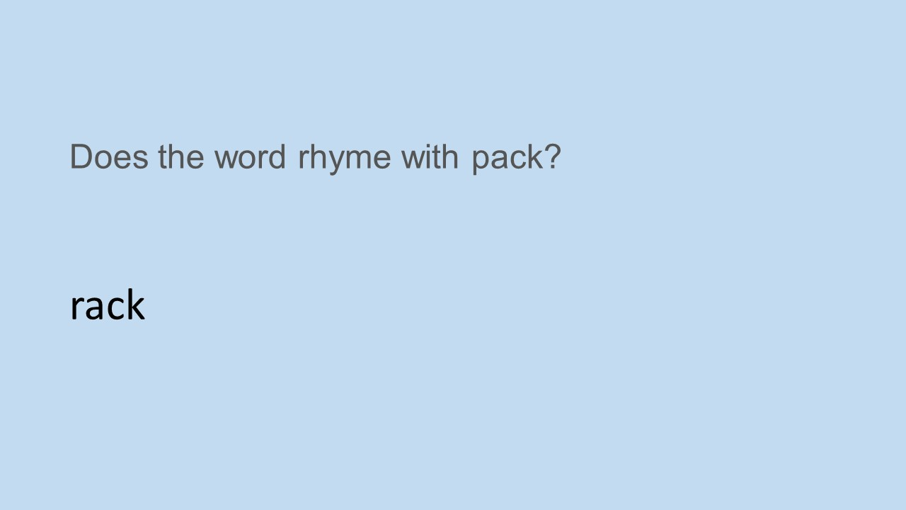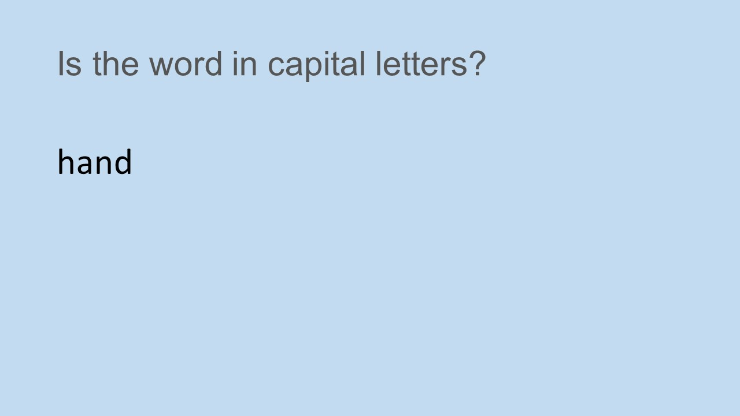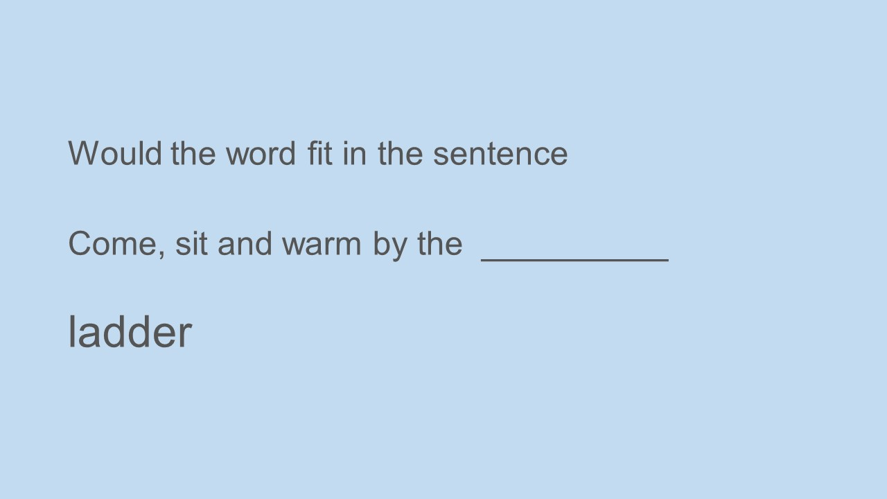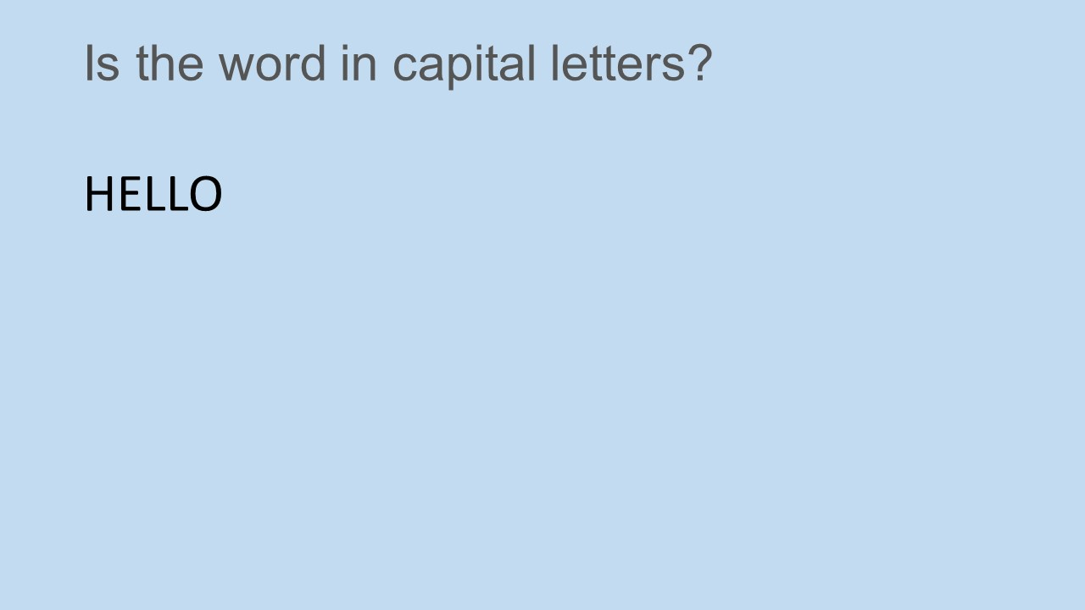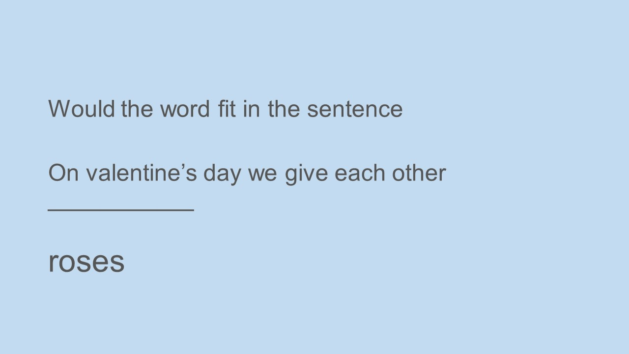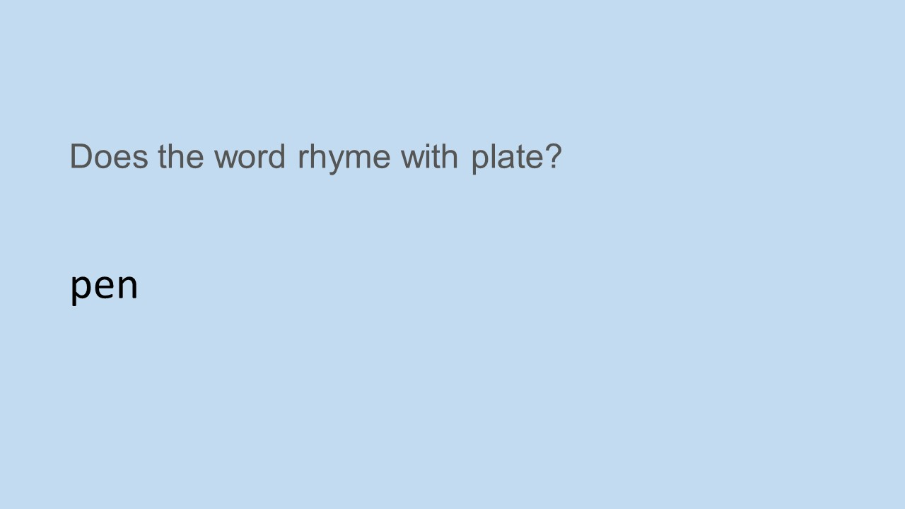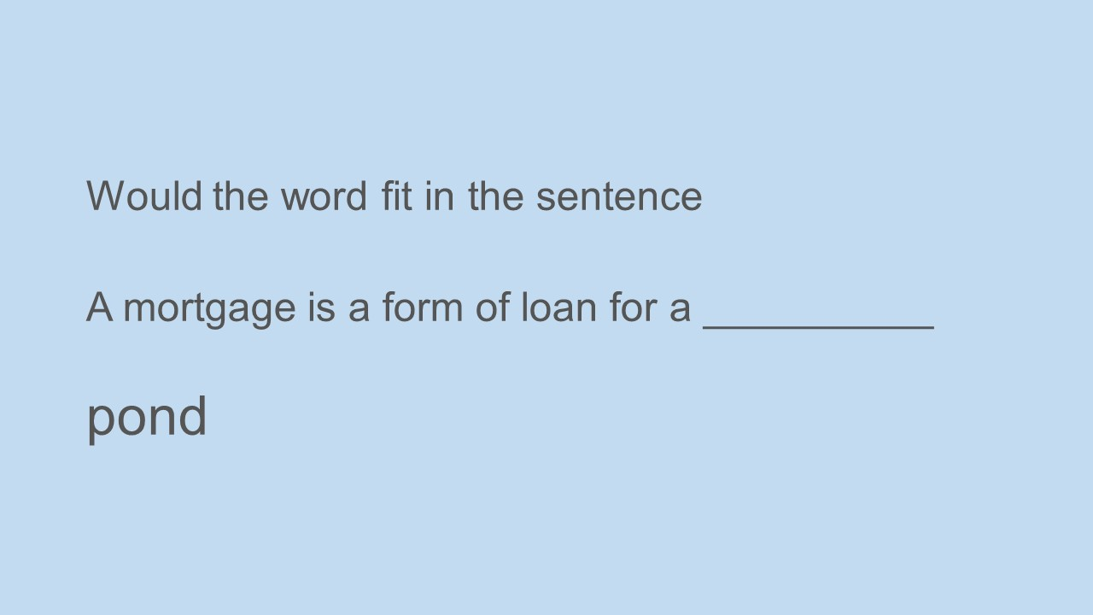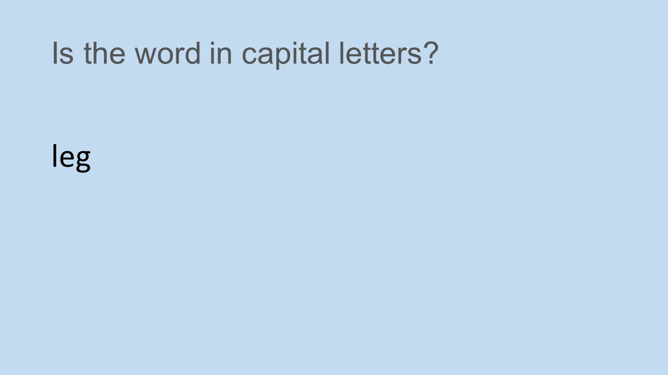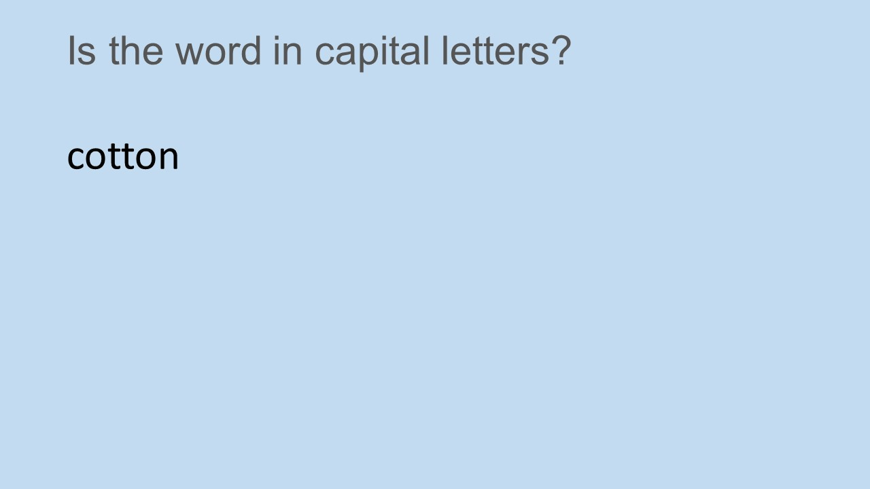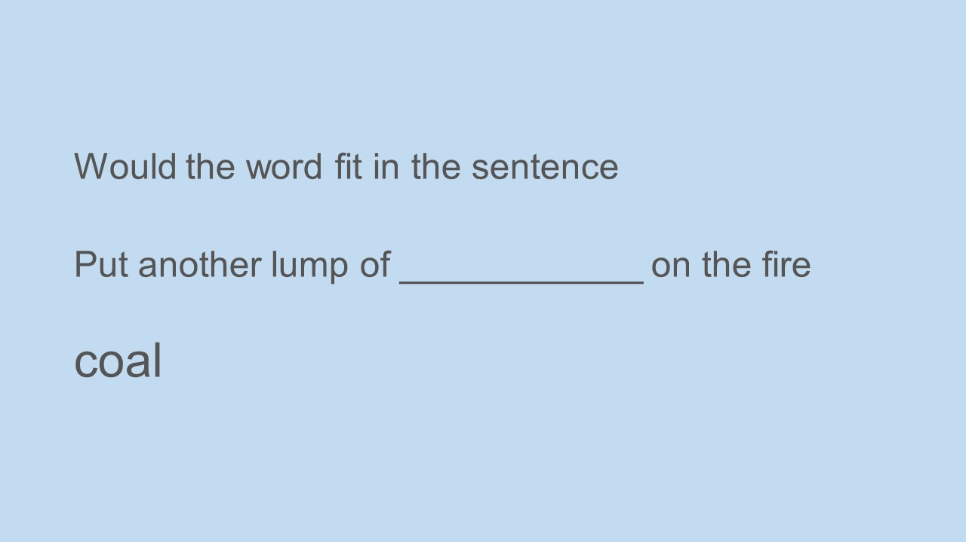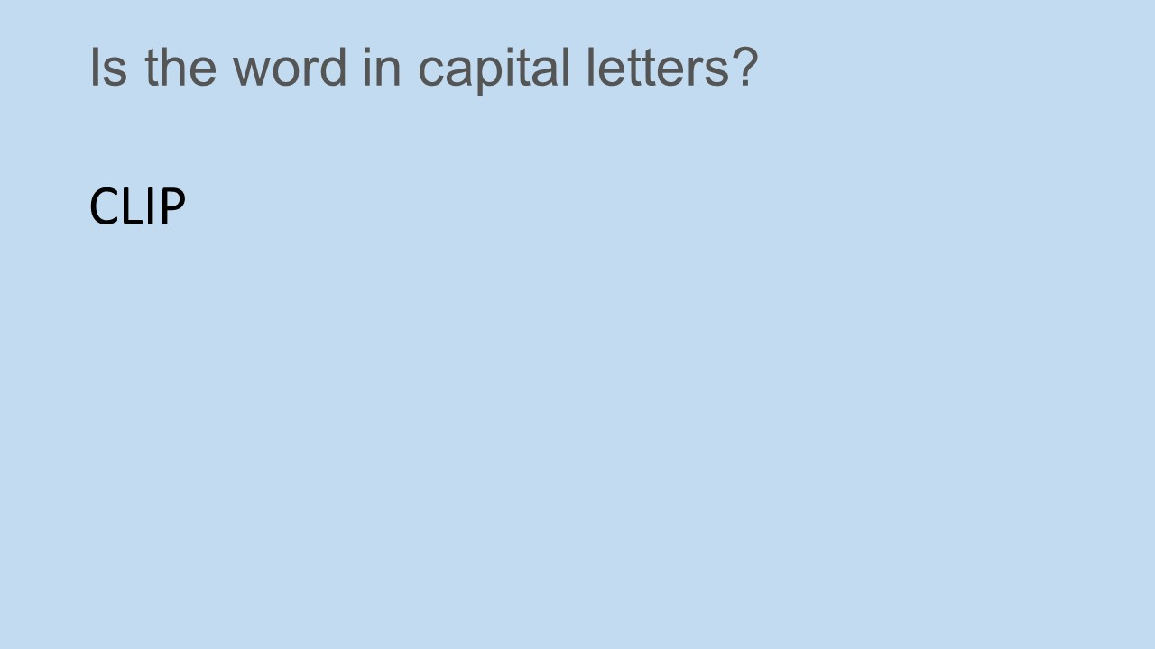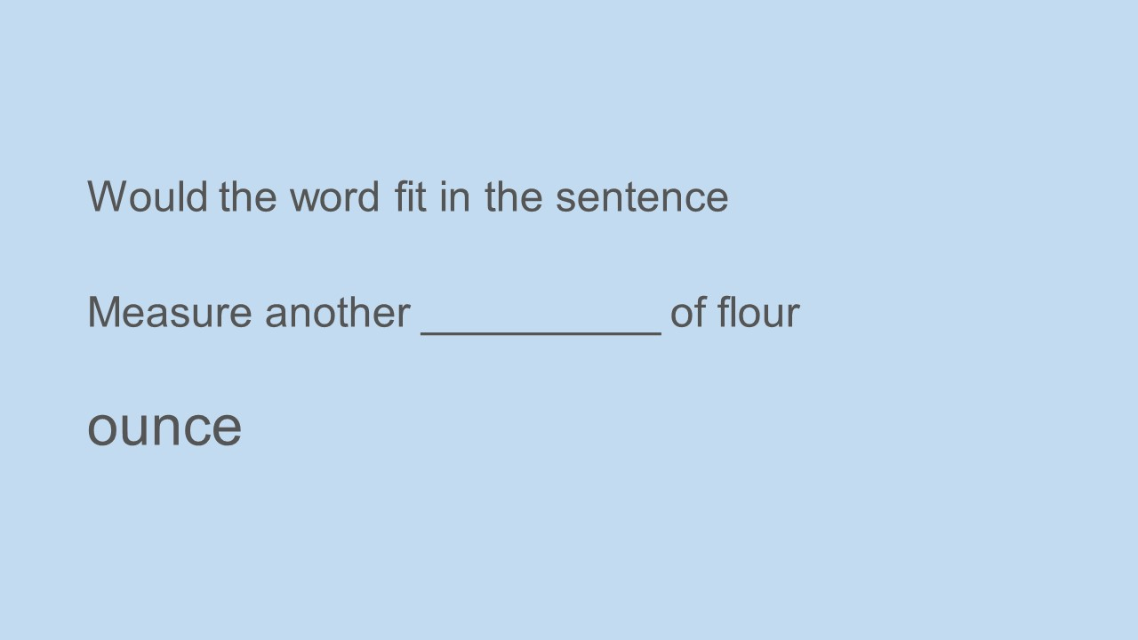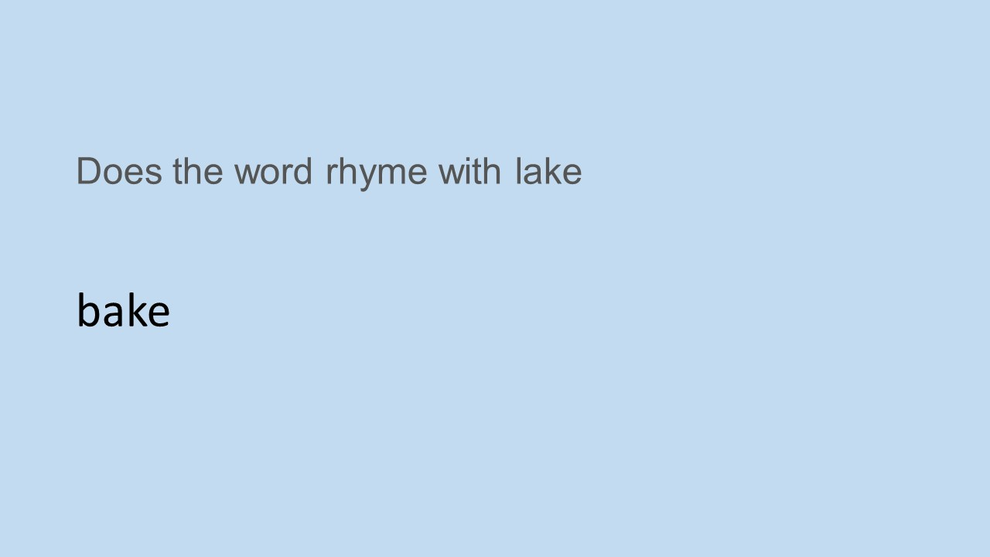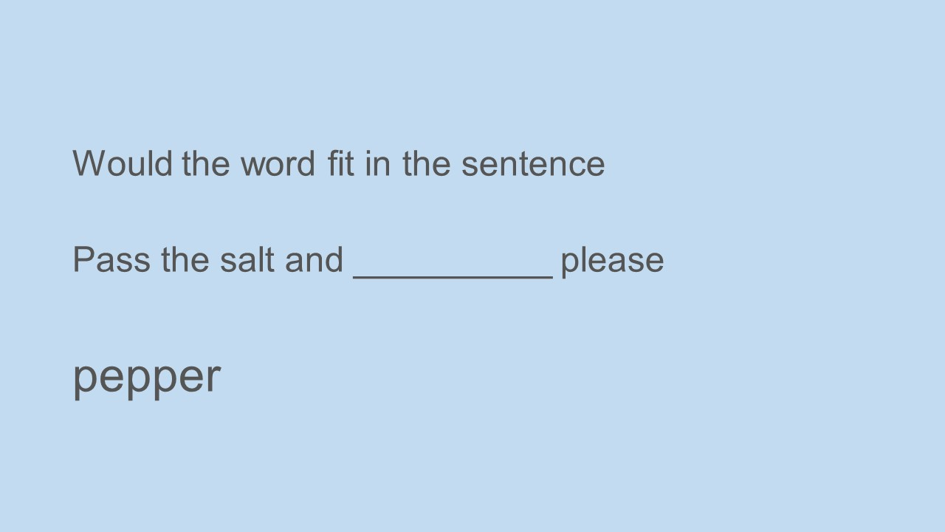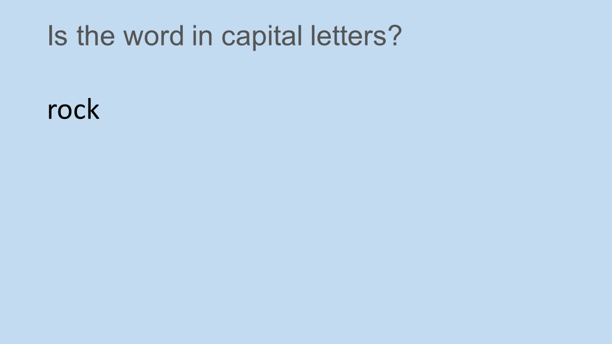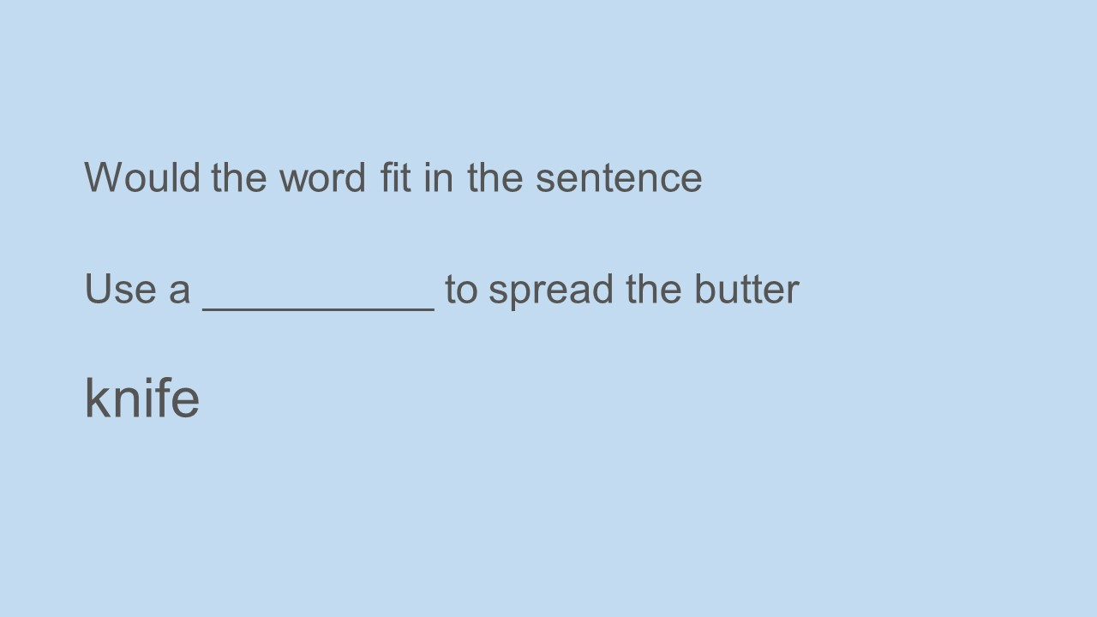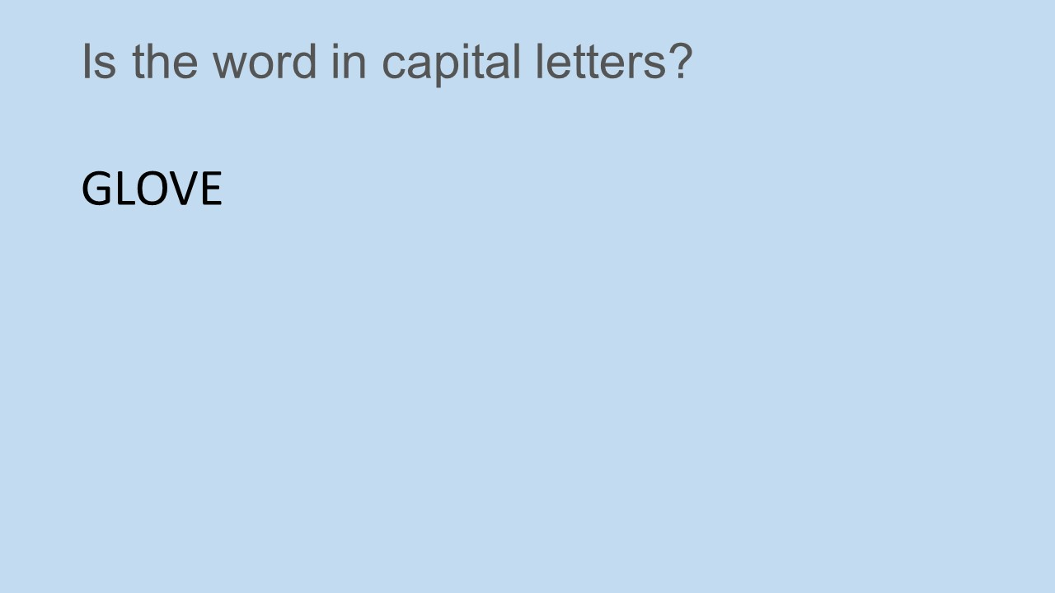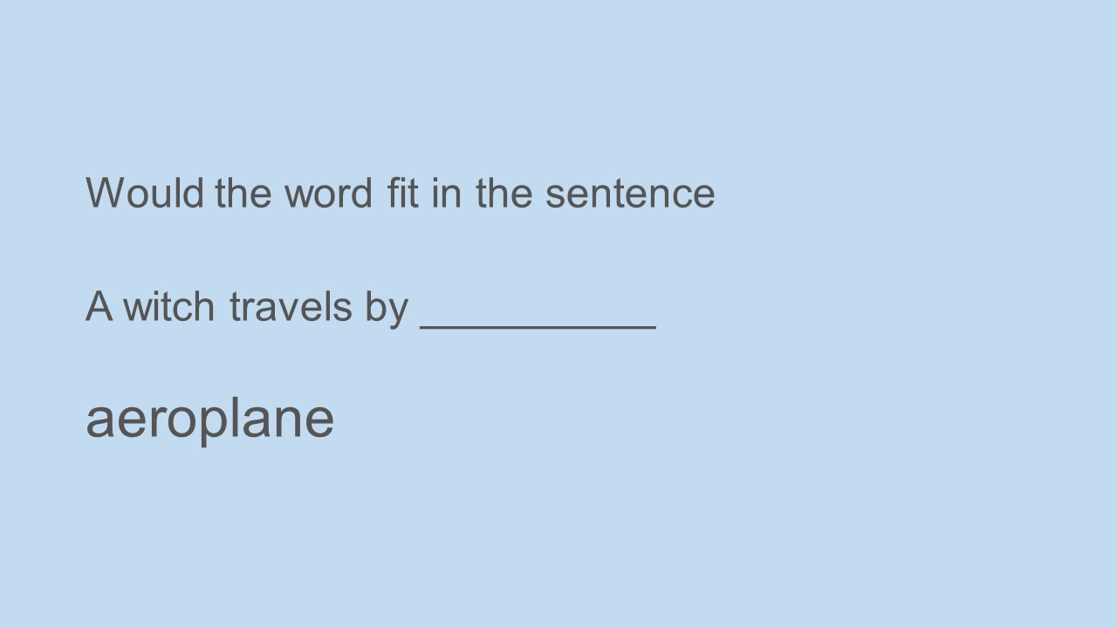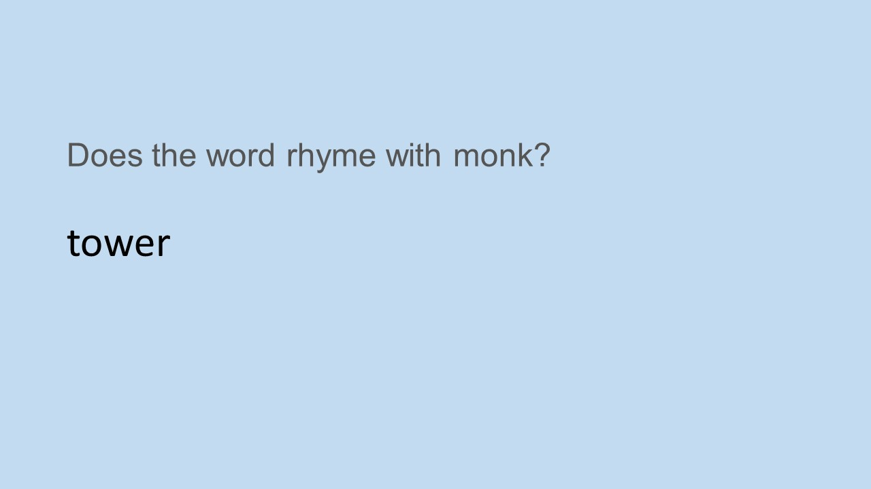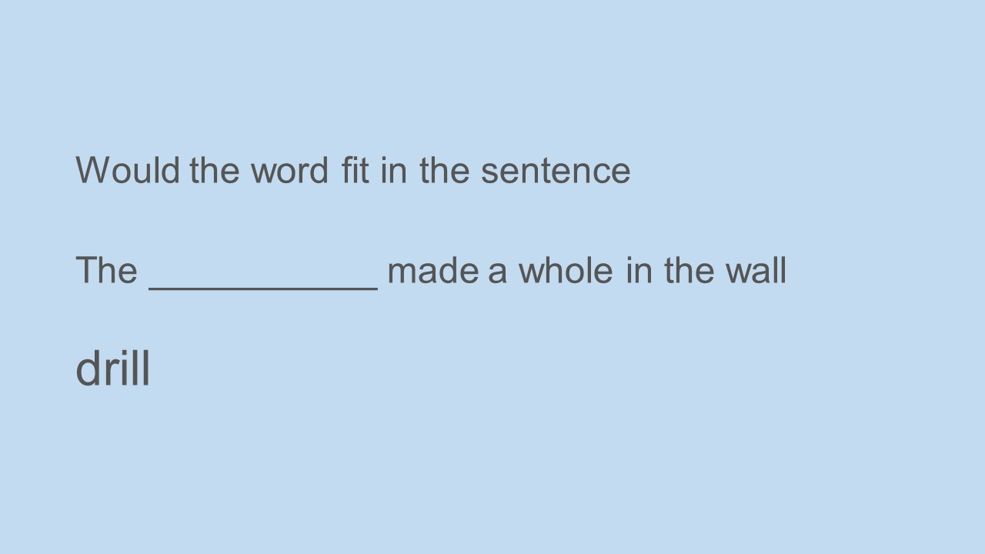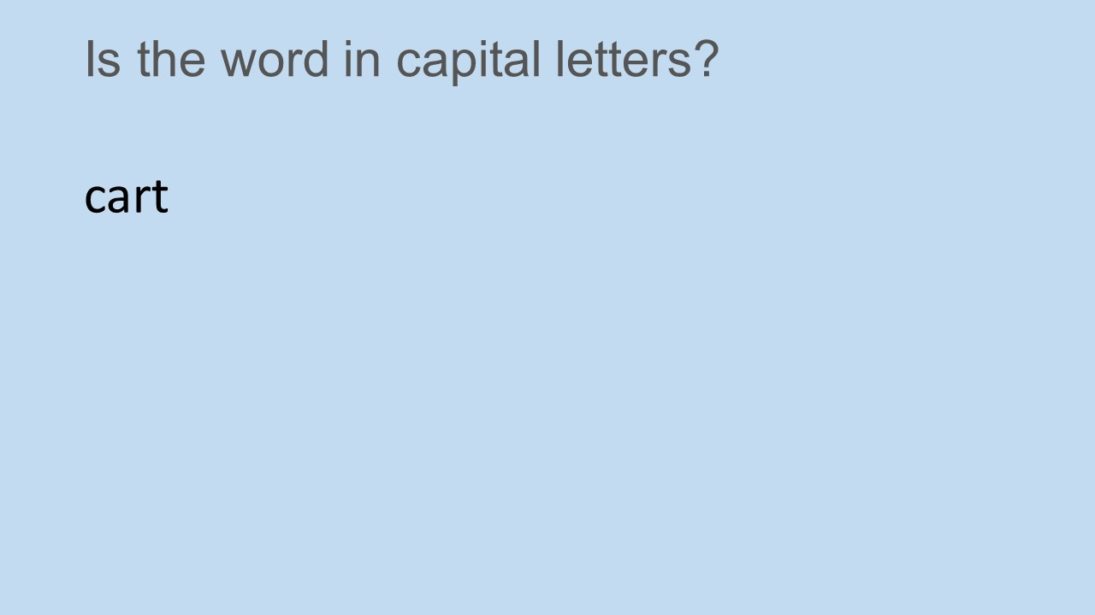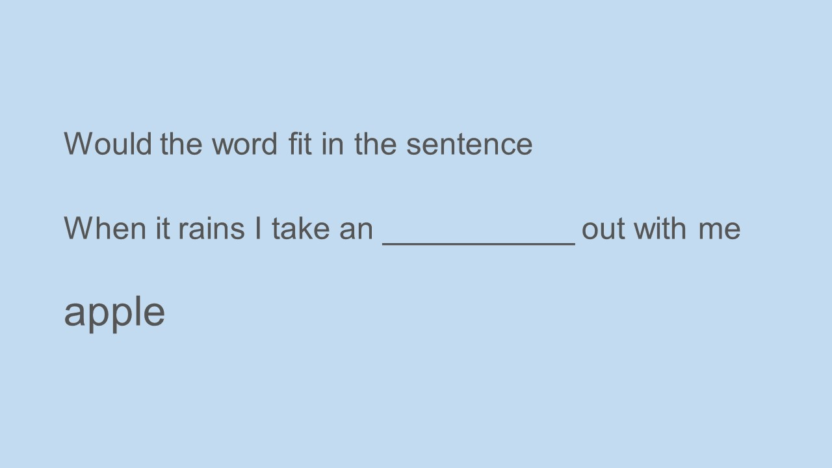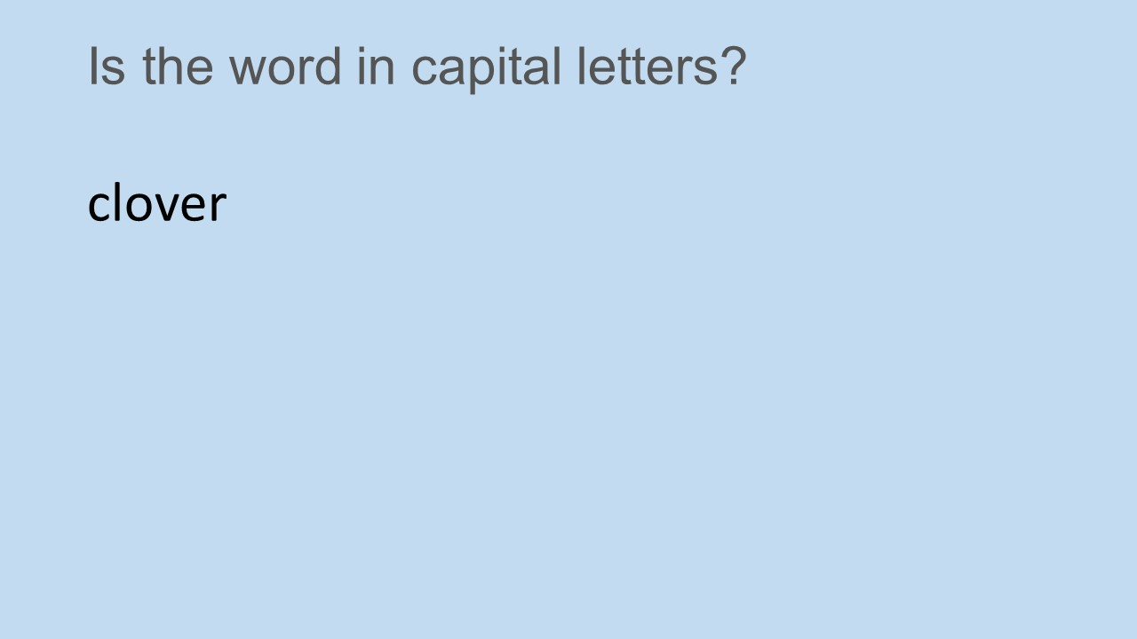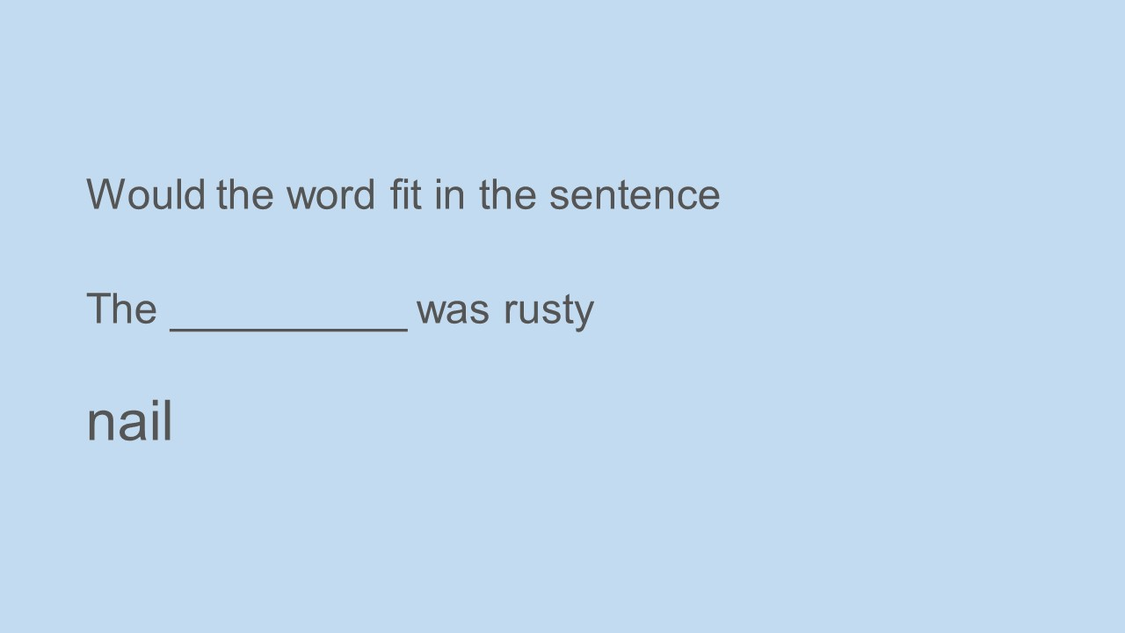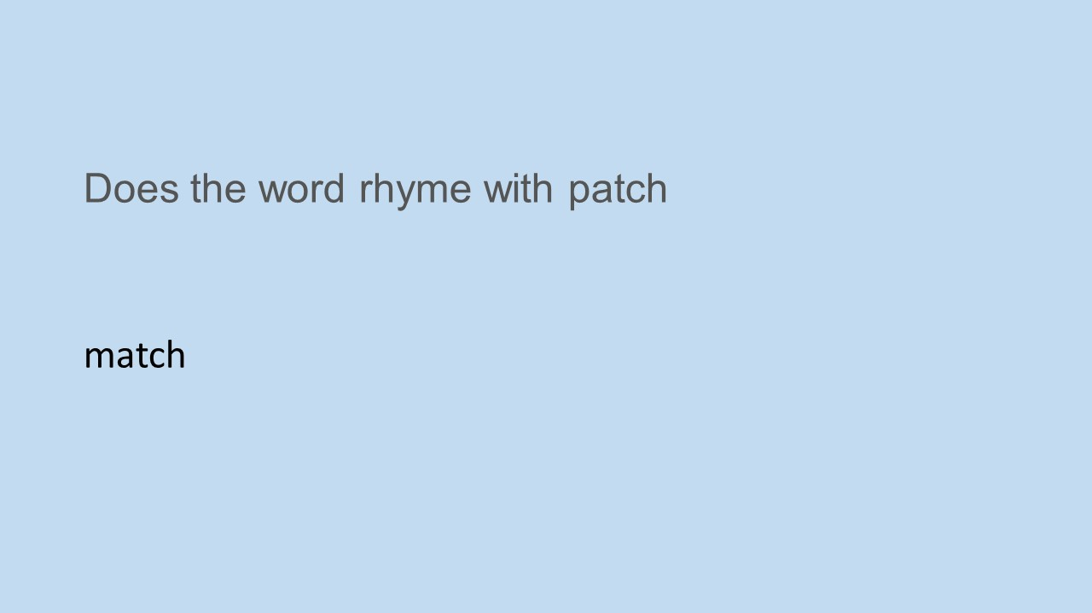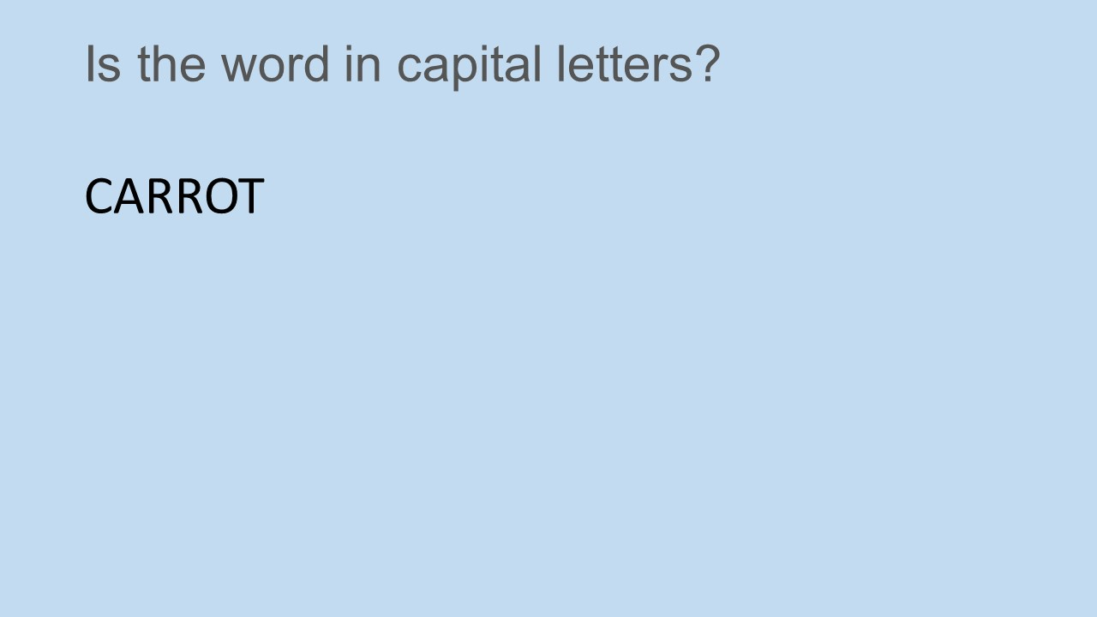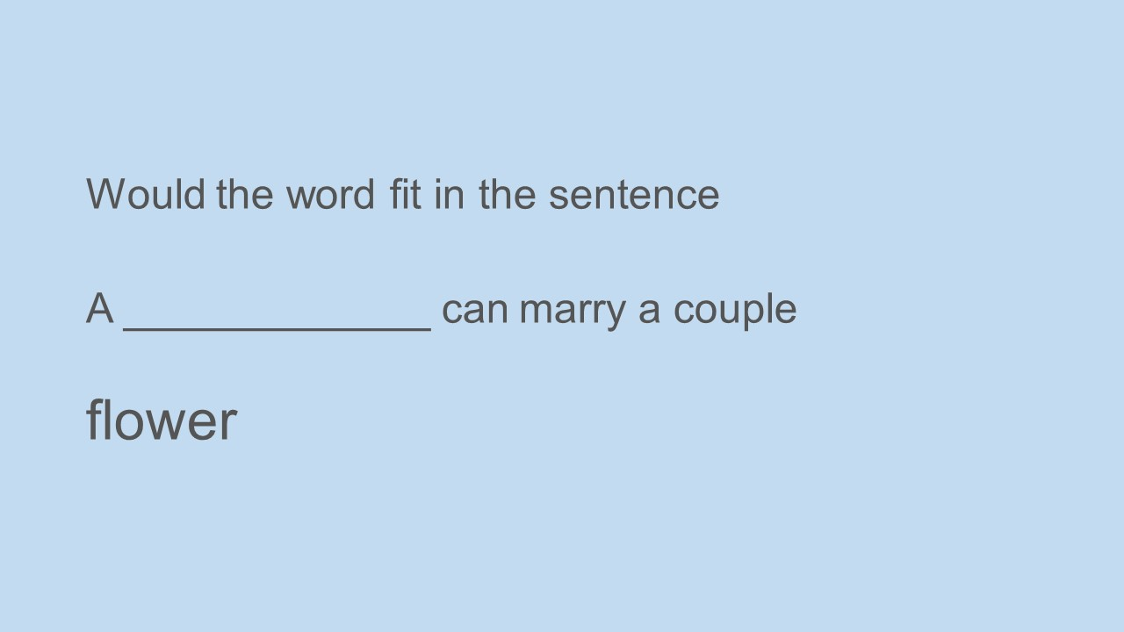

Appendix 4 – Yes/No Answer Sheet

Put a cross on YES or NO in response to what you see on the screen
 | YES | NO
 | YES | NO
 | YES | NO
 | YES | NO
 | YES | NO
 | YES | NO
 | YES | NO
 | YES | NO
 | YES | NO
 | YES | NO
 | YES | NO
 | YES | NO
 | YES | NO
 | YES | NO
 | YES | NO
 | YES | NO
 | YES | NO
 | YES | NO
 | YES | NO
 | YES | NO
 | YES | NO
 | YES | NO
 | YES | NO
 | YES | NO
 | YES | NO

 | YES | NO
 | YES | NO
 | YES | NO
 | YES | NO
 | YES | NO
 | YES | NO
 | YES | NO
 | YES | NO
 | YES | NO
 | YES | NO
 | YES | NO
 | YES | NO
 | YES | NO
 | YES | NO
 | YES | NO
 | YES | NO
 | YES | NO
 | YES | NO
 | YES | NO
 | YES | NO

Appendix 5 – Word List

Put a cross by all the original words that you saw when answering the questions
house | LOUD | rule
coat | lost | Fiddle
snail | elephant | muddle
desk | cheek | carrot
phone | tiger | mince
finger | fish | cream
lose | trowel | flower
rubber | juice | hose
throw | crowd | jumper
broom | match | grass
lion | skirt | last
shirt | frame | LAMP
text | rail | tank
glove | jump | sketch
knife | rope | coal
rest | tram | sweater
rice | rack | rock
tone | tack | towel
chair | HELLO | cotton
arm | rake | aeroplane
paint | hand | roses
time | mower | maze
leg | ladder | bake
train | chest | tower
book | rest | glass
clip | pen | play
pepper | pond | line
pear | motor | ounce
neck | foot | hat
paper | Cart | apple
drill | lazer | priest
light | nail | farm
case | harm | clover
tablet | list | razor
knee | ice | race
Appendix 6 – Ethics

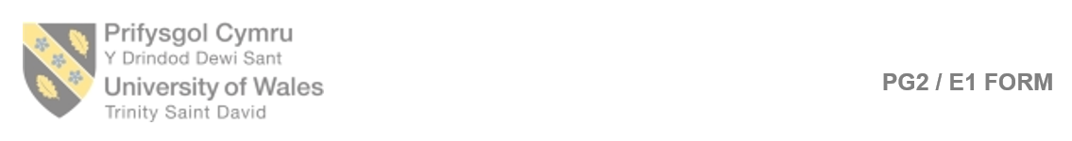
APPLICATION FOR ETHICAL APPROVAL
In order for research to result in benefit and minimise risk of harm, it must be conducted ethically. A researcher may not be covered by the University’s insurance if ethical approval has not been obtained prior to commencement.

The University follows the OECD Frascati manual definition of research activity: “creative work undertaken on a systematic basis in order to increase the stock of knowledge, including knowledge of man, culture and society, and the use of this stock of knowledge to devise new applications”. As such this covers activities undertaken by members of staff, postgraduate research students, and both taught postgraduate and undergraduate students working on dissertations/projects.

The individual undertaking the research activity is known as the “principal researcher”.

Ethical approval is not required for routine audits, performance reviews, quality assurance studies, testing within normal educational requirements, and literary or artistic criticism.

Please read the notes for guidance before completing ALL sections of the form.

This form must be completed and approved prior to undertaking any research activity. Please see Checklist for details of process for different categories of application.

SECTION A: About You (Principal Researcher)

Full Name: |  |  | Charlotte Greenway
Tick all boxes which apply:
Member of staff: | ☒ | Student: |  | ☐ | Honorary research fellow: | ☐

Faculty/School/Centre: | Psychology
Campus: | Carmarthen
E-mail address: | c.greenway@uwtsd.ac.uk
Contact Telephone Number: | 01267676923
For students:
Student Number: |  | Undergraduate | ☐
Programme of Study: |  | Taught Postgraduate | ☐
Director of Studies/Supervisor: |  | Research | ☐

SECTION B: Approval for Research Activity

Has the research activity received approval in principle?  (please check the Guidance Notes as to the appropriate approval process for different levels of research by different categories of individual) |  | YES | ☒ | NO | ☐
 |  |  |  | Date
If Yes, please indicate source of approval (and date where known): | Research Degrees Committee |  | ☐
 | Faculty Research Committee |  | ☐
 | Other (write in)  School ethics board |  | ☒ | 03.09.18
Approval in principle must be obtained from the relevant source prior to seeking ethical approval.

SECTION C: External Ethical Guidance Materials

Please list the core ethical guidance documents that have been referred to during the completion of this form (including any discipline-specific codes of research ethics, and also any specific ethical guidance relating to the proposed methodology). Please tick to confirm that your research proposal adheres to these codes and guidelines.
Code of Ethics and Conduct (2018) | ☒
BPS Code of Human Research Ethics (2nd edition, 2014) | ☒
The General Data Protection Regulation (GDPR) | ☒

SECTION D: External Collaborative Research Activity

Does the research activity involve collaborators outside of the University? |  | YES | ☐ | NO | ☒
If Yes, please provide the name of the external organisation and name and contact details for the main contact person:
Institution
Contact person name
Contact person e-mail address

Where research activity is carried out in collaboration with an external organisation
Does this organisation have its own ethics approval system? | YES | ☐ | NO | ☐
If Yes, please attach a copy of any final approval (or interim approval) from the organisation

SECTION E: Details of Research Activity

Indicative title: | The effects of levels of processing on memory recall
Proposed start date: | 16.10.18 | Proposed end date: | 9.11.18
Purpose of research activity (including aims and objectives)
Outline the purpose, aims and objectives of the research activity, including key research questions. Show briefly how existing research has informed the proposed activity and explain what the research activity will add and how it addresses an area of importance. (Maximum 300 words)
The basic prediction of the LOP approach is that the amount of information participants will recall/recognise will depend on how deeply the experimental stimuli were processed.

Craik and Tulving (1975) investigated the effects of different types of processing on the recall of words. They argued that deeper levels of processing result in more long lasting and more retrievable memories, whereas shallow levels of processing result in memories that are less long-lasting and less likely to be retrieved.

It is predicted (from the above theory), that words which are processed for meaning (deep processing) will be remembered better than words processed for sound (intermediate processing) which in turn will be recalled better than words which are processed for superficial characteristics such as shape, size or colour (shallow processing).

This explanation of memory is useful in everyday life because it highlights the way in which elaboration, which requires deeper processing of information, can aid memory. This has educational implications. Students can use semantic processing to revise which should result in deeper processing through using elaborative rehearsal. Consequently, more information will be remembered (and recalled) and better exam results should be achieved.

This research will help to confirm previous findings and the importance of elaborative rehearsal.
(this box should expand as you type)
Proposed methods
Provide a brief summary of all the methods that may be used in the research activity, making it clear what specific techniques may be used. If methods other than those listed in this section are deemed appropriate later, additional ethical approval for those methods will be needed. (Maximum 600 words)
In-class experiment using presumptive consent.

Students will be presented with a powerpoint slide that includes 45 trials (plus four practice trials). 15 structural/shallow words (Is this word in capital letters?) 15 phonological/intermediate words (Does this word rhyme with _?), and 15 semantic meaning/deep words (Does the word fit in the sentence? Cat’s meow, dogs_). While going through each slide students will be asked to place a cross in a yes or no box (e.g., Q3. Is this word in capital letters? – TRAIN – put a cross in the no box).

Students believe that this is the real test, but once they have completed the task above, the real task involves them recognising words from the powerpoint slides. The 45 words from the slides are placed amongst 105 words. Their task is to recognise as many of the 45 words presented to them, again putting a cross against as many of the 45 words as they can remember.

All data will be collated and analysed using SPSS.

(this box should expand as you type)

Location of research activity
Identify all locations where research activity will take place.
D003 – computer lab. Carmarthen campus.

(this box should expand as you type)
Research activity outside of the UK
If research activity will take place overseas, you are responsible for ensuring that local ethical considerations are complied with and that the relevant permissions are sought. Specify any local guidelines (e.g. from local professional associations/learned societies/universities) that exist and whether these involve any ethical stipulations beyond those usual in the UK (provide details of any licenses or permissions required). Also specify whether there are any specific ethical issues raised by the local context in which the research activity is taking place, for example, particular cultural sensitivities or vulnerabilities of participants.
N/A

(this box should expand as you type)

SECTION F: Scope of Research Activity

Will the research activity include: | YES | NO
Use of a questionnaire or similar research instrument? | ☒ | ☐
Use of interviews? | ☐ | ☒
Use of diaries? | ☐ | ☒
Participant observation with their knowledge? | ☐ | ☒
Participant observation without their knowledge? | ☐ | ☒
Use of video or audio recording? | ☐ | ☒
Access to personal or confidential information without the participants’ specific consent? | ☐ | ☒
Administration of any questions, test stimuli, presentation that may be experienced as physically, mentally or emotionally harmful / offensive? | ☐ | ☒
Performance of any acts which may cause embarrassment or affect self-esteem? | ☐ | ☒
Investigation of participants involved in illegal activities? | ☐ | ☒
Use of procedures that involve deception? | ☐ | ☒
Administration of any substance, agent or placebo? | ☐ | ☒
Working with live vertebrate animals? | ☐ | ☒
Other primary data collection methods, please explain in this box  Experiment (see above) | ☒ | ☐

If NO to every question, then the research activity is (ethically) low risk and may be exempt from some of the following sections (please refer to Guidance Notes).

If YES to any question, then no research activity should be undertaken until full ethical approval has been obtained.
SECTION G: Intended Participants

Who are the intended participants: | YES | NO
Students or staff at the University? | ☒ | ☐
Adults (over the age of 18 and competent to give consent)? | ☒ | ☐
Vulnerable adults? | ☐ | ☒
Children under 18? | ☐ | ☒
Prisoners? | ☐ | ☒
Young offenders? | ☐ | ☒
Those who could be considered to have a particularly dependent relationship with the investigator or a gatekeeper? | ☐ | ☒
People engaged in illegal activities? | ☐ | ☒
Others (please identify): | ☐ | ☒

Participant numbers and source
Provide an estimate of the expected number of participants. How will you identify participants and how will they be recruited?
They will part of the level 5 research methods cohort. Approx 24 students
this box should expand as you type)

Information for participants: | YES | NO | N/A
Will you describe the main research procedures to participants in advance, so that they are informed about what to expect? | ☒ | ☐ | ☐
Will you tell participants that their participation is voluntary? | ☐ | ☐ | ☒
Will you obtain written consent for participation? | ☐ | ☐ | ☒
Will you explain to participants that refusal to participate in the research will not affect their treatment or education (if relevant)? | ☐ | ☐ | ☒
If the research is observational, will you ask participants for their consent to being observed? | ☐ | ☐ | ☒
Will you tell participants that they may withdraw from the research at any time and for any reason? | ☐ | ☐ | ☒
With questionnaires, will you give participants the option of omitting questions they do not want to answer? | ☐ | ☐ | ☒
Will you tell participants that their data will be treated with full confidentiality and that, if published, it will not be identifiable as theirs? | ☒ | ☐ | ☐
Will you debrief participants at the end of their participation, in a way appropriate to the type of research undertaken? | ☒ | ☐ | ☐
If NO to any of above questions, please give an explanation
This is an in-class experiment and is part of their first assessed report. If they do not take part – they will not understand how to complete their assignment.

(this box should expand as you type)

Information for participants: | YES | NO | N/A
Will participants be paid? | ☐ | ☒ | ☐
Is specialist electrical or other equipment to be used with participants? | ☐ | ☒ | ☐
Are there any financial or other interests to the investigator or University arising from this study? | ☐ | ☒ | ☐
Will the research activity involve deliberately misleading participants in any way, or the partial or full concealment of the specific study aims? | ☐ | ☒ | ☐
If YES to any question, please provide full details
(this box should expand as you type)

SECTION H: Anticipated Risks

Outline any anticipated risks that may adversely affect any of the participants, the researchers and/or the University, and the steps that will be taken to address them.

If you have completed a full risk assessment (for example as required by a laboratory, or external research collaborator) you may append that to this form.

Full risk assessment completed and appended?

Yes ☐
No ☒

Risks to participants
For example: emotional distress, financial disclosure, physical harm, transfer of personal data, sensitive organisational information
Emotional distress. Students may be upset if their recall scores are low. In the debriefing I will reiterate what they have previously learned in relation to memory tests, and reassure them that this is no way linked to intelligence.

(this box should expand as you type)
If research activity may include sensitive, embarrassing or upsetting topics (e.g. sexual activity, drug use) or issues likely to disclose information requiring further action (e.g. criminal activity), give details of the procedures to deal with these issues, including any support/advice (e.g. helpline numbers) to be offered to participants. Note that where applicable, consent procedures should make it clear that if something potentially or actually illegal is discovered in the course of a project, it may need to be disclosed to the proper authorities
N/A
(this box should expand as you type)
Risks to investigator
For example: personal safety, physical harm, emotional distress, risk of accusation of harm/impropriety, conflict of interest
The risks to the investigator are minimal as this is an in-class experiment with students that the researcher already knows. The only risk may be researcher bias, but as the students will be writing up their own lab reports, this should not be an issue in the interpretation of results.

(this box should expand as you type)
University/institutional risks
For example: adverse publicity, financial loss, data protection
Minimal as I will follow BPS and University guidelines.
(this box should expand as you type)
Adverse outcomes
List measures put in place to limit any adverse effects or outcomes of research activity where appropriate. Include any emergency protocols.
I will follow the University’s emergency protocols if need be (as the experiment will take place on the premises).

(this box should expand as you type)

Disclosure and Barring Service
If the research activity involves children or vulnerable adults, a Disclosure and Barring Service (DBS) certificate must be obtained before any contact with such participants. | YES | NO | N/A
Has a DBS certificate been obtained? | ☐ | ☐ | ☒
SECTION I: Feedback, Consent and Confidentiality

Feedback
What feedback will be provided to participants, how will this be done and when?
Debriefing – verbal following the experiment

(this box should expand as you type)
Informed consent
Describe the arrangements to inform potential participants, before providing consent, of what is involved in participating. Describe the arrangements for participants to provide full consent before data collection begins. If gaining consent in this way is inappropriate, explain how consent will be obtained and recorded.
Presumptive – in-class experiment

(this box should expand as you type)
Confidentiality / Anonymity
Set out how anonymity of participants and confidentiality will be ensured in any outputs. If anonymity is not being offered, explain why this is the case.
No names/personal information will be attached to the individual scores.
(this box should expand as you type)

SECTION J: Data Protection and Storage

In completing this section refer to the University’s Research Data Management Policy and the extensive resources on the University’s Research Data Management web pages (http://uwtsd.ac.uk/library/research-data-management/).
 | YES | NO
Does the research activity involve personal data (as defined by the Data Protection Act)?  “personal data” means data which relate to a living individual who can be identified—  (a) from those data, or  (b) from those data and other information which is in the possession of, or is likely to come into the possession of, the data controller, and includes any expression of opinion about the individual and any indication of the intentions of the data controller or any other person in respect of the individual. | ☐ | ☒
If YES, provide a description of the data and explain why this data needs to be collected:
(this box should expand as you type)
Does it involve sensitive personal data (as defined by the Data Protection Act)?  “Sensitive personal data” means personal data consisting of information as to –  (a) the racial or ethnic origin of the data subject,  (b) his political opinions,  (c ) his religious beliefs or other beliefs of a similar nature,  (d) whether he is a member of a trade union (within the meaning of the Trade Union and Labour Relations (Consolidation) Act 1992),  (e) his physical or mental health or condition,  (f) his sexual life,  (g) the commission or alleged commission by him of any offence, or  (h) any proceedings for any offence committed or alleged to have been committed by him, the disposal of such proceedings or the sentence of any court in such proceedings. | ☐ | ☒
If YES, provide a description of the data and explain why this data needs to be collected:
(this box should expand as you type)

Will the research activity involve storing personal data on one of the following: | YES | NO
Manual files (i.e. in paper form)? | ☐ | ☒
University computers? | ☐ | ☒
Private company computers? | ☐ | ☒
Home or other personal computers? | ☐ | ☒
Laptop computers/ CDs/ Portable disk-drives/ memory sticks? | ☐ | ☒
“Cloud” storage or websites? | ☐ | ☒
Other – specify: | ☐ | ☒
For all stored data, explain the measures in place to ensure data confidentiality, including details of password protection, encryption and anonymisation:
There is no personal date – just scores (raw data).

(this box should expand as you type)

Will the research activity involve any of the following activities: | YES | NO
Electronic transfer of data in any form? | ☐ | ☒
Sharing of data with others at the University? | ☐ | ☒
Sharing of data with other organisations? | ☐ | ☒
Export of data outside the European Union or importing of data from outside the UK? | ☐ | ☒
Use of personal addresses, postcodes, faxes, emails or telephone numbers? | ☐ | ☒
Publication of data that might allow identification of individuals? | ☐ | ☒
Use of data management system? | ☐ | ☒
Data archiving? | ☐ | ☒
If YES to any question, please provide full details, explaining how this will be conducted in accordance with the Data Protection Act (and/or any international equivalent):
(this box should expand as you type)

List all who will have access to the data generated by the research activity:
The principal researcher

(this box should expand as you type)
List who will have control of, and act as custodian(s) for, data generated by the research activity:
The principal researcher

(this box should expand as you type)
Give details of data storage arrangements, including where data will be stored, how long for, and in what form. Will data be archived – if so how and if not why not.
N/A as data will not be stored. Raw data will be analysed in SPSS in class.

(this box should expand as you type)

SECTION K: Declaration

The information which I have provided is correct and complete to the best of my knowledge. I have attempted to identify any risks and issues related to the research activity and acknowledge my obligations and the rights of the participants.

In submitting this application I hereby confirm that I undertake to ensure that the above named research activity will meet the University’s Research Ethics and Integrity Code of Practice
Signature of applicant: |  | Date:

For students:
Director of Studies/Supervisor: | Dr Charlotte Greenway
Signature:
Date: | 15.10.18

For staff:
Head of School/Assistant Dean:
Signature:
Date:

Checklist: Please complete the checklist below to ensure that you have completed the form according to the guidelines and attached any required documentation:
☒ | I have read the guidance notes supplied before completing the form.
☒ | I have completed ALL RELEVANT sections of the form in full.
☒ | I confirm that the research activity has received approval in principle
☒ | I have attached a copy of final/interim approval from external organisation (where appropriate)
☐ | I have attached a full risk assessment (and have NOT completed Section H of this form) (where appropriate)
☒ | I understand that it is my responsibility to ensure that the above named research activity will meet the University’s Research Ethics and Integrity Code of Practice.
☒ | I understand that before commencing data collection all documents aimed at respondents (including information sheets, consent forms, questionnaires, interview schedules etc.) must be confirmed by the DoS/Supervisor, module tutor or Head of School.

RESEARCH STUDENTS AND STAFF ONLY
All communications relating to this application during its processing must be in writing and emailed to pgresearch@uwtsd.ac.uk , with the title ‘Ethical Approval’ followed by your name.
You will be informed of the outcome of your claim by email; therefore it is important that you check your University and personal email accounts regularly.

STUDENTS ON UNDERGRADUATE OR TAUGHT MASTERS PROGRAMMES should submit this form (and receive the outcome) via systems explained to you by the supervisor/module leader.

This form is available electronically from the Academic Office web pages: http://www.uwtsd.ac.uk/academic-office/

Application Process

All staff research projects and all research students must submit the Ethical Approval Form to the University Ethics Committee via the Academic Office (pgresearch@uwtsd.ac.uk). Staff research directly in relation to personal study for taught undergraduate or Masters programmes should be submitted via the Faculty procedures explained below.

Taught masters and taught undergraduate research Ethical Approval Forms are considered within Faculties. Faculties will provide details of the specific processes for this. Where the Ethical issues within any single ethical application are of particular concern the Faculty will refer these to the University Ethics Committee. Any student activity that involves the collection of primary data needs to undergo Ethical approval, this includes assignment work as well as dissertations.

Notes for guidance in completion of this form

Section A: About You
Please complete all relevant sections

Section B: Approval for research activity
Research proposals must be approved in principle before applying for Ethical Approval. The proposal approval only becomes final when the ethical approval is received.

The process for proposal approval varies according the individual and programme of study:
- Research students, by application on form PG1 to the Research Degrees Committee
- Taught students by review of research proposal within Faculties (Faculties provide specific details of these processes)
- Staff, by agreement by the Head of School/Assistant Dean

Section C: External Ethical Guidance materials
Many discipline areas are required to operate with the discipline specific codes of research ethics (for example health, psychology, education etc.), any such codes must be listed and you must tick to confirm that you have consulted with these.

Section D: External Collaborative Research Activity
Provide details of the external collaborative partners, where appropriate you might want to submit a copy of the external collaboration agreement with the Ethical Approval Form. If the partner requires the research to be subject to its own internal Ethical approval process then please provide details of that process and a copy of any final (or interim) approvals received from the organisation.

Section E: Details of Research Activity
Remember that the individuals reviewing this Ethical Approval Form may not have seen your research proposal, and also may not be experts in the specific area of your research. The information provided should therefore be jargon free and clearly stated.
Indicative Title: please use the same title as used on the research proposal.
Purpose: the Ethical approval process will want to ensure that the methods you propose are adequate and appropriate to address the research aims and objectives. Excessive additional data collection can be seen as unethical.
Proposed Methods: the Ethical approval process seeks to ensure that you understand the methods that are intended, and that the implementation of those methods will be appropriate and without unnecessary impact on respondents. Please be specific.
Location: this needs to mention geographical location and also local situation (for example, within Local Authority Offices in Cardiff, using a private room but close to other individuals). If you are collecting data within an organisational setting then you need to explain the permissions that you have obtained to do this.
Research Activity outside of the UK: please complete this section in detail, and note any guidance you have received. Also describe your own familiarity (or not) with the location that you will be utilising.

Section F: Scope of Research Activity
Please tick ALL of the research activities that might be undertaken. If any additional types of activity are intended then please add an extra box and describe these.
If you have answered no to all questions in F then sections G and J do not need to be completed. Section H should be considered, and may be completed. Signatures are still required in section K.

Section G: Intended Participants
Please tick all categories that might apply.
Numbers & Source: if you are using a series of different methods or research activities please list numbers for each stage/phase. Be clear about how you will find respondents. Will you use intermediaries, and if so how? How will you ensure compliance with your sampling strategy?
Information for participants: all participants should be appropriately informed about the research, what is expected of them and what will happen to the information that they provide. The Ethical review process does not ask to see this documentation, but requires this to be reviewed and approved by the Director of Studies in the case of research students, the supervisor/module tutor in relation to students on taught programmes and the Head of School/Assistant Dean in relation to staff research.

Section H: Anticipate Risks
All research carries some level of risk. The answers you provide to questions in this section will be reviewed to ensure that you have an appropriate understanding of the type of risks involved and how you can mitigate against these risks. If you have completed a full risk assessment, as required for example for laboratory work, field work, clinical tests, diving operations, or by a collaborative partner, you may append that to this form. In that case, please tick the box indicating this has been provided. You will not then be required to complete Section H.
Risk to participants Think very carefully about how your actions/questions/discussions might affect the people you are involving as participants. You might identify the risk as small but it would still be a risk. Many types of question have the potential to make respondents less content with their life / job; you need to recognise and try to ameliorate any such effects
If these are business owners, time with you may reduce profit.
In some locations physical risk is very real to both participants and yourself, please consider this.
Risk to you, the researcher Think about where you will meet people, if there are any dangers involved in the location. If you are meeting people as individuals think about using a public place. In general do not visit people in their own homes or remote locations. If you are talking to individuals about certain issues think about how their responses might affect you emotionally. What about the risk of collecting insufficient data?
Risk to the University When undertaking your research, you are acting as a member of the University (student or staff). Professionalism is important, so it is important to be well organised and well prepared. Punctuality, clarity etc. are all part of this. What will you do to ensure this? You must ensure you do not harm the good name of the University in any way and do nothing to undermine the reputation of the research it conducts and sponsors. Upholding high standards of conduct and integrity are vital in this regard. You must also conduct the research in such a way to minimise the potential for claims of negligence made against the University, its researchers and any collaborating individual or organisation. In this respect you should always comply with ethical, legal and professional frameworks, obligations and standards as required by statutory and regulatory authorities, as well as the university’s Research Integrity and Ethics Code of Practice. Research misconduct in this respect can take many forms, including:
- fabrication: making up results or other outputs (eg, artefacts) and presenting them as if they were real
- falsification: manipulating research processes or changing or omitting data without good cause
- plagiarism: using other people’s material without giving proper credit
- failure to meet ethical, legal and professional obligations: for example failure to declare competing interests; misrepresentation of involvement or authorship; misrepresentation of interests; breach of confidentiality; lack of informed consent; misuse of personal data; and abuse of research subjects or material
- improper dealing with allegations of misconduct: failing to address possible infringements such as attempts to cover up misconduct and reprisals against whistle-blowers

Adverse Outcomes. Think carefully about the possibilities, and cover here

Section I: Feedback, Consent and Confidentiality
Feedback to participants: outline your approach. Will interview transcripts be shared with respondents to check accuracy? Will summaries of questionnaire analysis be made available to respondents in some way? Will an overview report be provided? How and when?
Informed consent: Draft letter / e-mail / or heading (or footer) section of questionnaire must be approved by DoS/supervisor (if research student), supervisor/module tutor if taught student, or Head of School / Assistant Dean if a member of staff.
Confidentiality/Anonymity. Explain clearly how you will ensure confidentiality and anonymity.

Section J: Data Protection and Storage
Before completing this section it is necessary to read the University’s Research Data Management information. The questions that follow are designed to ensure compliance with the Data Protection Act as well as established research protocols.

Many research activities will involve electronic transfer of data and use of data management systems in the summarisation and analysis of data. You will need to explain these in relation to compliance with the Data Protection Act.
Think carefully about who will have access to your data, this will include supervisors and examiners. Also that a thesis will be made available via the University library and the British Library system. If you are seeking an access bar for a period of time after completion then mention it here. If you will provide a copy of your findings, or intend to give a presentation, to a facilitating/ supporting/accessing organisation then explain that in this section. But also think about the general principle of data sharing, as explained in the Research Data Management information.
In terms of storage of data please ensure security, and also mitigate against loss of data.

Section K: Declaration
Ensure the appropriate countersignatures have been provided
Look carefully at the checklist and ensure that you comply with and tick all that are relevant to your research.

Appendix 7 – Consent Form


School of Psychology
Carmarthen Campus

Study Consent Form

I understand that this research study is being carried out by a 2nd year Psychology Student for their dissertation, and that taking part in this study will involve [brief description]
This task will take approximately XX minutes to complete.
I understand that participation in this study is entirely voluntary and I am free to withdraw participation at any time without giving a reason. I am aware that if I have concerns about the study I can discuss these concerns with the researcher or academic supervisor at any time during or after the study.
I understand that the information provided by me will be held confidentially, with a code assigned in place of my name. These data will be stored indefinitely in accordance with the Data Protection Act.
I also understand that at the end of the study I will be provided with a debrief form and the opportunity to discuss any issues with the researchers.

I, Spencer Nicholas consent to participate in the study conducted by Charlotte Greenway, School of Psychology, University of Wales Trinity Saint David, Swansea under the supervision of Charlotte Greenway.

Participant Signature: Spencer Nicholas
Date: 16/10/2018
Name and signature of researcher taking consent
___________________________________________________________________

Appendix 8 – Debrief Form

School of Psychology
Carmarthen Campus

Study Debrief Sheet
(words underlined and in italics should be changed to fit your specific study)
The Effect of Shallow Processing, Intermediate Processing, and Deep Processing on Word Recognition

Thank you for taking part in the study.

The aim of this study was to explore the effect of shallow processing, intermediate processing and deep processing on word recognition. The study attempted to show that deeper levels of processing would result in greater word retention.

If you wish to withdraw your data from the study you must tell the researcher now. After this point, all of your data will remain confidential and we will not trace it back to you.

If taking part in this study has raised any questions please speak to the researchers on 1704551@student.uwtsd.ac.uk or contact the academic supervisor Charlotte Greenway on c.greenway@uwtsd.ac.uk.

Thank you once again for taking time to participate in this study.

Spencer Nicholas

BSc Honours Applied Psychology

University of Wales Trinity Saint David, Carmarthen

