

Student Name: Akul Shailesh Panchal

Student ID: 2428878

Module Name: Marketing Management

Module Code: LCMB7024

Lecturer’s Name: Dr Laila Maazouz ( London )

Word Count: 2691

Term 1
Table of Contents
1. INTRODUCTION 2
2. TASK 1: CRITICAL ANALYSIS OF THE MACRO MARKETING ENVIRONMENT 3
2.1 Overview of the Macro Marketing Environment 3
2.2 Selection of Two External Macro Marketing Actors 4
2.3 Critical Analysis of Each Actor 6
3. TASK 2: STRATEGIC RESPONSES OF PIONEERING AND FOLLOWER ORGANISATIONS 7
3.1 Pioneering Organisations’ Strategic Responses 7
3.2 Follower Organisations’ Strategic Responses 10
4. CONCLUSION 11
5. Reference 13

1. INTRODUCTION
Strategic marketing management is something that has one of the critical roles in terms of enabling companies to navigate the growing, complicated, and competitive marketplace. The prime purpose of this particular report is to analyse how companies can support strategic decision-making by evaluating the external macro-environmental forces and also by formulating adaptive planning that is suited to the pioneering companies. The report is going to concentrate on how external actors can shift the opportunities of marketing, threats of marketing, as well as the long-term competition, and also how companies can leverage the frameworks to respond efficiently. By performing that, the report will highlight the central aspect of awareness of the environment in terms of shaping the strategies of marketing which are resilient.
Evaluating the macro marketing environment is important in external forces, including political changes, growing technology, financial volatility, changing consumer behaviour and environmental pressure, which can directly impact the dynamics in the market and the performance of the companies. The structure evaluation of all of these forces can enable companies to anticipate the major disruptions and recognise the opportunities for growth, eventually reducing the challenges and associating the marketing plan. The environmental scanning equipment, including the PESTLE, can offer one of the systematic methods to analyse the macro factors that could help decision makers to know the present implications.
The report has been structured into two important tasks, where task 1 is going to provide a critical evaluation of the macro marketing environment that concentrates particularly on the two chosen external aspects and the implications regarding the pioneering/follower companies. Apart from that, task 2 is going to analyse how pioneering and follower companies are formulating the strategic responses utilising different strategic models. The report is going to conclude by making a summary of the important insights and reinforcing the significance of a consistent environmental overview in terms of enabling adaptive strategies of marketing.

2. TASK 1: CRITICAL ANALYSIS OF THE MACRO MARKETING ENVIRONMENT

2.1 Overview of the Macro Marketing Environment
Understanding the Macro Marketing Environment
It is noted that the macro marketing environment signifies the wide external factors that impact the strategic decisions of a company and the long-term competition (Yitbarek et al., 2025). Not similar to the micro environment that concentrates upon consumers and competitors, the macro environment engages broad societal, financial, technical, political, legal and environmental aspects that companies cannot directly control but should be consistently observing. The external forces have shaped the requirements of customers and the industrial conditions, which have made them central to the marketing management of strategy (Gini and Agala, 2023). For instance, the movement in demographic structures can redefine the markets targeted, technical advancement can change the development of the product and communication planning with pressure about the environment, reshaping the sustainability expectations. As the market has turned out to be globalised, knowing about the macro environment has turned out to be important for companies looking to stay innovative and competitive.
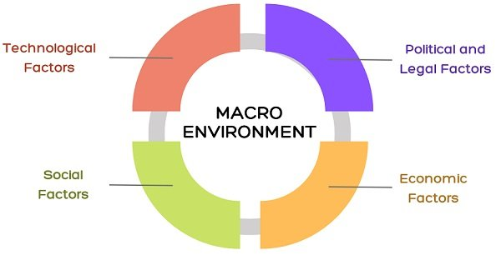
Figure 01: Macro Environmental Marketing Factor
Source: (Gini and Agala, 2023)
Application of PESTEL in Strategic Marketing
The PESTLE framework in this context helps in providing one of the structures as well as a comprehensive way to evaluate the environment of macro marketing. This helps in categorising the external factors towards 6 important dimensions that are political, economic, social, technological, environmental and legal (Citilci and Akbalik, 2023). This particular framework has enabled companies to systematically evaluate how diversified macro-level aspects can impact the choices of strategy. For example, the political policies, including the trade regulations or taxation, can impact the entry strategies in the market, while the financial indicators, such as inflation and customer spending, have changed pricing, and this demands forecasting as well.
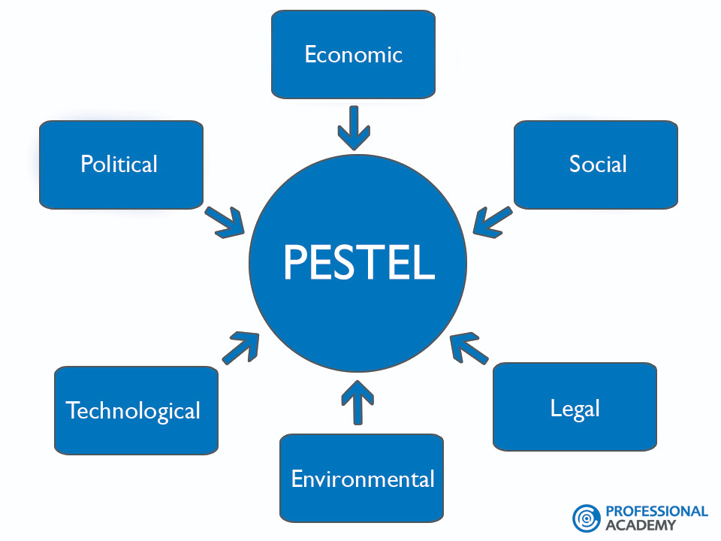
Figure 02: PESTLE
Source: (SpringWorks, 2021)
Social trends such as lifestyle alterations and cultural movements guided the segmentation, whereas technical advancement has formed opportunities for innovation. The environmental factors have pushed companies in the direction of sustainable practices of marketing with legal frameworks confirming compliance (Rashid, 2023). By utilising PESTLE, companies can easily recognise the external opportunities and the threats in the early stage, evaluating the strategic importance and strategies of decision marketing strategies that can be associated with the upcoming conditions in the market.

2.2 Selection of Two External Macro Marketing Actors
Selection of Two External Macro Marketing Actors
In the context of the retail sector of the UK, a couple of influential macro environmental actors include technological change and the economic situation. Both of these two factors are critically helping to shape the retail strategy presently, and their selection is now justified based on the scale of influence and the rapid growth.
Technological Change: Technological change is considered one of the powerful external factors since it is shaping fundamentally how customers in the UK shop and how retailers are operating (Ali et al., 2023). The movement towards e-commerce, the digital platforms, and automation is no longer so functional, and it is important for competition as well. As per the UK parliament research briefing, it is noted that the online retail sales have developed from approximately 5% of the retail sales in FY 2008 to around 27% presently. E-Commerce in August 2025 accounted for around 27.6% of the overall UK retail sales, excluding the respective automotive fuel (Hutton, 2021).
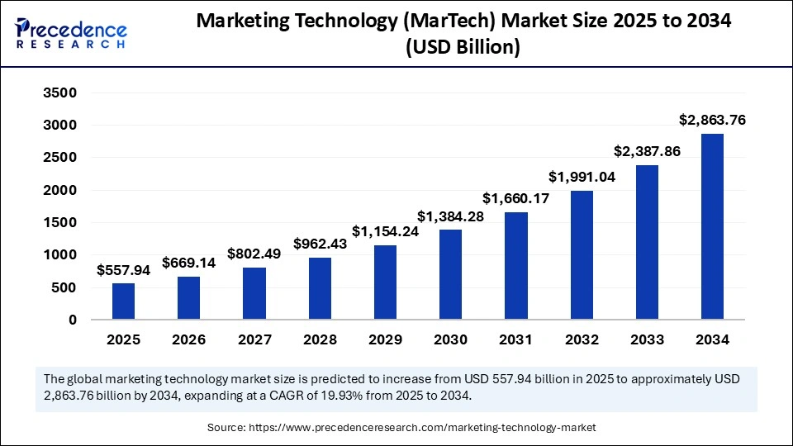
Figure 03: Marketing Technology
Source: (Precedence Research, 2025)
Economic Conditions: The economic conditions are considered to be the second critical macro factor because of their direct impact on the spending of customers, retail volume and the inflation rate (Gafurdjan, 2024). In the retail industry of the UK, the current data has highlighted considerable volatility, where the ONS has reported that retail sales have increased by 1% in February 2025 to approximately 0.9% in June 2025, but it has dropped by 2.7% in May 2025 (Ons.gov.uk, 2025). All of these fluctuations reflect the influence of macro-financial pressures, including inflation, dynamic wages, and consumer confidence.

Their relevance and current influence within Retail Industry
Technological change and economic conditions are the two relevant actors having superior relevance and influence across the retail sector of the UK (Sayad, 2022). It is noted that the Retail Economics Outlook Report of 2025 has highlighted that digital transformation has become imperative across the retailers of the UK, where they have started investing towards AI and automation (Retail Economics, 2025). Considering this, technical change is majorly relevant as it has introduced chances like data-driven customisation and new digital sales, and the threats such as technical description for the retailing companies. The strategic marketing decision should implement technology, and in consideration of channel strategy or consumer engagement, it is important to stay viable.
On the other hand, retail economists have further noted some of the discretionary spending which is majorly under pressure, having households creating a balance between the important purchase and discretionary classifications, such as tech furnishing (Ahmed et al., 2021). Alterations in financial conditions therefore, have risks and opportunities for the retailing companies. For the leaders in marketing, knowing the financial environment is important to make adjustments to the pricing strategies and to forecast the demand based on consumer affordability.

2.3 Critical Analysis of Each Actor
Technological Change
Technological advancement has formed one of the distinct chances for pioneering companies while having adaptation pressure considering the follower companies (Plekhanov et al., 2022). It is noted that the pioneers like Tesco and Amazon UK have implemented early consideration of customisation that is AI-driven, automation, as well as omnichannel implementation to improve consumer experience and efficiency for the operations (Fu, 2024). The early investments of Amazon towards automated fulfilment in centres have decreased the delivery period and enhanced the expense efficiency, helping to reinforce the competitive dominance. The follower companies, however, are going through superior investment expenses and reduced market response, which has restricted their capability to match the speed of service or digital capabilities. The rapid development of online retailing, which is reaching 27.6% of the entire UK retail sales in FY 2025, has formed opportunities for the pioneers to have expansion of the digital ecosystem but impacted the followers that do not have the technical readiness (Retail Economics, 2023).

Economic Conditions
Financial fluctuations impacted the pioneer as well as the followers in a different manner, shaping the resilience and the flexibility of the strategy. The large pioneering companies, such as Marks & Spencer's or Sainsbury's, have leveraged the economies of scale with a diversified portfolio of products for absorbing the downturns (M&S, 2022). For instance, despite a drop in the UK retail volumes in the month of May 2025, the company has been able to maintain its ability following the value focus promotions and optimisation of the supply chain. The followers engaging the small retailing companies are valuable to demand shocks with inflation because of the restricted financial buffers (Zikusooka Enock et al., 2025). The financial pressures have formed chances for pioneers in terms of capturing the moving requirement following competitive pricing and loyalty programs, while it is noted that followers faced challenges losing market share.

3. TASK 2: STRATEGIC RESPONSES OF PIONEERING AND FOLLOWER ORGANISATIONS

3.1 Pioneering Organisations’ Strategic Responses
The pioneering companies have responded to the external issues and opportunities by implementing the first mover benefits, capacity of innovation, as well as the strategic agility (Suntsova, 2024). Across the retail industry of the UK, the pioneering companies, including Amazon, Marks and Spencers and Tesco, have consistently reshaped their strategies in terms of maintaining the competition in the context of technical disruption and financial volatility. When confronted with the growing technical alterations, the pioneering companies are typically considered to have a proactive plan by making major investments towards digital changes and automation (Zhang and Song, 2020). For example, the early consideration of Amazon regarding the AI-driven logistics as well as predictive analytics has enabled a rapid period of delivery and reduced operational expenses. Similarly, the omnichannel transformation of Tesco that incorporates online with physical retailing has highlighted the strategic response targeted at capturing the growing digital requirement. In response to the financial uncertainty and the fluctuating patterns of spending between customers, the pioneering companies frequently utilise the diversified portfolio with value-associated promotions to mitigate the risk of finances.

Application of Ansoff’s Growth Matrix
Market Penetration
Pioneering companies frequently consider the market entry plan to support the position across the existing markets by improving the loyalty of consumers and enhancing the efficiency of services (Ferreira and Marques, 2024). Amazon UK exemplifies this, focusing on the ecosystem of Prime membership that provides rapid delivery and exclusive deals. All of these benefits improve the consumer's attention and support repeat purchases. The retail company Tesco also utilises club card pricing with customised digital promotions in order to get into the market properly to the present consumer base.

Product Development
Pioneer companies like Amazon frequently involve product innovation in order to respond to the advancement of technology and the growing requirements of customers. Another brand, Marks and Spencer, has demonstrated this following consistent improvement for the range of food products, engaging the premium readymade meals and the healthy options, specifically targeting the alternating choices of lifestyle (Dibie et al., 2021). The development of Amazon regarding their own brand product, Such as Eco smart speakers, has highlighted how Amazon has put forward new technology-guided merchandise to reinforce its leadership in the market.
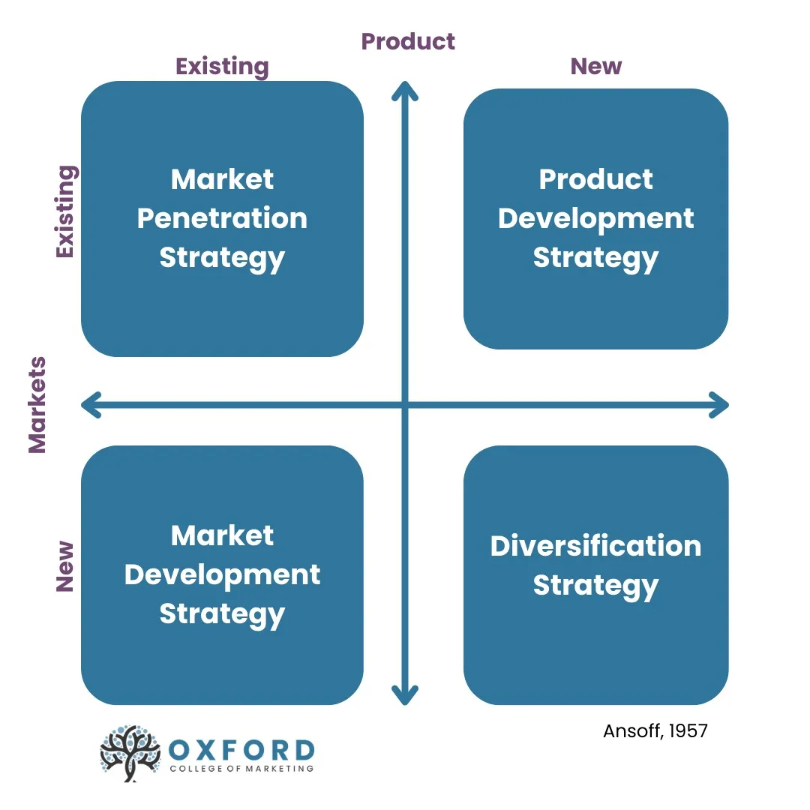
Figure 04: Ansoff Matrix
Source: (Oxford, 2023)
Market Development
Making expansion towards the new geographical segments is another response to the strategy. Tesco has been able to extend the online grocery to get to the rural as well as previously underserved places, capitalising upon the growing requirement for convenience (Wood et al., 2020). Similarly, the expansion of Amazon regarding Amazon Fresh across the cities of the UK has highlighted a deliberate development strategy for the market targeted at collecting a wide share of the grocery industry.

Diversification
The pioneering retailing companies have also diversified, mitigating the challenges that come up from the financial uncertainty (Oxford, 2023). The partnership of Marks and Spencers with Ocado to get into the online grocery marketplace highlighted strategic diversification that permitted companies to expand across the highly developed digital segment. The diversification of Amazon towards cloud computing following AWS has highlighted how pioneers have formed new streams of revenue to support the long-term resilience.

3.2 Follower Organisations’ Strategic Responses
The follower companies across the UK retail sector have sustained competition by considering adaptive as well as efficiently driven planning in response to the external pressures and also the market conditions that are pioneer-dominated (Teller et al., 2020). Unlike the companies in the pioneering status, the followers typically do not have a fast-moving advantage or extensive basis of resources, compelling them to give importance to expense optimisation and selective innovation following the specialised offerings. Going through rapid technical changes and growing digitalisation, the followers frequently invested in affordable technical solutions instead of the large-scale changes (Faruque et al., 2024). For example, the mid-sized companies such as the Range or Wilko have considered the click and collect option with basic E-Commerce platforms so that they could stay accessible towards the digital consumers.
The financial volatility has also changed the strategies of followers, which has pushed them to incorporate the value-driven pricing and eventually streamlined the supply chain to negotiate flexible contracts (Anguzu and Aila, 2024). The retailing companies like Poundland or B&M concentrate upon the discount-driven model to acquire the price-sensitive customers in this period of low customer confidence. In addition, followers do focus on the niche market area to neglect the direct competition, considering the dominant pioneer, and it is evident within brands such as Holland and Barrett, focusing on specialised health merchandise.

Application of Porter’s Generic Strategies
Cost leadership
The follower companies frequently considered cost leadership in order to stay competitive against the pioneers that have high resources (Ali and Anwar, 2021). By providing depreciated prices following the lean operations, as well as bulk purchasing, the follower company can acquire the price-sensitive customers, particularly in the period of financial uncertainty. The retailing companies like Poundland highlight this approach by properly maintaining the minimal overheads of the outlets and giving importance and cost effectiveness over the procurement (Poundland, 2025).

Differentiation
Some of the followers have been pursuing differentiation by concentrating on the specialised merchandise as well as the consumer experience. For example, Holland & Barrett differentiate the company by following niche concentration on health as well as wellness, which is supported by the knowledgeable employees in-store and customised advice (Holland & Barrett, 2023). This strategy enabled followers to avoid direct competition by focusing on the mass market, Pioneer companies, and creating loyalty across the targeted group of customers.
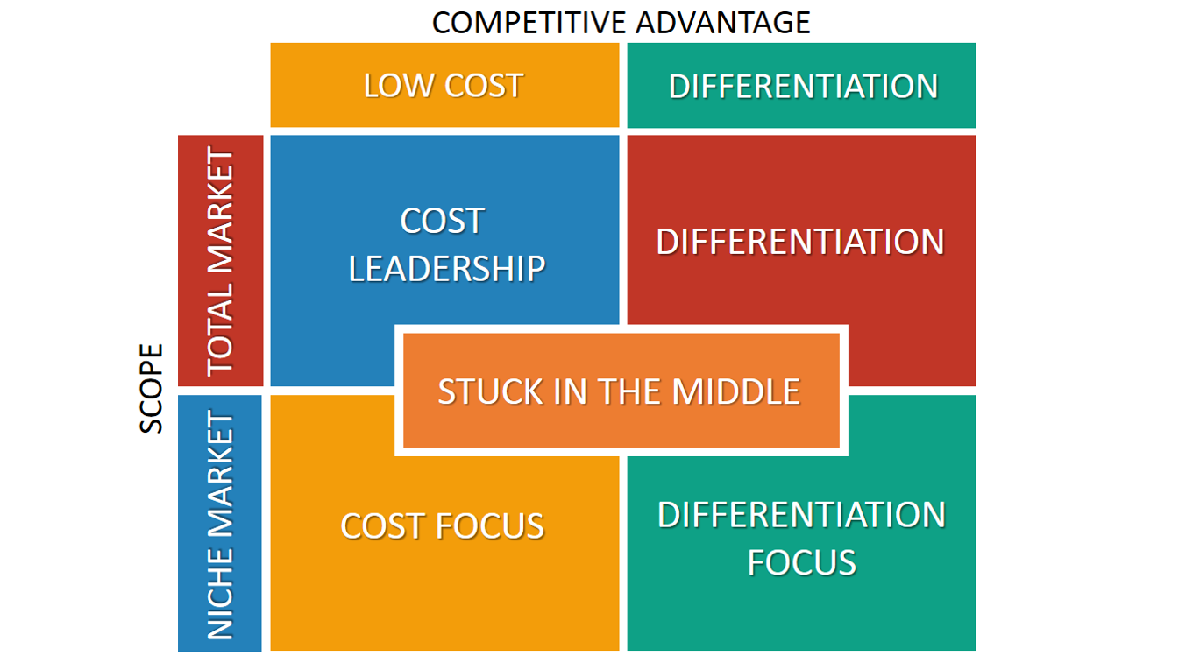
Figure 05: Porter’s Generic Forces
Source: (WP, 2022)
Focus strategy
The focus strategy is specifically efficient for the followers having restricted resources that have permitted them to target the segments with narrow markets (Bose, 2021). The retailing companies like Works concentrate on affordable stationery and craft supplies that have an appeal to a particular base of customers instead of competing widely.

4. CONCLUSION
The analysis has highlighted that the retail industry of the UK has changed significantly due to the macro environmental forces, specifically with the technical support and financial conditions. All of the factors can create chances and threats that could impact the pioneering as well as the follower companies in a different way. The pioneer companies need to focus on innovation with digital transformation, while the follower companies need to respond following the cost effectiveness. The study has implemented frameworks like PESTLE, Ansoff Matrix and Porter's Generic Value, where it has highlighted how every type of company formulates the plan that can be associated with the external pressure.
As a whole, this report has highlighted the strategic value of environmental scanning as the basis for efficient marketing decisions. By evaluating the macro level forces in a systematic manner, the company needs to anticipate the destruction and identify the chances to mitigate the challenges before they can get intensified. The adaptive response of marketing, including the digital innovation with value-based pricing, is also important to sustain the competition. As the technical change grows and the financial condition gets impacted, the capability to interpret the signals and respond proactively turns out to be critical.

5. Reference
Ahmed, M.E., Khan, M.M. and Samad, N. (2021). Income, Social Class and Consumer Behaviour: A Focus on Developing Nations. [online] ResearchGate. Available at: https://www.researchgate.net/publication/320491535_Income_Social_Class_and_Consumer_Behaviour_A_Focus_on_Developing_Nations.
Ali, B. and Anwar, K. (2021). Porter's Generic Competitive Strategies and their influence on the Competitive Advantage. [online] ResearchGate. Available at: https://www.researchgate.net/publication/352181915_Porter.
Ali, O., Osmanaj, V., Abdallah, M., Chimhundu, R. and Dwivedi, Y.K. (2023). The impact of technological innovation on marketing: individuals, organisations and environment: a systematic review. Ekonomska Istrazivanja-economic Research, 36(3). doi:https://doi.org/10.1080/1331677x.2023.2210661.
Anguzu, R. and Aila, F. (2024). Sources of Supply Chain Volatility: A Literature Review. International journal of supply chain management, 9(2), pp.20–36. doi:https://doi.org/10.47604/ijscm.2370.
Bose, T.K. (2021). Market Segmentation and Customer Focus Strategies and Their Contribution towards Effective Value Chain Management. International Journal of Marketing Studies, 4(3). doi:https://doi.org/10.5539/ijms.v4n3p113.
Citilci, T. and Akbalik, M. (2023). The Importance of PESTEL Analysis for Environmental Scanning Process. Advances in Marketing, Customer Relationship Management, and E-Services, [online] pp.336–357. doi:https://doi.org/10.4018/978-1-7998-2559-3.ch016.
Dibie, V.M., C P O Nto, Unanam, E.L. and Bassey, I.E. (2021). Effect of Product Innovation on Customer Acquisition and Retention. [online] Vol. 4 No.1, pp.50–62. Available at: https://www.researchgate.net/publication/356989184_Effect_of_Product_Innovation_on_Customer_Acquisition_and_Retention.
Faruque, M.O., Chowdhury, S.N., Rabbani, Md.G. and Khan, N.A. (2024). Technology Adoption and Digital Transformation in Small Businesses: Trends, Challenges, and Opportunities. International Journal For Multidisciplinary Research, [online] 6(5). doi:https://doi.org/10.36948/ijfmr.2024.v06i05.29207.
Ferreira, A. and Marques, M.B. (2024). The Importance of the Ansoff Matrix for the Study of the Information Services Market. [online] Canadian Journal of Information and Library Science. Available at: https://www.researchgate.net/publication/382141729_The_Importance_of_the_Ansoff_Matrix_for_the_Study_of_the_Information_Services_Market.
Fu, R. (2024). Analysis of Business Operation Mode and Marketing Strategy of British Mainstream Supermarket: Case study of Tesco. Journal of Education Humanities and Social Sciences, 43(1), pp.279–285. doi:https://doi.org/10.54097/895tzt69.
Gafurdjan, Z. (2024). INFLATION AND ITS EFFECTS ON CONSUMER BEHAVIOR AND ECONOMIC POLICIES. QO‘QON UNIVERSITETI XABARNOMASI, [online] 10(1), pp.3–6. doi:https://doi.org/10.54613/ku.v10i10.895.
Gini, K.B. and Agala, H.O. (2023). The Impact of Macro-Environmental Factors on Business Performance. International journal of research and innovation in social science, 7(11), pp.1837–1843. doi:https://doi.org/10.47772/ijriss.2023.7011145.
Holland & Barrett (2023). Holland & Barrett - the UK’s Leading Health Retailer. [online] Hollandandbarrett.com. Available at: https://www.hollandandbarrett.com/.
Hutton, G. (2021). Retail sales: Key Economic Indicators. commonslibrary.parliament.uk. [online] Available at: https://commonslibrary.parliament.uk/research-briefings/sn02818/.
M&S (2022). Annual Report 2022. [online] Marks & Spencer. Available at: https://corporate.marksandspencer.com/sites/marksandspencer/files/Annual%20reports/m-and-s_ar22_full-ar.pdf.
Ons.gov.uk (2025). Retail sales, Great Britain. [online] Ons.gov.uk. Available at: https://www.ons.gov.uk/businessindustryandtrade/retailindustry/bulletins/retailsales/february2025.
Oxford (2023). Using The Ansoff Matrix to Develop Marketing Strategy. [online] Oxford College of Marketing. Available at: https://blog.oxfordcollegeofmarketing.com/2016/08/01/using-ansoff-matrix-develop-marketing-strategy/.
Plekhanov, D., Franke, H. and Netland, T.H. (2022). Digital transformation: A review and research agenda. European Management Journal, [online] 41(6), pp.821–844. doi:https://doi.org/10.1016/j.emj.2022.09.007.
Poundland (2025). Poundland.co.uk | Amazing value every day. [online] Poundland.co.uk. Available at: https://www.poundland.co.uk/?srsltid=AfmBOopGctKLrzbB537AloLs-Q9u2lzci5fFUaODWMYAxRZbT2GV_3bW [Accessed 18 Nov. 2025].
Precedence Research (2025). Marketing Technology (MarTech) Market Size to Hit USD 2,863.76 Bn by 2034. [online] Precedenceresearch.com. Available at: https://www.precedenceresearch.com/marketing-technology-market.
Rashid, C.A. (2023). PESTEL Analysis and Porter’s Five Forces as Marketing Tools to Evaluate Morrison’s Performance and Strategy. Journal of Global Social Sciences, 4(15), pp.75–83. doi:https://doi.org/10.58934/jgss.v4i15.187.
Retail Economics (2023). Evolution of UK Online Retail | Retail Economics. [online] www.retaileconomics.co.uk. Available at: https://www.retaileconomics.co.uk/retail-insights-trends/the-evolution-of-online-retail-in-the-uk.
Retail Economics (2025). Retail and Leisure Outlook Report 2025 | Retail Economics. [online] Retaileconomics.co.uk. Available at: https://www.retaileconomics.co.uk/retail-insights/thought-leadership-reports/retail-and-leisure-outlook-report-2025.
Sayad, S.E. (2022). Delineation of UK Retail Sector: An Actor-Network Perspective. Academic Journal of Interdisciplinary Studies, [online] 11(2), p.83. doi:https://doi.org/10.36941/ajis-2022-0037.
SpringWorks (2021). How to conduct an effective PESTEL Analysis? [online] SpringWorks. Available at: https://springworks.ch/en/pestel-analysis/.
Suntsova, O. (2024). THE IMPACT OF ‘FIRST-MOVER ADVANTAGE’ ON GLOBAL MARKET STRUCTURE AND DYNAMICS. Intellect XXІ, (3, 2024). doi:https://doi.org/10.32782/2415-8801/2024-3.5.
Teller, C., Wood, S. and Floh, A. (2020). Adaptive resilience and the competition between retail and service agglomeration formats: an international perspective. Journal of Marketing Management, 32(17-18), pp.1537–1561. doi:https://doi.org/10.1080/0267257x.2016.1240705.
Wood, S., Coe, N.M. and Wrigley, N. (2020). Multi-Scalar Localization and Capability Transference: Exploring Embeddedness in the Asian Retail Expansion of Tesco. Regional Studies, 50(3), pp.475–495. doi:https://doi.org/10.1080/00343404.2014.926317.
WP (2022). Porter’s Generic Strategies: Differentiation, Cost Leadership and Focus. [online] Wp.com. Available at: https://i0.wp.com/www.business-to-you.com/wp-content/uploads/2016/09/Porters-Generic-Strategies.png?ssl=1 [Accessed 18 Nov. 2025].
Yitbarek, T.W., Wilson, J.R.U., Evans, A. and Dehnen-Schmutz, K. (2025). An analysis of macro-environment factors influencing the governance of tree planting schemes in Africa. Current Research in Environmental Sustainability, [online] 10, p.100302. doi:https://doi.org/10.1016/j.crsust.2025.100302.
Zhang, H. and Song, M. (2020). Do First-Movers in Marketing Sustainable Products Enjoy Sustainable Advantages? A Seven-Country Comparative Study. Sustainability, [online] 12(2), p.450. doi:https://doi.org/10.3390/su12020450.
Zikusooka Enock, Julius, A. and Asiimwe Isaac Kazaara (2025). Effects of Inflation on Pricing Strategies of Retail Businesses. A case of Supermarkets in Kampala Central Business District. [online] 4(7), pp.107–117. Available at: https://www.researchgate.net/publication/394022616_Effects_of_Inflation_on_Pricing_Strategies_of_Retail_Businesses_A_case_of_Supermarkets_in_Kampala_Central_Business_District.

