

International Market Entry Strategy and Marketing Mix of Pizza Hut in India and the United States
Programme: Master of Business Administration
Module: International Marketing: Principles and Practices

Name: Rambhai Vejabhai Modhavadiya
Student ID: 2516705
Module Code: LCMB7026
Lecturer:
Assessment: Individual Report
Word Count: 5,297 words
Submission Date: 24 July 2026
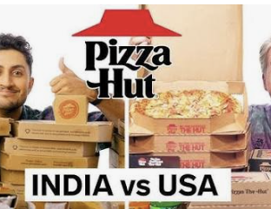

Table of Contents
Executive Summary 3
1 Section 1: International Market Entry Strategy and Marketing Mix 3
1.1 Introduction 3
1.2 Comparative Market Analysis 3
1.2.1 PESTEL Comparison 4
1.3 Socio-Cultural Comparison 6
1.4 Comparative STP Strategy 7
1.5 Comparative International Marketing Mix 7
1.5.1 Product 8
1.5.2 Price 8
1.5.3 Place 8
1.5.4 Promotion 9
1.5.5 People 9
1.5.6 Process 9
1.5.7 Physical Evidence 10
1.6 Market Entry Strategy in India 10
1.7 Ethical Evaluation in India 11
1.8 Recommendations 11
1.9 Conclusion 12
2 Section 2: Reflective Account Using Gibbs’ Reflective Cycle 13
2.1 Description 13
2.2 Feelings 13
2.3 Evaluation 13
2.4 Analysis 14
2.5 Conclusion 14
2.6 Action Plan 14
3 References 15

Executive Summary
This report compares Pizza Hut international marketing strategy in India and USA making it a critical comparison. In 2025, Pizza Hut had 108 countries and territories, 19,974 restaurants and was over 99% franchised with US$12.794 billion in system sales. Sales of systems, however, dropped 2%, same-store sales dropped 1% and even unit numbers dropped, showing that global scale is not the key to continued competitiveness (Yum!). Brands, 2026).
India has a huge population, urbanisation, growing organised food-service industry and digitally connected younger population, which are the sources of long-term growth potential in the country. However, factors such as decreased purchasing power, cultural diversity, and the high competition in prices and the inconsistent productivity of restaurants make implementation difficult. More established, more expensive and highly competitive, the United States offers higher purchasing power along with pizza consumption. The analysis indicates that Pizza Hut should follow selective adaptation strategy, which is a standardised brand, operating and food-safety core and locally adapted products, prices, communications and restaurant formats (Cateora et al., 2020; Mandler et al., 2021).
Franchising was the right model of market entry since it provided local capital, local knowledge and networks. However, there are examples of poor unit economics and a disjointed governance of outlets, pointing to the need to move from outlet growth to restaurant productivity. Disciplined site selection, a three-tier value structure, improved first-party digital relationships, one-franchise-governance and nutrition transparency and measurable packaging reduction are among the recommendations.

Section 1: International Market Entry Strategy and Marketing Mix

Introduction
International marketing demands organisations to decide on which aspects of marketing strategy remain constant around the world and which need to be changed in the local markets. Standardisation can cut down expenses, ensure uniformity of quality and boost international brand awareness. Adaptation can also enhance cultural relevance, customer acceptance and regulatory compliance, but can also increase product complexity, training and operating complexity (Cateora et al., 2020; Hollensen, 2020; Mandler et al., 2021). In effective international marketing it is necessary to have a contingent standardisation/ localisation balance instead of a complete standardisation/ localisation.
The issue is of great significance in the food service sector as products are culturally embedded in it. Factors like flavour, religion, dietary practice, price expectations, and consumption moments, affect the interpretation of an international restaurant brand (Kotler et al., 2022; Singh et al., 2023). Pizza Hut is an adequate case, due to its well-known status and some local adaptation in India. The report is done by comparing the Indian market with Pizza Hut's home market of the United States in terms of PESTEL, Hofstede, STP, the 7Ps, International entry-mode theory and ethical frameworks.

Comparative Market Analysis

PESTEL Comparison
India and the U.S. have significant differences in terms of market size and purchasing power. The potential market of India is roughly 1.46 billion people while the potential market of USA is about 341.8 million. But the average income per capita in India is around US$2,703 while that of the United States is around US$90,027. This means that India has population scale but has to face higher affordability constraints while the United States has a higher level of spending capacity but has higher labour, property and operating expenses (International Monetary Fund [IMF], 2026; World Bank, 2026a, 2026b).
Table 1: Comparative PESTEL Analysis
Factor | India | United States | Pizza Hut implication
Political | Federal system with national, state and city-level variation | Stable but multilevel restaurant regulation | Strong central controls with local compliance expertise
Economic | Large population, faster growth and low per-capita income | High purchasing power, mature demand and high costs | Affordable formats in India; differentiation in the US
Social | Young population, family dining, vegetarian demand and regional tastes | Convenience, customisation and established pizza consumption | Greater Indian menu and communication adaptation
Technological | Rapid digital-payment and aggregator growth | Mature applications, loyalty systems and analytics | Balance platform reach with first-party data
Environmental | Packaging, congestion and variable recycling infrastructure | Packaging, delivery emissions and stakeholder scrutiny | Measurable waste and packaging targets
Legal | FSSAI safety, claims and labelling regulations | FDA calorie-disclosure requirements for covered chains | More visible nutritional information in India
Source: Author’s own work based on FSSAI (2026), FDA (2026), IMF (2026), World Bank (2026a, 2026b) and industry evidence.
India's size in terms of its population is illustrated in Figure 1. As the population is not the same as current demand, restaurant accessibility, income distribution, urbanisation and competitiveness have to be taken into account to determine the commercially reachable market. Therefore, when Pizza Hut makes investment decisions it must consider the demand in the city, density of restaurants and economics of the restaurant, rather than just the population of a country (Kotler et al., 2022; Rosado-Serrano, 2019).
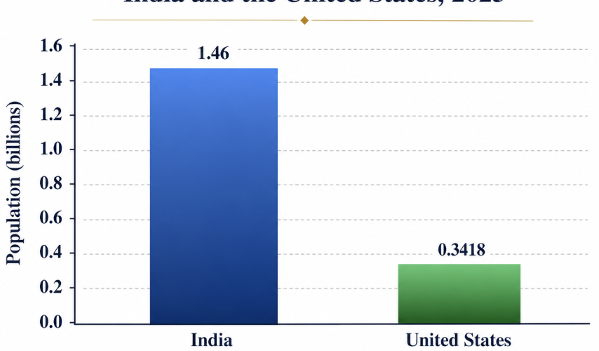
Figure 1: Population Comparison between India and the United States, 2025
Source: World Bank (2026a, 2026b).
The difference in purchasing power is shown in figure 2. Indian consumers tend to consider Pizza Hut a discretionary product and are likely to be sensitive to the product's entry price, shared bundles and promotional value. While the average American consumer has greater spending power, Pizza Hut faces competition from national chain restaurants, delivery-only alternatives to supermarkets and independent restaurants. This is because even though the absolute price may not be as important to American consumers, the comparative price may be (Kotler et al., 2022; National Restaurant Association, 2025).
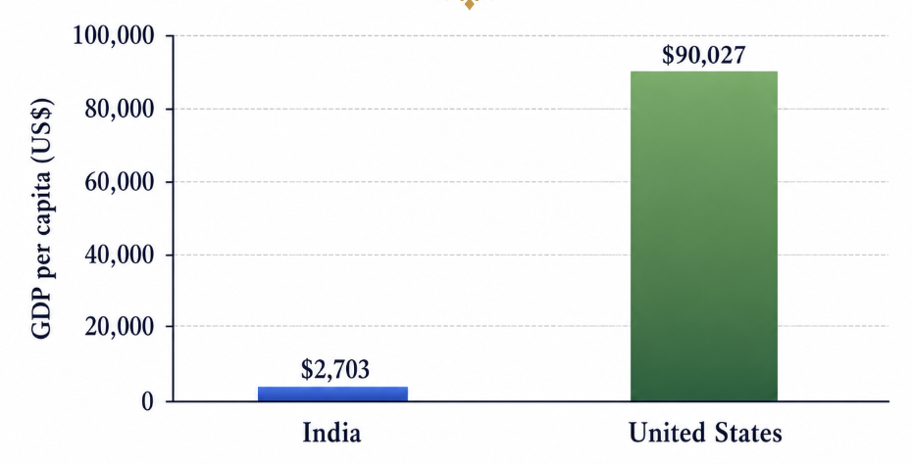
Figure 2: GDP per Capita Comparison between India and the United States, 2025
Source: World Bank (2026a, 2026b).
In FY2024, India's food-service industry is projected to be around ₹5.69 trillion and is expected to grow by around 8.1% annually until FY2028. The organised segment is anticipated to witness a higher growth rate, and will offer opportunities to established multinational chains with established brands, food safety measures and digital distribution channels (National Restaurant Association of India [NRAI], 2024). However, growth in the national industry doesn't mean that each location will make money.
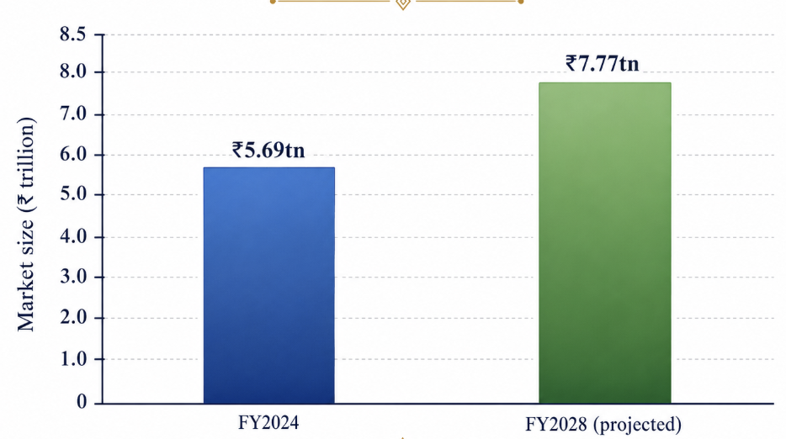
Figure 3: Growth of the Indian Food-Service Market
Source: National Restaurant Association of India (2024).
The Indian market is attractive but the outcome of the organisation is not. Devyani International's Pizza Hut segment saw an increase in revenue from ₹7.092 billion to ₹7.322 billion for the FY2024–25 period, despite a decline in the average daily sales from ₹37,000 to ₹34,000. The same-store sales fell 3.8%, and the brand-contribution margin was significantly lower at 7.2% to 2.7% (Devyani International, 2025). So expansion and rising revenues were coupled with declining restaurant productivity.
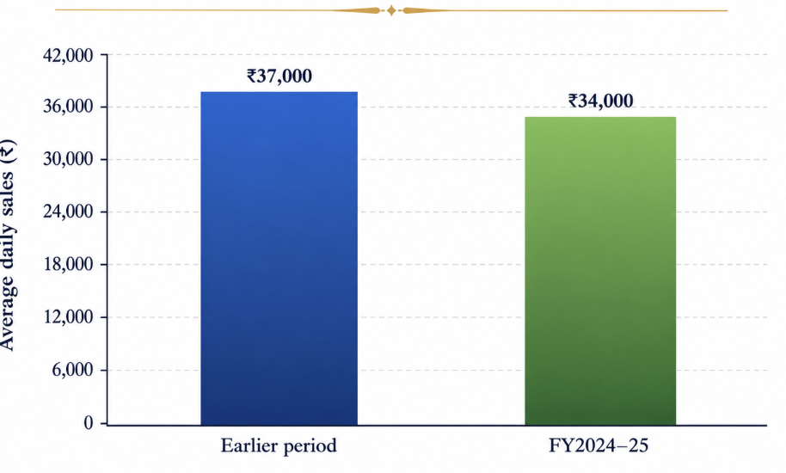
Figure 4: Pizza Hut India Average Daily Sales
Source Devyani International (2025).
Competition adds to the Indian opportunity. Domino's currently has over 2,200 Indian restaurants as opposed to about 950 Pizza Hut restaurants, and Papa John's plans to build 650 Indian restaurants by 2035. It means that Pizza Hut is unable to just depend on the fact that it's an established international brand. It necessitates unique experiences, improved restaurant productivity and local value added (Reuters, 2025).
The U.S. is undeniably the biggest commercial market in terms of restaurant spending, but is structurally mature. National Restaurant Association (2025) predicted that the restaurant industry would account for around US$1.5 trillion and 15.9 million jobs in 2025. Pizza Hut, however, recorded a drop in global system sales to US$12.794 billion in 2025, a 1% drop in same-store sales and a dip in the number of restaurants to 19,974 (Yum!). Brands, 2026). The evidence indicates that both familiarity and distribution are not enough if the proposition does not offer differentiation or if restaurant assets don't meet the expectations of the times.
Technology has emerged as a mainstay in both markets. While food-delivery apps make it more convenient and accessible, they also result in high commissions, dependency on promotions, and decreased customer data ownership. It is found that application usability, delivery reliability and the quality of food and information, as well as recovery procedures have found to affect satisfaction and loyalty (Koay et al., 2022; Lee & Han, 2022; Ma et al., 2024; Seo & Roh, 2025). Pizza Hut would be wise to continue acquiring aggregators and offer some rewards to incentivize repeat business from the users.
There is also a difference among legal and environmental aspects, which also affect marketing. Indian food advertising, claims, labelling and display is under the control of FSSAI, and covered US food chains will display calories for commonly available menu items and provide additional nutritional information (FSSAI, 2026; U.S. Food and Drug Administration [FDA], 2026). Environmental claims must not be based on product symbols, but the packaging weight, packaging material from recycled sources, recoverability and reduction of the packaging waste generated as food waste (Ketelsen et al., 2020; Otto et al., 2021).

Socio-Cultural Comparison
Hofstede's framework allows for a structured comparison of the cultural tendencies of national societies, but cannot be seen as a descriptive profile of each consumer. There are significant linguistic, religious, regional, generational and income differences in India, as well as in the United States. National scores should not be used to answer any research question instead of consumer evidence (Hofstede et al., 2010; Singh et al., 2023).
Table 2: Hofstede Cultural Comparison
Dimension | India | United States | Marketing implication
Power distance | 77 | 40 | More structured reassurance in India; informal communication in the US
Individualism | 48 | 91 | Sharing and family occasions in India; personal choice in the US
Masculinity | 56 | 62 | Achievement appeals possible in both markets
Uncertainty avoidance | 40 | 46 | Both markets can accept menu innovation
Long-term orientation | 51 | 26 | Relationship building in India; immediate benefits in the US
Indulgence | 26 | 68 | Socially framed treats in India; personal enjoyment in the US
Source: Hofstede et al. (2010) and The Culture Factor Group (2026).
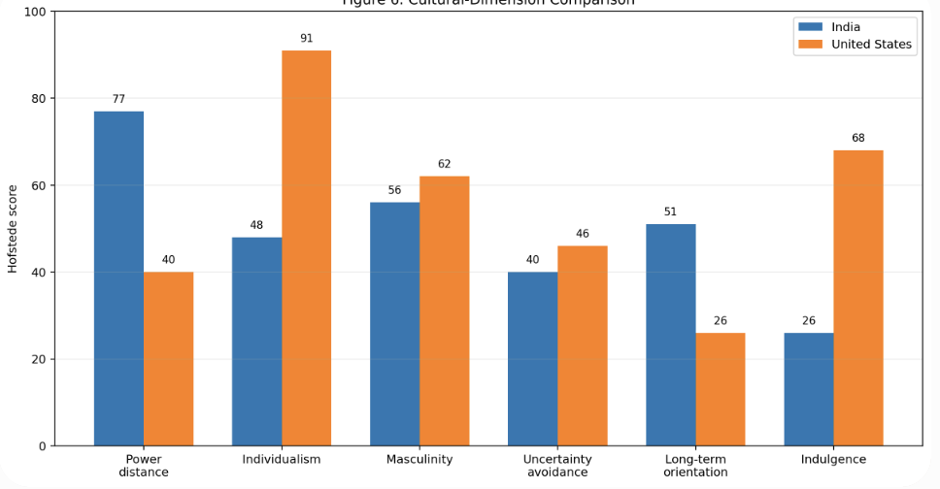
Figure 5: Hofstede Cultural-Dimension Comparison
Source: Hofstede et al. (2010), Singh et al. (2023) and The Culture Factor Group (2026).
India's less individualistic nature and more power distance allows for increased attention to family dining, sharing, and hospitable and trusted service. In contrast, more attention can be paid to individual customisation, personal convenience and loyalty rewards in the U.S. marketing. These are general trends, however. In the case of an Indian Gen Z consumer, they might want to purchase individual products, novelty, and take them with them; American consumers are more likely to buy pizza during a family event, work or sports event, etc. (Cateora et al., 2020; Singh et al., 2023).
The lower indulgence score for India does not mean that the demand for the indulgent products is low. Proposes to reimagine indulgence as a celebration, friendship occasion or family reward. American communications can be more direct, in terms of enjoyment, promoting personal enjoyment. Therefore, Pizza Hut needs to maintain the emotional global promise of enjoyment, but needs to be flexible about how Pizza Hut delivers on that promise (Hofstede et al., 2010; Hollensen, 2020).

Comparative STP Strategy
In both countries, Pizza Hut segments their customers into demographic, geographic, psychographic, behavioural and occasion segments. Families, sports customers, delivery customers, customers who are students, working adults, and individual-meal customers are all part of the US segments. Pizza hut needs to pay more attention to the vegetarian option, the tier of the city, region preference, family dining, student affordability and digitally active young professionals for Indian segmentation (Kotler et al., 2022; Pizza Hut, 2026; Pizza Hut India, 2026).
Table 3: Comparative STP Strategy
STP element | United States | India | Critical judgement
Segmentation | Families, individuals, sports occasions, delivery users and value seekers | Youth, families, offices, students, vegetarian customers and city tiers | Combine culture with behavioural and financial evidence
Targeting | Digitally active households and individual-meal users | Gen Z, professionals and value-conscious families | Avoid treating India as one national segment
Positioning | Dependable and familiar pizza occasions | Accessible global pizza with local flavour and social dining | Do not compete primarily through discounts
Source: Kotler et al. (2022), Pizza Hut (2026), Pizza Hut India (2026) and Devyani International (2025).
The elements to be taken into consideration while selecting a target include size of the segment, ease of access, competitive intensity, contribution, and customer life time value. The student may be responsive to entry, but this may only yield low profits, until converted to direct ordering repeat users. Families buy more often, but also value "dine-in" settings more greatly, and make larger purchases in those settings. Thus, the notion of long-term segment attractiveness (Lee & Han, 2022; Shankar et al., 2024) should not be confused with promotional response.
Pizza Hut is in a precarious space between delivery-centric, very low-priced and high-priced restaurants in the United States. It's been a dine-in restaurant for a while so there could be some differentiation, but dated restaurants reduces this advantage. Reliable pizza is the perfect accompaniment to any event and, thanks to digital technology, it is available as needed. The brand needs to be positioned as a readily available global pizza that provides locally exciting flavours, a social dining experience and a guarantee of delivery in India.

Comparative International Marketing Mix

Product
Pizza Hut needs to maintain a core, standardized global business - its brand, the pan pizza, food-safety practices, restaurant technology and operating know-how. The American menu is based on pizza, wings, pasta, desserts, combinations and individual/pairs. Pizza Hut has locally adapted their menu to include vegetarian and spice options like Paneer Makhni Masala, Tandoori Paneer etc., showcasing their Indian products (Pizza Hut, 2026; Pizza Hut India, 2026).
Localisation would result in cultural relevance and increase in inventory, training and preparation complexity. So each locally adapted product should be tried, bought again, and compared to ingredient overlap, preparation time and margin to test the product. Successful Indian products could also be introduced to relevant markets in the diaspora or regional markets which could enable the spread of innovation from domestic markets into the broader international market system (Cateora et al., 2020; Mandler et al., 2021).
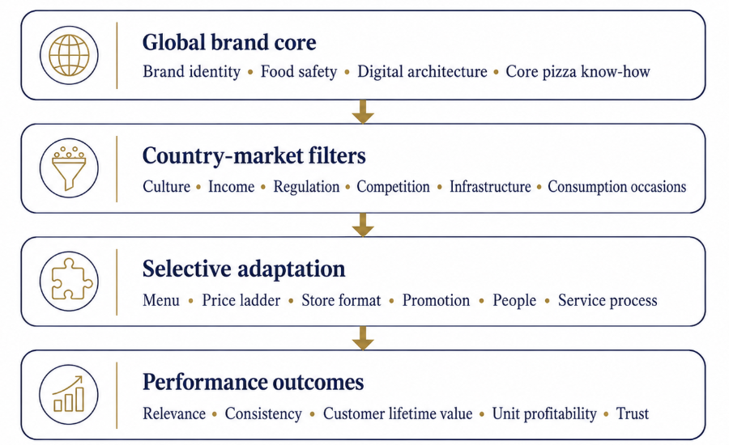
Figure 6: Selective Standardisation–Adaptation Framework for Pizza Hut
Source: Cateora et al. (2020), Jell-Ojobor et al. (2022), Kotler et al. (2022) and Mandler et al. (2021).

Price
US pricing is a high-income, transparent and very competitive market where bundles, promotional and loyalty offers are combined. Discounting can be effective in boosting sales in the short-term, but can also reduce the reference price for the customer and make them wait for the discount. Therefore, instead of the number of transactions, incremental contribution and repeat purchasing is the way to evaluate price promotions (Kotler et al., 2022; Lee & Han, 2022).
India needs a definite value chain. Trial products can be low cost and draw in students and new buyers; core products can be profitable and result in repeat purchases; expensive local foodstuffs can be monetized based on novelty and social dining. Devyani International's average daily sales and contribution margin dropped, suggesting that discounting to boost volume did not necessarily drive increased profit margins. Pizza Hut needs to make the final price, delivery fees and conditions easy to understand or else perceived unfairness will occur.

Place
Pizza Hut is available in Dine In, Delivery, Carry Out and Express Pizza Hut formats. It has a global system that is over 99% franchised with a lot of variability in terms of investment and execution (Yum!) Brands, 2026). Maintaining a weaker location in the U.S. should only be based on customer demand and economic analysis, not as a measure of network size.
In India devyani's Pizza Hut franchise grew from 567 to 630 outlets during FY2024-25 with sales left to 45% on-premise and 55% off-premise. This will help to establish a differentiated social dining chain, regular family outlets and smaller delivery driven services (Devyani International, 2025). Catchment demand, rent, payback and delivery density, not uniform national expansion, should be used to make property decisions.
While the role of the aggregators is important, they should not be the ones to hold the entire customer relationship. Pizza Hut must determine the profitability per channel, set standards for waiting times of riders and food temperature and leverage exclusive direct-order benefits to channel frequent riders to the application. According to service research, the restaurant and delivery service is seen as one integrated application and service for customers, with the application as the delivery service, and the delivery service as the restaurant (Koay et al., 2022; Ma et al., 2024; Su et al., 2022).

Promotion
US marketing efforts should be paired with tangible proof of the better restaurant and delivery behavior that comes with pizza marketing. If the experience is not reliable, then brand nostalgia and awareness are only likely to have a negative impact on sales. The communicative strategies that can be used for Indian campaigns are festivals, local flavour, youth culture, social occasions and affordability, but it is important that the communications be tested across regions, not assumed to be transferable nationally (Devyani International, 2025; Singh et al., 2023).
Digital personalisation has a positive potential for enhancing the relevance of the service, but also poses privacy and vulnerability challenges. But campaigns targeting children or young consumers need special attention as food marketing can affect preference and choice, food consumption (Boyland et al., 2025; World Health Organization [WHO], 2023). Promotion must go hand-in-hand with the operating capacity - if there is an increase in orders, there should be an increase in capacity or otherwise there will be no added value as there will be stock shortages, waiting times and service failures.

People
Staff interprets brand requirements into the real customer service. Typically, American consumers are looking for quick and casual delivery, while Indian dine-in customers might also prefer family-friendly dining, bilingual communication, and a friendly approach to vegetarian inquiries. These tendencies should be used for training but not as stereotypes for countries (Hofstede et al., 2010; Singh et al., 2023).
Training should be a mix of global areas of food safety, quality and complaint recovery, with local areas of dietary, language and aggregator coordination. The focus of performance measures should be on employee retention, audit compliance, order accuracy and service recovery as well as labour cost. A high turnover rate or unrealistic workload can tarnish the brand promise, even if advertising is of high quality.

Process
The quality of the order process is a key factor in the US process, because it requires simple ordering, accurate customisation, reliable preparation and fast problem resolution. Indian processes also necessitate vegetarian and non-vegetarian handling, coordination through delivery platforms and handling of promotional surges. To create value for customers, technology must provide a benefit in terms of speed, information quality and reliability (Koay et al., 2022; Seo & Roh, 2025).
Pizza hut should tie up promotional plans with ingredient capacity, employee capacity, and oven/riders capacity. With sales conversion, order-to-door time, rider waiting, accuracy, temperature, cancellation and refund rates should be tracked. These metrics are more comprehensive metrics to measure the success of a campaign than impressions or orders received.

Physical Evidence
Physical evidence refers to the restaurant condition, signage, uniforms, packaging and application design, as well as the look of the food that has been delivered. Older physical assets in the U.S. can be in opposition to a modern and convenient position. In India, restaurant space can be used as a 'wanted' but 'affordable' social space, but the investment should vary depending on the catchment economy and not a 'one size fits all' approach to design.
Packaging needs to maintain temperature and presentation and have to be as low impact as possible. But what people think of sustainable materials might not equal their life cycle performance. Pizza Hut should assess the weight of materials added to the pizza, the recycled content, the recyclability and food protection rather than focusing on general environmental claims (Ketelsen et al., 2020; Otto et al., 2021).
Table 4: Comparative 7Ps and Strategic Priorities
Element | United States | India | Priority
Product | Familiar and customisable menu | Vegetarian and spice-led adaptation | Protect the core; control complexity
Price | Deals and loyalty | Entry, core and premium ladder | Measure margin and repeat use
Place | Rationalise and modernise assets | Flexible formats and profitable catchments | Unit economics before outlet count
Promotion | Familiar occasions and convenience | Youth, festivals, value and local flavour | Capacity and ethical safeguards
People | Fast, informal fulfilment | Hospitality and dietary knowledge | Global standards with local training
Process | Ordering and delivery reliability | Dietary and aggregator coordination | Shared experience indicators
Physical evidence | Modern stores and digital interfaces | Social dining and compact formats | Match investment to demand
Source: Author’s own work based on the preceding analysis.

Market Entry Strategy in India
Pizza Hut entered into India in Bangalore in the year 1996 and grew mostly by local franchisees such as Devyani International and Sapphire Foods (Pizza Hut India, 2026). In the case of Pizza Hut, they were able to transfer the trademark, recipes, operating processes and training, and the franchisees provided the capital, the property knowledge, their experience in the labour market and their local networks (Dinu, 2018; Rosado-Serrano, 2019).
The rationale for the arrangement is given in Dunning's eclectic paradigm. Pizza Hut had brand equity, operating knowledge and technology to the benefit of the company. Market size, urbanisation and category growth were the location advantages India offered. In part the food quality and food/brand standards were internalised in the franchise contracts, and local implementation capabilities were employed (Dunning, 1988; Bretas et al., 2021).
The major weakness in the present era is the lack of good governance, not the way it was entered. Multiple operators resulted in duplication and it is said that it disrupted simultaneous advertising in the same geographic areas. According to the two companies, the transaction will create $934 million in annual synergies in the second full year from the completion of the transaction (2026a).
The integration could lead to a more centralized procurement, media, technology and data function, although it might have a negative impact on local experimentation due to scale. Pizza Hut should thus merge national with regional innovation budgets, independent audits and transparent restaurant scorecards. The stage of outlet growth should be replaced by the stage of governability of productivity in franchising.

Ethical Evaluation in India
While the moral question is whether Pizza Hut allows for informed and proportional consumer choice, especially from a younger demographic. Food marketing is a potential driver of an unhealthy diet and food intake, and obesity provides a large public-health backdrop (Boyland et al., 2025; WHO, 2023, 2025). While it does provide work, however, Pizza Hut also offers convenience and legitimate enjoyment. The ethical analysis should therefore make a step toward proportional improvements instead of regarding the product as intrinsically wrongful.
The key to a rights-based approach is good information regarding the price, calorie, allergens and portion at the moment of choice. There is a legal minimum in FSSAI regulation and information might need to be more visible to the consumer than the minimum compliance requires. The information on nutrition and allergens needs to be presented in a concise manner within the nutrition and allergen information provided by Pizza Hut India in its application and aggregator listings (FSSAI, 2026; FDA, 2026).
In cases of value promotion, that disproportionately affects children, students or consumers with less nutritional knowledge, there is a concern for distributive justice. While affordable products can help to expand access, responsible packages must offer smaller servings, also have a balanced approach to choices and clarity on amounts, and not keep promoting larger meals. In addition, the franchise margins, employee workloads, delivery-worker pressures and environmental waste must be taken into consideration in campaigns under the Stakeholder theory (Freeman, 1984; Jell-Ojobor et al., 2022).

Recommendations
The first thing Pizza Hut India needs to do is to follow the rule of unit economics before counting the units. New and existing restaurants should adhere to minimum averages in sales per day (ADS), contribution margin, rent and delivery density and payback. Weak units should be closed, moved or converted away from a permanent discount rather than supported via a permanent discount. Second, the brand must create a three-layered value chain: low-cost trial products, cost-effective core packages and high-value local innovations. Do not consider traffic as the metric for evaluating promotions, but rather incremental margin, 30-day repeat rate and customer lifetime value.
Third, there should be a centralised approach to procurement, national media, technology and customer data, with controlled experimentation in the region for food safety. The key to success is based on the procurement savings, audit scores, campaign consistency and restaurant productivity. Fourth, aggregators need to be acquisition channels but the first-party need to grow with rewards for direct order and saved preferences without any misleading loyalty schemes. Indicators are direct digital share, active enrollers, reorder frequency and platform commission as a percent of revenue. Last but not least, Pizza Hut India needs to do a bit of proactive work to enhance their nutritional disclosure, limit child behavioral targeting, and disclose packaging and food-waste metrics. Ethical responsibility ought not to be an extra corporate statement, but rather part of its positioning.

Conclusion
Selective adaptation is the key that determines Pizza Hut's international success. What is needed in the United States is a more definitive separation, a more solid digital delivery and asset rotation while in India affordability, cultural resonance and a disciplined restaurant economics is needed. While there has been a significant increase in the Indian relevance of the local menus, the average daily sales and margins have declined indicating that the concept of localisation and growth is not enough.
Though the proposed operator consolidation needs to be reworked for more control without stifling regionally available learning and improvement, franchising continues to be an appropriate business model for India. Sustainable competitive advantage should be achieved through profitable catchments, responsible value, reliable omnichannel service and transparent ethical performance.

Section 2: Reflective Account Using Gibbs’ Reflective Cycle

Description
I started the assignment by breaking down the assignment components into their major analytical categories namely PESTEL analysis, cultural comparison, Segmentation, Targeting and Positioning, 7Ps, Market entry strategy, ethical analysis, recommendations and reflection. This really helped me structure the work in a logical manner and ensured that all the requirements of the brief were covered. I chose India and the United States as the countries to compare because they provided a legitimate comparison between a developing country (host market) and the mature country (home market) where Pizza Hut was operating. Contrast opportunities served as a means of studying income, cultural, regulatory, customer and digital competitive differences.
In order to facilitate the analysis, I developed a matrix of evidence on which I placed theoretical concepts, company information, official statistics, regulatory information and contradictory information. Standardisation, adaptation, franchising, service quality and ethical marketing were explained using academic literature and evidence relating to Pizza Hut's performance was drawn from company reports and public sources. This helped me to relate theory to practice, rather than provide disjointed descriptions. This helped to streamline my argument and provide more justification for the recommendations.

Feelings
At first I thought India would be my growth market, and the USA my mature market. I presumed that as India grew more populous, more urban and experienced growth in food-service, there would be good commercial opportunities. I also thought that the USA would exhibit more predictable behavior due to increased purchasing power.
These assumptions were put to the test by the evidence. The overall food-service situation in India was good, but that of Pizza Hut in terms of average daily sales and same-store sales, contribution margin had eroded. Likewise, United States income per capita was significantly higher, but their Pizza Hut system sales, comparable sales and restaurant count were down. I at first was at a barrier with these inconsistencies because it did not allow for a straightforward comparison. I later, however, realised that they made the assignment better in allowing for increased critical thinking. Discovered that market attractiveness is not necessarily equal to company performance, and national growth is not a measure of the organisational success.

Evaluation
A strength of my approach was triangulation. Academic sources discussed the advantages and disadvantages of the standardisation, localisation, franchising and the quality of digital services.Official and organisational sources provided up-to-date performance data. When examining the results from several pieces of evidence, the study found that revenue growth and outlet growth can be achieved at the same time as a decline in restaurant productivity. This minimised the chances of gullibility about corporate growth stories.
The tables and figures were also helpful as they were not two separate descriptions of countries which had to be compared. The tables also helped me to go from description to managerial implications.
The key challenge was variability in the scope of the data. Some evidence was referred to Pizza Hut, Indian restaurants (Devyani) only. Limited insight into the profitability of the segments, customer lifetime value, and price elasticity was provided by public data. I therefore had to qualify recommendations as "recommendations" and not "facts. This highlighted that it was important to read and understand the geography, period, and unit of analysis with each statistic.

Analysis
The cultural comparison showed the problems of using the self-reference criterion, in which the other market is understood based on the assumptions made in one's own environment. While I was prompted to look at individualism, power distance, LTO and indulgence by Hofstede's model, the scores for the country could lead to stereotypes when applied to individuals. So I've put together a list of these cultural indicators and added them to the list of evidence, like menu adaptation, family dining, ordering online, ordering individually, etc. Culture was not just assumed but became a hypothesis to test instead of consumer research (Hofstede et al., 2010; Singh et al., 2023).
I also learned that the seven Ps are dependent on one another. Low price campaign has more impacts than price as it can impact kitchen capacity, employee workload, rider availability, demand forecasting, packaging and delivery time and franchise profitability. Similarly, local menu adaptation can enhance the relevance and boost the inventory, training and consistency expenses. Then the marketing mix needs to be viewed and managed as an integrated system.
The market-entry analysis I read shortened my wait to understand what franchising is all about. It was the low investment road to quick expansion that I was looking for first. The evidence also indicated that it is a continual governance relationship of control, incentives, knowledge sharing, reputation and local responsiveness. The proposed merger of Indian franchise operators can result in procurement and coordination efficiencies, but can also mean a lack of experimentation and challenge from the region. Therefore, the decision for international entry should be revisited on an ongoing basis and not just when entering a market for the first time.

Conclusion
This assignment was useful for me to distinguish between growth in the market and performance of the firm. As the food-service industry in India continues to grow, all Pizza Huts won't necessarily be profitable, and a brand with diminishing assets and/or a lack of differentiation is not immune from the dangers of high purchasing power in the US. I also gained more confidence to make good recommendations without complete evidence. I was not supposed to keep my uncertainty in the closet, I learned to make assumptions and provide the best evidence possible.

Action Plan
I will develop a data dictionary prior to writing for future assignments. This will determine the geographical scope, reporting period, measurement unit and limitations of each of the statistics. I will also perform sensitivity analysis to assess the impact of rent, average order size and delivery commission and density on recommendations. When applicable I will supplement secondary evidence with Customer surveys, interviews or an analysis of online reviews.
I will also develop an assessment map which correlates each learning outcome and marking criteria with evidence and section. Last but not least, I will keep applying Gibbs' reflective cycle in order to make measurable changes to the experience instead of finalizing reflection in general terms. This should facilitate more systematic research, better judgment, and better professional development (Gibbs, 1988).

References

Associated Press. (2026, February 11). Pizza Hut closing 250 US locations as Yum Brands considers sale. https://apnews.com/article/4479dc3e6fe0221db862f2148fbe1c82
Boyland, E., Muc, M., Coates, A., et al. (2025). Food marketing, eating and health outcomes in children and adults: A systematic review and meta-analysis. British Journal of Nutrition, 133(6), 781–805. https://www.cambridge.org/core/journals/british-journal-of-nutrition/article/food-marketing-eating-and-health-outcomes-in-children-and-adults-a-systematic-review-and-metaanalysis/4E66E9C31D358152D107F44A71DE9D03
Bretas, V. P. G., Alon, I., Rocha, T. V., & Galetti, J. R. B. (2021). International governance mode choice: Evidence from Brazilian franchisors. Journal of International Management, 27(2), 100851. https://www.sciencedirect.com/science/article/pii/S1075425321000314
Cateora, P. R., Money, R. B., Gilly, M. C., & Graham, J. L. (2020). International marketing (18th ed.). McGraw Hill. https://www.mheducation.com/highered/product/international-marketing-cateora.html
Devyani International Limited. (2025). Annual report 2024–25. https://dil-rjcorp.com/wp-content/uploads/2025/07/annual-report-2024-25.pdf
Dinu, A.-M. (2018). International market entry strategies. Academic Journal of Economic Studies, 4(2), 20–25. http://hdl.handle.net/11159/2179
Dunning, J. H. (1988). The eclectic paradigm of international production. Journal of International Business Studies, 19(1), 1–31. https://link.springer.com/article/10.1057/palgrave.jibs.8490372
Food Safety and Standards Authority of India. (2026). Food safety and standards regulations. https://www.fssai.gov.in/cms/food-safety-and-standards-regulations.php
Freeman, R. E. (1984). Strategic management: A stakeholder approach. Pitman. https://www.cambridge.org/core/books/strategic-management/6D1ED4712E2D1F2B4E8739BBEF609B30
Gibbs, G. (1988). Learning by doing: A guide to teaching and learning methods. Further Education Unit. https://thoughtsmostlyaboutlearning.files.wordpress.com/2015/12/learning-by-doing-graham-gibbs.pdf
Glaser, M., Jirásek, M., & Windsperger, J. (2020). Ownership structure of franchise chains: Trade-off between adaptation and control. International Journal of the Economics of Business, 27(3), 357–375. https://www.tandfonline.com/doi/full/10.1080/13571516.2020.1718460
Hofstede, G., Hofstede, G. J., & Minkov, M. (2010). Cultures and organizations: Software of the mind (3rd ed.). McGraw Hill. https://books.google.com/books?id=o4OqTgV3V00C
Hollensen, S. (2020). Global marketing (8th ed.). Pearson. https://www.pearson.com/en-gb/subject-catalog/p/global-marketing/P200000005139
International Monetary Fund. (2026). World economic outlook, April 2026. https://www.imf.org/en/publications/weo
Jell-Ojobor, M., Hajdini, I., & Windsperger, J. (2022). Governance of international franchise networks. Journal of Business Research, 139, 267–279. https://www.sciencedirect.com/science/article/pii/S0148296321006470
Ketelsen, M., Janssen, M., & Hamm, U. (2020). Consumers’ response to environmentally friendly food packaging. Journal of Cleaner Production, 254, 120123. https://www.sciencedirect.com/science/article/abs/pii/S0959652620301700
Koay, K. Y., Cheah, C. W., & Chang, Y. Y. (2022). A model of online food-delivery service quality, customer satisfaction and customer loyalty. British Food Journal, 124(12), 4516–4532. https://www.sciencedirect.com/org/science/article/abs/pii/S0007070X22001227
Kotler, P., Keller, K. L., & Chernev, A. (2022). Marketing management (16th ed.). Pearson. https://www.pearson.com/en-us/subject-catalog/p/marketing-management/P200000007478
Lee, S. O., & Han, H. (2022). Food-delivery application quality in customer-brand loyalty formation. International Journal of Hospitality Management, 107, 103292. https://www.sciencedirect.com/science/article/abs/pii/S0278431922001542
Ma, B., Wong, Y. D., Teo, C.-C., & Wang, Z. (2024). Understanding online food-delivery service quality through reviews. Journal of Retailing and Consumer Services, 76, 103588. https://www.sciencedirect.com/science/article/abs/pii/S0969698923003399
Mandler, T., Sezen, B., Chen, J., & Özsomer, A. (2021). Performance consequences of marketing standardisation and adaptation. Journal of Business Research, 125, 416–435. https://www.sciencedirect.com/science/article/pii/S014829632030847X
National Restaurant Association of India. (2024). India Food Services Report 2024. https://nrai.org/aboutNewsAndUpdate.aspx?ID=6EQtfBjriLQ%3D&Type=oS9yZygW1hU%3D
National Restaurant Association. (2025). Restaurant industry poised for growth in 2025. https://restaurant.org/research-and-media/media/press-releases/restaurant-industry-poised-for-growth-in-2025-industry-expected-to-employ-15-9-million-people-and-r/
Otto, S., Strenger, M., Maier-Nöth, A., & Schmid, M. (2021). Food packaging and sustainability. Journal of Cleaner Production, 298, 126733. https://www.sciencedirect.com/science/article/pii/S0959652621009537
Pizza Hut India. (2026). About Pizza Hut India. https://www.pizzahut.co.in/aboutus
Pizza Hut India. (2026). Pizza menu. https://www.pizzahut.co.in/menu/pizzas
Pizza Hut. (2026). Menu and nutrition information. https://www.pizzahut.com/c/content/menu
Reuters. (2025, August 26). Papa John’s to re-enter India with plan for 650 pizza stores by 2035. https://www.reuters.com/business/retail-consumer/papa-johns-re-enter-india-with-plan-650-pizza-stores-by-2035-2025-08-26/
Reuters. (2026, January 1). India’s KFC, Pizza Hut operators to merge in $934 million deal. https://www.reuters.com/world/india/sapphire-foods-devyani-international-merge-create-fast-food-franchisee-giant-2026-01-01/
Rosado-Serrano, A. (2019). Country dispersion in international franchising. International Journal of Retail & Distribution Management, 47(7), 752–771. https://www.emerald.com/insight/content/doi/10.1108/IJRDM-10-2018-0216/full/html
Seo, K., & Roh, T. (2025). Online and offline delivery qualities. Journal of Retailing and Consumer Services, 82, 104079. https://www.sciencedirect.com/science/article/pii/S0969698924003758
Shankar, A., Jebarajakirthy, C., Maseeh, H. I., et al. (2024). Why do consumers choose online food-delivery services? International Journal of Hospitality Management, 123, 103921. https://www.sciencedirect.com/science/article/abs/pii/S0278431924002330
Singh, N., Yu, J., Ariza-Montes, A., & Han, H. (2023). Functional, symbolic and experiential image across India and the USA. Humanities and Social Sciences Communications, 10, Article 36. https://www.nature.com/articles/s41599-023-01527-y
Su, D. N., Nguyen-Phuoc, D. Q., Duong, T. H., et al. (2022). How does mobile food-delivery service quality influence customer loyalty? International Journal of Contemporary Hospitality Management, 34(11), 4178–4205. https://www.sciencedirect.com/org/science/article/abs/pii/S0959611922000225
The Culture Factor Group. (2026). Country comparison tool. https://www.theculturefactor.com/country-comparison-tool
U.S. Food and Drug Administration. (2026). Menu labeling requirements. https://www.fda.gov/food/nutrition-food-labeling-and-critical-foods/menu-labeling-requirements
World Bank. (2026a). India: Country data. https://data.worldbank.org/country/india
World Bank. (2026b). United States: Country data. https://data.worldbank.org/country/united-states
World Health Organization. (2023). Policies to protect children from the harmful impact of food marketing. https://www.who.int/publications/i/item/9789240075412
World Health Organization. (2025). Obesity and overweight. https://www.who.int/news-room/fact-sheets/detail/obesity-and-overweight
Yum! Brands, Inc. (2026). Annual report 2025. https://www.sec.gov/Archives/edgar/data/1041061/000104106126000084/yum-20251231.htm

