Certificate in higher education, Computing for the workplace


Module name: Software Solutions for Business
Module code: ACCA 4026

Student name: Ruben Fabio Paquete Pires Sa Dabo
Student ID: 2540497
Group: 3

Lecturer’s name: Kwame Assa Agyei

Contents
Introduction 1
Task 1. e-Commerce Website builders/software solutions 1
1.1 Wix 1
1.2 Shopify 1
Task 2. Mind-map of contemporary software applications 1
2.1 Describe mind mapping and explain the benefits of using mind mapping 1
2.2 Create a mind map of contemporary software applications 2
Task 3. Office Applications 2
3.1 Four office software solutions for business operations 2
Ms Word 2
Ms Excel 2
Ms PowerPoint 2
Ms Access 2
3.2 Test any two features 2
Mail Merge 2
Task 4. Communication and Collaboration applications 3
4.1 One contemporary Communication and one Online Collaboration 3
Gmail 3
Zoom 3
4.2 Test one feature of a freely available Communication (1) and one feature of a Collaboration (1) application 3
Gmail 3
Zoom 3
Conclusion 4
References 4

Introduction
Because it Facilitates communications, Teamwork, data management, and provision of goods and services, technology is crucial to modern organisations. The employment of modern digital tools and software in corporate setting is examined in this assignment. It looks at Microsoft Office programs, main mapping and businesses software, e-comments website builders, and communication and teamwork tools. Along with practical demonstrations of certain software features, the assignment also takes into accounts the advantages and drawbacks of various technologies. The assignment seeks to illustrate how digital technology may enhance in modern businesses efficiency, organization, communication, and decision-making through several domains.

Task 1. e-Commerce Website builders/software solutions


Wix.
Wix is a cloud-based website that can build which will enables businesses to create a professional e-commerce website without requiring coding skills. Its drag-and-drop editor, AI website builder, and large selection of customisable templates make website creation simple and efficient. Wix includes features.

Features of Wix
With the help of Wix’s many features, companies can create and run polished e-commerce websites without requiring a high level of technological expertise. The platform’s drag and drop website editor makes it simple for users to alter layout and designs. Additionally, it has integrated e-commerce features like order administration, inventory tracking, safe online payment processing, product management, and shipping choices. Wix also provides mobile-responsive website designs, integrated search engine optimisation (SEO) tools, and access to the Wix App Market, where companies can add features like live chat, booking systems, customer reviews, and marketing apps. These characteristics enable companies to oversee several facets of their internet activities from a single platform.

Benefits of Wix
Wix is an appropriate e-commerce solution for small and medium-sized businesses because of its many advantages. Because of its simplicity of use, business owners may establish and manage a polished online store without employing a web developer, saving money and time. Thru integrated SEO capabilities, the platform also helps businesses increase their online presence, making it simpler for prospective clients to access their website thru search engines. Additionally, Wix facilitates business expansion by providing scalable solutions and supplementary apps that may be deployed in response to shifting business requirements. While the all- in one platform streamlines website management and frees up businesses to concentrate on boosting consumer engagement and online sales, its secure payment processing and dependable website hosting help foster client trust. [1]

Shopify

Shopify office a variety of service that are intended to assist companies and successfully setting up and running online stores. Because many develop an online store that represents their brand things to performance adaptable websites templates.

Features of Shopify
Shopify features processing, delivery, secure payment processing via Shopify payment, and product and inventory management. Businesses may sell their website social accounts, and on other online marketplace thanks to Shopify support of numerous sales channels. Additionally, the Shopify App Store offers access to apps like marketing, accounting, customer support, and analytics towards that can enhance an online store functionally. Such features give companies the resources they need to handle all factors of e-commerce from a single platform.
Benefits of Shopify
Shopify offers businesses a range of advantages, most notably the ability to lower the level of technical expertise needed to create and run an online store. Companies can save time and money by developing and oversee their website without having to start from scratch with an e-commerce system. In addition, Shopify scalable, allowing companies to expand their online operations and product offerings as they increase. Businesses may give customers a safer and more convenient shopping experience by utilising the platforms integrated payment and security service. Furthermore, Shopify marketing and analytics solutions can assist companies in check and sales results, comprehending consumers behaviour, and making more informed choices. Shopify is a good option for companies of all sizes because of these advantages.[2]

Task 2. Mind-map of contemporary software applications

2.1 Describe mind mapping and explain the benefits of using mind mapping

A visual method for organising, developing, and presenting knowledge around the main subject is mind mapping. The mind maps call four is position at the centre, with branches of sub-branches connecting related ideas. This framework makes it possible to convey information in oddly and understandable manner, which facilitates that identification of connections between various concepts. Keywords, brief phrases, pictures, colours, and symbols can all be included in mind maps.
Benefits of mind map
Both individuals and corporations can benefit for mind mapping in several ways. It can arrange complicated data into easy-to-understand visual framework, facilitating review and comprehension. Because Jesus can easily add new ideas to connect them with old ones, it can help promote creativity and brainstorming. Improved memory and recall of further advantages, since material can be made simpler to remember by combining key words, visual components, and linkages. By providing stuff with a clear picture of a project or problem, main maps can also help in planning, problem-solving, this is Jamaican, and teamwork in the workplace. Because they are simple to edit, store, and distribute among team members, digital main maps are very helpful.
Features of mind map
A mind map is helpful for arranging information because of several properties. The primary characteristics is a centre fee that stands in for the primary topic under investigation. Then, branches brunch out from the main subject to display relative concepts of clarifications. A hierarchical structure can be created by these branches having sub-branches with more information. To make knowledge easier to comprehend and retain, main maps can also incorporate keywords, colour, images, symbols, and formers. Other capabilities that digital main mapping software may offer include editing, teamwork, file attachments, linkages, and the capacity to share the main map with others.[3]

2.2 Create a mind map of contemporary software applications
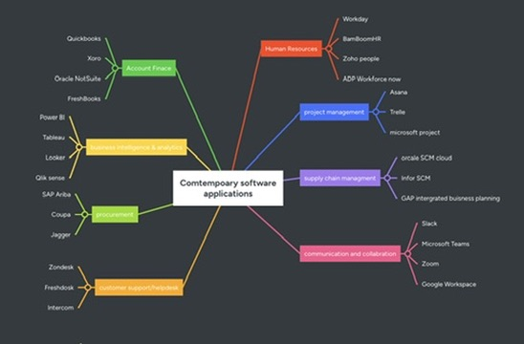

3.1 Four office software solutions for business operations

Ms Word

Microsoft Word is a popular word processing program that may be used to create, edit, convert, store, and share digital documents. Reports, correspondence, meeting minutes, contracts, business proposals, and other professional documents are frequently produced using it in commercial companies. Word offers users formatting tools and templates to help them quickly produce documents of a high calibre.
Features of Microsoft Word
Text formatting and document design capabilities are two Microsoft Word’s key features. To produce documents that are both professional and easy to read, users can alter the fonts, headings, colours, paragraph spacing, and page layout. Additionally, Word has built-in templates that let users construct documents without having to start from scratch. Tables, pictures, charts, hyperlinks, headers, and footers, page numbering, and automatic tables of contents are other helpful features. When companies need to create lengthy documents or structured reports, these tools can be quite helpful.
Benefits of Microsoft Word
The editing and review features in Word are another important characteristic. Spelling and grammar checks, comments, and Track Changes which lets users examine and recommend changes within a standard in Microsoft Word because multiple employees can review documents before they have been completed, this is especially helpful in the business world. In addition, Word encourages cooperation by letting users share and collaborate on documents. According to Microsoft, users can co-edit documents in real time, with indicators displaying the locations of other users’ edits. This can lessen the need for sharing several versions of the same document and enhance teamwork.
Limitations of Microsoft Word
But there are certain restrictions with Microsoft Word. Certain sophisticated capabilities are exclusive to the desktop version of word and I’m not accessible through the website version. When documents are saved or opened in different file formats, compatibility problems may also arise. For instance, Microsoft notes that when open documents are saved in open document format, certain Word functionality and formatting may be lost or altered. When businesses shared documents with users of several word processing programs, this might cause issues.[4]


Ms Excel
Businesses use Microsoft Excel, spreadsheet program created by Microsoft, to arrange, compute, analyse, and display data. Excel is useful for managing both little and big volumes of corporation data because it allows information to be entered into roles of columns within species. Excel can be used by organisations for a variety of functions, including stock management, sales records, financial analyst, budgeting, and employee data.
Features of Microsoft Excel
The ability to use formulas and functions is one of Microsoft Excel’s primary features. Formulas are built in functions like SUM, AVERAGE, IF, and COUNT allow Jesus to carry out calculations and automatically. This can minimise the need for full manual computations and save time. Additionally, Excel has capabilities like VLOOKUP, which can be used to find information in a table and achieve relevant data. These features enable companies to proceed an interpret data more effectively.
As well, excel offers capabilities for data analysis and visualisation. To display data visually and facilitate the understanding of patterns and trends, users can make charts and graphs. By gripping data into many categories, excels pivot Table functions enables users to summarise and evaluate massive databases. Because managers may utilise the data to spot trends, compare outcomes, and track performances, this can aid in commercial decision-making.
Benefits of Microsoft Excel
The use of Microsoft Excel in business has various advantages. By automating computations and simplifying repetitive activities, it can increase productivity. Because users may generate spreadsheets for various business needs, Excel is very versatile. In addition, organisations can show complex information in an easier-to-understand format with to its charts and analytical tools.
Limitations of Microsoft Excel
Excel does have certain restrictions, but. Spreadsheets that are large or complex can be challenging to handle and may be more prone to human mistake, especially when formulas or data are input improperly. Furthermore, when a company wants to manage extremely huge datasets or intricate relationships between various types of information, Excel cannot be as appropriate as specialised database software. Also, when many versions are made or when multiple users work with separate copies of the same file, spreadsheets can become challenging to manage. [5]

Ms PowerPoint

Microsoft created the presentation software program known as Microsoft PowerPoint. It is extensively used by organisations and companies to produce and deliver presentations incorporate in text, photos, charts, tables, videos and other multimedia information. Business Ing, meetings, training sessions, sales preparations, and project updates are just a few of the uses for PowerPoint.
Features of Microsoft PowerPoint
PowerPoint’s slide beast presentation system is one of its primary features. You just could make several stars and arrange data logically. With the help of PowerPoint many templates and themes, users may produce presentations that are professional and are consistent without having to start from scratch when creating each side. Additionally, users can alter backgrounds, fonts, colours, layouts, and other designs components to fit the needs of their presentation.
Furthermore, Microsoft PowerPoint office tools like charts and graphs that can be used to visually present corporate data, making it easier for audiences to recognise key detail details and patterns.
Benefits of Microsoft PowerPoint
Businesses can profit from PowerPoint in several ways. It can assist staff members in conveying information in an organised and eye-catching manner. For instance, a company may use PowerPoint to teach new hires, and a manager could use it to show sales results. An audience can comprehend complex material more easily if written content, visuals, and data visualisations can be combined. The time needed to produce polished presentations can also be decreased by using templates and design tools.
Limitations of Microsoft PowerPoint
PowerPoint do, however, have certain drawbacks. An excessive amount of tax, animation, or superfluous visual effects can render a presentation in effect effective. It can take a lot of effort to create a high-quality presentation, especially if users need to create specific designs at. Additionally, because PowerPoint presentations are typically intended to condense important points rather than offer in-depth explanation, they may not convey specific information as efficiently as a written report.[6]


Ms Access
Microsoft created the database management program Microsoft Access. It is intended to make structured data creation, storage, management, and retrieval possible for both individuals and businesses. Access is specifically made for maintaining databases, in contrast to programs like Microsoft Word, which is mostly focused on documents, or Excel, which is focused on spreadsheets and computations. Access can be used by businesses to manage data, including orders, product details, employee information, and customer records.
Features of Microsoft Access
The ability to create relational database is one of Microsoft access’s key capabilities. Tables with rows and columns can be used to structure data, and linkages between several tables can be established. For instance, a company could set up distinct tables for orders and customers and establish a connection between them. This makes it possible to manage linked data without needlessly repeating the same information.
In addition, Access offers queries that let users search, filter, and analyse data kept in a database. A business might, for instance, develop a query to identify every client who has placed an order during a specific time frame. Businesses can use queries to swiftly extract certain information from vast amounts of stored data.
The capacity to generate reports and forms is another crucial function. While reports can arrange database data into a format appropriate for viewing, printing, or sharing, forms offer an east-to-use interface for entering and viewing data in a database. For instance, a company may provide a report that displays monthly sales and construct a customer registration from all new customers.
Benefits of Microsoft Access
Organisations can profit from Microsoft Access in several ways. It can assist companies in efficiently retrieving vast amounts of linked information. Enhancing data consistency and minimising needless duplication can also be achieved by using tables, relationships, and validation rules. For companies that need a structured database but don’t need the scale of a major corporate database system, Access can be helpful.
Limitations of Microsoft Access
But Microsoft Access has its limitations as well. Large databases or businesses in need of a highly scalable database solution would find it unsuitable. Additionally, users may need to be somewhat familiar with database concepts like tables, relationship, queries, and primary made for Windows, which may limit its applicability to businesses that utilise other operating systems. [7]

3.2 Test any two features.

Mail Merge
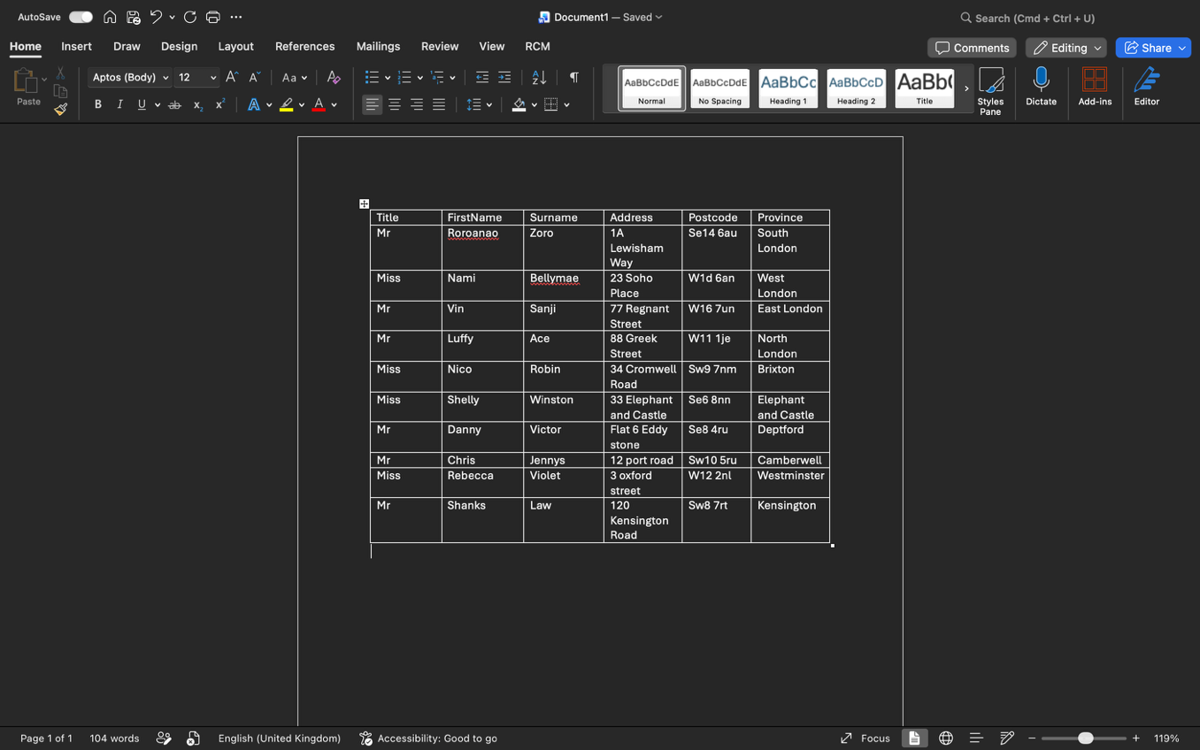

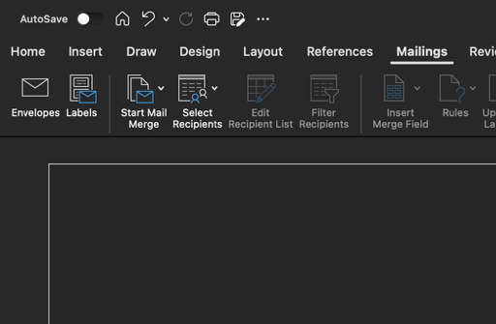
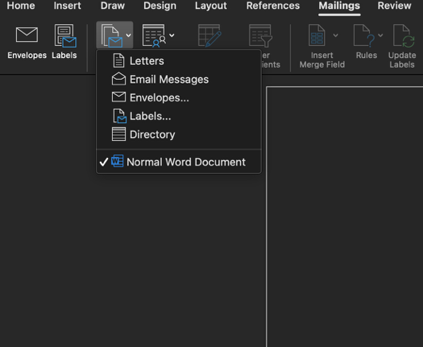
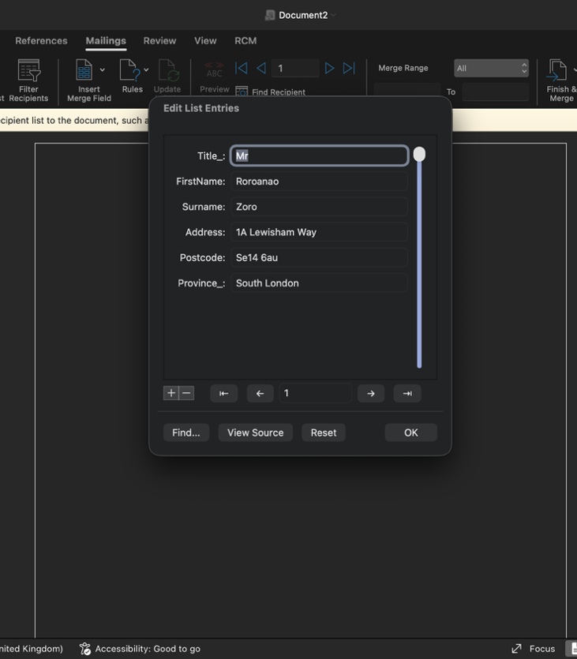

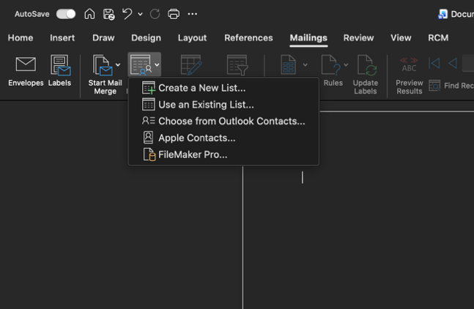

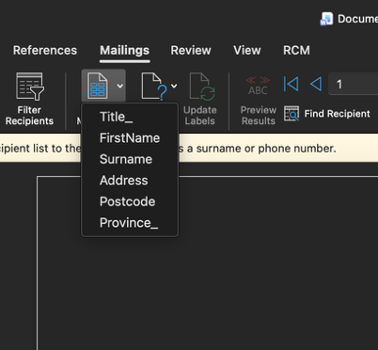

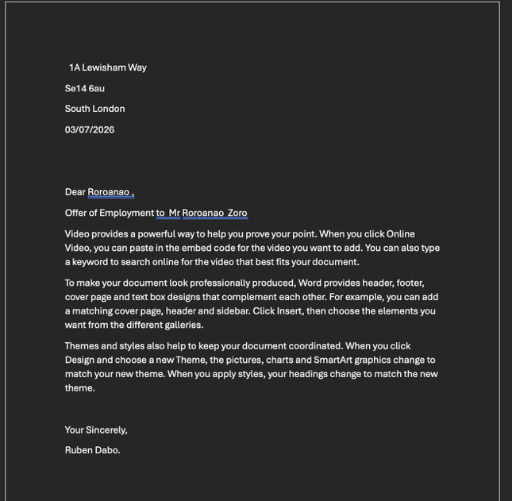

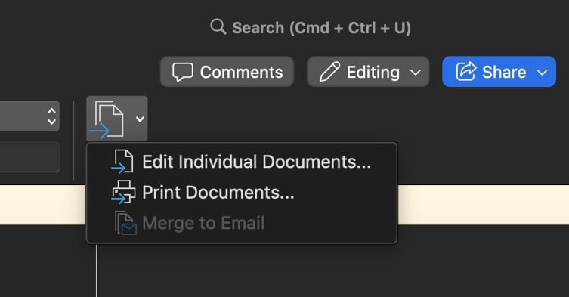

Task 4. Communication and Collaboration applications

4.1 One contemporary Communication and one Online Collaboration

Microsoft Teams
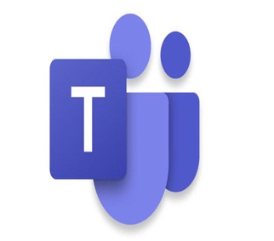
Microsoft Teams is a tool for collaboration and communication. It is intended to facilitate online collaboration, information sharing, and communication between people and organisations. Teams are very helpful for employees who work remotely because they can be utilised by organisations for meetings, messaging, file sharing, and collaborative work.
Features of Microsoft Teams
Instant messaging, which enables staff members to communicate via individual and group conversations, is one of Microsoft Teams primary features. Also, Teams offers audio and video conferencing, which enables staff members to conduct online meetings without being physically present. File sharing, which enables users to upload, access, and work together on documents, is another crucial function. Channels, which can arrange discussions and files related to teams, departments, or projects, are another feature of Teams. Teams also work with Microsoft 365 programs, including Word, Excel, PowerPoint, OneDrive, and SharePoint.
Benefits of Microsoft Teams
Businesses can benefit for Microsoft teams in a few ways. By enabling speedy messaging, phone calls, and video conferences, the software can enhance communication amongst staff members. Because workers may collaborate on document and share files while using the platform, it can help enhance teamwork. This can assist streamline business operations and lessen the need for numerous communication apps. [8]

Microsoft Outlook

Microsoft created Outlook, a program for organising and communicating. Businesses frequently use it to handle projects, contacts, calendars, and emails. Employees can use Outlook to schedule meetings, appointments, and other work-related tasks in addition to communicating professionally via email.

Features of Microsoft Outlook
Email management, which enables users to send, receive, organise, and search emails, is one of Microsoft Outlook’s primary features. Additionally, Outlook has a calendar that lets staff members plan events, appointments, and meetings. Organisations can better coordinate operations by allowing users to monitor the availability of other employees and invite them to meetings. Contact management is an additional function that lets users save and manage data about individuals they interact with. Additionally, Outlook offers features that might help users manage their messages, like folders, search tools, automatic replies, and email filters.
Benefits of Microsoft Outlook
Companies can profit from Microsoft Outlook in s few ways. Improved communication is one of the main advantages since employees can utilise email to interact professionally with coworkers, clients, and other businesses. By enabling staff members to plan meetings and oversee their daily tasks, the calendar can help enhance time management and organization. Employees can locate critical emails and information more quickly by using Outlook’s search and organization functions. [9]

4.2 Test one feature of a freely available Communication (1) and one feature of a Collaboration (1) application

Microsoft Outlook
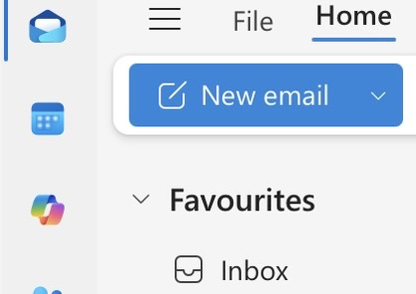
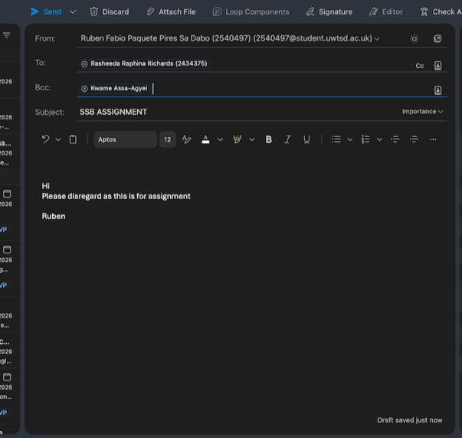






Microsoft Teams



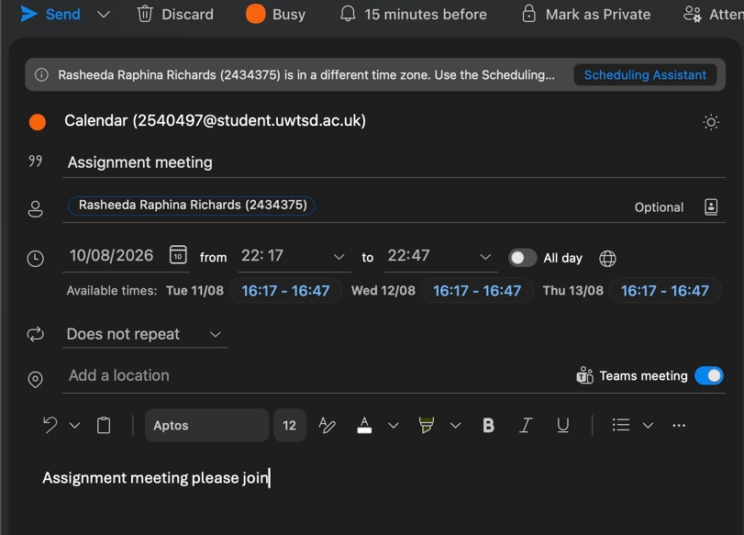



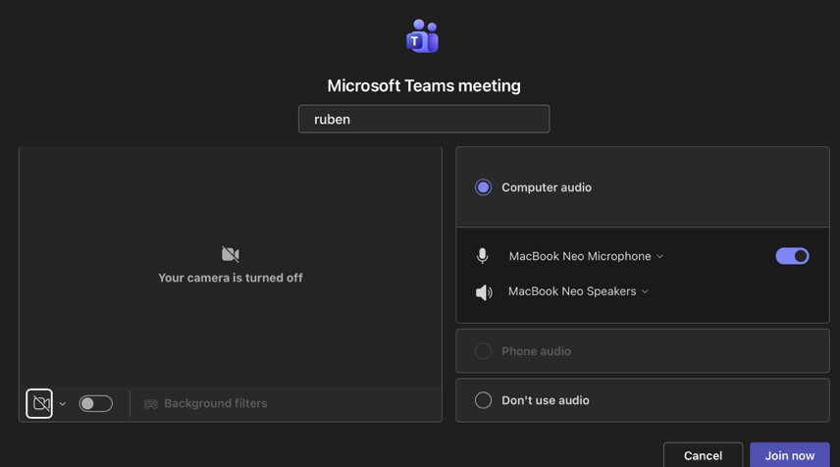



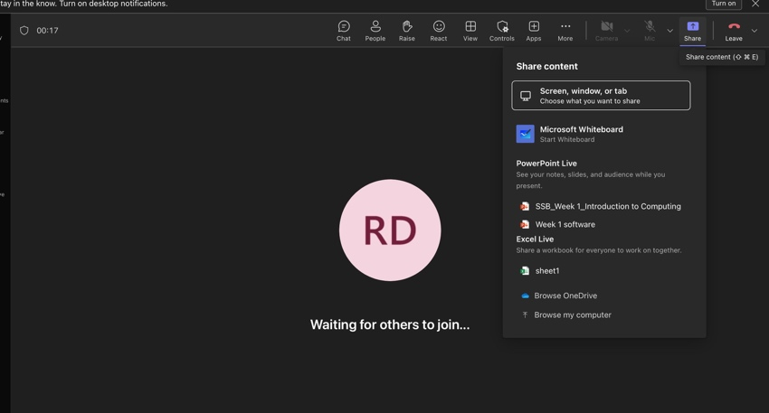

Conclusion
To sum up, this project has illustrated the significance of digital technology and software in contemporary corporate settings. Businesses can have an online presence and sell goods and services with the help of e-commerce website builders. While business software facilitates daily operations, mind mapping can aid in the organization of ideas. For document creation, data analysis, presentation delivery, and information management, Microsoft Word, Excel, PowerPoint, and Access offers helpful tools. Lastly, applications for collaboration and communication enable workers to collaborate more successfully. All things considered, when utilised properly in firms, these technologies can enhance productivity, organisations, communication, and decision-making.

References
[1] S. Rais and S. Lokhande, "Developing a library website using the Wix AI site generator," vol. 43, no. 2, pp.21–25, 2026,
[2] J. P. F. de Azeredo Pais, "No title," 2020,
[3] M. J. Somers, K. Passerini, A. Parhankangas and J. Casal, "Using mind maps to study how business school students and faculty organize and apply general business knowledge," vol. 12, no. 1, pp.1–13, 2014,
[4] U. F. Muogbo and C. J. Enemuo, "Interaction effects of teaching methods and gender on students' achievement and interest in Microsoft Word," vol. 5, no. 2, pp.206–213, 2026,
[5] A. Hyer, J. Sand, A. Cordova, B. Davis and A. Neet, "Using Microsoft Excel to Teach Foundational Data Analysis Skills in Online Learning: Evolution of a Time‐Honored Approach to Presenting Career Relevant Skills Into an Uncertain Future," 2026,
[6] I. Bouchrika, "best presentation tools other than PowerPoint that students can use in 2024," 7,
[7] A. Salma, D. A. Rahma, F. F. Rohmah, F. Awaliyah, H. Syahrizal and N. Farliana, "Development of a Microsoft Access-Based Mail Automation System to Improve Student Digital Administration," vol. 5, no. 4, pp.4027–4041, 2026,
[8] A. Puţanu, "Assessing Digital Platforms’ Impact on Organisational Communication Using Microsoft Teams", in Proceedings of the International Conference on Business Excellence, pp. 1482–1492.
[9] N. S. W. Bo, "OECD digital education outlook 2023: Towards an effective education ecosystem," vol. 15, no. 2, pp.284–289, 2025,

