

Programme: BA Business Management
Module code: LCBB4002
Community Engagement
Course work 2

Lecturer/Tutor: Molly Jack

Student: Petya Niklenova
Student ID: 1916916

Date: 22/05/2020

Reflective evaluation

Table of Contents
Introduction 3
1. Reflective evaluation – Kolb’s theory 4
1.1. Concrete experience 4
1.2. Reflective Observation 5
1.3. Abstract Conceptualization 6
1.4. Active Experimentation 7
2. Reflective practice and Gibbs’ reflective learning cycle. 8
Conclusion 10
References 10

Introduction

This report is a kind of reflective practice, which aims to create opportunities for the acquisition of knowledge and experience while reflecting on their own work, as well as to show critical thinking about ourselves and our own actions. Following this reflective assessment, a few learning and reflective theories will be discussed, so that they can help for a more systematically constructed evaluation. Two main theories will be involved in this reflective assessment, and they are Kolb’s learning theory and Gibbs’ reflective evaluation model. They will be presented more briefly, due to the fact that the main idea of this work is to produce a reflective evaluation based on course work-1.

Reflective evaluation – Kolb’s theory

Kolb has developed his theory for many years before he publishes it in 1984. His theory turns out to be a theory based on a complex of theories of one nature, which confirm each other. “The model gave rise to terms such as Four Dialectics of the learning cycle, 9-pixel resolution of Learning style types, experiential learning theory (ELT) and learning styles inventory (LSI)” (Kolb, 2014). The following diagram was selected as the clearest regarding the Four Dialectics of the learning cycle.

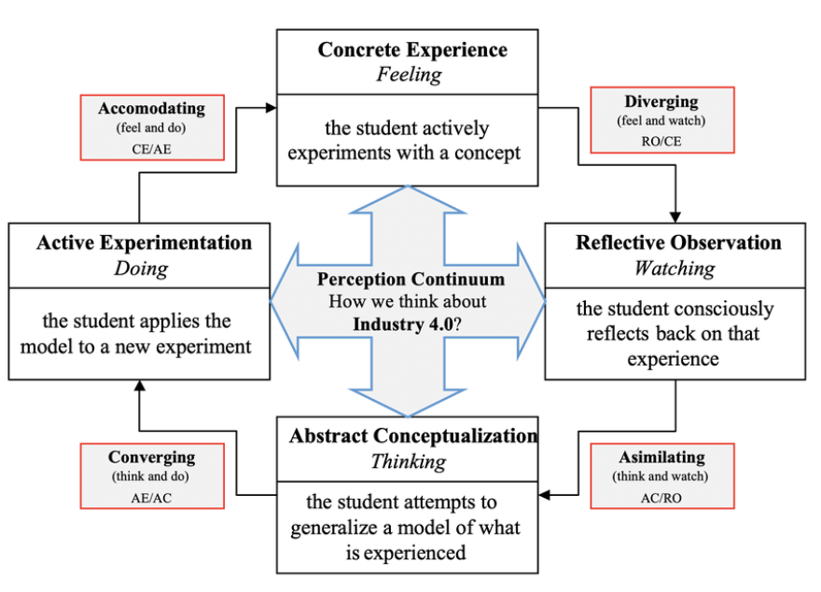
“Kolb's learning styles model and ELT”. Source: (Gencay, 2019)

Concrete experience

“Concrete experience – it refers to when a new experience or situation is encountered, or a reinterpretation of existing experience” (Nilson, 2010).
Referring to course work 1, it was both an interpretation of existing experience, and a concrete experience.
The first part the report required conducting environmental analysis for a business by own choice. For that reason, I selected Amazon, which is a famous giant, with worldwide scope, about which I have detected some problems with the employees. I have selected this company because I felt that there must be a deeper and more specific reasons for the problems with the employees they have. Moreover, that the second and third tasks of the course work one were also connected with the employees, because for the third par I have already selected the HR position, again feeling that once going to one concept, it will be good to see it into details and from different angles. Conducting SWOT and PESTEL analysis were a new experience for me.
The second part of the report required defining the role and importance of the employees for the businesses. This task was looking a little bit easy, but after I have reached to it, the truth was different. It was quite demanding job, because it required specific statements to be made, but at the same time they cannot be just said, but explained and underpinned with someone else’s statement too. It was difficult but not impossible. It was a generator of new experience.
The third and last part required to be chosen a significant management position and be discussed and explained in details, such as skills needed, duties, role and importance of the position, etc. For that task to be completed I have selected the management position of human resources (HR). This was the position which duties and responsibilities were connected with the first two parts of the report, so I felt it as most appropriate for the third task. It was also a responsible and demanding time and information task to be completed.
I felt that all of the three tasks will bring new experience for me, and even they were different by requirements I made it so that they were similar by nature. After the job was already done, I can clarify that all of the tasks brought new experience for me and not only, because they helped me to gather new knowledge, acquire new skills and gain important experience.

Reflective Observation

“Reflective Observation of new experience – of particular importance are any inconsistencies between experience and understanding” (Nilson, 2010).
During the process of conducting the environmental analysis, I was quite dedicated to ensure that I do find the real reason that makes issues with the employees of Amazon raise in such a great by all other factors business. The SWOT analysis were not that easy, that is why I had to do a detailed research and confirm any information found with a second source of information, that can prove the first. That is because there is a lot of old information, which is old and a mistake could be easily made.
It was difficult to understand which are the facts, that impact the high turnover of the warehouse employees in the company, and why exactly them. The reasons that could explain it was even more than one. It was shocking to see that such a great business has issues with the labour. However, the second task requiring to define the employees as an asset with value, and explain their role and importance for a business, helped me understand and find some of the reasons for the labour issue in Amazon.
What I have noticed from the whole work is that I did a great job by choosing the topics so similar, and that all of them deal with the employees. When observing the behaviour of the main subject in the three tasks, I have discovered more specific details, that could help me understand and define the main reasons for the high turnover of employees in the Amazon. Moreover, that after seeing the subject ‘employee’ from different point of view, I was able to generate more ideas of how the problem could be solved.
The position of human resource management was not very clear for me, and completing that task I was able to learn more about the role and importance of the position, as well as all of the things it is responsible for, all of the skills is necessary for it, what qualification and experience too. It was another important information that helped me learn a lot about this position.

Abstract Conceptualization

“Abstract Conceptualization reflection gives rise to a new idea, or a modification of an existing abstract concept (the person has learned from their experience” (Nilson, 2010).
Everything I have experienced during the course work one was of great importance for me and for my personal and professional development. Conducting environmental analysis is very useful skill that is very important for the contemporary business world. It also enriched my knowledge and experience. When learning even the little information could make difference. I now have learned how to do SWOT analysis for business, when before this work, I have dome it only for my individual development. The same analysis made for a business, brings another type of experience. It is completely difference to define yourself, as someone you know very well, and to define a business, that you maybe meet for first time in your life. It is a different experience and a needed experience.
The PESTEL helped me learn to think more objectively, because examining factors of global scope needs objectivity. I have learned something very important which happened during the process of conducting the external environmental analysis. That was the fact that the external factors can change just overnight. I had already completed one of the factors, when I suddenly read something new, which was important, but the information was out a day after my research was done. I have corrected my analysis as they must be very updated, but the situation made me remember for future, that even if I have already done some job, and if it regards information that could change overnight, then I have to check it to the day I have to submit my work.
The task regarding defying the employees as assets for the business, and treating them as such is very important. I have never before even thought about what are the employees for the business. Up to that point my perception about the employees was that the employees were just those who agreed to some job for the company against financial refund. Now though I have learned that my thinking was wrong, just because of the lack of knowledge in the past.
I have learned also, that the HR management is not only a position with higher salary than the regular employees, but a position with great responsibilities. Now I know that HR management is the department that deals with one of the most important and intangible assets for each organisation, the employees. This new knowledge has changed even my perceptions about why there is a need of good communication between the staff of a business and its HR management.

Active Experimentation

“Active Experimentation – the learner applies their idea(s) to the world around them to see what happens” (Nilson, 2010).
Thinking about everything new I have learned, all of the experience I have passed through and all of the skills I have gained, I am now feeling that I am more prepared to meet certain situation in my life. I am now clear that even if I have to buy a house, I should do analyse the strengths and weaknesses of the idea, as well as what the future could bring as taxes and rates of the borrowed from the banks for the mortgage. Knowing that an analysis could save me and my future, this experience is a great advantage for me.
Learning new things is always useful and it is sure that one day it will sure turn into advantages for the learner. Learning though, is not stronger than experience, because learned can be forgotten but experience last longer. Also, completing repeatable tasks aiming to get more experience will end in getting skilled in some area. Skills are important for any new job I could be looking for, as well as for my personal life’s needs. I am now dedicated that my idea to choose my topics in one specific area of the companies’ business structure was a good idea, because it makes the subject more clear and open opportunities for generating better ideas.

Reflective practice and Gibbs’ reflective learning cycle.

Reflective practice is a method of self-improvement usually used to assess our own thoughts and actions with the purpose of professional or personal development by learning. Reflective practice makes you feel responsible for yourself and motivates you of paying more attention to your self-development activities. It could look like a natural activity or instinctive action, but it is more effective when it was done professionally and with specific purpose.
Another most popular theory dealing with the reflective evaluations and reflective learning is the Gibbs’ reflective learning cycle.

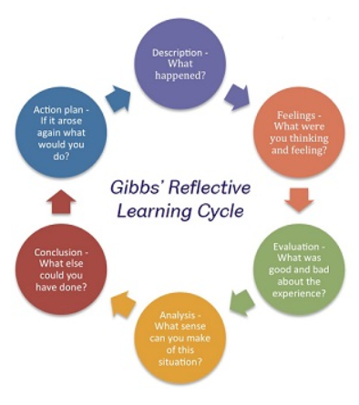
“Gibbs’ Reflective Learning Cycle”. Source: (The university of Sheffield, 2020)
Gibbs has defined six general stages of following while developing his theory. It is a method that define the path – learning by doing. “Gibbs (1988) believes that it is not enough just to have an experience in order to learn. Without reflecting on the experience, it may be quickly forgotten and its learning potential will be lost” (Pearce, 2003). This statement is adding to my belief stated above that I could forget the learned if I haven’t experiencing it, but it is now important to add that yes, If I don’t do reflection on it, then the learned and experienced could be lost.
So, even it is believed that the reflective practice is a process that is very useful when teaching children or young people, I am aware that it could also be very helpful towards Continuous Professional Development, because it enables future personal growth. I can classify the above written reflective evaluation as a reflective practice and add the fact that it was one more way to learn new things and gain new skills

Conclusion

The above reflective evaluation was very useful and played a role in validating the knowledge and skills acquired while completing the tasks and getting new experience. The two theories discussed proved this assertion, and also contributed to the acquisition of new knowledge and skills, which have the role of reinforcing other ones that have become the subject of reflective evaluation. Tracing the process of the two term papers, I can describe it as a cycle that fits perfectly into the combination of the two theories, Kolb's theory and Gibbs's theory.

References
Gencay, E., 2019. Kolb's learning styles model and experiential learning theory. [Online]
Available at: https://www.researchgate.net/figure/Kolbs-learning-styles-model-and-experiential-learning-theory_fig2_330281868
[Accessed 22 May 2020].
Kolb, D. A., 2014. Experiential Learning: Experience as the Source of Learning and Development. Second Edition ed. New Jersey: Pearson Education Inc.
Nilson, L. B., 2010. Teaching at Its Best: A Research-Based Resource for College Instructors. Third ed. San Francisco : John Wiley.
Pearce, R., 2003. Profiles and Portfolios of Evidence. First ed. Cheltenham: Nelson Thornes Ltd.
The university of Sheffield, 2020. Academic skills centre; Reflective Practice. [Online]
Available at: https://www.sheffield.ac.uk/ssid/301/study-skills/university-study/reflective-practice
[Accessed 22 May 2020].

