
Programme: Master of Business Administration
Module: International Marketing: Principles and Practices
Module code: LCMB7026
Lecturer: Tushara Balendran (London)
Assignment Title: International Marketing: Principles and Practices

Table of Contents
1.0 Introduction 3
1.1 Overview of the report 3
1.2 Aim of the report 3
2.0 Overview of the brand 4
2.1 Background of BMW 4
2.2 Operations of BMW in the UK and India 7
3.0 Comparison of the socio-cultural by analysing the macro-environmental analysis of Country A (UK) and Country B (India) 10
3.1 PESTLE Analysis (macro-environmental analysis) 10
3.2 Impact of the macro-environmental factors towards BMW in the UK and India 18
3.3 Impact of the socio-cultural factors of Country A and Country B towards BMW 19
4.0 Comparison of Brand’s STP strategies in Country A and Country B 20
4.1 STP strategic evaluation in the UK at BMW 20
4.1.1 Segmentation strategic objectives in the UK 20
4.1.2 Targeting strategic objectives in the UK 21
4.1.3 Positioning map strategic objectives in the UK 22
4.2 STP strategic evaluation in India for BMW 23
4.2.1 Segmentation strategic objectives in India 23
4.2.2 Targeting strategic objectives in India 24
4.2.3 Positioning map strategic objectives in India 25
4.3 Comparison evaluation for BMW in the UK and India 26
5.0 Comparison of Marketing Mix Strategies in Country A and Country B 26
5.1 Alignment with 7Ps marketing mix 26
5.2 Impact of marketing on the operations of BMW 32
6.0 Evaluation of the performance of marketing strategies' success by BMW in the UK and India 32
6.1 Annual Sales of BMW products in the UK and India 32
6.2 Market share and revenue in the UK and India 33
6.3 Number of branches available 33
6.4 Social Media Engagement in the UK and India 33
6.5 Brand Awareness levels of BMW in the UK and India 34
6.6 Key challenges faced by BMW in operating within the UK and India 34
7.0 Evaluation of marketing ethics practice 34
7.1 Marketing Ethics Practice of BMW in India 34
7.2 Marketing Ethics Practice of BMW in the UK 35
8.0 Recommendation & Conclusion 37
Reference List 39

1.0 Introduction

1.1 Overview of the report
International marketing principles and practices are part of strategic management, which determines how to sell products and services to global audiences. The study validates the international operation of Bayerische Motoren Werke AG (BMW) in the UK and India, which helps to present information regarding the strategic international operation. The potential analysis of the macroenvironmental analysis within the UK and India is reliable to understand the core conditions of the company. Moreover, the application of the Hofstede cultural dimension is efficient to analyse the social and cultural contribution in the UK and India, which adds credit to the BMW operation. Application of the STP strategies, followed by the 7Ps marketing mix strategies within the selected countries. The study will also focus on the marketing performance phenomenon, followed by the business ethical evaluation of BMW, which helps to build trust and credibility within the UK and India operations.

1.2 Aim of the report
The study aims to recognise the international marketing strategies utilised by BMW, which enhances success while using the strategies within the UK and India evaluation. In terms of analysing the core issues and problems, the study efficiently signifies the need for proper tactics to sustain within the selected countries.

2.0 Overview of the brand

2.1 Background of BMW
Bayerische Motoren Werke AG (BMW) Group is a German-based multinational conglomerate manufacturing vehicle organisation which has been operating since 1916 (BMW, 2019). The BMW operates under the brand names of BMW, Mini, Rolls-Royce and more. Furthermore, the company operates in more than 140 countries.
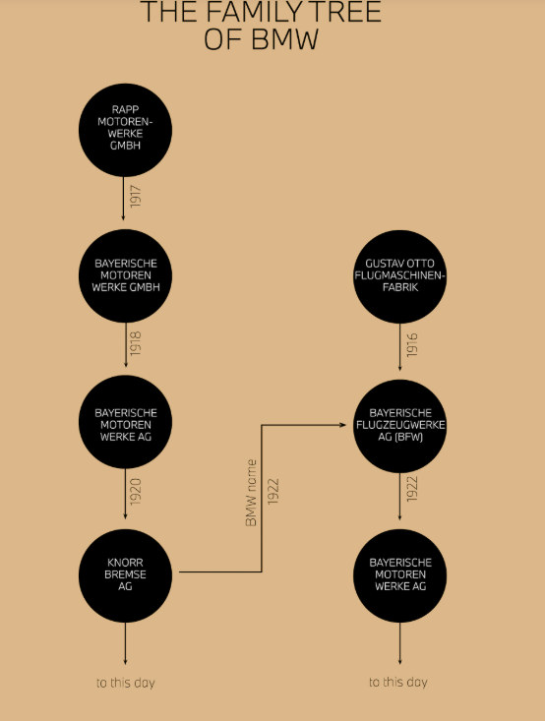
Figure 1: The family tree of BMW and its operational expansion
(Source: BMW, 2019)
The annual revenue of BMW has reached 142.3 billion USD in 2024, which has dropped from 155.4 billion USD in 2023 (BMW, 2024). Under the effective loss incurred to drop by -35.8% affecting the key performance rate in the company.
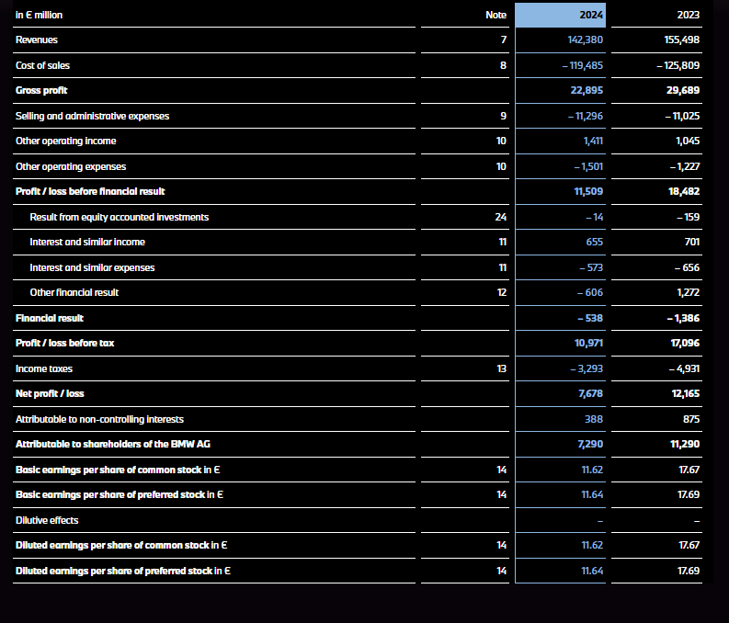
Figure 2: Financial summary of BMW (2023-2024)
(Source: BMW, 2024)
On the analysis, the EBIT margin within the automotive segment in BMW has increased by 6.3% in 2024, delivering access to a long-term sustainable target under the guidance approaches.

2.2 Operations of BMW in the UK and India
UK
BMW has highly enhanced its operation in the UK, as the firm has evaluated multiple manufacturing plants in the UK. Three UK manufacturing plants help to enhance the production of MINI and other BMW production in Goodwood and Rolls-Royce manufacturing units (Bmwgroup.jobs, 2025).
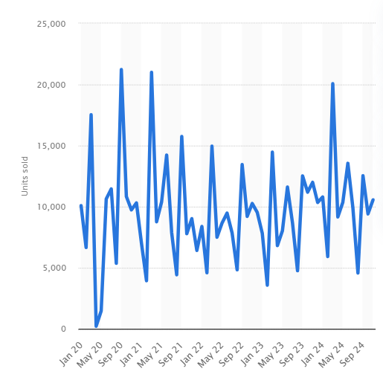
Figure 3: Monthly volume sales of the BMW vehicles passengers in the UK (2020-2024)
(Source: Statista, 2025)
Figure 3, almost 1,111,700 passenger cars sold in the UK by BMW by 2023, and 10,558 vehicles have been sold by 2024. The BMW operation in the UK is accessed with the global production network, while adding the local suppliers in the UK, and dispersed collaborative and high-value credibility are the core approaches while manufacturing the BMW (Winroth and Bennett, 2017).
India
BMW launched in India with the 100% subsidiary initiatives by the Group, which accessed with the facilities of a manufacturing plant in Chennai, India, a warehouse and training centres for the technicians, dealers and other employees (BMW Group PressClub, 2024). Under the strategic overview, BMW enhances almost 50% of the localisation materials and components during the production of the vehicles in the plants, and almost 17.500 units roll out in a single shift (Bmwgroup-werke.com, 2021).
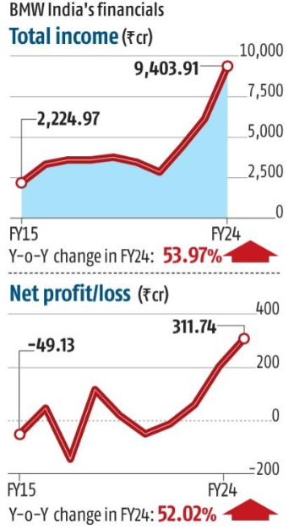
Figure 4: BMW financial performances in India
(Source: Patel, 2024)

3.0 Comparison of the socio-cultural by analysing the macro-environmental analysis of Country A (UK) and Country B (India)

3.1 PESTLE Analysis (macro-environmental analysis)
Political: Brexit formulated issues in the UK and the EU, determined regulatory and trading policies challenges (Eiser et al., 2021). The UK government evaluate foreign direct investment (FDI), which adds validation and effectiveness to the country's growth. A democratic system with unstable governmental evaluation. High support for the FDI policies, although the government supports tax incentives for the CKD assembly phenomenon. The political tension in both countries enhanced thge unfavourable situation for business expansion.
Economic: The inflation rate in the UK increased to 3.8% in July 2024, which affects the consumer price index (Statista, 2025).The unemployment rate has increased by 75.3% in the 3rd quarter of 2025 (Statista, 2025). Sensitive downturns in the economy of the UK are affecting the high-income market. The inflation rate analysed within India is 1.44% which has decreased by 0.25% since September 2025 (Ferreira, 2024). The unemployment rate in India has dropped to 4.4% in October 2025 (pib.gov.in, 2025). Deriving the middle class's demands for the luxury products. The economic instability enhances a unfavourable environment for the business expansion of BMW.
Social: The current population rate in the UK has increased to 69.3 million in 2024 (Clark, 2024). Rising preferences among the youth regarding the British production of the BMW models.Diverse culture and social preferences to sustainability.he population rate in India has reached 1.46 billion in 2025 (Worldometer, 2025). Influenced by status and prestige effectively enriches the premium positioning among the target audiences in the country. The increased adaptation of the BMW models has increased the market penetration, creating a favourable situation.
Technological:The UK is assessed with effective cybersecurity resilience, which is enriched with a technological ecosystem by the inclusion of AI technologies, and more helps to drive technological evaluation within the country (Abisoye and Akerele, 2022). Advanced technological evaluation, which is accessed with better battery sourcing, as well as infrastructure for charging. India is associated with technological advancement, which is connected with the advanced manufacturing and a highly technical development workforce (Rajendran et al., 2025). Enrichment of the software engineering evaluation, which adds cost-efficient technological support. The flourished technological market can be favourable for business expansion.
Legal:The UK has stronger employment laws and policies, where UK Employment Law expands the proper employee protection process (Morganlewis.com, 2025). Post-Brexit, the evaluation of changes in imports as well as exports in the EU. Labour law in India focuses on determining legal rights for employees. Determination of the intellectual property helps in improvement, which enriches the business appreciation. Cross-border legal complexities have become an unfavourable factor for business expansion.
Environmental: The UK Environmental Act 2021 is a framework which leads to access regulation for the protection of the Environment (UK Government, 2021).The Environmental regulations and laws are accessed with the Water Act 1974, the Air Act 1981 and more. The positive environment cultures establish a profitable environment for trading expansion.

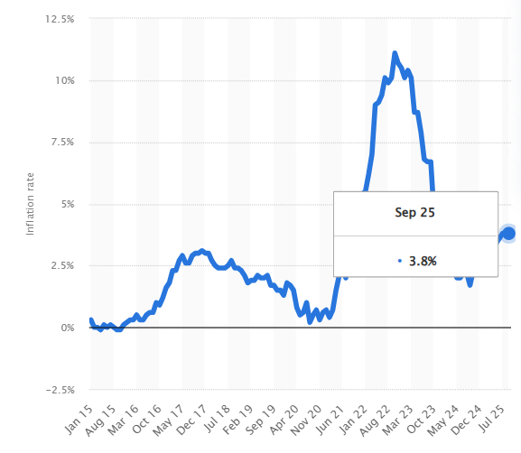
Figure 5: UK inflation rate 2025
(Source: Statista, 2025)
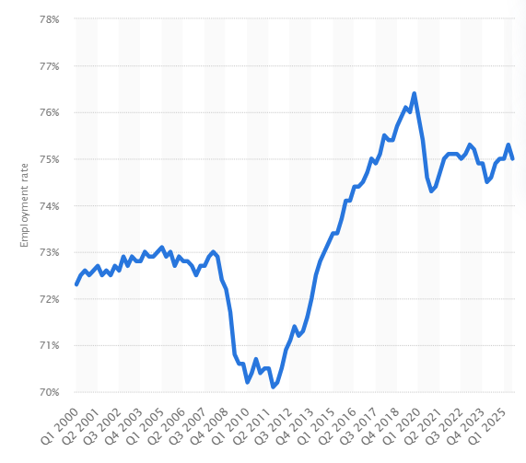
Figure 6: Unemployment rate in the UK
(Source: Statista, 2025)
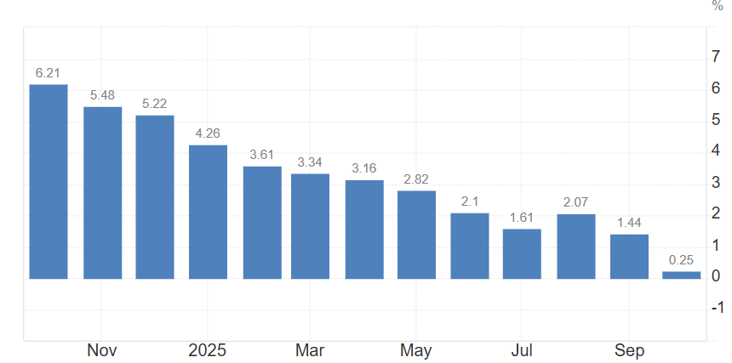
Figure 7: Inflation rate in India 2025
(Source: Ferreira, 2024)
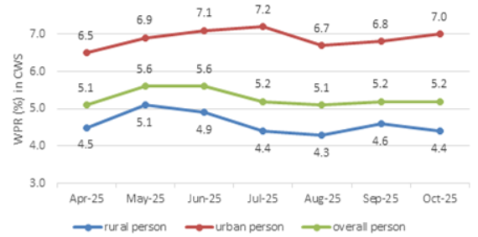
Figure 8: Unemployment rate in India
(Source: pib.gov.in, 2025)
Similarities and differences for the business expansion of BMW in the U.K and India:
The Matured market of the U.S. supports the business expansion of BMW, while in India, the expansion may witness considerable difficulties. Both aim to lead in luxury segments, with strong push for high-end models and EVs, tapping into growing affluent customer bases. Rapid investment in technology creates a profitable market scenario.

3.2 Impact of the macro-environmental factors towards BMW in the UK and India
Under the evaluation of the political interference, both the UK and India support the Foreign Direct Investments (FDI), which add efficiency to BMW to expand within these international countries; however, the unstable government in India and the evaluation of the Brexit issues affect the company to enhance its supply chain and import raw materials from different nations. Under the findings by Uddin et al. (2021), the Bank of England has dynamically warned of entering the recession period, which might affect the economy by 30% since 2020, and one-third of UK employees will be forced to get only 80% of their salary. Compared to it, India also faces a high inflation rate; however, the employment rate is low compared to the UK. This helps BMW to access efficient expansion in India, rather than in the UK. Analysing the technological expansion, India and the UK both enriched with technological support, as the UK-India collaboration of science as well as technology by signing a landmark agreement, which is enriched with the 2030 Vision (GOV.UK, 2023). These are effective for BMW to enhance the business integration and operation within both countries. Under the evaluation of the strict UK environmental and employment laws, which are effective for the support of the employees and environmental protection analysis. However, India is faced with the complex improvement of the regulations and laws which unable to support employment protection and amendments of the new laws. Furthermore, improving tax laws and intellectual property rights are under validation in India (George, 2023). This signifies that BMW is faced with legal issues while operating within India, although reliable UK legal policies are useful for the firm to work effectively.
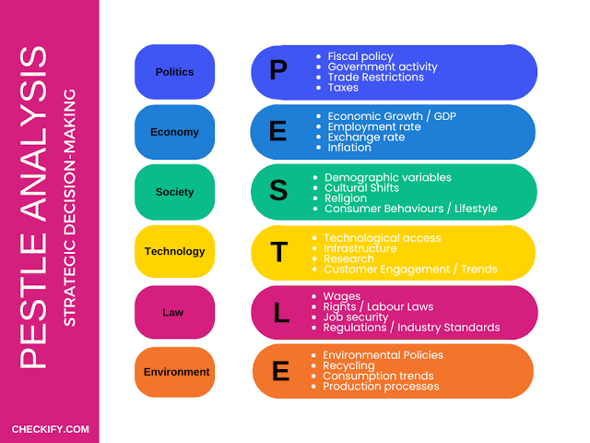
Figure 9: PESTLE Analysis
(Source: Chickify, 2025 )

3.3 Impact of the socio-cultural factors of Country A and Country B towards BMW
In terms of understanding the socio-cultural factors in India and the UK, it is necessary to evaluate the Hofstede cultural dimension analysis. This helps to understand the influences of values and behaviour between the different national cultural environments (Escandon-Barbosa et al., 2022).
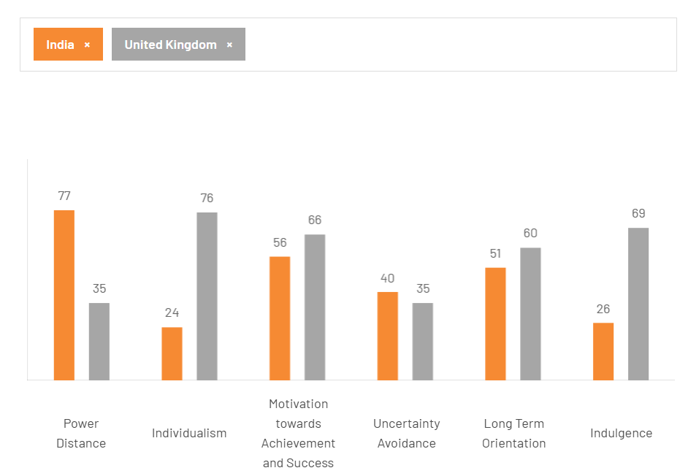
Figure 10: Hofstede cultural dimension analysis between India and the UK
(Source: Hofstede Insights, 2025)
Figure 9 has determined that India has scored in the Power Distance Index (PDI) of 77, which indicates a higher hierarchical and top-down structure evaluated in the Indian society as well as businesses. Compared to this, the UK received a PDI score of 35, which indicates minimal inequality within the society and the businesses (Hofstede Insights, 2025). The validation of the hierarchical society symbolises the need for status and prestige among the people (Körner et al., 2025). Hence, BMW significantly motivates the consumer behaviour within India, which adds credit and growth to the sales of the products of BMW.
Individualism vs collectivism has been assessed with a score of 48, whereas the UK has been assessed with a score of 89. The collectivism side is associated with the high preferences which are associated with a larger social framework, which is attributed to the individual which act within-group analysis. Whereas, UK focuses on private people and education in the early stages, which helps to access unique aspects. BMW determined that India is influenced by family preferences rather than individual aspirations; hence, the extension of safety features and customisation is the core need of the vehicles. However, the UK is enriched with personal lifestyle as well as self-obsession toward brands. This determines on personalisation of the uniqueness and performance features available within the selected vehicles.
Advantages and Disadvantages of Utilising Hofstede’s Model :
Oversimplification of the model is unable to offer the critical analysis aspects to interpret socio-cultural attributes. While a comparison between socio-cultural aspects can help in inspecting appropriate marketing opportunities for profitable expansion.

4.0 Comparison of Brand’s STP strategies in Country A and Country B

4.1 STP strategic evaluation in the UK at BMW

4.1.1 Segmentation strategic objectives in the UK
Factors | Description
Demographic | - The target age group are involved from 25 to 65 years old  - Middle to higher income demographic groups  - Under the occupational level, professionals and entrepreneurs are enriched
Behavioural | - Focuses on brand loyalty by connecting with the BMW financing, services and more.  - BMW targets the group which enriched with digital services and better networking (Kukkamalla et al., 2021).
Geographic | - Focus on the urban regions, which are enriched with Southeast England, London, Manchester and more (Grindrod, 2022).  - Strong evidence within the EV infrastructure evaluation.
Psychographic | - High lifestyle oriented with the luxury and technology analysis  - Eco-conscious driven segments are directed to the younger generation.
Table 2: Segmentation for the UK
(Source: Self-created)

4.1.2 Targeting strategic objectives in the UK
The BMW Group focuses on strong market positioning in 2024, where the brand is positioned with retained leadership in the global premium segmentation (BMW Group Report 2024). Growing of the UK segmentation, which focuses on the sustainability features and also specific customisation features, as these are effective for BMW to enrich its presence among the target audiences and market. The professional, urban families, entrepreneurs and more are the target audiences for the brand. The brand has segmented different series of vehicles such as 3 Series, 5 Series, X1, X3 and more models, which are hybrid and also accessible with affordable ranges appropriate for the professionals and urban families segmentation.

4.1.3 Positioning map strategic objectives in the UK
Competitors of BMW in the UK: Audi, Volvo, Porsche, Volkswagen.
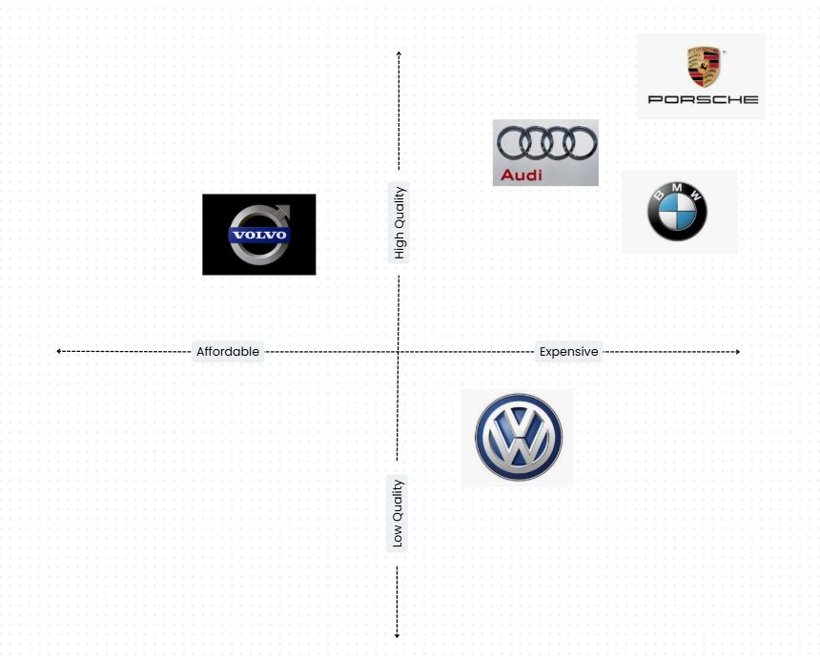
Figure 11: Positioning Map in the UK
(Source: Self-created)
The positioning evaluation of the BMW in the UK has resulted in a premium position, which is associated with high quality and an expensive price.

4.2 STP strategic evaluation in India for BMW

4.2.1 Segmentation strategic objectives in India
Factors | Description
Demographic | - The target audiences in India are available in the age group of 25 to 60 years, with a preference for luxury vehicles.  - Entrepreneurs, professionals, the creative industry and more show high preferences for the brand  - High to middle-income segments are analysed for the BMW marketing.
Behavioural | - Focuses on the affordable ranges of the vehicles, hence, BMW is authorised with the BMW 2 Series and the BMW iX1.  - Enriched with tech-oriented and digital services are reliable for accessing early adoption activities.
Geographic | - The target areas are the urban regions as it accessed with better infrastructure, valuable for the vehicle initialisation.  - Growing demands towards Tier 2 cities in India, which jumped to 30% sales of luxurious cars (Singh, 2025).
Psychographic | - Motivation and status-driven aspects, which have been analysed in the PDI culture  - Personality and prestigious symbolic buying initiation.
Table 3: Demographic segmentation in India
(Source: Self-created)

4.2.2 Targeting strategic objectives in India
BMW is authorised the use the differentiated targeting strategy, which concentrates on the fast-growing group that highly values the luxury products. The target audiences for the BMW in India are the young professionals, entrepreneurs, and family-oriented individuals. Moreover, the evaluation of the different model cars. BMW is influenced by the cheaper hardware options, which are reliable to decrease the price range of the car models (Weiss et al., 2021).

4.2.3 Positioning map strategic objectives in India
Competitors of BMW in India: Jaguar Land Rover, Tata, Mercedes-Benz and Audi
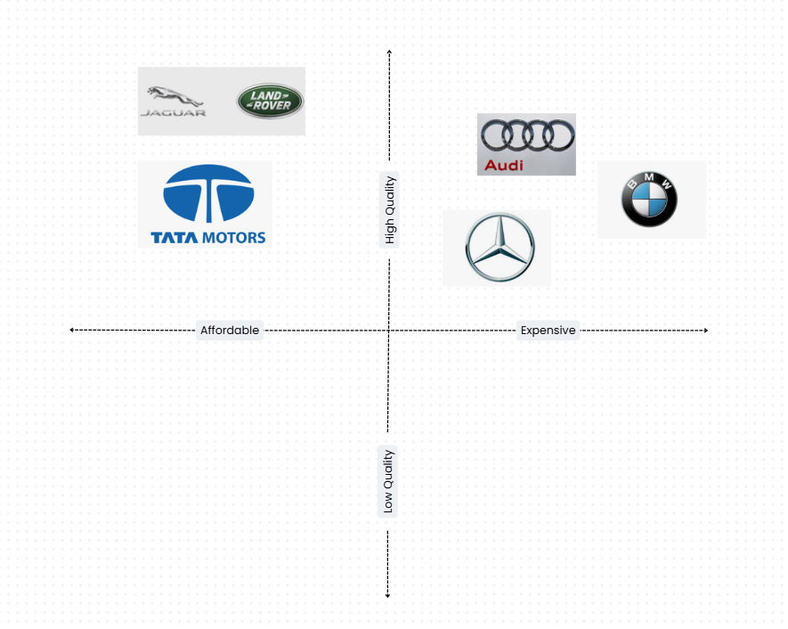
Figure 12: Positioning Map of BMW in India
(Source: Self-created)
Figure 11 shows significant positioning of BMW in the premium segment, whereas the competitors, Tata and Land Rover, are segmented into the affordable segment, which might incur high competitiveness.

4.3 Comparison evaluation for BMW in the UK and India
Comparing the segmentation evaluation, where BMW in the UK has high determination to the demographic and psychographic evaluation, which helps to sell the premium segmented vehicles in M-series, EV and premium segments. However, BMW's premium segment model has sold in the UK which has reaching 172,240 units under the qualification of the fully electric versions (BMW Group PressClub, 2024). However, the Indian market is enriched with the demographic segments, while seeking the affordable and family-oriented model, hence the authorisation of the EV models and the performance-oriented model of BMW are in significant demand. Under the record, in India, BMW has sold 1474 units of the EV in 2023, which has achieved a growth of 325% Y-O-Y compared to 2022 (Singh, 2024).

5.0 Comparison of Marketing Mix Strategies in Country A and Country B

5.1 Alignment with 7Ps marketing mix
Elements | UK | India
Product | - Sedans, Coupes, Convertibles, Gran Coupes, and SUVs (X-Series), plus high-performance M models, and a growing range of electric (i-Series) vehicles are the popular cars of BMW (BMW USA, 2025).  - Extreme consumer awareness regarding the luxury cars in the UK market is crucial to thrive in prosperity.  - The presence of inclusive technology, luxury and innovative features is the USP of the BMW products for grasping the attention of the tech-savvy consumers. | - Sedans (2 Series Gran Coupe) and luxury sedans (3, 5, 7 Series) to SUVs (X1, X3, X5, X7, coupe SUVs X4, X6), high-performance M models (M2, M5, M8), roadsters (Z4) are the preferred success (BMW India, 2025).  - Young professionals and tech-savvy consumers from the Indian market can help expand the business internationally.  - Assessing the preferences of the local consumers, BMW have offered a localised model to enhance consumer satisfaction.
Price | - Premium pricing of the products has grabbed the eyeballs of the UK consumers as inclusive quality and premium pricing showcase its long-term hetritageous glory in the international market domain.  - Inclusion of the high-end technology and an increase in the cost of production have influenced the premium market, drawing the attention of sophisticated consumers. | - BMW has adopted a competitive pricing strategy in India to establish a resilient and productive market culture related to the luxury car brands.  - Attracting the middle-class population in India, BMW can expand its operations in the international market (Business Standard, 2025).
Place | - The mature market cultures of the UK have encouraged consumers to expand licensing.  - The UK has witnessed 172,000 registrations in 2024, demonstrating the explicit sales growth (BMW Group, 2025). | - As the Indian marketplace is considered a saturated one, BMW India has adopted a more consumer-sensitive marketing to drive their sales prosperity.  - Selling 14172 units of cars, BMW has demonstrated its popularity (ET auto desk,2024).
Promotion | - Inclusion of the “Neue Klasse" series and financial offerings like “Personal contact purchase” has helped in expanding the business of BMW (BMW Group, 2025).  - Manufacturing longevity-based vehicles like EVs and promoting the use of electronic vehicles to consumers in the international market. | - The price drops in the automotive industry have been witnessed a huge drop following the inclusion of UK-India duty agreements (FTA), which widened the sales-related possibilities for the price-sensitive population (Business Standard, 2025).  - Increased numbers of the local production can reduce the manufacturing and delivery-related hindrances
People | - Inclusion of the most technologically talented employees can help expand technological inclusivity. | - The trading productivity of BMW can help in managing the operational trends and prosperity in the Indian market, with the retention of talented employees.
Process | - Focused on a digitally-first sales concept, BMW can expand the business.  - Promotion of the marketing and sales aspects in the digital platform, like traditional and social media platforms, can help in increasing the brand familiarity and popularity (BMW Group, 2025). | - The presence of creative campaigns on social media platforms helps in increasing the brand's popularity
Physical Evidence | - The luxurious ambience of the offline dealership intensifies the consumer participation.  - High-quality design and inclusive technology can evaluate the business operation of BMW in the international business domain. | - Exclusive materials and design of the products have represented the exceptional brand familiarity in the international business market.
Table: Marketing 7Ps
(Source: self-created)
Analysis:
Based on the abovementioned table, BMW’s marketing mix is straightforward, which focuses on consumer satisfaction and exceptional consumer experiences by offering a dynamic range of automotive products at both premium and affordable prices. The mature market base in the UK is responsible for expanding the business in the international market. As the UK consumers prefer the premium products over the affordable products can encourage the professionals of BMW to intensify the technological advantages in the product portfolio to increase the brand popularity and prosperity. Integration of i7 and iX processors has triggered the popularity of the BMW among the tech-savvy UK consumers (Press BMW, 2025). Increased sales rates of the product named Series 1 in the UK have showcased the popularity of the product. Renovation in the product designs and modification in the technological aspects can trigger the sales rates of BMW.
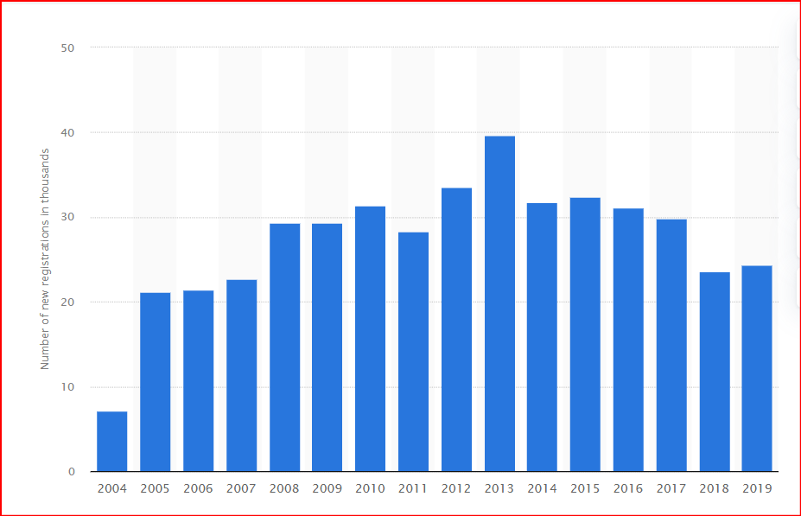
Figure 12: Sales growth of series 1
(Source: Statista, 2021)
Differences in the pricing model have created major differences in the marketing aspect to increase the market share to manage the explicit operational growth and prosperity. Declining sales growth around 24322 decreases the operational prosperity and productivity, intensifying the possibilities of extreme loss (Statista, 2021). The increased competition in the automotive industry following the post-COVID era can increase threats to the trading activities of BMW by discouraging business professionals from adopting environmentally competent products to manage trading resilience and proficiency. Offering an exceptional luxurious experience, the business professionals can grab the attention of the sophisticated, tech-savvy and young business professionals. Intense competition from Audi A4 and Mercedes-Benz C-Class has imposed notable threats to BMW to preserve its competitive position in the UK context.
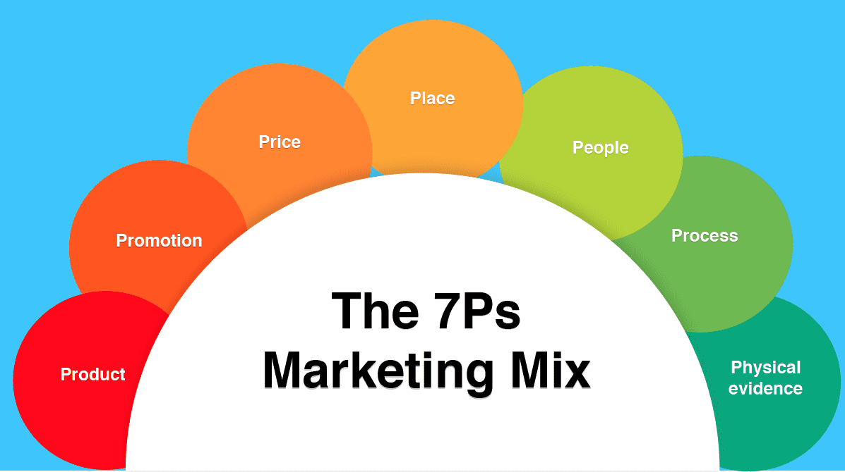
Figure 13: 7PS Marketing Mix
(Source: Smart insights, 2025)

5.2 Impact of marketing on the operations of BMW
Aligning the resource allocation and market demands, BMW can employ a dynamic business strategy to drive innovation and rectify the brand image. The business professionals engaged with BMW can change their production-related attitudes to adopt he “Vibrant transformation” process to meet the contemporary trends (Pressclub global, 2025). The increased competition among competitors in both the UK and Indian markets can restrict the worldwide expansion of BMW in the international business domain. The presence of inclusive technology in business cooperation is the prime reason for the increasing craze for the products among the sophisticated and tech-savvy community. Inclusive design, premium pricing and top-notch technologies can attract consumers from the UK market, whereas the competitive pricing and heritage brand image attracted the population of Indian cultures.

6.0 Evaluation of the performance of marketing strategies' success by BMW in the UK and India

6.1 Annual Sales of BMW products in the UK and India
According to the UK sales by BMW Group, it has been analysed that the total number of BMW and MINI sold was 172,240 units, which is recognised in the annual report of 2024, which has increased by 12% compared to 2023 (BMW Group PressClub, 2024). Analysing the report in the Indian market, BMW Group has sold more than 15,721 vehicles in 2024, of which 1249 units are fully EVs. This has been determined wth the growth of 11% compared to the record in 2023 (BMW Group PressClub, 2025).

6.2 Market share and revenue in the UK and India
Under the analysis of the data from BMW Group in the UK, which has secured the market share of 22.6% among the premium and luxury car segment in 2024 (BMW Group PressClub, 2024). The BMW UK group jas enriched with 5.1 million GBP revenue, determined to affect the overall business initiatives in the UK (cityam.com, 2024). Focusing on the market share in India, which has been analysed to increase by 34.23% within the luxury car segment (carlogos.org, 2022). The market revenue, which has reached 9403 crores INR in 2024 by the BMW Group in India (business-standard.com, 2024).

6.3 Number of branches available
As per the record, BMW has 150 BMW dealerships available throughout the UK, where England having 124 dealership units (bmw.co.uk, 2025). However, in India, BMW operates with almost 41 sales outlets and stores (press.bmwgroup.com, 2020). However, different third-party listed dealers are associated with a large number of BMW dealerships throughout India.

6.4 Social Media Engagement in the UK and India
BMW's social media engagement is one of the important aspects which helps the company to enhance its growth. Hence, BMW in the UK has enriched its Instagram followers of almost 377k (Instagram.com, 2017). However, in India, there is are presence of more Instagram followers, which has reached almost 1.6 million (hypeauditor.com, 2025). Analysing the comparison, BMW UK has a lower engagement rate than that of BMW India, where high followers increase the brand awareness throughout the globe.

6.5 Brand Awareness levels of BMW in the UK and India
In the UK, BMW has enriched its awareness rate, identified by YouGov Brand Index of 95.8% among UK adults (Yougov.com, 2023). The rise of Ad awareness also helps the brand to achieve success in the UK regions. However, analysing the overview in India, YouGov has ranked BMW with a score of 22.4% in the awareness levels in 2022 (Yougov.com, 2022).

6.6 Key challenges faced by BMW in operating within the UK and India
Highlighting the key challenges in the UK on shifting to the EV adaptation of the vehicles, which are growing stricter as the UK government targets if reduction of carbon emissions. BMW is challenged with low EV vehicles, which are the core challenges for the company to sustain in the area. Determination of the BMW in India, limited EV infrastructure, and slower adaptation of the EV also highlighted which affect the new launch EV model to sustain in India. Furthermore, higher import duties and policies affect the market as the luxury car prices grow higher.

7.0 Evaluation of marketing ethics practice

7.1 Marketing Ethics Practice of BMW in India
BMW India engages in extensive marketing activities, especially on social media platforms, as well as using mass media and traditional marketing channels. On the other hand, the brand also markets its BMW India Foundation, which supports the company’s CSR policy in committing towards local development (BMW India, 2025). In this regard, the company also focuses its customer-centric activities towards ensuring customer safety and is transparent about faults in its products. In this regard, in 2021, the company recalled its product models like BMW 1/3 Series, BMW X1/3/5/6, BMW M3, to the count of nearly 8000 cars due to a potential defect in the airbag deployment mechanism of the products (SIAM, 2022). However, certain ethical risks still affect BMW India, as the company’s positioning and consistent marketing as a premium aspirational brand can often tokenise green claims unless the advertisement claims of the firm meet the actual data related to their product emissions and lifecycle data. Moreover, BMW’s marketing decisions in the Indian market as a premium brand can often lead to the overshadowing of sustainability-related dialogue in society, with the discussion regarding the aspirational luxury premium features of the BMW products. In this regard, it can be seen that in the Indian Market, BMW in its marketing processes while presently having an established ethical structure, is at risk of engaging in unethical activities, as it can be prone to propagate its luxury brand position before promoting its commitments to environmental sustainability. Herein, it was also identified that in 2025, BMW India is looking to further explore and reposition itself in the Indian market segment (Storyboard 18, 2025). This provides the company to further clarify its ethical position, further enhancing ethical marketing practices within the firm in alignment with the strategic marketing direction of the firm in India.

7.2 Marketing Ethics Practice of BMW in the UK
In the UK, BMW faces several ethical challenges in its marketing activities, especially in relation to greenwashing allegations. For instance, in relation to one of the Google Ads launched by BMW in the UK in 2023, it was scrutinised by the ASA as it was found that the marketing claim without emission results to back claims of zero-emission cars was ruled by the ASA as a misleading advertisement, which can be characterised as an act of greenwashing (ASA, 2024). Moreover, in 2021, one of the radio advertisements of BMW in the UK was banned by ASA as it misled the customers, glorifying risky driving and promoting unsafe driving actions (ASA, 2021). This further shows the unethical marketing practices of BMW in the automobile market in the UK. Furthermore, in the context of BMW’s ConnectedDrive Ecosystem, it has been found that the company collects a large amount of personal information of consumers, and the company accordingly publishes its data privacy policies (BMW, 2025). However, the ethical debate regarding consent, clarity and third-party sharing of the collected consumer data reduces the ethical credibility of this marketing move of the firm. This shows that the marketing practices of BMW in the UK, while within the ethical framework of the firm, tend to breach the ethical boundary of the firm. This can be confirmed from its greenwashing attempts, ethically dubious activities related to consumer data collection, as well as the unethical and misleading of the consumers towards unsafe driving practices. Thus, the company in the UK market needs to improve its ethical policy implementation and practices, especially within its marketing processes.
Based on the above discussions on the ethical practices in the marketing processes of BMW in the Indian and the UK markets, it can be confirmed that the firm’s practices in the Indian market are way more ethical than in the UK Market. For instance, BMW India runs the BMW India Foundation, which commits to local development in the Indian market, showcasing tangible efforts for achieving sustainability. On the other hand, the BMW in the UK has yet to show any tangible efforts for its claimed commitment towards sustainability; instead, the firm is being proven in multiple instances to be engaging in greenwashing, as its marketing claims indicate the company’s capability to develop zero-emission cars without providing relevant lifecycle emission data. While the BMW in the UK market faces multiple ethical challenges, in the Indian market, the company, at most faces the risk of potential ethical breaches, but at present are not reported to be unethical in their marketing conduct.

8.0 Recommendation & Conclusion
To improve the standards of the current international marketing of BMW in the Indian and UK markets, the following can be recommended to the firm.
- Localisation of the EVs in Alignment with Local Infrastructure: In India, through the above analysis, it was identified that the charging infrastructure-related challenges lead to slower uptake, while the slower uptake of EVs in the UK is related to the rising compliance issues. In this regard, BMW should scale up the localisation of its EV manufacturing facilities in India and the UK while deepening related partnerships with the Indian Government and Regulatory Bodies to support effective and legally compliant EV manufacturing.
- Redesigning Ethical Marketing Frameworks in the UK: It was identified that the UK Market is facing ethical challenges related to BMW’s Greenwashing and other unethical marketing practices. In this regard, BMW in the UK must redesign its Ethical Marketing Frameworks, ensuring strict implementation of the frameworks, wherein marketing claims made public are backed by evidence-based data analysis.
In conclusion, the international marketing performance of BMW in the Indian market and in the UK market demonstrates the company’s ability to utilise its standard core competencies to navigate market complexities in culturally and environmentally different UK and Indian Markets. BMW’s marketing position in the UK Market is shaped by the digitally mature, technologically credible, and strictly regulated premium EV consumer bases. On the other hand, in the Indian market, BMW’s position is dependent on the growing consumption of a status-driven, fast-growing consumer base. In this regard, while BMW is able to better adapt to the local marketing nuances in the Indian and the UK markets, its ethical marketing conduct in the UK market requires further improvement.

Reference List
Abisoye, A. and Akerele, J.I., 2022. A practical framework for advancing cybersecurity, artificial intelligence and technological ecosystems to support regional economic development and innovation. Int J Multidiscip Res Growth Eval, 3(1), pp.700-13. DOI: https://doi.org/10.54660/.IJMRGE.2022.3.1.700-713
ASA (2021). ASA Ruling on BMW (UK) Ltd. Available at: https://www.asa.org.uk/rulings/bmw--uk--ltd-a21-1104415-bmw--uk--ltd.html [Accessed 18 November 2025]
ASA (2024). ASA Ruling on BMW (UK) Ltd. Available at: https://www.asa.org.uk/rulings/bmw--uk--ltd-a23-1209400-bmw--uk--ltd.html [Accessed 18 November 2025]
BMW (2025). BMW ConnectedDrive Privacy Policy. Available at:https://www.bmw.co.uk/content/dam/bmw/marketGB/bmw_co_uk/owners/bmw-connecteddrive/legal-information/BMW_CD_PP_GB-EN_2022.07_Final.pdf.asset.1666694485342.pdf [Accessed 18 November 2025]
BMW USA (2025) All BMW Models. Available at: https://www.bmwusa.com/all-bmws.html [Accessed 18 Nov. 2025].

BMW Group (2025) New sales and marketing strategy. Available at: https://www.bmwgroup.com/en/news/general/2021/marketing-strategy.html [Accessed 18 Nov. 2025].
BMW Group (2025). BMW Group UK Leads the Premium Segment in 2024 with Strong Electric Growth. Available at: https://www.press.bmwgroup.com/united-kingdom/article/detail/T0447261EN_GB/bmw-group-uk-leads-the-premium-segment-in-2024-with-strong-electric-growth?language=en_GB [Accessed 18 November 2025]
BMW Group (2025). The Neue Klasse BMW Group enters a new era. Available at: https://www.bmwgroup.com/en/company/neue-klasse.html [Accessed 18 November 2025]
BMW Group PressClub, 2024. BMW Group India Sets the Pace with Strong Start in 2024. [online] Available at: https://www.press.bmwgroup.com/india/article/detail/T0440938EN/bmw-group-india-sets-the-pace-with-strong-start-in-2024?language=en. [Accessed 18 Nov. 2025].
BMW Group PressClub, 2024. BMW Group UK Leads the Premium Segment in 2024 with Strong Electric Growth. [online] Available at: https://www.press.bmwgroup.com/united-kingdom/article/detail/T0447261EN_GB/bmw-group-uk-leads-the-premium-segment-in-2024-with-strong-electric-growth?language=en_GB [Accessed 18 Nov. 2025].
BMW Group PressClub, 2024. BMW Group UK leads the premium segment in 2024 with strong electric growth. (no date) BMW Group PressClub. Available at: https://www.press.bmwgroup.com/united-kingdom/article/detail/T0447261EN_GB/bmw-group-uk-leads-the-premium-segment-in-2024-with-strong-electric-growth?language=en_GB& (Accessed: 18 November 2025).
BMW Group PressClub, 2025. BMW Group India continues its trailblazing performance. Highest-ever annual car sales of 15,721 units with +11% growth. [online] Available at: https://www.press.bmwgroup.com/india/article/detail/T0447350EN/bmw-group-india-continues-its-trailblazing-performance-highest-ever-annual-car-sales-of-15-721-units-with-11-growth?language=en& [Accessed 18 Nov. 2025].
BMW Group Report 2024. Downloads: BMW Group Report 2024 (no date) Downloads | BMW Group Report 2024. Available at: https://www.bmwgroup.com/en/report/2024/downloads/index.html (Accessed: 18 November 2025).
BMW India (2025). BMW India Foundation: Driving positive change. Available at: https://www.bmw.in/en/topics/bmw-india-foundation/BMW-India-Foundation.html [Accessed 18 November 2025]
BMW, 2019. How the BMW name was created | BMW.com. [online] Bmw.com. Available at: https://www.bmw.com/en/automotive-life/BMW-name-meaning-and-history.html. [Accessed 18 Nov. 2025].
BMW, 2024. Income Statement | BMW Group Report 2024. (2024). Income Statement | BMW Group Report 2024. [online] Available at: https://www.bmwgroup.com/en/report/2024/financial-statements/income-statement/index.html. [Accessed 18 Nov. 2025].
bmw.co.uk, 2025. Find a BMW centre - dealers, Test Drive & Service Near Me. Available at: https://www.bmw.co.uk/en/footer/contact/find-a-bmw-centre.html (Accessed: 18 November 2025).
Bmwgroup.jobs, 2025. Our UK & IE Locations | BMW Group Careers UK. [online] Available at: https://www.bmwgroup.jobs/gb/en/location.html [Accessed 18 Nov. 2025].
Bmwgroup-werke.com, 2021. BMW Group Plant Chennai. [online] Available at: https://www.bmwgroup-werke.com/chennai/en.html [Accessed 18 Nov. 2025].
Business Standard (2025). India-UK FTA a positive step; car prices unlikely to change: BMW, Mercedes. Available at:https://www.business-standard.com/economy/news/india-uk-fta-a-positive-step-car-prices-unlikely-to-change-bmw-mercedes-125051100111_1.html [Accessed 18 November 2025]
business-standard.com, 2024. BMW India consolidated net profit rises 52% to Rs 311 crore in FY24 (2024) Business Standard. Available at: https://www.business-standard.com/industry/auto/bmw-group-india-reports-52-profit-surge-in-fy24-as-luxury-car-demand-rises-124102700202_1.html (Accessed: 18 November 2025).
carlogos.org, 2022. BMW Sales Figures & Market Share in India (2008-2022) (no date) CarLogos. Available at: https://www.carlogos.org/reviews/bmw-sales-figures-in-india.html (Accessed: 18 November 2025).
Checkfy (2025) PESTLE Analysis for Strategic Decision-Making. Available at: https://checkify.com/article/pestle-analysis/[Accessed 18 Nov. 2025].

cityam.com, 2024. BMW back in the black after UK sales move up a gear (2024) City AM. Available at: https://www.cityam.com/bmw-back-in-the-black-after-uk-sales-move-up-a-gear/ (Accessed: 18 November 2025).
Clark, D., 2024. UK Population 2018 | Statista. [online] Statista. Available at: https://www.statista.com/statistics/281296/uk-population/.[Accessed 18 Nov. 2025].
Eiser, D., McEwen, N. and Roy, G., 2021. The trade policies of Brexit Britain: The influence of and impacts on the devolved nations. European Review of International Studies, 8(1), pp.22-48. https://brill.com/view/journals/eris/8/1/article-p22_22.pdf
Escandon-Barbosa, D., Ramirez, A. and Salas-Paramo, J., 2022. The effect of cultural orientations on country innovation performance: Hofstede cultural dimensions revisited?. Sustainability, 14(10), p.5851. https://www.mdpi.com/2071-1050/14/10/5851
ET auto desk (2024) BMW Group India records best-ever sales in 2023, gears up with 19 new models in. Available at: https://auto.economictimes.indiatimes.com/news/passenger-vehicle/bmw-group-india-records-best-ever-sales-in-2023-gears-up-with-19-new-models-in-2024/106724374 [Accessed 18 November 2025]
Ferreira, J., 2024. India Inflation Rate Below Forecasts. [online] Tradingeconomics.com. Available at: https://tradingeconomics.com/india/inflation-cpi.[Accessed 18 Nov. 2025].
George, A.S., 2023. Evaluating India's economic growth: challenges and opportunities on the path to 5 trillion dollars. Partners Universal International Innovation Journal, 1(6), pp.85-109. DOI: https://doi.org/10.5281/zenodo.10307006
GOV.UK, 2023. UK to boost tech and innovation ties with India. [online] Available at: https://www.gov.uk/government/news/uk-to-boost-tech-and-innovation-ties-with-india [Accessed 18 Nov. 2025].
Grindrod, J., 2022. Iconicon: A journey around the landmark buildings of contemporary Britain. Faber & Faber. https://books.google.com/books?hl=en&lr=&id=zP42EAAAQBAJ&oi=fnd&pg=PP7&dq=Focus+on+the+urban+regions+of+BMW,+which+are+enriched+with+Southeast+England,+London,+Manchester+and+more.+&ots=G8UnMeKe5D&sig=5ug3QqWMnUN70_5gAdrXPnP_g0k
Hofstede Insights, 2025. Country Comparison Tool. [online] Theculturefactor.com. Available at: https://www.theculturefactor.com/country-comparison-tool?countries=india%2Cunited+kingdom. [Accessed 18 Nov. 2025].
hypeauditor.com, 2025. Free Instagram audit tool - HypeAuditor (no date) HypeAuditor.com. Available at: https://hypeauditor.com/free-tools/instagram-audit/ (Accessed: 18 November 2025).
Instagram.com, 2017. BMW UK (@bmwuk) • Instagram photos and videos. [online] Available at: https://www.instagram.com/bmwuk/ [Accessed 18 Nov. 2025].
Körner, R., Overbeck, J.R. and Schütz, A., 2025. Structuring hierarchy concepts: Evaluating measures of power, status, dominance, and prestige on the basis of an integrative model and systematic literature review. Psychological Bulletin, 151(3), p.322. http://fis.uni-bamberg.de/bitstreams/5632fe0d-2167-4e82-9407-1aeac7ce4fd2/download
Kukkamalla, P.K., Bikfalvi, A. and Arbussa, A., 2021. The new BMW: business model innovation transforms an automotive leader. Journal of Business Strategy, 42(4), pp.268-277. https://www.emerald.com/jbs/article-pdf/42/4/268/1509332/jbs-02-2020-0021.pdf
Morganlewis.com, 2025. UK Employment Law 2024 Year in Review and a Look Forward to 2025 Webinar: Key Takeaways. [online] Available at: https://www.morganlewis.com/pubs/2025/03/uk-employment-law-2024-year-in-review-and-a-look-forward-to-2025-webinar-key-takeaways.[Accessed 18 Nov. 2025].
Patel, D. 2024. BMW India consolidated net profit rises 52% to Rs 311 crore in FY24. [online] @bsindia. Available at: https://www.business-standard.com/industry/auto/bmw-group-india-reports-52-profit-surge-in-fy24-as-luxury-car-demand-rises-124102700202_1.html.[Accessed 18 Nov. 2025].
pib.gov.in, 2025. All press releases: Press Information Bureau. Available at: https://www.pib.gov.in/allrelease.aspx (Accessed: 18 November 2025).
press.bmwgroup.com, 2020. The Official Press Portal of the BMW Group in 19 languages. We provide you with the latest press releases of the BMW Group free of charge and at first hand. The material comprises text, photos, audio, video and TV footage. Available at: https://www.press.bmwgroup.com/india/ (Accessed: 18 November 2025).
Pressclub BMW (2025) News in Brief from BMW Group UK. Available at: https://www.press.bmwgroup.com/united-kingdom/article/detail/T0452904EN_GB/news-in-brief-from-bmw-group-uk?language=en_GB[Accessed 18 November 2025]
Pressclub BMW (2025). Additional images: BMW Group Design shows design installation “Vibrant Transitions” in Milan. Available at: https://www.press.bmwgroup.com/global/article/detail/T0449096EN/additional-images:-bmw-group-design-shows-design-installation-%E2%80%9Cvibrant-transitions%E2%80%9D-in-milan [Accessed 18 November 2025]
Rajendran, S., Prakash, C., Shakir, M., Alwetaishi, M., Dhairiyasamy, R., Rajendran, P. and Lee, I.E., 2025. Enhancing competitiveness in India’s electric vehicle industry: impact of advanced manufacturing technologies and workforce development. Scientific Reports, 15(1), p.15647. DOI: https://doi.org/10.1038/s41598-025-97679-9
SIAM (2022). SIAM Voluntary Recall. Available at: https://www.siam.in/siam-voluntary-recall.aspx [Accessed 18 November 2025]
Singh, A. 2025. Used luxury car sales jump 30% in tier 2 cities; 80% buy now digital. [online] @bsindia. Available at: https://www.business-standard.com/industry/auto/used-luxury-car-sales-jump-30-per-cent-in-tier-2-cities-80-per-cent-buys-now-digital-125072400857_1.html [Accessed 18 Nov. 2025].
Singh, V. 2024. Exclusive | BMW to localise EV portfolio in India as volume grows. [online] India Today. Available at: https://www.indiatoday.in/auto/latest-auto-news/story/exclusive-bmw-to-localise-ev-portfolio-in-india-as-volume-grows-2499887-2024-02-09 [Accessed 18 Nov. 2025].
Smart Analysis (2025) How to use the 7Ps Marketing Mix. Available at: https://www.smartinsights.com/marketing-planning/marketing-models/how-to-use-the-7ps-marketing-mix/[Accessed 18 Nov. 2025].

Statista (2021) Number of BMW 1 Series passenger cars registered for the first time in Great Britain from 2004 to 2019Available at: https://www.statista.com/statistics/463251/bmw-1-series-annual-sales-in-great-britain/?srsltid=AfmBOorAwvyfaIdaV5SjECIR8CuSf5skwyXBU5CHXvZ-djwcMayr-rGr[Accessed 18 November 2025]
Statista, 2025. UK employment rate 2025| Statista. [online] Available at: https://www.statista.com/statistics/281992/employment-rate-in-the-united-kingdom/?srsltid=AfmBOorACnMEzUIp5nA6yBzzlGmKiI7ugpbJahc4oziBP-t-EibNUQ73 [Accessed 18 Nov. 2025].
Statista, 2025. UK inflation rate 2025| Statista. [online] Available at: https://www.statista.com/statistics/306648/inflation-rate-consumer-price-index-cpi-united-kingdom-uk/?srsltid=AfmBOoojRZUWJUtAi5vaexinMuEEYqkRAYJ6seT6T-MFdPJFXNyukFfK [Accessed 18 Nov. 2025].
Statista, 2025. UK: BMW monthly sales volume | Statista. [online] Available at: https://www.statista.com/statistics/300405/bmw-car-sales-in-the-united-kingdom/?srsltid=AfmBOorl203F3kMhQV5FIwwYAJyVnZAnR6N7ImfMfKguj8hppMCEv3Nc [Accessed 18 Nov. 2025].
Storyboard 18 (2025) BMW India invites pitches for creative mandate. Available at:https://www.storyboard18.com/brand-marketing/bmw-india-invites-pitches-for-creative-mandate-66955.htm [Accessed 18 November 2025]
Uddin, M., Chowdhury, A., Anderson, K. and Chaudhuri, K., 2021. The effect of COVID–19 pandemic on global stock market volatility: can economic strength help to manage the uncertainty?. Journal of Business Research, 128, p.31. https://pmc.ncbi.nlm.nih.gov/articles/PMC9754760/pdf/main.pdf
UK Government, 2021. Environment Act 2021. [online] Legislation.gov.uk. Available at: https://www.legislation.gov.uk/ukpga/2021/30/contents. [Accessed 18 Nov. 2025].
Weiss, N., Schreieck, M., Wiesche, M. and Krcmar, H., 2021. From product to platform: How can BMW compete with platform giants?. Journal of Information Technology Teaching Cases, 11(2), pp.90-100. https://journals.sagepub.com/doi/pdf/10.1177/2043886920944185
Winroth, M. and Bennett, D., 2017. International production networks in the automotive industry: drivers and enablers. https://publications.aston.ac.uk/id/eprint/31570/1/INTERNATIONAL_PRODUCTION_NETWORKS_IN_THE_AUTOMOTIVE_INDUSTRY.pdf
Worldometer, 2025. India Population (2024) - Worldometers. [online] Worldometers.info. Available at: https://www.worldometers.info/world-population/india-population/.[Accessed 18 Nov. 2025].
Yougov.com, 2022. YouGov Automotive and Mobility Rankings 2022 India. [online] Available at: https://yougov.com/articles/41720-automotive-and-mobility-rankings-2022-india [Accessed 18 Nov. 2025].
Yougov.com, 2023. The path to prestige: Tracking conversion rates among German luxury car brands in the UK. [online] Available at: https://yougov.com/en-gb/articles/47267-the-path-to-prestige-tracking-conversion-rates-among-german-luxury-car-brands-in-the-uk [Accessed 18 Nov. 2025].

