Jess Eardley (2217994)
UWTSD
Abstract
This report contains the evaluations of a work-based group project surrounding an explosive munition design by an OME engineering design team. The design teams roles, communication, outputs and reflections are explained. The report is written from the view of the Trials Lead. The challenges of working in a team are also discussed in the body of this report. The report concludes the design teams efforts as well as supervisor feedback. Action points are advised for future projects based on reflections from the author.
Work Based Group Project
Process Review

Table of Contents
Table of Figures 2
1. Introduction 3
2. Project Brief 3
3. Role Assignment 3
4. Communication 5
5. Project Deliverables 7
6. Feedback 9
7. Conclusion 10
8. Reflections 11
8.1. Actions for Future 11
9. Works Cited 12
10. Appendices 13
10.1. Appendix 1 Presentation Speech 13
10.2. Appendix 2 Trials and Testing Research 15
10.3. Appendix 3 Trials and Testing Slides 17
10.4. Appendix 4 Requirements Meeting Notes 19

Table of Figures
Figure 1 Microsoft Teams Calander showing when the group meetings were organised for 5
Figure 2 Group action tracker/ to do list 6
Figure 3 Questions gathered for the project’s supervisor 8
Figure 4 Feedback from the supervisors from the design review meeting 8
Figure 5 Feedback on project presentation by project supervisors 9
Figure 1 Fatality Calculations [6] 15

Introduction

A design team was created and consisted of students with different explosive engineering disciplinaries. A project was briefed to the design team to create a design concept for a new munition. The team members chose different roles within the team dependant on their experience. These were, Manufacturing, Safety and Governance, Trials and Testing, Product Safety and Disposals.

Project Brief

First the project design brief was introduced, create an OME munition capable of meeting the stakeholders’ requirements. The project design teams were assigned by the project supervisor. The main customer briefed the design requirements and notes were made to be briefed out to the design team at their first meeting.

Role Assignment

The roles taken by each member of the team were as follows:

- Manufacturing Lead – In charge of leading the discussions and reaching how the HE subsystem would be manufactured and linking to the manufacturing requirements.
- Product Safety Lead- Lead of ensuring the product would meet the required safety standards contained in the project requirements. This included the safe arming mechanisms in the munition.
- Safety and Governance Lead- In charge of researching the governing and legislative bodies surrounding the munition and ensure the munition would meet these regulations.
- Trials and Testing Lead- In charge of researching how the munition would need to be tested and creating a Go and No-Go result threshold. Also, in charge of how this trials data would be presented to no-technical stakeholders.
- Disposals Lead- In charge of how the munition would be safely disposed of at the end of its life cycle. Also, a view into how the explosive waste from manufacture would be disposed of.

There were two members who were interested in Safety Lead, so the safety section was split into ‘Safety and Governance’ and ‘Product Safety’.

The Author chose the Trials Lead due to the previous experience on explosive trials, data collection and analysis. Another task the Trials Lead acquired was the designing of the munitions concept using Computer Aided Design (CAD) software called SolidWorks.

The team required a lot of guidance, so an organised team leader was required. This role was initially split between the Manufacture Lead and the Trials Lead for most of the design book activities.

The Trials lead ensured that meeting times were suitable as well as chased members to ensure everyone attend the meetings. The meeting notes, team member workload and the authoring of the action list were the responsibility of the Trials Lead.

Communication

The group communicated via ‘WhatsApp’ and ‘Microsoft Teams’. The group communicated well using these tools. The out of office meetings were organised for 17:30 every Thursday, to work with contracted work hours. The group also created a collaborative design book, to ensure 24/7 access to every member of the group.

The Group required some encouragement to complete the tasks however once asked they usually completed in a timely manner. This was all part of time managing the project which made for great practice for managing people and project deadlines.

The meetings outside of office on ‘Microsoft Teams’ were created by the Safety and Governance Lead and were attended by 4/5 members with 1 member turning up halfway. This tardiness was mitigated with more reminders of meeting times. If a member wasn’t available for the meeting a message to the group chat was used. This ensured that work could be allocated to the missing member, and the group didn’t wait around on the call.

The Trials Lead created a meeting agenda, and the group discussed respectfully. Care was taken to ensure that the workload was fair for each member, everyone was encouraged to speak up if what they were tasked with was manageable. The team members were happy to be allocated their tasks. Support was given with in the team to get the tasks done such as messaging each other once a task in the chain was completed so the others could complete theirs. However, if a member wasn’t sure how to complete the section allocated to them in the design book, they left it to be discussed at the meeting and not mentioning it in the group chat. This became a little frustrating as the meeting was redirected to aid with other members overdue work delaying progress on next tasks. The tasks then fell to the team leaders to quickly complete whilst in the meeting so the group could move on.

The Trials Lead had to communicate with the other role leads such as the Manufacturing Lead, to give them the information about how the manufactured HE/Frag fill would be tested. If the trial outcomes were to conclude a no-go the design team would have to take the munition back to the design concept, however, if the trials outcomes were a go the Manufacture Lead would have to provide advice how to proceed with large scale manufacture. There was additional communication between the Trials Lead and the Disposals Lead for advice on dealing with the trials waste.
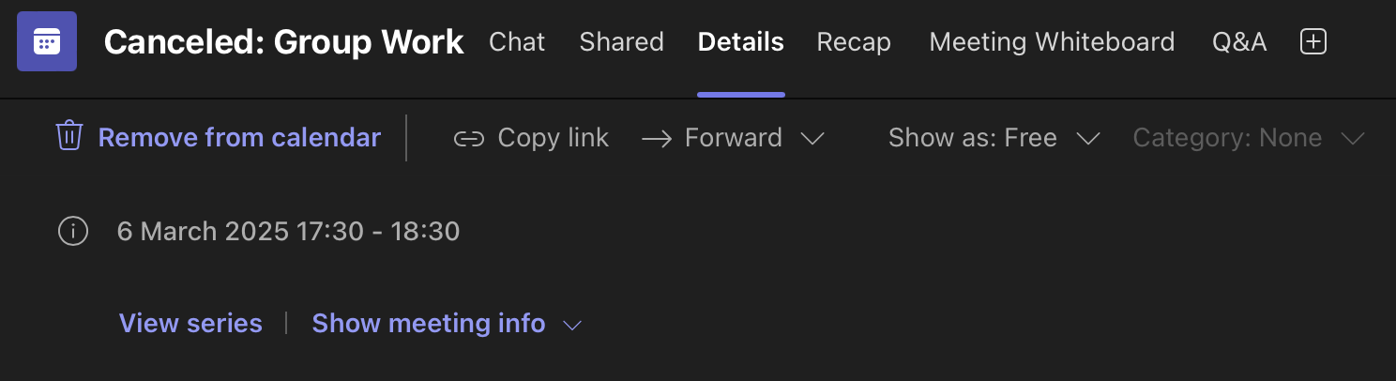
Figure 1 Microsoft Teams Calander showing when the group meetings were organised for
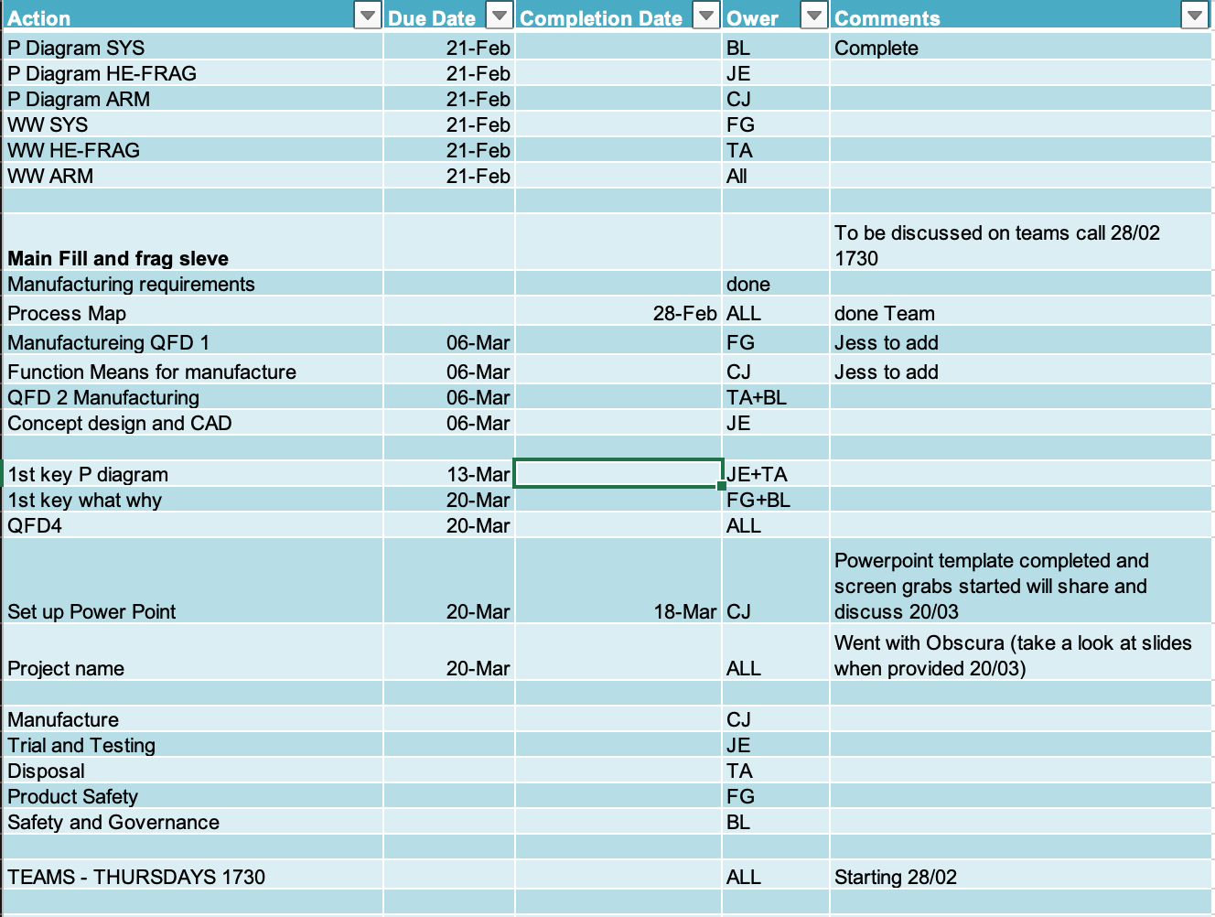

Figure 2 Group action tracker/ to do list

Project Deliverables

The group completed the design book sections discussing how the munition would be designed and how it would function. The group would often split up to complete these sections coming back together in at an organised meeting to discuss progress and move forward with further sections. The group also together decided on the project name of “Obscura”.

Once the design got to the later stages of development the team collated progress into a presentation to brief at a design review with the customer. The questions from the group were collated by the Trials Lead to be asked at the review meeting, See Figure 3 The Trials lead made feedback notes on this meeting to take back to the project meetings see Figure 4.

After the group completed their designated design book sections the Trials Lead researched how the munition would need to be tested to ensure it functioned as required. The Research sheet see, Appendix 2. The Trials Lead then took this research and discussed with the team before adding to the project’s presentation. The Trials Lead also completed the SolidWorks CAD design for the project’s presentation.

The design team then created a draft presentation adding in the design book screen shots and explaining how each tool aided in the creation of the design. The design team divided their presentation into sections and ensured every team member had an even number of sections to discuss plus their own slides on their chosen subject. Each member was tasked to write their own slides using the selected design for the PowerPoint. The slide notes were a team effort, each note section was scribed by the Trials lead while the discussion took place. Each member wrote their slides in their own time, coming to the meetings to discuss progress and questions. The team was able to link to each section and link back to the requirements. The design team made efforts to attend meetings to practice presentation slides as well as ensure that the presentation had cohesion. This was made a little difficult by the Disposal slide being left to the last minute however the team came together to practice the rest. Each member of the team would present, and the others would time the presentation. The timer was then paused, and the design team gave feedback on presentation speech, slides and presentation style. The team was very invested in ensuring everyone was comfortable with their slides and presented well. The final practice before the presentation was performed well, a clicker was used, and the presentation came only slightly over the allotted time.

The Trials Lead made a script for the presentation. This script was condensed to bullet points and presented to the group during one of the organised presentation practice sessions however they struggled with remembering parts of the speech and tripped over words. The decision was keeping the script and tried to practice more.

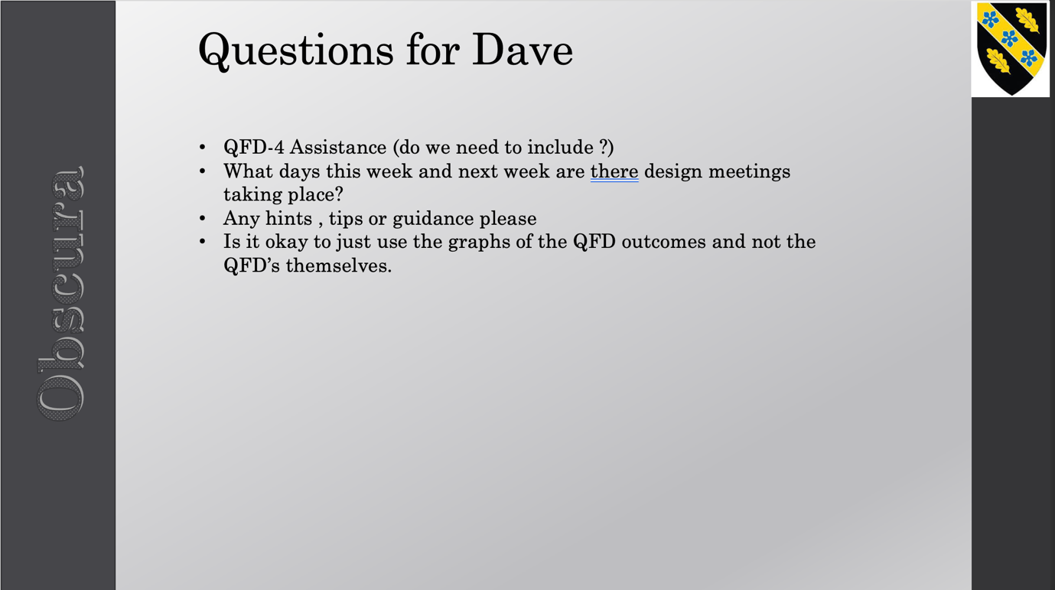
Figure 3 Questions gathered for the project’s supervisor

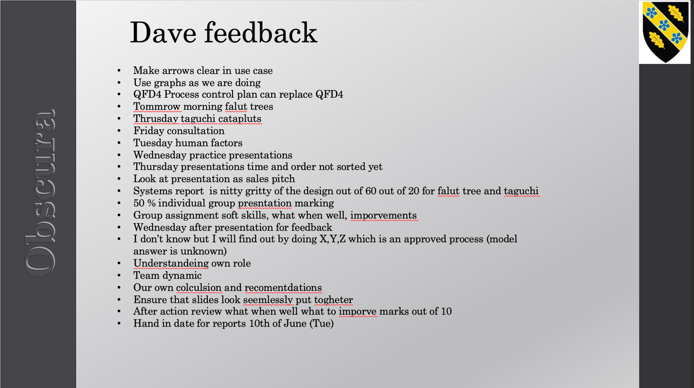
Figure 4 Feedback from the supervisors from the design review meeting

Feedback
The feedback after the presentation was given by the project supervisors, see Figure 5.

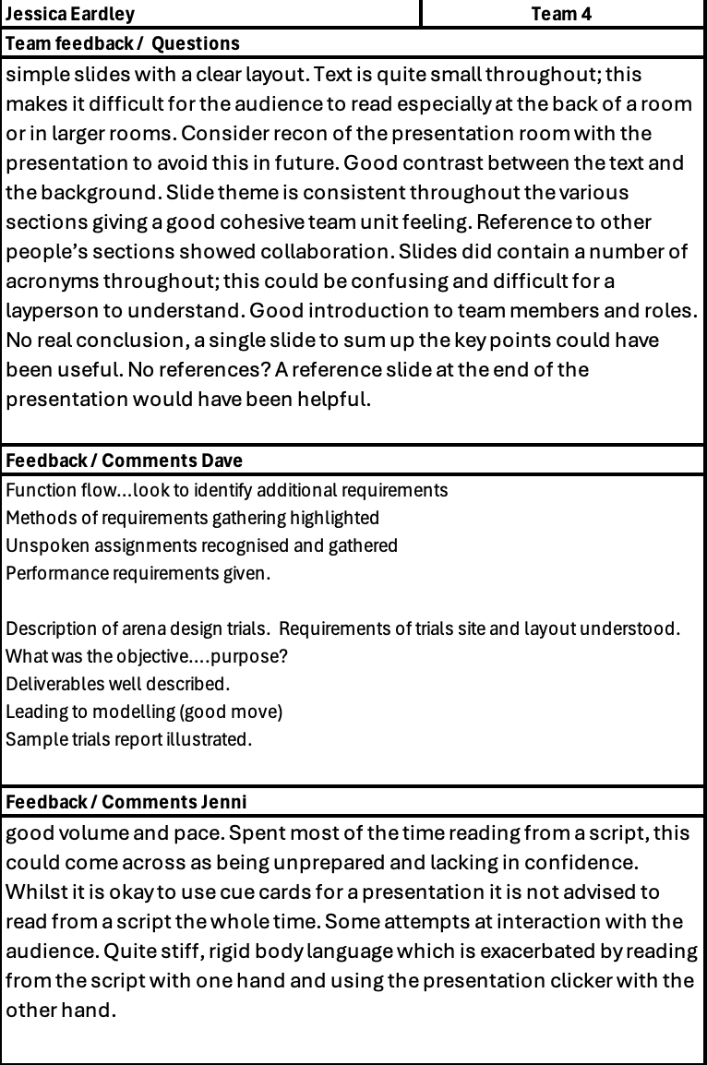
Figure 5 Feedback on project presentation by project supervisors

Conclusion

The group work went well however, not all members contributed equally. This led to challenges in achieving collective objectives. This was brought to the attention of the Project Supervisors for advice. The Trials Lead added an action tracker to keep everyone accountable for their work.

However, the group was respectful in tone when discussing work or differences of opinions. During the practice sessions, this respect was also show when giving others feedback on their presentation. The group worked well together, making design decisions as a team and attending presentation practice meetings to keep project momentum.

The Trials Lead had the opportunity to experience some time as a project lead and learnt valuable lessons in people management. This role was challenging, and the Trials Lead was pushed out of comfort zones having to develop skills such as patience and resilience.

Reflections

The final presentation went well and the feedback from the supervisor was fair. It was identified that the presenters could have practiced more to increase confidence. The presentation flowed well, and the presenters linked back to the group work and each other’s slides. This was praised in the feedback from the supervisor, see Feedback section. The group worked hard on their slides and wanted to succeed.

Actions for Future

To enhance future performance, adjustments could be made using cue cards as prompts for the presentation rather than a script. This would aide with presenter confidence, and with the audience interactions. This was reflected in the feedback from the supervisor. The presentation would be improved with, explaining acronyms and increasing text size to suit the layout of the larger room to ensure that the audience sitting further back could read the slides. Furthermore, the presentation could have benefitted from adding a conclusion and a reference slide.

The trials and testing slide would have benefited from explaining the objective clearer. The objective could have been shown in the first slide along with the requirements of the trial. The main performance objective of the trial was understood by the presenter as, testing the performance of the main fill to evaluate the muntion performance against its key requirements of defeating multiple targets while minimising collateral damage.

The Trials lead identified this Civil Service Learning (CSL) Modern Leadership course, [1]. This would help develop their confidence and develop skill. This Course is face to face, takes 3 hours and does bare a cost. This course would aid with leading a team as this is the role that the Trials Lead fell into on multiple occasions throughout the project work. The team relied on the Trials Lead for task delegations and some decision making as well as time managing.

Works Cited

[1] | UK Governemnt, “Modern Leardership,” [Online]. Available: https://learn.civilservice.gov.uk/courses/D5e0TqKsTKqyKttj93bGow.
[2] | United Nations, “Explosion Danger Area Calculator,” UN, [Online]. Available: https://unsaferguard.org/un-saferguard/explosion-danger-area.
[3] | Cranfield University, “Cranfield Ordnance Test and Evaluation Centre (COTEC),” [Online]. Available: https://www.cranfield.ac.uk/Centres/Centre-for-Defence-Chemistry/Cranfield-Ordnance-Test-and-Evaluation-Centre.
[4] | National Occupational Standards, “Plan the trial of explosive substances and/or articles,” Nov 2020. [Online]. Available: https://www.issee.co.uk/sites/default/files/nos/3.8.pdf.
[5] | MOD, “Range design criteria and specifications JSP 403 Volume 2 Edition 3 Change 6,” Feb 12. [Online]. Available: https://assets.publishing.service.gov.uk/media/5a7a4fa3ed915d1fb3cd6f76/JSP403_Vol2_Chap02_DLRSC.pdf.
[6] | N. M. Q. H. L. J. Stewart MG, “Explosive field trial for repetitive testing of VBIEDs to probabilistically measure blast and fragmentation hazards,” International Journal of Protective Structures, vol. 15, no. 4, pp. 937-963, 2024.
[7] | I. C. E. S. David Felix, “Real-time calculation of fragment velocity for cylindrical warheads,” Defence Technology, vol. 15, no. 3, pp. 264-271, 2019.
[8] | N. K. a. ,. R. P. ,. H.-G. M. ,. S. H. Erkai Watson a, “Four-view split-image fragment tracking in hypervelocity impact experiments,” International Journal of Impact Engineering, vol. 135, 2020.

Appendices

Appendix 1 Presentation Speech

BL hand over
​
USE CASE​
​
​
- We created a use case by going on a Gemba visit to discover how the customer uses a similar system and created a functions flow.​
​
- We watched and interviewed the users use a similar system to help define desired and unwanted behaviour of a new system. ​

- A few key functions that we identified: the users loaded the munition manually to the drone and the target was acquired with a laser; This is something we took through to our design concept.

REQUIREMENTS​
​
Requirements were gathered from a range of stake holders such as users, legislators and the main customer. These were gathered during, Gemba visits, interviewing the main customer and having regular meetings with them as well as obtaining relevant guidance from legislative bodies such as JSP, STANAGS and HSE regulations made available online and through the business safety portals. We scheduled regular meetings with the main customer, however only obtaining the expressed requirements. The other requirements were determined by meeting as a group to determine missed basic requirements such as the munition having a safe arming distance to ensure the users safety.​

REQUIREMENTS LIST​
​
Here is a list of the requirements that we obtained from the stakeholders such as ” the collateral damage to adjacent rooms must be minimised” and basic requirements such as “The regulator requires the munition shall comply with Defence Standards and OME Regulations” determined by the design team. Example of some of Non- functional performance requirements given by the main customer and the user : Munition accurate to 1m and affect area of 10m x 8m x 4m. This tells the design team how well these requirements need to be achieved by.​
​
Hand to FG

Hand over from CJ

REQUIREMENTS:​
​
An arena trial is required to test a selection of fragment sleeve materials and their performance to understand what material is best suited for our main effect. ​
​
FOR A TRIAL TO BE PLANNED THE FOLLOWING IS REQUIRED:​
​
- The range required would have to have a 500m radial cover suitable for the trial, as well as licensed for at least 0.5kg of 1.1 high explosives and complainant to DSA 03- OME part 3 vol 4​

- The range would have to have suitable mitigations in place such as a hard cover large enough for the trial staff and instrumentation team a suitably qualified RSO or TCO​

- I would also require a Trials manager of suitable NOS qualification and experience to manage the trial as well as complete a trials plan and risk assessment to be signed of by the relevant safety authority’s​

- I would require instrumentation such as; High Speed Video cameras, velocity foils and strawboard packs to gather data on velocity, impact time and fragment penetration data. ​

​

TRAIL SET UP:​
​
This is an arena trial, our trial would look similar, with the war head in the centre surrounded by strawboard and mitigation such as Pendine block/sand. Instrumentation equipment such as HSV would have to be protected from the fragment hazard using splinter-proofs.

Hand to FG

Appendix 2 Trials and Testing Research

OBJ: Performance of the warhead, HE/ Frag subsystem

Requirements:
Range large enough for a safety distance of 500m to test 0.5kg cased fragmenting charge [2].
Pendine blocks/sand mitigation for frag
Fragment catching facilities/ equipment such as fragment packs/ strawboard for data capture [3]
HSV for velocity and images of fragments
TM with NOS [4]
Handbook of defense ranges safety (JSP 403) [5]

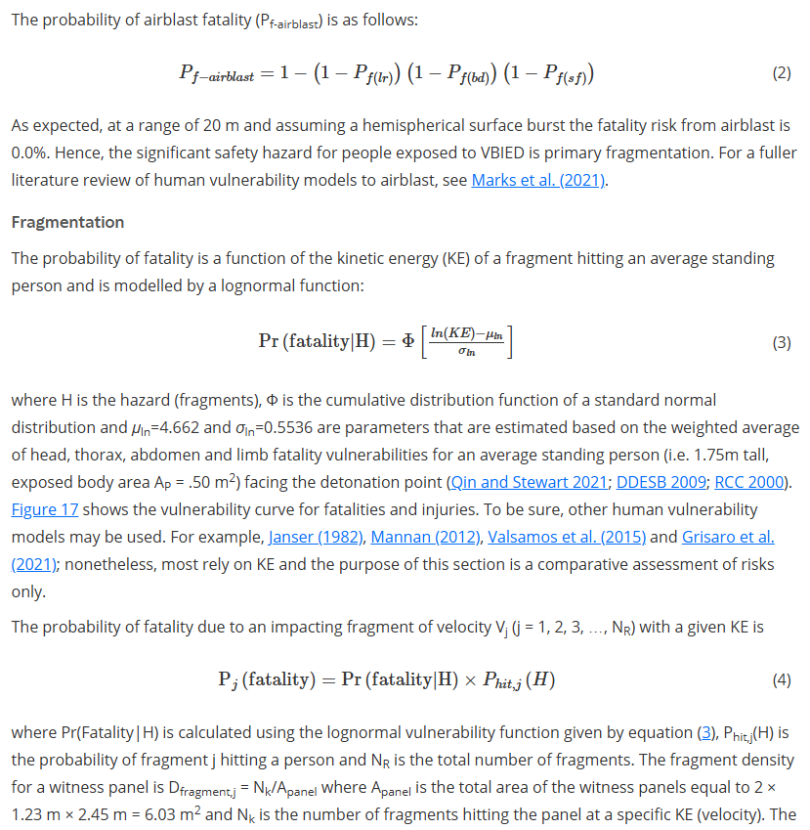
Figure 1 Fatality Calculations [6]

Test deliverables:
Prestation
Velocities of fragments
Weight, size and locations of fragments
HSV footage of fragment

Trials and test techniques:
Get modeling team modeling of fragment trial, to ensure that fragments will be captured within the trials arena as well as ensure safety distances.
Arena trial, fragment packs
Full scale trial
Real-time calculation of fragment velocity for cylindrical warheads [7]
Four-view split-image fragment tracking in hypervelocity impact experiments [8]

Analysis of trials data:
Fragment picking, weighing fragments. (to find spread, weights, size)

Putting fragment information back into modeling

Feedback into the trials process:
Trials wash-up meeting
Report including analysis data
Mock report sheet to show how I am going to show the results
reporting go no go – report and wash-up presentation to tell them if it succeeded or not.

Presentation of trials data:
Report
Modeling
Trials wash-up meeting

Appendix 3 Trials and Testing Slides

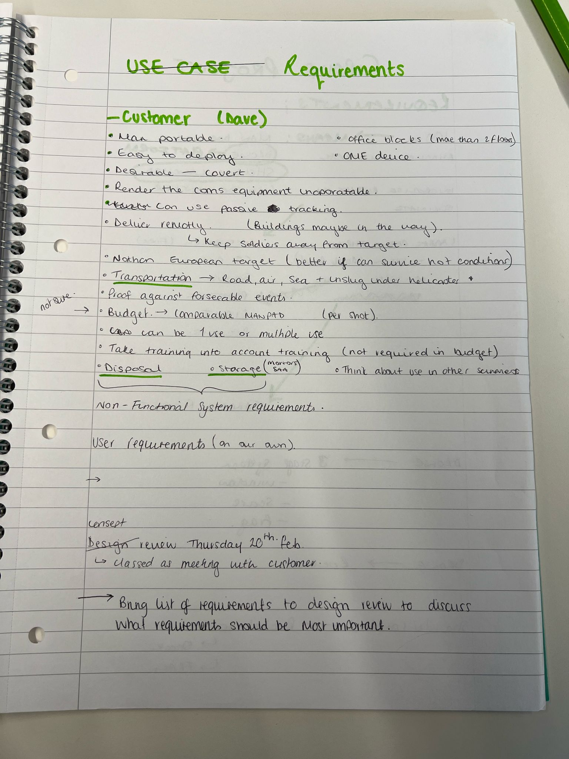
Appendix 4 Requirements Meeting Notes

