

Programme: MBA- Masters of Business Administration

Module:: Strategic Management

Module code: LCMB7003

My name: Psalmist George N. K. KING

Student No.: 1606028

Topic: Tesla Motors

Lecturer: Gladius Kulothungan

Date: 02/09/2022

Contents
Executive Summary 2
Introduction 5
Vision Mission and Objectives 6
Industry Overview 6
External Environment Analysis 6
Economic Analysis 7
Social Analysis 8
Technological 8
Industry Analysis 9
Porter’s Five Force Analysis 9
Threat of new entrants 9
Bargaining power of supplier 10
Power of Buyers 10
Threat of substitutes 10
Rivelary 10
Internal Environment Analysis 11
VRIO Analysis 11
Value Chain Analysis 12
Corporate Analysis 12
HR Functions 13
Inbound Logistics 13
Outbound Logistics 13
Operations 13
Sales and Marketing 14
Service 14
Discussion 14
SWOT Analysis 14
Future 15
Conclusion 16

Executive Summary

Tesla Motors is a U.S. automobile manufacturer based in the state of California. Electric cars, solar panels, and lithium batteries are the company's primary products. The company's goal is to provide cars that are affordable and of high quality for the average consumer. Audi, Lexus, Mercedes-Benz, and BMW are just a few of the automakers who have chosen to concentrate on high-end models, ignoring the needs of those with less disposable income and, as a result, less money to spend on repairs. Seeing a market opportunity for low-cost vehicles, Elon Musk, CEO of Tesla Motors, set out to fill that need. As a result, even if the firm has only been in existence for less than 15 years, it is critical to look at the company's market entrance strategy, profitability, and the predicted growth of the automobile industry as a whole. In this article, the entry strategy is analyzed considering various theoretical frameworks and suggestions are made accordingly.

TESLA'S ENTRY INTO THE U.S. AUTO INDUSTRY

Introduction
Toyota and General Motors controlled the American vehicle market when Tesla was founded. This didn't stop Tesla from entering the market. The corporation established a well-calculated entrance strategy that involved starting with a minimal viable invention, namely the creation of the high-quality electric automobile that would be offered to a small number of clients who could afford it. Thompson et al. stress the importance of a business plan since it enables a firm to evaluate its path of action (3). It helps businesses anticipate market dangers and opportunities. Tesla Roadster was the company's first special automobile. Concerning electric automobiles, the corporation was unsure of how long it would take to fully charge a vehicle and where it might be charged. Tesla struggled with capital. The initial plan was to produce a stylish, low-volume car with the company's limited financial resources. In its early stages, the company struggled to raise funding, forcing Elon Musk to sell assets like Zip2 to reduce manufacturing delays (Van den Steen 6). Tesla's entry strategy was not typical of a new market participant compared to Toyota, BMW, and Mercedes-Benz. Van den Steen said the firm sold less than 2500 Roadsters, which met Elon Musk's market entrance target.
Nissan should learn from Tesla's strategy. According to Thompson et al., the corporation intended to lead the pace in the vehicle market with its E.V.s, which may have influenced Nissan's choice to create the Leaf. Nissan should introduce limited numbers of initial automobiles instead of mass-producing cars with innovative technologies. Customers are cautious about accepting new technology like electric automobiles due to performance concerns.
They set out to prove that driving an electric car didn't involve compromising quality or speed for the purpose of environmental friendliness when they formed Tesla in 2003. Tesla currently makes infinitely scalable, sustainable energy generating and storage solutions. Tesla is confident that the world will be a better place if fossil fuels are phased out. Electric vehicles were introduced in 2008 with the launch of Tesla's Roadster model. It wasn't long until the Tesla Model S, the company's first premium all-electric sedan, became the best-selling vehicle in the world. The Model S has a 0-60mph acceleration time of 2.28 seconds, the longest range of any electric vehicle, and over-the-air software updates that make it the most sophisticated automobile on the road today. Since its introduction in 2015, the Model X has obtained 5-star safety ratings from the National Highway Traffic Safety Administration (NHTSA) in every single category of its evaluation. Elon Musk's "Secret Master Plan" was fulfilled in 2016 when Tesla introduced the Model 3, a low-cost electric vehicle that went into production the following year. On the heels of this, Tesla unveiled the safest and most comfortable vehicle ever — Tesla Semi – which is expected to save customers at least $200,000 over a million miles based on fuel expenditures. Providing a single renewable energy product isn't enough for Tesla; it also produces a unique set of energy solutions that can be utilized by individuals, companies, and utilities to govern renewable energy generation, storage, and consumption. Tesla's automotive and energy solutions are supported by Gigafactory 1, a facility targeted at reducing battery cell prices. With in-house cell manufacturing, Tesla is able to meet its production objectives while creating thousands of employments.
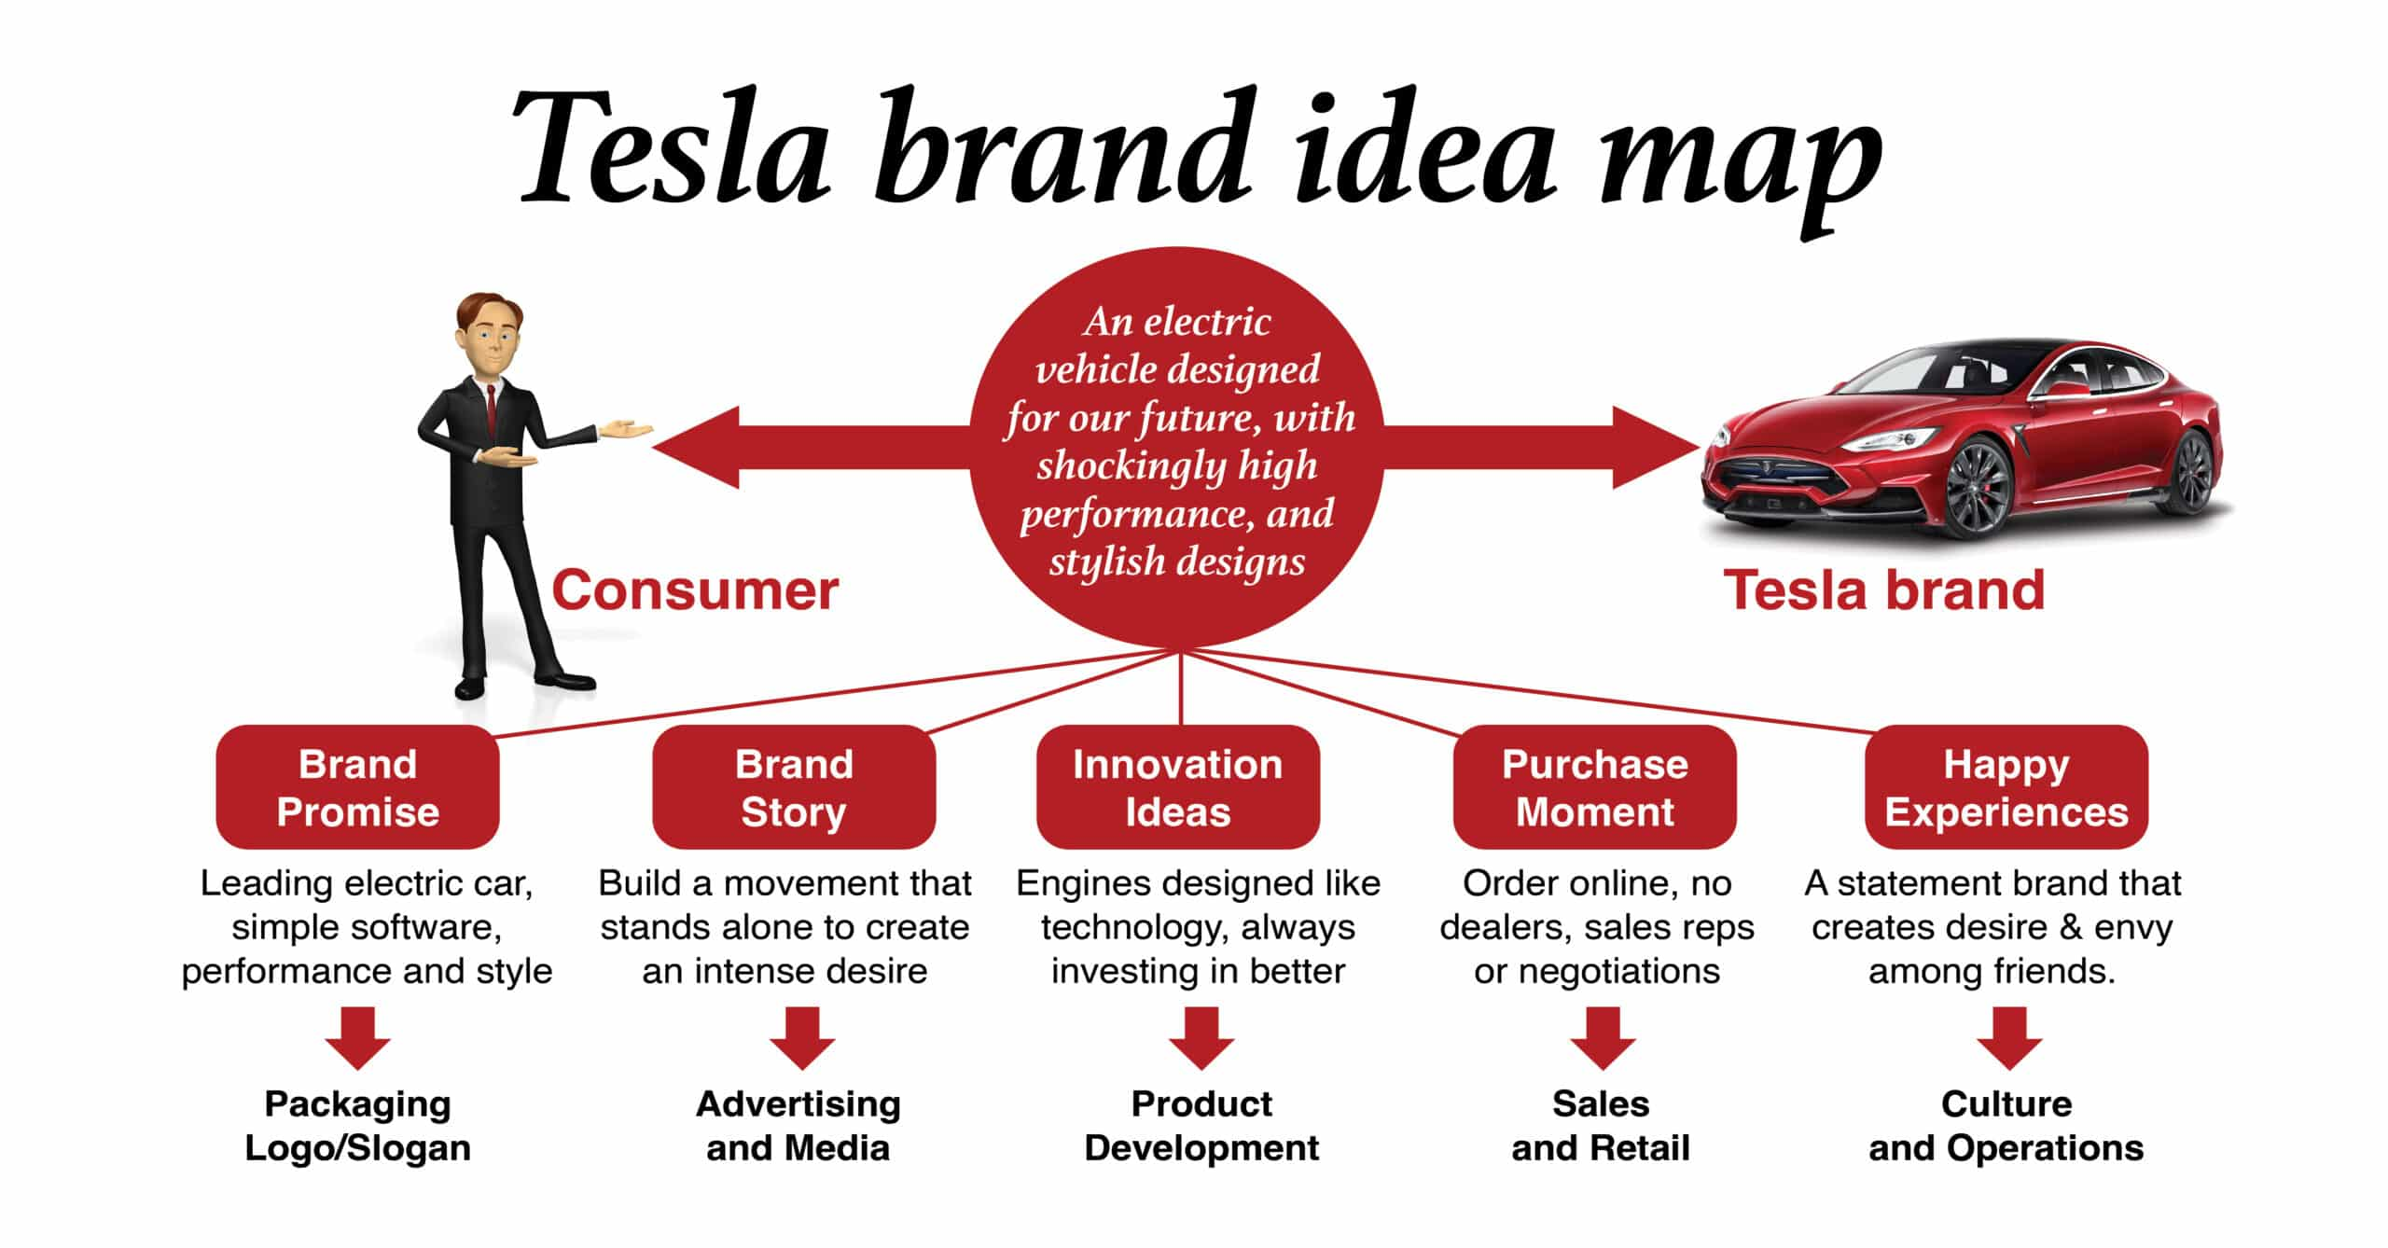
Error! Hyperlink reference not valid.Figure 1: Tesla brand idea map. Beloved Brand

Vision Mission and Objectives
When it comes to electric automobiles, Tesla's goal is to make it "the most compelling automotive company of the 21st century by driving the world's shift." In addition, Tesla's goal is to provide safe and dependable automobiles that are also environmentally friendly. In the near future, Tesla is focusing on four major goals: Integrate energy generation and storage, extend to include the key modes of terrestrial transportation, have autonomy, and share (Musk, 2016). In order to achieve the mission statement's stated aim, these four objectives have been established. Sustainability in energy has been a long-term aim of Tesla, and these four goals were recently adopted to keep pace with contemporary societal demands.

Industry Overview
The automobile industry in the United States is the world's second biggest and accounts for 2.7% of the country's total GDP (Amadeo 2019). Despite the fact that new automobile sales in the United States have increased by a flat 1% (Sull & Reavis 2019, p.15) since 2016, the industry is being fundamentally disrupted by the arrival of electric cars (E.V.s). Americans, who have a history of buying huge automobiles, are beginning to buck the trend. Between 2008-2017 and 2018-2023, analysts expect a total of 7% of the market share from the crossover, light truck, and mid/large vehicle categories to be transferred to the small and luxury/sports car categories (Sull & Reavis 2019, p.17). Participants in the automotive sector include automakers, suppliers (tiers 1, 2, and 3) as well as consumers (individual buyers and dealerships).
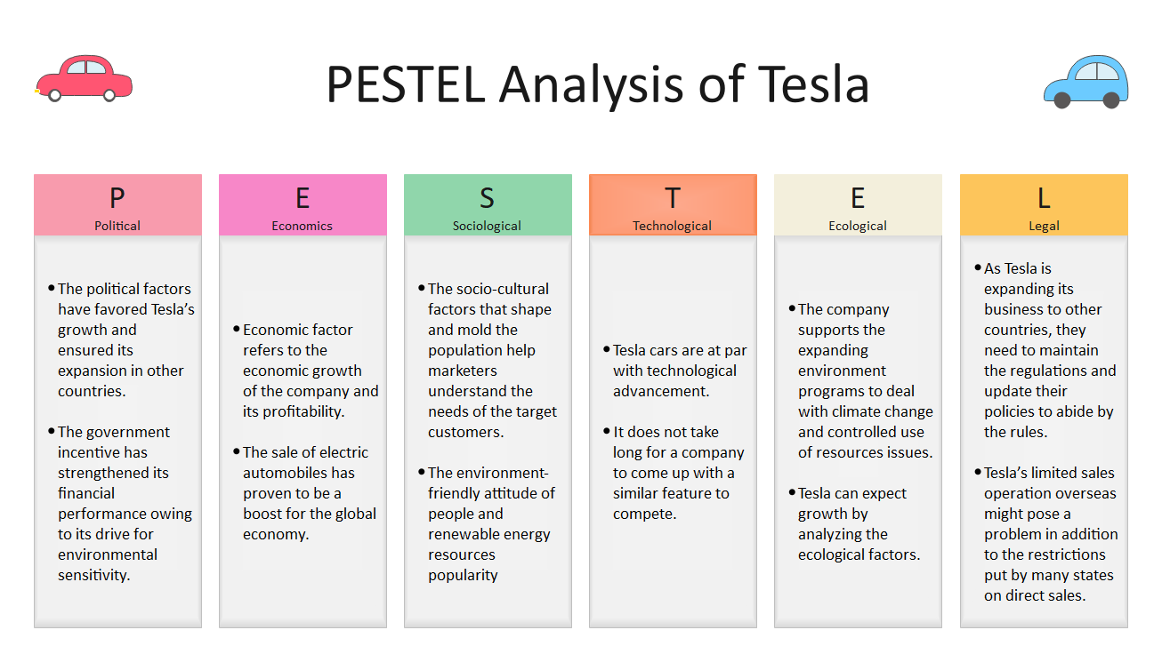
Figure 2: Tesla pestle analysis. Wondershare EdrawMax 2021

External Environment Analysis
Identifying how government policies and/or changes in law influence the economy, the automobile sector, and Tesla Inc. is the first step in performing a PEST study. In order to encourage the use of electric cars, a number of countries and municipal authorities throughout the world have already established government incentives. The federal tax credit is the first political aspect impacting Tesla's operations. Customers of electric cars can deduct from their state tax bill the number of federal tax credits they have accrued as a result of their purchase. The purpose of this incentive is to encourage consumers to purchase and utilize energy-efficient automobiles. Therefore, it applies to Tesla and its competitors, such as General Motors, Ford, Nissan, Toyota, and BMW Group." When Tesla hit the 200,000-vehicle threshold for plug-in vehicles in the United States in June, it was declared ineligible for a $7,500 federal tax credit, which was phased out over six quarters (E.V.s, 2020) On April 1, 2020, and General Motors will be the second automaker to lose its federal tax credit eligibility, while other manufacturers' customers will continue to get the full federal tax credit. This might be a problem for Tesla since it could allow its competitors to gain market share. International ties between China and the United States are another aspect. We all know that the United States and China have the most significant bilateral relationship in the world. Because both nations have no compelling security interests or political principles, they are neither allies nor adversaries in the eyes of most international affairs analysts (Affairs, 2014). The current US-China trade war had an impact on Tesla, as have the steep 25 per cent tariffs imposed on select Chinese-made imports into the U.S. The majority of Tesla's goods are manufactured in the United States or Canada, but the company still relies on Chinese suppliers for several of its computer systems, including its third-generation autopilot computer system. Tesla's third-generation autopilot computer system is now being developed for practically all of their cars, and this condition might boost the cost of those items significantly.
The President's actions and decisions will have an impact on Tesla's business because the company is based in the United States, notably in Nevada and California (Vault, 2019). If what we saw at Trump's event in Michigan is to be believed, President Trump is fighting against the Green New Deal, which aims to transition America away from fossil fuels and toward sustainable power generation (News, 2019). He also stated that he would limit the number of automobiles that a family may purchase to one in order to combat electric vehicles. The 2020 budget proposed by Trump would eliminate all-electric car tax incentives, and the loans that helped Tesla and other manufacturers fund new vehicle technologies. His unsupportiveness was also displayed on this budget. To assist the U.S. automobile sector in fulfilling greater mileage standards and reduce the country's dependency on foreign oil, Congress enacted a $25 billion direct loan program in the fall of 2008, known as the Advanced Technology Vehicles Manufacturing Loan Program. Tesla received $465 million from this financing program to help establish a manufacturing plant in California (Post, 2017). We might thus infer that Tesla should be cognizant of the dangers posed by government incentives, the US-China relationship, and President Biden's regulation.

Economic Analysis
As the global economy grew, so did the number of electric car deals. The global economy was expected to grow by 3.5% in 2017. Electricity developments were spurred by these rises in Asia and Europe, as well as the United States. The sale of electric vehicles increased by almost 30% between 2016 and 2017. Electric cars are becoming increasingly popular, which is often linked to growth in the global economy. In 2019, and 2020, global economic growth is expected to remain around 3%. It is expected that electric car advertising will reach $1.5 trillion by 2025, up from last year's $39.8 billion (Kesha, 2019). This is a huge opportunity for Tesla to secure funding thanks to this financial element. For Tesla, the decline is solely due to an increase in the price of raw materials. As their automobiles become more widely accepted, materials prices may fall. For instance, the reasonableness of the company's electric car products is one example of this outside aspect. The business improves as the use of renewable energy sources becomes more commonplace. More people buying Tesla electric cars means cheaper material costs and a more useful vehicle for the general population (Umar, 2019). Electric vehicles' overall prices are lowered by decreasing battery costs, which are a key part of the overall cost. The development of Tesla's Powerwall batteries represents a tremendous opportunity for the company. They are making it more affordable and accessible. Electric batteries, the primary source of energy for electric vehicles, have become more and more efficient in recent years, and battery costs have dropped from $1000/KWh in 2010 to $227/KWh in 2016. Additionally, the costs are predicted to fall to $190/KWh by the end of the decade. However, buyers in several countries are investing in high-end luxury automobiles such as SUVs and BMWs. For Tesla, this is a good thing because they are perceived as luxury automobiles with the most up-to-date gadgets. It's also a great idea to provide white-collar residents with a vehicle. Even though Tesla has minimal competition in the electric car market at this time, as well as the fact that people want it (Kesha, 2019), this is a smart move on Tesla's part for the average person to have an option like this.

Social Analysis
Cultural: a focus on energy efficiency and renewable sources of power The rising popularity of low-carbon lifestyles and an increasing preference for sustainable energy are driving the growth of Tesla autos. As the globe moves toward renewable energy, Tesla's low carbon emissions are a major strength. For the great majority of people, the prospect of driving an electric car is enticing, and this is especially true for those who are more concerned about the environment. The use of fossil fuels is reduced significantly by an electric car, making it better for the environment. Electric vehicles are also more cost-effective to maintain and operate than regular automobiles (Tiwari, 2017). Creating an equal distribution of income in developing markets The growing wealth disparity in developing nations presents an opportunity for Tesla to improve its financial performance. People who can afford the company's pricey automobiles will be more likely to acquire them as the wealth dispersion trend continues. With a strong brand image and a large customer base, Tesla Inc.'s market share and customer base are directly linked. We've never seen a company like Tesla Motors before since it's set up shop in its own industry. No other car company on the market has the luxury features and totally electric capability as Tesla does (Tiwari, 2017). Customer value: technological advancement and environmental friendliness. Entrepreneurial company leaders and tech-savvy techies make up the majority of clients, who also tend to be environmentally conscious. Those in the upper-middle class with an annual salary of more than $100,000 are within this group. Males make up the vast bulk of the audience (Tiwari, 2017).

Technological
PEST study of TESLA in macro-environment explains the influence of technology on the firm. When it comes to automobiles, technological advancements have always played a significant role. They've changed how vehicles are built, operated, and maintained. With electric, hybrid, or solar-powered vehicles, technology plays a significant role in how fuel is used. Modern autonomous technology promises to minimize accidents, consumption of energy, pollution and traffic congestion. This is a global trend. Autonomous vehicles have been discussed for more than a decade, but their high cost has prevented them from being mass produced on a wide scale. In spite of this, the output of this technology has increased significantly worldwide (Bagloee, Tavana, Asadi, & Oliver, 2016). Autopilot and Autosteer, two Tesla-developed self-driving features, were integrated with the company's most recent innovations. Autopilot capabilities are available in more than a half-dozen different automobile brands as of the beginning of 2020: Cadillac; Kia; Hyundai; Audi; BMW; Mercedes Benz; Nissan; Infiniti; and Volvo, among others (Review, 2020). The electric car is another technical innovation that has a direct impact on the automobile industry. Rather than a question of when, the shift to electric vehicles is a question of how fast it happens, according to Forbes. As Volvo, which just debuted its first all-electric car, Volkswagen, which has just launched and marketed the ID.3, and Tesla, which recently constructed a plant in China, has said (Dans, 2019). More than 1.1 million electric vehicles were registered in the United States in 2018, with sales exceeding 2017 levels (EEI, 2019). Since driving an electric automobile is less expensive than driving a gasoline-powered vehicle, many individuals have made a move. Car-sharing is one of the newest innovations in the automotive business. As a fleet operator aiming to compete with Uber or Grab, German carmakers have sought to enter the carsharing business. According to Forbes, the German auto industry is dominating carsharing. The price of an electric vehicle is significantly greater than that of a gasoline-powered vehicle, making carsharing a viable option for electric car producers. Many countries' markets for carsharing and other internet services have grown rapidly in the last few years (Sanvicente, Kielmanowicz, Rodenbach, & Ramos, 2018). This analysis outlines how Tesla and other automotive makers might gain more market share by joining the automobile sector. For the "Tesla Network," Tesla will support human drivers before enabling a robotaxi fleet, according to CEO Elon Musk in FourthQuarter Earnings Call.

Industry Analysis

Porter's Five Force Analysis

The threat of new entrants
Entry Into Fear Entering the U.S. automotive industry as an OEM is difficult because of the enormous amount of money required not only to design and build a new car but also to develop and expand a company's brand, construct production facilities for the vehicle's manufacturing process, hire, train, and establish a third-party dealer network. Competition with the industry's heavyweights will require new entrants to invest even more money in staying abreast of the newest technological advances. As a result, international OEMs have proved to be a serious threat to American OEMs (Lee 2020) in the market, as they are already well-established, have achieved success, and are well-known. Despite their obstacles, Tesla managed to enter the U.S. car industry, which was a tremendous achievement.
There are no further industry exits after this discussion. To defend the industry and economy, there is a strong desire to keep barriers in place. The automobile sector in the United States employs around 3 million people, and OEM resources are highly specialized. After the Global Financial Crisis of 2008, government assistance and foreign acquisitions kept U.S. OEMs from going out of business (Sull & Reavis, p.3).

Bargaining power of supplier
The sector needs just a small number of suppliers, and because of the high level of saturation, suppliers have little clout. For this reason, OEMs may easily obtain the components and systems they need from more than 11,000 different suppliers. In the Tesla worksheet, the only firm with a 2 in front of that figure is the market leader, which has a 2.3 percent share of the market (Lee 2020). Technology and software are taking market share from traditional components and hardware, resulting in new entrants entering the supplier sector and compelling incumbent suppliers to expand their inventory to keep up with an innovation or quit (Sull & Reavis 2019, p. 3).

Power of Buyers
U.S. automobile sector sales are expanding among millennials, but their purchasing habits are not typical of the American market since they choose small and some crossover vehicles (Sull & Reavis, p.5). They prioritize safety, fuel efficiency, and quality above all else in the purchase of a vehicle, with price, roominess, and their favourite brand at the bottom of the list of priorities. A wide range of replacements, including international options, gives customers more leverage, and their trends can affect OEMs' production and design. The profitability and longevity of dealerships are also affected by the power of purchasers, which is a large component of the sector. Research suggests that 75 per cent of Americans would be receptive to moving the purchasing process online and fully avoiding the dealership if they were able to do so (BusinessWire 2015).

Threat of substitutes
Although the threat of alternative products is growing, it is not now a threat to the automobile sector. Even if environmentally friendly transportation choices like walking, bicycling, electric scooters, ride-sharing, and public transportation are being promoted and made more widely available, none of these can fully replace the comfort and convenience of driving one's own automobile. U.S. government subsidies and tax refunds are encouraging customers to choose more ecologically friendly automobiles in the face of increased competition from hybrid and electric vehicles (Sull & Reavis 2019, p.6).

Rivalry
Because of this oligopoly, the automobile business in the United States is worth several hundred billion dollars. A total of 45.6% of the industry's market share was held by U.S. original equipment manufacturers in 2017, with the remaining 54.4% coming from foreign OEMs (Lee 2020). U.S. OEMs have a competitive edge in that they don't have to pay international tariff fees, although most foreign OEMs have a greater profit margin in the U.S. car manufacturing business. As interest in self-driving cars grows, internet giants like Google, Apple, and Uber are partnering with original equipment manufacturers to do research and development. This gives OEMs a leg up on the competition. OEMs face four major issues as a result of the U.S. automobile industry's transformation: Automation, connectivity, and electrification all play a role in the future of transportation. The Roadster, Tesla's first foray into the electric-vehicle market, is a direct response to these obstacles. They were able to push down the market by introducing models S, 3, X, Y, and the cyber trick after they had that brand awareness. At 0.2 percent of the U.S. market, Tesla is the smallest player in the traditional automobile business, yet they have achieved significant advancements (Rao 2009). Using hot causes (rebellion against traditional gas-guzzlers) and cool mobilization strategies (launch events), Tesla has been able to target a specific, passionate set of buyers, and the brand has a certain 'cool' element that no other OEM has been able to match up with. While established OEMs in the U.S. automobile sector should be aware of Tesla's potential, the company's competitive position may be weakened if they devote adequate resources to research and development and build a progressive strategy (Sull & Reavis 2019, p.1).

Internal Environment Analysis
Electric vehicle engineering, vehicle engineering, vehicle manufacturing, energy storage, computer-aided design, and crash test simulation are Tesla's main skills, according to the company's 2017 Annual Report. Aside from self-driving capability and long-range battery life, Tesla's distinguishing features include its vCID (vehicle control and information display) software and its Dual Motor Powertrain, which provides for rapid motor reaction and precise control of performance.

VRIO Analysis
Tesla's resources and capabilities have been analyzed using a resource-based perspective (VRIO) study to determine its competitive advantage. Elon Musk, Tesla's CEO, and the company's R&D and inventive engineers, who are responsible for the E.V.s' distinctive looks, are highlighted in the VRIO, which can be found in Appendix 1. To give you a better idea of what I'm talking about, To put it another way, everything that Tesla has to provide is of great value. It's not only that the company's goods will help it sell automobiles and make money; they'll also help solve a pressing worldwide problem: our reliance on fossil fuels. In addition to the automobile sector, Tesla's clean energy solutions have the potential to reduce the need for traditional energy resources through enhancing technology and accessibility. Inventiveness: Tesla's patented intellectual property and R&D are always inventing new and better renewable energy products. When it comes to electric vehicles, no other manufacturer has matched Tesla's technology, software, or Supercharger network. Its brand and reputation reflect the uniqueness of its products. No one can copy Tesla's goods now that the company has invested a lot of money and resources into its "blue ocean" approach. As a result of its cutting-edge R&D and exclusive technologies, the firm is today the undisputed leader in the electric vehicle market. What keeps Tesla's edge in the "blue ocean" is a combination of leadership and engineering innovation, clean-energy gigafactories, and a focus on research and development. In his quest to make manufacturing more efficient, Elon Musk discovered that people were "underrated" and an essential element of the process that couldn't be replaced by robots (Sull & Reavis 2019, p.2).
In the short term, Tesla has a leg up on the competition due to its headquarters in Silicon Valley, sustainable energy gigafactories, and a nationwide Supercharger network. A competitive advantage is its ability to be copied through the use of proprietary batteries. Elon Musk, Tesla's CEO, is the most valued resource in the category of sustainable resources. His experience as an entrepreneur has given him the ability to recognize and hire the greatest people. Attracting talented and motivated employees has been made easier because of Tesla's location in Silicon Valley, as well as its focus on R&D, which has made it an attractive place for them to work. The firm's profitability, liquidity, and debt have been assessed using financial ratios from the 2017 full fiscal year and the first half of 2018 (Lee 2020), and the study suggests that the company is in bad financial condition.
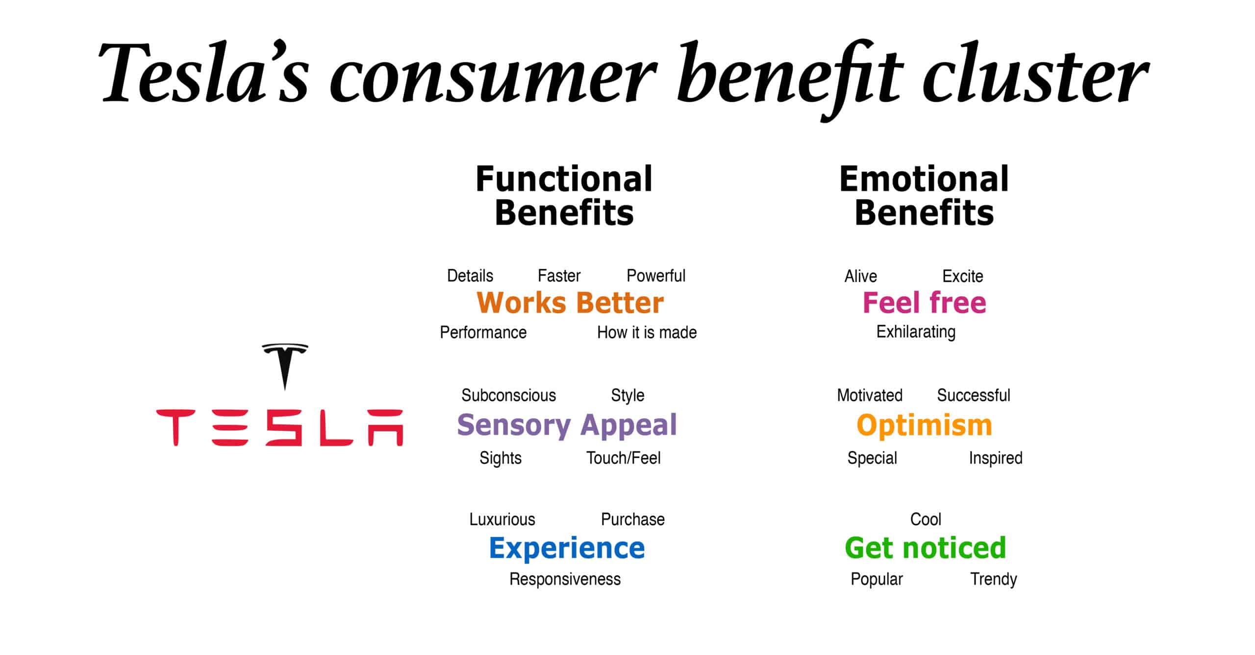
Figure 3: Tesla customer benefit cluster.

Value Chain Analysis

Corporate Analysis
The views, expectations, and values of a corporation's members are reflected in its corporate culture. Tesla has an innovative problem-solving corporate culture, which encourages talented individuals to discover solutions to present and develop challenges in the target market that might produce profit for Tesla. This corporate culture In response to the environmental concerns raised by conventional non-electric automobiles, Tesla introduced its line of high-performance electric vehicles. This was a natural outgrowth of their company philosophy. Tesla goes into further detail regarding their company culture by focusing on the following six aspects: First, move quickly. It is a goal of Tesla's corporate culture for its employees to be able to adjust quickly to market trends and shifts. Tesla's employees, for example, are capable of developing the world's longest-lasting battery for the car sector. Do something that is impossible. Tesla's employees must be encouraged to go beyond the box and achieve the seemingly impossible while creating cutting-edge products. New ideas and solutions are recognized in unorthodox ways because of this culture. It is evident in the training Tesla provides its employees to go above and beyond the usual limitations of efficiency and inventiveness in automobile design. 3. Be innovative all the time. Tesla's corporate culture emphasizes the ongoing nature of innovation within the firm, which is at the heart of Tesla's business model. The corporation, for example, is always working to enhance the design of its energy storage products. Using "basic principles" as a guide, explain your reasoning. Tesla's personnel are urged to look into the underlying causes of problems in order to find solutions in the real world. For example, Tesla's energy storage devices provide a solution to the issues of harnessing renewable energy and improving energy efficiency.
Consider the viewpoint of the business owner. This corporate culture is set because Tesla wants its employees to assist company development, help the business thrive, and increase the integrity of the firm in its industry. Tesla's vision and objectives are further supported by this ownership attitude, which encourages employees to take ownership of their own performance. 6. We're all in this together. In the end, the corporate culture at Tesla unites individuals into a cohesive unit dedicated to the company's advancement. With this corporate culture in place, disputes are minimized, and synergy is improved, resulting in the most effective use of each employee's unique abilities and skills. Talented Tesla employees are encouraged to seek out new and creative ideas that help the company stand out in the automobile, energy and storage market. Even if this technique works, it's likely to be influenced by Tesla's unique company culture. It has been said by Tesla CEO Elon Musk that the company's goal is to join the market at the top end and then drive down the market to larger unit volume and cheaper pricing with each subsequent model. Tesla's company culture aids in the efficient and effective implementation of this plan. Tesla's management uses its corporate culture to maximize employees' creative and inventive potential in order to develop a model that is both affordable and of the same high quality as Tesla's high-end competitors. Tesla's culture also provides fresh options for the company to strategically improve its business performance and makes Tesla a prominent entity in the international automobile and energy sector. Employees will be more closely aligned with Tesla's strategic goals as a result of the company's "think like an owner" corporate culture. According to Hunger Wheelen's book, a company's culture is a reflection of the founders' principles and the company's goal.

H.R. Functions
To keep up with rising demand and manage worldwide expansion, Tesla outsources human resources functions. As a result of outsourcing, the company is better able to concentrate on its core competency: creating and manufacturing electric cars. The 2010 Equity Incentive Plan implemented by Tesla provides for the awarding of stock options, restricted stock units (RSUs), and stock purchase rights to workers, as well as a generous salary. As a result of the need to attract and retain bright personnel to remain competitive, H.R. management has become a key area of attention for most technology businesses.

Inbound Logistics
For the manufacture of electric vehicles, energy storage devices, and solar panels, Tesla inbound logistics means receiving and storing raw materials. It is not unusual for Tesla to employ a wide range of rare materials in addition to the conventional set of materials. When it comes to designing and constructing electric vehicles, Tesla has all of the necessary in-house expertise. In addition, the gallery's merchandise is sparsely stocked. There are various providers who create and distribute other components in a timely way. It drastically cuts down on the number of time workers have to wait between jobs and boosts productivity.

Outbound Logistics
Tesla sends electric automobiles to its own retail locations and galleries in the United States and 29 other countries. Additionally, buyers may expect their electric vehicles to be delivered directly by the corporation. For quick sales, the electric car manufacturer normally keeps a modest stock of automobiles in stock at each of its dealerships. The vast majority of clients opt to personalize their cars online by placing an order. Tesla prefers to sell directly to customers rather than through dealers and re-sellers. Direct sales of Tesla automobiles prevent additional rises in the price of the vehicles. However, given that delivery schedules might be unpredictable.

Figure 4: Tesla brand idea map. Beloved Brand

Operations
Lathrop produces aluminium components for Tesla. It's finalized in Tesla's Fremont facility. Tesla masters vertical integration. Some plant areas are adaptable and can handle a range of items. This technique speeds up Tesla's manufacturing while maintaining quality. Tesla's skills in CAD and crash-test simulations should speed up future model development. The Tesla Gigafactory will produce battery material, cells, and packs. Tesla's battery packs will be cheaper since it plans to generate more lithium-ion batteries than the world combined. Tesla's major source of value generation is robotics. Up to eight robots work on one Model S at once, each performing up to five tasks: welding, riveting, grasping and transporting materials, bending metal, and installing components.

Sales and Marketing
Traditional advertising isn't a big part of Tesla's marketing strategy. Instead, word-of-mouth and media attention are the primary sources of sales growth. Model S and the Tesla Roadster have appeared in a number of well-known films and television shows, including Suits, Iron Man, and Fifty Shades of Grey. Tesla owners are forward-thinking, open-minded people who enjoy high-end, cutting-edge automobiles with a "coolness factor.". Media coverage like this has a significant influence on the popularity and trendy image of Tesla products. The Tesla customer is reached via high-profile, high-end venues. The vast majority of Tesla's automobiles are individually customized. As a result of this, Tesla distinguishes itself from rivals that rely on dealerships to sell their vehicles and so produce value for the customer.

Service
Customer support is a top priority for Tesla's engineers and development teams, who collaborate closely at these service centres to solve problems more quickly. As a result of the Tesla Supercharger network, electric vehicles will no longer have to contend with the inherent range problem that comes with owning one. In order to boost consumer confidence and save operating expenses, Tesla provides their customers with a 50 000-mile warranty coverage.

Discussion
Tesla Motors has a number of advantages over its competitors that can help it achieve its aims. Having Elon Musk as a competitive advantage is impossible for any other company. In order to alleviate range anxiety and provide Tesla Motors a competitive edge, the company is constructing and growing its own supercharging network. In order to ensure uninterrupted manufacturing and high quality standards, Tesla has implemented vertical integration, which enables the company to produce its most important components in-house. Because of the economies of scale that will be achieved through the Gigafactory, future Tesla models will be more cost-competitive. Tesla has had some unanticipated delays in the past, and these delays might happen again in the future. As a result of the company's reliance on single-source suppliers, these delays are mostly responsible. Prospective buyers who have already booked the new model may cancel their orders if they have to wait an excessive amount of time for their cars to arrive.

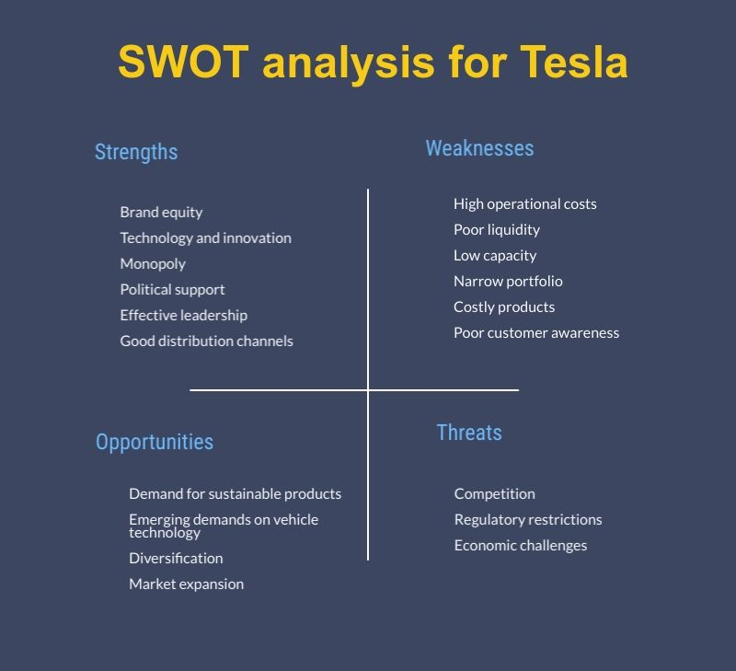
Figure 5:

SWOT Analysis
Strengths: Enhances the Efficiency of the Use of Energy Solar power and other renewable energy sources are used extensively by Tesla, which is a pioneer in electric automobiles. For the development of its renewable energy firm and the expansion of its global market, Tesla has worked with significant corporations in Southeast Asia, including APDA and Yes Energy Tesla's cutting-edge engineering is astounding. The design and development of electric cars is another area where we devote a lot of effort in order to ensure that our clients have the best possible experience. A long-term brand identity. Energy and other profitable products are anticipated to be long-lasting and reliable for corporations. He's a well-known face in the neighbourhood.
Weakness: To a degree, one's presence has a limit. The automobile market is extremely competitive, and Tesla is concurrently attempting to establish itself as a worldwide player. The high-end renewable energy brand Tesla is well-known for its premium line of renewable energy equipment. When it comes to electric cars, there are two potential issues: accessibility and customer confidence. Preparation for the Next Generation In a single presentation, Elon Musk established himself as the face of the Tesla brand. A lot of things are going on with Elon Musk.
Opportunities: Technology for Self-Driving Cars In terms of safety and convenience, Tesla's autopilot system is legendary. Customers and investors alike may rely on it since we uphold the highest standards of trustworthiness. As the company's self-driving technology improves, so does Tesla's model S. It's becoming more and more common for people to want to reduce their dependence on gasoline-powered automobiles as they become more concerned about the environment. The Science and Technology of Batteries Tesla has said that it intends to produce its own battery cells in-house. This has the potential to be a game changer for businesses since it lowers their production costs. As a large number of new employment are created, this will help the economy as well. Threats to the Market's Competitiveness Large corporations like BMW and Volkswagen are vying with Tesla in the field of renewable energy cars. In the future, vehicles may be able to utilize new sources of energy.
Threats: As a result of increased competition, operational expenses may rise and profit margins narrow. Automakers that employ renewable energy sources must be able to maintain long-term viability. Additionally, there is a shortage of electric vehicle servicing infrastructure in North America and Asia, which might pose a challenge to Tesla's business model.'

Future
Tesla's business model suggests that any car company could simply copy Tesla's time model, but since Tesla's technology is among the most cutting-edge and high-quality, it will be difficult for any other automotive manufacturer to copy Tesla technology. As a result, it is in Tesla's best interest to maintain its existing business strategy. If Tesla maintains its existing corporate culture, it will put pressure on its staff to continually innovate according to the company's corporate culture. Tesla might help the company enhance innovative high-tech goods that will undoubtedly appeal to its clients, notwithstanding the present corporate culture. In addition, Tesla's corporate culture encourages the company to respond quickly to market demands and solve problems, resulting in products that meet the needs of and appeal to a wide range of customers. To maintain its position as the market leader in electric automobiles, Tesla must maintain its existing company culture. To keep Tesla's distribution costs low and its operational expenses manageable, a thorough examination of Tesla's functional resources has revealed that the company stands to gain significantly from making continuous improvements to these resources, such as its manufacturing process and expanding its properties for the production of its product. If the research and development are done successfully, Tesla may also have new innovations for their product to apply and profit from the fact that it offers more value to Tesla's product that differentiates Tesla from others. Predicting the company's future is possible if Tesla continues on its current trajectory.

Conclusion
There has been a delay in the delivery of all Tesla's E.V. models because of the company's failure to meet release deadlines. In addition to damaging Tesla's brand and customer loyalty, delayed deliveries have a negative impact on stock prices and profitability (Collins 2018). Because of Tesla's dependence on its own resources, the company's long-term sustainability is at risk. Tesla's parts are new and highly specialized; thus, broadening the firm's supply chain hasn't been an option for the company because of this. Manufacturing processes that are scalable and repeatable are the goal of this problem. Suppliers ready to adapt their production procedures in order to supply Tesla with the components it needs for car production might be a possibility for Musk. There are many Tesla suppliers that can't produce cars in a timely and high-quality manner as a result. Due to a lack of supplier diversity, the company's high manufacturing costs were passed on to the retailing process of vehicles, which resulted in huge losses to its profit margin. Tesla's supply chain diversification will result in a cheaper cost of goods sold (COGS) and an increase in revenue. Tesla CEO Elon Musk is now able to negotiate better deals with OEM suppliers because of overstock. State regulation favouring third-party dealerships over manufacturers is a second hurdle to Musk's Master Plan (Sull & Reavis 2019, p.13). Some countries don't allow direct sales of Tesla vehicles; therefore, Musk should look into working with third-party dealers in such countries. Additionally, he will have to come up with a plan for the 111 Tesla stores in 26 states and DC., in which it is mentioned (Sull & Reavis 2019, p.13)

References
Amadeo, K 2019, ‘The Economic Impact of the Automotive Industry’, The Balance, September 30, viewed August 13 2020, https://www.thebalance.com/economic-impact-ofautomotive-industry-4771831#:~:text=In%202018%2C%20the%20U.S.%20automotive,industry%20employs%2017.9%20million%20people.
BusinessWire 2015, Car Buyers Want Better Digital Experience, April 16, viewed August 13 2020, https://www.businesswire.com/news/home/20150415005102/en/Car-Buyers-DigitalExperience-Ready-Complete-Entire
Collins, J 2018, ‘Tesla's Weak Financials Are Finally Being Exposed In Its Stock Price’, Forbes, March 27, https://www.forbes.com/sites/jimcollins/2018/03/27/teslas-weak-financials-are-finally-beingexposed-in-its-stock-price/#1f68ac675f23
Lee, K 2020, ‘Tesla Workbook’, Assessment 1 Resource, Griffith University. Rao, H 2009, Market Rebels: How Activists Make or Break Radical Innovations, Princeton University Press, New Jersey.
Sull, D & Reavis, C 2019, ‘Tesla’s Entry into the U.S. Auto Industry’, Case Study, MIT Sloan School of Management, Massachusetts Institute of Technology
Affairs, F. (2014). How China and America See Each Other. Retrieved from Foreign Affairs: https://www.foreignaffairs.com/reviews/review-essay/how-china-and-america-see-eachother
Bagloee, S. A., Tavana, M., Asadi, M., & Oliver, T. (2016). Autonomous vehicles: challenges, opportunities, and future implications for transportatoin policies. Journal of Modern Transportation, 284-303. Dans, E. (2019, October 19).
Three Major Technological Changes That Are Going To Redefine The Automotive Sector And Change Our Lives. Retrieved from Forbes: https://www.forbes.com/sites/enriquedans/2019/10/19/three-major-technologicalchanges-that-are-going-to-redefine-the-automotive-sector-and-changeourlives/#67e0854e532e EEI. (2019).
Electric vehicle Trends and Key Issues. EEI. E.V.s, I. (2020). Today Federal Tax Credit Tesla Gone. Retrieved from Inside E.V.s: https://insideevs.com/news/390520/today-federal-tax-credit-tesla-gone/
Kesha, F. (2019). PESTLE Analysis of Tesla Inc: The growth of the eco-friendly electric car. Retrieved from PESTLE Analysis: https://pestleanalysis.com/pestle-analysis-of-tesla/
News, F. (2019, March). Trump mocks Green New Deal, pokes fun at electric cars during Michigan rally. Retrieved from Fox News: http://www.foxnews.com/politics/trumpmocks-green-new-deal-pokes-fun-at-electric-cars-during-michigan-rally.amp
Post, W. (2017). This Government loan program helped Tesla at a critical time trump wants to cut it. Retrieved from Washington Post: https://www.washingtonpost.com/news/innovations/wp/2017/03/16/this-governmentloan-program-helped-tesla-at-a-critical-time-trump-wants-to-cut-it/
Review, A. (2020). Cars with Autopilot in 2020. Retrieved from Autopilot Review: https://www.autopilotreview.com/cars-with-autopilot-self-driving/
Sanvicente, E., Kielmanowicz, D., Rodenbach, J., & Ramos, E. (2018). Car Sharing in Europe: Key technology & social innovation drivers.
Tiwari, J. D. (2017). Marketing Research on Tesla Inc - Strategic Anaysis.
Umar, F. (2019, April 22). Tesla PESTLE Analysis. Retrieved from Marketing Tutor: https://www.marketingtutor.net/tesla-pestle-analysis/
Vault. (2019). Company Profile of Tesla. Retrieved from Vault: https://www.vault.com/companyprofiles/auto/tesla-motors-inc

