

Student name: Bozica Katic
Student ID: 2008115

Module name: Public Health Policy
Module code: BMHP5013_LON
Lecturer: Edward Goka

Table of content

- Introduction ……………………………………………………………. 1
- Strategies for a measure, monitor, and control
the incidence of coronavirus…………………………………………. 2
- Public health policy …………………………………………………… 4
- Models and theories of health behaviour change …………………. 5
- Impact of legislation and policies ………………………………….... 7
- Ethical considerations ……………………………………………….. 7
- Recommendation …………………………………………………….. 8
- References ……………………………………………………………. 9
- Appendix ………………………………………………………………11

Introduction/ Background

In this report, I will discuss and analyse the similarities and differences of different approaches and strategies used to measure, monitor, and control the incidence of Covid-19 in the UK and Croatia. I will refer to the appearance of the current Covid 19 pandemic; look at the current public health approaches of these countries to reduce and control the incidence of Covid 19; discuss the models and theories of health behaviour change; ethical considerations and recommendation of policy.
Coronaviruses (Latin: Orthocoronavirinae, Coronavirinae) are a group of viruses that cause disease in mammals and birds. Viruses in humans cause respiratory infections, such as colds, which are usually mild. Rare forms, such as SARS, MERS, and COVID-19 disease, can be fatal. There are no antiviral drugs to treat the virus but now there are vaccines. Human coronaviruses were discovered in the 1960s. The earliest human coronaviruses studied were from human cold patients, later called human coronavirus 229E and human coronavirus OC43. Since then, other human coronaviruses have been identified, including SARS-CoV 2003, HCoV NL63 2004, HKU1 2005, MERS-CoV 2012, and SARS-CoV-2 in 2019. Most of them are involved in serious respiratory infections. Severe acute respiratory syndrome coronavirus 2, abbreviated: SARS-CoV-2 (previously: 2019-nCoV or 2019) is an infectious virus that has caused a new respiratory disease - COVID-19. The virus was discovered in Wuhan (China) in late 2019 and has spread around the world. On March 11, 2020. the World Health Organization has declared the coronavirus epidemic a public health threat of international importance due to the rapid spread of the epidemic and the large number of unknowns related to it. Strategies have been put in place to prevent the spread of the epidemic globally. As of September 17, 2020, 227,909,513 cases had been confirmed, of which 204,589,438 were cured and 4,685,679 died. January 29, 2020 was the first two cases in the UK. The first case of the SARS-CoV-2 virus in Croatia was confirmed on February 25, 2020.

Strategies for a measure, monitor, and control the incidence of coronavirus

The disease can be transmitted from person to person through small drops from the nose or mouth that spread when a person with COVID-19 coughs or rains. That is why it is important to be more than one meter away from a person who is ill. These droplets descend on objects and surfaces around a person. Other people can get COVID-19 by touching those objects and surfaces with their hands and then touching their eyes, nose, or mouth.
Handling is considered a close contact for the spread of droplet-borne diseases, and it is therefore recommended that people be handled as little as possible as this reduces the risk of potential transmission of Covid-19 and other diseases. Several similar strategies, aimed at preventing the spread of the disease, have been undertaken by public health in Croatia and the United Kingdom. That includes staying home, universal lockdown, closures of borders. People are advised not to move unless necessary. Many worked from home, and only key workers went to work. Social, religious gatherings, sporting events and educational institutions were closed. Classes were held online, phone appointments with a doctor. In Croatia, it was not allowed to leave the place of residence (special passes and a good reason were needed to travel from city to city), public transport and flights were abolished. 2 - meter social distancing measures have been introduced to prevent close interaction with others. Insulation and self-insulation measures are introduced. Isolation (sick people) and self-isolation (healthy people) mean that a person is accommodated and stays for a few days in a special room to prevent the spread of an infectious virus. It is recommended to wash your hands with soap, for 20 seconds, every 20 minutes, as well as to wear masks that cover nose and mouth to protect yourself and others, people get tested, take vaccina. Some scientific meta-analyses have shown that wearing masks, physical distancing and washing hands reduce the incidence of covid 19. The effects of other measures (general lockdown, isolation, and self-isolation, closing borders and institutions) are explained descriptively due to the heterogeneity of studies (Talic et al., 2022).
Epidemiology is a study that explains how the disease is distributed in the population and the factors that influence determine this distribution. Covid 19 has become a public health issue worldwide and needs to be monitored and under control in every country, on the local and national level. Public Health England, in the UK, as well as the Croatian Institute of Public Health in Croatia, gather information for strategic decision making to stop the spread of the virus to the public (Editor, 2022). There are different approaches and control strategies: surveillance, screening, immunization, education, legislation, social welfare, and environmental controls. Surveillance is the best way to measure the effect of any disease in any geographical area. There are different types of surveillance methods like surveillance in the community, surveillance in primary care, virology surveillance, surveillance in secondary care and the most important mortality rate surveillance (Editor, 2022). Surveillance measures how many people are positive for Covid-19 in the United Kingdom and Croatia at a given time (weekly / daily report of positive Covid-19 cases, mortality rate, hospitalization rate). Descriptive epidemiology gives us data on the state of infection of the population (answers the questions of who, where and when) and we can see how big the problem is (Editor, 2022) (COVID-19 - CNIPH report, 2022).

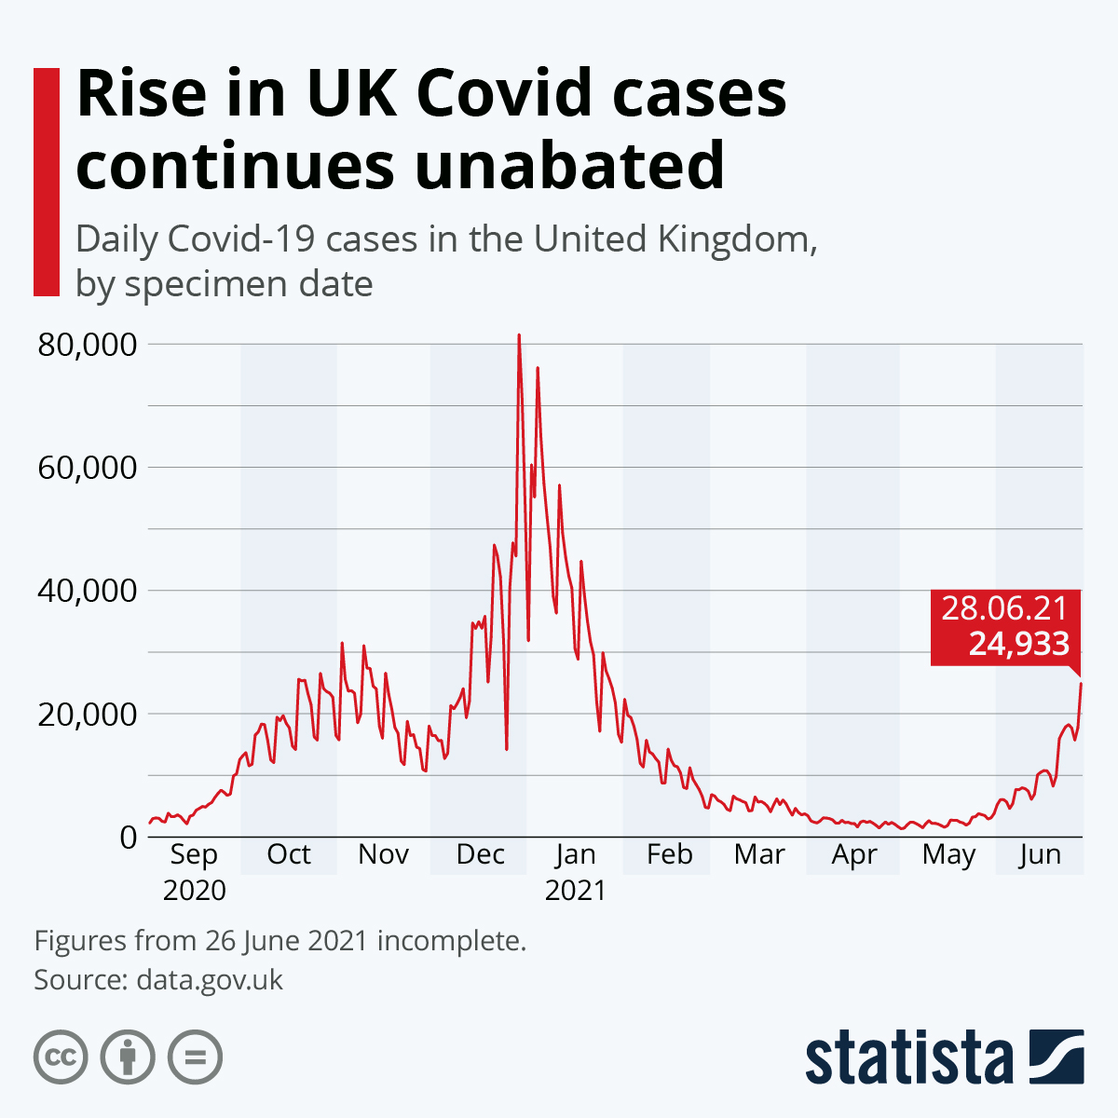
(Editor, 2022)

Positive persons and testing from the beginning of the epidemic until December 26, 2021, by weeks in Croatia

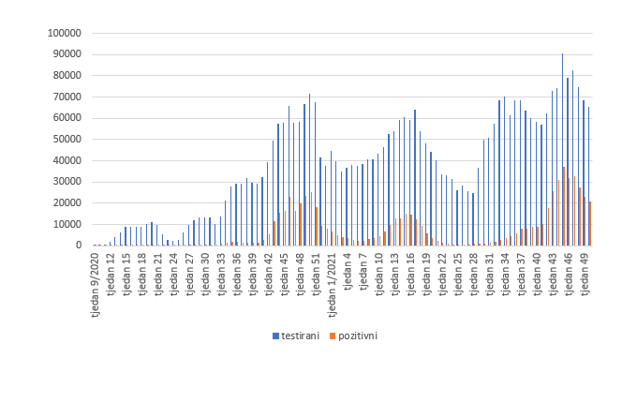
(COVID-19 – report HZJZ-a, 2022)

Health screening use tests to help diagnose Covid 19, before somebody got symptoms. Immunization is getting a vaccine in advance to increase the body's immunity to Covid 19. Through the learning process members of a community can improve awareness, and control the disease.

Public health policy

Public health policy can’t stop spreading the virus Covid 19 but can keep it under control. Public health policy is a set of actions, measures that prevent disease; promote the health and wellbeing of the public. It is important to control disease in the community. Department of Health and Social Care (DHSC), NHS National Services Scotland, UK Health Security Agency (UKHSA), Northern Ireland Public Health Agency (PHA), Wales Public Health (PHW) and NHS England jointly adopt policies to overcome Covid 19 transmission and concurrent recovery strategies. According to the new policies the services within the health sector will allow the organizations to assess the delivery services from 2021 to 2022. Nowadays, England switched to "Plan B" for the emergence of a new Omicron variant. It includes vaccines and testing remain the most recommended means of protection against Covid 19, recommended that people continue to work from home if possible; wearing face masks covering the nose and mouth remain mandatory in all closed public facilities and transport, in certain conditions are required NHS Covid Pass with a negative test or fully vaccinated with NHS Covid Pass (GOV.UK, 2022). In Croatia, citizens are encouraged to be vaccinated, as the most effective way to defend against disease and reduce the pressure on the health system, just as in the UK. Wearing a mask in public places and transport is essential. The decision of the National Civil Protection Headquarters of the Republic of Croatia of 4 October 2021 introduced special security measures of mandatory possession of COVID 19 certificates. Mandatory is possession of the COVID 19 certificate, as a prerequisite for all civil servants and employees, civil servants and employees in public services, officials and employees in local and regional self-government and employees of companies and institutions founded by the Republic of Croatia, state administration bodies and local and regional self-government units. COVID 19 certificate is also mandatory for all citizens who come to their premises. The introduction of these policies has reopened the question of whether the application of certain epidemiological measures restricts human rights and whether this discriminates against some citizens (Tretnjak, 2022). Both countries have different conditions for passengers entering and leaving the country. Depending on the situation in each country, governments mitigate or tighten preventive measures.

Models and theories of health behaviour change

From the beginning of the Covid 19 pandemic to the present day, the pandemic has been taking place in waves. The non-adherence to the recommended behaviour of individuals in society has contributed a lot to this. Public health strategies to combat the spread of Covid 19 are most effective when a certain proportion of the population strictly adheres to the recommended measures.
Understanding people’s behaviour processes is an important factor in health promotion and disease prevention. An individual's behaviour toward their health is an important factor in health behaviour and changes in health behaviour (RGN and RGN, 2002). Some various models and theories explain the change in health behaviour. Models are more based on diagnosing and understanding the psychological factors that explain behaviour while theories try to explain the very process of behaviour change.
The health belief model is based on the fact that people will change their health behaviour only if they realize that their health is endangered. Otherwise, they will not change their health behaviour. In my opinion, this is one of the models that have the strongest effect on the individual and keeps him in the bondage of his own, deep beliefs. The most difficult thing is to influence the change in the behaviour of people who fall under this model. E.g., people who do not believe they will be infected with the virus are likely to refuse to receive the vaccine. Some are convinced that the vaccine can worsen their general health, so they are against the vaccination measure.
The transtheoretical model explains the process of changing behaviour through individual stages. The disadvantage of this model is the impossibility of lasting sustainability of the achieved change in health behaviour, or easy return to the initial stages of behaviour change. External changes and personal problems of an individual contribute to this. As an example, we can take a person who, for some reason, refuses to wear a mask in public. He then goes through all five stages of this model and decides to wear a mask to protect himself and others around him. After some time, under some external influence (e.g., talking to a friend, reducing the number of infected ...) or for personal reasons, he stops wearing the mask again.
The theory of reasoned action is based on a preliminary consideration of the consequences of health behaviour before performing the behaviour itself. In this model, the power of intention determines to perform or not perform behaviour and behaviour change. A change in intention (behaviour) can be influenced by influencing a change in an individual's attitude or beliefs (Glanz, Rimer & Viswanath, 2008, p.76). The intention is shaped by social pressure and personal attitude. If a person has a positive attitude towards wearing a mask and their environment supports that attitude, then the person’s intention to wear a mask would be strong and they would most likely change their health behaviour and wear a mask. But if a person has a negative attitude towards wearing a mask or their society does not support it, then the person's intention to wear a mask would be weak, so, likely, the person would not wear a mask. Some scientific research shows that lower compliance with preventive measures is characteristic of the younger generation, people with high-risk behaviour, low empathy, and low trust in government. Wearing masks had the highest level of compliance and social distancing the lowest (Wright, Steptoe and Fancourt, 2021).

Impact of legislation and policies

Universally the use of the mask is compulsory, all patients and visitors with all the individuals should be bound to wear the mask in public places at least until 2022 April. For all health and social care, workers are mandatory to wear a mask while on the job. The second rule is about the physical distancing, there should be at least 1–2-meter distance in the hospitals and public places. The testing, survey and screening for SARS-CoV-2 will continue all winter, so other lung pathogens can also affect the individuals, so the health care sector should arrange all the requirements. Concerning Omicron and all other harmful variants of concern, all the staff and health care sector should confirm the availability of Ventilation, the capacity of space and should concern about the prevalence and physical distancing. All the clinical workers and Covid 19 patients should wear respiratory protective equipment (RPE) and a proper protection kit. All health and social workers in England who come face to face with service users must be fully vaccinated against COVID-19 to continue working. In this way, the weakest people, such as the elderly, the sick and the disabled, are maximally protected from the spread of the virus. Fully vaccinated people reduce the risk of infection by 50% -60% (GOV.UK, 2022). In Croatia, the policy is different. Not all health and social care workers need to be vaccinated. If they are not vaccinated, they must do a Covid 19 test every 48 hours.

Ethical considerations

This epidemic of Covid 19 changed the world. People were forced to abruptly change their lifestyles. The very beginning of the pandemic, as well as the speed of its spread, shocked everyone, especially the health and social care system. People were divided into one who respects and one who does not adhere to the public health measures. In the situation of the declared epidemic of Covid 19, the personal responsibility of the individual is even greater, because it is necessary to prevent the spread of the infection in the community and requires increased social responsibility based on the principle of solidarity. The policy of implementing the legislation in practice has met with resistance from some citizens. Citizens are confused that representatives of the government and public staff do not respect the measures they prescribe. E.g., they do not wear masks during public gatherings; church gatherings are allowed, and all others are forbidden (in Croatia). The rules are not the same for everyone. People feel discriminated against. Although vaccinated people can spread the infection, in some cases they do not need to be tested. In Croatia, the decision to vaccinate everyone will be made by politicians and not by medical or public health experts. It is neither ethically appropriate nor professional.

Recommendations

No single strategy can stop the spread of Covid 19, but all strategies together (based on evidence) at the community and individual levels can stop the transmission of Covid 19 infection (Honein, M., A., et al., 2020). We should find a way to motivate individuals to change their health behaviour, to adhere to all measures, not just some. Strategies to increase compliance should focus on increasing overall motivation for: education, information on the spread of infections, saving lives, sanctions and returning to normal. COVID-19 control must be developed to make the majority of the population feel confident and implement the necessary behavioural strategies. The most effective way to manage Covid 19 is isolation, testing and monitoring (Caduff, C., 2020). Every country's public health must be the initiator of every intervention, not politics.

References

Caduff, C. (2020) ‘What Went Wrong: Corona and the World after the Full Stop’, Medical anthropology quarterly, 34(4), pp. 467–487.
Editor, B., (2022) Coronavirus (COVID-19): Using data to track the virus - UK Health Security Agency. [online] Ukhsa.blog.gov.uk. Available at: <https://ukhsa.blog.gov.uk/2020/04/23/coronavirus-covid-19-using-data-to-track-the-virus/> [Accessed 7 January 2022].
Glanz, K., Rimer, B. & Viswanath, K., (2008) Health behaviour and health education, Theory, Research and Practice, 4 th edn., San Francisco: John Wiley & Sons
GOV.UK. (2022.) Government to introduce COVID-19 vaccination as a condition of deployment for all frontline health and social care workers. [online] Available at: <https://www.gov.uk/government/news/government-to-introduce-covid-19-vaccination-as-a-condition-of-deployment-for-all-frontline-health-and-social-care-workers> [Accessed 7 January 2022].
GOV.UK. (2022) Prime Minister confirms move to Plan B in England. [online] Available at: <https://www.gov.uk/government/news/prime-minister-confirms-move-to-plan-b-in-england> [Accessed 7 January 2022].
Honein., M., A., et al, (2020) Summary of Guidance for Public Health Strategies to Address High Levels of Community Transmission of SARS-CoV-2 and Related Deaths, MMWR and Morbidity and Mortality Weekly Report, 69, p.p. 1860-1867
Hzjz.hr. (2022) COVID-19 – izvješće HZJZ-a. [online] Available at: <https://www.hzjz.hr/aktualnosti/covid-19-izvjesce-hzjz-a/> [Accessed 7 January 2022].
RGN, A. and RGN, H., (2002.) Role of self-efficacy and behaviour change. International Journal of Nursing Practice, 8(2), pp.106-115.
Talic et al., (2022) Effectiveness of public health measures in reducing the incidence of covid-19, SARS-CoV-2 transmission, and covid-19 mortality: systematic review and meta-analysis, [online] The BMJ. Available at: https://www.bmj.com/content/375/bmj-2021-068302, [Accessed 6 January 2022].
Tretnjak, A., (2022.) Pravna analiza – Nove mjere suzbijanja epidemije COVID-19: I zaštita i ograničavanje prava. [online] Pučka pravobraniteljica. Available at: <https://www.ombudsman.hr/hr/pravna-analiza-nove-mjere-suzbijanja-epidemije-covid-19-i-zastita-i-ogranicavanje-prava/> [Accessed 7 January 2022].
Wright, L., Steptoe, A. and Fancourt, D., (2021) Patterns of compliance with COVID-19 preventive behaviours: a latent class analysis of 20 000 UK adults. Journal of Epidemiology and Community Health, pp. Jech-2021-216876.

- Appendix



