
MODULE TITLE | KNOWLEDGE AND INFORMATION MANAGEMENT SKILLS
MODULE CODE | BMSW 5106_LON
TERM | TERM 1
LECTURER NAME | MOHAMED KALAM
STUDENT NAME | MIRELA RADU
STUDENT ID | 1914030

How Amazon became the fastest growing organization during pandemic

Table of Contents
Introduction 3
The background of Amazon 3
Knowledge Information Management 4
The importance of knowledge management 4
How to satisfy customers using knowledge management 5
Delivery and Returns 5
Physical Options 5
Digital Service Experience 6
Product Experience 6
Knowledge and Information Management tools: 6
SECI model 7
Socialization (Tacit to Tacit) 8
Externalization (Tacit to Explicit) 8
Combination (Explicit to Explicit) 9
Internalization (Explicit to Tacit) 9
Benefits and Disadvantages of SECI model 9
WIIG Model 9
The 4 stages of WIIG model: 9
Most essential dimensions of the WIIG model 10
The Choo Sense-Making Model 11
Knowledge Management tools used by Amazon 12
Conclusion 13
References 14
Appendix (300 formative submission) 15

Introduction

The main purpose of this report is to reflect how Amazon became the fastest growing organization during the pandemic and what key knowledge management theories and techniques were used.
Amazon is an extensive internet-based organization that sells books, movies, music, housewares, electronics, toys, and many more goods either directly or intermediary between other retailers and amazon’s customers. Amazon’s business services include renting data storage and cloud computing. Its online presence is substantial such as, in 2012, 1 percent of the internet traffic in North America travelled in and out of Amazon.com data centers. Amazon.com was named in the first place because it starts with the first letter of the alphabet.

The background of Amazon
In 1994 Amazon initiated the business by selling books online and they promised to deliver books to any type of reader and anywhere. Amazon.com was often criticized by analysts and financial journalists which seemed to be justified by the lack of company profit until the end of 2001. However, the founder Jeff Bezoz thought that the best way of succeeding is to “get big fast” and this was a slogan that Bezos has printed on the employee’s T-shirts. Amazon.com did grow fast and in less than a year its revenue jumped from $15.7 million in 1996 to $148 million in 1997, and then to $610 million in 1998.
In 1998 Amazon started selling music and videos. In 1999 the company was selling electronics, video games, software, homeware, toys and many more (Hall, N/A).
In 2020 Amazon informed that that the profit increased by 37% due to the pandemic sales increase. The company revenues exceeded analysts’ expectations with its net income increased to $6.3bn in the third quarter comparing with the third quarter 2019 where the net income was £2.1bn (Helmore, 2020).
These gains came even though the company has decided to spend $4bn on personal protective equipment, cleaning products and facilities and salary increase.
Amazon announced that they are looking to add 100.000 seasonable jobs to assist with the high demands.

Knowledge Information Management
The knowledge management is the process of gathering, sharing, and using the knowledge in the best way to achieve organizational objectives (Koening, 2018).
Knowledge is essential in our day-to-day activities for us to be able to complete our task at work efficiently. It is well known that the knowledge management is important to any organization are: the process of decision-making become easier, learning routine helps building learning organizations and encourages changes and innovation. To make sure all the employers have access to the knowledge within the organization, the employees with a wider knowledge can make quick and important decisions that will bring a benefit to the company.
The knowledge management becomes more and more important each year. As the market will always become competitive one should be able to identify if there are any issues and respond quickly to innovations. The benefits of knowledge management are that the workplace will be more efficient, efficient decision making, increased collaboration, improve organizational knowledge, increased employee’s happiness, and confidence due to the knowledge acquired, training and innovation (valamis.com, 2019).
The main characteristics of knowledge are that using knowledge does not mean it will be consumed and passing knowledge around will not result in losing it.

The importance of knowledge management
As mentioned above the knowledge management is important as it improves the efficiency of been able to make pertinent decisions. By increasing the innovation within an organization, customer’s access to the best practices will also increase and employees hiring and firing rate is reduced. Knowledge management is responsible to understand the level of knowledge in an organization, where the knowledge is located, for example in a specific department, in the old files or with one of the team members, etc. and how to transfer the knowledge is the best way to the relevant people to be able to use is in the best way and ensure that is not lost.
In another words, the knowledge management is important because helps the organizations to learn from their past mistakes and successes, it makes a better use of the existing knowledge identifying when a department needs to improve, it promotes a long-term focus on developing the best abilities and skills clearing the knowledge that is no longer needed, increases the ability to innovate (Hajric, 2018).

How to satisfy customers using knowledge management
Customer experience can bring a business up or down no matter how great is the service or the product might be. Customers experience improvement can generate a considerable income to the company, while a poor customers experience can cost the company a lot of pf money. 70% of customers say that they will continue to support a company that offer excellent customer service, while 61% of the customers say that they stopped supporting a company due to a poor customers experience. Happy customers are more likely to remain loyal and as per Thinkjar CEO Esteban Kolsky found that 72% of the customers will talk with at least six people about the good customer service experience. However, Kolski found that 13% of the unhappy customers will tell at least 15 people that they had a bad customer experience. Therefore, to keep the customers happy a company must satisfy customers demands for excellent customers’ service and this is where the knowledge management system comes in (Hajric, 2018).
As mentioned above the success in any organization depends on providing a high-standard customer service. Amazon.com customer service operation consists in internally as well as externally managed contact centers. For over 20 years Amazon has been leader in e-commerce with its almost unique product inventory and competitive prices and not only for that reason has been a successful reason to become legendary is the combination of customers service and wide range of products that keeps the customers loyal.
Delivery and Returns
When it comes to delivery or return the experience is effortless and this is something that customers are willing to give their loyalty for in exchange. To make the delivery process easy for the customers Amazon has introduced free shipping for all orders over $25 and also introduces Amazon Prime for £119 a year which offers the customers to get free shipping on thousands of single possible.
Physical Options
Recently Amazon has introduced “self-service kiosc” called Amazon Lockers where the customers and chose a place that is easy for them to access for pickup. For those who prefer to shop groceries online Amazon provides “Amazon Fresh” which can be delivered at home same day or scheduled delivery for an extra fee. Another option is “Amazon Restaurants” where the customers can order meals and get them delivered same day. Another part of providing a great experience is the digital experience for the customers. In order to make it easy for the customers to when making purchases Amazon has introduced one-click system and “Dash” buttons. Dash buttons recognizes the need of customers to re-order certain items. Dash buttons are available on the web, in-app voice activation through Alexa as well as for purchases. Returning an item to Amazon is an easy process as many of the items are sent with a prepaid, printed return label. In 2018 Amazon teamed up with Kohls to place return kiosks in selected locations, for the customers who prefer to drop the returned items physically.

Digital Service Experience
Another part of great product experience is the digital experience for the customers. One of the easiest and most common way to access Amazon is Amazon App in particular for Prime Day. If a product is not available at the time we wish to purchase, Prime members are able to select the item and get notification when it becomes available.
72% of the customers expect to receive a response to a complaint within an hour. Customers Service via social is vital. Whether is through the website, the app or the social media Amazon is able to carry out the customers experience through multiple channels. They understand that they need to make an impression an provide a great customer experience that will determine loyalty on other channels.
Product Experience
Amazon has created an easy ordering system which was expected by the consumers combining the ability to search with the ability to refine by brands, average customer review, price, availability as well as specific categories to the brand.
Also, to help the customer decide on the product, Amazon provides the option to learn about the product and understand if the product meets the expectations and needs, mainly through reviews and ratings as well as a handy recommender system to help customers understand which product is the best or based on products bought together by another customers.
Another system that was introduced to make life easier for the users is the intelligent product like Alexa which was introduced in November 2014. Alexa is not just a way to shop, but it can be used in playing music, setting alarms, giving news updates, and controlling networked smart devices (Hunersen, 2019).

Knowledge and Information Management tools:
Knowledge is the most important asset in the daily activities of an organization helping to perform and complete the works efficiently and it can be viewed as individual or collective. Individual knowledge comes from an individual, while collective knowledge action comes from a group of individuals or organizations.
There are two types of knowledge: tacit knowledge and explicit knowledge. The tacit knowledge is the knowledge that uses a practical method or shortcuts in order to produce solutions something as best practices, skills, know-how, best practices etc. It could be sometimes hard to make the individual knowledge effective or to standardize it. The tacit knowledge is a codified language so that it could be transmitted in systematic and recognized language.
Knowledge management is created by the clash of human resources, information technology, organizational development, change management, brand and reputation management, evaluation, and performance.
Knowledge management models are a mixture of information or data into another format that can be used to improve, share and process knowledge for the purpose of developing intelligence. All these are used for the organization to collect, store, and analyze knowledge so they can have an advantage over the competitors.
Some examples of knowledge management models are: SECI model (Nonaka and Takeuki), The Choo model, The Sense-making model, Wiig model (Mohaj, 2017).

SECI model
SECI model was proposed by Nonaka in 1991 and then expanded by Nonaka and Takeuki in 1995. SECI consist of socialization (tacit to tacit), externalization (tacit to explicit), combination (explicit to explicit) & internalization (explicit to tacit). The knowledge involved in this model moves in circle like a spiral whereby tacit knowledge and explicit knowledge interact with each other continuously and this is how the knowledge process is created. The aim is that the knowledge that is held with individuals is shared to other individuals so that they connect to a new knowledge. The amount of knowledge is increases continuously when more rounds are done in the model.
Explicit knowledge is articulated, codified, and it is easy to be collected, stored, or distributed. Explicit knowledge is specified both in writing and verbally (books, images, graphs, database, audio video). The reason why the explicit knowledge is recorded is to be kept for future generations.
Tacit knowledge – in contrast with the explicit knowledge, the tacit knowledge exists in the mind of employees and is more difficult to understand, articulate or to communicate among individuals. Tacit knowledge is non-verbal, valuable unrecorded and personal (Semertzaki, 2011).
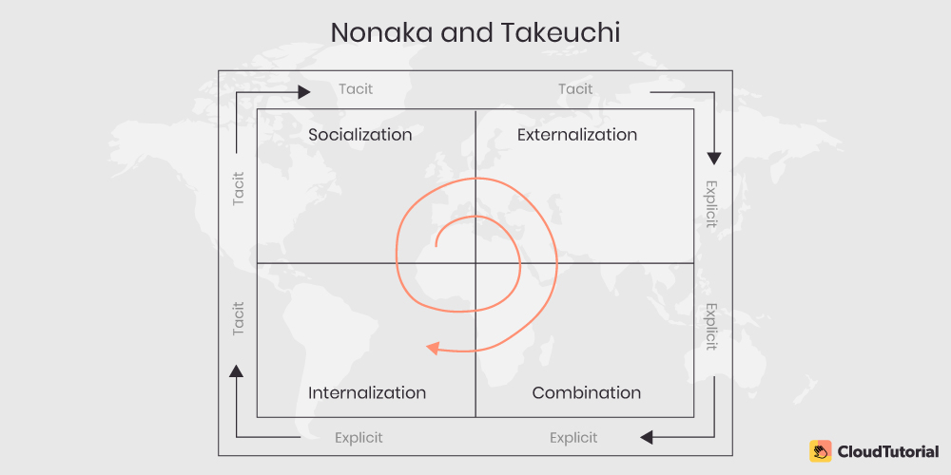

Socialization (Tacit to Tacit)
Socialization is the process of sharing the tacit knowledge while socializing, face-to-face communication or sharing individual experience, or observation, imitation, and practice through apprenticeship. Apprentices work together with the people that train them and get their knowledge by imitation, observing and putting the knowledge in practice. Socialization can sometimes come from interaction with customers or by interacting with a group of individuals within organization.
Disadvantages:
- the knowledge will remain tacit
- most of the time is not noted, written, or captured
- could be difficult sometimes and time consuming
- it depends on the ability of other people to share the knowledge

Externalization (Tacit to Explicit)
Externalization is the process of trying to transform the tacit knowledge to explicit knowledge in the way of developing models and concepts. At this stage, the tacit knowledge is becoming more understandable, so others can understand it and use it. In other words, externalized knowledge is the foundation of creating a new knowledge. In contrast to the socialization, the externalization is written and tangible and permanent. In this way it becomes easy to be shared with others.

Combination (Explicit to Explicit)
Combination is the process of assembling the explicit knowledge to wider entries and new ideas system. In another words, the explicit knowledge is collected from the people inside the organization as well as from the people from outside the organization and then assembled, modified, and changed to a new knowledge. At this point the knowledge is analyzed and organized and will be shared among the members of the organization. Combination provides a better understanding and an efficient transferring of the contents.
Internalization (Explicit to Tacit)
Internalization is when the explicit knowledge converts in tacit knowledge and it becomes some of the individual basic information. At this point the knowledge moves back to socialization where the individuals are sharing the knowledge in silence. In this way the knowledge increases and some old concepts in that an organization might have to be changed (S, 2006).

Benefits and Disadvantages of SECI model

Benefits of SECI Model:
- Appreciates the dynamic nature of knowledge and knowledge creation
- Provides a framework for management of the relevant processes
Disadvantages of SECI Model:
- The fact that is based on a Japanese organization which relies on tacit knowledge and employees usually stick with a company for life.
- The way the concept in arrange in a spiral line, the steps cannot be skipped, neither can go counterclockwise.

WIIG Model
Karl Wiig model (1993) refers to the principle that, the information must be organized in order to be valuable for the organization, depending on what the knowledge will be used for.

The 4 stages of WIIG model:

- Building knowledge
- Holding knowledge
- Pooling knowledge
- Applying knowledge
Building knowledge – refers to gathering knowledge from internal as well as external sources and it covers tacit and explicit knowledge.
Holding knowledge – is the process of keeping the acquired knowledge in such formats that are easy to be recovered and in the people that are going through training.
Pooling knowledge – using the pertinent knowledge management to be able to exchange ideas within groups of experts.
Applying knowledge – in this case the work process will change or improve by the way knowledge is used (helpiewp.com, n.d.).

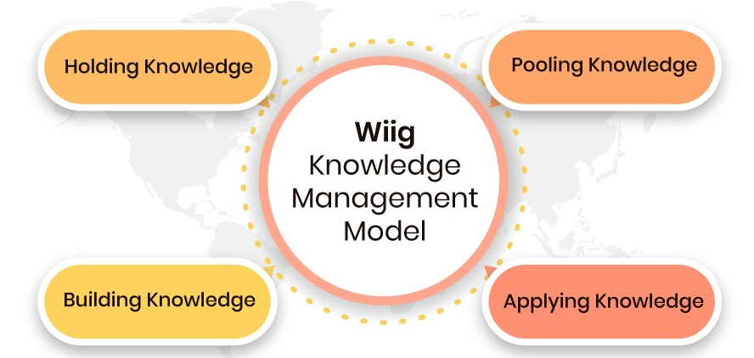

Most essential dimensions of the WIIG model
- Completeness
- Connectedness
- Congruency
- Perspective and purposed
Completeness – it narrates the amount of important knowledge that is available in a specific source. It is very important that the to ensure that the knowledge is complete if the information is available, otherwise the knowledge cannot be used, and no one will know about its existence.
Connectedness – is the guidance between well-understood and well-defined relations between different knowledge objects. Most of the time the knowledge objects are linked between each other. As a result, when a knowledge based is more connected the content will be more consistent and therefore it will be more valuable.
Congruency – in a case where all the facts, perspectives, concepts, values, judgements as well as the relational connections between the objects are consistent, we can call a knowledge base congruent. It happens rarely when knowledge contents meet these ideals.
Perspective and purposed – this is a technique where we have knowledge but only from a particular point of view for a certain purpose. This model is trying to contour different levels of internalization of knowledge and as a result could be interpreted as a refinement of Nonaka and Takeuki (thecloudtutorial.com, n.d.).

The Choo Sense-Making Model refers to making sense, creating knowledge and making the right decisions. The Choo knowledge management model aims to monitor how the information is selected and transmitted further into the organizational actions.
The three most important three components of the Choo Sense-Making Model are focused on:
- Sense-Making
- Knowledge Creation
- Decision-making skills
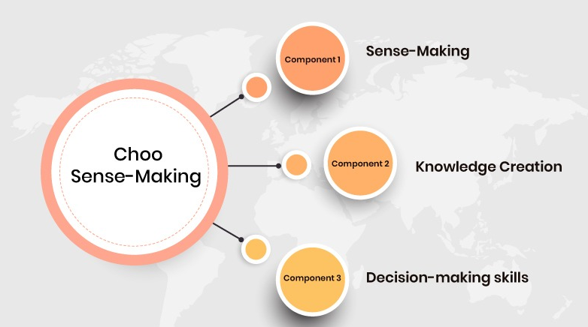

Sense-Making: the organization is focused on growing in fast and complex environment.
At this point the company is adopting various activities by making changes, picking a certain type of clients, suppliers as well as competitors.
Knowledge Creation refers to innovation. The company can create or collect data or information in order to create a new concept named organizational knowledge. Once the information is ready it helps in creating new products, services, or a better experience.
Decision making helps the company to use all the information in taking the best decisions (thecloudtutorial.com, n.d.).

Knowledge Management tools used by Amazon

From the beginning Amazon understood that the customers experience (to be able to find what they want is an easy way) was the secret to success. Amazon uses the knowledge management to add value to the customers in the following ways:
One portal, one interface – everything they sell, or any business that has to do with them is through the same portal. This brings comfort and confidence for the clients and makes their customer experience easy avoiding anxiety as they are doing research on the website. This also brings comfort for the employees.
Consistent presentation - all products have a displayed presentation where possible from reviews to product specification. This is as a result of a special content management where they create the information and then present it to the users in a steady manner. Another benefit is the ability to track or register any information. The benefit for the workers is the fact that they don’t need to interpret the products as a result of being displayed in a different manner.
Modular content the pages on Amazon are organized such sections to be easy to read. When additional options are added they are presented just as an option. This helps the workers to see only the content they are looking for and is saving them the time of having to scan documents in order to find the relevant information. Is about finding what is needed and not about only searching.
Distributed upstream content creation the product companies are the ones that are generating the content despite that fact that it looks like Amazon is controlling what we see. Looking at Amazon’s way of operating, at the standards, policies, or the look of the contents it gives the feeling like it all came from the same location which makes it easier to be used. The responsibility of completing the content moves to the most responsible person by moving the creation of the content to the source.
Remarkable personalization the thing that customers find the most impressive about Amazon is the way the website seems to know them. The site gets to know the clients better each time they use it. This way Amazon remind the customers search history, recommended similar products, or what other clients are buying together with the product we are searching for. As much as the system gets to know better the user, the efficiency and productivity will increase.
Extremely easy and consistent transactions whether the user is only searching for a product, or adding it and keeping it in the basket, even requesting for further information, the process is always the same. As soon as the content is showing if is available the ease of use will become critical for the knowledge management effort.
Subscriptions, alerts, and reminders to make it easy and not having to research daily for the same product, users can choose the option to be sent a reminder or can join a subscription list so anytime a product becomes available regular updates will be sent. The knowledge Management can bring and improvement in the productivity when is combined with personalization without having to do the same research which can sometimes be exhausting. This is what is called productivity.
Feedback – when it comes to feedback, Amazon is one of the most successful eCommerce websites. This is because the company pays a high importance to what the customers have to say and is known that the feedback will also give a value back to the customers. The feedback is placed right on the product and the shoppers are given the opportunity to rate the review. Using feedback on the value of content is one of the best ways to measure is the knowledge management is effective. The feedback has a better impact than downloads or page visitors.
Reduced servicing by designing the website in a friendly manner and comprehensive to the users the calls to Amazon call center are reduced. This saves the company an enormous cost and increases the customers satisfaction. Not only reducing call center but also email enquiries can bring incredible cost savings to the company.
Performance-centered whether the users are looking to cancel or change the order, return an item, or change payment or shipping method or check the orders history, Amazon provides an easy way to for the customers to accomplish their tasks. This approach is beneficial for the workers as they are able to perform their work more efficiently.
Great online help easy to use, read and easy to follow, on Amazon website the “help” option helps in improving customers experience, increasing customer satisfaction and it saves company cost.
Mobility amazon.com and amazon app can be used anytime and anywhere on any device. No need to worry about working hours (Rosenberg, 2014).

Conclusion

In conclusion the knowledge management information tools and techniques help the companies to increase the efficiency so the company can satisfy the customers expectations. Knowledge management is important because it helps the companies learn from their mistakes. By offering an excellent service it would generate the company a generous income.

References
Hajric, E., 2018. A theoretical and Practical Guide for knowledge Management in your Organisation , s.l.: Emil Hajric.
Hajric, E., 2018. Improve Customer Experience with Knowledge Management. [Online]
Available at: https://www.customerservicemanager.com/improve-customer-experience-with-knowledge-management/
[Accessed 13 April 2021].
Hall, M., N/A. Amazon.com. [Online]
Available at: https://www.britannica.com/topic/Amazoncom
[Accessed 04 April 2021].
Helmore, E., 2020. Amazon third-quarter earnings soar as pandemic sales triple profits. [Online]
Available at: https://www.theguardian.com/technology/2020/oct/29/amazon-profits-latest-earnings-report-third-quarter-pandemic
[Accessed 04 April 2021].
helpiewp.com, n.d. 4 Knowledge Management Models That Can Supercharge Your Organisation. [Online]
Available at: https://helpiewp.com/knowledge-management-models/
[Accessed 28 April 2021].
Hunersen, C., 2019. Why Amazon is a leader in customer experience. [Online]
Available at: https://www.qualtrics.com/blog/amazon-customer-experience-leader/
[Accessed 14 April 2021].
Koening, M. E., 2018. What is KM? Knowledge Management Explained. [Online]
Available at: https://www.kmworld.com/About/What_is_Knowledge_Management
[Accessed 11 April 2021].
Mohaj, H. K., 2017. The Impact of Knowledge Management Models for the Development of Organizations. [Online]
Available at: https://www.researchgate.net/publication/314063133_The_Impact_of_Knowledge_Management_Models_for_the_Development_of_Organizations
[Accessed 15 April 2021].
Rosenberg, M., 2014. The Knowledge Management Genius of Amazon.com. [Online]
Available at: https://learningsolutionsmag.com/articles/1480/the-knowledge-management-genius-of-amazoncom
[Accessed 30 April 2021].
Semertzaki, E., 2011. Tacit and explicit knowledge. [Online]
Available at: https://www.sciencedirect.com/topics/computer-science/explicit-knowledge
[Accessed 29 April 2021].
S, M., 2006. SECI model (Nonaka & Takeuchi). [Online]
Available at: https://knowledgeandmanagement.wordpress.com/seci-model-nonaka-takeuchi/
[Accessed 22 April 2021].
thecloudtutorial.com, n.d. Models of Knowledge Management (KMModels) Explained. [Online]
Available at: https://www.thecloudtutorial.com/knowledge-management-models/
[Accessed 28 April 2021].
valamis.com, 2019. Knowledge Management. [Online]
Available at: https://www.valamis.com/hub/knowledge-management#:~:text=Knowledge%20management%20is%20important%20because,decisions%20that%20benefit%20the%20company.
[Accessed 10 April 2021].

Appendix (300 formative submission)

How Amazon became the fastest growing organisation during pandemic
The main purpose of this report is to reflect how Amazon became the fastest growing organisation during the pandemic and what key knowledge management theories and techniques they use.
Amazon is an extensive internet-based organisation that sells almost everything from books to groceries either directly or intermediary between other retailers and amazon’s customers.
In 1994 Amazon started by selling books online. The founder Jeff Bezoz thought that the best way of succeeding is to have a big and fast growth (McFadden, 2021).
During the pandemic Amazon’s profit was double comparing with the same period last year despite the height cost caused by the coronavirus the company hired 1075 thousand new employees due to the business growth expanding the grocery capacity by 160 per cent (Lee, 2020).
Knowledge is essential in our day-to-day activities for us to be able to complete our task at work efficiently.
The knowledge management is the process of gathering, sharing and effectively using knowledge (Keoning, 2018).
The main reasons why knowledge management is important to any organisation are: the process of decision-making become easier, learning routine helps building learning organisations and encourages changes and innovation (Quast, 2020).

Knowledge management theories/models that will be cover in the report:
SECI model was proposed by Nonaka in 1991 and then expanded by Nonaka and Tekeuki in 1995. SECI consist of socialisation (tacit to tacit), externalisation (tacit to explicit), combination (explicit to explicit) & internalisation (explicit to tacit).
Wiig model refers to the principle that, in order for the information to be valuable for the organisation, it must be organised depends on what the knowledge will be used for.
The Choo Sense -Making model, refers to sense making, knowledge creation and decision making. The Choo knowledge management model aims to monitor how the information is selected and transmitted further into the organisational actions. (Mohajan, 2017)
REFERENCES
Keoning, M. E. (2018, January 15). What is Knowledge Management? Knowledge Management Explained. Retrieved March 2021, from kmworld.com: https://www.kmworld.com/About/What_is_Knowledge_Management
Lee, D. (2020, July 30). Amazon doubles quaterly despite Covid-19 costs. Retrieved March 2021, from ft.com: https://www.ft.com/content/7a42b1d8-9ca7-4827-aaae-729fdb7637f5
McFadden, C. (2021, February 17). A Very Brief History of Amazon: The Everything Store. Retrieved March 2021, from https://interestingengineering.com/: https://interestingengineering.com/a-very-brief-history-of-amazon-the-everything-store
Mohajan, H. K. (2017, March N/A). The Impact of Knowledge Management Models for the Development of Organisation. Retrieved from researchgate.net: https://www.researchgate.net/publication/314063133_The_Impact_of_Knowledge_Management_Models_for_the_Development_of_Organizations
Quast, L. (2020, August 20). Why Knowledge Management Is Important To The Success Of Your Company. Retrieved March 2021, from forbes.com: https://www.forbes.com/sites/lisaquast/2012/08/20/why-knowledge-management-is-important-to-the-success-of-your-company/?sh=7bec8d63681c

