Student Name: Malinka Pavlova
Student Number: 1906953
Lecturer Name: Anita Nan
Module Name: Academic and Employability Skills

Table of contents
Introduction……………………………………………………………3
Time managment……………………………………………………..3
Critical Thinking ……………………………………………………..5
Communication………………………………………………………5
Academical reading.…………………………………………………6
Paraphrasing …………………………………………………………7
Summarising………………………………………………………….7
Referencing……………………………………………………………7
Note-taking from reading……………………………………………8
Conclusions…………………………………………………………..8
References……………………………………………………………8
Appendix 1…………………………………………………………...11
Appendix 2…………………………………………………………..14

Introduction
The aim of this report is to analyse my academic and employability skills. The skills which will be analysed are time management, critical thinking, communication, reading proficiency, paraphrasing, summarising, note-taking and referencing. The main focus will be on my strength and weaknesses and on ways for improvement.

Time management
Definition – Time management is our ability to use time effectively, in order that the right time is spent on the right activity. Effectively managing our time allows us to identify specific time slots for activities, according to their importance. Time management is simply making the best use of the time that is available (Morgan, 2017).

Time management as a concept is not difficult but is hard to put into practice (SkillsYouNeed, 2011-2019). Important aspects of time management are affective planning, goals setting and objectives, having a deadline, delegation of responsibilities and prioritisation of activities as per their importance. Understanding the importance, as well as what to do, to prioritise and focus and use a diary, are important steps in developing the time management skill. (Juneja, 2011-2019)

Time management is one of the most fundamental academic skills as well as very important employability skill. Studying at university involves various tasks such as attending lectures, thinking and doing research on subjects, doing presentations and taking exams. To compete the tasks successfully, as a student, I need a considerable amount of time. Failing to manage my time, leads to unsatisfactory performance in exams, or failure. Time management is the main employability skill the employers look for. To arrive on time at one’s workplace, to be able to finish the task or schedule on time, also to meet the deadline is very important and shows if a person is reliable and potentially a good leader (Morgan, 2017).

I had considered myself having good time management skills as I am usually capable of completing tasks during the allocated time. Since I have started studying at university, I have struggled to manage my time effectively and found it challenging to fit my allocated tasks into a set time schedule.
To prioritise my time, I have to identify which task is urgent and which one is important. Urgent task requires immediate action. However, tasks which could be classified as ‘important’ require less immediate response in comparison to those classified as urgent. Therefore, urgent and important is not fixed status and I need to review the etasks regularly. I have to have a list of important but not urgent small tasks which can be done in ten minutes between other tasks or in break time (SkillsYouNeed, 2011-2019).

Being organised and tidy is another principle which can optimise my time. I need to keep my workspace tidy in order to find notes and papers easily. I will have three piles to keep, pass on to others and to throw away (SkillsYouNeed, 2011-2019).

Difficult tasks are to be scheduled for the time of the day we work more efficiently (SkillsYouNeed, 2011-2019). I found I am more productive in the evening, and so I allocate my most challenging tasks to this time of day

Another important aspect of time management is allowing myself to postpone activities until a suitable time to do them. This is not procrastination for its own sake, but effective scheduling. When having doubt about a particular task, I will talk to a colleague or lecturer and seek advice (SkillsYouNeed, 2011-2019).

I have not multi-task. It is always better to finish one job, then do another. In the case of having lots of tasks, grouping them together and doing similar tasks consecutively keeps the brain focused. (SkillsYouNeed, 2011-2019).

Critical thinking
Definition – The development and usage of information beyond storage memory and iterations (Morgan, 2017).

One of most important set of skills for study at University as well as for career development is the set of critical thinking skills. To be able to think clearly and reasonably, to understand the consistency between ideas, to be able to think reflectively and independently, is what the lecturers and employers will be looking for in students’ and employees’ work. People with good critical thinking skills are active learners. Their approach is systematically identifying, analysing and solving problems (SkillsYouNeed, 2011-2019).

A very important aspect of thinking critically is foresight. To be able to think critically, we need the following skills: observation, analysing, interpretation, reflection, evaluation, conclusion, explanation, problem solving and decision making. I believe I have the basis of those skills but need to improve on them. When approaching a problem, I have to think of the issue in an objective and critical way. Then I need to identify if the arguments are in relation to that particular topic and evaluate how strong the point of view is. Then I need to recognise the weaknesses and the negative points of the argument as well as a lack of satisfactory evidence. I have to be able to notify the implications that can be behind the arguments or evidence and to provide well-structured support and reasoning for my arguments (SkillsYouNeed, 2011-2019).

Communication
Definition – The process of exchanging information, thoughts and ideas in mutual understanding between two or more people or from one organisation to another is called communication (Griffiths and Dunham, 2015). Communications can be vocal by using voice, written using printed books, magazines, or digital media such as websites and e-mails, visual using logos, graphs, maps, charts, and non-verbal using body language, tone and gestures. More often it is a combination of all of these (SkillsYouNeed, 2011-2019).
Having good communication skills is needed in most aspects of life. To be able to communicate will have a positive effect on leadership skills, on the ability to work in teams, on presentation performance, and to work cross-culturally (SkillsYouNeed, 2011-2019).

Components of communication for para-linguistic cues are speech’ speed, the volume of the speech, pitch and intonation and exchange in any of those (Morgan, 2017). I have to work on controlling the volume of my voice, as some people find it very high. I speak clearly and within reasonable speed. I put intonation in my speech, do not talk monotone, which engages the recipient. My non-verbal behaviour includes direct eye contact with the recipient. As living in a multicultural society, I use body gestures cautiously. I try to keep my body and movement in a way that shows confidence. I consider myself a good listener.

In general, I have good communication skills but need improvement in written communications. As English is not my first language sometimes, I find it difficult to express my thoughts in writing. This can result in the recipient not fully understand my meaning or tone. The way to improve my writing communication skills is to take additional time to improve my English grammar. Furthermore, it was recommended by my lecturer based on my in-class exercise 1 (Appendix 1).
Academic reading
Definition - Reading skills is the ability of an individual to read, comprehend and interpret written words on the page of an article or/and reading materials. Academic reading is the ability to understand the author’s position. It is an active process which leads to knowledge developing (SkillsYouNeed, 2011-2019).

Why do I need to develop reading skills? Reading is a highly important academic skill, but one I find challenging because English is not my first language. I have to practice my skimming and scanning skills in order to process large amount of written texts.

In doing my research I have to identify and read selectively, using the referral list. Most importantly, I have to identify my own relevant materials. To increase my understanding, I have to check out the text while reading it and re-reading the material if not understood. I need to increase my reading speed and read more advance texts (Cottrell, 2019).

Paraphrasing
Definition – Taking a passage and rewriting it in your own words, keeping the original idea so the facts remain intact (Cambridge University Press, 2019). While paraphrasing, it is very important to acknowledge the material as a reference. Paraphrasing is an academic skill.

I have basic knowledge of paraphrasing. Based on In-class exercise 1 (Appendix 1), I need to improve my paraphrasing skills as well as my English grammar. The paraphrased text has to be shorter than the original one. My results show I need to allocate additional time on reading and writing in English. With more exercises and writing my assessments, I believe those skills will improve in time.

Summarising
Definition – Giving a brief statement of the main part of the information is called summarising (Cambridge University Press, 2019). While summarising, referring to the original material is very important. Summarising is an essential academical skill. Moreover, summarising can be a helpful skill at work.

Based on in-class exercise 2: Summarising (Appendix 2), I have good summarising skills. Nevertheless, I did not pay attention to the exercise’s request to write approximately 175 words and have written much more. I need to improve my ability to summarise and write shorter summaries. As English is not my first language, I need to practice more on reading and writing.

Referencing
Definition- Referencing is academical skill and means acknowledging the resources we use in our studies (Pears and Shields, 2019).

It is very important to have very good referencing skills. I have basic knowledge of this and need to work more on developing this skill. Writing my assessments is very useful and will give me invaluable practice in referencing my materials.

Note-taking from reading
Definition - Note-taking is an effective way of engaging with the printed word while studying. It is an academic skill. Taking notes can be a useful skill in the workplace as well. Note-taking helps to remind us of the information we read or hear. Having this skill is very useful in summarising or paraphrasing (SkillsYouNeed, 2011-2019).

I need to develop the skills for taking notes while reading. There is a large amount of reading materials while studying and taking notes while reading is essential in University. The skill of taking notes will have a significant effect on reducing time-wasting, as well as understanding and remembering the materials covered in the course (Cottrell, 2019).

Conclusion
The analysed skills in this report are ones which I found important and will help in University and the workplace. The study focused on ways for improvement. The academical skills of paraphrasing, summarising, academic reading, note-taking and referencing will be developed during my studying at University. My weakness is my English level of knowledge, as it is not my first language. My English grammar needs to improve. With better time management and improved critical thinking approach, I will achieve better results in time.

References
Cambridge University Press (2019), Paraphrasing, Available at: https://dictionary.cambridge.org/dictionary/english/paraphrasing (Accessed: 27 December 2019)

Cambridge University Press (2019), Summarising, Available at: https://dictionary.cambridge.org/dictionary/english/summarize?q=summarising (Accessed: 27 December 2019).

Cottrell, S. (2019). The Study Skills Handbook. 5th edn. London: RED GLOBE PRESS.

Cottrell, S. (2017). Critical Thinking Skills: Effective Analysis, Arguments and Reflection. 3rd edn. London: RED GLOBE PRESS
Cottrell, S. (2015). Skills for Success: Personal Development and Employability. 3rd edn. London: PALGRAVE

Griffiths, B.A. and Dunham, E.B. (2015) ‘Communication’, in Maund, A. Schriek, M and Tinkler, P. Certificate in Higher Education: Skills for Workplace Student Yearbook: Chapter 3. London: Sage Publication, pp. 45-65

Juneja, P. (2011-2019) Management Study Guide. Available at: https://www.managementstudyguide.com/time-management.htm (Accessed : 22 December 2019).

Morgan, P. (2016) The Business Student’s Guide to Study and Employability. Sage Publications

Pears, R. and Shields, G. (2019) Cite Them Right: The Essential Referencing Guide. 11th edn. London: RED GLOBE PRESS

SkillsYouNeed (2011-2019) Communication Skills. Available at: https://www.skillsyouneed.com/ips/communication-skills.html (Accessed: 20 December 2019).

SkillsYouNeed (2011-2019) Critical Thinking Skills. Available at https://www.skillsyouneed.com/learn/critical-thinking.html (Accessed: 21 December 2019).

SkillsYouNeed (2011-2019) Effective Reading. Available at: https://www.skillsyouneed.com/learn/effective-reading.html (Accessed: 20 December 2019).

SkillsYouNeed (2011-2019) Time Management Skills. Available at: https://www.skillsyouneed.com/ps/time-management.html (Accessed: 19 December 2019).

Appendix 1

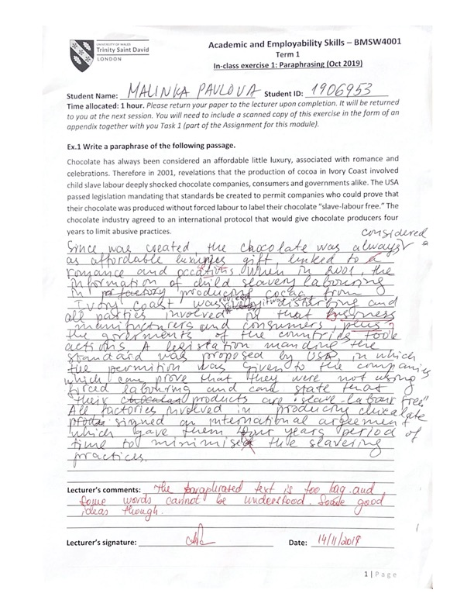

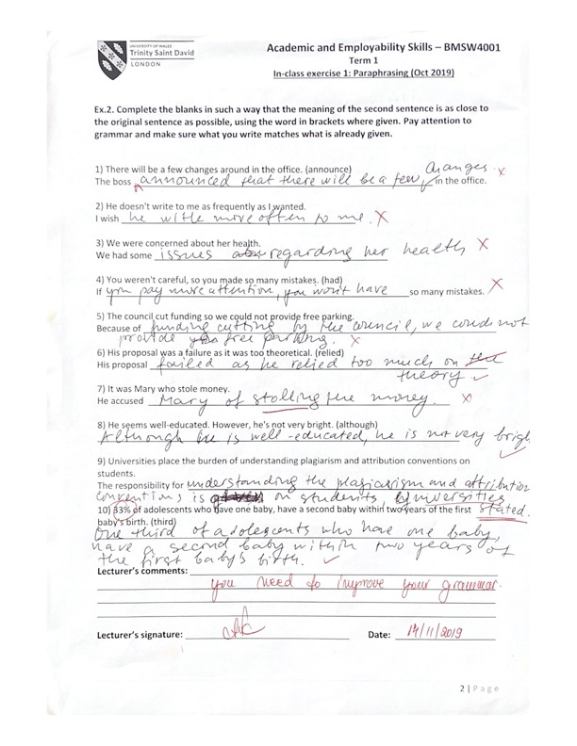

Appendix 2



