University of Wales Trinity Saint David
School of Engineering



CFD and Emissions Modelling
ACEA7005

Jacob Quarry
(2000885)
21/04/2024
Contents
1 Introduction 1
1.1 Aims 1
1.2 Objectives 1
2 Literature Review 2
2.1 Emissions Regulations 2
2.2 Literature 4
3 Methodology and Setup 6
3.1 Geometry 6
3.2 Ansys 7
4 Validation 9
4.1 2000 RPM 9
4.2 5000 RPM 10
5 Solutions 12
6 Conclusion 21
7 Appendix 22
8 References 23

Introduction

Aims
The aim of this paper is to attempt to ascertain the best options for a combustion powertrain for passenger vehicles that meets likely future emissions targets, focusing on the 2035 targets.

Objectives
This will be achieved by:
- A literature review covering the current trends in the problem.
- Modelling of an engine using Ansys Forte
- Validating this CFD model against real world pressure data from the Ford Sigma
- Modelling proposed solutions in Forte
- Using the data from Forte to build an Engine model in Ricardo WAVE
- Use the WAVE model to model how the solution would be likely to perform

Literature Review

Emissions Regulations
In the past few decades there has been a rapid reduction in the amount of permissible emissions in passenger vehicles, as seen in the euro classifications. A key consideration is carbon dioxide emissions due to its role as a greenhouse gas and the push to reach global warming targets and other emissions are key due to protecting air quality (Kalaskar et al. 2023). For combustion to be viable it needs to be reconsidered to meet these increasingly stringent requirements (Serrano et al. 2019; Kovacs et al. 2022).
Carbon Dioxide target levels(European Commission 2024)
From Year | CO2/km
2025 | 93.6
2030 | 49.5
2035 | 0

So if combustion is still to be used by 2035 it is essential that there is no carbon dioxide at the exhaust. This excludes all hydrocarbons as a byproduct of their complete combustion of any hydrocarbons is carbon dioxide. Moving away from carbon based fuels also solves the issue of carbon monoxide emissions from incomplete combustion, which is incredibly difficult to truly eliminate as even in a very lean combustion it is possible for there to be rich pockets which may incompletely combust. Carbon monoxide is a pressing issue from a transport sector standpoint due to its toxicity. Alongside this, and not exclusive to hydrocarbon fuels, nitrous oxide emissions must also be considered, these have also been targeted for reduction by the euro standards as shown in figure 1.
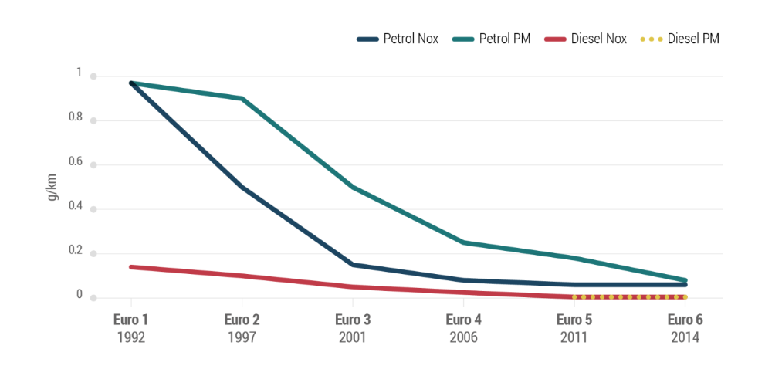
Figure 1 - Graph showing comparison of allowable tailpipe nitrous oxide emissions (ACEA 2024)
Given the formation of nitrous oxides stem from the nitrogen in the air it is impossible to remove the precursor reactants if its atmospheric air that’s being combusted. Fortunately however, the nitrogen doesn’t begin to break down and react until a substantial temperature (of around 1800K) is reached, and as a result it is possible to be controlled (Luo and Lee 2020; Rouleau et al. 2021; Tsukamoto et al. 2023). It is also worth considering that the euro regulations are proposed to be increased from tail pipe emissions exclusively to bigger picture emissions, such as those of brake pads and tyres (ACEA 2024). This may work to the favour of combustion due to the generally greater weight of electric vehicles.

Literature
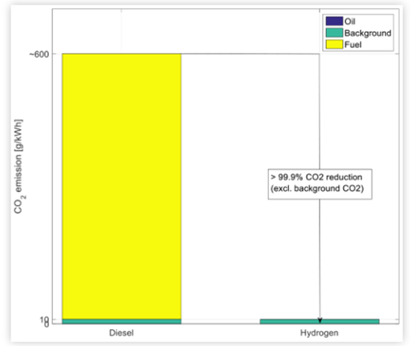
Figure 2 - CO2 emissions from both diesel and hydrogen (Bekdemir et al. 2022)
Due to zero carbon dioxide target by 2035 excluding hydrocarbons, other fuels must be considered that don’t contain carbon. This excludes alcohols, a common fuel for reducing emissions. As a result, this points to the use of hydrogen for combustion. Furthermore, by pursuing hydrogen, it’ll promote a symbiotic situation between hydrogen combustion vehicles and hydrogen fuel cell vehicles. In pure oxygen, hydrogen combustion would only produce water vapour as an emission, meeting both green house gas and air quality concerns. However, nitrogen oxides are of a greater concern with a hotter burn temperature (Luo and Lee 2020; Rouleau et al. 2021; Tsukamoto et al. 2023). This is however a much more manageable emission, and even if any is produced by the combustion it can be mitigated through exhaust after treatment, as is well established in diesel powertrains (Rouleau et al. 2021; Bekdemir et al. 2022; Kalaskar et al. 2023).
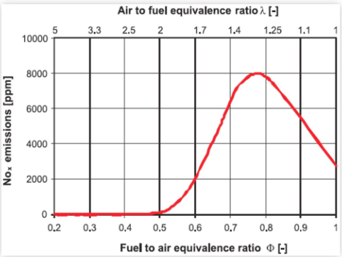
Figure 3 - Impact of equivalence ratio on nitrogen oxide emissions (Kalaskar et al. 2023)
There are however a number of methods available to reduce the emission however, generally consisting of methods to reduce the in-cylinder temperature during combustion. Three leading methods are water injection, exhaust gas recirculation and lean burn operation (Luo and Lee 2020; Bekdemir et al. 2022; Kovacs et al. 2022; Mariani et al. 2023). Figure 3 shows that by burning hydrogen at half the stoichiometric level, nitrogen oxide emissions can be virtually eliminated. Beyond this point however, homogeneity becomes a more pressing issue with unstable combustion and rich pockets of fuel still producing emissions (Bekdemir et al. 2022). This can be worsened by the use of direct injection, when compared to port injection, as despite the increased volumetric efficiency, the fuel has less chance to mix and become more homogenous (Bekdemir et al. 2022; Kalaskar et al. 2023). When spark ignition is being used, the window of lean burn operation sits around 1.8 to 2.4 lambda for minimal emissions whilst still having stable combustion (Bekdemir et al. 2022). When ran too lean, the unstable combustion leads to the issue of hydrogen being unburned and leaving out the exhaust, severely limiting fuel efficiency.
Exhaust gas recirculation is very useful for the ability to rapidly drop temperatures by reducing the portion of the intake charge that can burn. Furthermore, it has utility as reducing power output without pumping losses from closing a throttle.

Methodology and Setup

Geometry
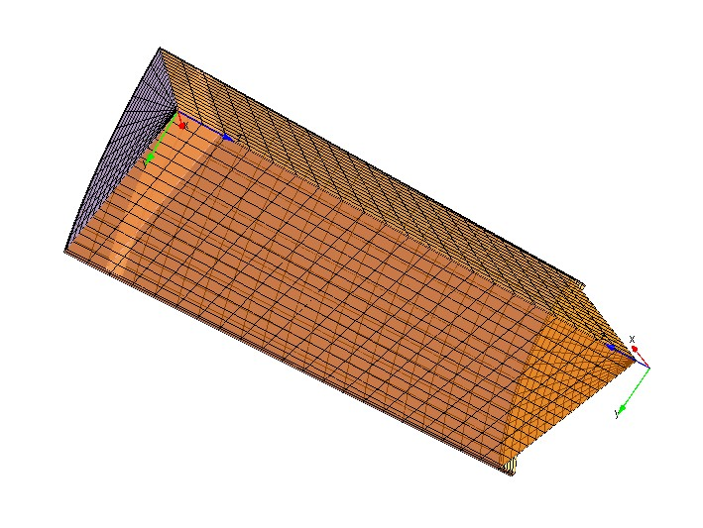
Figure 4 - Sector mesh of the approximate Sigma Cylinder
For the combustion simulation, a sector mesh was used, in this case of 60 degrees of the cylinder. This was to reduce the processing requirements when simulating and to then extrapolate out from the sixth to the entire cylinder. Furthermore the geometry was simplified from the real world example to save on setup time having to 3D scan an model a cylinder head and piston. The combustion chamber was approximated as a cylinder with diameter identical to the cylinder bore and a height of 7.29mm to attempt to retain the correct compression ratio. Furthermore, the Sigma engine uses a largely flat piston which was approximated as entirely flat (ie excluding valve cutouts) for simplicity. From this method a compression ratio of 11.95 was achieved which is a substantial overestimation of the 11.16 with the true sigma geometry. This is a first key limitation of the simulation and may overestimate cylinder pressures.
It is also worth noting that a significant issue was found in the geometry configuration where in some scenarios the Ansys meshing in the sector mesh tool produced an uneven mesh with triangular cells vertically. This caused a number of failures initially due to them not compressing properly through cylinder travel. This was mitigated by using the auto mesh function within Ansys forte from the surface mesh produced by the sector mesh tool.

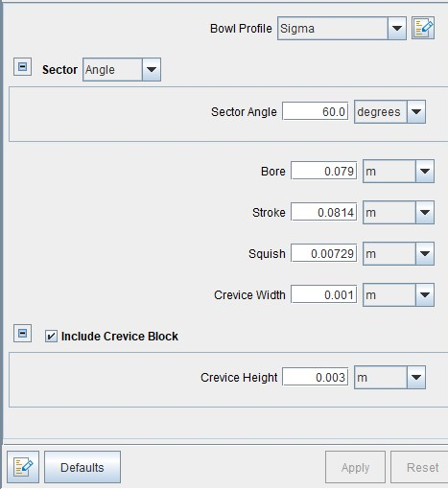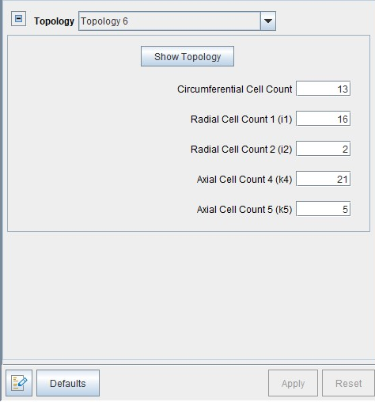
Figure 5 - Demonstration of the engine input paramters and mesh configuration

Ansys
The mesh was imported into ansys and largely the default values from the ansys diesel demonstration were used, taking a cycle from -165 degrees to 125 degrees to encapsulate the closed valve portion of the cycle. In addition, a spark plug was placed as close as possible to the axis (1mm down from the head and 1mm from the axis) and aligned in the middle of the sector arc. This is to approximate the central spark plug of a pent roof combustion chamber as closely as possible when the data is extrapolated. Ambient conditions remained the same throughout with an air temp of 300K and 1 bar of pressure.
Port injection was approximated throughout as this is the configuration used in the ford sigma engine and how it was decided to test hydrogen combustion due to the poor mixing apparent with direct injection increasing emissions. However, it was very crudely approximated as a truly homogenous mixture at a chosen fuel ratio, not reflecting a real world scenario. As a result, it is definitely worth considering how this is a best case scenario.
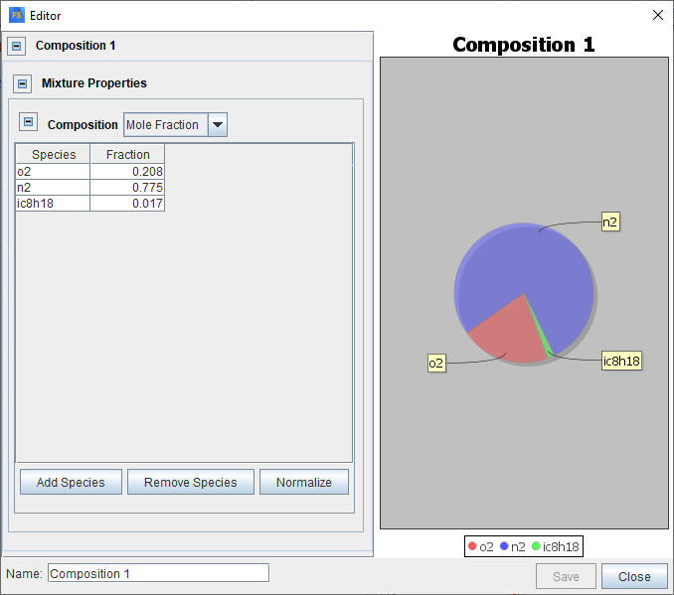
Figure 6 - Ansys demonstration of stoichiometric octane
Figure 6 shows an example of the intake charge configuration used in Ansys. Iso-octane was used as an approximation of pump petrol and each fraction of each molecule was determined in every scenario by the stoichiometric fuel calculator provided by Owen Williams. This does pose another limitation as octane is only an approximation. For the validation study an equivalence ratio of 1 was used as opposed to the 1.11 recorded in the sigma combustion data as it was found to be a better fit. This is potentially due to the increased combustion efficiency from the true homogenous conditions.

Validation

2000 RPM
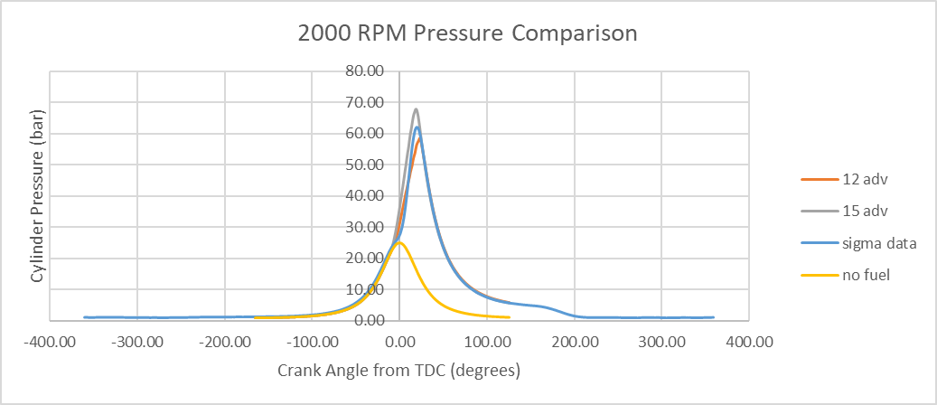
Figure 7 - Overview of cylinder pressures at 2000 rpm
Figure 7 shows generally a good fit of the pressure data between the measured and simulated values, particularly pre and post combustion. There is a notable difference in peak pressure however, but the two comparison spark advances nicely sandwich the measured data showing the value is attainable.
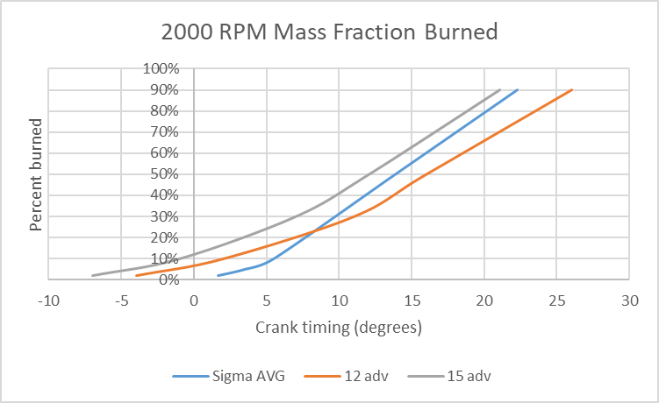
Figure 8 - Mass Fraction Burned at 2000 RPM
The key differentiation between the measured and simulated can be seen in figure 7 in the very initial phase of pressure rise. This is further shown in figure 8 where the general trend of the measured mass fraction burned is steeper, bar the initial start of combustion. This is likely due to the outlined limitation with poor homogeneity initially slowing the burn down until the size of the flame front grows and the generally richer mixture causes a faster flame speed. Again the two varied spark advance settings define the window encapsulating the measured data for the majority.

5000 RPM
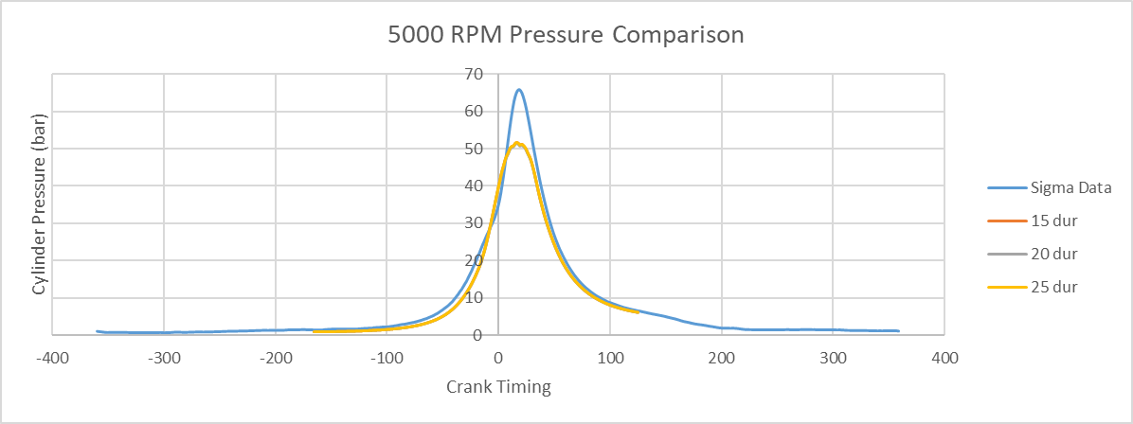
Figure 9 - Demonstration at 5000 RPM
The pressure data at 5000 rpm doesn’t match as nicely as it does at 2000 rpm. At the beginning of combustion the simulation underestimates the measured but then slightly overtakes. The peak combustion pressure significantly underestimates the measured values but it was found that changing advance increasingly exaggerated the different combustion profile. It appears that at higher rpm the fact that combustion happens in fewer degrees happens to exaggerate the influence the mass fraction burned has upon the pressure trace. The focus of this testing was to ascertain if changing the settings of spark duration had any tangible impact on the pressure trace or burn profile which wasn’t found. It may be more prevalent in leaner mixtures but this was not explored.

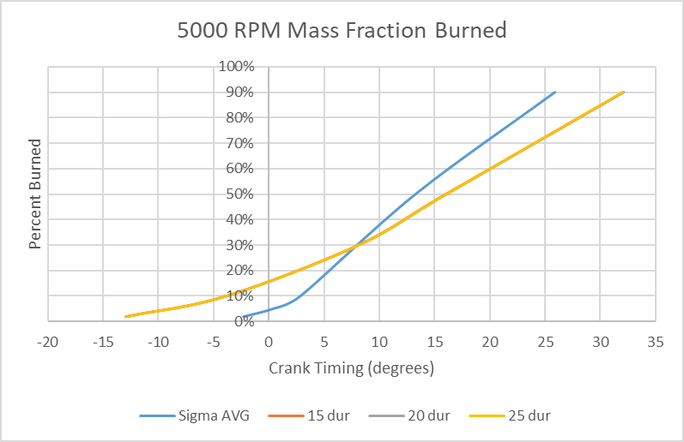
Figure 10 - 5000 rpm mass fraction burned
The crossover can be seen even more clearly in the mass fraction burned graph and is explained the same as the 2000 rpm study just more exaggerated due to more degrees happening in that same time.

Solutions
Two methods of reducing the cylinder temperature, and therefore nitrogen oxide emissions, were employed in this testing. A very lean burn of 0.5 equivalence ratio hydrogen and hydrogen at 1.0 eqv with a three phases of water being directly injected the cylinder. 0.01 grams being injected at 10 degrees before spark, 0.05 grams being injected 10 degrees after that and 0.075 injected at 30 degrees afterwards to bring the temperature down after combustion. This gives a total of 0.135 grams being injected and making up approximately 10% of the cylinder mass fraction. The two of these were compared to a cylinder of hydrogen at 1 equivalence with no water injection and another test of octane at one equivalence. All of these had the spark timing at 6 degrees advanced which although not optimal for the slower burning lean burn and octane allowed a direct comparison between every configuration degree by degree. 5000 rpm was chosen for testing as it represents a poor case for the combustion, everything happens much quicker and needs to be more carefully tuned.
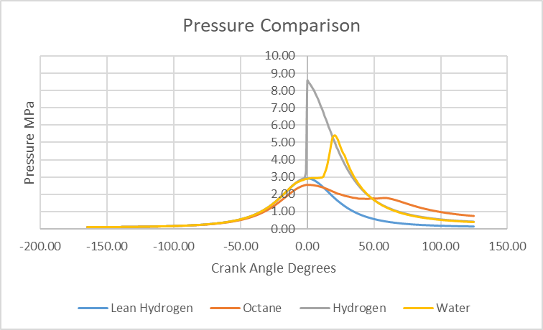
Figure 11 - Pressure comparison between the 4 tests
Figure 11 shows how unfair the testing is towards octane as it is combusting about 20 degrees later than it should. This however does show that tuning maps built for petrol would need to be drastically changed in order to accommodate hydrogen combustion. It also shows how the reduced temperatures of the hydrogen with water injection substantially slow combustion at the start and noticeably delay and extend combustion compared to stoichiometric hydrogen.
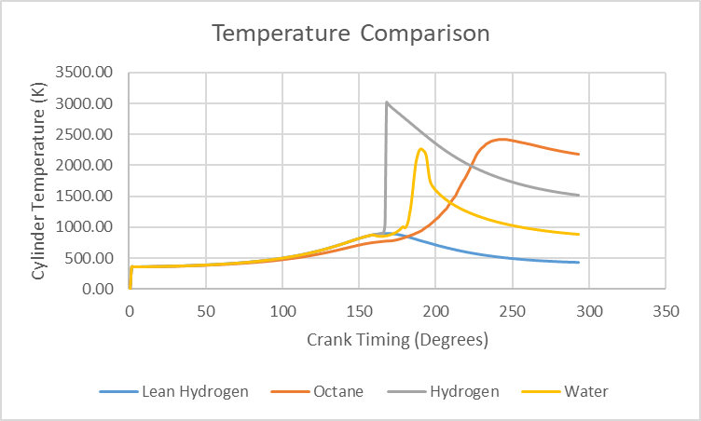
Figure 12- Temperature comparison between the four tests
Figure 12 however shows that the water injection is incredibly effective at managing the cylinder temperatures when compared to regular hydrogen and octane. It keeps the temperatures much lower than the baseline comparisons and also for a much shorter time. It would also make the exhaust less energetic and waste less energy down the exhaust due to the final temperature being 500 and 1000 degrees less. It is noteworthy that before combustion the octane has slightly lower in cylinder temperature than the hydrogen. This is likely due to the gaseous hydrogen in the mix against the liquid octane. As a result, energy that would’ve heated the cylinder was taken by the specific latent heat of vaporization of the fuel.
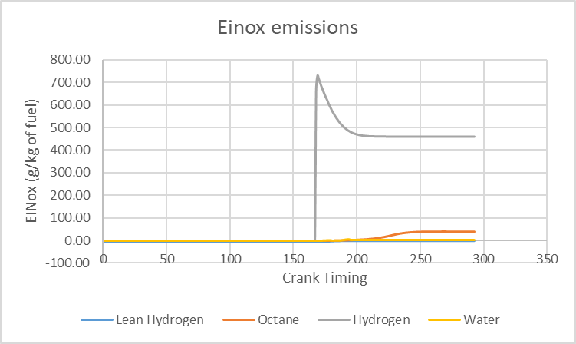
Figure 13 - EINox emissions of the 4 simulations
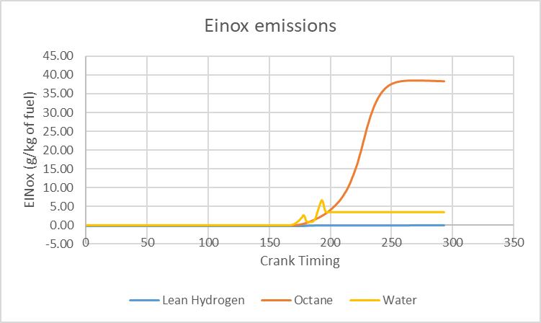
Figure 14 - EINox excluding hydrogen
Figure 13 shows just how much nitrogen oxide emissions are created by the higher temperatures of the stoichiometric combustion of hydrogen. By comparison Figure 13 has the same results but excluding the stoichiometric hydrogen. This highlights just how effective the water injection is at reducing the emissions given how every other input variable is the same. At the end of the cycle when the exhaust would open, there is 0.75% the grams of Nox within the cylinder when water injection is used when compared to the stoichiometric hydrogen. When compared to octane there would be 9.03% as much emitted.
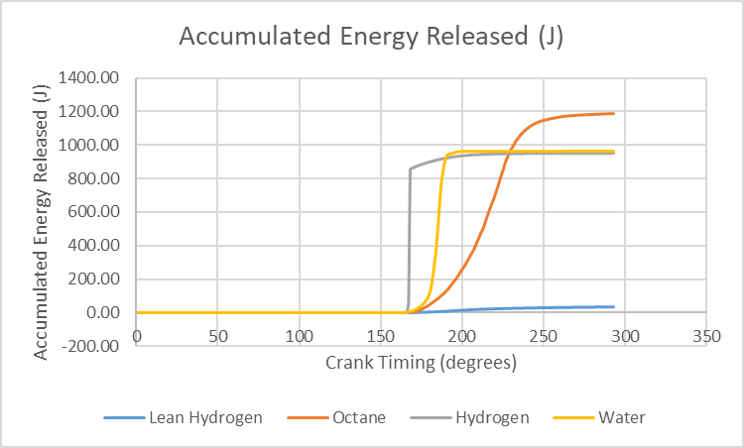
Figure 15 - total energy released across the four tests
Figure 15 shows that the water injection also results in a comparable amount of energy release throughout the cycle when compared to the stoichiometric hydrogen. This indicates that the engine power would be comparable between the two. It is also noteworthy that the higher specific energy of the octane means that even in the incredibly suboptimal conditions it produces 20% more energy than the hydrogen combustion. From this, it could be presumed that with the spark timing correctly set for the octane it would make a substantial amount more power throughout the cycle, likely with yet greater emissions however. This also highlights a limitation of the lean burn hydrogen. It is unfair in this case as the overall combustion was poor of the lean burn but it only produces a fraction of the energy, absolutely maximum half the amount of stoichiometric hydrogen in this case, causing an even greater reduction in power.
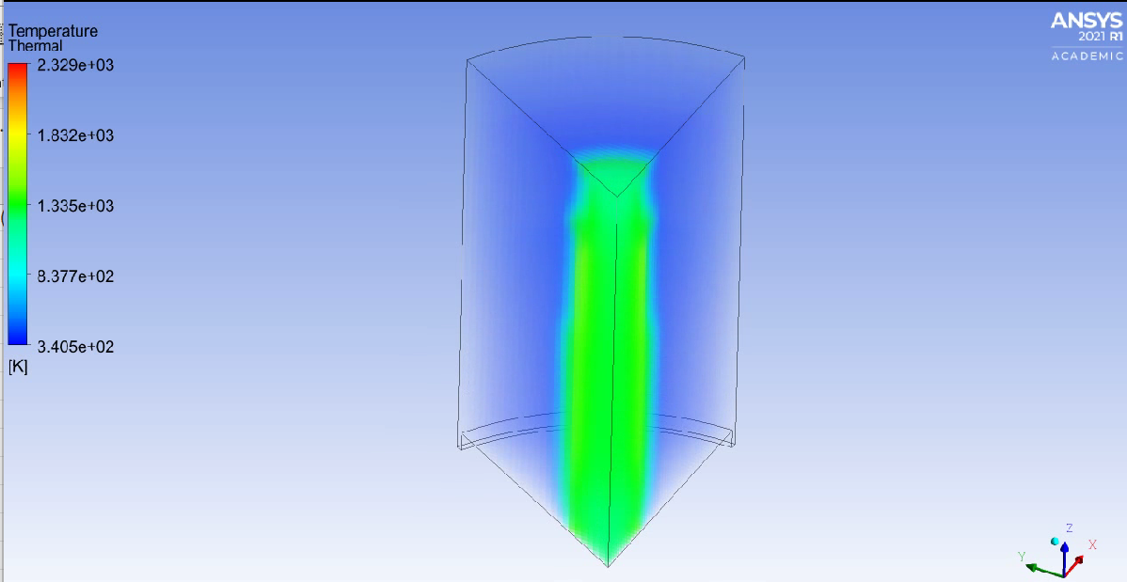
Figure 16 - Temperature map for the lean burn condition
The limitation of the 0.5 equivalence test is shown by figure 16. Only a very narrow portion of the cylinder combusted and the rest remained unburned. This highlights the unstable combustion of the lean mix identified in literature and limits the utility of the study. In order for better combustion the spark would’ve had to have been massively advanced, due to how much slower it burns. It would’ve also been advantageous to use a higher compression ratio as this makes the combustion chamber more energetic.
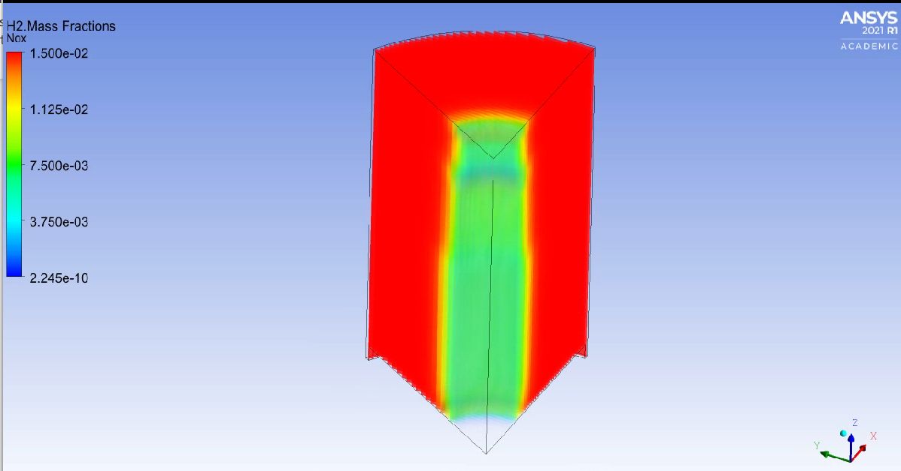
Figure 17 - H2 in the cylinder
This is further shown by figure 17 highlighting the unburnt hydrogen remaining in the cylinder which would be wasted down the exhaust. This would result in an incredibly inefficient Brake Specific Fuel Consumption. This further highlights how the cylinder geometry would need to be substantially changed for a lean burn to work, such as a much longer stroke in relation to the bore.
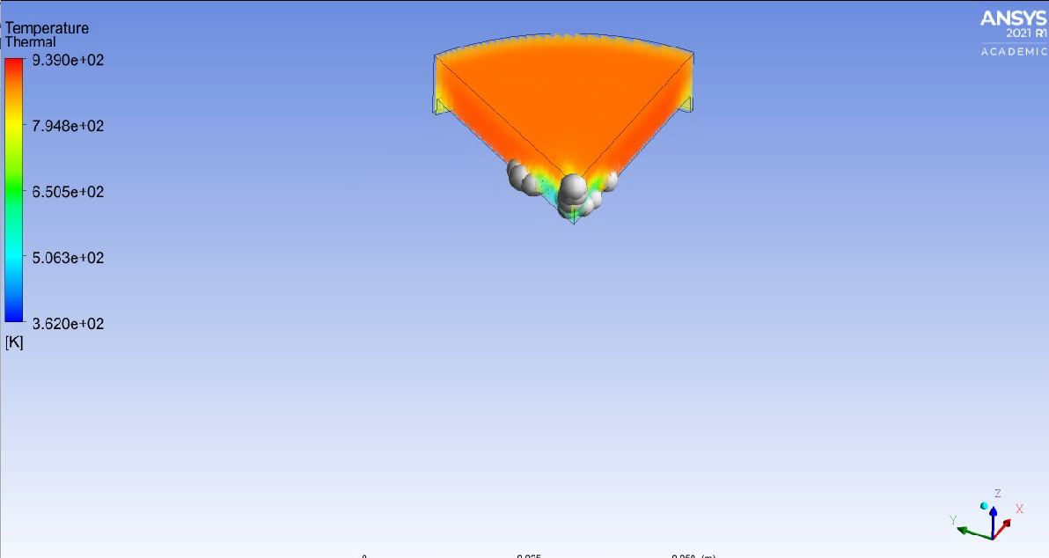
Figure 18 - The first injection of water prior to spark
Figure 18 shows the first injection of water in the water injection simulation, acting to reduce the temperature of the fuel before it is combusted.
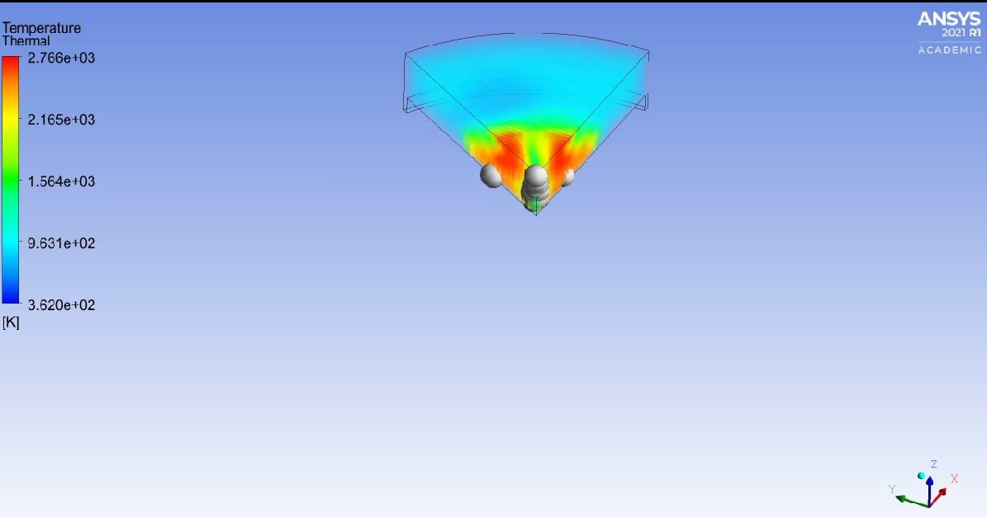
Figure 19 - Second water injection during combustion
Figure 19 shows the flamefront being parted by the second water shot directly into the flame kernel. This slows the combustion down and substantially reduces the temperature.
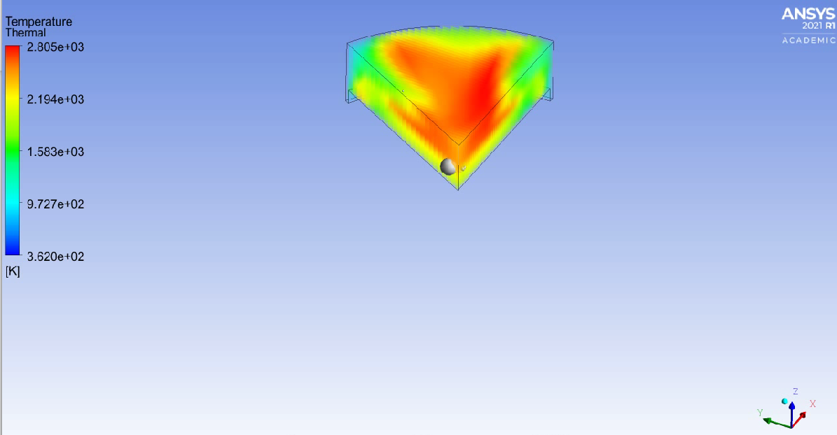
Figure 20 - Complete combustion in the cylinder
Figure 20 shows the combustion spreading to the entire cylinder a few degrees later combusting all of the remaining hydrogen and showing a few droplets of water left to evaporate, demonstrating the prolonged effect of that water shot on reducing the temperatures. This also explains the dwell observed in figure 11 and the slower and more gradual combustion of the hydrogen. This dwell indicates that the water injection could take a substantial amount of greater spark advance than just the hydrogen.
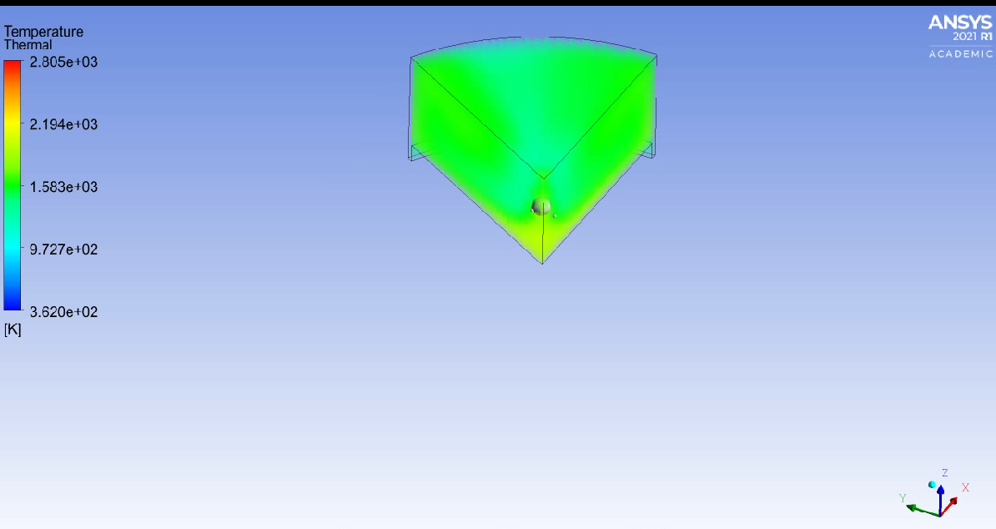
Figure 21 - Final shot of water in the cylinder
Figure 21 shows the final injection of water into the cylinder that serves to rapidly bring down the temperatures and reduce the duration of NOx production. This can be seen in the temperature data in figure 12 with the rapid drop off after the peak. This was to retain maximum performance but not risk emission production with the retained heat.
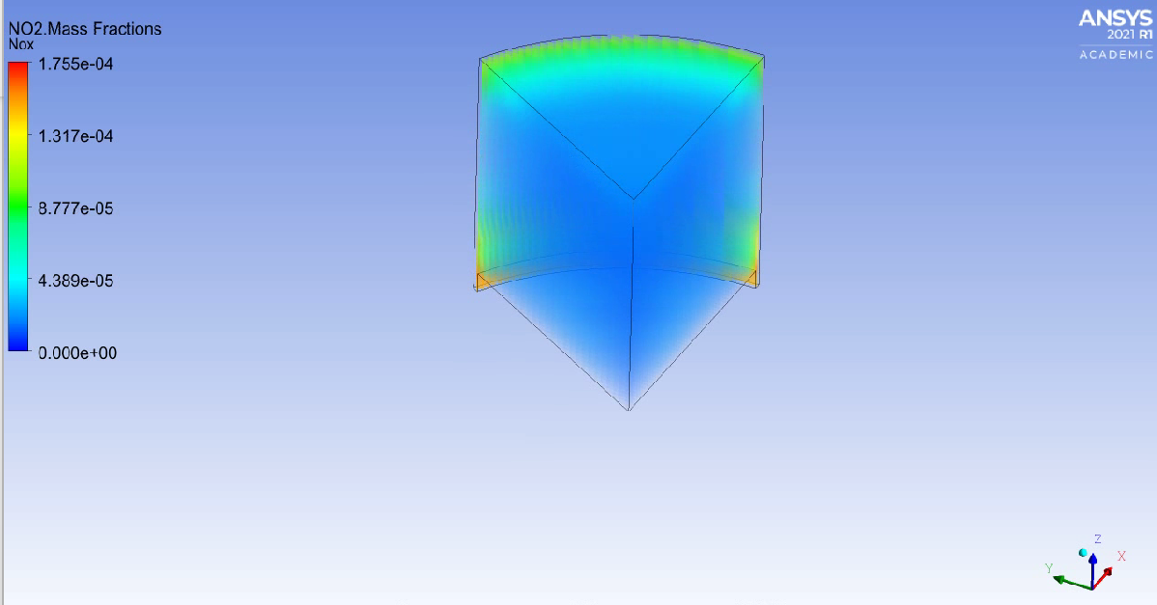
Figure 22 - Stoichiometric hydrogen with no water injection
It is noteworthy that the majority of the NO2 created by the stoichiometric hydrogen engine (without water injection) is produced in specific spots of the engine. This highlights an issue with the simplified geometry. By rounding these regions, such as the mating surface at the combustion chambers and the edge of the piston crown then the emissions of the engine could be significantly reduced by eliminating hot spots. This would also be advantageous for hydrogen use as it reduces the risk of pre ignition from hot spots of the cylinder.

Conclusion
This study indicates that with complicated and specific management conditions, water injection is a very effective tool for managing the in-cylinder temperatures of the engine. However, this is likely an overestimation of its effectiveness due to the aforementioned issues with the purely homogenous mixture. Emissions would be greater due to rich pockets of fuel and the flame front would be less predictable as a result. This might limit the applicability of carefully coordinated water injection and result in less being injected or at slightly sub-optimal times.
Alongside this, the simplified geometry appears to have exaggerated the emissions of the stoichiometric hydrogen combustion in particular so the savings might not be as great as outlined. A further experimental limitation, and a particularly severe one, is that the combustion testing data wasn’t inputted into wave to give an idea of how the engine would actually perform and as a result a number of assumptions (such as energy released being used as a comparison) had to be made. This was due to time constraints as a result of trying to optimize the water injection. As an extension of this paper, and to increase its utility, the combustion data would be inputted into the wave dual fuel example model provided by Owen Williams. The energy released and mass burned would be used to build reflective fuel files.
A further extension, not done for better comparisons, would be to optimize each engine configuration for its scenario. For example, better geometry with less hot spots, higher compression on the lean burn model, greater spark advance on the octane combustion. This would allow truly fair and representative comparisons of the technologies. This would then be a lot more useful when inputted into wave.

Appendix
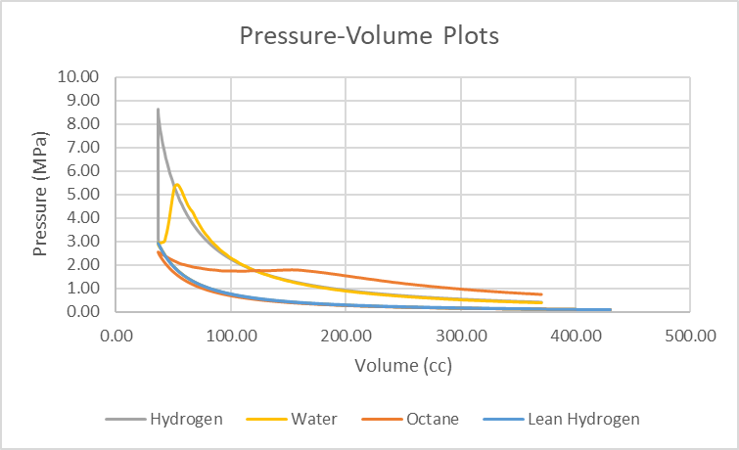
Figure 23 - Pressure-Volume plots of the simulated engines

References
ACEA. 2024. Fact sheet: ‘Euro’ pollutant emission standards - ACEA - European Automobile Manufacturers’ Association. Available at: https://www.acea.auto/fact/fact-sheet-the-euro-pollutant-emission-standards/ [Accessed: 21 April 2024].
Bekdemir, C., Doosje, E. and Seykens, X. 2022. H2-ICE Technology Options of the Present and the Near Future. SAE Technical Papers (2022). doi: 10.4271/2022-01-0472.
European Commission. 2024. CO₂ emission performance standards for cars and vans - European Commission. Available at: https://climate.ec.europa.eu/eu-action/transport/road-transport-reducing-co2-emissions-vehicles/co2-emission-performance-standards-cars-and-vans_en [Accessed: 21 April 2024].
Kalaskar, V., Conway, G., Handa, G., Joo, S. and Williams, D. 2023. Challenges and Opportunities with Direct-Injection Hydrogen Engines. SAE Technical Papers. doi: 10.4271/2023-01-0287.
Kovacs, D., Rezaei, R., Englert, F., Hayduk, C. and Delebinski, T. 2022. High Efficiency HD Hydrogen Combustion Engines: Improvement Potentials for Future Regulations. SAE Technical Papers (2022). doi: 10.4271/2022-01-0477.
Luo, Q. and Lee, C.F. 2020. Controlling Strategy for the Performance and NOx Emissions of the Hydrogen Internal Combustion Engines with a Turbocharger. SAE Technical Papers 2020-April(April). doi: 10.4271/2020-01-0256.
Mariani, A., Brequigny, P., Masurier, J.-B., Unich, A., Minale, M. and Foucher, F. 2023. Experimental Investigation on the Combustion of Biogas Containing Hydrogen in a HCCI Engine. SAE Technical Paper Series 1. doi: 10.4271/2023-24-0056.
Rouleau, L., Duffour, F., Walter, B., Kumar, R. and Nowak, L. 2021. Experimental and Numerical Investigation on Hydrogen Internal Combustion Engine. SAE Technical Papers (2021). doi: 10.4271/2021-24-0060.
Serrano, D., Zaccardi, J.M., Müller, C., Libert, C. and Habermann, K. 2019. Ultra-Lean Pre-Chamber Gasoline Engine for Future Hybrid Powertrains. SAE Technical Papers 2019-September(September). doi: 10.4271/2019-24-0104.
Tsukamoto, Y., Tanno, S., Miyamoto, Y., Sakai, H., Omura, T. and Takahashi, D. 2023. Analysis of the effect of hydrogen combustion characteristics on engine performance. Available at: https://www.sae.org/content/2023-32-0039 [Accessed: 21 November 2023].

