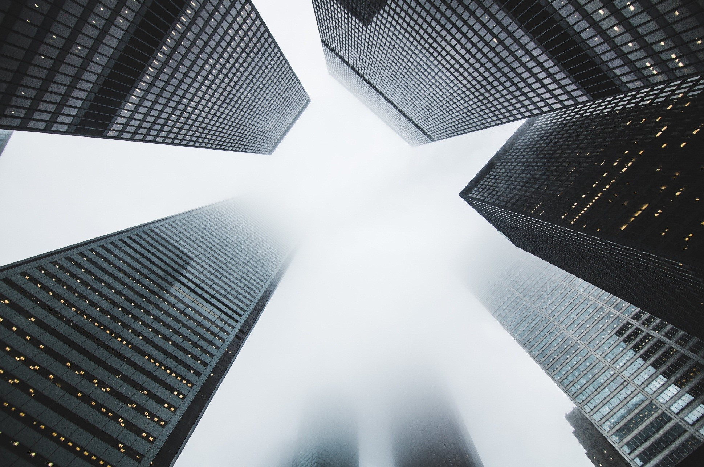
CLIMATE CHANGE AND FOOD SECURITY AROUND THE WORLD
Newsletter 2019
Volume 1 Issue 1
BIANCA BOLDIS
STUDENT 1808715

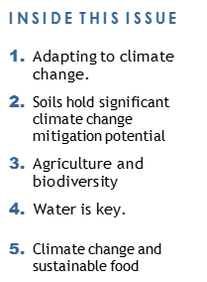  “During centuries the human have conquer and wiping down species” | 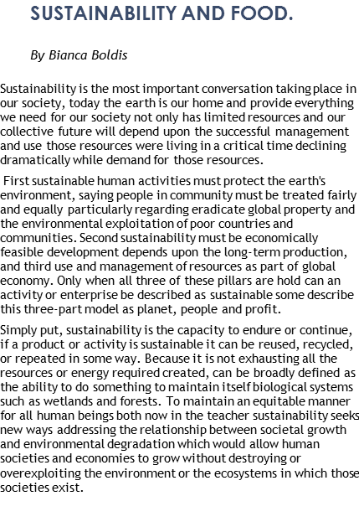
Human Impact on the Earth
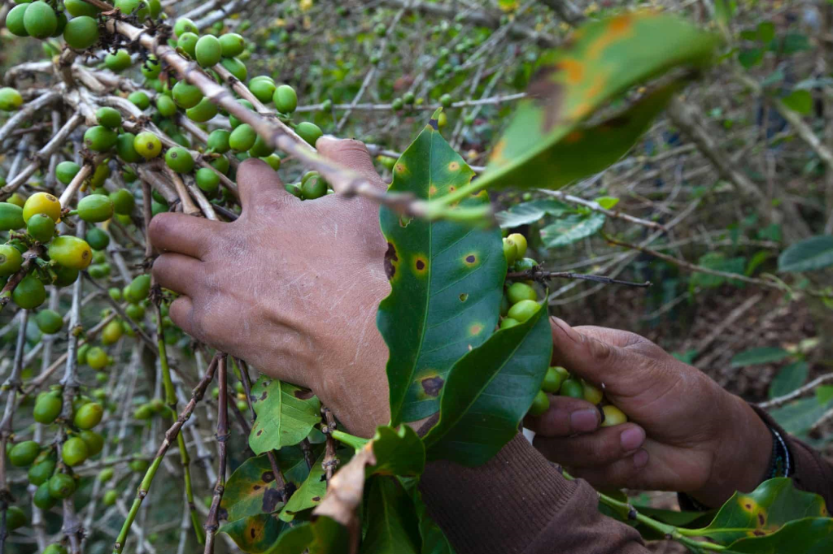  Is nothing wrong with the earth, the revolutionary ecological system in nature worked for billions of years, the selfishness of the individuals and the human impact on the earth is the biggest problem. During centuries the human have conquer and wiping down species and, on the way, destroying cultures in the process, species has been extinct, millions of animals killed and the ecosystem in a slow process, and we still doing it but on more large scale (2).  Food and hunger already affect millions of people.  The climate change plays an important role in many countries and for example Middle East and North Africa countries have experienced unpredictable changes in the past few years and those changes creates instability for food security serious water can trains are likely to worsen and will continue to provoke local conflict over resources for example the Arab Spring and will affect the most poor countries who rely on rainfall like Morocco in Syria.  The forecast changes in the rainfall patterns in the Mediterranean region because they relied heavily on rain, agriculture some good aspect of the clime and change in the rain patterns it can be seen in Egypt where the dry and hot climate with very poor agriculture Egypt developed a carbon fertilization and combined with widespread irrigation infrastructure the productivity increased but recent studies confirm that this change in the climate will have consequences in the food prices and therefore based on demographic and urban emigration trends, the rural area will face challenges with the food security (3). | 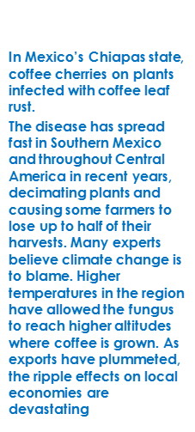

Page 2
Since ancient times the food trade played an important role in the political scale to and, to a greater or lesser level, the commercial part to maintain and, to a greater or lesser level, the commercial part can make a country richer.  Over the last three decades the increasing number of goods trade has developed an complex red of networks with a handful countries controlling it, country who is on the lead of exporting the biggest amount , but also importing the goods lacking from, are taking as much benefit from, that is why the biggest countries in the world has taken actions to offer free , open and true trade with the rest of the countries, like for example the N.A.F.T.A agreement signed in 1994 under the president Clinton government and was put on practice to help the trade between Canada, Mexico and U.S.A (7) .  Debates around this agreement continues but one thing is for sure the economic, wages and the trade increased the countries involved in the agreement and therefor the number of people emigrate between the countries has been the lowest in the last decade. The water play an crucial role in the food security of a country and the export of goods, countries with reduce water supply can grow fruits critics and vegetables and have a high level of exporting this but in change they will have to import rain fed crops , which will be difficult for them to grow. The role of the trade food is to provide, and it is important because some countries are continues increasing their exporting their goods and some countries in the African continent where are not able to produce as much. In the recent years the international community has recognise the need of the commitment to the food trade and the importance of a framework to avoid fraud and find a link with the climate change in an environment already fragile and damage. The food trade is an important part of a country supply and international change is the major income of the many farmers around the world, but also something to worry about regarding the short falls and specially the consequences of the climate change and other countries are able to provide but with not excessive prices and avoid speculation. The international community are made an political commitment to growing export and has recognise the importance to secure supply for the population but without speculations, and the target that says to correct and prevent negative implications and lift the restrictions, which will allows the free trade for all the countries (8).  EXPORTING AND FOOD TRADE  Giving the security and access to food for everyone it can be a challenging plan and even harder to eradicate hunger in the world, but doesn’t mean it is impossible, food security can be produce by many ways, from new and improve approach that pursue higher levels of grain production through calculated rent out cultivable foreign land or even reduce the amount of food waste end up in the landfill. Also, the policies and political approaches to an economy stable, funding directed to the small business and farmers, poor diet, wellbeing and social stability have a connection with the food security around the globe (4). Accomplish sustainable food security and environmental is an integral task, where all of us have their say or to do, to provide food sustainable there are a large list of to dos. Unfortunately, agriculture and conservation land are not always congruent, that’s why many of the climate change is happening now, deforestation and floods are destroying the crops fields or even the rain absence is just one of the many factors. Those are just of few factors who are threating our already damage ecosystem, the illegal hunt of our in-danger species, illegal fishing and illegal mining are destroying our fauna and wildlife, we are just our own enemies (5). | 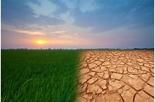  The water plays an important role in agriculture  70% is used to raise crops.
Food and hunger
already affects
millions
of people

Page 3
AGRICULTURE AND BIODIVERSITY

Page 4
Because the market prices of crops and food is so instable the result is quick changes on the higher  prices, and we had examples of companies who  not only manage to win profit by spicing the prices and have enormous benefits and become multimillionaire not carrying about the people who lost their lives or land for them to become so. That is why the safe policies and peace environment for all around the globe is important and for the wellbeing of society who in major cases of missing crops are the first ones to suffer.  Major change happened in 2016 with considerable political events that brought positive and negative impact on the market trade. President Donald Trump election to govern US and the UK choice of leaving the EU, has shape the trade accord between the countries and had to reconstruct the agreement with countries around.  Donald Trump during the campaign under his oratory “make America great again” has put in danger the relationship with the principal’s exporter trying to rise the tariffs imports, and verbally attacked China and Mexico in more than one occasion. In a fair world leaving behind NAFTA , taking only an example like Mexico who would give up exporting from US and start doing business with Brazil, that would bring a bust of money to an economy already growing and even could use the money to fight against the drug cartels and take back the autonomy over the most of the vast Mexican territory.  GLOBAL FAIR TRADE FOOD  Without doubt there is a connection between climate change and agriculture, is there where no barriers for a fair trade market the prices would be stable and might have changes in the way we consume some of the products and the amount of food end up in the land fill at the end of the day. |  | UK has a successful deal about importing unprocessed food, now UK is 60% self-efficient and we must take in consideration the alternatives of how we will replace the 40% remained to cover the high demand.  Several traits UK has to deal with after withdrawing EU first is the chicken , has been proved that United state chickens was banned in Europe because of chlorine washing process, United States still using pesticide on their fresh products and has been proved , the products after washing still has maximal residues level left.  EU has banned the drug called Ractopamine who is injected to pigs to develop more muscle and less fat in their body, European Safe Food Authority has banned the drug in EU but US still rely heavily on it use.  And those are only few examples of the difference’s legislation between EU and US who will have major gain is Brexit take place and the two countries start doing business and importing the unprocessed food (9).
Every five seconds a child dies from hunger, that is six million children at year, the population of Manhattan and Paris together, today some of us wake up at four meals at day while some of us wake up at nothing,we may live in different worlds but we share the same planet and what may affect some of us now it will affect all of us in the future. Without actions climate change will cause wide spread decreases and crap years, for every 1 DEGREE rise in temperature we get a 10% DECLINE in agriculture production. As oil become more expensive the cost of food will increase, water shortages threaten to reduce the global food supply by more then 10% in the next 25 years, in poverty areas the growing population can not keep up feeding them, if we don’t work to contraatack this effects, will we loose our ability to grow up food on our planet. By 2030 will be an estimated 1.8 billion more people to feed, instability political rise while the food become less and that scares. If we don’t act now it may be to late. The global food demand must increase 50% more in 20 years, to change the future we need to work from the ground, by working together with small scale farmers around the world we can not succeed we need to invest in agriculture development like we do with emergency aids like an agriculture aid to build an foundation for the future tomorrow. In the last decade the groups growth double in Asia helping move hundreds of people out from poverty, in Africa double in productivity will take out from poverto 70 millions of people.If we enable communities to grow when they can deliver their food at the strong markets, if we invest in woman and protect our national resources, we can catalise the growth of viable and stable economy and so hope for a better saffer world (10). What was the option back in 1960 to creat and grow more food: creating land for crops but that’s not viable anymore because we use all the land possible and more, the protection for the next 30 years we have to double our food production, to do that we have to increase yealds from land we don’t have anymore. We loosing land by 1% per year because of land erossions, wind erossion and salinization’s due to irrigation and chemicals, water we already have  limites resources and other threats that stress the  scientific community with subject related to food security. The climate changes is an additional  threat and there is more 1 billion people suffering  from famin or not getting to get two meals per day |  | The agriculture has change and innovations include machines who are autonomous pickers, UK researchers has fabricate a machine who picks up  the strawberry more faster then the humans, robots  or drons could preciasly remove weeds and using 90% less pesticides. Tinny cameras will monitorise  the cops yield and send sensor and measurements  to the farmers phone and when is the best time to harvest, the BONI-ROB can take a sample of the soil.  Company as AGRIBOTIX has already planned for using robots to grow and harverts corps without the human not even enter the yealds. The Farmers Business Network combines data from many farms  in a giant data base and give it the members the macro power of the overview site that traditional are not seen. This are just a few of the new innovated  solution to help farmers, worldwide the way of  farming has change and they are able to use tecnologie and knowledge to develop a sustainable agriculture of the future.  The ability to capture more data in agriculture is  giving the researcher the chance to analyse the data work and receive help from scientific research to  offer tools to improve the management of the soil.  Coming up with solution is not going to replace labour is going to replace certain types of work but still need of workers to do the jobs, technologies will make that labour efficient, the farming benefits from using innovating technologies.  Having a full control and sustainable agriculture and sometimes the communities should help between  them and everyone will like to see something  different and in simbiose with the envirment without harming an ecosystem already fragile.

REFRENCE LIST.

1.Nobbs, Christopher. Economics, Sustainability, and Democracy: Economics in the Era of Climate Change. Abingdon: Routledge, 2013. Print. Routledge Frontiers of Political Economy.

2. Energy, Sustainability and Society. (2011). Web.

3. Food Security in the Middle East

By Nadine Katkhuda | June 30, 2017 | Middle East, Sustainable Developme

4. Wright, Brian, and Carlo Cafiero. "Grain Reserves and Food Security in the Middle East and North Africa." Food Security 3.S1 (2011): 61-76. Web.

5, Eklund, Lina. "On Virtual Water and Food Security in the Middle East and beyond." Your Middle East (2016): Your Middle East, 2016. Web.

6. Johnstone S, Mazo J (2011) Global warming and the Arab spring. Survival 53: 11–17

7 Daily G, Dasgupta P, Bolin B, Crosson P, Du Guerny J, Ehrlich P, Folke C, Jansson AM, Jansson BO, Kautsky N (1998) Food production, population growth, and the environment.

8. Boskin, Michael J., and NAFTA at Twenty: The Past, Present, Future of the North American Free Trade Agreement. NAFTA at 20 The North American Free Trade Agreement's Achievements and Challenges. Chicago: Hoover Institution, 2014. Hoover Institution Press Publication NAFTA at 20. Web.

9.https://www.cieh.org/news/blog/2018/7-threats-to-food-safety-after-brexit (accessed, 2019)

10.World Bank (2007) World Bank report, assessing the impact of climate on crop water needs in Egypt. Global environment facility. Policy research working paper, WPS4293, 35 pp

11. Bruce, Lee, Haites, Bruce, J. P., Lee, Hoe-sŏng, Haites, Erik F, and Intergovernmental Panel on Climate Change. Working Group III. Climate Change 1995: Economic and Social Dimensions of Climate Change. Cambridge: Cambridge UP for the Intergovernmental Panel on Climate Change, 1996. Print.

12. Fawaz MM, Soliman SA (2016) The potential scenarios of the impacts of climate change on Egyptian resources and agricultural plant production. Open J Appl Sci 6:270–286

13. Moriondo M, Bindi M (2007) Impact of climate change on the phenology of typical Mediterranean crops. Ital J Agrometeorol 3:5–12

14. https://www.cieh.org/news/blog/2018/7-threats-to-food-safety-after-brexit/ Chartered Institute of Environmental Health

