Daniel Davies
2013713
17/12/2022

Applied Programmable Logic Controllers
– ACDA6000
Assignment: Factory Control
Contents
Abstract 2
Literature Review 2
Factory IO Design 4
Overview 4
Large and Palletiser Box Sorters 5
Small and Medium Box Sorters 6
Control Panel 6
PLC Ladder Program 7
HMI Design 8
Home Screen 8
Engineer Screen 8
Conclusion 9

Abstract
In this report the design of a factory system, that sorts four types of boxes as well as the control behind it, will be explained. The system is to sort four types of boxes by using the components available in the Factory IO software, the four types of boxes are palletiser, small, medium and large boxes, these can be distinguished by comparing size and/or weight of the boxes. The system has various fault warnings and alarms that alert those using the system to problems.
The report will include the design features of the factory IO system, the PLC program, explanation of the PLC program and the design of the HMI system. An operational flow chart will be included to show the basic operation of the system. The system is simulated using the Tia V16 software and Factory IO to show the full operation of the system and the integrity of the design.

Literature Review
PLCs have been used in industry since the 1960s to help control industrial processes, taking over from relay logic. The first sector to use PLCs was the automotive industry by General Motors.
PLCs can be programmed in various languages, including but not limited to ladder logic, function block diagram and structured text. They also use various logic systems depending on the manufacturer, for instance, Siemens PLCs could use logosoft, S5, S7 or the more recent TIA. Whereas Alen Bradley PLCs use SCADA. Engineers who work on one of these may not know how to work on another type of PLC depending on their training and experience.
PLCs in general are tough and work in harsh environments, although should be kept away from water and high humidity environments.

PLC Types
PLCs come in two main forms, compact and modular, each with its own advantages and disadvantages. These are explored below:
Type | Compact (Brick) | Modular (Rack Mounted)
 | 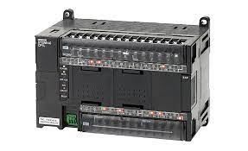 | 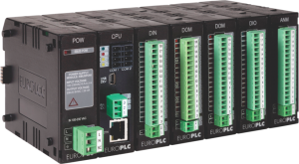
Pros | - Generally cheaper  - Ideal for smaller applications | - Expandable I/O  - Expandable Memory  - If one part fails, it can be replaced without replacing the entire PLC  - Customisable to meet requirements
Cons | - Set number of I/O  - If one part fails, entire PLC must be replaced  - Unable to be customised to meet requirements | - Unable to use parts of one manufacturer with others from another manufacturer  - Expensive

Factory IO Design

Overview
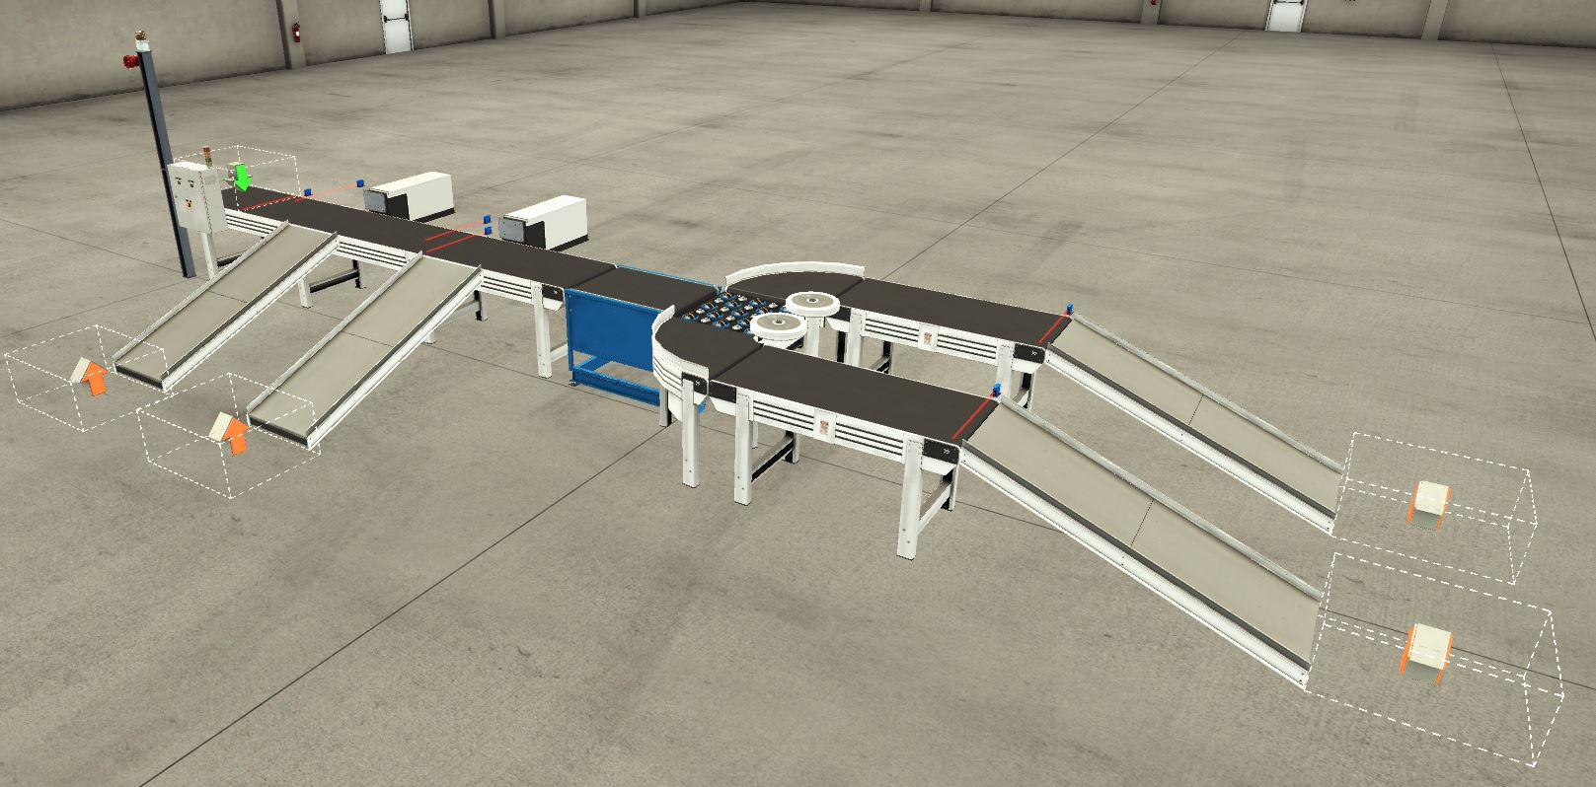
The Factory IO system is made up of three sections, section one is where the large and palletiser boxes are sorted. The second section encompasses the sorting of the small and medium boxes. The last part is the control panel and the alarm system. Each of which is explained in detail in the following sections. The system has been designed to use minimal space while still keeping it neat, tidy and easy to understand where things are and seeing them in operation.
The large green arrow is the infeed system that emits a random assortment of the four types of boxes that are sorted by the system, these being palletiser, small, medium and large boxes. The large orange arrows are package removers, these remove the packages after they have been sorted and counted so that they do not clutter up the space and cause the simulation software to run slowly.
The system is set up so that when activated, not all of the conveyors turn on at once, it is programmed so that it is done in sections so that initial current draw of the system is minimal.

Large and Palletiser Box Sorters
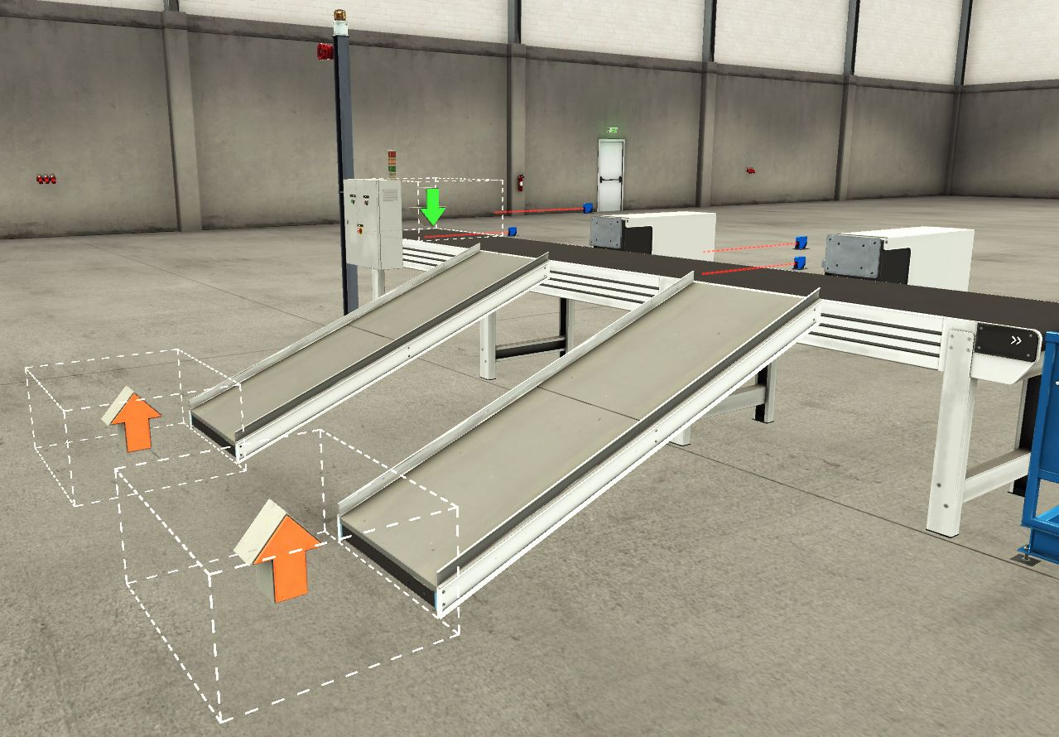
The first step of this part of the system is a sensor next to where the infeed of boxes is, this sensor is for counting the number of boxes entering the conveyor system.
The next sensor is set so that only the large boxes can trigger it, once a large box passes by, the pusher activates and sends it to the large box remover at the bottom of the ramp.
The next step is to distinguish between small, medium and palletiser boxes, as palletiser boxes are very thin, they will only be detected by the lower sensor, the small and medium boxes however, are the same height and will both set off both sensors. This means that when boxes pass by the sensors, the pusher will activate if only the lower sensor is triggered, therefor pushing the palletiser boxes down the ramp to the palletiser box remover.
If both sensors are set off by either small or medium boxes, the boxes will pass by the next section of the system.
Where as the small and medium boxes are counted by sensors at the end of their respective conveyors, the large and palletiser boxes are sorted by detecting when the pusher has extended fully, thus indicating a large or palletiser box has been sent to the removers and increasing their counters.

Small and Medium Box Sorters
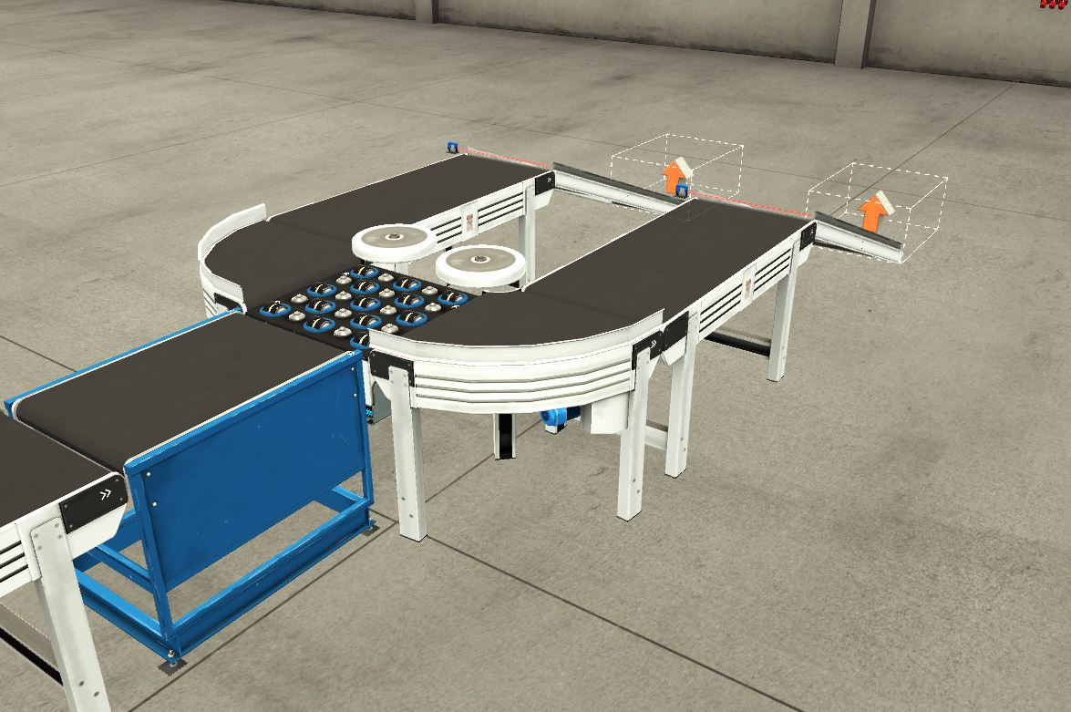
This part of the system is made up of two key parts, the conveyor scales and the pop up wheel sorter. The boxes pass along the conveyor scales and are sorted into small and medium boxes based on the voltage output of the scales, this is determined by the weight of the boxes, small boxes giving an output of less than 4.5V and the medium boxes giving an output of over 4.5V. The pop up wheel sorter activates and moves left or right depending on which box is being sorted, the conveyors for that section activate once the size of the box is known and send them to the removers. The sensors at the end of the conveyors are for counting the number of boxes that pass through them.

Control Panel
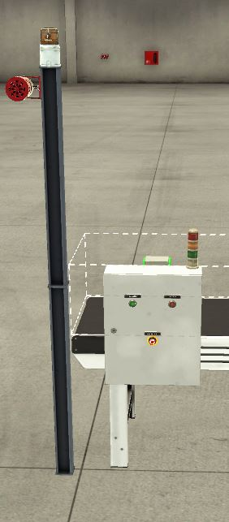
The control panel section is made up of three parts, the actual control panel which has a physical start, stop and emergency stop on it for operator use. Stack lights that show the current state of the system, green meaning the system is active, amber meaning there is a warning present and red meaning that there is an alarm present and the system is halted. The final part is the siren and warning light, which activate when there is a system alarm.

PLC Ladder Program
The PLC program was written using the Siemens TIA V16 software, this works with the Factory IO system using a simulation feature. The program is written in ladder logic which resembles standard electrical drawings and is relatively easy to understand.
When describing the program operation, some abbreviations may be used:
NO: Normally Open
NC: Normally Closed
There are some principles of operation of some of the basic components of the program detailed below:
Normally Open Switch: Only allows the signal to pass through when it is engaged.
Normally Closed Switch: Will only allow the signal to pass through when not activated, will cut off the signal if engaged.
Output: Shown as a set of brackets, these are output bits that when all preceding conditions are met, will be active, these can be either internal memory tags (M bits) or external actuators (Q bits) such as conveyors and pushers.
I bits: these are physical inputs received by the PLC, such as sensors and switches
M bits: These are internal tags that can act as inputs or outputs depending on how they are used, but will only directly have an affect on the conditions within the PLC and not the physical inputs or outputs of the system unless followed or preceded by a physical I or Q tag.
ID bits: These are physical digital inputs, used when a sensor gives a precise reading and isn’t just on or off.
Each network of the program is explained in the following sections.

Start, Stop and E-Stop Circuit Network
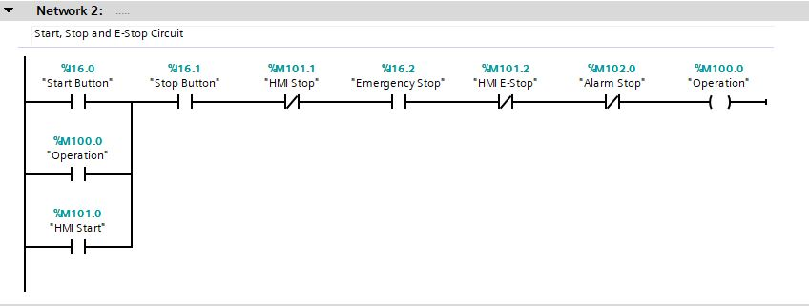
Although this is network 2, this is the first network of the program. Network 1 only contains a block that allows the TIA V16 software to communicate with the Factory IO program. This network is what starts the PLC program, there are 2 start buttons, I16.0 which is the physical start button located on the control panel, M101.0 is the start button located on the HMI screen. There are then five things that stop the circuit running in various cases, these are the physical stop button (I16.1) the HMI stop button (M101.1), the physical E-Stop (I16.2), the HMI E-Stop (M101.2) and the Alarm Stop (M102.0). When all of these are satisfied the Operation output engages and allows the system to run, it is latched on by a normally open gate in parallel with the start buttons as this allows the system to continue running if the start buttons are released.
The physical buttons, such as the start, stop and E-Stop buttons are all shown as normally open gates in the PLC program although physically, the start button is the only one that is actually a normally open contact, the stop and E-stop buttons would be normally closed contacts but this would cause issues in the PLC program if written this way.
The HMI and PLC inputs are all normally closed gates as they are not physical and are engaged unless the input is activated.

Operation Light Circuit Network
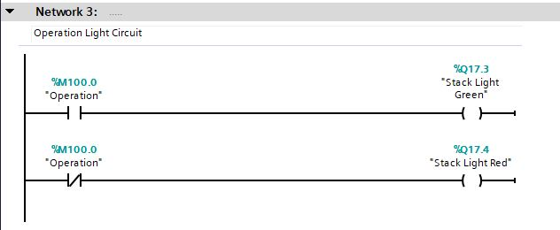
The operation light circuit is very simple, when the system is operating, the NO gate is engaged, the green stack light activates and lights up. When not operating, the NC contact allows the signal to pass, the red stack light output is activated and lights up.

Conveyor 1 Start Network
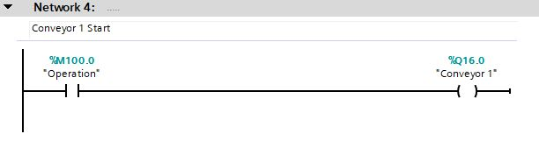
When the system is set to operate, the first conveyor starts automatically as the output is engaged once the operation output is made.

Large Box Pusher
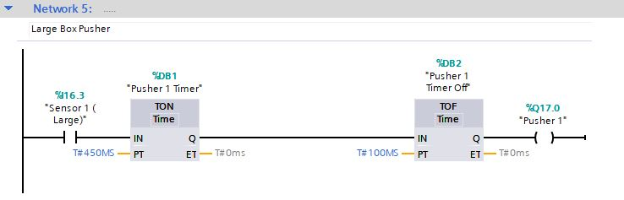
Network 5 controls the pusher for large boxes. As large boxes are the only ones that can activate the sensor, when a large box passes by, the on delay timer activates and pushes the box off the conveyor and into the removal bin once it is central to the actuator. The off delay timer means that the pusher then retracts once it has extended and ready to push another box once activated again. The output Q17.0 is the output tag for the large box pusher.

Palletiser Box Pusher Network
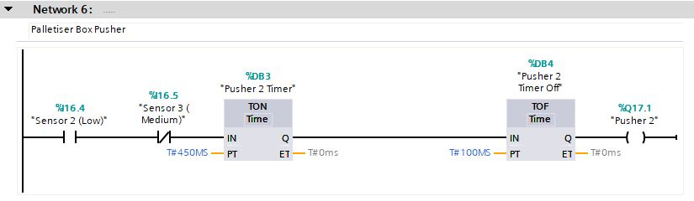
As the palletiser boxes are very thin and will only trigger a sensor that is placed at the lowest point on the conveyor, two sensors mounted one above the other, can be used to determine what kind of box passes, is the low sensor (I16.4) is triggered and the medium sensor (I16.5) isn’t then the NO contact on the low sensor will engage and the NC contact will not, thus allowing the timer network for the pusher to work. The timer network works in the same way as the one for the large boxes.

Scale Conveyor and Wheel Sorter Network
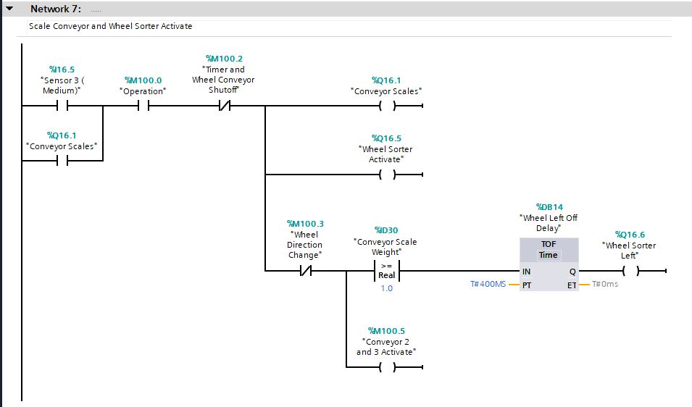
This network determines the activation of the scale conveyor and the wheel sorter, when the medium sensor (I16.5) is activated, this means either a small or medium box, which are the same height, has passed by the sensor. This allows the conveyor and wheel sorter to turn on (Q16.1 and Q16.5 respectively), this starts the conveyor and the wheel sorter will start spinning. Below the activation part of the network is the directional control for the sorter, as long as the direction change contact isn’t engaged and a box is on the conveyor, determined by the comparator block needing a voltage of more than 1 from the scales conveyor. The wheels will then turn to the left to direct small boxes in that direction, until the “wheel left off delay” timer removes the direction change and return the sorter wheels to their default position of straight ahead.
If the wheel direction change contact isn’t engaged then this also activates conveyors 2 and 3 which send the small boxes to their removal bin.

Timer and Wheel Conveyor Shutoff
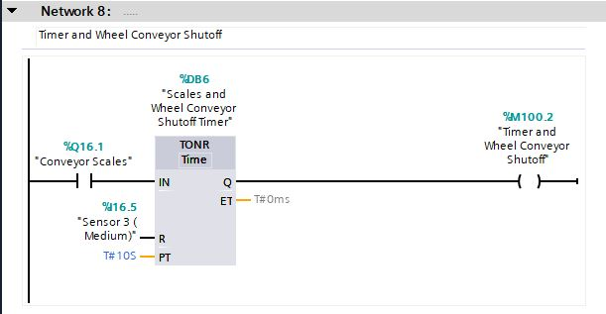
If a medium or small box isn’t detected for 10 seconds, the sorter and conveyor will shut down to save energy until another medium or small box is detected.

Wheel Sorter Direction Change Network
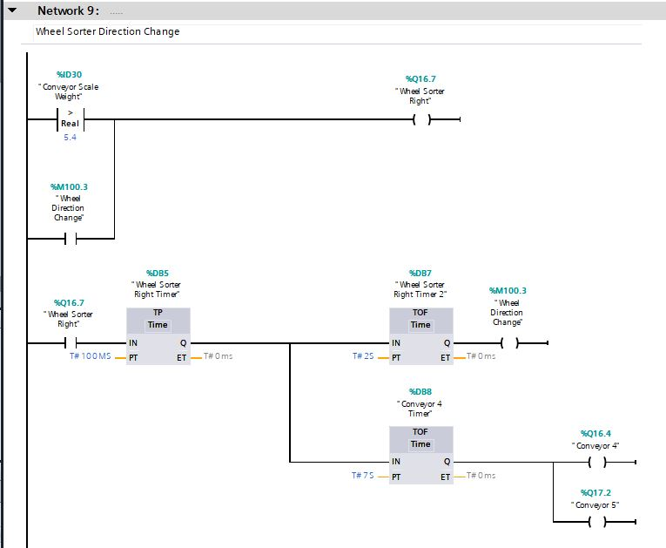
The first part of the network is what determines whether the wheels change to face right for the medium boxes. If the conveyor detects a medium box, a signal of over 5.4V will be seen and this activates the “Wheel sorter right” output. This in turn starts a pulse that sets off two other timers, “Wheel sorter right timer 2” (DB7) sets the “Wheel direction change” output bit, which as seen in network 7, stops the sorter sending boxes to the left, this works for 2 seconds before allowing the sorter to return to its default position ready for the next box. The other timer, “Conveyor 4 time” (DB8), turns on the conveyors that transport the boxes sent to the right, to the medium box removal bin. This timer is set to 7 seconds as it gives the conveyors plenty of time to transport the box to the end before shutting off.

Conveyors 2 and 3 Activate
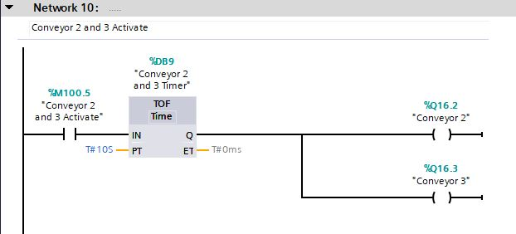
When the small boxes are detected, as seen in network 7, the sorter is set to the left and the conveyors that transport the boxes are activated, they are on a 10 second off delay so that after 10 seconds, if another small box isn’t detected, the conveyors will shut off to save power until reactivated upon the detection of another small box.

Box Counter Network
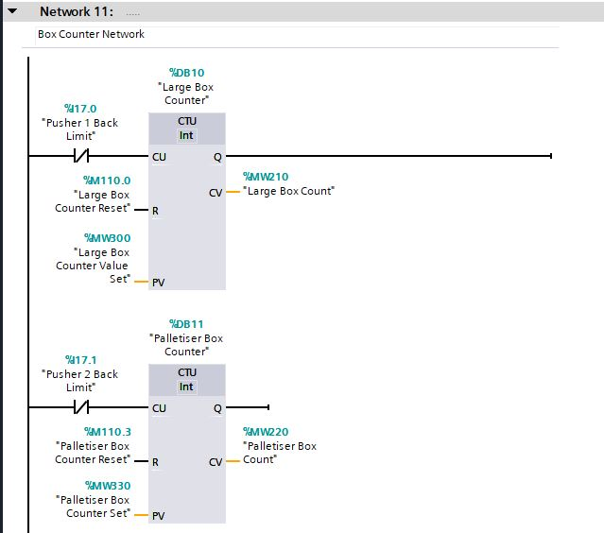
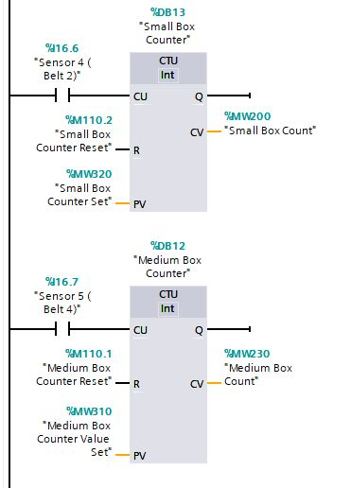
The box counter network is simple in operation, a set stimuli is used to count the boxes that leave the conveyor network. For large and palletiser boxes, the stimuli is when the pusher for each is extended, which sends a positive signal before retracting, and increases the count by 1. The Stimuli for the small and medium boxes are sensors set at the end of each respective conveyor before the boxes go into the removal bins. These sensor will activate when the boxes pass and increase the count by 1 on their respective counters.
Each counter has 5 parts, an input signal (CU) which increases the count when activated, an output (Q) which isn’t used in this example, but otherwise would activate once the limit of the counter is reached. There is a reset (R) which sets the counter back to 0 once activated. A limit set (PV) which indicates the value at which the counter activates its output. The count value output (CV) is the value at which the counter is currently at.
In this network the reset, limit set and the count value are all linked to memory bits or words, which are determined and sent to the HMI system, this allows the reset to be done by the reset button on the HMI, the limit can be set on the HMI as this is not guaranteed to be a set value and can be adapted to the situation, for example, if you wanted to put 10 large boxes per pallet, you can set the value to 10, but this can be changed if you wanted to increase or decrease the number of boxes per pallet etc. The count value memory word is used to in 2 ways, the first is that it is tagged to a HMI tag that allows it to be seen on the HMI so operators can see exactly how many boxes are in each batch, the second is that it is used in a comparator block to allow the fault and alarm system to work as intended. Each value can be set individually from the HMI for each box type.

Counter Fault Network
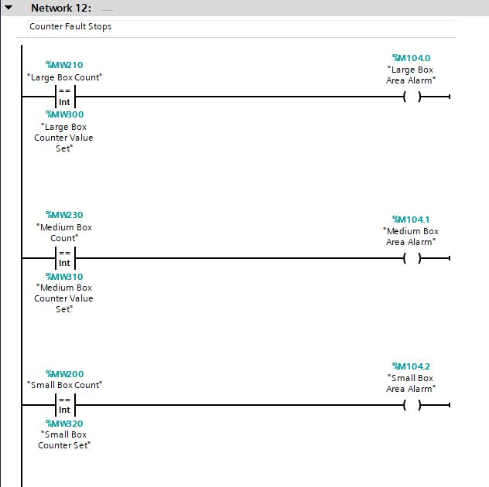
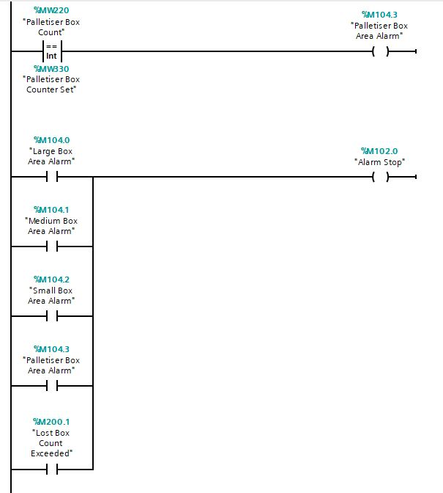
An alarm will be set for each box type if it reaches its limit number, which is set in the HMI. Each comparator block compares the count value and the limit set of each respective box type and when they are the same will cause an alarm to be set.
When either of the alarms for each box type or the “Lost box count exceeded” tags are set, the alarm stop is activated, which will stop the system, this is shown in network 2.

Alarm Light and Siren Network
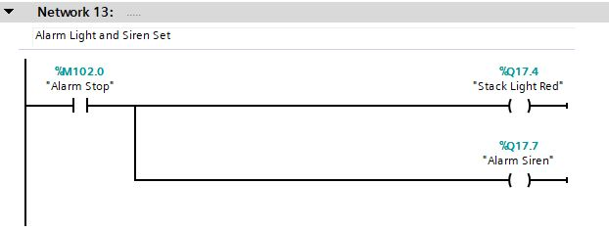
When the “Alarm Stop” tag is set, as well as the system stopping, a siren and the red stack light will light up to indicate to the operators that there is a problem.

Counter Reset Network
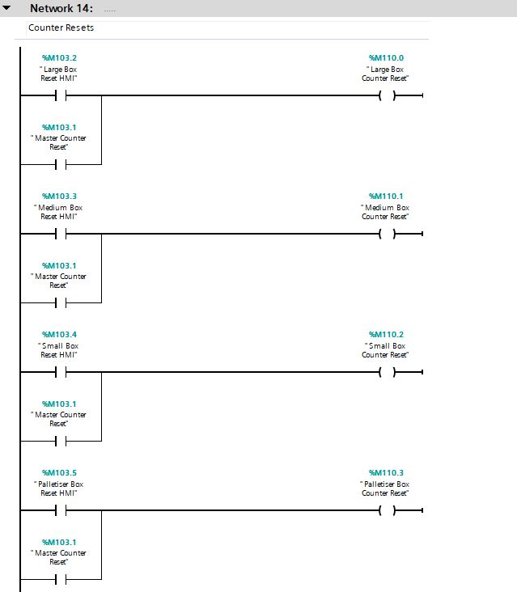
This is the reset network, each counter can be reset individually or via a master reset which will reset all of them. This is because in a real life situation, if you had a full set of boxes in the large removal bin but only a fraction of what would be needed in the small box bin, you wouldn’t want to take away and reset the small box bin.

Warning Network
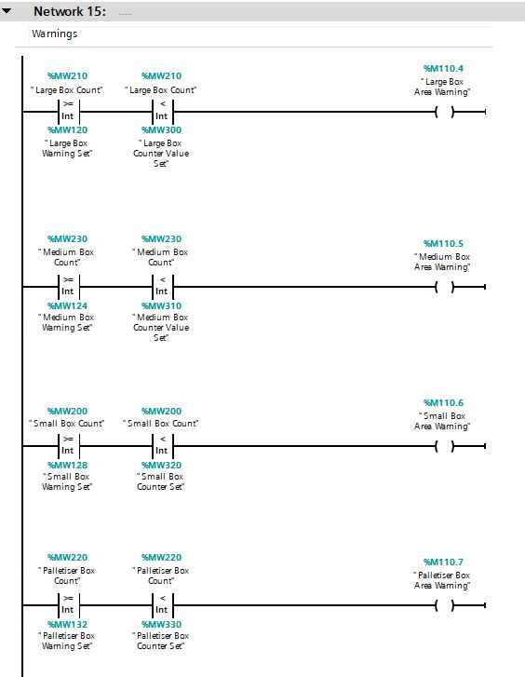
Each box line has a warning and an alarm set up, the alarm set up has already been explained, the warning section is slightly more complicated but essentially works in the same way. The count value of each counter is compared between a greater or equal to block and a less than block, this means that when between the two values, the warning will be set for that line. The comparator block values are set via the HMI, the greater than or equal to comparison value is set by the “…warning set” tag respective to each line, the less than comparator is set with he same tag as the alarm for each line, this is so that when it reaches the alarm stage, the warning for that goes off but the alarm is on instead.
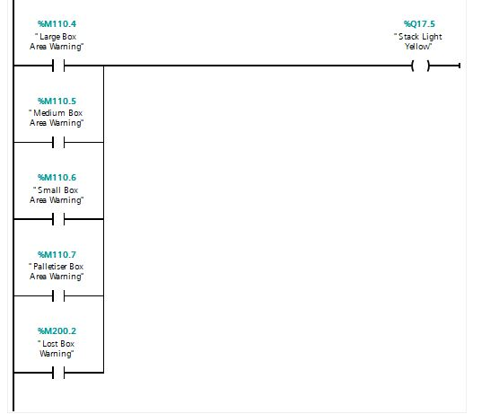
The yellow stack light is set by any of the lines being in a warning state as determined by the counter system above, or the lost box warning input.

Lost Box Network
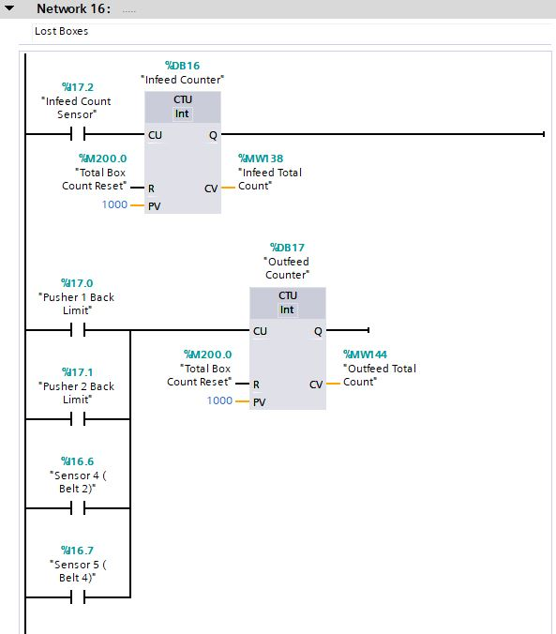
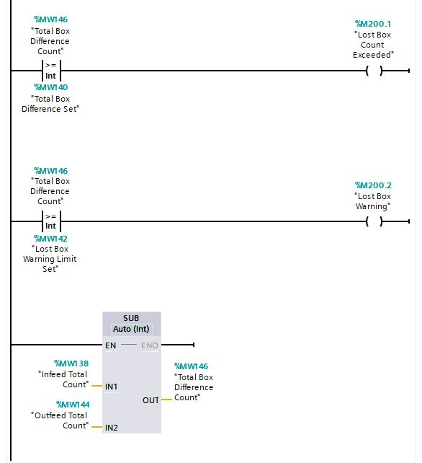
The lost boxes section is relatively straight forward, a sensor is placed right next to the infeed of the system, this counts every box that passes it and increases the counter with each box. A second counter is then activated by any and all of the inputs used to count the boxes leaving each of the lines. A subtraction block is then used to subtract the number of boxes detected leaving the system from the ones entering the system, the count value of that block is then used to compare to two set values that are set in the HMI, these are the “Total box difference count”, which once it has reached and/or exceeded a set value, sets the alarm output. The other is the “Lost box warning limit set” which when it is greater or equal to that value will set the warning output.

HMI Design
The HMI has two distinct screens, the home screen, for use by operators under normal operational circumstances and the engineer screen, for use by engineers for initial set up of the system and when faults and alarms are active.

Home Screen
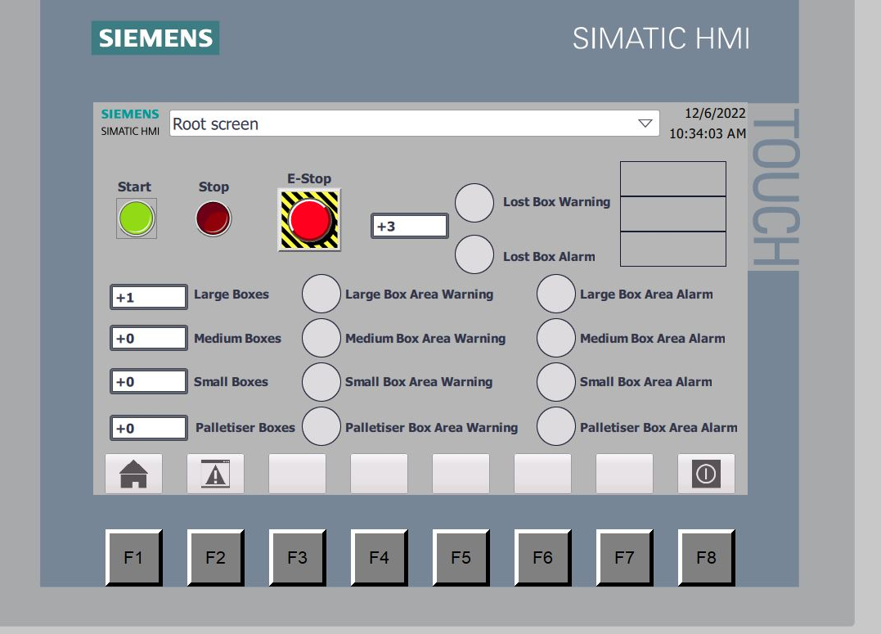
This is the standard home screen, this shows the start, stop and E stop buttons on the HMI and the counts for each box type, it also shows the present warnings and alarms.
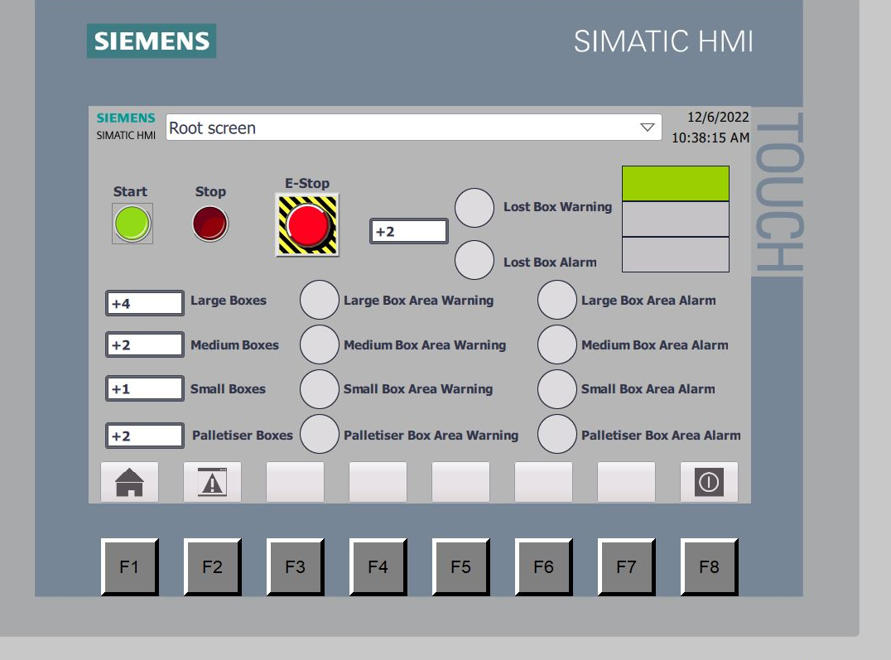
This the home screen under operation conditions, the green stack light replica is visible on the top right of the screen, as well as the counters showing the number of boxes for each section.
The home screen and engineer screens can be swapped between by pressing either F1 or F2 on the screen.

Engineer Screen
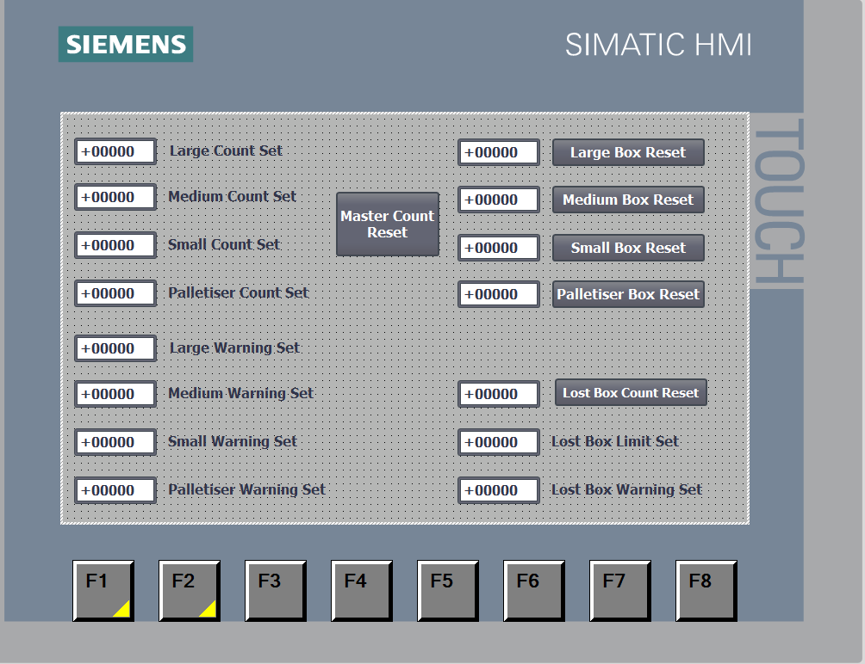
When first starting the PLC program and Factory IO, the engineer screen must be entered and the values for each warning and alarm need to be set and then the master reset pressed, this ensures the system is ready to go.
As can be seen on the engineer screen, the left hand side shows the count limit set values, these are set by pressing on the box and entering the number. The top right of the screen shows the current value of each counter, this will increase as the number of each box increases. Next to each one is an individual reset that will only reset that particular counter, with the lost box counter and set values being in the bottom right of the screen. The limit set being the value that will trigger the alarm and the warning set being what will trigger the warning. The current lost box count value is above those with the individual reset button next to it. The master reset is in the middle of the top of the screen, this will reset all counters in the program.

Fault Screens
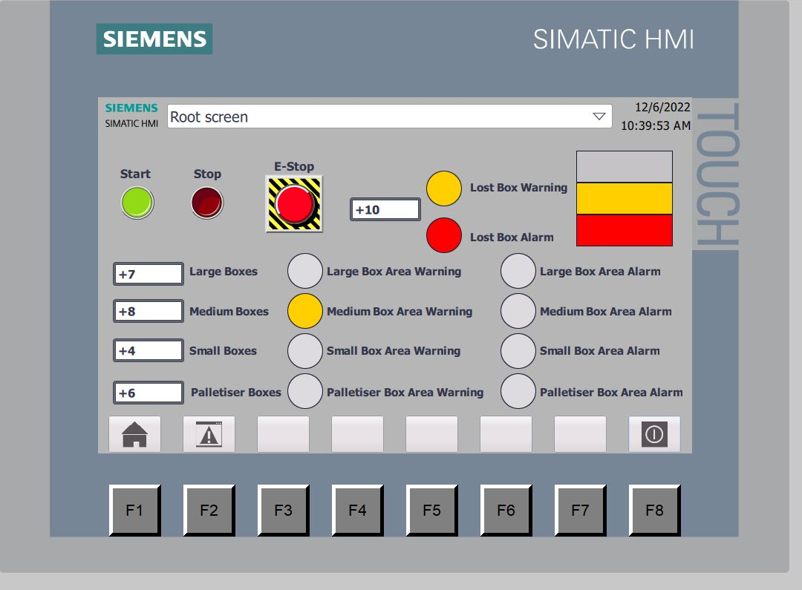
This screen shows both fault and alarm function, the medium boxes have a warning present, in this particular scenario, the warning value was set to greater than or equal to 8 and less than 10. This shows the warning on the screen and the yellow stack light mimic is also lit, which means the actual yellow stack light will also be lit. The missing box alarm is also present, this is due to lost boxes being equal to 10 in this scenario, this means that the system will be stopped until the counter is reset and the system restarted. The red stack light will be lit as well as the mimic light. When stopped, the green stack light is no longer lit, as can be seen.

Warning and Alarm System
The warning and alarm system works as follows:
Each box type is counted when it is deposited in its respective removal bin, when the number of boxes reaches a certain level, the warning light will come on, the number of boxes is determined by the engineer/operator, this will show that the box removal bin is almost at capacity and will soon need to be changed.
An alarm limit is also set, when this value is reached, the system will stop and cannot be restarted until the alarm/counter has been reset by the engineer. This allows the operators to remove the bin for the respective box and place a new one for when the system restarts.
There is also a warning and alarm for lost boxes, the number of boxes that enter and exit the system are counted, if the difference reaches a certain limit, then the warning will trigger, and the alarm will trigger once it has reached the maximum limit, again stopping the system, this allows an investigation to be carried out as to why there are missing boxes and how they are falling off. Both values are set in the engineering screen by the engineer.

Conclusion
The system works as intended in relation to the specification, the HMI contains all relevant features and the capability for the engineer or operator to alter certain parameters such as warning and alarm limits. The system has an alarm and warning system that allows those operating the system to see faults that have occurred and can clear them to allow the system to operate again.
There are a few improvements that could be made to the system if done again, the weighing scale system could be improved if the box stopped on the conveyor, took a weight measurement then moved again. This would give a more accurate weight measurement to allow proper determination of whether the box was small or medium.
The HMI could be improved also by spreading the information over three or four screens instead of the original two, this is because the screens are a little cramped and could be done with a better layout to make it easier to see and understand all the information for the engineer and operator.
Some minor improvements could also be made, such as using extra sensors to count the large and palletiser boxes instead of using the extension of the pusher. This would make it more accurate as the pusher could activate without actually pushing the box into the removal bin.

