ACBA6005 Advanced Building Services and Environmental Design
Building Services Assignment 01

Author: Owen Brown 1901187

Table of Contents
2 List of Figures 2
3 Introduction 3
4 Heating, Ventilation, and Air Conditioning 3
4.1 Serviced Apartment HVAC Requirements 4
4.1.1 Heating 4
4.1.2 Heating Controls 6
4.1.3 Ventilation 6
4.1.4 Air Conditioning 11
4.2 Gymnasium/Spa HVAC Requirements 11
4.2.1 Air Conditioning 11
4.2.2 Heating 12
4.2.3 Ventilation 13
4.2.4 Controls 13
4.3 Summary of Recommendations 13
5 Power and Lighting Systems 14
5.1 Power 14
5.1.1 On-Site Generation 14
5.1.2 Safety 14
5.1.3 Metering and Building Energy Management 15
5.2 Lighting 15
5.2.1 Daylight 15
5.2.2 Artificial Light 16
5.2.3 Lighting Controls 17
5.2.4 Emergency Lighting 18
5.2.5 Accessibility 18
6 Critical Appraisal of the Fabric and Services Recommendations 19
6.1 Building Envelope and Structural Frame 19
6.1.1 The Building Form 19
6.1.2 Airtightness 20
6.1.3 Glazing 21
6.1.4 Structural Frame 22
6.2 Services 22
6.2.1 Electricity 23
6.2.2 HVAC 23
6.2.3 Lighting 23
6.3 Designing for the future 23
7 Conclusion 24
8 References 25

List of Figures
Figure 1. Example of a direct electric panel heater (Glen Dimplex, 2022). 5
Figure 2. Example of key card controls in a hotel room (BRE, 2014). 6
Figure 3. Background ventilation with intermittent extract (Author, 2022). 7
Figure 4. High and low background ventilation to building with single sided facade (Author, 2022). 8
Figure 5. Passive stack ventilation (Author, 2022). 9
Figure 6. Mechanical Ventilation and Heat Recovery (MVHR) (Author, 2022). 10
Figure 7. Cutaway view of MVHR unit (BSRIA, 2017). 10
Figure 8. Variable Air Volume (VAV) air conditioning system (Author, 2022). 12
Figure 9. Angled photovoltaic (PV) array on flat roof (SolarAge, 2020). 14
Figure 10. Building Energy Management System (BEMS) (Chin and Lin, 2016). 15
Figure 11. Accessible switches and socket heights (The Building Regulations, 2010, Approved Document M). 19
Figure 12. Highly insulated cavity and SFS wall (British Board of Agrement, 2021). 21
Figure 13. Horizontal shading to windows (Zheng, 2022). 22

Introduction
The high rise building proposed for St Mary’s Street, Cardiff will comprise of car parking and gymnasium/spa to the basement, retail units near the ground floor, offices on floors 0 to 6, and serviced apartments on floors 7 to 16. This report will evaluate options and make recommendations for the heating, ventilation, and air conditioning system for two of the buildings different uses, critically evaluate and make recommendations for power and lighting systems, and critically appraise the services recommendations along with the fabric choices for the proposed mixed-use building. This report is a continuation of the construction methods and material report produced for ACBA6004. A summary of the recommendations from that report can be seen in table 1 below.

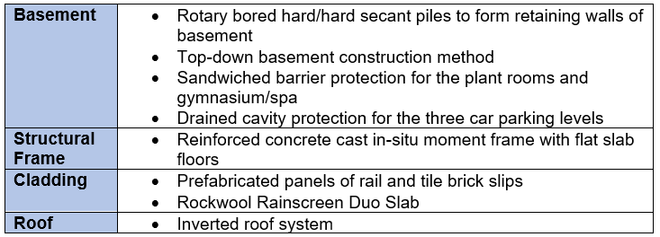
Table 1. Summary of construction methods and material recommendations for the proposed building (Author, 2022).

Heating, Ventilation, and Air Conditioning
The purpose of a Heating, Ventilation, and Air Conditioning (HVAC) system is to create an indoor environment that is acceptable to the building occupants, and this is achieved by:
- Creating a comfortable indoor temperature
- Controlling contaminants from outdoor and indoor sources
- Providing an adequate supply of unpolluted air
- Maintaining acceptable humidity levels
(Chartered Institution of Building Service Engineers (CIBSE), 2016a).

Comfortable indoor temperatures are important because in order for humans to remain healthy, they need to sustain a core body temperature of 37.6ºC, as hypothermia can occur if core temperatures drop to 35ºC, and heat stroke if it rises to 40.5ºC (Evans, 2016). A supply of fresh air that is free from pollutants and contains the correct level of moisture is essential for occupant comfort and health, as is a method of expelling interior contaminants and excessive humidity to maintain a good Indoor Air Quality (IAQ) (McMullan, 2018).

Serviced Apartment HVAC Requirements
HVAC strategies will be discussed in this section, with consideration given to their suitability for the serviced apartments in this building. Recommendations will be given for the most suitable strategies.

Heating
Due to the variable climate of the United Kingdom, heating will be required in the majority of buildings (CIBSE, 2016a). Mains gas boilers are the most common form of heating in England and Wales (Office for National Statistics (ONS), 2021). Gas heating commonly uses a Low Temperature Hot Water (LTHW) heating system, where water is heated by a gas boiler and transported to heat emitters such as radiators via a circulating pump (Hall and Greeno, 2017). The plant room is in the basement and the serviced apartments are on floors 7 to 16 of the proposed building. The Health and Safety Executive (HSE) (2022) classify buildings with at least two residential units as high rise if they have seven or more storeys or are 18m or over. A hot water heating system has been dismissed as CIBSE (2016a) state that the high pressures exerted from serving a number of floors in high rise buildings imposes special requirements on the piped water systems. If gas boilers were installed in the proposed building, they would need to be replaced before the end of their serviceable life, as the Welsh Government plans for no gas boilers to be in use by 2030 (Hayward, 2021).

It is also important to consider sustainable heating sources, with the intention of lowering carbon emissions, when designing any new building. The following alternatives to gas boilers are all low carbon sources of heat:
- Biomass boiler
- Air Source Heat Pump (ASHP)
- Ground Source Heat Pump (GSHP)
(Building Services Research and Information Association (BSRIA), 2017).

However, a biomass boiler that uses wood pellets or chips as fuel would not be suitable for this building because their slow response times will not be compatible with the fluctuating heat demand, and due to a large space being required for fuel delivery and storage they are not suitable for this city centre location (BSRIA, 2017). And it should be noted that air source and ground source heat pumps, that work by absorbing heat from the air or ground into a fluid that is passed through a heat exchanger, increasing the temperature, and transferring it to water that circulates through the system to heat emitters, have high upfront capital costs (Energy Saving Trust (EST), 2022a; EST 2022b).

It is reasonable to suggest that serviced apartments have similar HVAC requirement to hotel and student accommodation rooms. CIBSE (2016a) cite direct electric panel heaters as a suitable alternative to LTHW heating for hotel rooms as long as the heat losses from the building fabric are very low. An energy audit of a highly insulated student accommodation block in London with direct electric panel heating revealed that its carbon emissions had improved on the good practice benchmarks by being 36% lower and had lower capital costs than gas heating (Vadodaria, 2014). The proposed building will have a highly insulated envelope with low air leakage rates (see 6.1.2), which will lessen the required heating demand, as will the installation of Mechanical Ventilation and Heat Recovery (see 4.1.3.4) and phase change materials (see 6.1.4).

The decarbonisation of the mains electrical distribution grid (see 6.2.1) means that direct electric panel heaters are being increasingly specified to provide space heating to new build developments (Glen Dimplex, 2022). Electric panel heaters can be radiant heaters that heat people and objects instead of the air, but these are most useful for spot heating in buildings with high air change rates (CIBSE, 2016b). Due to the low air leakage rates of the proposed building, an electric convector heater would be suitable. This type of heater has an element inside a cabinet with grilles provided at high and low level to induce airflow by natural convection (CIBSE, 2016b).
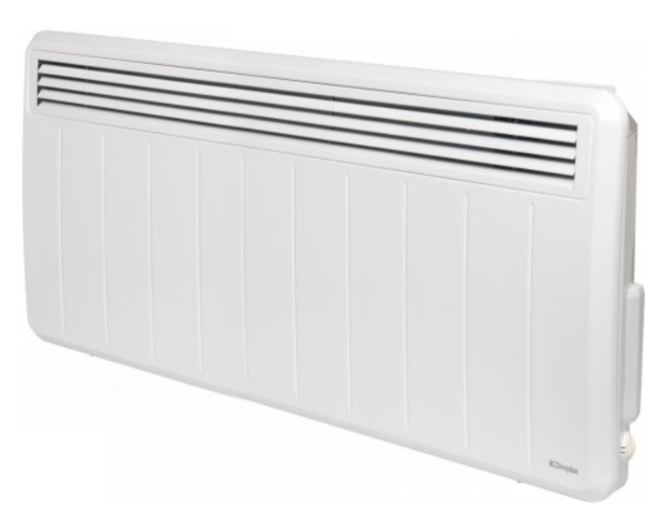
Figure 1. Example of a direct electric panel heater (Glen Dimplex, 2022).
Recommendation 1
Direct electric panel heaters.

Heating Controls
Key controls in the form of a coded card that is also used to gain entry (see figure 2), are typically used in hotel rooms to ensure that energy is not wasted when the room is vacated (Building Research Establishment (BRE), 2014). This would be an effective way to ensure the heating is off when the serviced apartment is not occupied. Energy usage can also be reduced by using a room thermostats, sited away from direct sunlight, to sense the air temperature in a room and switch off the heat emitter when the set temperature is achieved, and switch on when the temperature falls below a set parameter (Hall and Greeno, 2017).

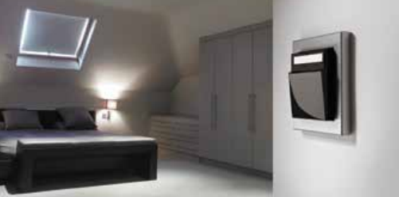
Figure 2. Example of key card controls in a hotel room (BRE, 2014).
Recommendation 2
Key card controls to ensure heating is off when room is vacated.
Recommendation 3
Room thermostats to reduce energy use and keep heating to set parameters.

Ventilation
Ventilation falls into two categories, uncontrolled ventilation from unintended gaps in the building fabric where air can infiltrate, and controlled ventilation via natural or mechanical means that has been purposely provided (Evans, 2015). Uncontrolled ventilation can result in 15% heat losses and should be minimised wherever possible to avoid negative effects on thermal comfort, possible unintended consequences, and increased carbon emissions (Pelsmakers, 2015).

To comply with the requirements of the Building Regulations (2010) Approved Document F:
- Extract ventilation must be provided to kitchen, bathroom, and utility room
- Fresh air must be supplied to all habitable rooms at a rate not under 0.3l/s per m2 of total internal floor area
- Each habitable room must have a method of purging air to the outside at a rate of 4 air changes each hour. If this is not practicable via an openable window or door, then mechanical extract must be used.
These requirements can be met via:
- Background ventilation with intermittent extract
- A passive stack
- Continuous mechanical ventilation (extract only)
- Mechanical ventilation (supply and extract) with heat recovery (MVHR)
(Evans, 2015).

Background ventilation with intermittent extract
In this system Intermittent extractors in a kitchen are required to have a minimum extract rate of 30l/s if next to a hob, or 60l/s if elsewhere, and in a bathroom a minimum rate of 15l/s (Evans, 2015). Background ventilation is usually provided by trickle ventilators in windows, and 5000mm² minimum is required for each habitable room, and 2500mm² for each wet room (Hall and Greeno, 2017). Purge ventilation is usually provided by openable windows. The Air in Cardiff has high levels of PM_{2.5} fine particulate matter, and in 2021 had higher levels of this matter than London (Withers, 2021). This system has been dismissed due to the need for unfiltered outside air for background and purge ventilation. Figure 3 shows a simplified diagram of this system to a house. When using this system for serviced apartments, it is likely that the ductwork run through a suspended ceiling.

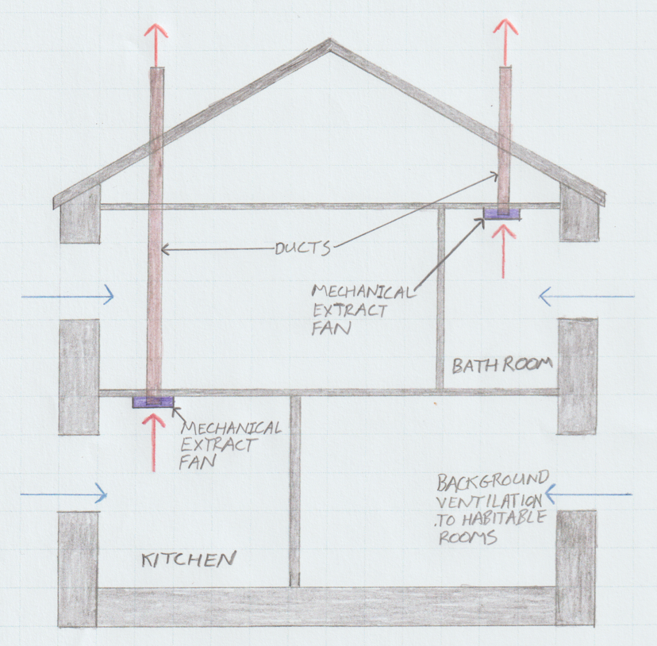
Figure 3. Background ventilation with intermittent extract (Author, 2022).

It is likely that the serviced apartment may have a single sided façade, in which case the building regulations (2010) Approved Document F requires background ventilation to be at high and low levels to promote air flow (see figure 4).

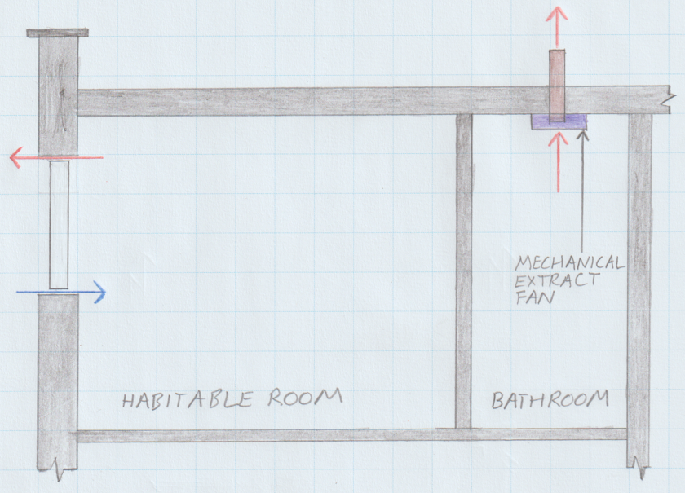
Figure 4. High and low background ventilation to building with single sided facade (Author, 2022).

Continuous mechanical ventilation (extract only)
This system is similar to background ventilation with intermittent extract but requires continuous mechanical extract of 13l/s to kitchens and 8l/s to bathrooms and background ventilation of 2500mm² to all rooms without extraction and all internal doors to have an undercut of 7600mm² to allow for air transfer (Building Regulations, 2010, Approved document F). This system has also been dismissed due to outside air quality concerns.

Passive stack Ventilation
Passive stack ventilation (PSV) also uses background ventilation, but relies on the natural buoyancy of warmer air, and the wind blowing across the top of the stack to create a venturi effect to extract (McMullan, 2018). PSV stack does not require any additional energy but has been dismissed as it is most effective on buildings no greater than four storeys (Hall and Greeno, 2017). Figure 5 shows a simplified diagram of this system to a house.

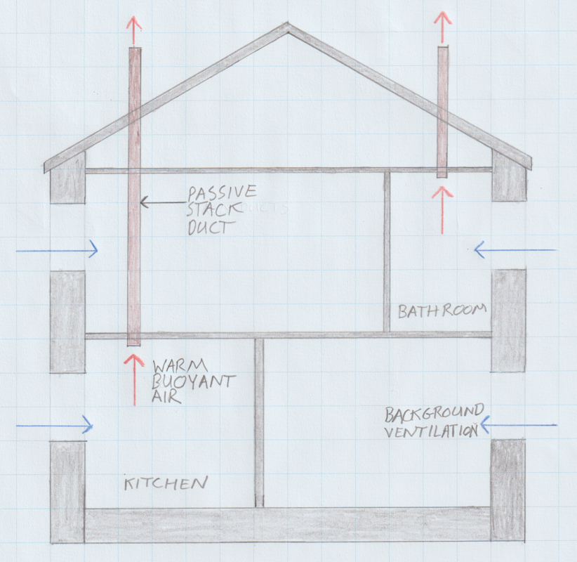
Figure 5. Passive stack ventilation (Author, 2022).

Mechanical ventilation (supply and extract) with heat recovery (MVHR)
To maintain good IAQ, hotels commonly use a system that continuously supplies air to bedrooms and continuously extracts from bathrooms (CIBSE, 2016a). Mechanical supply and extract ventilation that incorporates heat recovery saves energy and carbon by ensuring that the heat in the extracted air is not wasted (EnviroVent, 2019). With this system it is possible to recover 90% of the heat from the extracted air, which is exchanged to the inlet duct to warm the supply air, and whilst these systems are predominantly used for heat recovery, they can also be used to recover cooling when indoor temperatures are cooler than outdoor (CIBSE, 2016c). Ideally the system should automatically bypass the heat exchanger when internal temperatures dictate that heat recovery is not required (EnviroVent, 2019). An undercut of 7600mm² to all internal doors is required to allow air transfer (Evans, 2015). This system negates the need for background ventilation (Hall and Greeno, 2017). And can be specified with a boost function to satisfy the purge requirements of the building regulations (Hodkinson, 2022). Figure 6 shows a simplified diagram of a MVHR system in a house. When using this system for serviced apartments, it is likely that the MVHR unit will be inside a service cupboard and the ductwork run through a suspended ceiling.

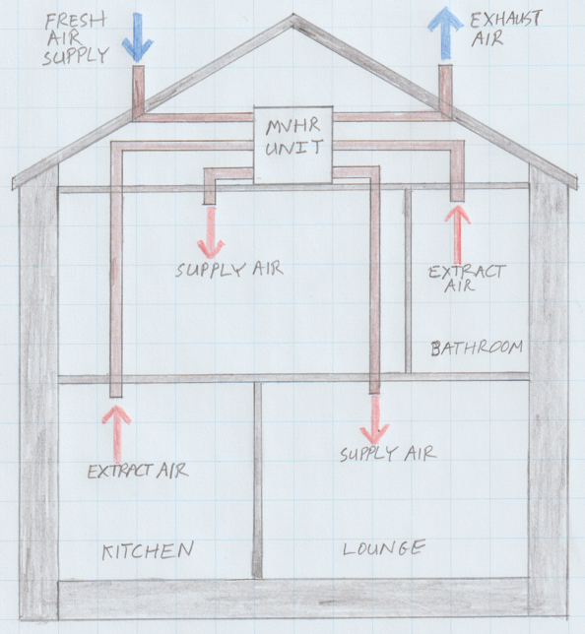
Figure 6. Mechanical Ventilation and Heat Recovery (MVHR) (Author, 2022).

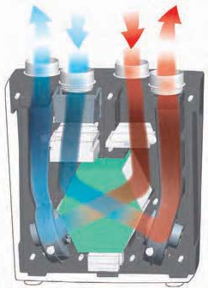
For the above reasons, this is the recommended ventilation system for the serviced apartments. It should be noted that an appropriate filter will be required on the inlet duct to ensure that the high levels of fine particulate matter in the outside air do not enter the apartments. An appropriately sized unit is required to each apartment over a centralised unit, as each apartment will have differing requirements depending on occupancy, activity levels, and orientation. A cutaway view of an MVHR unit is shown in figure 7 to illustrate how the heat is exchanged inside.
Figure 7. Cutaway view of MVHR unit (BSRIA, 2017).

Recommendation 4
Localised mechanical supply and extract ventilation with heat recovery.

Air Conditioning
True air-conditioning systems fully control the cleanliness, freshness, temperature, and humidity of the air but in the UK the term is commonly used to describe a comfort cooling system that does not control humidity (BSRIA, 2017). The need for air conditioning in the UK is rare, and passive cooling measures should always be deployed first as air conditioning can vastly increase operational carbon and costs, and the heat dumping from numerous units can increase urban temperatures (Pelsmakers, 2015). As the building will be highly insulated, have controllable ventilation, and employ passive shading measures, it is recommended that air conditioning or comfort cooling is not required for the serviced apartments.

Gymnasium/Spa HVAC Requirements
HVAC strategies will be discussed in this section, with consideration given to their suitability for the gymnasium and spa in this building. Recommendations will be given for the most suitable strategies.

This facility will be located on the first basement floor (adjacent to the plant room) and will not have any windows or background ventilation but will benefit from the high thermal mass of the concrete frame and the earth surrounding the perimeter wall. The HVAC system for the gymnasium/spa must be able to cope with rapidly changing occupancy and activity levels, the high heat and moisture gains from physical activities, and will need to be able to be zoned to suit the different needs of the facility (CIBSE, 2016a).

Air Conditioning
There are many different types of air conditioning systems. An overview of the systems listing their advantages and disadvantages is provided in table 2 below.

System  Type | System Performance |  |  |  |  | Space Requirements
System  Type | Control | Noise Level | Air Distribution | Energy Efficiency | Maintenance  Costs | Plant Room | Occupied Area | Ductwork
Constant  Volume | Good but limited | Low | Very good | Good to average | Low to Average | High | None | High
Variable Air Volume | Good but complex | Low | Very good | Very good | Average to high | High | None | High
Fan Coil  Units | Good | Can be high | Fair to good | Average | High | Low | None or moderate | Moderate
Chilled Beams | Good | None | Uses  Ventilation | Very good | Low to Average | Low | None | None
Chilled  Ceilings | Good | None | Uses  Ventilation | Very good | Average to high | Low | None | None
Displacement  Ventilation | Good | Very low or none | Good | Very good | Average to high | Low | None or moderate | Moderate
Room-based  Heat Pumps | Very good | Can be high | Good | Very good | Average to high | Low | None or moderate | None
Split  Systems | Local only | High | Poor | Poor | Average to high | Low | None or moderate | None
Variable  Refrigerant | Good | Can be high | Fair | Good to average | Average to high | Low | None or moderate | None
Table 2. Overview of air conditioning systems (BSRIA, 2017).
A Variable Air Volume (VAV) air-conditioning system is suitable for multiple zones that have different cooling demands, has low noise levels, very good air distribution, and very good energy efficiency (BSRIA, 2017). The system uses an Air Handling Unit (AHU) located in a plant room to cool (when required) and condition the supply air, ductwork to transport the chilled air to the required area, and a terminal unit with a thermostatically controlled damper to control the amount of cold air (Hall and Greeno, 2017). The damper never closes below the amount calculated to maintain the required amount of fresh air (BSRIA, 2017). A simplified diagram of a basic VAV system to a single zone is shown in figure 8. Ductwork would normally supply multiple zones and each terminal unit would be after a tee in the main ductwork.

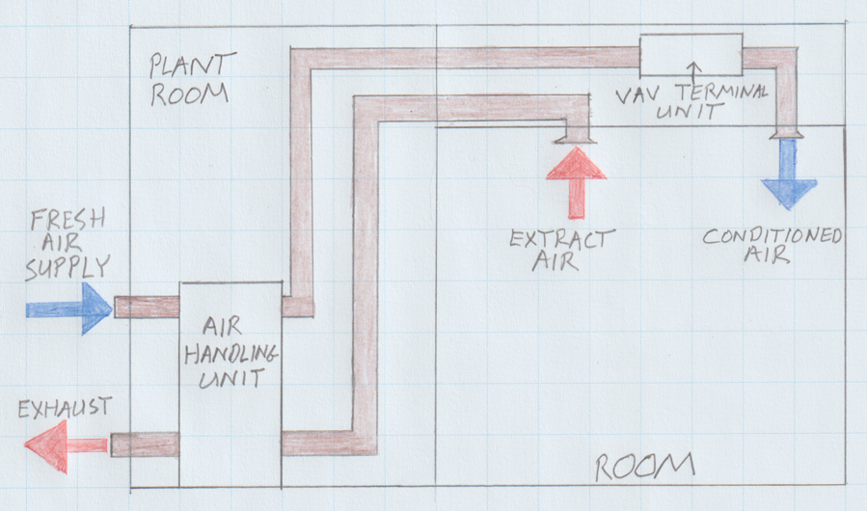
Figure 8. Variable Air Volume (VAV) air conditioning system (Author, 2022).

Recommendation 5
Variable Air Volume (VAV) air conditioning system.

Heating
Many buildings using VAV have convectors or radiators positioned to the cooler perimeter walls to satisfy their heating demand, but heating units can be incorporated into the VAV terminal units (BSRIA, 2017).

Heaters in the terminal units are the recommended option for the gymnasium/spa because of the fast response times and because the facility does not have exposed perimeter walls or windows.

Recommendation 6
Heaters in VAV terminal units.

Ventilation
Effective ventilation is critical in the gymnasium to remove users metabolic heat gains and associated humidity and body odour (CIBSE, 2016a). A VAV system
incorporates a variable speed extract fan within the AHU which extracts air from the required areas via ductwork (BSRIA, 2017).

Recommendation 7
Supply air via VAV air conditioning. Extract air via VAV air handling unit.

Controls
Room thermostats (see 4.1.2) to sense the room temperature and communicate with the system to supply only the required amount of heating or cooling would minimise energy consumption. Time controls such as time switches enable plant to be switched on and off at appropriate times to match occupancy patterns (BSRIA, 2017). As it is expected that this facility will be unoccupied for timetabled periods, time switches are recommended to ensure energy is not wasted when the facility is not occupied.

Recommendation 8
Time controls to match occupancy patterns.

Summary of Recommendations
Serviced Apartments
Heating | Direct electric panel heaters
Heating Controls | Key card controls
Heating Controls | Room thermostat
Ventilation | Localised MHVR
Air Conditioning | Not required
Gymnasium/Spa
Air Conditioning | Variable Air Volume (VAV)
Heating | Heaters in VAV terminal units
Ventilation | Supply air via VAV air conditioning. Extract air via VAV air handling unit.
Controls | Time controls
 | Room thermostats

Power and Lighting Systems

Power
The main power source proposed for the building is mains grid electricity that will be supplemented by a source of on-site generation (see 5.11). The sustainability of mains electricity is discussed in 6.2.1.

On-Site Generation
The proposed building has a large flat inverted roof which provides an opportunity for on-site generation via solar photovoltaic (PV) panels grouped into angled arrays to capture the maximum amount of sunlight. Although PV does not require sun to work as it is natural light that is converted into a viable source of electrical energy (Hall and Greeno, 2017). PV works best in unshaded areas that face within 10º of south, and the panels should be set at a 34º to 40º tilt angle and kept clean to achieve the best annual electricity production (Pelsmakers, 2014). If the electricity generated from the PV exceeds the buildings demand, the additional electricity can be stored in rechargeable batteries for times when the demand is higher than production, or if the system is grid connected can be exported back to the electricity grid and potentially generate revenue (BSRIA, 2014).

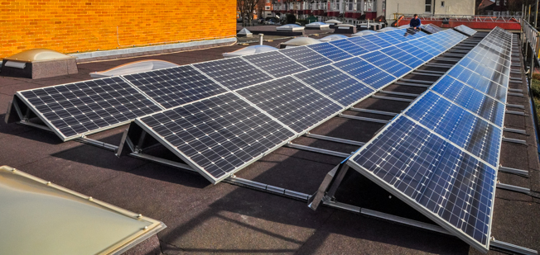
Figure 9. Angled photovoltaic (PV) array on flat roof (SolarAge, 2020).

Safety
New first and second fix electrical installations in the UK must be installed, commissioned, and tested in compliance with the 18th Edition of the Institution of Engineering and Technology (IET) Wiring Regulations contained in BS 7671:2018+A2:2022 (IET, 2022a). All circuits will need protection from overcurrent and short circuit faults which can be provided by fuses or circuit breakers, and protection from earth faults which is provided by earth conductors and supplementary earth bonding (BSRIA, 2014). All installed electrical equipment will need to have an Ingress Protection (IP) rating suitable for the environment where it is located (IET, 2022b). Electrical installations must be tested at regular intervals (normally every 5 years but can be more frequent) to ensure the safety of the system by a competent person following the procedures in BS 7671 (BSRIA, 2014).

Metering and Building Energy Management
It is important that all energy uses are calculated before a project commences as unregulated plug loads are often not properly considered at design stage and can be as much as 50% of a buildings operational energy (LETI, 2020). As well as the utility or tariff meter supplied by the energy company, it is essential that privately owned sub-meters are installed in new buildings on specific end uses such as plug loads, heating, lighting etc to highlight where energy use is high and where there may be opportunities for improvement (BSRIA, 2014). The Building Regulations (2010) Approved document L2A requires automatic data collection and meter reading facilities. Installing wireless meters and sensors that have two-way communication with the internet to measure and control building services is quick and unintrusive, can result in 30% energy savings, and achieve payback in under 18 months (Thorpe, 2014). Once the meters and sensors are installed, a Building Energy Management System (BEMS) (see figure 10) can be installed, which is a computerised system that monitors, controls, and optimises the mechanical and electrical services to create comfortable environments when occupied but ensure no energy is wasted (Thorpe, 2014). Cardiff Metropolitan University implemented automatic monitoring and targeting of energy use in 2018 and have been able to reduce their carbon footprint whilst making gas and electricity savings that equate to £1m over a five-year period (Carbon Trust, 2014).

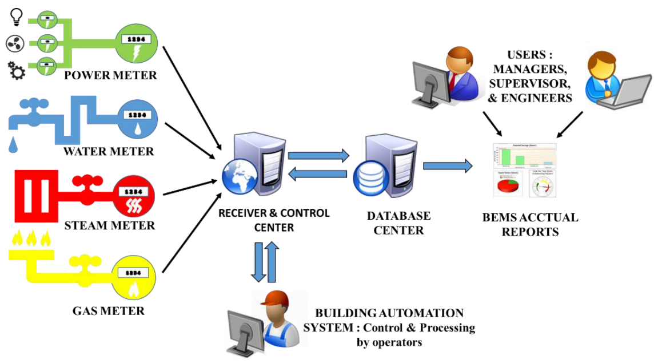
Figure 10. Building Energy Management System (BEMS) (Chin and Lin, 2016).

Lighting

Daylight
Daylight has beneficial psychological and physiological properties, and when utilised correctly is a financially and carbon free light source that can provide spaces with lighting that offers excellent colour rendering and user comfort (Carbon Trust, 2017). Windows have the additional benefit of providing a visual connection to outside which can relieve the tiredness associated with being inside for long periods during the day (British Standards Institution, 2018). However too much glazing can create an overheating risk. LETI (2020) recommends commercial offices have 25-40% of wall area as windows to all elevations, and that large scale housing has 10-15% on east and west elevations, 10-20% on north elevations, and 20-25% on south elevations in order to balance daylight with overheating risk.

Artificial Light
Artificial lighting requires a power supply, a luminaire (light fitting), and a lamp (Bulb or tube) (BSRIA, 2014). Historically, lamps have been incandescent, meaning that a filament is heated to a temperature where it glows, or discharge lamps where a gas or vapour has electric current passed through and a luminous arc is formed between electrodes to give off light (McMullan, 2018). Whilst existing buildings may still have these legacy forms of lighting in place, new constructions should always consider Light Emitting Diodes (LED) as first choice (Carbon Trust, 2017). LED’s rely on the process of electroluminescence from a DC voltage exciting an active semiconductor layer to produce light (McMullan, 2018). LED’s have the longest lamp life (typically 25,000-75,000+ hours) and highest efficacy of all commonly used lamp types and provide instant light that is simple to control (Carbon Trust, 2017).

It is essential that lighting is well designed as poor lighting can cause eyestrain and associated symptoms such as eye irritation, breakdown of vision, headaches, and fatigue, and in the workplace can cause musculoskeletal issues from adjusting position to get closer to tasks or block out reflections etc (Health and Safety Executive (HSE), 1997). The above issues can be alleviated by ensuring that the correct illuminance (measured in lux) level appropriate for the area or task is achieved. Luminous flux (measured in lumens) is the amount of light that a lamp (bulb or tube) produces, and illuminance (lux) is the amount of light that falls on an area, calculated as 1 lux = 1 lumen per m² (Carbon Trust, 2017). An example of required illuminance levels for different areas and activities is shown in table 3. The proposed building will also need to be designed to prevent excessive daylight from windows and ensure that appropriate luminaires are correctly positioned to prevent contrasts in illuminance that create discomfort or disability glare (Carbon Trust, 2017). A light loss factor must also be calculated as part of the lighting design that considers the losses from the lamp output declining over time, dirt on the luminaire reducing output, and the room surfaces becoming less reflective over time (McMullan, 2018).
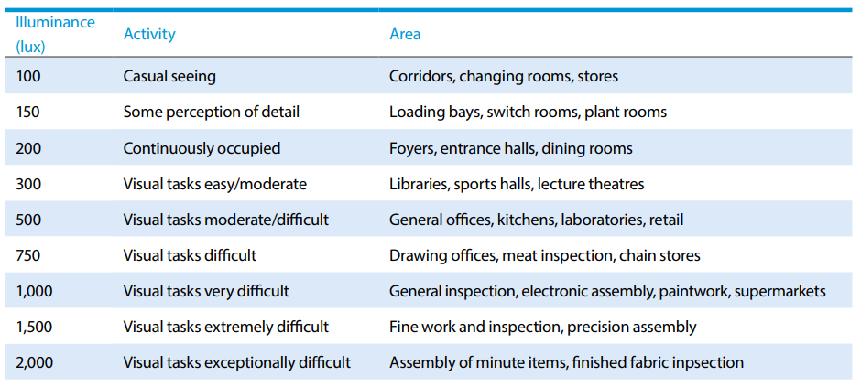
Table 3. Required illuminance levels (Carbon Trust, 2017).

Lighting Controls
Lighting controls are essential to manage the lighting use of a building and ensure that the correct lighting is applied to the correct space at the correct time, and to ensure that no energy is wasted from lighting being left on when spaces are unoccupied (Carbon Trust, 2017). Appropriate controls should be part of every lighting design, and when deployed correctly, typically yield energy savings of 30-40% or even more in certain circumstances (BRE, 2014).

Lighting controls can be:
- Manually controlled – switching or dimming by the occupant.
- Time controlled – automatic on and off switching at set times, or automatic off switching after a set period.
- Occupancy controlled – presence detection.
- Daylight linked controlled – switched or dimmed in response to daylight levels.
(BRE, 2014).

Manual Controls
These are usually in the form of switches but are becoming more flexible with increasing use of wireless controls operated by Bluetooth, WiFi, infrared, or radio frequency transmitters, or via a computer (BRE, 2014). The key card control system described in 4.1.2 is a form of manual control and is an effective way to ensure that lights are not accidentally left on in serviced apartments and lesser used areas of a building such as plant rooms and storerooms (BRE, 2014).

Time Controls
Time controls are an effective way of ensuring lighting is not left on when the space is unoccupied and works well in spaces that operate to timetabled hours, such as schools, supermarkets, and leisure centres (BRE, 2014).

Occupancy Controls
Presence detection controls automatically switch the lighting on when movement is sensed, and off when the detection area is vacated (Carbon Trust, 2017). This type of control is effective in spaces that do not receive natural daylight such as internal stairwells, storerooms, or toilets, and are also suit to areas where people are carry things and do not have a free hand to operate switches (BSRIA, 2014).

Daylight linked controls
These controls use sensors to measure the amount of daylight illumination internally and switch the artificial lighting on or off, or dim accordingly, and can also be used on outside lighting (Thorpe, 2014).

Examples of appropriate controls for spaces is given in table 4 below.

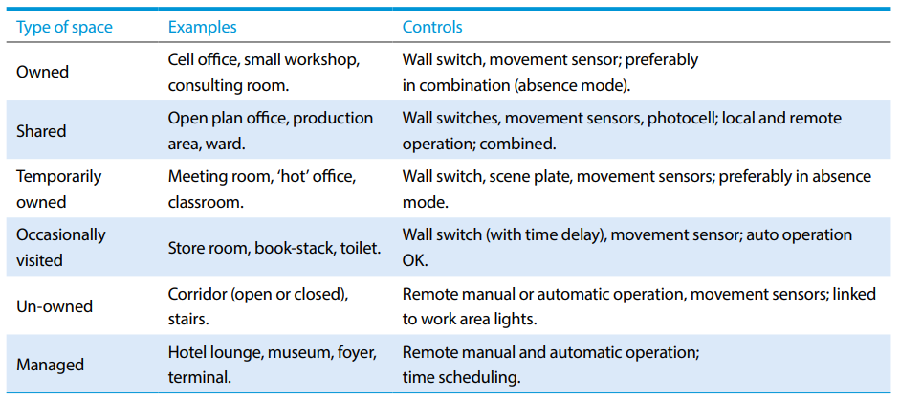
Table 4. Appropriate lighting controls for spaces (Carbon Trust, 2017).

Emergency Lighting
Emergency lighting illuminates, or remains illuminated, in the event of a power failure to the regular lighting of occupied areas, and in order to identify escape routes, direction and emergency exit signs must be used and kept illuminated through integral or external lighting sources (BSRIA, 2014). For escape routes with widths of 2m or under, 1 lux must be maintained along the centre line of the route and 0.5 lux to the central 50% of the width (BSI, 2013). Emergency lighting needs testing at regular intervals to ensure that in the event of a power failure it is working (HSE, 1997). A short test of all emergency luminaires and signs is required monthly, and a long test to ensure lights remain on for the specified time required by the relevant British Standard (BSI, 2004). This specified for most commercial premises is three hours, and this is also the case in blocks of flats or maisonettes for the common access routes only (BSI, 2016).

Accessibility
All switches and sockets within the habitable rooms of the building must be accessible should be located at suitable heights (see figure 11) to ensure they can be reached by persons with limited reach (Building Regulations, 2010, Approved Document M).

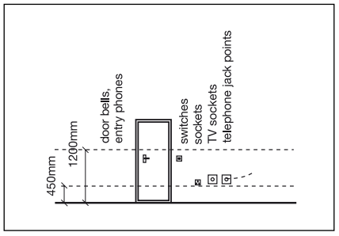
Figure 11. Accessible switches and socket heights (The Building Regulations, 2010, Approved Document M).

Critical Appraisal of the Fabric and Services Recommendations
Building fabric and services should work together as part of an integrated design, as a well-designed envelope will modify the climate and reduces the need for services as they are only required to moderately enhance conditions internally (CIBSE, 2012).

Building Envelope and Structural Frame
The main functions of a building envelope are to:
- In winter: diminish uncontrolled ventilation, minimise fabric heat losses, and maximise beneficial internal and solar heat gains.
- In summer: reduce solar heat gains to avoid overheating.
- Provide natural ventilation (if external conditions allow).
- Provide optimum daylighting.
(CIBSE, 2012).

The Building Form
Because the proposed building is a large and high rise, it will have a low form factor. The form factor of a building can be calculated by dividing the exposed external area by the internal floor area, and buildings with a low form factor such as apartment blocks will have lower winter heat losses and a lower energy demand (see table 5) (LETI, 2020).

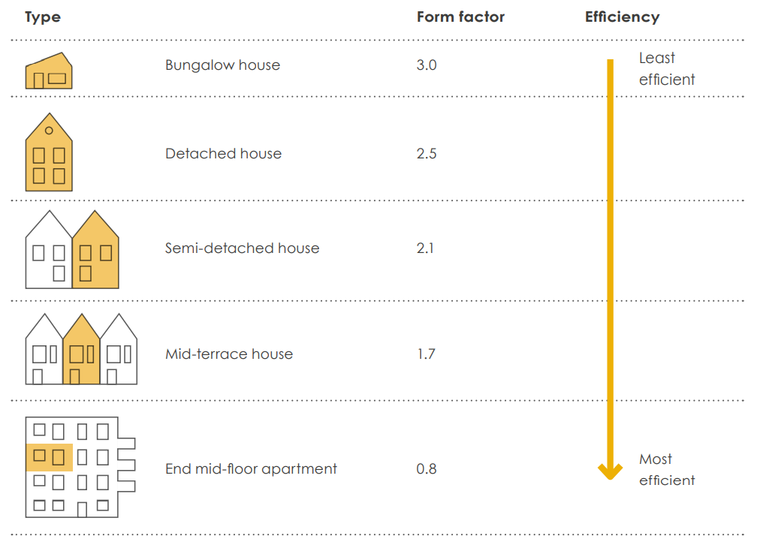
Table 5. Building form factor (LETI, 2020).

Airtightness
The proposed building will require high levels of airtightness to minimise heating and cooling demand and to ensure that the designed thermal resistance of the envelope is achieved (Smith and Gorse, 2021). The recommended brick slip cladding system utilising stone wool cavity insulation and stone wool insulation to the Structural Steel Framing System (SFS) (see figure 12) will provide high levels of airtightness if installed correctly. The recommended flat slab floors and square perimeter columns provide simple edge details which are easy to seal, giving them a low failure risk (The Concrete Centre, 2020). Regular inspection of the envelope installation is recommended to ensure there are no avoidable thermal bridges or gaps that would allow thermal bypassing, as there is currently a skills and knowledge gap within the construction industry, resulting in a performance gap that can cause buildings to use 40% more energy than predicted by building compliance tools at design stage (LETI, 2020).

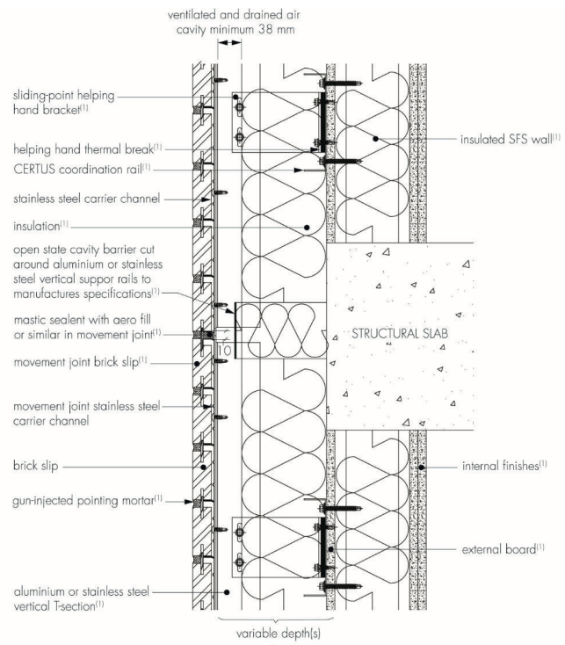
Figure 12. Highly insulated cavity and SFS wall (British Board of Agrement, 2021).

Glazing
Using the window to wall ratios discussed in 5.2.1 is the best way to reduce heat loss and ensure beneficial solar gain in winter, provide optimum levels of natural light, and reduce the risk of excessive solar gain in summertime (LETI, 2020). The south facing elevation will be at most risk of summer overheating through glazing, but this can be further reduced by implementing mitigation measures such as designing deeper reveals to this elevation or specifying windows with interstitial blinds built in as these are more effective than internal blinds (Bradley and Bloxham, 2020). Horizontal shading (see figure 13) is also effective and relatively simple to incorporate on this elevation and will reduce solar gains in the summer when the sun is higher whilst allowing additional daylight and beneficial solar gains in the winter when the sun is lower (Pelsmakers, 2022).

Triple glazing is often used on low carbon buildings for the following reasons. The external walls of a newly constructed dwellings must achieve or better a U-value of 0.21 W/m².K, and the windows must achieve or better 1.6 W/m².K (Building Regulations, 2010, Approved Document L1A). And the walls of new buildings other than dwellings must achieve or better a U-value of 0.35 W/m².K, and the windows must achieve or better 2.2 W/m².K (Building Regulations, 2010, Approved Document L2A). High performing commercial double glazed windows that advertise U-values of 1.31 W/m².K are available (Ideal Combi, 2022). However, this is still far from the U-value of the wall and represents a weak point in the envelopes thermally efficiency, but this disparity can be reduced by installing triple glazed windows which typically have U-values around 0.8 W/m².K, and the additional layer of glazing also increases the windows acoustic performance (Brinkley, 2020).

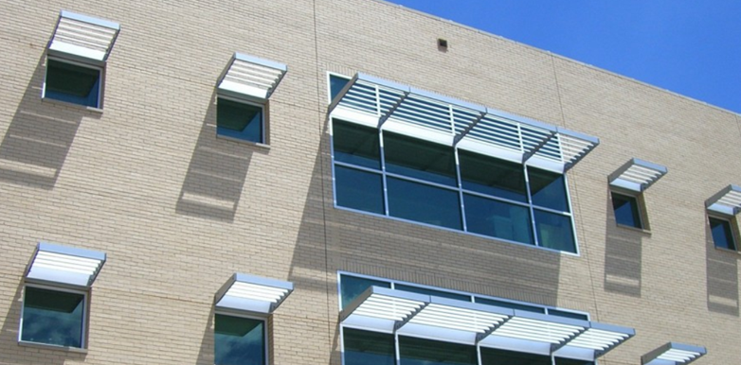
Figure 13. Horizontal shading to windows (Zheng, 2022).

Structural Frame
The concrete frame of the proposed building has a high thermal mass. This mass will reduce the energy required for heating and cooling, as the thermal response of the building is slowed by the concrete absorbing heat during the day and passively releasing it at night as the internal temperatures drop (Shafigh et al., 2018). It is possible to mimic these properties on the materials with a low thermal mass, such as partition walls and ceiling tiles, with the addition of a phase change material. A phase change product called Energain is available in various size panels and was effectively used in the World Wildlife Fund UK headquarters to improve a lightweight timber roof and give it a thermal mass equivalent to 50-70mm of concrete (Gerrard, 2015).

The sustainability of concrete is questioned due to the high temperatures required to make cement, but the thermal properties mentioned above, along with its durability, a long-life expectancy that makes building reuse possible, and ability to be recycled into aggregates, mean that it can be an integral part of a circular economy, particularly if it is sourced locally and cement substitutes are added (Sturgis, 2020).

Services
The material choices and technologies incorporated into the structural frame and building envelope will modify the interior climate and significantly reduce the reliance on the building services to create comfortable indoor spaces.

Electricity
The services will be predominantly powered by mains grid electricity and supplemented by solar PV. The power source is becoming more sustainable as the UK Government (2021) have committed to decarbonising the UK’s electricity production by 2035, moving away from fossil fuels for generation, and to using renewables and nuclear instead. In 2018, 53% of the UK’s electricity was generated by low carbon nuclear and renewable sources (Ambrose, 2017). Favourable sunny and windy weather conditions on Easter Monday 2021 saw 80% of the UK’s grid electricity generated from renewable sources (BBC News, 2021). It is reasonable to assume that the percentage of low carbon electricity generated will increase year on year as the UK Government commission more renewable and nuclear sources of electricity generation.

The photovoltaics recommended for this project are one of the lowest cost, lowest maintenance, and most durable ways of harnessing solar power, but have only been specified as a supplementary source of power, because the seasons in the northern hemisphere dictate that they will generate less power in winter when the demand for heating is lighting is higher (Thorpe, 2014).

HVAC
Well-designed natural ventilation systems have the lowest operational costs and lowest operational carbon of all ventilation systems (MacLennan, 2022). It is recognised that the mechanical ventilation strategies for the serviced apartments will create operational carbon during the buildings lifetime, but this is reduced by incorporating heat recovery along with the grid decarbonisation described above and has been deemed to be the most feasible option at this time due to the air quality concerns discussed in 4.1.3.1.

Lighting
Lighting accounts for 20% of the generated electricity in the UK (Carbon Trust, 2017). LED lighting technology has been recommended for this project as it is up to 80% more efficient than some legacy forms of lighting, with careful consideration given to appropriate lighting controls as substantial savings are possible with the correct controls, such as typical energy reductions of 30-50% to office environments (Carbon Trust, 2017).

Designing for the future
As energy supplies decarbonise and the UK attempts to become net zero by 2050, reducing the embodied carbon from the greenhouse gas emissions created from the extraction of raw materials, the manufacturing processes, the transportation to site, and the installation of every building element has increasing importance (UK Green Building Council, 2017). This can be achieved by standardising designs fully utilising BIM to reduce waste, selecting materials with a low carbon footprint, designing buildings to last longer, or the cradle-to-cradle approach of designing for deconstruction so buildings can be taken apart at the end of their useful life and the elements recycled or reused (Pitman, 2021). It is recommended that the proposed building is designed with services, fabric U-values and airtightness rates that greatly improve on the figures quoted in the building regulations approved documents, as these are the current worst acceptable figures, and buildings designed in this way will require retrofitted energy efficiency measures to achieve net zero before 2050 (Arbabi, 2021).

Conclusion
It is possible to construct a low carbon building by utilising the recommendations and critical analysis within this report to greatly reduce the carbon embodied within the building, reduce future operational carbon emissions, and eliminate the additional carbon associated with retrofitting the building before 2050. In the near future, it is likely that an increasing number of buildings will be designed to be net zero. But currently the additional costs required to construct a net zero building are prohibitive at an estimated at 5.3% for residential buildings, and between 8% and 17% per square metre of gross internal area for offices (Lane, 2020). However, it stands to reason that these costs will reduce as the sustainable and renewable technologies become more common, and when combined with a demand from ethical building users looking for sustainable buildings to rent or buy, new net zero buildings are likely to become more prevalent than low carbon buildings.

References

Ambrose, J. (2019) Low-carbon energy makes majority of UK electricity for first time. Available at: https://www.theguardian.com/environment/2019/jul/25/low-carbon-energy-makes-majority-of-uk-electricity-for-first-time (Accessed: 13 May 2022).

Arbabi, H. (2021) Active Building Centre Research Programme. Can we meet 2050 carbon targets for residential buildings? Available at: Can we meet 2050 carbon targets for residential buildings? (abc-rp.com) (Accessed: 21 May 2022).

BBC News (2021) Britain's electricity system 'greenest ever' over Easter. Available at: https://www.bbc.co.uk/news/uk-56657299 (Accessed: 13 May 2022).

Bradley, J. and Bloxham, A. (2020) Viability Analysis: High Rise in Birmingham. Available at: https://www.building.co.uk/data/viability-analysis-high-rise-in-birmingham/5105331.article (Accessed: 21 May 2022).

Brinkley, M. (2020) Triple Glazed Windows: Do They Make Sense? Available at: https://www.homebuilding.co.uk/advice/triple-glazed-windows-do-they-make-sense (Accessed: 20 May 2020).

British Board of Agrement (2021) Agrement Certificate 21/5870 Brick Slip Support Systems. Certus Brick Slip Cladding System. Watford: British Board of Agrement.

British Standards Institution (2004) BS EN 50172:2004 BS 5266-8:2004 Emergency escape lighting systems. BSI Publications.

British Standards Institution (2013) BS EN 1838:2013 Lighting applications – Emergency lighting. BSI Publications.

British Standards Institution (2016) BS 5266-1:2016 Emergency lighting – Part 1: Code of practice for the emergency lighting of premises. BSI Publications.

British Standards Institution (2018) BS EN 17037:2018+A1:2021 Daylight in Buildings. London: BSI Publications.

Building Regulations (2010) Approved Document L1A Conservation of fuel and power. New Dwellings. Welsh Government.

Building Regulations (2010) Approved Document L2A Conservation of fuel and power. New buildings other than dwellings. Welsh Government.

Building Regulations (2010) Approved Document F: Ventilation. Welsh Government.

Building Regulations (2010) Approved Document L2A: Conservation of fuel and power. New buildings other than dwellings. Welsh Government.

Building Regulations (2010) Approved Document M: Access to and use of buildings. Welsh Government.

Building Research Establishment (2014) DG 498 Selecting lighting controls. Watford: HIS BRE Press.

Building Services Research and Information Association (2014) The Illustrated Guide to Electrical Building Services. 3rd Ed. Bracknell: BSRIA.

Building Services Research and Information Association (2017) The Illustrated Guide to Mechanical Building Services. 3rd Ed. Bracknell: BSRIA.

Carbon Trust (2014) Reducing footprints and increasing brainprints: the role of UK universities in carbon reduction. Available at: https://www.carbontrust.com/news-and-events/insights/reducing-footprints-and-increasing-brainprints-the-role-of-uk-universities (Accessed 13 May 2022).

Carbon Trust (2017) Lighting. Bright ideas for efficient illumination. Available at: https://www.sustainabilityexchange.ac.uk/lighting-technology-overview-ctv049 (Accessed: 12 May 2022).

Chartered Institution of Building Services Engineers (2012) CIBSE Guide F. Energy efficiency in buildings. 3rd Ed. London: CIBSE Publications.

Chartered Institution of Building Services Engineers (2016a) CIBSE Guide B0. Applications and activities: HVAC strategies for common building types. London: CIBSE Publications.

Chartered Institution of Building Services Engineers (2016b) CIBSE Guide B1. Heating. London: CIBSE Publications.

Chartered Institution of Building Services Engineers (2016c) CIBSE Guide B2. Ventilation and Ductwork. London: CIBSE Publications.

Chin, J and Lin, S. (2016) ‘A Behavioral Model of Managerial Perspectives Regarding Technology Acceptance in Building Energy Management Systems’, Sustainability, 8(7), pp. 641. DOI: 10.3390/su8070641

Energy Saving Trust (2022a) Air Source Heat Pumps. Available at: https://energysavingtrust.org.uk/advice/air-source-heat-pumps/ (Accessed: 11 May 2022).

Energy Saving Trust (2022b) Ground Source Heat Pumps. Available at: https://energysavingtrust.org.uk/advice/ground-source-heat-pumps/ (Accessed: 11 May 2022).

EnviroVent (2019) EnviroVent's MVHR Systems Receive Passive House Certification. Available at: https://www.envirovent.com/blog/envirovents-mvhr-systems-receive-passive-house-certification/ (Accessed: 11 May 2022).

Evans, M.A. (2015) Guide to the Building Regulations. 3rd Ed. London: RIBA Publishing.

Evans, M.A. (2016) How Buildings Work. Newcastle upon Tyne: RIBA Publishing.

Gerrard, J. (2015) ‘The Living Planet centre-a Sustainable home for WWF-UK’, The Structural Engineer, pp. 16-22. Available at: https://expedition.uk.com/wp-content/uploads/2014/06/2015-Structural-Engineer-article.pdf (Accessed: 19 May 2022).

Glen Dimplex (2022) Direct Acting Panel Heating. Available at: https://www.gdhv.co.uk/heating-cooling/direct-acting-electric-panel-heaters (Accessed: 10 May 2022).

Hall, F. and Greeno, R. (2017). Building Services Handbook. 9th Ed. Abingdon: Routledge.

Hayward, W. (2021) Target for no-one in Wales to use a gas boiler after 2030, climate change minister says. Available at: https://www.walesonline.co.uk/news/wales-news/climate-change-wales-gas-boilers-21344951 Accessed: 13 May 2022).

Health and Safety Executive (1997) HSG38 Lighting at work. Available at: https://www.hse.gov.uk/pubns/books/hsg38.htm (Accessed: 12 May 2022).

Health and Safety Executive (2022) Building Safety Regulator. Available at: https://www.hse.gov.uk/building-safety/regulator.htm (Accessed: 10 May 2022).

Hodkinson (2022) Ventilation, MVHR and summer overheating. Available at: https://www.hodkinsonconsultancy.com/ventilation-mvhr-summer-overheating-part-f/ (Accessed: 11 May 2022).

Ideal Combi (2022) Commercial Windows. Futura+. Available at: https://idealcombi.com/commercial/products/futura-plus/ (Accessed: 20 May 2022).

Institution of Engineering and Technology (2022a) About BS 7671. Available at: https://electrical.theiet.org/bs-7671/about-bs-7671/ (Accessed: 13 May 2022).

Institution of Engineering and Technology (2022b) IP Ratings. Available at: https://www.iec.ch/ip-ratings (Accessed: 13 May 2022).

Lane, T. (2020) Countdown to zero: how can the UK meet its 2050 carbon targets? Available at: https://www.building.co.uk/focus/countdown-to-zero-how-can-the-uk-meet-its-2050-carbon-targets/5109420.article (Accessed: 21 May 2022).

London Energy Transformation Initiative (2020) LETI Climate Emergency Design Guide. How new buildings can meet UK climate change targets. London: LETI.

MacLennan, D (2022) Ventilation. Available at: https://www.netzerocarbonguide.co.uk/guide/designing-and-building/ventilation-systems (Accessed: 22 May 2022).

McMullan, R. (2018) Environmental Science in Buildings. 8th Ed. London: Red Globe Press.

Office for National Statistics (2021) Energy efficiency of housing in England and Wales: 2021. Available at: https://www.ons.gov.uk/peoplepopulationandcommunity/housing/articles/energyefficiencyofhousinginenglandandwales/2021 (Accessed: 10 May 2022).

Pelsmakers, S. (2015) The Environmental Design Pocketbook. 2nd Ed. London: RIBA Publishing.

Pitman, K. (2021) RICS World Built Environment Forum. Lowering embodied carbon: five trends in building design and construction. Available at: https://www.rics.org/uk/wbef/megatrends/urbanisation/lowering-embodied-carbon-five-trends-in-building-design-and-construction/ (Accessed: 22 May 2022).

Shafigh, P. et al. (2018) ‘Concrete as a thermal mass material for building applications - A review’, Journal of Building Engineering, 19, pp.14-25. DOI: 10.1016/j.jobe.2018.04.021.

Smith, M. and Gorse, C. (2021) Building Surveyors Pocket Book. Routledge: Abingdon.

SolarAge (2020) Solar PV panel arrays. Available at: http://solarage.co.uk/solar-panels/ (Accessed: 25 May 2022).

Sturgis, S. (2020) ‘Everyone has to up their game on whole-life carbon’, in The Concrete Centre, Concrete futures: remixed - how concrete is evolving for a net-zero built environment. London: MPA The Concrete Centre.

The Concrete Centre (2020) Concrete Framed Buildings. London: MPA The Concrete Centre.

Thorpe, D. (2014) Energy Management in Buildings. Abingdon: Routledge.

UK Government (2021) Plans unveiled to decarbonise UK power system by 2035. Available at: https://www.gov.uk/government/news/plans-unveiled-to-decarbonise-uk-power-system-by-2035 (Accessed: 10 May 2022).

UK Green Building Council (2017) Embodied Carbon: Developing a Client Brief. UK Green Building Council.

Vadodaria, K. (2014) ‘In-use energy performance evaluation of a student accommodation in the UK’, International Journal of Low-Carbon Technologies, 9, pp. 268-276.

Withers, E. (2021) Air pollution in Cardiff worse than London. Available at: https://cardiffjournalism.co.uk/thecardiffian/2021/02/16/air-pollution-levels-in-cardiff-are-worse-than-london/ (Accessed: 11 May 2022).

Zheng, C. (2022) Architectural louver aluminium sunshade for window shading. Available at: https://zwhcherry916.en.ecplaza.net/products/architectural-louver-aluminum-sun-shade-for_3161625 (Accessed: 25 May 2022).

