
Travel Review of

The following review is based on Disneyland Paris, an extremely popular tourist attraction, visited by people from all over the world yet classed as a niche market. ‘Niche market’ is aimed at a particular, more specific group of tourists and usually applies to a generally smaller segment of the population rather than appealing to the masses. The niche market in this instance is ‘theme park tourism’. Disneyland is well known for its colourful parades, meet and greet events with life size Disney characters and the handsome princes and beautiful princesses who can be seen throughout the park. It is evident to all who visit that these appeal to the majority of young visitors to the park. However, some are unaware that Disneyland Paris is classed as a theme park with its numerous adventurous rides and high-octane rollercoasters, aimed at satisfying the needs of all thrill seekers. Disneyland is easily accessible from across the world with regular flights into its two international airports – Charles de Gaulle (CDG0) in the north and Orly (ORY) in the south. The Eurostar, high speed railway connects London with Paris via the channel tunnel, allowing convenient, swift access for those living in Great Britain. The Paris Metro system is one of the most extensive underground transport systems in the world and allows visitors to travel directly from the city of Paris into the magical world of Disney. For those who wish to be truly immersed in Disney magic there is the option to stay in one of its many resort hotels or lodges. These are located just a short walk from the main attractions and allow parents to enjoy fun packed days with their children whilst avoiding the distress of having to make a potentially long return journey with over tired children.
Disneyland Paris attracts a large number of people every year, although there has been a fluctuation in visitor numbers over the years.
Year: | Visitor Numbers:
2014 | 14.2 million
2015 | 14.8 million
2016 | 13.4 million
2017 | 9.66 million

By studying these statistics, we see that there has been a clear drop in numbers since 2015, with a somewhat drastic drop in 2017. The decrease in visitor numbers could be a result of the Paris bombings and shootings on 13th November 2015 resulting in 137 fatalities - 130 victims, 7 perpetrators. When a terrorist attack such as this happens, we tend to see the number of visitors to the city and surrounding attractions drop quite significantly until people feel it is safe to return to the destination. ‘https://www.bbc.co.uk/news/world-europe-34818994’
Even though the attack wasn’t within the Disneyland resort itself, the knowledge that Paris had been a recent target for terrorism can leave the public very wary with regard to visiting in the near future, people tend to be particularly anxious about visiting largely populated areas within that city, a densely populated attraction such as Disneyland would be avoided by many. However, it could be argued that the visitor numbers didn’t drop drastically in 2016, many people may have already booked in advance for 2016 and were unable to cancel without financial penalty, deciding that they did not want to lose their money or possibly showing strength and resilience in the face of terrorism. People would not have booked yet for 2017 and that could be why the numbers dropped more dramatically that year. Another reason the numbers dropped in 2017 could be as a result of the terrorist attacks happening around the world, including the attack on the ‘Ariana Grande’ concert in Manchester in May 2017 and the attack on London bridge in June 2017. The Ariana Grande concert attack appeared to target families, teenagers and young adults, with this being the main target market for Disneyland Paris it is highly probable that these particular visitors were wary of visiting such highly populated areas, hence the drastic fall in numbers. When comparing financial figures with tourist numbers there are no trends or noteworthy fluctuations prior to 2016, however, in 2016 Disneyland saw an 858-million-euro loss and a 10% decrease in visitor numbers. ‘http://disneylandparis-news.com/en/financial-documents/’
One of the main performance indicators for Disneyland Paris has to be visitor numbers, despite the events of 2015 Disneyland continues to attract millions of visitors wanting to experience the magic it has to offer. With more than 320 million visitors passing through its turnstiles since 1992, the park accounts for 6.2 percent of France's tourism income and has been a boom for local employment, employing some 16,000 staff. ‘www.cnbc.com’
Disneyland has a large number of competitors across the world such as Alton Towers in the UK, Legoland in the UK and Port Aventura in Spain but these are unable to market the magic of Disney. The Disney brand has proven to be highly sustainable. New enchanting films with memorable characters are created and brought to life in the parks. Disneyland Paris continues to be developed with plans for three new areas based on Marvel superheroes such as Spider-Man and the Hulk, Star Wars and the animated film Frozen. These areas will be starting to appear in 2021. ‘uk.reuters.com’
Another key performance indicator is Trip Advisor Reviews.
Rating level | Ratings
Excellent | 7,383
Very good | 4,128
Average | 2,424
Poor | 1,225
Terrible | 1,032

The majority of ratings are in the ‘excellent’ and ‘very good’ range, such results would influence people to visit to this destination, particularly after reading all the positive reviews. There are some bad reviews to be found, but this tends to be the case for all destinations, and the positive ratings outweigh the negative. The following pictures are a sample of the reviews Disneyland Paris receive.
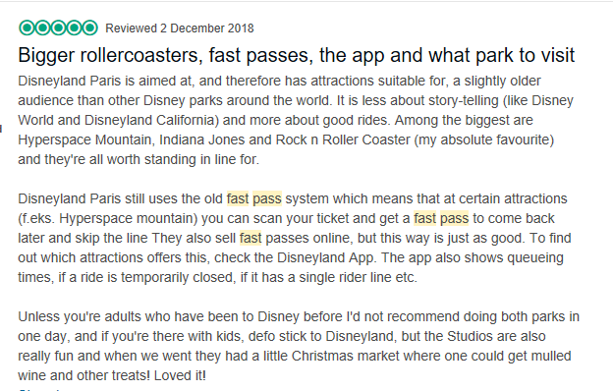

(Positive experience with fast passes, app and the park in general)
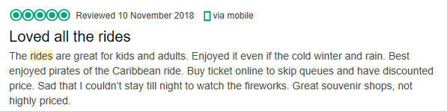

(Positive experience with the rides and gift shops)
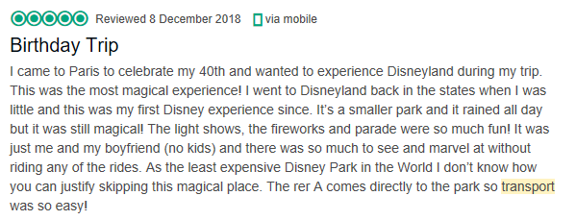

(Positive overall experience and good transport links)
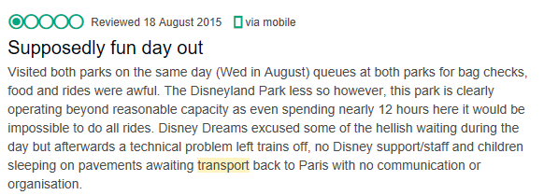

(Negative experience with the queues in the park and technical issues with transport)
‘www.tripadvisor.co.uk’
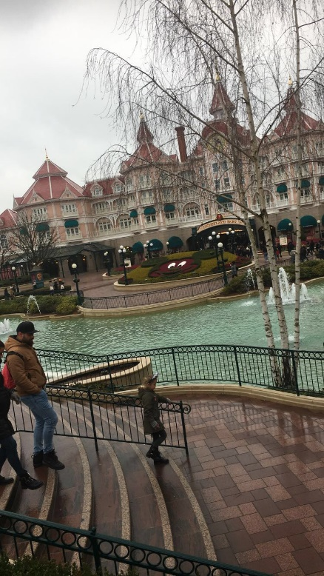
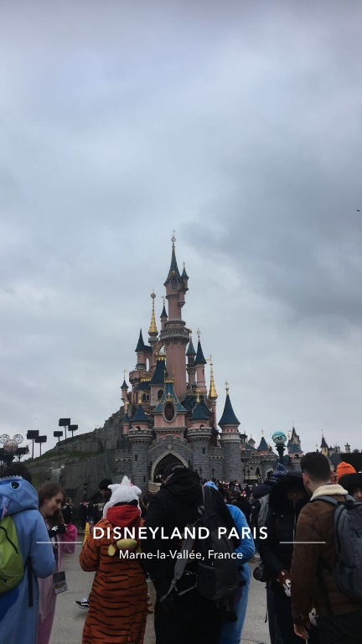
Having recently visited with a group of friends, we would advise potential visitors to plan their visit well in advance, taking into consideration the journey to the resort, transport options and times. Think about an early start to the day in order to maximise the time at the attraction. Plan an itinerary to include any shows/parades you wish to see and don’t forget the truly magical firework display which brings your day to a jaw dropping close. Print an online map of the parks, highlighting the key rides that you wish to visit or download the Disneyland app. Allow time to eat and for the all-important souvenir shopping. We planned everything in advance, we purchased our entry tickets online before travelling to Paris, and visited the nearby metro station to speak to an advisor with regard to the tickets we should purchase and the line we should take for a direct journey into the resort. As the metro service is frequently used by Paris locals, the trains can be very busy and travellers should be aware even that a ticket does not secure you a place on the train. Fortunately, the trains depart every 15 to 20 minutes so if you miss one another will along shortly. From our experience we know that travellers are well advised to book tickets and transport beforehand.

Entering the park is straightforward, you are able to use an e-ticket sent to your phone or simply scan your printed ticket at the machine. Even though we had easy access to our tickets on our phones we had to wait in the same queues as people with printed tickets, there were no fast queues for e-tickets. A recommendation for Disneyland Paris to consider would be to have two separate turnstiles allowing people into the park, one queue for those with printed tickets and another for e-ticket holders. Printed ticket holders tended to take longer as they were rummaging around in their bags for the tickets, whereas e ticket holders had access to their ticket within seconds. Our online tickets had fast passes included, however, once we had entered the park, we then found that we could only use the fast-pass for one ride per hour, and often the queues for the fast pass weren’t any shorter than the general queues. Disneyland Paris could potentially overcome this issue by charging a little extra for fast-pass tickets.
Before visiting Disneyland Paris, we downloaded the ‘Disneyland Paris’ App. This proved to be extremely worthwhile and we would highly recommend it. It has maps of the parks, and where the attractions are located. It shows the current wait time for all the rides, be it a 90-minute wait or merely 5 minutes, which proved very useful. The app is regularly updated throughout the day and therefore reliable. It shows which rides (if any) are temporarily closed and the show and parade times for the day are also displayed. However, if we hadn’t had access to the app there were always plenty of staff willing to help and guide us to our destination. The guest service within the park was of a high standard and that is one thing you can’t receive through an app.
We found all shows and parades to be very well organised, the parades started promptly and made their way around a large area of the park, so that everyone could see the floats with the Disney characters and performers. We were extremely impressed by the illumination show and the fireworks at the end of the night, once again this started on time and well-loved film clips were projected on to the Disney castle allowing everyone a clear view. The fireworks were breath-taking and brought a memorable day to a very satisfying end. Disneyland Paris would appear to have cleverly chosen the venue for its end of the day illumination show, when the show comes to an end, all visitors have to walk down the main street towards the exit. Both sides of the main street are full of shops selling all of the famous Disney merchandise. These shops aim to entice people in to avoid getting caught up the exiting crowds and to encourage others to spend the last of their Euros on a special keepsake or gift for a loved one.
Disneyland Paris has been heavily supported by the French government from the outset. Some of the key government strategies to support the success of Disneyland Paris include, the sale of 4,400 acres of land at the average farmland price to Disney, and the lending of US$770 million at interest rates considerably lower than the market rates. The government financed the majority of the key infrastructure within the park at US$400 million, and organised for the trans-continent train TGV to stop at the front entrance of the park; as well as extending the Paris subway to make Disneyland a terminal. They also arranged a ‘direct link with traffic from the Euro tunnel’.

Disneyland Paris knows how to market itself, this is achieved by producing heart felt, memorable adverts, such as the highly popular duck advert, that has pulled at many people’s heart strings; https://www.youtube.com/watch?v=G4qMqbL9ACo. They also provide brochures online, in PDF form and in colourful, hard copy for collection at local travel agents.


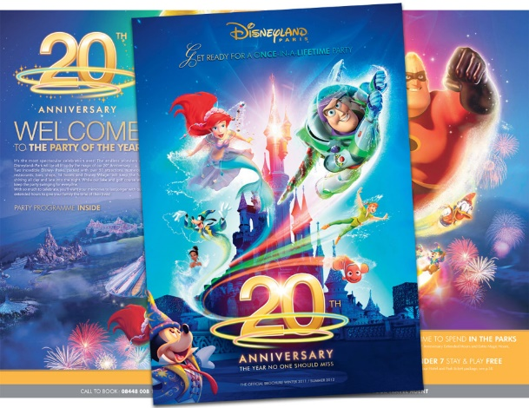

In 2017 Disneyland Paris celebrated its 25th Anniversary, they held special anniversary shows and parades, as well as a creating a dedicated page on their website which included a video to celebrate the 25 years of magic. ‘http://25th-anniversary.disneylandparis.co.uk/’
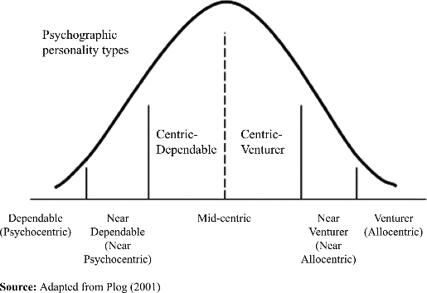

Following our visit to Disneyland Paris, we studied Plog’s theory and concluded that the ‘average visitor’ to Disneyland Paris is mid-centric personality, however, for the thrill seekers visiting for the exhilarating rides then we are looking more towards the near allocentric and allocentric side of the diagram.
Overall, Disneyland Paris is a sustainable attraction that features highly in the tourism industry, it is constantly evolving alongside Disney’s new movie releases. Following our recent visit, we would recommend that the management team consider charging for fast pass tickets as well as creating a separate queue for e-ticket holders. We struggled to find any further recommendations as Disneyland Paris lived up to and sometimes exceeded our expectations.
Did we find magic at Disneyland Paris? Absolutely!


References :
‘Walt Disney makes 2 billion euros investment in Disneyland Paris’, [Online]. Available at: https://uk.reuters.com/article/us-disney-france-investment/walt-disney-makes-2-billion-euros-investment-in-disneyland-paris-idUKKCN1GB1NT, [Accessed on 19-03-19]
‘Disneyland Paris’, [Online]. Available at: https://www.tripadvisor.co.uk/Attraction_Review-g226865-d189258-Reviews-Disneyland_Paris-Marne_la_Vallee_Seine_et_Marne_Ile_de_France.html - 2019, [Accessed 19-03-19]
‘Walt Disney to invest 2 billion euros in Disneyland Paris’, [Online]. Available at: https://www.cnbc.com/2018/02/27/walt-disney-to-invest-2-billion-euros-in-disneyland-paris.html, [Accessed 19-03-19]
‘The official brochure: 21st March 2018 – 1st April 2019’, [Online]. Available at:https://brochure.disneylandparis.com/A18/UK/catalogue/index.html#page/I, [Accessed 19-03-19]
‘Disneyland Paris 20th Anniversary brochure now available’, [Online]. Available at:https://www.dlptoday.com/2011/11/17/20th-anniversary-disneyland-paris-brochure-now-available-events-line-up-confirmed/, [Accessed 27-03-19]
‘Disneyland Park Paris’, [Online]. Available at: https://disney.fandom.com/wiki/Disneyland_Park_(Paris), [Accessed 27-03-19]
‘Where the magic begins’, [Online]. Available at: http://www.smallworldvacations.com/blog/archives.cfm/page/137, [Accessed 27-03-19]

