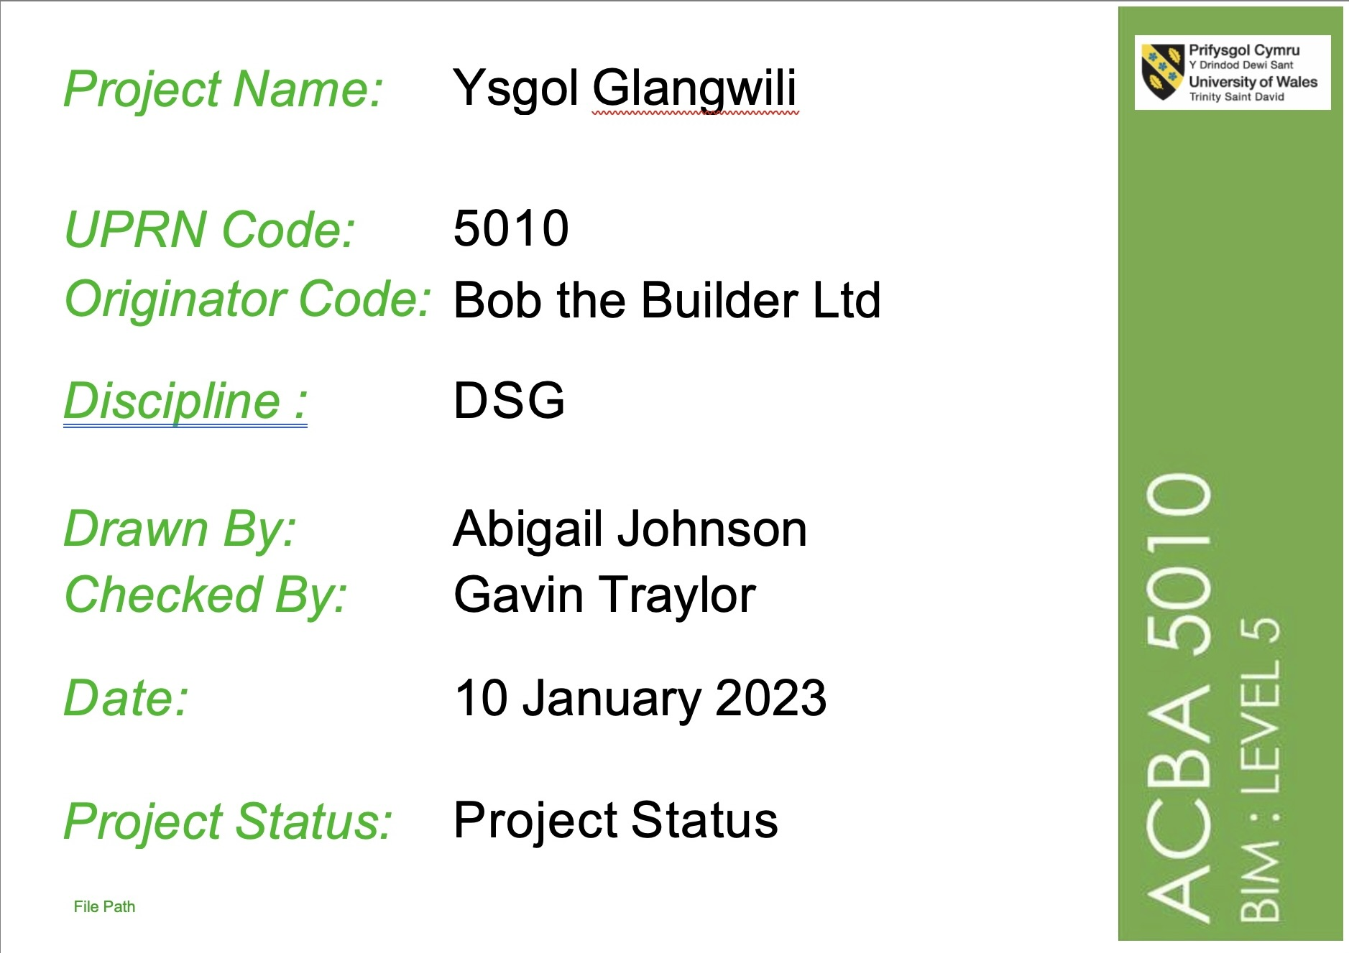

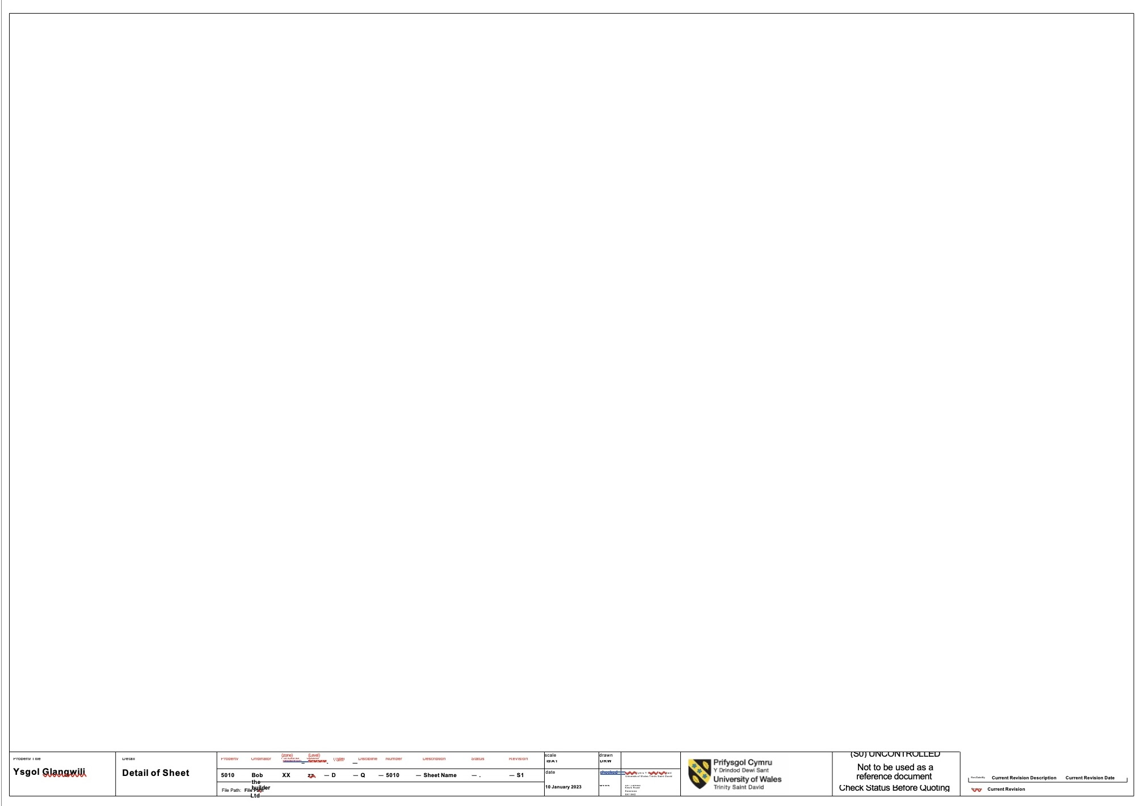

BOB THE BUILDER LTD
College Street,
Lampeter,
Ceredigion,
SA48 930
12 December 2022
Councillor
Carmarthenshire County Council
County Hall,
Castle Hill,
Carmarthen
SA31 1JP

Dear Councillor Evans,

Building Information Modelling sometimes called Building Information Management (BIIM) is used in construction projects as a process that encourages collaborative working and sharing of information between all the disciplines involved in design, construction, maintenance, and use of building throughout the building’s whole life cycle.

Thanks to BIM there is a notable increase in productivity and quality within Architecture, Engineering and Construction (AEC) while at the same time decreasing construction errors, cost, and delivery time for projects. (Rossana, 2017)

BIM is advancing technologically and there must be a way to measure its advancement or development this is what is known as BIM maturity. BIM maturity has 4 levels ranging from level 0 to 3, BIM maturity is often depicted using the Bew Richards wedge inserted below in figure 1.

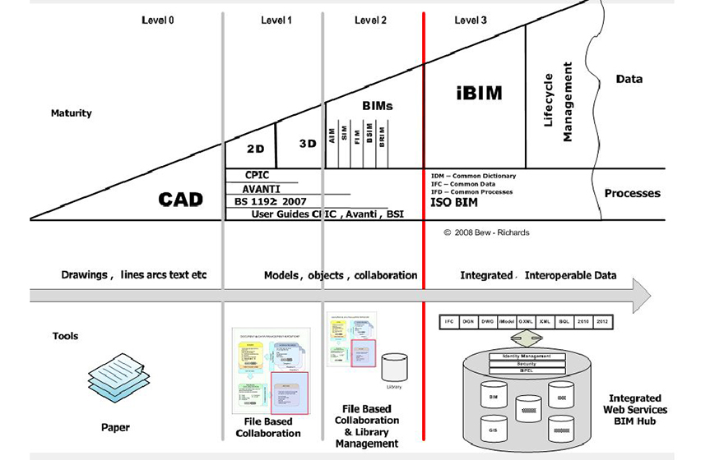
Figure 1 the Bew Richards Wedge (Department of Business, Innovation and Skills, 2011)
LEVEL 0

Also called low collaboration this level shows no use of BIM within it, it has no collaboration between project team. The wedges shows that the tools used within this level is paper so any information exchanged will be done using paperwork and most of which would be 2D Computer Aided Drawings (CAD) which would be unmanaged. Electronic prints or paper or a combination of bother were used for output and distribution in the project.

LEVEL 1

This is also called partial collaboration this now involves the use of not only 2D CAD but, 3D CAD as well, in this level the computer aided drawings are now managed and governed by British Standards. The tool used in this level is file-based collaboration which can be done using a Common Data Environment (CDE) this project will be using the CAFM system but in level 2. A common data environment is a digital information platform that centralizes project data storage and access this information is BIM data. (Kirby, 2022)

To advance to level 1 these following points should be achieved:

- Roles and responsibilities of all stakeholders should be outlined (CIC BIM Protocol)
- Standardized naming convention should be adopted
- Creation and maintenance of project-specific codes and spatial coordination
- Adoption of Common Data Environment of Electronic Document Management System for information sharing between all teams.
- Setting up an appropriate information hierarchy that supports CDE and document repository

LEVEL 2

Also called full collaboration this is the level the UK Government recommends for public sector projects. This level that allows for easy sharing of information amongst project members. All the parties work on their local 3D CAD models and information is exchanged through a common file format. These systems allow organizations to combine external data with their own model to create a federated BIM Model. (United BIM, 2019) This is the level that we will be working at to complete the school.

The CAD software used by each party must be able to work with one of the common file formats such as Industry Foundation Class (IFC) or Construction Operation Building Information Exchange (COBie). For This is the method of working that has been set as a minimum target by the UK government for all work on public-sector work.

The most crucial part of this level is the BEP BIM Execution Plan this is a plan that is created by suppliers to explain how the information modelling parts of a project will be carried out. This comprehensive document helps participants within in the project understand that expectations and roles. This is a very important element to create before beginning any construction project the BEP all roles, responsibilities, and real time communication in sync.
A BEP includes:

- How the data in the actual BIM files should be generated, managed, documented, and shared

- Elements such as agreed roles and responsibilities within the BIM process

- A strategy for key deliverables and a guide to vital project milestones.

- Project Execution Plans and Task Information Delivery Plans that demonstrate when information will be prepared, who is responsible for doing what, and which protocols and procedures they will use

- Practical working procedure details (such as file name conventions and software used), as well as a common set of annotations, abbreviations, and symbols to be used in the BIM process. (Ramage, 2022)

There are two (2) types of BEP’s:

- Pre-contract Plan
- Post-contract Plan

The pre-contract plan these are first plan presented during the tendering stage and may address any requirements set out by the client in a document such as an EIR.

An EIR Employer Information Requirements as the name suggests will highlight the information required by the employers from bother the project’s team and the suppliers of the project. It provides the project team and client with the necessary information to respond to a tender. To create this document Organization Information Requirements (OIR), Project Information Requirements (PIR) and Asset Information Requirements are used to generate an EIR.

An OIR is states the information needed for an organization to satisfy its requirements and meet its objectives related to business operations and asset management. AIR is a document which gathers all the needed assets, management and maintenance procedures. PIR describes the clients’ requirements for the management of a specific facility in relation to the service the equipment or space

The post-contract plan as the name suggests is drawn up after the contract is given whilst the other is before the contract is given

LEVEL 3

Is called full integration or open BIM which includes complete and full collaboration in construction, planning and the operational Lifecyle of the project. The data is collected, shared, and stored using a single source of data. This level is the goal for the construction industry. “Level 3 concept enables all the participants to work on the same model simultaneously which eliminates the chance of conflicting information.” (United BIM, 2019) This is the level that all projects should strive to attain.

I do hope the information given in this letter highlights my wealth on knowledge of the requirements of BIM maturity and how information is shared.


ABIGAIL JOHNSON
Lead Consultant at BOB THE BUILDER LTD
2114475

Enclosure

Level of information need is described in the book The little book of BIIM as “the minimum granularity to avoid over-production of information leading to waste and so consideration should be made on the purpose of any produced information.” (BSI, 2020) Level of information need which was once known to the old standards PAS 1192 as LOD (Level of definition/detail/development. LOD switched to Level of information need because as time passes BIM progresses and the need for clearer and less excessive need for information.

Level of information need more simply put is described as focusing on individual information deliverable and determining the need and purpose for that information and that is everything from the projects use, to who is going to use it, who is going to produce it and how is it going to be produced. This can be measured in several different ways through different metrics and looking at the granularity of the information. Which may be our geometrical information all the way through to our documentation to be included as well and these need to be described clearly within a set of information requirements and these can be described in different stages of the project normally during the inception the organization information requirements (OIR) through the asset information requirements (AIR) and then directly into the project.

The RIBA stages of a project show the maturity of a project from start to finish it is used by the client and project team to help plan and organize the project and be a point of reference.
It brings greater clarity to the different stages of a construction project and over the years it has evolved and been updated to reflect the changing trends in project approaches. The RIBA plan of work has proved to be an extremely popular and highly regarded framework and has become a widely used industry tool by all types of construction professionals and companies. The RIBA plan of works can be found in figure 1 which depicts the 8 stages 0-7 that a project should progress through to its completion and after.

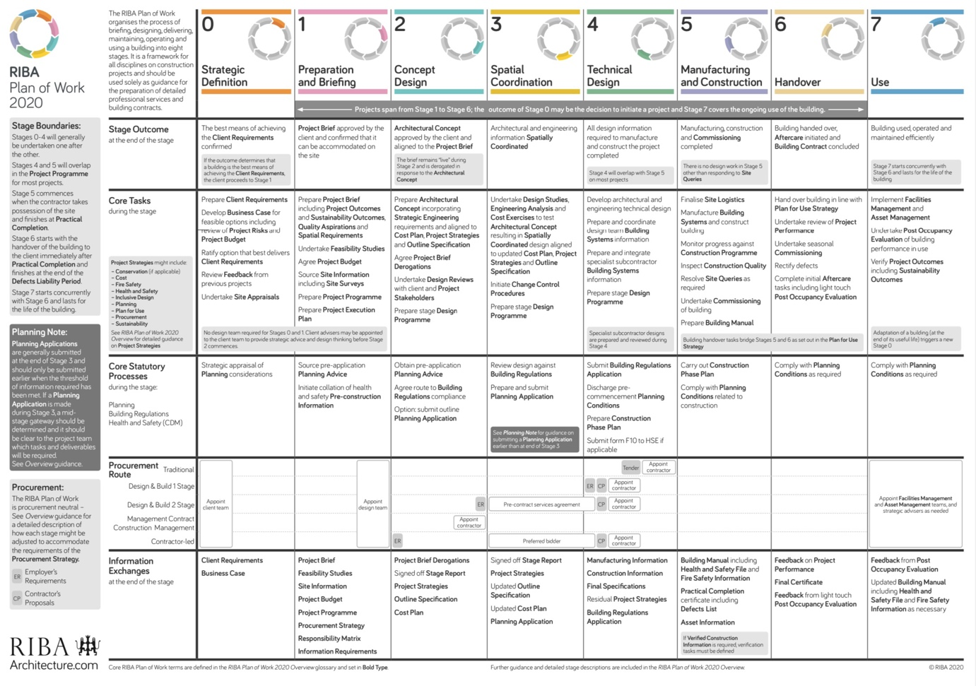
Figure 1 RIBA Plan of Works (RIBA, 2021)

Information level of need has three (3) main categories:

- Geometrical information
- Alphanumeric information
- Documentation
These three categories are what we use to determine and distinguish information level of need.

To attain levels of information needed there are questions that need to be answered to attain the correct information such as:

- What is the is the information?
- When is the information needed?
- Who? Who is required to deliver the information and who requires the information?
- Why? What is the purpose of the information?

By answering these questions, it will make it easy for us to understand level of information need

The RIBA work plan will be examined by its stages and the level of information need will be expressed per stage.

LEVEL 0

This is strategic definition in this level documentation as a level of need will be found. At this stage in the project this is where the planning and brain storming occurs, and all of this will need to be recorded. At this stage the client is gathering the project team and begins to discuss what the project is and what it entails. Documents such as reports, specifications and possible rough sketches will be done at this phase.

Alphanumeric information is also used in this level which is the mixture of the letters and numbers. Alphanumeric information may come in the form of labeling documents properly to identify and organize documents so that these documents will have an appropriate naming convention.

In this level geometrical information will also be needed in the form of detail where u explain in detail what exactly the project is or should be about and the appearance of the project.

This stage is where the project is currently at.

LEVEL 1

This is the preparation and brief level, this is where a design team is being picked as well as a site location, had that not already been air marked which includes site surveys, the project budget will also be discussed and the procurement and tendering routes. This is the stage where the BIM Execution Plan will be created as well as stating the intending outcome of the project.

Documentation is also needed in this level because cost plans will be produced at this level as well as the BEP. Signed documents choosing the design team as well as updated sketches and photographs will be needed in this level.

To organize the different documents, sketches or photos alphanumeric information will be used to do so.

LEVEL 2

This is the concept design level as its name suggests this is the level where the project’s designs are submitted by the architect. The cost plan is also finalized at this point and a contractor is hired, strategies for the project will also be discussed and documented.

The drawings would be in detail specifying materials and sizes, these drawings will be in 2D and 3D. These drawing will also use alphanumeric information to label them as well. Documentation will also occur in this level pictures of the site and a completed cost plan.

LEVEL 3

The spatial Coordination stage again documentation and alphanumeric information will be done. This level is trying to complete the same documents in level three errors will be raised in this level and fixed and these changes will be documented appropriately and given labels in the form of alphanumeric information.

LEVEL 4

The technical design stage is where design drawings will be finalized, cost plans, contracts agreed to, and a contractor will be appointed. The drawings are also checked against building codes and a construction phase plan is done up.

At this level is where we see 4D BIM come into play which is where scheduling is added to the construction model, which is all a form of geometrical information location, detail and appearance is also dealt with at this stage.

LEVEL 5

This is the manufacturing and construction level where the construction phase plan is being executed. Whatever final queries with the location is investigated and a building manual is created and complying with the construction phase plan.

Documenting and alphanumeric information are also part of the level.

LEVEL 6

The building is now complete and is handed over hence the name of this level being handover. In this level this is where post company evaluation is completed, a completion certificate is given and there is feedback from the project of which will be documented and will be labeled appropriately for future records.

LEVEL 7

This level is called use this is where the project has been handed over and is operational. This is where maintenance comes into play at this level depending on the age of damage of the building there may be plans and details explored to facilitate maintenance.

However, documentation will occur here, and this will have to be labeled appropriately

It should be noted that every level contains documentation because it is needed throughout the entire phase and stage of a project. Documentation in the form of contracts are very crucial when it comes to building a project.

The appropriate labeling in the form of alphanumeric is needed as to not confuse different documents and make it easy for information to be found and accessed

And Geometrical is needed to get the important information such as the detail, dimensionality, location appearance and parametric.

The Employer Information requirements (EIR) is an essential document in the BIM process It sets out the information to be delivered, and the standards and processes to be adopted by the supplier as part of the project delivery process. (CANTENDA, 2022)

The EIR is divided into three (3) parts commercial, management and technical.

Commercial

- Data delivery schedule
- Client strategic purpose.
- Defined BIM project deliverables.
- BIM-specific competence assessment.

Management

- Standards.
- Stakeholder's roles and responsibilities.
- Data security.
- Coordination and clash detection process.
- Collaboration process.
- Compliance plan.
- System performance constraints.
- Scheduling Model review meetings.
- Health & safety, and construction design management.
- Planning work and data segregation (model management, naming conventions, etc.)
- Asset information delivery mode

Technical

- The software platforms that the client wants to use in the project e.g. what Common Data Environment (CDE) will be used.
- Data Exchange Formats.
- Level of detail.
- Training requirements. (CANTENDA, 2022)
BIBLIOGRAPHY

- BSI (2020). Little Book of BIM. [online] Available at: https://www.bsigroup.com/globalassets/localfiles/en-us/brochures/bim/little-book-bim.pdf.

- CANTENDA (2022). Employer’s Information Requirements (EIR). [online] Catenda. Available at: https://catenda.com/bim-glossary/employer-information-requirements/.

- CITB (2021). What is BIM? - CITB. [online] www.citb.co.uk. Available at: https://www.citb.co.uk/about-citb/partnerships-and-initiatives/building-information-management-bim-for-site-workers/what-is-bim/.

- Department of Business, Innovation and Skills (2011). A report for the Government Construction Client Group Building Information Modelling (BIM) Working Party Strategy Paper Strategy Paper for the Government Construction Client Group From the BIM Industry Working Group. [online] Available at: https://www.cdbb.cam.ac.uk/system/files/documents/BISBIMstrategyReport.pdf.

- Kirby, M. (2022). What Is a Common Data Environment and How Is It Used In Construction? [online] constructible.trimble.com. Available at: https://constructible.trimble.com/construction-industry/what-is-a-common-data-environment-and-how-is-it-used-in-construction.

- McPartland, R. (2014). BIM Levels explained. [online] NBS. Available at: https://www.thenbs.com/knowledge/bim-levels-explained.

- Mordue, S., Swaddle, P. and Philp, D. (2016). Building information modeling for dummies. Chichester, West Sussex, United Kingdom: John Wiley And Sons, Inc.

- Palma, T.D. (2022). Exchange Information Requirements: What is an EIR in BIM? [online] BibLus. Available at: https://biblus.accasoftware.com/en/exchange-information-requirements-what-is-an-eir-in-bim/.

- Ramage, M. (2022). What Is a BIM Execution Plan and What Should It Include? constructible.trimble. [online] 6 Jan. Available at: https://constructible.trimble.com/construction-industry/what-is-a-bim-execution-plan-and-what-should-it-include.

- RIBA (2021). RIBA Plan of Work. [online] Architecture.com. Available at: https://www.architecture.com/knowledge-and-resources/resources-landing-page/riba-plan-of-work.

- Rossana (2017). Maturity Model and BIM Levels. [online] Trace Software. Available at: https://www.trace-software.com/elec-calc-bim-maturity-model-and-bim-levels/.

- United BIM (2019). BIM Maturity Levels Explained- Level 0 | 1 | 2 | 3 | United-BIM. [online] United-BIM. Available at: https://www.united-bim.com/bim-maturity-levels-explained-level-0-1-2-3/.

‌

