

Emotional Intelligence in the Workplace
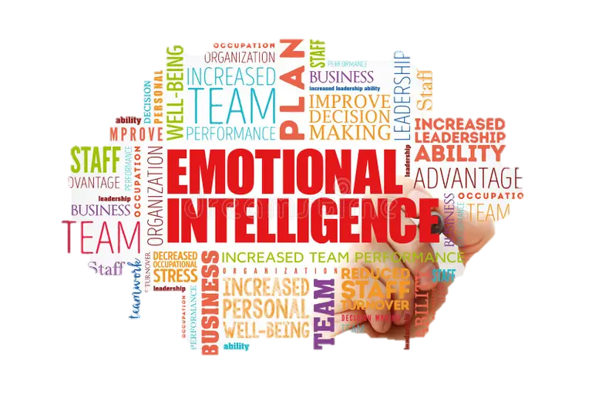

Student Name: TATYANA IVANOVA
Student Number: 2412523
Course Name: Developing Emotional Skills
Lecturer Name: Prof. Kazeem Oseni
Session: 10 August 2026

CONTENTS

Introduction…………………………………………………………….….3

TASK 1: 1. Emotional Intelligence Models……………………….........4

1.1 Goleman’s Emotional Intelligence Framework……………….4

1.2 Mayer and Salovey’s Ability Model…………………………….5

1.3 Bar-On’s Emotional-Social Intelligence Model………………..6

1.4 Comparative Analysis…………………………………………….6
2. Applying EI to Improve Performance………………………………….….7

3. EI, Communication, and Collaboration…………………………………...8

4. EI and Employee Well-being………………………………………………9
5. Critical Evaluation………………………………………………………….10

6. Conclusion…………………………………………………………….……12

Task 2: The Multigenerational Workforce…………………………..….…..13

1. What Is a Multigenerational Workforce?...............................................14
2. Generation X (Born 1965–1980) …………………………………………15
3. Millennials (Born 1981–1996) ………………………………………..….16

4. Generation Z (Born 1997–2012) …………………………………..…….17

5. Comparison and Organisational Implications……………………..……18

6. Summary……………………………………………………………….…..19
Overall Summary of the Report…………………………………………..20
References……………………………………………………………………21

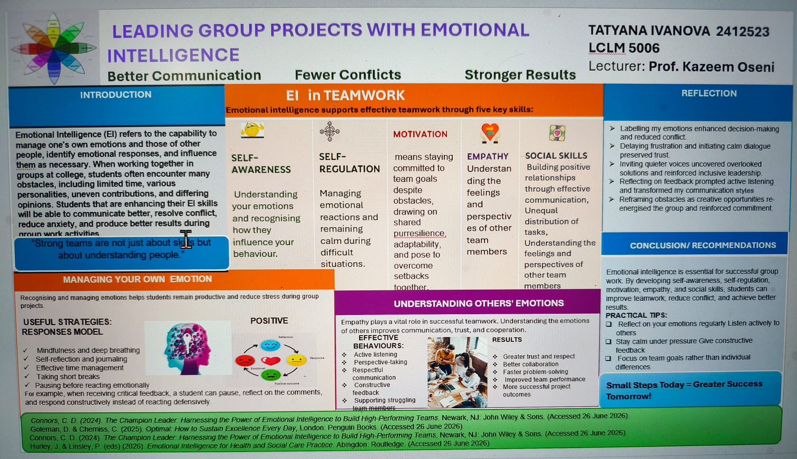

Introduction

Emotional Intelligence (EI) refers to the capacity to recognise, understand, manage, and effectively use emotions in oneself and others. The term was first formally defined by Salovey and Mayer (1990) as “the ability to monitor one’s own and others’ feelings and emotions, to discriminate among them, and to use this information to guide one’s thinking and actions”. This foundational definition established EI as a distinct construct separate from cognitive intelligence, positioning emotional awareness as a critical component of human effectiveness.

In today’s contemporary workplace, EI has become increasingly vital. Organisations face unprecedented challenges including rapid technological change, hybrid working models, diverse and multigenerational workforces, and heightened expectations around employee well-being. Research consistently demonstrates that teams with higher emotional intelligence manage conflict more effectively, adapt better under pressure, and collaborate more effectively. Moreover, employees with strong EI report greater job satisfaction, exhibit resilience against workplace stress, and contribute more positively to organisational outcomes. As Goleman (1995) popularised, EI can matter more than IQ in predicting professional success and leadership effectiveness.

This report critically evaluates three prominent EI models: Goleman’s Mixed Model, Mayer and Salovey’s Ability Model and Bar-On’s Emotional-Social Intelligence Model. It analyses how employees can apply EI components to improve performance, collaboration, and well-being, and examines EI's contribution to communication, conflict management, leadership, and decision-making within modern organisations.

Task 1: Emotional Intelligence Models

1.1 Goleman’s Emotional Intelligence Framework

Daniel Goleman’s (1995) model, popularised through his bestselling book, comprises five core constructs: self-awareness, self-regulation, motivation, empathy, and social skills.

- Self-awareness involves recognising one’s own emotions, strengths, weaknesses, and their impact on others. Goleman (1995) identified self-aware individuals as those who enjoy good psychological health and maintain a positive outlook.
- Self-regulation refers to managing emotional reactions, controlling impulses, and remaining calm during difficult situations.
- Motivation encompasses intrinsic drive, persistence, and commitment to goals despite obstacles.
- Empathy involves understanding the feelings and perspectives of others.
- Social skills relate to building positive relationships, managing teams, and influencing others effectively.

Goleman’s framework is classified as a mixed model because it combines emotional abilities with personality traits and behavioural competencies. It emphasises practical, real-world application and has been widely adopted in leadership development, HR practices, and organisational training programmes. However, critics argue that Goleman’s broad conceptualisation lacks empirical rigour and clear boundaries, with some accusing it of presenting “old wine in new bottles”.

1.2 Mayer and Salovey’s Ability Model

Mayer and Salovey (1997) refined their original definition to focus exclusively on four emotion-related abilities, arranged hierarchically from basic to complex:

1. Perceiving Emotions: The ability to accurately identify emotions in oneself and others, as well as in objects, art, and stories.
2. Facilitating Thought: The ability to generate, use, and feel emotions to facilitate cognitive processes and communication.
3. Understanding Emotions: The ability to comprehend emotional information and understand how emotions combine and progress through transitions.
4. Managing Emotions: The ability to be open to feelings and modulate them in oneself and others to promote personal understanding and growth.

This ability model treats EI as a genuine intelligence, measured through performance-based tests such as the Mayer-Salovey-Caruso Emotional Intelligence Test (MSCEIT). Unlike Goleman’s model, it strictly separates EI from personality traits and focuses solely on cognitive-emotional abilities.

The ability model offers stronger scientific validity and clearer construct boundaries. However, critics note that the MSCEIT has faced challenges with discriminant validity and that the model struggles to justify why it includes certain emotion-related tasks while excluding others.

1.3 Bar-On’s Emotional-Social Intelligence Model

Reuven Bar-On’s model conceptualises EI as a cross-section of interrelated emotional and social competencies that determine how effectively we understand ourselves, relate to others, and cope with daily demands. The model comprises five meta-factors with ten core components:

- Intrapersonal: Self-regard, emotional self-awareness, assertiveness
- Interpersonal: Empathy, interpersonal relationships
- Stress Management: Stress tolerance, impulse control
- Adaptability: Reality-testing, flexibility, problem-solving

Bar-On’s framework is also a mixed model that integrates emotional abilities with social competencies and personality dispositions. It emphasises overall well-being and effective coping with environmental demands. The model is operationalised through the Emotional Quotient Inventory (EQ-I), a self-report measure.

1.4 Comparative Analysis

The three models differ fundamentally in how they conceptualise EI. Mayer and Salovey’s ability model treats EI as a pure cognitive ability, measured through maximum-performance tests. Goleman and Bar-On, by contrast, adopt mixed models that combine abilities with traits and behaviours, measured through self-report questionnaires. While Goleman emphasises practical workplace competencies, Bar-On focuses more broadly on emotional-social functioning and well-being. The ability model offers greater scientific precision, whereas the mixed models provide more accessible, applied frameworks for organisational use. Each model has informed EI measurement and training, though the lack of consensus on a single definition remains a significant challenge.

2. Applying EI to Improve Performance

Employees can leverage the core components of EI to enhance individual and team performance. Self-awareness enables employees to recognise their personal strengths and development areas, allowing them to seek appropriate training, delegate tasks effectively, and avoid overcommitting. For example, a project manager who recognises a tendency toward micromanagement can consciously step back and empower team members, improving both efficiency and morale.

Self-regulation helps employees remain composed under pressure, making more rational decisions rather than reacting impulsively. When faced with tight deadlines or critical feedback, self-regulated individuals pause, assess the situation objectively, and respond constructively. This reduces errors, prevents regrettable outbursts, and maintains professional credibility.

Motivation drives productivity and goal achievement. Employees with high intrinsic motivation persist through setbacks, maintain focus on long-term objectives, and inspire others through their commitment. In practice, a sales team member who maintains enthusiasm despite repeated rejections is more likely to ultimately secure contracts and exceed targets.

Research confirms that strong EI helps individuals identify, regulate, and express emotions effectively, building resilience to workplace stress and improving interpersonal interactions. Consequently, employees with higher EI report greater job satisfaction and demonstrate superior performance outcomes.

3. EI, Communication, and Collaboration

Emotional intelligence is foundational to effective workplace communication and collaboration. Empathy—the ability to understand and share the feelings of others—enables employees to read nonverbal cues, recognise unspoken concerns, and tailor their communication appropriately. An empathetic manager, for instance, notices when a team member appears withdrawn and initiates a supportive conversation, potentially preventing burnout or disengagement before it escalates.

Social skills encompass the ability to manage relationships, build networks, and lead teams effectively. Employees with strong social skills facilitate inclusive discussions, resolve disagreements constructively, and create psychological safety within teams. They actively listen, give and receive feedback graciously, and adapt their communication style to diverse colleagues.

EI significantly enhances conflict management. Emotionally intelligent individuals approach disagreements with composure, seek to understand opposing perspectives, and focus on problem-solving rather than personal attacks. A leader with high EI can transform conflicts into opportunities for growth by facilitating open dialogue, acknowledging emotions without judgment, and guiding teams toward mutually acceptable solutions. Research indicates that effective conflict management approaches, supported by EI, facilitate constructive responses to workplace disagreements, thereby strengthening team cohesiveness and performance.

4. EI and Employee Well-being

Emotional intelligence plays a crucial role in supporting employee well-being. Stress management is a direct benefit: individuals who can recognise early signs of stress and regulate their emotional responses are better equipped to maintain composure and productivity during challenging periods. Rather than becoming overwhelmed, they employ coping strategies such as mindfulness, reframing, and seeking social support.
Resilience—the capacity to adapt and recover from adversity—is closely linked to EI. Employees who understand their emotions can process setbacks constructively, learn from failures, and maintain optimism, making this adaptability invaluable in organisations facing constant change and uncertainty.

EI also enhances job satisfaction and workplace relationships through empathy and social skills, building supportive networks that buffer stress and foster trust, collaboration, and a positive culture. Studies show mindfulness boosts EI, and EI mediates the link between mindfulness and work engagement. Developing EI is thus essential for individual resilience and organisational health.

5. Critical Evaluation
Dimension | Generation X (1965–1980) | Millennials (1981–1996 | Generation Z (1997–2012)
Values | Independence, self-reliance, work-life balance | Purpose, collaboration, personal growth | Ethics, diversity, mental health, authenticity
Expectations | Autonomy, flexibility, good salary | Learning opportunities, flexible hours, value alignment | Job security, flexibility, transparency, upskilling
Communication | Direct, efficient, face-to-face or phone | | Instant messaging, emails, transparency | Informal, visual, digital-first, authentic
Motivation | Autonomy, recognition, challenge | Purpose, growth, feedback | Purpose, flexibility, technology, inclusion
Technology | Pragmatic users, value infrastructure | Tech-savvy, embrace digital tools | Digital natives, AI adopters, expect cutting-edge tech

While EI has gained widespread acceptance, critical examination reveals significant limitations and controversies.

Strengths of EI models include their practical applicability and intuitive appeal. Goleman’s framework, despite its scientific limitations, has transformed leadership development and HR practices globally. The ability model offers robust empirical foundations and clear measurement through performance-based tests. Bar-On’s comprehensive approach recognises the interconnection between emotional and social competencies. Research confirms that EI predicts important outcomes in health, education, relationships, and the workplace.

However, significant limitations persist. First, the concept remains poorly defined, with fundamental disagreement between ability- and mixed-model proponents. Goleman’s assertion that EI encompasses “everything apart from IQ” renders the construct virtually boundless and empirically untestable. Second, mixed models lack discriminant validity, overlapping substantially with established personality constructs such as the Big Five. Third, the claim that EI is more powerful than IQ in predicting success lacks robust empirical support and has been criticised as overblown.

EI does not always lead to positive outcomes. Emotionally intelligent individuals can potentially manipulate others’ emotions for selfish or unethical purposes. High EI combined with low integrity may enable sophisticated deception, emotional exploitation, or toxic leadership. Moreover, excessive emotional atonement can lead to emotional exhaustion or compassion fatigue, particularly in caring professions. The ethical dimension of EI remains underexplored.

Finally, measurement challenges undermine scientific credibility. Ability-based tests like the MSCEIT have shown limited overlap with self-report measures, raising questions about what each assesses. Self-report inventories are susceptible to social desirability bias and may reflect self-perception rather than actual ability. The proliferation of commercial EI tests with weak empirical foundations further confuses the field.

In conclusion, while EI offers valuable insights into workplace behaviour, organisations should adopt a nuanced, evidence-based approach, recognising both its potential and its limitations.

6. Conclusion

This report has critically analysed the role of emotional intelligence in contemporary organisations. Defined as the ability to monitor, discriminate, and use emotional information to guide thinking and action, EI has become increasingly vital in modern workplaces confronting complexity, diversity, and constant change.

Three prominent models—Goleman's Mixed Model, Mayer and Salovey's Ability Model, and Bar-On's Emotional-Social Intelligence Model—offer complementary yet distinct perspectives. Goleman emphasises practical workplace competencies applicable to leadership and team dynamics; Mayer and Salovey provide scientific rigour through ability-based measurement, treating EI as a cognitive capacity; and Bar-On integrates emotional and social functioning with psychological well-being, offering a holistic framework.

Employees can apply EI components to enhance performance through self-awareness, self-regulation, and motivation; improve communication and collaboration via empathy and social skills; and support well-being through stress management and resilience. However, a critical evaluation reveals conceptual ambiguities, measurement challenges, and the potential for manipulative use of EI, underscoring the need for ethical application.

Overall, EI remains a valuable construct for understanding and improving workplace dynamics. Organisations should invest in evidence-based EI development programmes, integrate EI into leadership selection and training, and foster emotionally intelligent cultures that value both performance and well-being. When applied critically and ethically, emotional intelligence can significantly enhance individual fulfilment, team collaboration, and organisational success in the contemporary workplace.

Task 2: The Multigenerational Workforce

1. What Is a Multigenerational Workforce?

A multigenerational workforce refers to an organisation that employs individuals from multiple generational cohorts simultaneously. Today’s workplace is the most age-diverse in history, with up to five generations working side by side—from the Silent Generation to Generation Z. Each generation brings distinct values, communication styles, work expectations, and technological preferences shaped by the social, economic, and technological contexts they grew up in.

This diversity presents both significant opportunities—such as blending the experience of older workers with the innovation of younger ones—and considerable challenges, particularly around communication gaps, differing expectations, and technological adoption. Research indicates that more than half of employees report at least moderate friction due to generational differences in the workplace. However, a multigenerational workforce can also increase learning through mentorship and reverse mentorship opportunities. The following sections examine three key generations: Generation X, Millennials, and Generation Z.

2. Generation X (Born 1965–1980)
Often dubbed the “forgotten generation” because it sits between the larger Baby Boomer and Millennial cohorts, Generation X grew up amid economic uncertainty, rising divorce rates, and the dawn of the digital age. Many Gen Xers were “latchkey kids”—children who came home to empty houses after school while both parents worked—which fostered deep self-reliance and independence.
Workplace values and expectations: Gen X values independence, self-sufficiency, and personal responsibility. They are pragmatic, results-driven, and deeply committed to work-life balance, prioritising leisure time more than previous generations. They seek diverse and global thinking, appreciate flexible work environments, and value autonomy and innovation. Gen X employees focus most on good salaries and want a short or no commute to work.

Communication style: Gen X prefers direct, upfront information followed by the independence to tackle tasks on their own. As self-reliant workers, they do not require constant oversight and often prefer to be left to get on with things. They are comfortable with both traditional face-to-face interactions and digital communication, viewing technology as a tool rather than a lifestyle.
Motivation: Gen X is motivated by autonomy, efficiency, and meaningful recognition. They value employers who respect their independence and offer flexibility to balance work with family responsibilities. They respond well to direct and honest feedback and are highly comfortable with change, seeking out challenging and interesting jobs.
Attitude towards technology: Gen X were the first to have computers but will remember what it was like before computers and the internet. They are technologically savvy but view technology pragmatically as a tool. Around half of Gen X workers agree that advanced workplace technology is important, though they are less likely than younger generations to embrace emerging technologies such as AI.

3. Millennials (Born 1981–1996)

Millennials, also known as Generation Y, grew up during a period of relative economic stability but launched their careers during the Great Recession of 2008. They are now the largest cohort in the workforce.

Workplace values and expectations: Millennials seek purpose in their work and prioritise personal development. They value flexibility, collaboration, diversity, and guidance over command. They are vocal about their expectations and desire inclusive environments. Millennials want learning opportunities and flexible working hours, and they are most focused on work that aligns with their values.

Communication style: Millennials favour instant messaging, texts, and emails. They appreciate transparency and straightforward communication, especially from senior leaders. They bridge old-school corporate etiquette and digital-first collaboration. Open dialogue, regular feedback, and honest leadership communication are baseline expectations.

Motivation: Millennials are motivated by purpose, personal growth, and collaborative environments. They seek recognition, regular feedback, and opportunities for learning and development. They thrive when their work aligns with their personal values and contributes to a larger mission.

Attitude towards technology: Millennials are tech-savvy and embrace digital tools for communication, collaboration, and productivity. They are comfortable with remote work, digital collaboration platforms, and innovative technologies. Approximately 39% of millennials report using AI daily or several times a week. They seek balance and meaning, using technology to reclaim time and independence.

4. Generation Z (Born 1997–2012)

Generation Z, often referred to as “Zoomers” or “digital natives,” is the first generation to have grown up entirely in the digital age. They entered higher education and the workforce amid the COVID-19 pandemic, which accelerated remote work and heightened awareness of social responsibility.

Workplace values and expectations: Gen Z values job security, work-life balance, and mental health above all else. They are highly conscious of social justice, environmental issues, and racial and gender equality. Purpose-driven work is paramount, with flexibility, autonomy, and transparency being key priorities. They value authentic leaders, inclusion, opportunities to upskill, and in-person connection. Gen Z demands ethics, diversity, and personal sustainability.

Communication style: Gen Z prefers instant, easily digestible, and actionable information. Their communicative repertoire is marked by multimodality, informality, and visual semiotics such as emojis, memes, and abbreviations. They favour informal, efficient communication and do not want work relationships to feel overly formal or inauthentic. They expect transparency, purpose-driven communication, and workplace flexibility.

Motivation: Gen Z is motivated by purpose, flexibility, technology, mental health, and inclusion. They value job security and stability but are not afraid to change jobs if their needs are not met. They are driven by meaningful work, friendly colleagues, respect for personal time, and clear goals and responsibilities.

Attitude towards technology: Gen Z is the first true digital-native generation. They use digital tools not just for socialising but to solve problems efficiently at work. 29% of Gen Z workers report using generative AI in the workplace. They expect digital tools to make their job easier and are reshaping workplace norms by embracing AI, normalising mental health chats, and being more authentic at work. Gen Z prioritises flexibility, autonomy, and purpose, often viewing AI as a creative partner that accelerates ideas.

5. Comparison and Organisational Implications

Dimension | Generation X (1965–1980) | Millennials (1981–1996 | Generation Z (1997–2012)
Values | Independence, self-reliance, work-life balance | Purpose, collaboration, personal growth | Ethics, diversity, mental health, authenticity
Expectations | Autonomy, flexibility, good salary | Learning opportunities, flexible hours, value alignment | Job security, flexibility, transparency, upskilling
Communication | Direct, efficient, face-to-face or phone | Instant messaging, emails, transparency | Informal, visual, digital-first, authentic
Motivation | Autonomy, recognition, challenge | Purpose, growth, feedback | Purpose, flexibility, technology, inclusion
Technology | Pragmatic users, value infrastructure | Tech-savvy, embrace digital tools | Digital natives, AI adopters, expect cutting-edge tech

The multigenerational workforce presents both challenges and opportunities for contemporary organisations. Communication gaps arise from differing preferences—Gen X values directness, Millennials favour transparency, and Gen Z expects informality and visual communication. Employers must pay close attention to technological disparities before introducing new systems. Different expectations around work-life balance, flexibility, and career progression can create friction.

However, these differences also create powerful opportunities. Gen X brings independence, pragmatism, and a strong work ethic; Millennials contribute purpose-driven collaboration and technical proficiency; Gen Z offers digital fluency, fresh perspectives, and social consciousness. Organisations that move beyond stereotypes and intentionally leverage each generation's strengths—through mentorship, reverse mentorship, flexible policies, and inclusive communication—will be better positioned to foster collaboration, trust, and long-term success.

6. Summary

The modern workplace brings together Generation X, Millennials, and Generation Z—each with distinct values, communication preferences, motivational drivers, and attitudes towards technology. Gen X values independence and pragmatism; Millennials seek purpose and collaboration; Gen Z demands authenticity and digital fluency. While generational differences can create friction, they also present powerful opportunities for innovation, mentorship, and cross-generational learning. Organisations that embrace age diversity and adapt their policies, communication, and technology strategies accordingly will be better equipped to attract, retain, and engage talent across all generations.

Overall Summary of the Report

Task 1 analysed emotional intelligence through three prominent models: Goleman’s mixed model (self-awareness, self-regulation, motivation, empathy, social skills), Mayer and Salovey’s ability model (perceiving, facilitating, understanding, and managing emotions), and Bar-On’s emotional-social intelligence model (intrapersonal, interpersonal, stress management, and adaptability competencies). The report demonstrated how employees apply EI to improve performance through self-awareness and self-regulation, enhance communication and collaboration through empathy and social skills, and support well-being through stress management and resilience. Critical evaluation revealed both strengths—practical applicability and empirical support—and limitations, including conceptual ambiguity, measurement challenges, and the potential for EI to be used manipulatively.

Task 2 examined the multigenerational workforce, defining it as an organisation employing multiple age cohorts simultaneously. Generation X (1965–1980) values independence, work-life balance, and direct communication. Millennials (1981–1996) seek purpose, collaboration, and transparency. Generation Z (1997–2012) demands authenticity, digital fluency, mental health, and flexibility. While generational differences create communication gaps and technological disparities, they also offer opportunities for mentorship, innovation, and cross-generational learning.

Overall, both emotional intelligence and generational awareness are essential for effective contemporary organisational practice. EI enables individuals and leaders to navigate emotional complexity, build trusting relationships, and foster resilience. Understanding generational diversity enables organisations to create inclusive, flexible environments that leverage the strengths of all age groups. Together, these competencies equip organisations to thrive in an increasingly complex, diverse, and rapidly changing world of work.

References

Connors, C. D. (2024) The Champion Leader: Harnessing the Power of Emotional Intelligence to Build High-Performing Teams. Newark, NJ: John Wiley & Sons. (Accessed 8 August 2026)

Goleman, D. (1995) Emotional Intelligence: Why It Can Matter More Than IQ. New York: Bantam Books. (Accessed 8 August 2026)

Goleman, D. & Cherniss, C. (2025) Optimal: How to Sustain Excellence Every Day. London: Penguin Books. (Accessed 8 August 2026)

Hurley, J. & Linsley, P. (eds) (2026) Emotional Intelligence for Health and Social Care Practice. Abingdon: Routledge. (Accessed 8 August 2026)

Mayer, J. D., Salovey, P. & Caruso, D. R. (2002) 'Mayer-Salovey-Caruso Emotional Intelligence Test (MSCEIT)', Toronto, Ontario: Multi-Health Systems, Inc.(Accessed 8 August 2026)

Connors, C. D. (2024). The Champion Leader: Harnessing the Power of Emotional Intelligence to Build High-Performing Teams, Newark, NJ: John Wiley & Sons (Accessed 8 August 2026)

Goleman, D. & Cherniss, C. (2025). Optimal: How to Sustain Excellence Every Day, London: Penguin Books. (Accessed 8 August 2026)

Gonzales, M. (2022). Emotional Intelligence for Students, Parents, Teachers and School Leaders: A Handbook for the Whole School Community. Singapore: Springer, (Accessed 8 August 2026)

Harvard Business Review, Goleman, D., Ibarra, H., David, S. & Eurich, T. (2025). HBR's 10 Must Reads on Emotional Intelligence, Updated and Expanded. Boston, MA: Harvard Business Review Press. (Accessed 26 June 2026)

Hasson, G. (2024). Emotional Intelligence: Managing Emotions to Make a Positive Impact on Your Life, 2nd ed. Hoboken, NJ: Capstone/Wiley. (Accessed 26 June 2026)

Hurley, J. & Linsley, P. (eds) (2026). Emotional Intelligence for Health and Social Care Practice. Abingdon: Routledge. (Accessed 26 June 2026)

Goleman, D. (2020). Emotional Intelligence: Why It Can Matter More Than IQ, 25th anniversary edn. London: Bloomsbury. (Accessed 8 August 2026)

