curtis gwyther
1811172
Design, Development and Manufacturing – 3-Jaw Co bot End-effector
ACMA5002

Introduction
This report will look at the undertaking of a design study for a 3-jaw Gripper – end effector which is intended to be used with co bot systems, The end effector is intended to be used for a variety of different pick and place operations. A concept design appraisal will be conducted on the existing design that has already been generated and further development work will be undertaken and will consider and optimise the manufacturability of the final design. Consideration will also be made to the expected customer needs, and a justification of the manufacturing processes used as the parts will be mass produced with the required volumes being between 1000 and 2000 units per week. In the report will also be a description of the techniques used to generate new features and modify the existing design, A failure mode effect analysis of the design and some environmental factors that have been considered.
Contents
Introduction 1
Concept Design Appraisal 2
Assembly 2
Gripper Jaw 3
Cylinder 3
Worm and Shaft 4
4
Development of Design Specification 5
Manufacturing process proposal 5
Gripper jaw and Join 5
Drive plate 6
Cylinder 6
Motor 6
Shaft and Worm 6
Design and development work 7
Gripper jaws 7
Joins 7
Drive plate 8
Cylinder 8
Shaft 9
Worm 9
Additional considerations in the design 10
Conclusion 11
Works Cited 11

Concept Design Appraisal
The design for this 3-jaw gripper arm has been designed with no considerations for manufacturability or assembly in mind and therefore each of the parts have been analysed and an FMEA has been conducted on the various parts to uncover any potential problems that will arise if the current design was to be manufactured.

Assembly
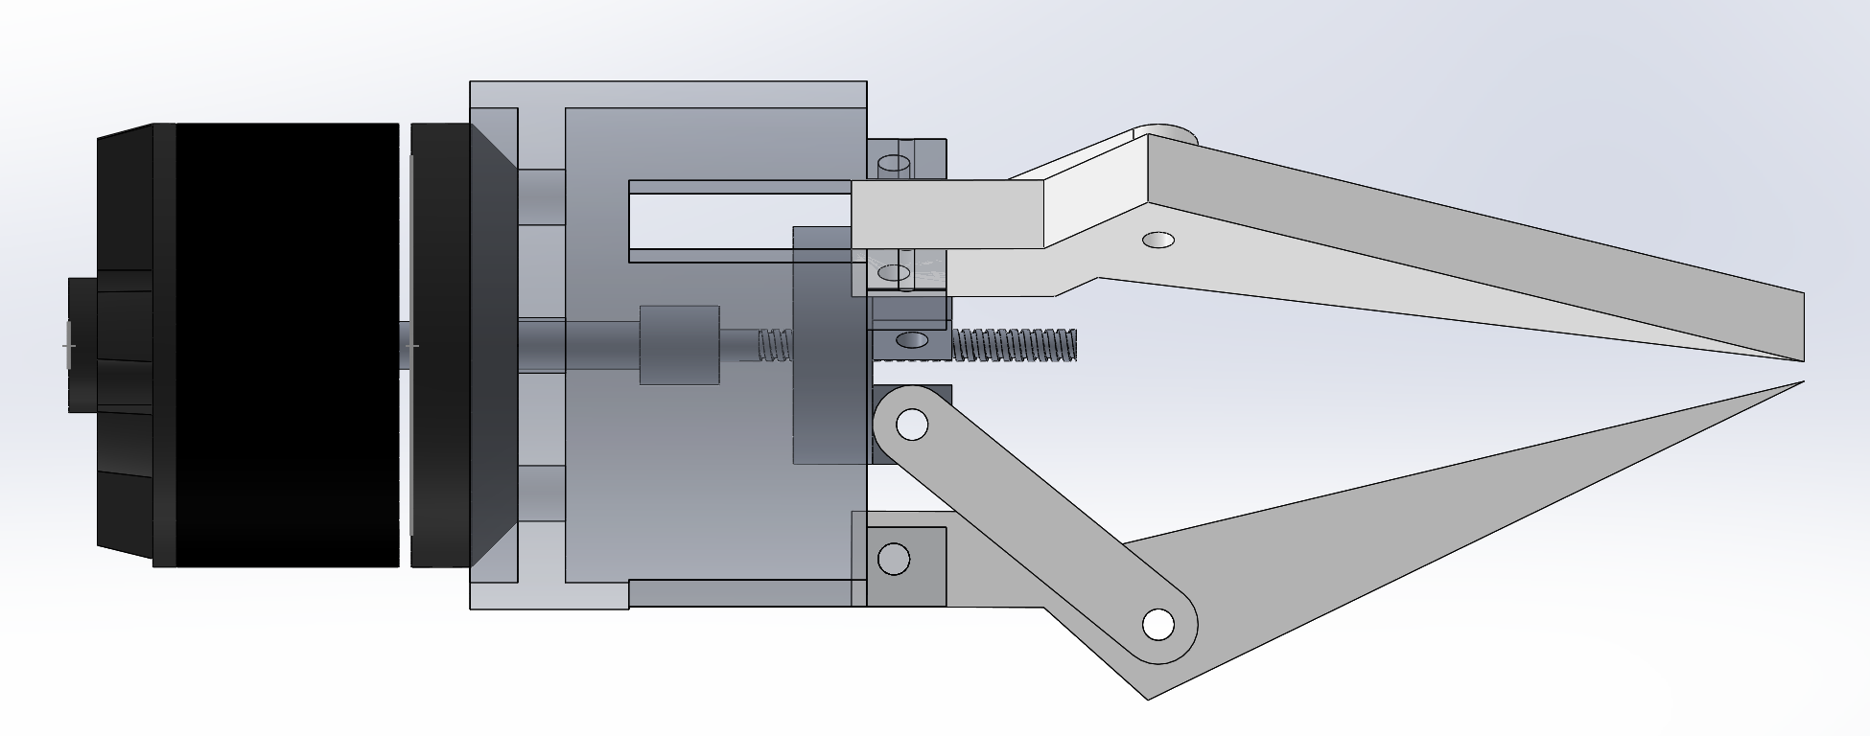
No threaded fasteners or pins/dowels.
By looking at the current assembly the first thing that is noticeable is that there are no threaded fasteners in place in the jaws or joins to keep the assembly together, there is also no pin or dowel in the cylinder connecting to the jaws to secure them without these the part would fall apart, and it would be impossible to assemble. Secondly there are no tolerances or clearances been specified with any of the components this will cause problems most evidently with the jaws, the joints and also the shaft.
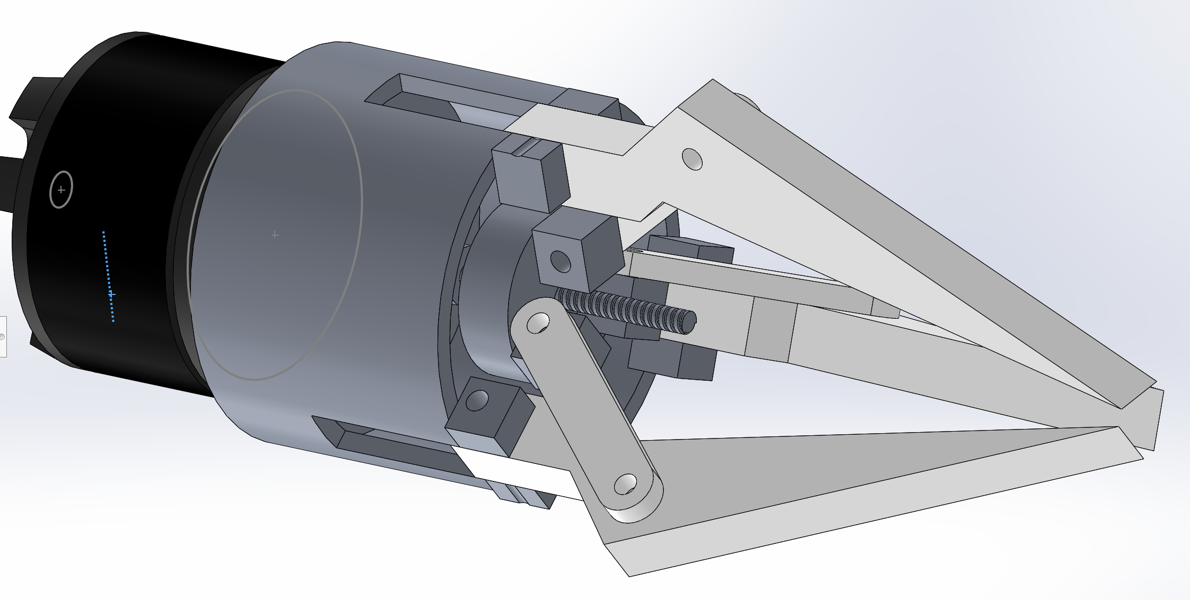

Here you can see where a lack of defined tolerances and clearance will cause the part to not function as intended with the potential that at best the jaw would rub against the cylinder and at worst would not fit or not move at all.
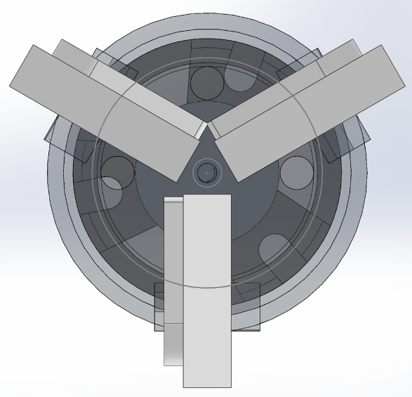
In this image you can see another of the clearance and tolerance issues that will arise from this design concept where the two joins meet, this will be another area where the assembly will not be able to function as intended. The joins here would impair each other’s movement.

Gripper Jaw
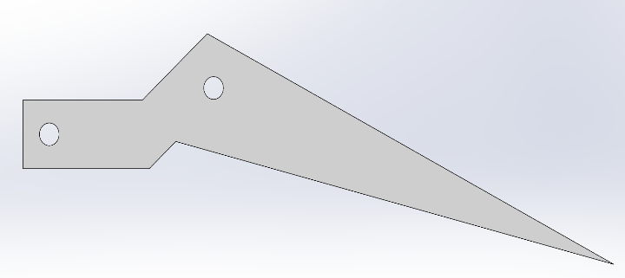
The point of the end of the gripper jaw is very thin and comes to a straight point, this would be a weak point in the design and would be prone to breaking or snapping off after many uses under the stresses of pick and place operations. This small surface area could also potentially lead to parts slipping out of the jaws grip.

Cylinder

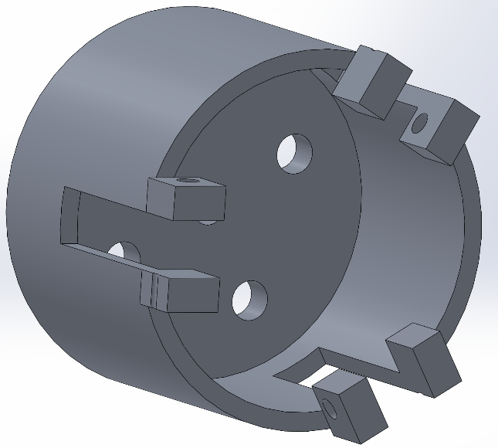
The cylinder has the issue that the hole in the square protrusions is not in the centre of the protrusion which will weaken the strength of the protrusion by decreasing wall thickness, also the hole does not line up with the other side with one hole being on the outer edge of the part. Also the protrusions have no support and overhang the centre bore significantly this could lead to them caving in or warping under load.

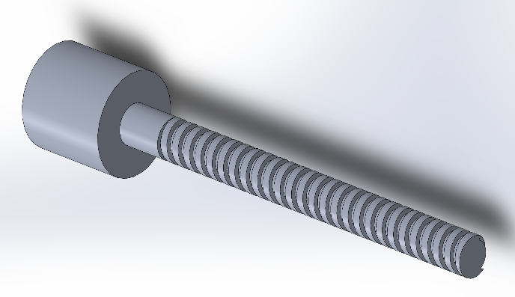
Worm and Shaft
As with anything that has a thread there is always the danger that it could be cross threaded during assembly and could potentially wear quickly depending on material choice.

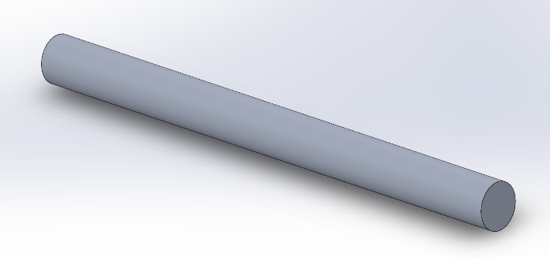
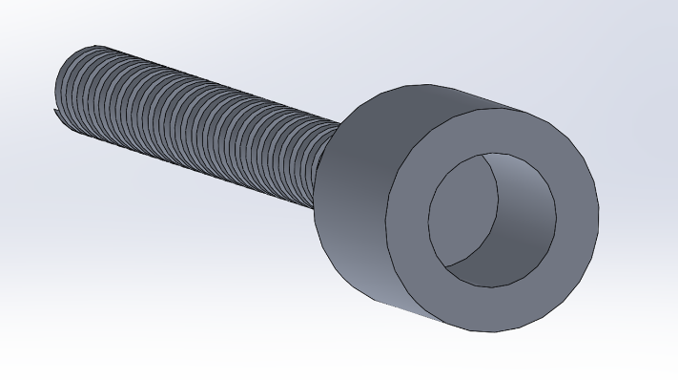
The shaft has no means of staying connected to the worm this would cause the shaft to rotate but not transfer its rotational force to the worm, In the current concept design this means that the shaft could come loose or that there would not be enough rotational force on the worm to turn the part leading to the gripper arm being unable to open and close its jaws.

Development of Design Specification
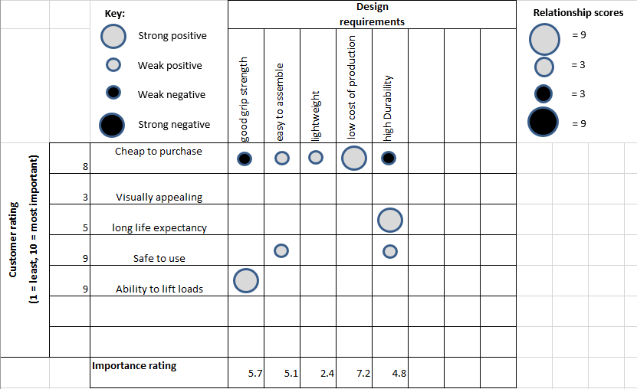To help with the design specification I have compiled a list of Customer needs and compared them with the design requirements of the product. As you can see in the table the most important area to focus on is creating a product with a low production cost so that it is cheaper for the customer, then an adequate grip strength to complete a variety of loads, ease of assembly would be next so trying to minimise the amount of separate components to assemble will have to be considered, followed by the durability of the gripper which will come from material selection and changes to the design and finally keeping the overall weight of the product as low as possible which would also be achieved by altering the design and material selection.

Manufacturing process proposal
In this section the manufacturing processes that were selected for each component will be discussed, these are the processes believed to be able to meet the required production volume of between 1000 and 2000 parts a week while also keeping the cost of production as low as possible.

Gripper jaw and Join
For the Gripper jaws and joins the manufacturing method selected is plastic injection moulding, there are many reasons that injection moulding was selected as the most suitable method of manufacturing these parts firstly the high volume of products that need to be produced is perfect for injection moulding which requires high volume production for the initial cost of tooling to make sense from the company’s perspective. There is also the low cost of production when the initial cost of tooling has been paid as it is an automated process, the main cost after this would be the cost of plastic for the mould which is far cheaper than metal. (Associates, 2019) Injection moulding is also well suited to make these parts as the three gripper jaws will be the same and also the joins will be the same, this standardisation of parts will mean that only two moulds would need to be purchased to make the six individual parts required. Injection moulding also has low scrap rates when compared to traditional manufacturing processes and lower amounts of material waste. The material that was selected for this process is Polypropylene this was selected due to its high tensile strength which should allow the material to withstand heavy loads and also it is recyclable therefore any waste material from the injection moulding or at the end of the life cycle of the jaws or joins they could also be recycled rather than simply disposed of. (steel, 2020)

Drive plate
The Manufacturing process selected for the driveplate is first die casting and then finishing on five axis milling/turning, the reasoning behind this decision is that the driveplate could be produced in two setups on a five axis lathe if some design changes are made that would accommodate this process, Five axis lathes such as the mazak INTEGREX i-400S which can perform milling as well as turning operations both of which would be required in the production of the part. (Mazak, 2021) The part could be done quickly and efficiently through these processes by using a cast to create the shape of the finished part and then finish machining on the multi axis machine such as cleaning up the outside of the part, drilling and tapping the centre hole, finishing walls of the protrusions, finishing the floor on the front of the drive plate then drilling the holes in the side of the protrusions. Casting the driveplate from a mould will save time in machining the part as the complex shapes will already be close to or within tolerance form the cast and will also reduce the amount of material waste reducing the overall material cost per part and a high level of repeatability (casting, 2019). The material for the drive plate would be aluminium to keep the weight of the gripper lower than if it were produced from steel.

Cylinder
The cylinder is another part that would need to be die cast and then machined on a five axis lathe but whereas the Drive plate was purely for time and cost reasons, the cylinder needing to be done in this way is due to the protrusions on the front of the part that overhang the inside bore, machining this from a billet would take a considerable amount of time even with design changes compared to first having a part that is cast close to specification and then is finished machined. The cylinder will also be made from stainless steel, this material choice was made because even though stainless steel is heavier than aluminium this will increase the structural strength of the part which is more important to the customer.

Motor
For the motor, the decision was made to purchase this part in and not manufacture it. The motor should be a standard part that can be acquired and attached to the rest of the gripper arm at the assembly stage. Purchasing the motor should be more cost effective than producing the part in the quantities that are required for the customer.

Shaft and Worm
The shaft and worm can both be turned using a cnc lathe from a billet, the shaft being just a straight shaft will be quickly produced on a lathe and the worm could be produced in two setups with the application of a steady when screw cutting the thread, this process is best suited for these parts as there is not a significant amount of machining to be done from a billet in comparison to the cylinder and driveplate. The shaft and worm would also be made from aluminium as stated before to keep the overall weight of the gripper arm low.

Design and development work
This section will focus on the changes to the design that have been made to ensure that the part is able to be manufactured and can satisfy the design requirements for the product. It will also touch on product life cycle factors such as disposability and recyclability of the components.

Gripper jaws
The first design change that will be made to the grippers is the addition of a 1mm fillet that will encompass the part this will help with material flow and avoid sharp corners on the part, the second design change will be that the centre of the Jaw will be cored out creating a thin wall to reduce the chance of the plastic sinking when cooling. Another change will be that there will be ribbing from the walls to the hole in the jaw to secure the hole and add rigidity to the structure of the jaw. The final design change will be that the point of the jaw will be changed to flatten off on the end to increase the surface area between the jaw and anything that it will be required to lift, this will increase the stability of the gripper when lifting objects. These design changes have been made mostly to accommodate the manufacturing process of injection moulding. (Labs, 2021)
ribbing.
Core out.
1mm fillet.
flatten off this area.

Joins
A similar approach to the joins will be made as the Gripper jaws as this part will also be made through injection moulding. A 1mm fillet will be employed on the outside edges of the joins to improve material flow, then as with the gripper the centre of the part will be cored out leaving thin walls that will reduce sinking of the plastic during cooling and ribbing will be employed to strengthen the structure of the part.
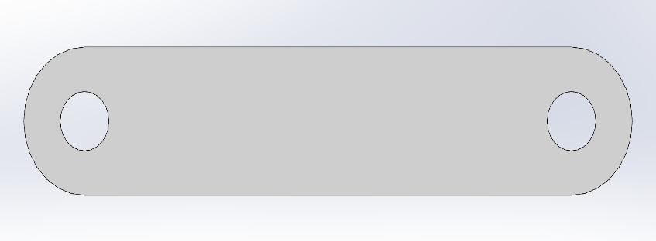
Core out.
Ribbing.
Fillet.

Drive plate
The changes to the drive plate will be subtle, the first change will be to the protrusions, the outside walls will be rounded to keep the outside of the part circular without the corners that are currently jutting out over the outside diameter, secondly the holes in the side of the protrusions will be tapped m3 this is so that when an m3 bolt is used to assemble the gripper there is no need for a nut on the other side making the assembly easier with less components. Finally, the corners of the part would have a 0.5mm fillet as the part is casted it would need this to increase material flow.
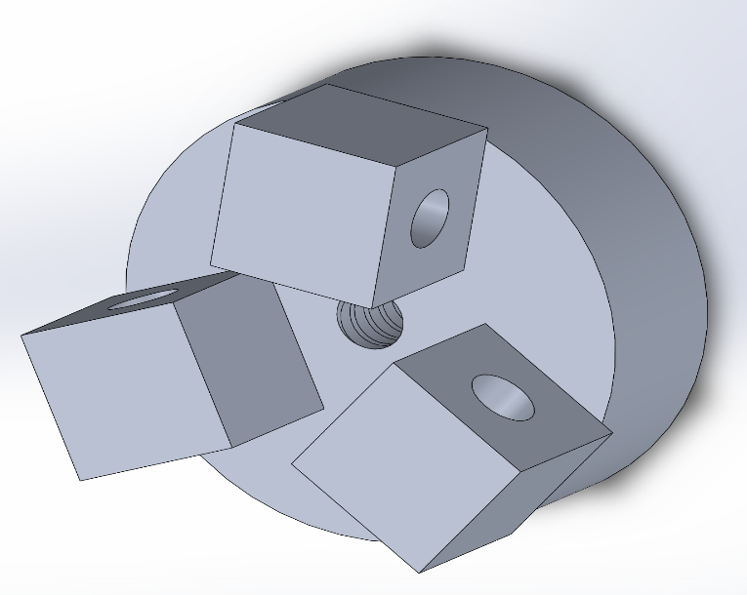
Round these areas
Tap m3

The hole will be specified not to be tapped through, with each taped hole being on the same side all the way around this is to prevent the part from being assembled incorrectly with the joins clipping into each other as seen in the concept design appraisal.

Cylinder
On the cylinder the changes that have been made are, the hole in the protrusion will be made centre and will be aligned to the opposite protrusion, also on this hole one side will be tapped m3 and the other will be clearance on an m3 bolt this is also to eliminate the need for a nut to be used. The holes apart from the centre hole for the shaft will be removed, the protrusions on the front of the cylinder will have the outside rounded in line with the outside diameter and will have a wall going down to the bottom of the bore to strengthen the protrusions and to avoid them from caving in or warping under load. Finally, as with the drive plate the cylinder will have a 0.5mm fillet on the outside edges as this part is also cast before being finish machined.
Round outside.
Align holes.
Tap one side.
Add wall.
Fillet.

Shaft
The only design change to the shaft that will be made will be the inclusion of a clearance hole for an m3 bolt through one side of the shaft, this was added so that the part could be assembled properly, stay connected to the worm and also transfer its rotational force to the worm which drives the gripper arm. A chamfer on the front and back of the shaft was added to avoid sharp corners making it easier to handle and also make the part more aesthetically pleasing.
Chamfer.
Inclusion of clearance hole.

Worm
The worms design changes are that on the front of the thread a lead in would be added to reduce the chance of cross threading or damaging the thread when assembling and also make it easier to assemble. Chamfers would be added to the outside edges to once again avoiding sharp corners to make handling of the parts easier and also making them more aesthetically pleasing. The final change would be to add a clearance hole for m3 through one side of the worm that would align with a tapped hole on the other side, this was added so that an m3 bolt could be lined up through the hole in the shaft and assembled properly.
Clearence and tapped hole added.
Chamfers.
Lead in.

Additional considerations in the design
The decision was made to use m3 bolts throughout the design, this feature was made for ease of assembly purposes and standardisation with only m3 bolts needed it reduces the number of different components needed to carry out maintenance and assembly. Threaded holes were added to the assembly where possible to reduce the need of nuts being used in the assembly, again this was done for ease of assembly, unfortunately in the connection between the gripper jaw and join a nut would still need to be used.
A general dimensional tolerance of +/- 0.25mm would be used throughout most of the sizes on the components with the exception of areas such as where the gripper jaw meets the cylinder and the connection of the shaft and worm. This is done because generally a larger tolerance such as this will lead to decreased production cost (ZONE-CHING LIN, 2002) as less care needs to be taken when machining these areas as they do not affect the function of the product as much as other areas.
Clearance holes will be made at +0.1mm, -0mm such as the holes in the gripper jaw, joins, cylinder, worm and shaft.
There would be a sliding fit required for the shaft meeting with the back bore of the worm, this would typically be achieved by using a h7 fit on the bore in the worm which would be a tolerance of 0mm, +0.01mm and a g6 fit on the shaft which would be -0.004mm, -0.01mm. This fit would allow for the shaft to slide and spin in the bore without being able to move freely or fit loosely. (bearings, 2021)
There would need to be a specified clearance on the dimensions of where the gripper jaws fit in the cylinder, this would need to be +0.05, +0.1 on the slot in the cylinder and 0, -0.1 on the overall width of the gripper jaw, this would ensure that the gripper arm is not too big for the slot and is free to move in the slot without rubbing.
The specific aluminium chosen for the Worm, shaft, and drive plate would be LM24, this aluminium alloy was selected because of its low cost in comparison to other cast aluminium, its high tensile strength and its excellent casting characteristics. (castings, 2021)
The purchased motor will be welded to the back of the cylinder, although this does mean that it makes recycling the material more difficult and its more likely to be disposed of it will make assembly easier as there will be no threaded fasteners required.
For the cylinder a low carbon Stainless alloy with a high chromium content would be ideal as this part will outlast the others, this is a slightly more expensive material choice that is corrosion resistant and durable (materia, 2002) which makes more sense here compared to other parts and this will mean that only the more easily recyclable parts, the gripper jaw and joins being made out of Polypropylene and the shaft, worm and drive shaft being made from LM24 aluminium will need to be maintained or replaced while the cylinder would remain functional.
The decision to use Polypropylene over pvc was made by the company because even though pvc is cheaper than Polypropylene and has a higher tensile strength pvc is not recyclable, it was felt that public perception would be improved if the gripper arm were more environmentally friendly by not using pvc and that the parts could be reused after they have ended their life cycle by recycling them into new pellets. (2H, 2021)

Conclusion
In conclusion I believe that the design changes that have been made will make the gripper arm more usable with the errors in the design highlighted in the FMEA being fixed and also that the gripper arm is easier to assemble and manufacture. The new design features have been made around the design specification using manufacturing processes such as injection moulding and casting that have high initial costs due to requiring the manufacture of a mould but once that is completed have very low costs in producing parts, these are viable because of the volumes of between 1000 to 2000 units per week where cost per unit is more important than the initial costs of the mould. The design while being low cost to produce does not sacrifice in durability of the main gripper body with the cylinder being manufactured from stainless steel and if any of the plastic joins or gripper jaws need to be replaced the design allows for this to be done easily with standardisation of the parts and error proofing such as with the position of the m3 tapped holes on the drive plate. Even though the weight of the product was not as important as other factors this was still something that was strived for in the design process to ensure that the m3 bolts would not have additional strain from the weight of the parts on top of any loads that needed to be lifted. This final design is a vast improvement over the original even when looking at small changes like increasing the surface area of the gripper jaw points to reduce the likelihood of parts slipping or scratching during pick and place operations. The biggest commercial risk involved with the design is the high initial tooling cost that comes from the injection mould and casting tooling but this risk factor is mitigated by meeting the customer needs on cost, durability, being light weight and easy to assemble.

Works Cited
2H, 2021. 2H Structured Media PP vs. PVC. [Online]
Available at: https://www.2h.com.au/f/PP%20vs.%20PVC-e.pdf
Associates, P., 2019. plastik city. [Online]
Available at: https://www.plastikcity.co.uk/blog/advantages-disadvantages-of-injection-moulding/
bearings, s., 2021. simply bearings. [Online]
Available at: https://simplybearings.co.uk/shop/Info-Pages-ISO-Limits/c4746_4779/index.html?page=1#Q3
casting, m. p. d., 2019. mpd. [Online]
Available at: https://midlandpressurediecasting.co.uk/pressure-die-casting/
castings, M., 2021. MRT castings. [Online]
Available at: https://www.mrt-castings.co.uk/aluminium-casting-characteristics.html
Labs, P., 2021. proto labs. [Online]
Available at: https://www.protolabs.co.uk/resources/design-tips/design-essentials-for-injection-moulding/
materia, t., 2002. Cast Stainless Steels. [Online]
Available at: https://www.totalmateria.com/page.aspx?ID=CheckArticle&site=kts&NM=67
Mazak, 2021. mazak usa. [Online]
Available at: https://www.mazakusa.com/machines/integrex-i-400/
steel, M., 2020. 7 Need-to-Know Polypropylene Material Properties. [Online]
Available at: https://www.marlinwire.com/blog/7-need-to-know-polypropylene-material-properties
ZONE-CHING LIN, D.-Y. C., 2002. Cost±tolerance analysis model based on a neural networks method. Cost±tolerance analysis model based on a neural networks method, 40(6).

