Anna Misiak-Ali (2311228)
University of Wales Trinity Saint David
Blogs

Contents
Blog 1 2
Blog 2 3
Blog 3 5
Blog 4 7
Blog 5 8
Bibliography 10

Blog 1

Where to start project management? It starts with the goal.
If you don’t know where you are going, how you will know if you are there? According to Visakh (2022) every single project should have clearly specified goals. Without thinking it through we can have problems with achieving our goals. How to initiate a project that at the end we can say ,we did it because we followed our plan, instead , we managed’? We can use SMART method as a way to determine our aims (Nellenbach and Hinds, 2000):

Specific- goals are clearly stated and the needs of the project to be accomplished. Information who is responsible, and what steps need to be completed to achieve it.
Measurable- there should be a source of information that allows us to determine if our goals were achieved.
Achievable- goals should be realistic to achieve, the challenges of achieving goals might need to use more specific resources but the process of learning something new can be rewarding.
Relevant- your goals need to be aligned with your objectives. The goal must be realistic and achievable within the resources and time.
Time-bound- goals have define deadline, all the projects must start and finish, creating visible timeline gives us sense of urgency.
SMART in project management should be done with clarity and specificity.

Blog 2

Agile vs. Waterfall. What is the difference?
Agile is a framework that allows us to work in a mindset which helps to respond much faster to a changing requirement. The goal for Agile is to release benefits through project lifecycle instead waiting to the end of the project. It also helps to catch any problems and act quickly to solve the problem. Agile is mostly used in software development as the changing world and demands allows you to adjust said Garcia (2022).
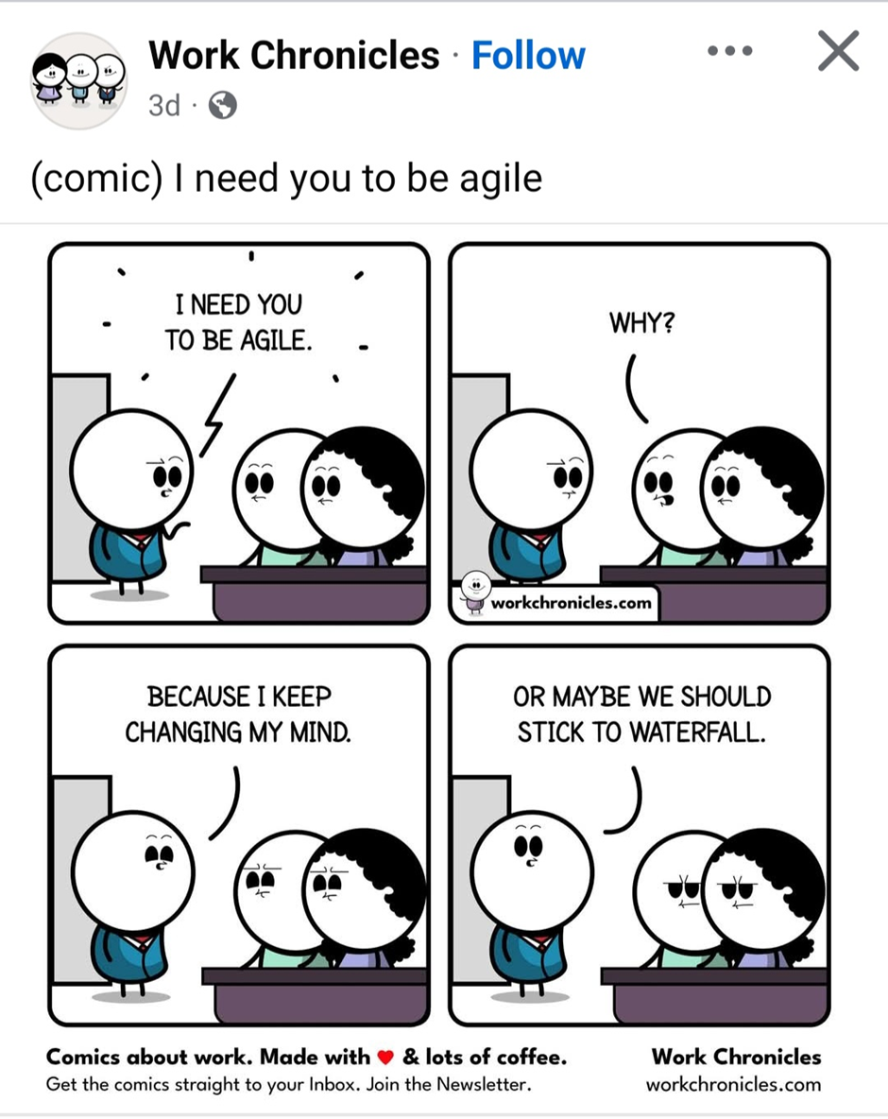

Waterfall is more linear and stricter. Team must follow steps of the project until the current phase is completed. Each step is clearly defined. All the project steps are defined in the first part of the project. The requirements set at the beginning of the project don’t change during the project course. High requirements of the documentation suit the waterfall project model as it requires repeatable and predictable processes. Waterfall is effective for projects that are well-defined, and changes are minimal, ensuring consistency and traceable control (Project Management, 2025).
Waterfall project cycle
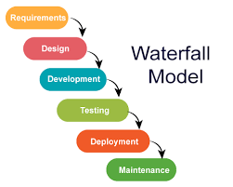
Source: Google images

Important difference is that the waterfall project is fixed, linear plan compared to agile method that priorities and require changes after customer feedback session.

Blog 3

How to make a Gantt Chart?

Gantt Chart is a graphical explanation of activity against the time. In the case of a Gantt chart, the most important thing is that it is understandable and legible. The construction of a Gantt chart should be divided into stages and tasks. Just like a project schedule. Let's check what needs to be done:
The first stage requires division the project into goals staged, partial.

The second stage involves determining the time, duration of the entire project,
implementation of stage tasks, implementation of partial tasks.

In the third stage, we determine the order of tasks and their start and end dates. Pay special attention to the task completion dates – they will be needed
to determine the critical path in the project.

The final stage is to collect all the information and create a Gantt chart.
At this stage, consider the specific use of the Gantt chart – whether it should be legible only for you or primarily for the Team you manage.

Gantt chart
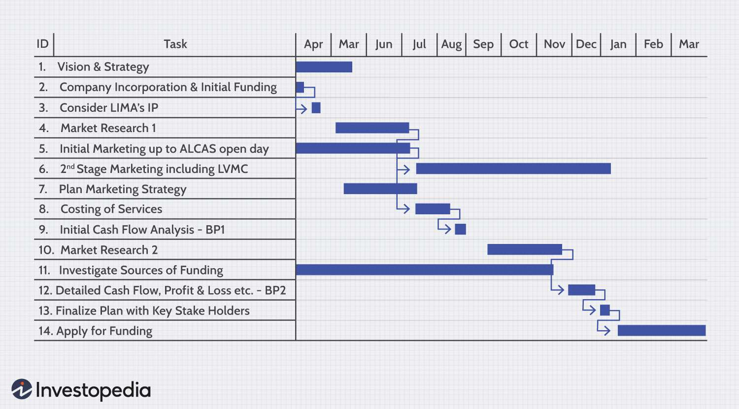

LaPrad (2025) states that the most important advantages of Gantt charts are strategic planning, dependency management, real-time tracking, resource balancing, stakeholders alignment, and risk management. All those benefits show why Gantt charts are the most use tool across so many industries.

Blog 4

COMMUNICATION WITH STAKEHOLDERS. WHY IT IS IMPORTANT TO YOUR PROJECT?

Communication is the KEY but first we have to know who stakeholders are? The concept of stakeholders according to Barney and Holak (2023) refers to individuals, groups or organisations that influence or are influenced by the activities of an enterprise. Stakeholders are entities that influence the goals of an organisation or are influenced by its activities, both directly and indirectly.
Effective communication allows for understanding stakeholder expectations, as well as effectively managing their involvement in the company's projects and activities. Most important aspects of communication are:
- Building trust- regular and clear communication with stakeholders helps in building trust, however weak communication can result in withdrawal from the project.
- Better decision making- it helps to understand needs and expectations, in a result better decision making.
- Risk reduction- good communication helps to recognise potential conflicts, so you can react faster, and preventive actions put in place.
- Increase engagement- dialogue with stakeholders can increase their involvement in project implementation.
Why are stakeholders important to organisations?
Stakeholders are extremely important because each of them can affect the organisation in different ways. Employees can increase or decrease their performance, customers can recommend or discourage products, and investors can withhold their funding.

Blog 5
The first project came to an end, and it is a time for self-reflection. To gain clarity and give myself space for improvement I need to ask myself few important questions.
What are my biggest strengths and weaknesses?
I think my bigger strengths are the ability to work in a group. It motivates me to work better and learn from other members of the group. My weaknesses will be time management. I need to plan my schedule so I can progress with my work and finish it on time without a stress associated with it.
What are my limitations and how I can overcome them?
The experience with group project opened new opportunities for me to learn. As a team we used manday.com app to create our Gantt Chart and WBS but it was only trial, and the app stopped working half through the project. Lesson learnt, check how long you can use app before you have to buy a subscription.
What did I learn about myself recently?
I was responsible for control process in this project. This experience helped me to realise areas I need to improve. The application called association for project management (apm.org.uk) help me to find areas of my improvement and I can trace my progress.

Self-assessment
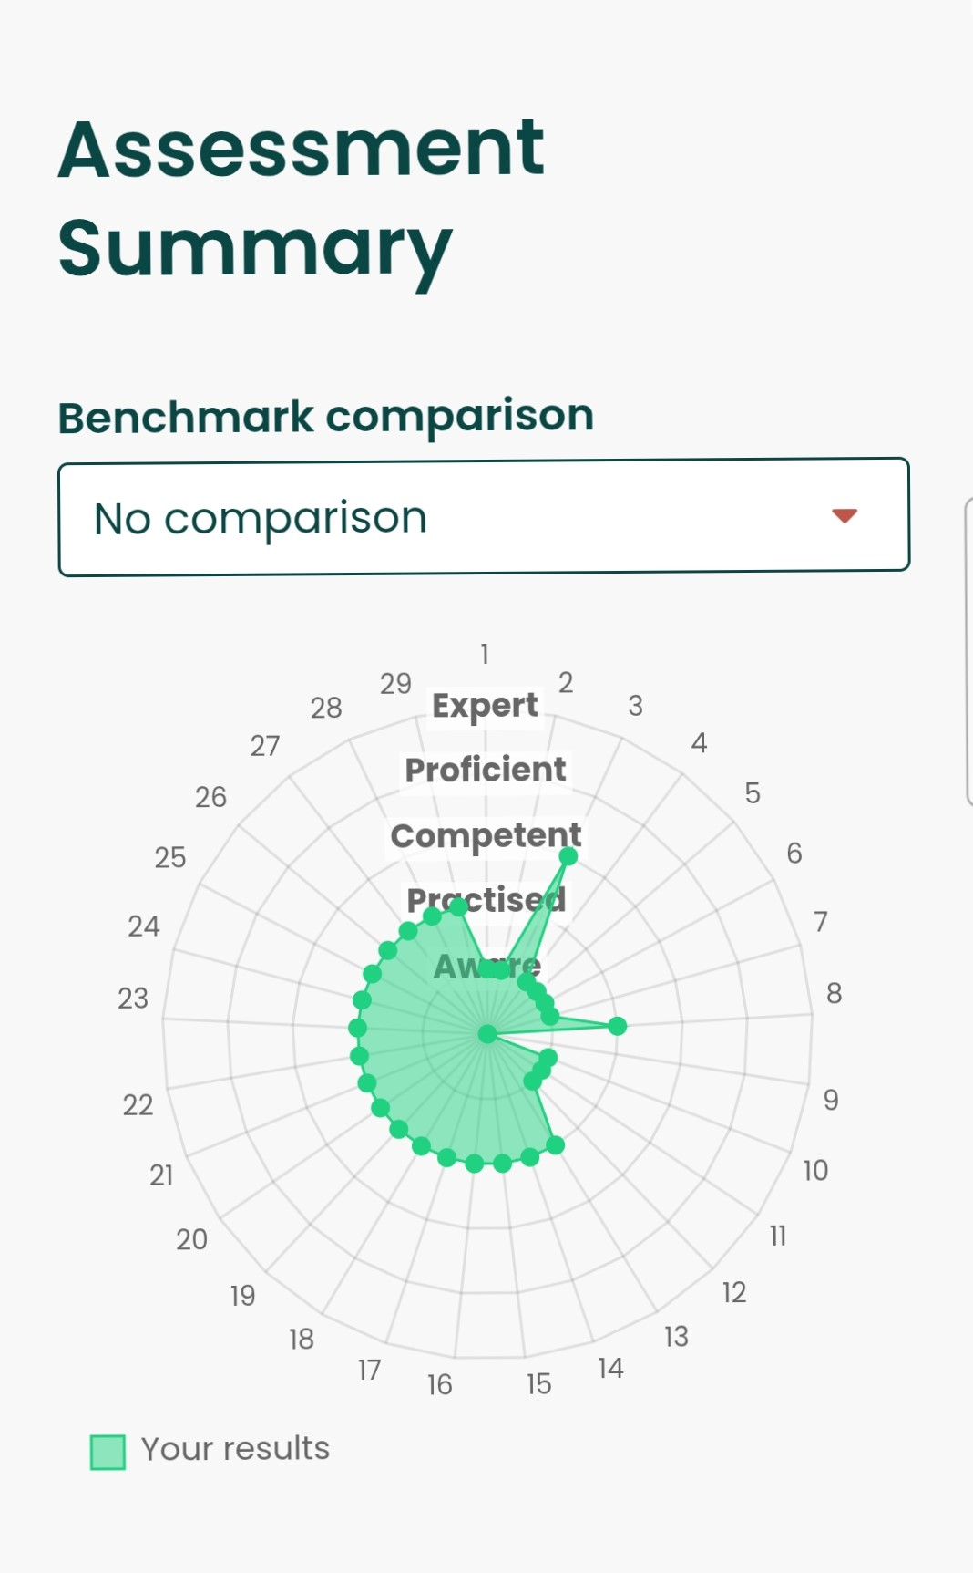
Source: apm.org.uk

Bibliography

Barney, N. and Holak, B. (2023) Stakeholders. [Online]. TechTarget. Last Updated: 12 January 2023. Available at: https://www.techtarget.com/searchcio/definition/stakeholder (Accessed 1 July 2025).
Garcia, H. (2022) Why do we need agile project management? [Online]. Association for Project Management. Last Updated: 19 December 2022. Available at: https://www.apm.org.uk/blog/why-do-we-need-agile-project-management/ (Accessed 1 July 2025).
LaPrad, L. (2025) What Is a Gantt Chart? A Project Manager’s Guide to Smarter Planning. [Online]. teamgantt. Last Updated: 3 June 2025. Available at: https://www.teamgantt.com/what-is-a-gantt-chart (Accessed 1 July 2025).
Nellenbach, J. M. and Hinds, P. (2000) Get SMART for better management. PM Network, 14(8), 76–78. Available at: https://www.pmi.org/learning/library/smart-style-better-project-management-4605 (Accessed 1 July 2025).
Project Management. (2025) Waterfall Model. [Online]. Project Management. Last Updated: 2025. Available at: https://www.projectmanager.com/guides/waterfall-methodology (Accessed 1 July 2025).
Work Chronicles. (2025) Work Chronicle. [Photograph]. USA: Facebook.
Visakh, R. (2022) What is SMART in Project Management. [Online]. STARAGILE. Last Updated: 26 August 2022. Available at: https://staragile.com/blog/smart-in-project-management (Accessed 1 July 2025).

