TASK 1:

ANALYSIS OF LEADERSHIP IN TIMES OF EXPONENTIAL CHANGE

BMSW6101
TUTOR: Eric Osei

BY
NAZIA CHOUDHURY
1817657

Contents
INTRODUCTION – TASK 1 3
1: LEADERSHIP PHILOSOPHIES AND LEADERSHIP STYLES: 4
2: THREE LEADERSHIP STYLES MOSTLY IDENTIFIED WITH MODERN LEADERS IN UNCERTAIN TIMES: 6
2.1: Contingency Theories: 7
2.2: Transactional Theory: 7
2.3: Transformational Theory: 8
3: CREATING A CONSTRUCTIVE WORKING ENVIRONMENT FOR POSITIVE OUTCOMES 9
CONCLUSION: 10
INTRODUCTION – TASK 2 12
1.1 Presentation on leadership styles: 12
1.2 Understanding My Leadership Style: 13
1.3 Learning to Paraphrase: 13
CONCLUSION: 14
REFERENCES: 15

INTRODUCTION – TASK 1

This report is based on a case study about Chris; a manager of a large organization who although well qualified and has a long successful career, his authoritarian leadership style is no longer effective in the emerging modern day challenges of a pandemic and rapid changes in globalization, advancements in technology, etc, which are leading to staff turnover, low morale and motivation and a decline in performance and profits.

The report will explore how emergent leadership can help Chris become an effective agile leader. It will first discuss the relationship between leadership styles and philosophies, then go onto discuss 3 types of emergent leadership and how Transformational leadership would be best for Chris. Finally the report will look at how Chris can create a constructive working environment to generate positive outcomes.

1: LEADERSHIP PHILOSOPHIES AND LEADERSHIP STYLES:
A leader is someone who manages and motivates people in different situations, guiding and influencing them to goals and problem solving to maximise performance and profit and meet organisational goals (Gasaway, 2006).
Sethuraman and Suresh (2014) suggest leaders have a born skill and have natural innate traits and philosophies in order to take responsibility and control. Leadership is also an ability both natural and acquired, and a skill which can be studied and learned understanding people,budget/finance. They know how to combine behaviours a) Task behaviour which is goal orientated, facilitating the process to be completed and b) Process Behaviour; how task is accomplished, for authoritarian leaders this is normally by micromanaging which although gets results and structure, creates a negative, de-motivated working environment as is the case for Chris, and c) Relationship leadership style which is employee orientated to focus on work culture, employee recognition and motivation so they feel valued and engaged, increase production and performance (Church, 1995). Leadership is a relationship which isn’t linear but interactive between leaders and followers to improve business practices and processes and an influence process influencing followers towards a common goal within an ethical framework of rules and regulations (Hannah and Avolio, 2011).
There is however a downside to leadership whereby leadership is complex and has many different dimensions and can be characterised by toxicity and corruption of influencing people for personal gains.
An effective leader must first understand the philosophies of leadership style as this helps the leader to become more competent, increase profitability, sustainability and performance in competitive markets (Arsalana and Staubb, 2013). Leadership philosophy is the key assumptions of a fundamental behaviour which inspires leadership behaviour.
According to Aithal and Kumar (2016) Douglas McGregor developed Theory X and Y in the 1960’s to manage organisational behaviour (see table below). Theory X assumes that humans are lazy, need direction and goals so need micro managing. Theory Y assumes that humans are more innovative and creative, work on their own iniative and are goal focused so need little management, these leaders motivate and engage employees and are tuned to helping them. Theory Z by William Ouchi in 1981, focuses on employee well being professionally and personally in order to retain employees and get loyalty (McGregor, 2016). However, Aithal and Kumar (2016) go on to suggest that due to globalisation and changes in technology and work culture Theory A (Theory of Accountability) was developed to make people accountable for their work so that they value it.
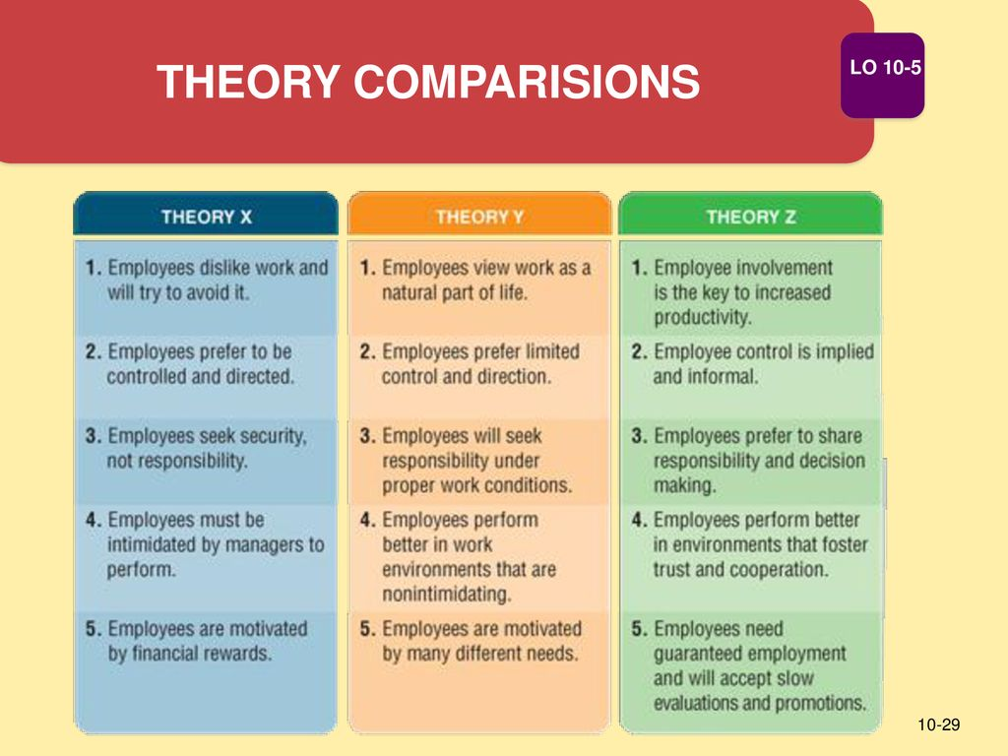

Theory X Assumptions are linked with autocratic style leadership who manage and control.
Theory Y Assumptions are associated with a democratic style of leadership – relationship orientated not task orientated, no need for control, leaders are facilitators not managers.
There are 3 leadership styles: Authoritarian, Democratic and Laissez-Faires, however there is no best leadership style, leaders need to adapt to each situation and guide their followers in challenging situations.
Authoritarian leadership style: Like Theory X, view followers as needing direction to avoid mistakes, they determine tasks, procedures and exert influence and control over the group. They don’t encourage communication among members but prefer communication to come to them directly. They make decisions without talking to the team which can be demoralising but is effective in challenges and emergencies. This leadership style generally has negative outcomes like limiting creativity, no trust or confidence in members who have defiance, freedom of choice, group interests and ability to criticise is ignored, thus members have low morale. However outcomes can sometimes be positive for example some people like lazy people prefer tasks to be given to them, this is also beneficial for young or inexperienced people who need direction or jobs like the army or police. It is also effective in time controlled projects and there is discipline and security (Khan et al, 2015).
Democratic Leadership Style: like Theory Y this type of leader is empowering and innovative and guides as opposed to directing. They speak in an egalitarian way giving objective feedback and promote communication. This style of leadership is collaborative and inclusive and is most effective with highly skilled or experienced workers. It is beneficial as it boosts confidence, gives greater group member satisfaction that give and have high engagement, motivation and originality. However the outcomes for this type of leader can also be negative as it takes too much time and effort and can have slower decision making as they go back to the group to get opinions which would result in lower productivity. It can also result in inefficiencies and lead to procrastination and resentment from weaker members (Warrick, 1981).
Laissez-Faire Leadership Style: like Theory Z, these leaders do not control followers but give freedom at work, this autonomy gives job satisfaction as the leaders just manage relationships and have a very laid back attitude with minimal influence. This leads to mainly negative outcomes like little productivity as members are directionless and don’t know what to do. Giving complete freedom can result in a chaotic atmosphere, and these employees cannot time manage well (Chaudry and Javed, 2012).
Chris has an authoritarian style of task leadership which although worked well for him over the last 25 years enabling him to meet targets and be successful as he was well qualified, it was needed as his team were aggressive so needed control. He did not adapt to challenging times like the Covid19 pandemic and rapid change in advancements in technology, globalisation, etc, this shows his leadership skills are poor. An effective leader changes his leadership style according to the situation, however, authoritarian leaders find this difficult to do as they like to keep total control and not be challenged. Chris’s authoritarian leadership adopts the philosophy of Theory X that people need direction and control, has led to low morale, less motivation and engagement and mental health issues resulting in poor performance and low profits from his employees who no longer wish to work under him or resign. Chris is more of a manager than a leader as he does not have the drive or vision to motivate his employees or create a positive working environment. He needs to change his leadership style to democratic and adopt philosophy Y; listen to his employees, taking feedback and input for decision making and problem solving of the challenges he is facing as well as constructive criticism to engage with his members and learn how to adapt to the new business environment and change (Jamal, 2014). Chris can get engaged and loyal employees team through good communication, trust, intrinsic and extrinsic rewards and influencing them towards a common goal

2: THREE LEADERSHIP STYLES MOSTLY IDENTIFIED WITH MODERN LEADERS IN UNCERTAIN TIMES:

An effective leader needs to have a blend of both task and relationship leadership, looking at the wellbeing of employees at the same time meeting targets and goals (Henkel, Marion and Bourdeau, 2019). Therefore emerging leadership styles are needed to adapt to follower needs and help to achieve goals in a changing environment. Leaders also need to learn leadership skills which are critical for success; these are different from traits that are normally part of your personality (Lamm, Carter and Lamm, 2016). This consists of 3 components: Administrative skills, Interpersonal skills and Conceptual skills.
In challenging situations successful leaders should be able to show tolerance, patience and emotional stability and be more hands on. They need to re strategise and re-allocate resources by thinking on their feet to resolve problems then go back to the drawing board and re-strategising. Managers should be re-trained in areas of weakness.
Due to globalisation and rapid and constant changes in organisations, decisions need to be made quickly and across different people so leaders like Chris need visions and creativity (Naile and Selesho, 2014).
In order to create strategic change Chris need to:
- Envision future strategies
- Align the company to carry out the strategies
- Embody change by implementing practice

New emergent theories of leadership styles are needed to do this based on traits and skills and leader’s behaviour and styles are needed like contingency models, transactional and transformational leadership.

2.1: Contingency Theories:
Contingency theories developed in the 1960’s suggest that there is no single way of leadership; rather leadership style should be situational depending on the industry or culture.
The 3 most popular models of contingency theories are Fiedler’s Contingency Theory (how a person’s leadership style matches the situational favourable), House’s Situational Leadership Theory (leader should adapt leadership style to situation) and Hersey and Blanchards’s Path-Goal Theory; contingencies are leadership style and followers maturity and characteristics (Mallette, 2005). This approach is based on the premise that leaders should adapt their leadership style to the situation rather than use one style of leadership in order to be sustainable (Vroom and Jago, 2007). They are based on 3 contingency variables: business strategy, external environment and company size and type. In order for leaders to be effective they must adapt their skills in challenging situations with different approaches focusing on motivation, task management or relationship management. An example of a modern day leader who practices this theory during challenging times is the New Zealand prime minister Jacinta Ardern who in 2019 guided her shocked country through the aftermath of the Christchurch shootings by swiftly introducing new gun laws and then in 2020 she responded to effectively to Covid19 pandemic by limiting its spread in her country. She is good at crisis management.
The advantages of this theory are that leaders are creative, innovative and are situation orientated as opposed to stereotypes. It also gives leaders discretion in decision making and helps them to plan for challenges that may happen and recover quickly from challenging situations (Stern, 2013). The disadvantages are that it cannot explain why certain leadership styles are effective in some situations and not others and there are no clear guidelines of action for leaders in different situations (Reinking, 2012).

2.2: Transactional Theory:
Nanjundeswaraswamy and Swamy, (2014) suggest that Transactional leadership developed in the 1970’s is formed through a series of mutual exchanges, A transactional leader uses task leadership to work with followers to achieve goals in a positive way by motivating and rewarding as well as punishing when performance is decreasing (see table below). The advantages of this theory are that it is effective in crisis management predicting fast results and increasing profit, it allows swift decision making and gives structure. The disadvantages of this theory are that this type of leader is strict and does not change their style; followers are blamed for negative outcomes. Followers also have low morale and creativity. An example of a modern leader who uses this model successfully would be Bill Gates who initially was a very strict leader who although charismatic he micromanaged staff to meet deadlines and targets to build his company Microsoft during a time of emerging globalisation and technological advancements through technological innovation and good business strategy. Through control, he quickly and efficiently met goals then rewarded staff. The style of leadership depends on what benefits the leader and the organisation responds to what the employee is doing. Followers choose a leader who is most beneficial for them and minimises negatives, they identify with leaders who inspire and motivate and have charismatic personalities (Thite, 2000).

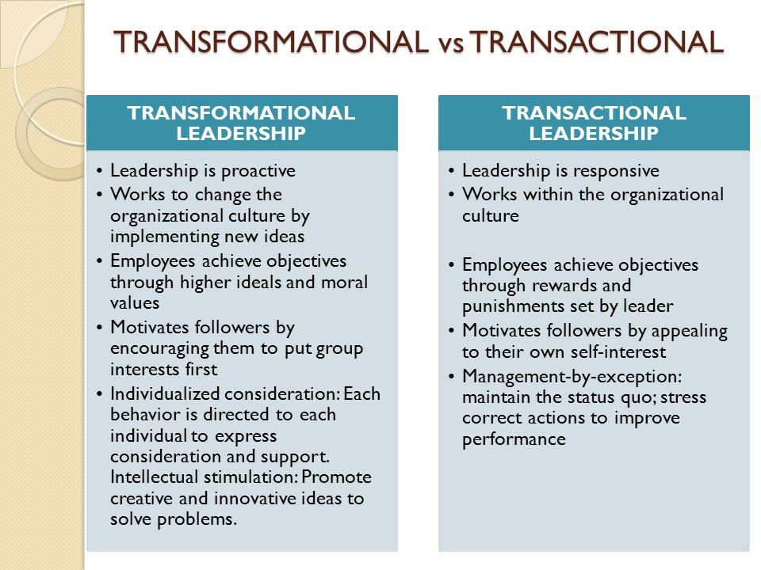

However a transactional leader does not go further than the organisational boundaries and practices, they look at short term goals and are not flexible and don’t adapt to change well, therefore a more transformational approach is needed that is both task and relationship orientated as seen in the table above (Alavi, Rabah and Jones, 2021).

2.3: Transformational Theory:
De Smet, Lurie and St George (2018) state when faced with a challenge an effective leader needs to think outside of the box, however Chris does not adapt, he needs to be dynamic and adapt to the emerging situations to succeed. He can do this by being a Transformational leader. They go on to suggest that a successful transformational leader needs to be honest and pro-active, have integrity and self confidence to take risks (Simons, Palanski and Treviño, 2013). He also needs cognitive ability and technical expertise to push towards goals and improvement by having knowledge of the business and the intelligence to formulate strategies and solve problems with correct decision making, calmness and confidence. He needs to be emotionally mature and exercise power to benefit the whole organisation and empower followers to reduce staff turnover (NCube, 2010). He needs to transform his followers by inspiring them and to identify with him and the organisations goals through his charisma to gain their admiration and engagement. This can be done by promoting organisational identity based on collective values and beliefs to achieve the organisations vision and by inspirational motivation; encouraging the development of followers, leading by example to transcend own interests for the sake of the organisation and common good, and by fostering an ethical work environment with clear values, priorities and standards. Chris can do this by having intellectual stimulation and soliciting new and novel approaches for performance of work and creative problem solutions from followers and by practicing individualised consideration; listening and giving special consideration to the growth and development of followers (Shamani and Abbas, 2020).
The advantages of following Transformational theory is that it lowers turnover costs, leaders can effectively generate and administer change, problem solve efficiently and leaders recognise followers as individuals motivating and inspiring them to exert discretionary effort leading to happy followers, high performance and profits. However the disadvantages are that change can be time consuming, followers can be manipulated by leaders who have poor ethics and moral values, followers can have burn-out, lack of short-term focus, needs constant open communication and feedback (AlGhanem, Braganza, and Eldabi, 2019).
An example of a successful transformational leader is Amazons leader Jeff Bezos who encouraged and motivates his workers to commit to and share the vision of Amazon with task leadership. He is creative, innovative and adaptable to change to remain competitive especially during Covid19, taking advantage of quarantine and home shopping to make his business a success. However, he is an autocratic leader who micromanages his employees to his high standards.
Successful leaders can be transformational and transactional but ideally need to be adaptive to the situations and challenges they are faced with, if Chris had done this he could have predicted the emergent challenges and prepared for them better by managing more sensitively and having contingency plans and strategies like staff training on technology, team building exercise, by doing Performance Management Cycles: planning, tracking, feedback and formal review (Aguinis, 2019).

3: CREATING A CONSTRUCTIVE WORKING ENVIRONMENT FOR POSITIVE OUTCOMES

No particular style of leadership works in challenging times therefore effective leaders need to be Agile. Modern and challenging business environments make it difficult for organisations to predict future opportunities and threats, therefore agile leaders are needed to develop strategies and mechanisms ensuring their leadership culture models guide and facilitate a smooth transition towards a holistic organisational agility (Attar and Abdul-Kareem, 2020).
Nienaber (2010) states an agile a leader must first create a clear vision of their ideal future state and a mission of how to get there; it is a sharing of a common goals imbedded in values and culture to provide a guiding philosophy and a meaningfulness to work. A vision enables an organisation to set a framework which they develop and set procedures and strategies to craft goals achieved through creating a positive climate and work culture (Khuong and Huang, 2015). Chris can do this by creating a constructive work environment. This would consist of 4 components as suggested by Drysdale and Gurr (2017):

- Building cohesiveness; increase participation and production and build trust by listening and accepting feedback so group members are satisfied. Currently there is no trust or teamwork between Chris and his team so he needs to build cohesiveness.
- Build structure by setting clear goals and communicating mission, allows creativity and uniqueness. Challenge for leaders is finding how members can contribute to vision. Currently Chris is relying on the traditional role of leadership and allowing the natural state but needs to set new goals addressing the challenges of the crisis.
- Standard of excellence; skills needed to acquire goals, efforts, clear expectations and direction, leaders should use 3R’s (require, review and reward) by give constructive feedback and address low performance issues which will result in satisfaction and greater group identity (Pan, 2000). At this point Chris isn’t challenging the people but he needs to look at his review process in general and existing goal process so that he could reward those who contribute to the achievement of the goals within the crisis.
- Clarifying norms and standards; leaders should shape norms to maximize group effectiveness by give a roadmap guiding principles or behavior which is also effective for group functionality. Chris cannot function without norms and standards so needs to now set standards that address his challenges.

Happy teams make a happy environment. Therefore leaders should not just create vision but a good working environment as shown in the 4P’s of business: people, price, promotion, place = profit.
Chris currently has a bad working environment with unhappy staff so he would need to improve this. As a manager of a large organisation he needs to make strategies to predict and action in emergents from reading the signs which were building up for a few years. If he had been and agile leader and built structure and clarified norms and standards to understand what was happening in the world around him and listened to feedback from his team and fellow leaders he could have eased the challenges he was facing like new technologies, automation, human interconnectivity, and the network effects, working from home, and dealing with economic outputs, human resources and logistic issues through utilising ‘Promising trends, such as, working online, electronic commerce, virtualization of the workspace, and virtual health’ to his advantage to create a more effective work environment (Zafar et al, 2018). By also building cohesiveness and standard of excellence he could have got better performance and motivation from his team as well and had less staff turnover. He did not ‘confront the challenges or exploit the opportunities’ by becoming an agile leader.

CONCLUSION:
The report has shown leadership varies depending on context. To lead in modern times leaders need to be adaptive and agile and construct a working environment, by doing this Chris could have dealt effectively with challenges in times of exponential change. In order to resolve his problems he needs to change his Authoritarian leadership style and Philosophy X assumptions to a more democratic style of leadership using Theory Y and become a more transformational leader.

TASK 2:

REFLECTION ON MY LEARNING ABOUT EMERGENT LEADERSHIP SKILLS

INTRODUCTION – TASK 2

This reflective essay will look at my experience with the course, what I have learnt and how I can improve.
I learnt many things on this module however due to words limit constraints I will be focusing on 3 issues using the Gibbs Reflective Cycle (Wikstr, 2012) model to analyse and review my findings. My reflections will be about doing a presentation on leadership, my leadership style and learning to paraphrase.

1.1 Presentation on leadership styles:
1. Describe: in week 5 i did a 5 minute video presentation on Streams on leadership styles and how it aligned with my own leadership style.
2. Feeling. I was nervous at first as this was my first time using streams and doing an audio presentation as I was used to do face to face presentations where i could express myself through body language as well as verbally, utilising prompts and leading questions from the tutor. I found despite having no video visual I presented more confidently as I was not self conscious and could refer to my notes when needed. I did however get flustered when trying to upload it as it was a complicated process.
3. Evaluation after a few practices runs I was able to record my presentation successfully and achieved a high mark which I was pleased with. It motivated me to work harder and do well in my assignment. However the process of uploading the presentation was difficult and time consuming due to the size of my file. Other students also struggled with this. This could be improved by using a different platform like PowerPoint which is easier to use.
4. Analysis on reflection I could have shortened my presentation as I went over by one minute which shows that I need to improve my time management skills (Adair, 1973). It also taught me that I need to improve my IT skills. However I thoroughly enjoyed doing the presentation as I feel that presenting is one of my strong skills that I do confidently and successfully.
5. Conclusion: I found that doing a presentation online without prompts from the teacher improved my confidence further and showed me my capabilities to work independently.
6. Action plan: moving forward I need to learn more IT skills and enhance my presentation skills to achieve full marks.

1.2 Understanding My Leadership Style:
1. Describe: In week 3 we learnt about our own leadership style through discussions and activities. I was also able to analyse my leadership style in the presentation.
2. Feeling: I found that my leadership style is democratic but I feel I have elements of authoritarian depending on the situation (Al Khajeh, 2018). I was happy to learn that it is beneficial to be an agile transformational leader as previously I thought I could only use one style.
3. Evaluation: This course has taught me my leadership style is effective and has given me confidence to pursue roles in leadership as I feel more knowledgeable and know how to lead in challenging situations. I did not find the topic hard as it was explained clearly with examples which I found intriguing. I feel it could be improved by doing a practical project leading a task or event to see what my strengths and weaknesses in leadership are.
4. Analysis: My learning during this module helped me to understand emergent leadership better and how I can improve my own leadership skills.
5. Conclusion: I have learnt that Leadership style is very important in how we deal with people and situations. If done correctly can give great satisfaction and a sense of achievement.
6. Action plan: Going forward after discussing with my tutor I would look at enhancing and improving my leadership skills by further study.

1.3 Learning to Paraphrase:
1. Describe: In week 3 and 6 we learnt how to do paraphrasing and referencing which I found very useful as previously referencing hasn’t been clear from past tutors and it helped ith my assignment. In week 2 we also learnt how to read abstracts and conclusions for a quick summary and were able to paraphrase these to avoid wasting time.
2. Feeling: I was confused at first with how to paraphrase effectively and have always gone over my word counts in assignments which can be frustrating and time consuming.
3. Evaluation: The interactive class activities helped me enormously to effectively paraphrase making my writing easier. It also helped me in my assignment as I was able to use these paraphrased points in my writing which was very helpful.
4. Analysis: Paraphrasing has helped me make myself more clear and concise when speaking and writing avoiding unnecessary points. In hindsight I could have used this skill to write better assignments in the past and achieve better grades.
5. Conclusion: I have learnt a valuable skill which I will be able to use in my future work and assignments effectively to avoid things like plagiarism and helping me to express myself concisely (Rogerson and McCarthy, 2017).
6. Action plan; going forward I will practice paraphrasing more and apply it to my work more effectively.

CONCLUSION:
In reflection this course has helped my enhance my leadership skills and deal with challenges effectively. It has also improved my written and oral skills by critically analysing and applying what I have learnt.

REFERENCES:
- Adair, J.E., 1973. Action-centred leadership (pp. 07-084428). New York: McGraw-Hill.
- Aguinis, H., 2019. Performance management for dummies. John Wiley & Sons.
- Aithal, S. and PM, S.K., 2016. Theory A for Optimizing Human Productivity
- Alavi, S.T., Rabah, S. and Jones, A., 2021. STUDYING TRANSACTIONAL AND TRANSFORMATIONAL LEADER AND LEADERSHIP IN GOVERNMENT AND PRIVATE ORGANIZATIONS IN UAE. International Journal of Management (IJM), 12(4).
- AlGhanem, N., Braganza, A. and Eldabi, T., 2019. Plural leadership during organisational transformation initiatives (Vertical & Horizontal). KnE Social Sciences, pp.90-108.
- Al Khajeh, E.H., 2018. Impact of leadership styles on organizational performance. Journal of Human Resources Management Research, 2018, pp.1-10.
- Arslana, A. and Staubb, S., 2013. Theory X and Theory Y Type Leadership Behavior and its Impact on Organizational Performance: Small Business. Procedia-Social and Behavioral Sciences, 75, pp.102-111.
- Attar, M. and Abdul-Kareem, A., 2020. The Role of Agile Leadership in Organisational Agility. In Agile Business Leadership Methods for Industry 4.0. Emerald Publishing Limited.
- Chaudhry, A.Q. and Javed, H., 2012. Impact of transactional and laissez faire leadership style on motivation. International Journal of Business and Social Science, 3(7).
- Church, A.H., 1995. Allan H. Church. Managing Service Quality, 5(6), pp.26-31.
- De Smet, A., Lurie, M. and St George, A., 2018. Leading agile transformation: The new capabilities leaders need to build 21st-century organizations. McKinsey & Company.
- Drysdale, L. and Gurr, D., 2017. Leadership in uncertain times. International Studies in educational administration, 45(2), pp.131-159.
- Gasaway, R.B., 2006. The leader-follower relationship. Fire Engineering, 159(7), pp.12-13.
- Hannah, S.T. and Avolio, B., 2011. The locus of leader character. The Leadership Quarterly, 22, pp.979-983.
- Henkel, T.G., Marion Jr, J.W. and Bourdeau, D.T., 2019. Project Manager Leadership Behavior: Task-Oriented Versus Relationship-Oriented.
- Jamal, A.H., 2014. Leadership Styles and Value Systems of School Principals. American Journal of Educational Research, 2(12), pp.1267-1276.
- Khan, M.S., Khan, I., Qureshi, Q.A., Ismail, H.M., Rauf, H., Latif, A. and Tahir, M., 2015. The styles of leadership: A critical review. Public Policy and Administration Research, 5(3), pp.87-9
- Lamm, K.W., Carter, H.S. and Lamm, A.J., 2016. A theory based model of interpersonal leadership: An integration of the literature. Journal of Leadership Education, 15(4), pp.183-205.
- Mallette, L.A., 2005, March. Theory Pi-Engineering leadership not your theory X, Y or Z leaders. In 2005 IEEE Aerospace Conference (pp. 4389-4397). IEEE.
- McGregor, D., 1960. Theory X and theory Y. Organization theory, 358(374), p.5.
- Naile, I. and Selesho, J.M., 2014. The role of leadership in employee motivation. Mediterranean Journal of Social Sciences, 5(3), p.175.
- Nanjundeswaraswamy, T.S. and Swamy, D.R., 2014. Leadership styles. Advances in management, 7(2), p.57.
- Ncube, L.B., 2010. Ubuntu: A transformative leadership philosophy. Journal of Leadership Studies, 4(3), pp.77-82.
- Nienaber, H., 2010. Conceptualisation of management and leadership. Management Decision.
- Pan, D., 2000. IT [Information Technology] as a Change Agent in Education and National Development.
- Reinking, J., 2012. Contingency theory in information systems research. In Information Systems Theory (pp. 247-263). Springer, New York, NY.
- Rogerson, A.M. and McCarthy, G., 2017. Using Internet based paraphrasing tools: Original work, patchwriting or facilitated plagiarism?. International Journal for Educational Integrity, 13(1), p.2.
- Sethuraman, K. and Suresh, J., 2014. Effective leadership styles. International Business Research, 7(9), p.165.
- Shamani, A.K.M. and Abbas, O.A., 2020. The effect of agile leadership in reducing work pressure (a field study of administrative leaders in the colleges of University of Samarra. PalArch's Journal of Archaeology of Egypt/Egyptology, 17(7), pp.11823-11848.
- Simons, T.L., Palanski, M. and Treviño, L., 2013. Toward a broader–but still rigorous–definition of leader integrity: Commentary.
- STERN, E., 2013. PREPARING: THE SIXTH TASK OF CRISIS LEADERSHIP. JOURNAL OF LEADERSHIP STUDIES, 7(3).
- Thite, M., 2000. Leadership styles in information technology projects. International Journal of Project Management, 18(235), p.241.
- Vroom, V.H. and Jago, A.G., 2007. The Role of the Situation in Leadership.2.
- Warrick, D.D., 1981. Leadership styles and their consequences. Journal of Experiential Learning and Simulation, 3(4), pp.155-172.
- Wikstr, B.M., 2012. A visual art museum in Sweden as pedagogical scenery: Gibbs’ reflective cycle guiding student nurses in the reflective process.
- Zafar, S.M., Al Ajmi, Q., Chaubey, D.S. and Salando, J.B., 2018. Analysing leadership style to become a legend leader: An exploration. International Journal of Engineering and Management Research (IJEMR), 8(3), pp.49-56.

