

RESULT

ASSIGNMENT DETAILS AND FEEDBACK
SOUTH WEST WALES CENTRE FOR TEACHER EDUCATION
Sections marked with * should be completed by module lead
Student name: | Harry Wayne-Smith | Student P number: | 1704431
Programme: * | Secondary Post Graduate Certificate in Education – Mathematics (11-18)
Module: * | Curriculum Development and Enhancement | Module Level (6 or 7): | Level 7
Module code: * | ECSP7002 | Contribution to Overall  Module Assessment (%): * | 100
Module Lead:* | Jan Barnes
Assignment Title:* | Reflections on Teaching and Learning | Assignment No (x of x): | 1
Start date:* |  | Submission deadline:* | 14th May 2018 –full submission
Return date of provisional marks & written feedback:* | 11th June 2018

Referencing: | In the main body of your submission you must give credit to authors on whose research your work is based. Append to your submission a reference list that indicates the books, articles, etc. that you have read or quoted in order to complete this assignment (e.g. for books: surname of author and initials, year of publication, title of book, edition, publisher: place of publication).
Submission: | All assignments must be submitted to Turnitin unless otherwise instructed by the Lecturer.  Note: the Turnitin version is the primary submission and acts as a receipt for the student. Late submission of the electronic version of the assignment will result in a late penalty. Penalties for late submission: Up to one week late, maximum grade D. Over one week late, Refer. Only the Extenuating Circumstances Panel may grant an extension. | Date: | 14/05/2018

Module lead to tick to indicate if a hard copy version of the assignment must be submitted.* | YES
 | NO | √

Contents page
- Introduction

- Literature Review

- School Policy & Practice & Diagnostic Test

- Methodology & Ethics

- Evaluation

- Conclusion

- Limitations & Future Development

- Appendix

- References

Introduction
School A is an 11-16 comprehensive school located in Swansea, Wales with around 500 attending students (Estyn, 2016). 70% of School A’s pupils are from the 20% most deprived areas in Wales (Estyn, 2016). I decided to conduct my investigative research on pupils with low mathematical competency, leading to the selection of ‘lower attaining’ year 9 and year 7 classes. These pupils find mathematics highly challenging and, as a result, demonstrate a higher volume of misconceptions within most topics of mathematics.
I have decided to focus on the misconceptions students have when learning about probability such as believing that six is harder to obtain than any other number on a die. In particular, I will focus on the impact of a carefully designed scheme of work on pupils’ use of misconceptions in probability and associated assessment for learning. Having two different year groups will improve the reliability and validity of the experiment plus allow me to research deeper into the root cause of misconceptions in probability and to identify if a trend is continued throughout pupils’ progression in school. This will be researched using a pre/post-test method and classroom interventions. When dealing with probability, many students in this school have a belief that an outcome always has a 50% chance of occurring. I aim to tackle this misconception through strengthening pupils understanding of this topic by creating relational understanding and implementing Assessment for Learning (AfL) strategies. I turn, not only improve their test scores but develop each pupil’s reasoning skills along the way. Lessons will therefore be designed with a focus to enhance pupils understanding of probability and how the number and frequency of outcomes affects the probability of an event. In order to accurately track pupil progression a pre-test and a post-test will be conducted and the data compiled to pinpoint areas for improvement to be utilised in the future teaching of this topic.
Literature review
One of the most notable pieces of research found in Britain’s mathematical education has been the discovery that a majority of pupils constantly ‘invent’ rules to explain the patterns they see daily (Askew and Wiliam, 1995). While many of these invented rules are correct in certain circumstances, they are limited to a select domain and when pupils use these rules outside of the parameters but within the same topic, a misconception develops. An example would be pupils who learn early on that a short way to multiply by ten is to ‘add a zero’ but have not fully understood the theory behind this statement. Subsequently, when a new element such as multiplying by fractions or decimals by ten comes into fruition then this method no longer works and can produce confusion and a disdain for mathematics (Chamber & Timlin, 2013).

A misconception is not necessarily incorrect but rather an underdeveloped method that the pupil has created and may be a natural progressive stage of learning and understanding (Swan, 2001: 154). A misconception may be defined as children’s ideas that differ from definitions and explanations (Schmidt, 1997). Misconceptions may arise from a lack of knowledge or understanding, a lapse of attention or a slip of a pen indicating that miscommunication may be the key perpetrator (NCETM, 2018). Leatham et al. (2016, p 1236) agree that miscommunication has a major impact upon the creation of misconceptions testifying that:-

“The border between effective and ineffective communication of a mathematical idea can be crossed based on the use or misuse of a single word.”

We infer the meanings of what someone says and classroom communication only works because of shared assumptions of this meaning and false assumptions inevitably lead to misconceptions (Cobb, Yackel, & Wood, 1992, Cockburn & Littler, 2008). The key areas that influence misconceptions are; expertise, experience, subject knowledge, imagination and creativity, mood and attitude and confidence as stated by the National Centre for Excellence in the Teaching of Mathematics (2018). It is evident from my own teaching experience that there are various common misconceptions pupils tend to make in mathematics. These misconceptions arise frequently and are consistently similar from pupil to pupil. Johnson (1989:2) cited in Tanner and Jones (2003, 87) claims that:-

“If such responses are taken as indicative of an erroneous mode of reasoning rather than coincidental carelessness then we can infer that such wide-scale misconceptions are held by large numbers of pupils.”

The Concepts in Secondary Mathematics and Science (CSMS) in 1974 and the Assessment of Performance Unit (APU) annual surveys provide further evidence that these common misconceptions in maths are not restricted within a lesson, year group, or a school but is in fact nationwide if not worldwide.

The CSMS investigated the understanding of ten essential mathematical topics. The research investigated the ways in which pupils aged 11-15 solved problems then attempted to understand any errors that they made. The CSMS (1974) cited in Tanner and Jones (2005, 87) found that “many pupils used informal methods” to work out answers rather than the expected taught algorithms and that “identical incorrect responses were given by many of the pupils” thus leading to mathematical errors. This data was seconded by the APU (1985), who annually surveys pupils aged 11 to 15 on mathematical concepts and skills, identifying similarities to that of the CSMS such as common widespread errors from pupils who used their own methods to work out answers which seemed accurate to the pupil but were actually providing an incorrect explanation.

Subsequent research has further queried as to why pupils did not use the taught algorithms, opting instead to use their own strategies to work out mathematical questions. Researchers such as Hart (1984) cited in Tanner and Jones (2003) attempted to identify more effective teaching approaches whilst Tanner and Jones (2003) claim that more recent research has found that pupils continue to make similar errors. Cockburn and Littler (2008) disagrees with Hart, indicating that there is a vast array of strategies that can potentially create misconceptions in a child’s thinking and this can create difficulties in said child’s future mathematical development.

Sarwadi and Shahrill (2014) consider how misconceptions may occur. They suggest reasons such as incorporating an instrumental teaching method as opposed to that of developing a relational understanding. Building on this, Skemp (1976) discusses the impact of this in detail, stating that instrumental understanding teaches via rules, structure and formulae, whereas relational understanding delves into the reasoning of why these rules and structures are used and how they work. Piaget (1972) suggest by learning relationally, learners can either assimilate, a process whereby new ideas are fitted to what a child already knows, or accommodate, whereby the existing schemata has to be restructured to fit new information, in order to solve problems effectively.

Tanner, Jones and Davies (2002) specifically consider misconceptions associated with probability claiming that misconceptions associated with probability come from everyday life rather than originating purely from the classroom. They illustrated this by using the example of board games where a six needs to be thrown to begin or end the game, leading pupils to believe that a six is harder to throw than any of the other numbers as they associate the probability of getting a 6 to be the same as that of getting any other number (Tanner, Jones and Davies, 2002, Amir & Williams, 1994). Contrary to this, a study conducted by Schoon (1995) implies that most misconceptions originate within the classroom as teachers also tend to believe the same misconceptions as their pupils.

Tanner, Jones and Davies (2002) feel that because of games involving events of equal probabilities such as board games, pupils believe that all outcome are equally likely or have a ‘50/50’ chance of occurring. Shaughnessy (1977) agrees with this, stating pupils believe outcomes to all be equally likely. Another distinguished ‘everyday’ problem is the use of mathematical terminology associated with probability where terms such as ‘that’s a certainty’ are often used with less precise meaning and can further confuse pupils when learning this topic.

Fischbein and Schnarch (1997) suggest that pupils have the following misconceptions with regard to probability after conducting a research to find the main recurrent fallacies pupils may have with respect to working with probability. These are; Equiprobability; Representativeness; Positive and Negative Regency; Compound and Simple Events; Effects of Sample Size; Heuristics of Availability and High Exposure. The description of how each of these misconceptions develop is listed below:

- Equiprobability occurs when pupils attribute the same probability in a random experiment to different events regardless of their actual chances (Jones, Langrall, & Mooney, 2007; Lecoutre, 1992; Lecoutre & Rezrazi, 1998).
- Representativeness occurs with pupil’s misconception of it being highly unlikely for numbers to arise consecutively or consisting of a certain section of values as opposed to a variety or cross section of the entire sample, thus leading pupils to think that it is more likely that there will be a random selection of numbers throughout the entire sample (Hirsch & O’Donnell, 2001; Kahneman, Slovic, & Tversky, 1982; Shaughnessy, 1992, Chambers & Timlin, 2013).
- Negative and Positive Recency is where pupils have the misconception that previous events will have an effect on the results of independent future events (Fischbein and Schnarch, 1997). Therefore, pupils are more likely to feel that if you have just tossed three heads then the chances of tossing a tails on the next toss is more likely or conversely that heads has a higher chance since it has appeared a higher amount of times.
- Compound and Simple Events is the misconceptions of thinking that if events are random then the results of a series of independent events are equally likely. This is blatantly false when considering the example of flipping a coin and comparing the probability of getting two heads with the probability of getting a heads and a tails (Haigh, 2012).
- Effects of Sample Size is the misconception of believing that when determining probability from statistical data, sample size is irrelevant.
- Heuristic of Availability is the estimation of probability with respect to the ease of which instances are recalled by students. (Fischbein and Schnarch, 1997)
- High Exposure is the possible influence fashioned from media sources. By seeing events that have occurred on TV, pupils can be lead to believe that probabilities of events occurring are higher or lower than they actually are. Pupils may believe that the more something is seen in the media is in correspondence with the chances of it happening in real life even though these events are often news and not everyday events.

Clearly there are many misconceptions associated with probability and quite often these have been established early in life. Barriers particularly associated with the idea of chance and skill need to often be broken down. Tanner and Jones (2003) claim that it is not enough to tell a pupil where they have gone wrong and for a pupil to truly understand and learn they need to be helped in the construction of new knowledge and connect this to their own prevailing perceptions, hence, implying a relational style of teaching. This links back to Skemp’s (1976) research on the impact of relational and instrumental understanding upon pupils learning where he discusses the short term benefit of correction is far less beneficial than that of a more relational method that combines the pupils’ prior knowledge with the new content.

Tanner and Jones (2003) claim that when pupils are taught a topic, they will develop their own personalised versions of that which is being taught, including methods and theories. This is clearly essential for the teacher to know beforehand in order to understand that although the teacher may feel they have delivered a clear exposition, the pupils may not have made the expected connections or have a true understanding of the process as they have developed their own conceptual version of the lesson. As mentioned earlier by Tanner and Jones (2003), errors in initial understanding can lead to continued errors as the topic is developed since the barriers associated with the fundamental basic knowledge has not been broken down.

Tanner and Jones (2003) assert that, for learning to take place, pupils need to be able to compare their ideas with that of the teacher’s official account throughout interactions within the classroom. However, Tanner and Jones (2003) also acknowledge that pupils will not necessarily know that they are wrong and have a misconception, and so, it is up to the teacher to make sure that they are fully aware of each pupil’s understanding and where misconceptions are found so that they challenge them and, in turn, amend these clerical errors.

Moreover, it is also plausible that pupils may get the correct answer to a problem by using inefficient strategies (Tanner and Jones, 2003). Therefore, in this instance, the teacher may not recognise that a misconception has occurred since the pupil found the correct answer. Further probing into the methods used by the pupil to obtain the answer is needed in order to understand the processes that the pupil used to achieve the answer and to critically establish if an error has occurred. This again links back to the development and systematic application of a flawed conceptual structure (Tanner and Jones, 2003). If errors are not detected at the initial stages of learning a topic, broken down and redeveloped into new connections then this will cause pupils to fabricate misconceptions, thus restricting further development of understanding within the topic. Consequently, it is clearly important for teachers to openly discuss and interact with the class, extracting their ideas and using these to improve learning rather than just telling them their mistake and providing instructions of how to rectify it. Pupils need to be given the opportunity to discuss their ideas which will encourage them think further and self-regulate or even correct their own mistake. This, of course, will lead to teaching and learning becoming more effective as well as reducing the amount of misconceptions created by students.

When working with probability, pupils are required to have a strong understanding of fractions, decimals and percentages since there is a heavy use of these when calculating probability. According to the Welsh National Curriculum (2016), Key Stage 3 pupils should be able to use equivalence of fractions, decimals, percentages to compare proportions and express the probability of an event as a fraction or decimal, percentages. The mere mention of fractions can make even adults shudder and according to Nuffield Maths (1991) “It has been said that ‘fractions’ have been responsible for putting more people off mathematics than any other single topic!” This bold statement implies that many people struggle with the concept of fractions and have further difficulties in utilising them effectively. This will have a correlated impact upon the learning of probability since fractions are used to represent the number of successful desired outcomes and the total number of possible outcomes. The issue pupils supposedly have with calculating fractions derives from their time in primary school and the urgency of introducing calculations involving fractions rather than building pupils understanding through visual and kinaesthetic means (NCETM, 2018).
Misconceptions of decimals are normally caused by the way pupils read the values past the decimal place, reading 3.14 as ‘three point fourteen’ as opposed to ‘three point one four’, and this leads to errors in ordering and estimating the size of decimals. With the use of visual aids, pupils can become further confused as the value they imagine may be much larger or smaller in reality (NCETM, 2018, Chambers & Timlin, 2013). In addition, percentages can provide an array of issues with pupils. One such issue is the ability to find a percentage of a number as students may not understand that that value is to be considered as 100% when finding percentages of said value. Another is that the mathematical process is not fully understood but is take as a rule that must be applied. Pupils then perform this without any understanding as to what they are calculating or the reasons behind it (NCETM, 2018). Furthermore, pupils also need to be able to convert fractions to decimals, decimals to percentages, percentages to fractions and vice versa. This requires a strong understanding of all three topics and an ability to break down their own understanding of the topics to then interpret and calculate the conversions. With all the misconceptions discussed, this task alone seems near impossible for a pupils to perform unless they have been taught relationally and surplus time has been taken on each topic.

The research studied suggests that probability is particularly difficult for pupils to fully comprehend because of the numerous misconceptions pupils may have formed from an early age, the amount of content linked within probability and because of the disparities in the use of language during everyday life as opposed to the use of language within a purely mathematical context.

School Policy & Practice & Diagnostic Test

Within School A, the mathematics department closely adhered to the scheme of work (SOW), as seen in appendix 4, set by Education through Regional Working (ERW), an alliance of six local authorities governed by a legally constituted joint committee (ERW, 2018). ERW aims to reduce the impact of poverty on attainment, improve teaching and learning experiences and provide high quality support to schools (EWR, 2018).

The SOW, highlights what students should learn over the course of the topic, providing a breakdown of lesson objectives, and lists the prior knowledge required to fully partake in each lesson. Probability is broken into two sections, theoretical probability and relative frequency, in School A’s SOW as there is a distinct difference in difficulty between both topics. For this study, the focus was solely on the theoretical probability section. Theoretical probability is probability based on reasoning written as a fraction or ratio of the number of successful or favourable outcomes to the total number of possible outcomes (Akuna et al., 2009). This is normally written as a fraction and is represented as seen:

$$\frac{Total number of successful, favourable outcomes}{Total number of possible outcomes}$$

Year 9 and Year 7 students have different targets to achieve when learning about probability with the lessons building understanding from previous years and experience as pupils’ progress through the year groups. The Year 7 SOW focuses on developing pupils’ comprehension of the notion of chance and being able to create and annotate a probability scale with words and numerical values between 0 and 1. In line with this, the Year 9 SOW builds on this by continuing to develop pupils’ ability to use accurate probability lexicon, create probability scales and introduces the reasoning of finding the probability of an event not happening and the ability to calculate probabilities based on varying outcomes using the sum of all outcomes is equal to one.

Since both of the Year 9 and Year 7 classes studied were of a lower aptitude, I created a diagnostic test, found in appendix 1, consisting of ten questions suited to their expected levels of competency after being taught the topic. The diagnostics test consists of a variety of questions to exploit all misconceptions the pupils could have had as discovered by Fischbein and Schnarch (1997) and incorporate all aspects of the SOW in both year 9 and year 7. To further assist my understanding of what misconceptions the pupils had, I included a section for every question where they were encouraged to provide their reasons for the answer provided. This explanation would then be used to give me an insight into the pupils mind and thus help to exploit misconceptions whilst teaching the topic.

Several questions have a visual graphic to aid in pupils understanding of the questions and to encourage reasoning skills. Four questions were of multiple choice with misconceptions selected purposefully alongside the correct answer. This was done as to provide scaffolding to learners yet still provide a challenge and force the use of knowledge to accurately answer the question. Linking this with the provision of an explanation demonstrates that the learner has thought about the question and not simply guessed an answer. The final two questions were linked to assess if pupils could use either fractions, percentages or decimals to answer the first of these questions and then convert them into decimals and place the answers on a probability scale in decimal form. This was done to see if conversions contributed to the overall misconceptions found in probability or if it was just a general hindrance to learners’ progression.

Methodology & Ethics
In order to conduct research and acquire the results to explore the impact of a carefully designed scheme of work on pupils’ use of misconceptions in probability and associated assessment for learning I decided to use a testing method where pupils were given a ten question exam before and after being taught the topic in order to compare results and identify improvements (Sundberg, 2017). This commonly used quantitative instrument, known as pre and post testing, allowed me to assess the level pupils were currently attaining and plan appropriate lessons that would combat the key misconceptions pupils had within the test as well as providing a basis of comparison for the post test results (Paradise Valley Community College, 2018).
There exists several disadvantages concerning this method of testing. Firstly, it is difficult to fathom if changes are due to classroom learning since pupils are also exposed to external influences. Secondly, there is the potential issue with the statistical aspect because, if pupils attained low scores, their results are more likely to go up as opposed to those who attained high scores who would show little or no visible progression (EEF, 2013). Finally, pupils’ motivation is higher during the initial test but tends to drop when partaking in the post-test and this can affect the accuracy of the results.

The pre-test and the post-test were identical as to provide a baseline to assess pupils’ competence and highlight continuing errors as well as improvements within the subject matter. The negatives of this is the potential influence of sitting the first test where pupils may recall questions, and hence, recall answers. To combat this, pupils were not informed of their success within the test and so, were unable to decipher which questions they may have answered correctly, leaving them no distinct advantage that could severely hinder the research and tamper results. (Quote)

A key benefit to pre- and post-testing is the ease of measuring the ‘value added’ impact of the study and accurately measure how much each student has, or has not, improved (Paradise Valley Community College, 2018). Furthermore, without a pre-test, an ‘after-only’ design of documenting learning dons a much weaker approach since positive change cannot necessarily be attributed to the effectiveness of the program (Paradise Valley Community College, 2018).). By implementing a pre-test, it is possible to determine a baseline and judge whether the post-test becomes biased due to pupils reducing the amount of effort conducted (EEF, 2013).
Reliability and validity are essential factors that need to be consider when undertaking any research activity. Reliability refers to the degree to which a test is consistent and stable in measuring what it is intended to measure. Test validity refers to the degree to which the test actually measures what it claims to measure (Campbell and Stanley, 1963). These factors go hand-in-hand as if a test is not valid then it is pointless to check reliability and vice versa (Phelan & Wren, 2006). Thus, when using testing to obtain research data, it is paramount to ensure that the test is appropriate, valid and reliable (Linn, 1993).
To maintain a high level of reliability, two separate year groups were tested and taught in the same manner. This assists in reducing the possible impact of external influences upon the study conducted. Additionally, by increasing the sample size, the consistency of the results from the study will become more prominent. The test itself also promotes reliability through consisting of an appropriate number of questions and being given to pupils in a test/re-test fashion. These factors contribute to keeping a consistent and stable measurement of the misconceptions within probability.

Validity was not an issue as prior research was conducted before the creation of the test to discover the key misconceptions in probability and questions that would suit the relevance of each criteria. The completed design was also looked over by the head of mathematics at School A before being giving to the students to attempt.

There are a range of issues which can impact the reliability of the study, namely influences that cannot be controlled by the researcher, or in this case, the class teacher. For instance, pupils are not only influenced by the lessons specifically designed to combat their misconceptions in probability. They are also influenced via external stimuli outside of lesson leading to very few variables can actually be controlled when performing any educational experimentation and can threaten the validity of the study conducted (Cohen, 2002).

When conducting any research within educational facilities, certain guidelines have to be followed. These guidelines are highlighted by the British Educational Research Association (BERA) in the Ethical Guidelines for Educational Research (2011) hand book. Abiding by this, researchers should uphold ethical respect for any persons involved in the research they are undertaking with all individuals being treated fairly, sensitively, and within an ethic of respect and freedom from prejudice (BERA, 2011). Voluntary participants should understand and agree to participation understanding that their anonymity will be assured and in which way the data will be used under compliance of the Data Protection Act (1998).

All students were given a consent form to fill in and complete, detailing their acceptance of what the study entailed as well as informing them of their right to withdraw their information from the study. To fully assist their understanding of the form, a simplified version was created and a discussion was held to answer any question student had in accordance with UNCRC Article 3, and 12 (Unicef, 1990). Playing the role of a teacher and researcher had little to no impact on pupils as the only change to their lessons was the introduction of the pre- and post-test which all pupils attempted after an explanation of the reason they were asked to complete it.

Furthermore, AfL strategies have demonstrated notable improvements in pupils attainment in assessments, improving pupils performance equal to that of between one to two grades at GCSE level (Black & William, 2005). Thus, these strategies have been incorporated within the lessons conducted during the research to further improve pupils understanding and attainment (Black et al., 2003; Fernandes & Fontana, 1996; QCA, 2003). The AfL strategies used within the classroom included questioning of pupils understanding in the form of mini plenaries and an end of lesson multiple choice or bingo activity with the use of mini whiteboards to assess all learners comprehension of each lesson. Further questioning was then directed at pupils to confirm correct methodology and understanding. These AfL strategies effectively evaluated the success of each classroom intervention (Chambers & Timlin, 2013).

Evaluation

Throughout, my evaluation I will be referring to graphs one and two which can be found in the appendix 2 and 3 respectively. These graphs were produced in order to easily analyse the compiled data regarding before and after marks of the 18 pupils who sat the probability test as well as a breakdown of marks for each question from the whole cohort.

Given my knowledge of both classes, I was pleasantly surprised by the increase in attainment by the majority of the pupils. The range of attainment from the pre-test to the post-test with regard to individual questions was at worst a decrease of three marks and at best an increase of nine marks.

By studying graph one it is clear to see that most pupils achieved either the same mark or higher after the four lessons I taught on probability. Only three pupils had a decrease in attainment but this was at most a three mark deficit. It is probable, therefore, to assume that most pupils currently have an improved understanding of the topic, although, subsequent testing in the future may be needed to substantiate this and further evaluate the retention of information regarding probability. There was a significant increase in attainment with the majority of pupils in Year 7 with one pupil increasing from 2 out of 17 in the pre-test to almost full marks at 16 of 17 in the post-test. There were only four pupils who obtained an improvement of 1 or fewer in this year group. These pupils had not attained a good mark in the first test and could, therefore, be seen to have not fully grasped the topic of probability and may still have misconceptions in this area.

Pupils in Year 9 seem to either attain the same mark or improve by an additional four or five marks. Most pupils had achieved a reasonably high score in the first test and, therefore, their improvement may only be seen to be marginal given that their test scores were high in the first instance. Only one pupil lost a mark in the post-test when comparing both tests however, they too had a high initial mark so this error may have been one of miscalculation and not misconception. Although, the pupils sat the same test twice, I feel that this had no bearing on the increase in overall marks as the pupils were not informed of the test marks and also the test was not given back to the pupils nor a walkthrough undertaken to assist corrections. This meant pupils had no clue as to how well they performed in either test. This assisted in prohibiting any tampering of the test and keeping the test reliable.

Graph two breaks down the test into the number of pupils who got each question correct before and after the four probability lessons. Question 9b showed the most improvement with an additional nine pupils getting the question correct. This is followed by questions 9d and 10b with six more pupils getting the questions correct. Conversely, question 1 and 4b saw a regression with one fewer and three fewer pupils respectively getting the question correct.

Question 1 tested the pupil’s understanding that events are not equally likely. This misconception of equiprobabilty was prominent in the pre-test as only half of the pupils answered correctly. Research has suggested that pupil’s everyday life experiences which are associated with probability cause difficulties in understanding (Tanner, Jones and Davies 2002, 168) and pupils attribute the same probability in a random experiment to different events regardless of their actual chances (Jones, Langrall, & Mooney, 2007; Lecoutre, 1992; Lecoutre & Rezrazi, 1998). For example, the pupils in this study, when writing their reasoning stated that because there are only two options, the probability of rain is 50% since it will happen or it won’t, focusing on the wording rather than the reality.

The second test shows a drop in understanding and may be linked to pupils thinking more literally and theoretically rather than realistically. Some answers, see appendix 5, also stated that that the statement was true even though the reasoning was ‘it will rain’ or ‘it is likely to rain’ linking to the early learning of a pupil playing a part in the misinterpretation of some of the language used in mathematical probability. Moreover, in the test papers where pupils have got this question wrong, little thought appears to have gone into this question. I feel that this may not be caused by a misconception as such, but rather a lack of thought by the pupil. This question requires little reading and, as the first question on the test, pupils may disregard it as an easy question and not put in as much thought and care into their answer as they should. The pupils that had the question wrong may still have the same misconceptions that they had in the first test. In which case, my lessons designed to break down these misconceptions may not have been successful for all pupils. This was covered mostly in the first lesson and so, time may have been a factor that influenced pupils answers, either by reverting back to their own methods or attempting to incorporate their new learnings in an attempt to find the correct answer (Stylianide, 2011; Fujii, 2014).

Question 2 relates to the misconceptions associated with probability that come from everyday life and media rather than originating purely from the classroom. An example of such is found in board games where a six needs to be thrown to begin or end the game, leading pupils to believe that a six is harder to throw than any of the other numbers as they associate the probability of getting a 6 to be the same as that of getting any other number (Tanner, Jones and Davies, 2002, Amir & Williams, 1994). The first test showed that pupils had some problems and thought there was more of a chance of throwing other numbers such as three and four than that of a six or one. This evidence (although of a small sample size) concurs with current research which suggests that pupils find sixes harder to throw due to social experiences such as the playing of board games. (Tanner, Jones and Davies 2002). The second test showed that there was a notable improvement in test scores for this question with four more pupils providing a correct answer. The reasoning provided also showed that pupils had a firmer understanding and could accurately explain their answer. The remaining five incorrect answers were still under the misconception that obtaining a six was harder to get. During the lessons much time was spent with pupils making up their own definitions and discussions about how and why events may or may not be certain, unlikely etc. This follows current research which suggests that “pupils need to compare their ideas with the teachers official version during classroom interaction” Tanner and Jones, 2000, 92)

Question 3 related to recency bias where pupils have the misconception that previous events will have an effect on the results of independent future events (Fischbein and Schnarch, 1997). Initially, of the pupils who answered incorrectly, most were under the impression of positive recency and that the coin would land on heads again, not considering that every coin flip is independent and the chances are even in this case. In the post-test, pupils had a greater understanding and many made the connection of a coin flip being independent. This was discussed during the second lesson and used with the introduction of calculating theoretical probability.

Questions 4a and 4b related to representativeness. It was not surprising that many of pupils in test one felt that there was less chance of winning the lottery with consecutive numbers as opposed to randomly selected numbers. This finding agreed with Fischbein and Schnarch (1997) “it seems very likely that the events chosen will be from all over the sample space”. Similarly, it seems very unlikely that the selection will consist only of a piece of the sample space. This misconception was considered in lesson three through a question and answer activity. Pupils continued to feel that a random selection of three letters from the alphabet e.g. ‘c g u’ would be more likely to be picked than consecutive letters such as ‘a b c’. After much debate about this topic and teacher guidance to encourage pupils to apply the probability formula the class were in agreement that ‘c g u’ was as likely as ‘a b c’. The representativeness questions, 4a and 4b, in the second test had mixed results with a slight improvement to 4b but a drop of three correct answers for 4b. I believe this could be attributed to learners’ lack of motivation to answer the second part or an issue with reading the question fully. Most pupils may have written one answer for both parts and this may have impacted the marking, hence, having an effect on resulting outcome. However, I feel that there is a critical flaw in my work here. I am unable to identify specifically what the pupil’s misconceptions or error was for this question or any of the questions in this test as I did not interview any of the pupils. If I was to conduct this type of experiment again I would be sure to interview pupils in order to discover at what stage of the process they went wrong, as Tanner and Jones (2003) suggest, there may be “key flaws in their conceptual structures” or they may be “over generalising a rule, principle or concept” they could be “misinterpreting” the information or they may “just be wrong”. Without conducting these interviews, and as no workings were needed to be shown on the test I am not sure where the process broke down, for the questions that were not as successful.

Question 5 showed only a slight improvement between tests. A possible reason for this may be that pupils who are confident with fraction got it right the first time around. This question was discussed in lesson 3 through question and answer and the use of fractions was also built upon to assist pupils’ comprehension. Subsequently, two additional correct answers were recorded in test two.

Question 6 considers the use of fractions to calculate the probability of a selection that is not of an equal chance. In the pre-test, no student provided a correct answer although some of the reasoning was accurate. After exploring this in detail in lessons two and three using worked examples and a multiple choice quiz, pupils performed much better in the post-test with five correct answers and greatly improved reasoning yet it was observable that they had difficulties with this. One misconception that seemed to arise was the miscalculation of placing ratio into a fraction and not changing the denominator to the total sum. This error lies more in the pupils’ knowledge of fractions rather than probability but this led to a low number of pupils grasping the concept fully.

Question 7 was not successful for the pupils in test one or test two although, they did show an improvement from test one to two in terms of their reasoning ability and understanding of what is required. It is possible that this question was marked too harshly and more emphasis should have been applied to the reasoning behind the answer.

Similarly to question 5, question 8 only showed a marginal improvement. Pupils preferred to select the even chance option rather than looking at the visual aid and noting that, even though there are only two colours, the sizing was not equal. This was touched upon in lesson three but the exploration of varying sizes was approached by using varying amounts of equal sized portions. Thus, I obviously did not thoroughly ensure that the pupils’ understanding was complete and that all misconceptions addressed.

There are many misconceptions I feel that pupils may have encountered in question 9a-d. For example, miscounting the characteristics of the animals seems to be the cause of low marks achieved in 9b. I feel pupils may have become confused about the amount of variables e.g. black, horns, tails, legs, picture cards. It could be argued that the fact that most pupils got question 9b wrong in test one may either be down to them not understanding or that as Tanner and Jones (2003) suggest their misconception may be down to making a careless errors due to the occasional lapses in concentration

Pupils did not perform well in the first test but the post-test shows a dramatic improvement. The results for question 9a and 9d provided the largest improvement after the four lessons on probability. This may be down to much class discussion and my visual representation of a comparable question through my power point presentation but I believe this is more so attributed to the multiple mini plenaries conducted within lesson and the use of visual multiple choice questions that improved pupils’ understanding, which indicates that I thoroughly ensured that the pupils’ understanding was complete and that all misconceptions addressed.

Question 10a-d uses the information pupils obtained from question 9a-d and indicated a good improvement after the four lessons. This question was challenging to pupils as they needed to be able to convert fractions into decimals and place the values on a probability scale since many struggle with the concept of fractions, decimals and conversions, having further difficulties in utilising them effectively thus negatively effecting the number of correct answers (Nuffield Maths, 2013). The data is flawed slightly as not all pupils completed this question, but those that did, performed extremely well with almost all answers being located correctly using their own data. I expected all pupils to answer this correctly as a whole lesson was spent on probability scales. On reflection, Tanner and Jones (2003) suggest, to improve learning, more assistance in constructing new knowledge was needed in order to connect it to their existing concepts and this may have given pupils a strong understanding of the concept.

Conclusion

I feel that the general increase in performance in the post test and pupils individual results show that my four lessons were to a certain extent, successful. Pupils on average improved by three marks with two pupils gaining more than ten marks in the second test. On reflection, I will explicitly consider the questions that waned or only slightly improved and the reasons behind this. By including reasoning sections, I was also able to collect qualitative data to further guide my teaching and make speculations and assumptions from the types of answers to identify where pupils continue to hold on to their misconceptions and the type of misconceptions held. In addition, from prior research, I was more aware of common misconceptions in probability when teaching.

Tanner and Jones (2003) declare that before a lesson, good teachers anticipate exactly what their pupils are most likely to misinterpret. Although, I feel I had done this to a certain extent I also feel reviewing alternative teaching methods and developing more pupil led and kinaesthetic lessons would have been greatly beneficial to me in my allocation of time and to further improve pupils’ comprehension rather than solely relying on teaching different areas of probability with the use of method and worksheet practice. Also, I possibly should have spent more time in the lessons encouraging class discussion and trying to break down any misconceptions the pupils may have had particularly with questions linked to fractions and those where real life factors needed to be considered. All of these factors may have led to improved results and all pupils improving substantially.

By undertaking this research, I have become more aware of misconceptions within probability but also throughout all mathematical topics. I have learned that teaching in a more relational manner and encouraging self-discovery in students can yield a firmer understanding and assist in eradicating misconceptions. Through using two separate classes, I have been able to identify that pupils in Year 7 improve much more than those in Year 9. However, this is also partial to statistical bias as Year 7 pupils performed worse than the year 9 pupils in the first test and so, have a larger area for improvement. The comparison between both groups is interesting as it suggests that pupils are not exposed to probability enough in primary schools, only being introduced at year 5 (Welsh Government, 2016). This means many students have maintained their partially correct ideas to be used as the foundation for further learning when entering secondary schools (Clement et al., 1989). It is likely that the pupils in Year 9 performed better on average as they have had more exposure to probability and thus more opportunities to develop their understanding and amend any misconceptions.

The marginal improvement, or lack thereof, implies that misconceptions can be remarkably resistant to change (Black & Lucas, 1993). Therefore, testing pupils and identifying where the errors are based will help teachers to focus lessons on exploiting this misconceptions and in turn, improve learners understanding and competence within each topic. By performing systematic checks, teachers can assess if pupils have fully grasped the concept or method and has not reverted back to their original, incorrect concept or method. These checks should be in the form of AfL strategies such as questioning, mini plenaries and group discussions.

Combining AfL strategies and a relational style of teaching and learning as opposed to a more instrumental approach with no assessment of pupils understanding vastly counteracts and combats misconceptions perceived by pupils. I believe that, although I took this approach, I have not perfected it and this is the cause of several pupils performing under my expectations. Thus, I will strive to improve the style in which I present information and plan a lesson more accordingly to take advantage of the true benefits of incorporating the practice of relational understanding and AfL strategies (Skemp, 1976).

If I were to perform this test again, I would reconsider several questions within the test, either adapting the wording or making them more specific towards certain misconceptions. I would also have a reasoning section under every question as opposed to a select few to gain greater insight into every students thought process and hence discover misconceptions more feasibly. With regards to the teaching of the topic I would include more examples, discuss in more detail the reasoning behind methods and concepts and act more as a facilitator with learners finding answers and methods through self-discovery and simply guiding them in the required direction. I would also extend the amount of lessons between the pre- and post-test to accommodate for these improvements and the time it would take. Executing the post-test directly after teaching pupils the final lesson on probability provided a good insight into how each pupil performed, however, I would like to have carried out another test several weeks later to see if pupils retained the misconceptions or if they accepted the new correct concepts and methods. This test would have then highlighted the true effectiveness of the lessons taught.

Limitations & Future Development
As previously mentioned within the methodology section, there are several limitations to conducting research using pre/post-tests. The first of which is the impact of external influences. Since the course of the research cannot be tested in strict, controlled conditions, pupils may also be affected by external influences of other subject lessons, home life and socialising with others. This could impact on the results of the post-test and it is impossible to determine that the outcome is due solely to the lessons taught.

Secondly, there is the potential issue with the statistical aspect of the test. If pupils attained low scores, their results are more likely to go up as opposed to those who attained high scores, and resultantly, would show little or no visible progression (EEF,2013) Finally, pupils’ motivation is higher during the initial test but tends to drop when partaking in the post-test and this can affect the accuracy of the results. This result was noticed during my post-test as pupils actually decided against completing the final question and ignored question 4b.

In terms of physical limitations, the test was conducted with two small groups of students within the same school. This is a ‘one-shot’ approach as once the topic has been taught, a pre-test would be tainted, yielding far different results to those already observed (Jupp, 2006). To attain more accurate results, it is recommended that the test would be conducted in several school and to a wide array of learners within an intended criteria. The pupils tested were placed within low sets and this limits the information to testing only pupils with a certain level of competency rather than a selection of more able and confident pupils and lower attainment pupils within the school. Performing a longitudinal study, where participants are observed over a long duration of time is also highly unreliable as pupils move between sets, teachers and classrooms throughout their time in school. These would have to be attributed as additional influences which could have been controlled but not without the pupils’ best interests at heart (BERA, 2011).

Time constraints to teach each topic within a set amount of lessons also exerted pressure as some pupils require additional time to fully comprehend a topic. Because of this restriction, lessons may be more rushed and expectancies would be higher as lessons are designed to show progression of a learners understanding, building and developing their learning.

Moreover, to identify misconception in future lessons, the use of AfL techniques is essential. Assessing pupils at key points of the lesson through questioning, activities and plenaries. Furthermore, the use of starters to assess pupils’ prior knowledge can be used to pinpoint certain misconceptions before the start of each lesson, this can then be resolved through classroom discussion, exemplary example and relational understanding. All of these elements are recommended to be in every lesson and this will then guide a scheme of work for each topic. The SOW will demonstrate the progression of lessons, detailing the main objectives of each lesson on top of the overall subject objective. Within the SOW, there should be misconception guidance to assist teacher. This guidance could include suggestions of questions to use within each lesson as to extract misconception as well as activities to create a more pupil led lesson, promoting self-discovery and relational understanding.

As a result, an alternative method is to conduct a pre-test at the start of each topic to identify the key misconceptions present within the classroom. This would take up a lot of time to prepare and put into effect but would also provide highly valued and useful information. The pre-test could also be in the form of a mind map that pupils create. These methods would assist the teacher in improving pupils understanding of each topic, and thus, improving attainment.

7869 words

Appendix

Appendix 1 – Probability Test
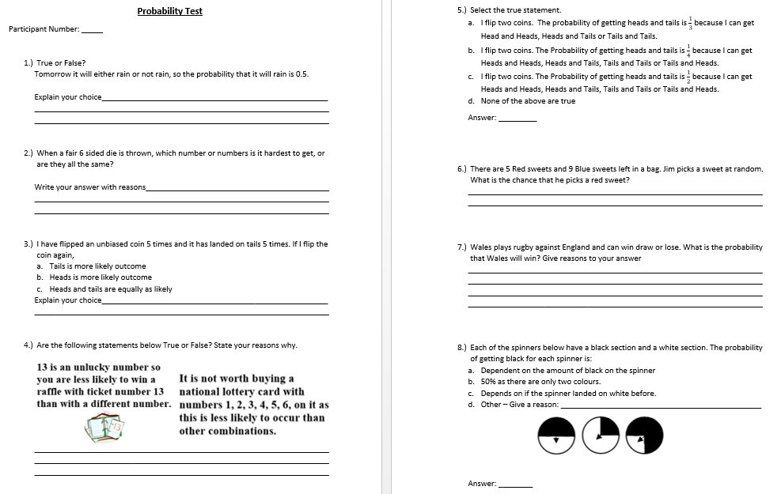
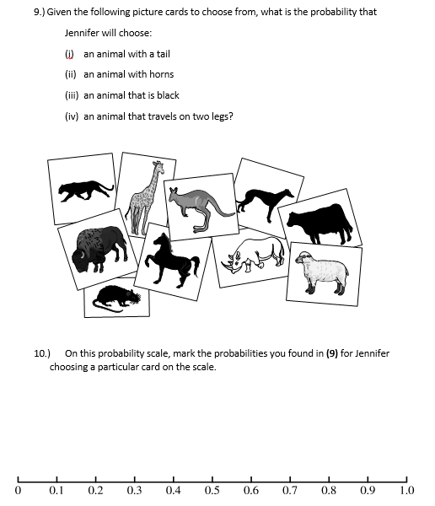

Appendix 2 – Graph 1

Appendix 3 – Graph 2

Appendix 4 – Schemes of Work
Year 7 SOW
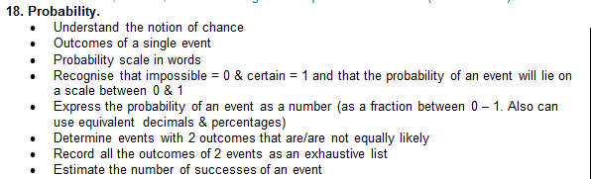
Year 9 SOW
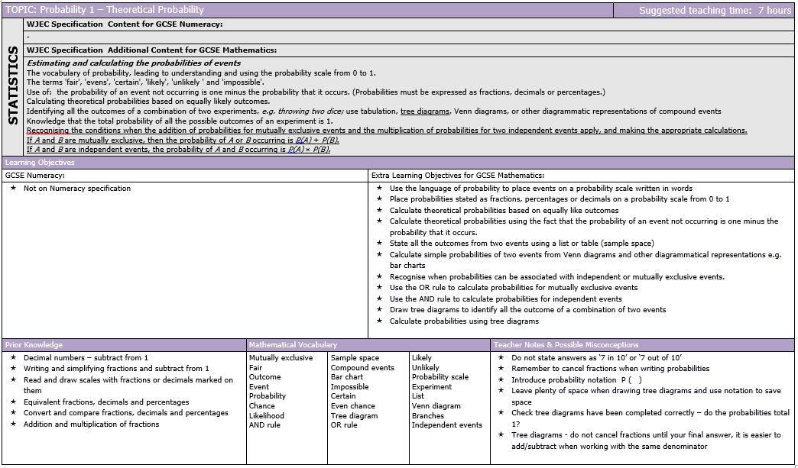

Appendix 5 –Pupils’ False Reasoning

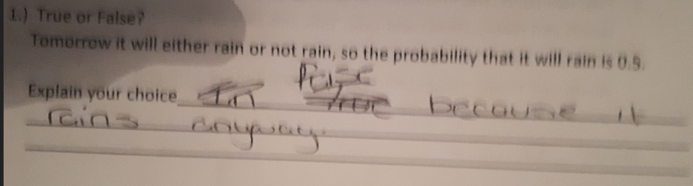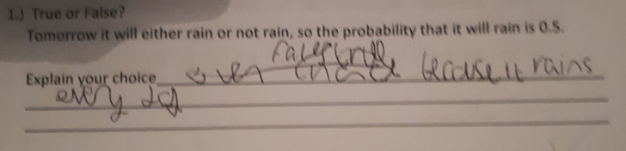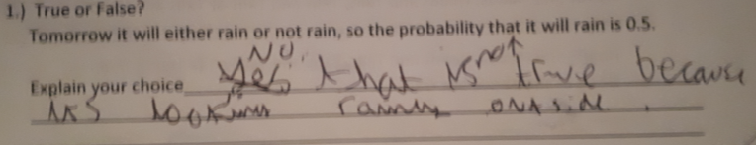

Appendix 6 – Topic Pack

Probability Teaching Pack
Guidance for Teachers
Year 7 & 9 (Low attaining), 4 x 60 minute lessons
The main emphasis of the following 4 lessons is for pupils to improve their understanding of probability. Each question should be thoroughly investigated as a class and any misconceptions that arise should be broken down preferably by the pupils (or if necessary with probing questions/guidance from the teacher) through class discussion/debate to encourage the pupils to think for themselves. This will hopefully, help to eliminate any identified misconceptions.

Lesson 1 (All resources can be found in Appendix 3)
Likelihood and Probability Scale

Objectives
Introduce different probability terms and ensure pupils refer to them using their precise meanings and ensure that the pupils understand what each term actually means.

Notes
To introduce some of the probability terms, use the prepared starter. ‘Unscramble the following letters to reveal the mathematical terms used in probability’. This is aimed at the pupils to become familiar with the different terms used and help with spelling.

The main exposition of this lesson is based on the discussion of the precise meanings of the terms used in probability.

Use the animated power point presentation. Discuss with pupils “What is probability?” followed by the introduction of the Likelihood Scale. Each term should be discussed using their precise meaning before progressing.

Activity – Split class into 5 groups with each group being given one of the following terms, Impossible, Unlikely, Even Chance, Likely, Certain. In each group pupils are expected to determine an event which would relate to their probability term, and discuss with the class. On completion the terms would rotate, and the process would be repeated until each group had used each term.

On completing this activity the focus can return to the animated power point presentation and the probability scale can be introduced and discussed. Ensure to link the probability scale with the likelihood scale.

To finish the lesson the pupils could be given the probability crossword.

Level descriptions
Ma 4
Level 3 – Understand likelihood scale
Level 5 – Understand probability scale from 0 - 1

Lesson 2 (All resources can be found in Appendix 4)
Introducing Calculating Probability

Objectives
Calculate the probability of simple events

Notes
This lesson refers greatly to the animated power point presentation.

To start the lesson recap on the precise meaning of different probability terms.(Refer to slides 1 & 2). Pupils could be picked at random and to answer each questions before revealing the answer. It is essential that pupils explain fully why they have chosen the answer they have and how they worked out the answer. This is essential to ensure there are no flaws in the process they have used to determine the answer.

Slide 3 should be used to recap on the probability scale and emphasis on the use of fractions, decimals and percentages (rather than probability terms) should be used to show the probability of an event happening.

Slide 4 introduces how to calculate probability, and slides 5 & 6 use visual examples. Pupils should be again picked randomly and encouraged to suggest how they would work out the visual examples before revealing the answers to the pupils. Misconceptions that arise at this point should be discussed and rectified with the help of the class.

Slide 7 is intended for the pupils to attempt while the prepared worksheet is handed out.

The plenary involves questions and answers where pupils would be randomly selected to answer and quizzed why. Again the pupils’ explanations are important in the identification and breaking down of misconceptions.

Level descriptions
Ma 4
Level 4 – Understand and use simple probability.
Level 5 – Understand probability scale from 0 – 1. Justify and find probability by selecting and using methods based on equally likely outcomes.

Lesson 3 (All resources can be found in Appendix 5)
Continuation of previous lesson - Calculating Probability

Objectives
Calculate the probability of simple events

Notes
Starter (refer to slide 1) consists of simple probability questions. Pupils given a short time to calculate then pupils should be randomly picked to answer the questions and explain the process used. Again as in previous lessons time should be spent discussing the answers pupils give and the process they used to arrive at the answer. This is to identify misconceptions and identify any flaws in the process a child uses even if the answer is correct.

Lesson to continue with worksheet from previous lesson with an additional worksheet prepared.

The plenary should involve a discussion of events involving Representativeness and Negative and positive recency. This should be done through a teacher lead question and answer process, in order to establish pupils understanding. Moreover, the use of a quiz and mini whiteboards provides an effective AfL strategy.

Level descriptions
Ma 4
Level 4 – Understand and use simple probability.
Level 5 – Justify and find probability by selecting and using methods based on equally likely outcomes.

Lesson 4 (All resources can be found in Appendix 6)
Calculating Probability

Objectives
All probabilities of an event add up to 1.
Probability of an event not happening = 1 – The probability of the event happening

Notes
This lesson refers greatly to the animated power point presentation.

Starter (refer to slide 1) consists of simple probability questions which involved the pupils to recall the different number types. Pupils given a short time to calculate then pupils should be randomly picked to answer the questions and explain the process used. Again as in previous lessons to ensure any misconceptions pupils still have are highlighted.

The main body of the lesson should refer to slides 2-5 ‘probabilities adding up to 1’ and ‘the probability that something will not happen’, followed by questions shown on power point slide. Extension worksheet available.

Plenary is a bingo activity to engage pupils through competitiveness. Additional time is to be used discussing the answers and talking through the processes used to attain the answers to the questions shown on the slide. Again this should be done by randomly selecting pupils.

Level descriptions
Ma 4
Level 5 – Justify and find probability by selecting and using methods based on equally likely outcomes.
Level 6 – Understand that mutually exclusive events add up to 1.

Examples of slides and resources used within lessons

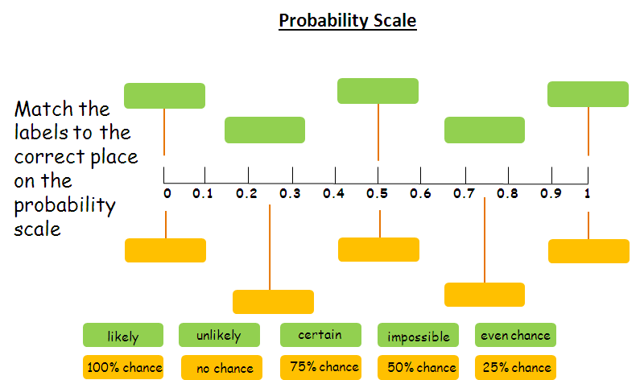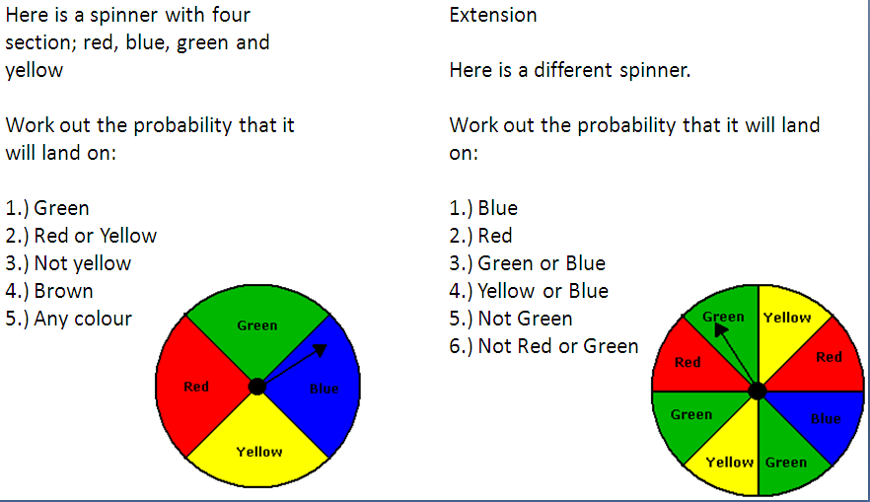

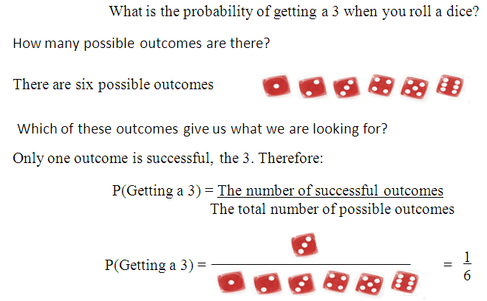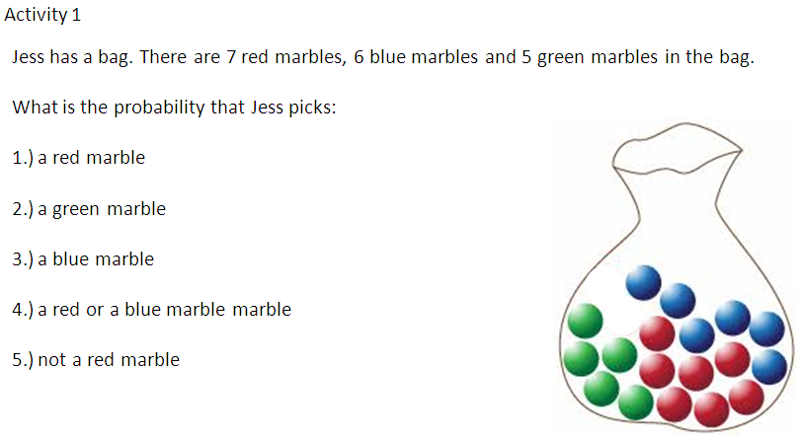
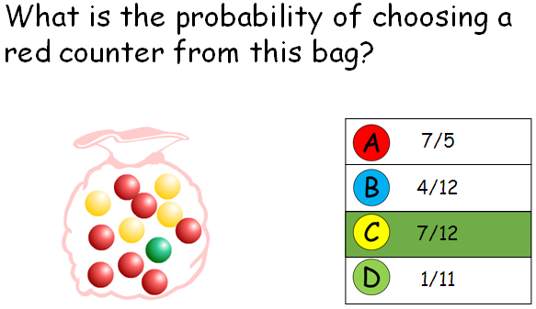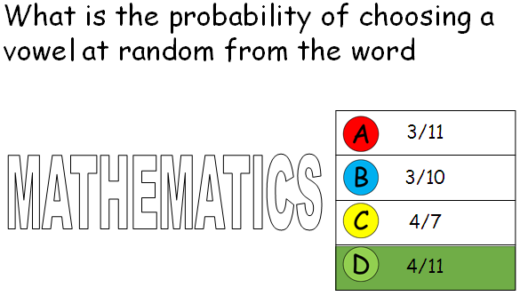

References

Akuna, J., Bauwens, J., Bauwens, W., Ewen, S., Podlewski, S., Quigley, J., Stodden, N. (2009), Kaʻimi loa o ka hihi Project: Maths Dictionary –Theoretical Probability http://www.webquest.hawaii.edu/kahihi/mathdictionary/T/theoreticalprobab.php

Amir, G. and Williams, J., 1994, July. The influence of children's culture on their probabilistic thinking. In Proceedings of the Eighteenth International Conference for the Psychology of Mathematics Education (Vol. 29, pp. 24-31).

APU (1985) Probability Assessment of Performance Unit Report, HMSO, London

Askew, M. and Wiliam, D. (1995) Recent Research in Mathematics Education 5-16 (London: HMSO)

Black, P. and Wiliam, D., 2005. Inside the black box: Raising standards through classroom assessment. Granada Learning

Black, P. J. and Lucas, A. M. (1993). Children’s Informal Ideas in Science. London: Routledge.

Black, P., Harrison, C., Lee, C., Marshall, B., William, D. (2003) Assessment for Learning: Putting it into Practice. Maidenhead; Open University Press

British Educational Research Association (BERA), (2011), BERA Ethical Gudelines 2011 https://www.bera.ac.uk/wp-content/uploads/2014/02/BERA-Ethical-Guidelines-2011.pdf

British Government, (1998), Data Protection Act 1998, Crown

Campbell, D.T. and Stanley, J.C., 1963. Experimental and quasi-experimental designs for research. Handbook of research on teaching. Chicago, IL: Rand McNally.

Chambers, P. and Timlin, R., 2013. Teaching mathematics in the secondary school. Sage.

Clement, J., Brown, D.E. and Zietsman, A., 1989. Not all preconceptions are misconceptions: finding ‘anchoring conceptions’ for grounding instruction on students’ intuitions. International journal of science education, 11(5), pp.554-565.

Cockburn, D., Littler, G., (2008), Mathematical misconceptions: a guide for primary teachers: London: SAGE

Cohen, L., Manion, L. and Morrison, K., 2002. Research methods in education. routledge.
Education Endowment Foundation (EEF), (2013), Pre Testing in EEF Evaluations https://v1.educationendowmentfoundation.org.uk/uploads/pdf/Pre-testing_paper.pdf

Education through Regional Working (Date Accessed: 5th May 2018), About Us http://www.erw.wales/about-us/

Education through Regional Working (Date Accessed: 5th May 2018), ERW Aims and Values http://www.erw.wales/about-us/erw-aims-and-values/

Estyn (2016) School Inspection Report, Cardiff: Estyn https://www.estyn.gov.wales/sites/default/files/documents/Dylan%20Thomas%20Community%20School_1.pdf

Fernandes, M. and Fontana, D., 1996. Changes in control beliefs in Portuguese primary school pupils as a consequence of the employment of self‐assessment strategies. British Journal of Educational Psychology, 66(3), pp.301-313.

Fischbein, E. & Schnarch, D. (1997) The Evolution with age of Probabilistic, Intuitively based Misconceptions, Journal for Research in Mathematics Education., 28, (1), 96-105

Fujii, T., 2014. Misconceptions and alternative conceptions in mathematics education. In Encyclopedia of mathematics education (pp. 453-455). Springer Netherlands.

Haigh, J., 2012. Probability models. Springer Science & Business Media.

Hirsch, L. S., & O’Donnell, A. M. (2001). Representativeness in statistical reasoning: Identifying and assessing misconceptions. Journal of Statistics Education, 9(2). http://www.amstat.org/publications/jse/v9n2/hirsch.html

Jones, G., Langrall, C., & Mooney, E. (2007). Research in probability: Responding to classroom realities.In F. Lester (Ed.), The second handbook of research on mathematics, 909–956. National Council of Teachers of Mathematics (NCTM), Reston, VA

Jones, G., Langrall, C., & Mooney, E. (2007). Research in probability: Responding to classroom realities. In F. Lester (Ed.), The second handbook of research on mathematics, 909–956. National Council of Teachers of Mathematics (NCTM), Reston, VA

Kahneman, D., Slovic, P., & Tversky, A. (1982). Judgment under uncertainty: Heuristics and biases. Cambridge, England: Cambridge University Press.

Leatham, K.R., Peterson, B.E., Merrill, L.M., Van Zoest, L.R. and Stockero, S.L., 2016. Imprecision in classroom mathematics discourse. In Proceedings of the 38th Annual Meeting of the North American Chapter of the International Group for the Psychology of Mathematics Education (pp. 1236-1243).

Leatham, K.R., Peterson, B.E., Merrill, L.M., Van Zoest, L.R. and Stockero, S.L., 2016. Imprecision in classroom mathematics discourse. In Proceedings of the 38th Annual Meeting of the North American Chapter of the International Group for the Psychology of Mathematics Education (pp. 1236-1243).

Lecoutre, M. P. (1992). Cognitive models and problem spaces in purely random situations. EducationalStudies in Mathematics, 23, 557-568.

Lecoutre, M. P., & Rezrazi, M. (1998). Learning and transfer in isomorphic uncertainty situations: Therole of the subjects’ cognitive activity. In L. Pereira-Mendoza, L. Seu, T. Wee, & W. K Wong (Eds.), Statistical education – Expanding the network. Proceedings of the fifth International Conference onTeaching of Statistics, 1105–1111. Voorburg, Netherlands: ISI Permanent Office

Linn, R.L., 1993. Educational assessment: Expanded expectations and challenges. Educational evaluation and policy analysis, 15(1), pp.1-16.

NCTEM, (Date Accessed 5th May 2018), Misconceptions with the Key Objectives https://www.ncetm.org.uk/public/files/2042723/Misconceptions+with+the+Key+Objectives2.doc

Nuffield Maths 3 Teachers’ Handbook: Longman 1991

Paradise Valley Community College (Date Accessed 5th May 2018) Pre-Post Testing https://www.paradisevalley.edu/al-archive/docs-assess/PrePost.doc

Phelan, C. & Wren, J., (2006), Reliability and Validity: UNI Office of Academic Assessment https://chfasoa.uni.edu/reliabilityandvalidity.htm

Piaget, J., 1972. Intellectual evolution from adolescence to adulthood. Human development, 15(1), pp.1-12.

Qualifications and Curriculum Authority (QCA), (2003), Assessment for Learning: Using Assessment to Raise Achievement in Mathematics. London: HMSO

Sarwadi, H.R.H. and Shahrill, M., 2014. Understanding students’ mathematical errors and misconceptions: The case of year 11 repeating students. Mathematics Education Trends and Research, 2014, pp.1-10.

Schmidt, H.J., 1997. Students' misconceptions—Looking for a pattern. Science education, 81(2), pp.123-135.

Schoon, K.J., 1995. The origin and extent of alternative conceptions in the earth and space sciences: A survey of pre-service elementary teachers. Journal of elementary science education, 7(2), p.27.

Shaughnessy, J. M. (1992). Research in probability and statistics: Reflections and directions. In D. A. Grouws (Ed), Handbook of research on mathematics teaching and learning, 465–494. New York: Simon & Schuster Macmillan

Shaughnessy, J.M. Educ Stud Math (1977) 8: 295. https://doi.org/10.1007/BF00385927

Skemp, R.R., 1976. Relational understanding and instrumental understanding. Mathematics teaching, 77(1), pp.20-26.

Stylianides, A.J., 2011. Towards a comprehensive knowledge package for teaching proof: A focus on the misconception that empirical arguments are proofs. Pythagoras, 32(1), pp.1-10.

Sundberg, M.D., 2002. Assessing student learning. Cell Biology Education, 1(1), pp.11-15.
Swan, M. (2001) “Dealing with misconceptions in mathematics” in Gates, ed. (2001: 147-65)

Tanner, H. & Jones S. (2003), Becoming a Successful Teacher of Mathematics, London and New York: RoutledgeFalmer.

Tanner, H., Jones, S. and Davies, A. (2002), Developing Numeracy in the Secondary School, London: David Fulton Publishers

UNICEF UK, (1990), The United Nations Convention on the Rights of the Child (UNCRC), London, UNICEF

V. Jupp, (2006) One Shot Design: SAGE Dictionary of Social Research: SAGE http://dx.doi.org/10.4135/9780857020116.n133

Welsh Government (2016) Curriculum for Wales: Programme of Study for Mathematics, Key Stages 2–4 Cardiff Crown http://learning.gov.wales/docs/learningwales/publications/150717-nc-maths-en-v2.pdf

