An Early Years Practitioners Handbook : A Guide to Transitions


(Source: thehullhub.co.uk, 2020)

Contents

Introduction Page 3
The Needs of the Child Pages 4-6
The Role of the Adult Pages 7-8
Partnerships Page 9
Interventions Pages 10-11
Proposed Outcomes Page 12
Reference List Pages 13-15

Introduction

Aims
The aim of this handbook is to help Early Years Practitioners to understand the importance of transitions and the affect they have on children’s development. The handbook will explore a variety of information and theorists’ views on why effective communication is essential to ensuring that transitions are smooth and successful. It will look at several factors that aid smooth transition and provide a selection of interventions that an Early Years Practitioner can use in their practice. This handbook will focus on the transition of young children from their home to a childcare setting.

What is transition?
Transition is “a change from one form or type to another, or the process by which this happens” (Cambridge Dictionary, 2022).
“Transitions are changes that take place in a child’s life, which require them to adapt to a new set of circumstances” (Welsh Government, 2021).
Transitions are milestone events for children that will influence their development. Starting at a childcare setting is an exciting point in a child’s life but it can also be a time of uncertainty and anxiety as children learn to settle into a new environment with unfamiliar people. Getting transition right is vital and involves everybody working together to make the transition as smooth as possible (Early Years Matters, 2022).
Brooker (2008) points out that one of the biggest transitions a young child will experience is attending a nursery or pre-school setting. She discusses the importance of Early Years Practitioners understanding the children’s needs and using effective communication skills to provide smooth transitions from home to nursery. For young children practitioners will need to understand that they may not be able to communicate verbally so the practitioner will need to look for non-verbal cues and react to the child based on these.
Patel (2022) states that transition to a childcare setting can be stressful as separation anxiety affects both children and parents. By building good relationships with parents, practitioners can reassure them and make them feel comfortable about leaving their child in their care. This will also help the child as they witness positive conversations between their parent and keyworker.

The Needs of the Child

Nutbrown and Clough (2014) explain the importance of ensuring that a child’s emotional needs are met as a priority when they start at a new childcare setting to make the transition from home to setting effective. They discuss the relationship between self-confidence and motivation and state that a child can flourish and develop when they feel safe and have their emotional needs met.
Maslow’s theory and hierarchy of needs would be considered when thinking about young children and transitions as Maslow’s theory explains that children need their basic needs to be met for them to be able to achieve and develop further skills. A child transitioning from home to a childcare setting will need to feel safe and secure and have their physiological needs met before they can begin to settle into a new environment and build relationships with their peers and carers.
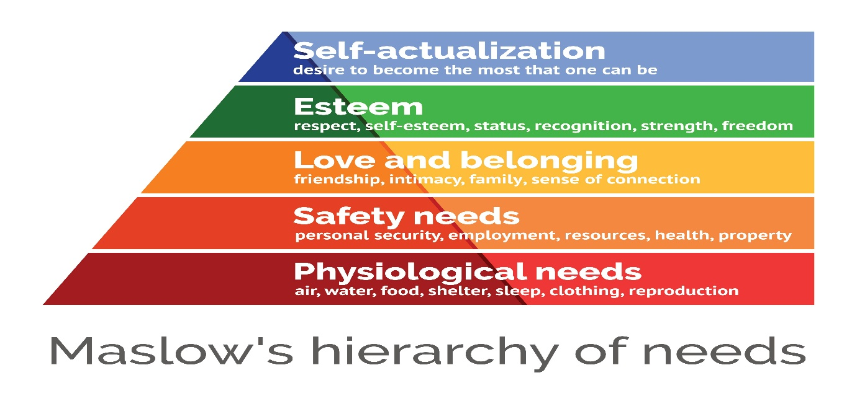(Source: Thoughtco.,2022)

Montessori believed that education begins from birth and adults need to be effective at observing in order to enhance children’s learning. She says that all children have ‘sensitive periods’ when they are ready to learn using their senses and practitioners need to be able to identify these periods and intervene effectively (Pound, 2008).
Piaget and Vygotsky both explained that children are active learners and learn through interactions with their caregivers, peers and environment. They believed that there is a huge emphasis on play and the learning that takes place as a child plays which is reinforced by adults observing and planning based on the observations they made (Smidt, 2015). Vygotsky’s theory – The Zone of Proximal Development is described as the gap between what a child can do alone and what they can do with the help and support of someone more skilled and experienced. This does not always mean an adult; it can be a child who has more skills and experience to support their peer in their learning. This theory is also known as ‘scaffolding’ as Vygotsky emphasised the importance of others around the child including family and the community in supporting the child’s development (Pound, 2008).
Communication is a key element during a transition period for a child, especially in the Early Years. A young child is not always able to express how they are feeling so it is essential that practitioners recognise non-verbal cues to understand how that child is feeling and to communicate with them in a way that helps them to feel safe and secure in their surroundings (Lindon and Brodie, 2016).
Welsh Government (2021) recognises that all children are unique and may require varying levels of support during a transition period. They state that practitioners need to maintain a child-centred approach and focus on a child’s emotional development and well-being during transition to a childcare setting. When a child has developed their emotional needs and feel comfortable in a setting they are then able to access many activities and develop other skills. Practitioners also need to consider any additional needs a child may have and work with relevant agencies to meet that child’s needs effectively during transition and in setting.

Practitioners will always consider the United Nations Convention on the Rights of the Child in every aspect of working with children. During a transition period for a child, the main articles considered are Article 3 – Best Interests of a Child – everybody involved in the child’s transition needs to ensure that the best interest of the child is always the focus and Article 12 – Respect for the views of the child – children have the right to express their views and feelings and have them heard by others around them. It is essential to include the child as much as possible and take their views into account at every stage of transition (TES, 2019).
(Source: TES, 2019)

Bronfenbenner’s bioecological model studies human development over time and suggests that interactions between a child and their environment will influence the child’s development. He puts the child at the centre of the model with four ecological systems surrounding them, starting with those closest to the child. The four ecological systems are:
- Microsystem = the individuals and environment closest to the child and where the child feels most comfortable, so these include home, family, siblings and their school environment.
- Mesosystem = the second layer involves interactions that directly influence the child’s development between characters of the microsystem. These include interactions between family members and practitioners at a childcare setting.
- Exosystem = this layer considers actions that affect the child indirectly. For example, a parent could lose their job which would cause financial strain on the family.
- Macrosystem = the cultural and societal influences on the child (Learning Theories, 2022).
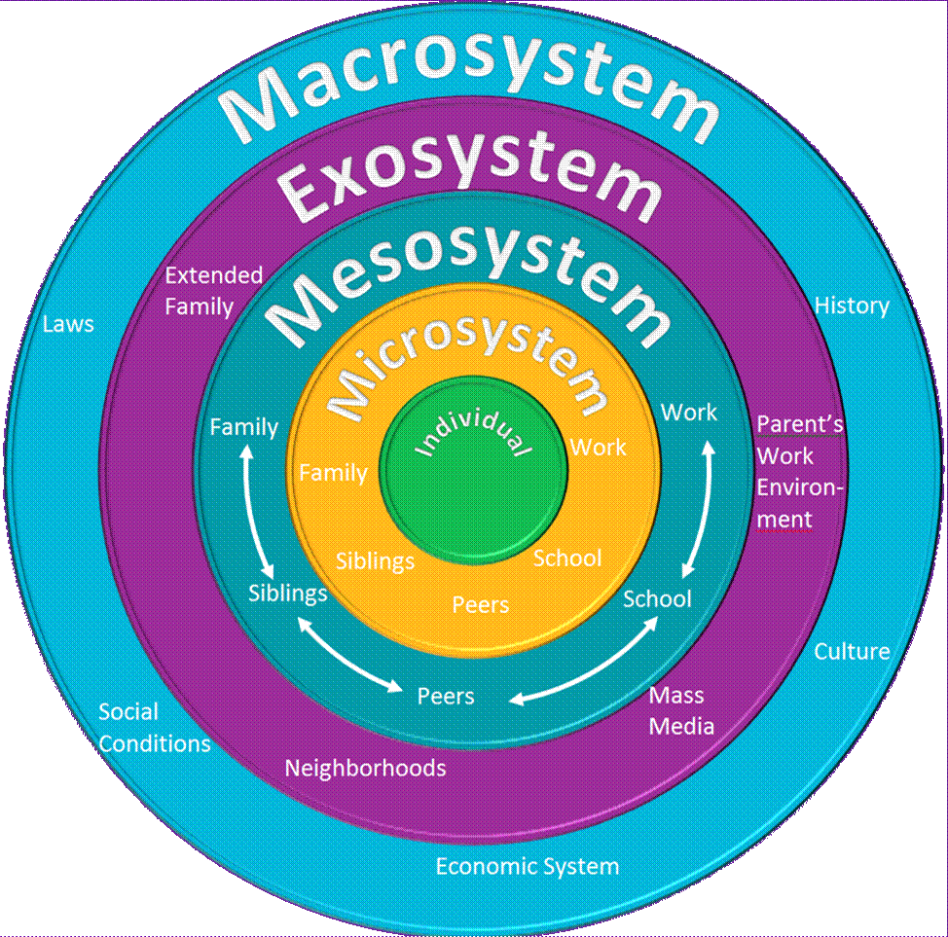(Source: Slideshare,2015)

The Role of the Adult

Before starting at a childcare setting a child may not have built many relationships with others but they will have formed a strong attachment with their primary caregivers. To aid successful transitions a practitioner needs to be aware of attachment theories and understand the ways in which they can best support the child and family during the transition period.
Bowlby’s attachment theory explains that a child forms an emotional bond with their caregiver from birth to ensure survival. The baby quickly realises that if they cry, they will get their needs met or receive interaction from their parents. Bowlby’s work still influences practice today and is one of the main reasons for the keyworker system and involving parents in their child’s learning and development (Pound, 2014).

Ainsworth expanded on Bowlby’s attachment theory and considered the points that children need to have strong attachment bonds with those around them to develop their own self-esteem and self-confidence. She also discussed the fact that children can form many positive attachments with those people closest to them. Ainsworth believed that children with positive relationships can flourish and perform well at school. However, there are some children who are unable to form positive relationships or attachments for a variety of reasons which could lead them to problems such as depression and anxiety in later life.
(Source: ntrblog41.blogspot.com, 2021)
According to Bruce (2011) a keyworker system works well in a childcare setting as it gives the opportunity for children to form strong and positive attachments with their keyworker which will help effective transitions. By allocating children a keyworker at their setting that practitioner can focus their attention on a small number of children and build relationships with the child and their families. The practitioner will need to reassure the parents that their child is safe and happy in their care, whilst also reassuring them that they are not taking the place of the parent. The relationship between a keyworker and parent is fundamental in ensuring a positive transition and experience in a childcare setting.
Lindon and Brodie (2016) point out that communication is key during a transition period. They explain that practitioners need to communicate well with parents to find out everything that they need to know about their child, especially their likes and dislikes. The parents know exactly what will help their child to settle in and feel comfortable at a setting, so it is vital for the practitioner to listen and understand what the parents say. The practitioner will also spend time observing the child and discovering their likes and dislikes at the setting, allowing them to plan activities to suit that child each day.
The Curriculum for Wales recognises the importance of the enabling adults and an enabling environment in a childcare setting. It explains how vital it is for young children to have a high standard, rich learning environment to explore, as well as knowledgeable adults to support and enhance children’s learning and experiences (Welsh Government, 2022).
Another important consideration for the adult is to be a good role model. Bandura’s theory explains that children imitate behaviours that they experience so it is crucial for all practitioners to remember that their actions can be copied and that they need to always behave appropriately (McLeod, 2016).

Partnerships

“Real partnerships should be developed between parents and staff in supporting the transition process” (Welsh Government, 2017).
Communication with parents will play a fundamental part in a child’s transition into a childcare setting. The keyworker should use the time during induction to speak to the parents to find out everything possible about the child which will help them to understand and get to know the child and help with transition into the setting. Parents hold the most valuable information about their child so these interactions will help aid transition (Welsh Government, 2017).
Alongside parents and family members, some children may have other professionals involved in their care. It is vital for the childcare setting to communicate with any other professionals or agencies involved with a child to get any information needed to aid the transition process (Booker, 2008). Practitioners should aim to build relationships with other professionals such as specialist teachers so that they are able to ask for any help or support they need.
Trodd (2012) discusses the importance of establishing good relationships with parents and other professionals involved in a child’s life. She also states that communication is key in continuing and updating these relationships, sharing information regularly with all involved. Trodd (2012) also points out that parents may need support during the transition period so it is the practitioner’s role to explain the process positively and ensure that parents understand and feel comfortable with it.
Another essential partnership during a child’s transition to a childcare setting is the staff team at the setting. Bruce (2011) discusses the need for practitioners to work well together as a team to provide the best possible environment for the children in their care. Keyworkers will need to share information regarding their new key children with other staff members to ensure that everyone is aware of the best ways to support that child. The best way to do this would be at a staff meeting whilst the children are not in attendance.
Partnership working during transitions is considered in Bronfenbenner’s ecological model as he highlights the need for positive interactions between parents and school to enable the best experience for the child (Guy-Evans, 2020).
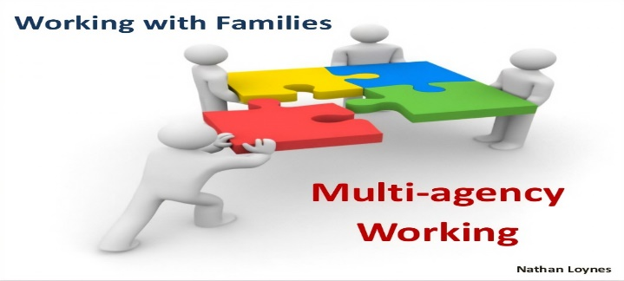(Source: Slideshare, 2013)
Interventions

“Research suggests that transitions are central to young children’s development and emotional wellbeing, and the way in which the first transitions are handled could have a significant impact on the child’s capacity to cope with change in the short and long term” (TheEducatorUK, 2017).
Practitioners in Early Years settings have a responsibility to follow policies and procedures to ensure that young children have an effective and smooth transition from home to childcare settings (TheEducatorUK, 2017). There are many different interventions that can be in place to promote smooth and positive transitions. Some of these are detailed below.
Home Visit – This intervention gives the opportunity for practitioners to meet a child for the first time in their own home which would hopefully mean that they feel safe and comfortable and maybe more willing to interact with the practitioner. The home visit would be an informal visit where the practitioner can meet the child and discuss with the parents the plan for transition. It would also allow time to answer any questions or concerns that the parents may have, hopefully making them feel less anxious about their child starting at a setting. However, it is also important to consider that some families may not feel comfortable allowing people into their home and may feel that they will be judged. Therefore, it is essential to adapt the intervention plan for each child and their family, ensuring that the initial visit/meeting takes place wherever the child and family feel most comfortable (Allingham, 2019).
Induction at setting – If a family would not feel comfortable with a Home Visit, they can attend an induction at the setting. The practitioners would invite the child and their parents to the setting, giving the child the opportunity to explore whilst the parents complete paperwork and discuss transition plans with the practitioner or setting Leader. An example of a form to be completed during this induction is an “All About Me” form which is used in Cardiff Flying Start settings (Welsh Government, 2017) These forms can be completed by parents alongside the child’s keyworker as they detail all of the child’s likes and dislikes, including any areas that the parents feel that their child may need support.
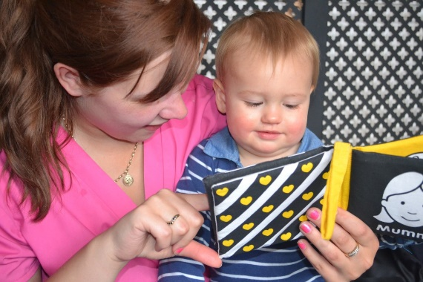
(Source: EarlyYearsCareers, 2016)
Keyworker – During their induction at setting, the child and parent can be introduced to their child’s keyworker. Pacey (2022) acknowledges the importance of allocating children a keyworker so that they can form a bond with one particular person that will help them to settle in as they start at a childcare setting. The keyworker would also form relationships with the child’s parents, family and any other professionals involved with the child to get to know the child as much as possible and understand how they can best support that child through their transition.
Settling-in Sessions – These sessions are shorter than the ‘normal’ session that a child would attend every day. Initially, parents would be invited to spend some time at the setting alongside their child which allows the time for the child to explore the setting with their parents, feeling safe and secure and understanding that their parents like the setting and believe it is a safe place to leave them. Parents would then be encouraged to leave their child at the setting with their keyworker for a short period of time. This process will help the child to start building a bond with their keyworker whilst their parents are not there. We would then slowly increase the time the child attends the setting without their parents and work up to them attending for a full session based on the child’s and parent’s needs and feelings (Pacey, 2022). Every child and family are different so these sessions would be completed based on their needs, some children may need numerous settling in sessions before attending for a full session, whereas others may only need minimal settling in sessions. Another intervention that we would use during these sessions is to bring along a child’s comforter or favourite teddy whilst they develop their confidence at the setting as having something to make them feel comfortable would help the transition process.
(Source : ChildcareCenter.us, 2022)
Stay and Play sessions – Stay and Play sessions held regularly at the childcare setting would give parents the opportunity to play with their child and to see the progress they have made at the setting. These sessions also allow time for parents and keyworkers to catch up and share any new information regarding the child. Cardiff Flying Start encourage parents to attend Stay and Play sessions in their local area prior to starting at a childcare setting so that the child and parent can begin to understand the process of transition and to carry out some of the activities that would be provided daily at a setting. By attending these sessions, parents are also able to meet other families in the local area, some of which may have already transitioned children into a childcare setting so would be available to offer advice and support to new parents approaching transition with their child (www.flyingstartcardiff.co.uk, no date).

Proposed Outcomes

The desired outcome is to see a child who feels happy, safe and secure in their new environment after their transition process. If the child experiences an effective, positive and smooth transition they will have the skills to allow them to build positive relationships with their peers and keyworkers, feel confident and comfortable to explore the setting and activities and develop their skills in all areas of learning. A child who has experienced a positive transition will have formed a strong attachment bond with their keyworker but also have acquired the skills to form relationships with other staff at the setting and feel confident to approach them for support (Bruce, 2011).
By observing regularly and adapting activities to meet each individual child’s needs, practitioners can support the children to develop all skills. Smidt (2015) points out that adults need to observe regularly and understand when they need to intervene in a child’s play to enhance their learning. She also discusses the importance of practitioners being a good role model as children will also be observing the adults around them and copying their behaviour.
Ensuring that children have positive experiences of transition at all stages of their lives will help them to fulfil their potential and access all opportunities available to them in a positive manner. Having knowledgeable, professional practitioners in their childcare and education settings will promote their development in all areas (TheEducatorUK, 2017).

Reference list

Allingham, S. (2019) ‘TES Magazine’. EYFS: How to get home visits right [article]. Available at: https://www.tes.com/magazine/archive/eyfs-how-to-get-home-visits-right (Accessed: 27 November 2022.
Brooker, L. (2008) Supporting Transition in the Early Years. Berkshire: Open University Press.
Bruce, T. (2011) Early Childhood Education. 4th edn. London: Hodder Education.
Cambridge Dictionary (2022) Meaning of transition in English. Available at: https://dictionary.cambridge.org/dictionary/english/transition (Accessed: 19 November 2022).
Cherry, K. (2022) ‘Very Well Mind’. What is Attachment Theory? [article]. Available at: https://verywellmind.com/what-is-attachment-theory-2795337 (Accessed: 20 November 2022).
Childcare Center.us (2022) Stay and Play Childcare – New Kent VA Child Care Center [image]. Available at: https://childcarecenter.us/provider_detail/stay_play_childcare_new_kent_va (Accessed: 30 November 2022).
Early Years Careers (2016) Top tips on building a secure bond with your key child [image]. Available at: https://www.earlyyearscareers.com/eyc/careers-in-childcare/top-tips-building-secure-bond-your-key-child/ (Accessed: 30 November 2022).
Early Years Matters (2022) Transitions. Available at: https://www.earlyyearsmatters.co.uk/eyfs/positive-relationships/transitions/ (Accessed: 19 November 2022).
Flying Start Cardiff (no date) Stay and Play. Available at: https://www.flyingstartcardiff.co.uk/what-we-do/stay-and-play/ (Accessed: 27 November 2022).
Guy-Evans, O. (2020) ‘Simply Psychology’. Bronfenbenner’s Ecological Systems Theory [article]. Available at: https://www.simplypsychology.org/bronfenbenner.html (Accessed: 27 November 2022).
Hwb.gov.wales (no date) Foundation Phase professional learning: Transitions. Available at: https://hwb.gov.wales/playlists/view/035d2c01-6076-4ef2-b251-543adf08cd9e/ (Accessed: 19 November 2022).
Learning Theories (2022) Bronfenbenners Bioecological Model of Development (Bronfenbenner). Available at: https://learning-theories.com/bronfenbenners-bioecological-model-bronfenbenner.html (Accessed: 20 November 2022).
Lindon, J. and Brodie, K. (2016) Understanding Child Development 0-8 years. 4th edn. London: Hodder Education.
McLeod, S. (2016) ‘Simply Psychology’. Bandura – social learning theory [article]. Available at: https://www.simplypsychology.org/bandura.html (Accessed: 22 November 2022).
Ntrblog41.blogspot.com (2021) John Bowlby Quote/John Bowlby Attachment Theory Quotes [image]. Available at: https://ntr-blog41.blogspot.com/2021/06/john-bowlby-quote-john-bowlby.html (Accessed: 27 November 2022).
Nutbrown, C. and Clough, P. (2014) Early Childhood Education. History, Philosophy and Experience. 2nd edn. London: SAGE Publications Ltd.
Pacey (2022) Seperations and Transitions. Available at: https://www.pacey.org.uk/working-in-childcare/spotlight-on/2-year-olds/seperation-and-transitions/ (Accessed: 27 November 2022).
Patel, A. (2022) ‘Teach Early Years’. Transitions in Early Years – Ideas for supporting children and families [article]. Available at: https://www.teachearlyyears.com/a-unique-child/view/supporting-transitions-in-the-early-years/ (Accessed: 20 November 2022).
Pound, L. (2008) How Children Learn. London: Step Forward Publishing Ltd.
Pound, L. (2014) How Children Learn. 2nd edn. London: Practical Pre-School Books.
Simply Psychology (2022) Maslow’s Hierarchy of Needs. Available at: https://www.simplypsychology.org/maslow.html (Accessed: 19 November 2022).
Slideshare (2013) Multi-agency working [image]. Available at: https://www.slideshare.net/NathanLogues/multi-agency-working (Accessed: 27 November 2022).
Slideshare (2015) Theories of Development – Life Span Development [image]. Available at: https://www.slideshare.net/unnatish1/theories-of-development-life-span-development (Accessed: 20 November 2022).
Smidt, S. (2015) Observing Young Children. The role of observation and assessment in early childhood settings. 2nd edn. Oxon: Routledge.
TES (2019) Diamond 9 for the UNCRC (United Nations Convention on the Rights of the Child) = Rights Respecting [image]. Available at: https://www.tes.com/teaching-resource/diamond-9-for-the-uncrc-united-nations-convention-on-the-rights-of-the-child-equals-rights-respecting-12 (Accessed: 27 November 2022).
The Educator UK (2017) Managing Transitions in Early Years. Available at: https://www.the-educator-org/managing-transitions-early-years/ (Accessed: 27 November 2022).
The Hull Hub (2020) Early years childcare advice for keyworkers [image]. Available at: https://thehullhub.co.uk/early-years-childcare-advice-for-key-workers/ (Accessed: 27 November 2022).
ThoughtCo. (2020) Maslow’s Hierarchy of Needs [image]. Available at: https://www.thoughtco.com/maslows-hierarchy-of-needs-4582571 (Accessed: 20 November 2022).
Trodd, L. (2012) Transitions in the Early Years. London: SAGE Publications Ltd.
Welsh Government/Education for Wales (2022) A Curriculum for funded non-maintained nursery settings. Available at: https://hwb.gov.wales/api/storage/b1801d78-38c3-4320-9818-d9996c21aef8/220914-a-curriculum-for-non-maintained-nursery-settings (Accessed: 22 November 2022).
Welsh Government (2017) Flying Start – Annex. Transition Guidance. Available at: https://gov.wales/sites/default/files/publications/2019-07/flying-start-transition-guidance-for-professionals.pdf (Accessed: 27 November 2022).

