MODULE | THE GLOBAL BUSINESS ENVIRONMENT
STUDENT NAME | DIANA GABRIELA BUCATARU
STUDENT ID | 2122807
LECTURER | NADEEM MIRZA
MODULE CODE | LCBB4005
ASSIGNMENT TITLE | ASSESSMENT 1

Table of Contents
Introduction 3
Company Overview 4
Figure 1: Bentley Logo 4
Business Environment of Bentley 5
SWOT Analysis 5
Figure 2: SWOT Analysis 5
PESTLE Analysis 6
Figure 3: PESTLE Analysis 7
Porter’s Five Forces 10
Figure 4: Porter’s Five Forces 10
Value Chain Analysis 11
Figure 5: Value Chain Model 12
Conclusion: 14
References 15

Introduction
Global business is a feature of the modern economy that has emerged due to technological advancements that have enabled firms to conduct their operations on an international scale. In the context of business, globalisation refers to the exchanging of goods and services on a global scale. Generally, the world's business climate can be thought of as the atmosphere in different countries, with outside factors affecting asset use and capacity dynamic navigation unrelated to the company's home climate. Furthermore, one of the primary learning objectives is to become aware of the various elements that can affect an organisation's strategic decision to expand its operations to other countries. Both internal & external environment plays an essential role in global business. However, this research will look at the automobile brand Bentley's SWOT, PESTLE, and Value Chain and their competitive advantages regarding their core values on sustainability and the obstacles they face in global markets.

Company Overview
Bentley is a British automobile manufacturer that produces luxury vehicles. It is well-known throughout the world for producing high-end automobiles. Designers, developers, and manufacturers of high-end cars are all employed by this British corporation. The firm is renowned throughout the world for its beautifully designed automobiles and for providing luxury automobiles that meet the needs of a wide range of people (Bentley Motors, 2022). W. O. Bentley launched the company on January 18th, 1919, in North London. Crewe, England, serves as the organisation's headquarters. It was purchased in 1931 by Rolls-Royce Motors, and it was purchased again in 1998 by Volkswagen AG, which Volkswagen Group now owns. During that period, this company was a wholly-owned subsidiary of Volkswagen AG.
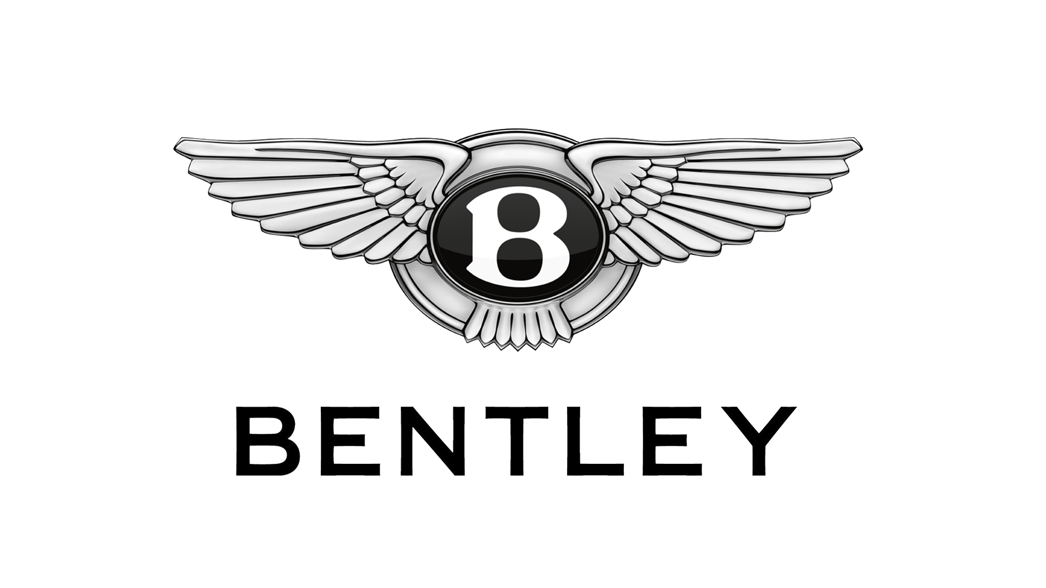

Figure 1: Bentley Logo
Source: (Official Bentley Motors website | Powerful, handcrafted luxury cars, 2022)

Business Environment of Bentley
The business environment is the set of rules and regulations that ensures the organisation functions smoothly and with integrity. These factors affect the company's legal obligations. It also defines the company's nature and operations. Internal and external business environments both jeopardise the organisation's operations. It controls its internal environment but not its external environment. External factors shape the company's policies. Accounting for the business environment allows management to develop measures to reduce the impact of environmental factors on productivity and competitiveness (Worthington, 2018). They achieve their aims and objectives quickly while making significant progress. SWOT, Porter's Five Forces, Value Chain, and competitive advantages can all be used to assess the business environment.

SWOT Analysis
SWOT analysis is a system for evaluating what is happening and creating masterful courses of action. A SWOT investigation is planned to help a practical, truth-based, information-driven assessment of an association's, drives, or alternately industry's strengths, weaknesses, opportunities & threats (Whittington, 2017). A SWOT analysis is a practical, truthful, and information-based way to figure out what an organisation, drive, or industry is good at and what it could do better. The SWOT analysis of Bentley is given below-


Figure 2: SWOT Analysis
Source: (Whittington et al., 2017)
Strengths
- Uniquely, Bentley vehicles blend luxury and sportiness, so no other product can.
- Bentley maintains a robust global market share and brand equity position.
- Its high price and limited supply add to the brand's uniqueness and worth as a status symbol (Baron, 2018).
- Support from the world's largest carmaker, Volkswagen
- The brand's worth is enhanced when Bentleys are owned by high-profile clients like the royal family or worldwide celebrities.
Weaknesses
- Bentley has a limited foothold in emerging regions where the affluent population rises.
- A lack of output means a loss of potential clients.
- Hostile to the environment.
- They cater to a specific demographic. This market has minimal room for expansion. So fast growth is unsustainable.
Opportunities
- Bentley may think about expanding its legacy and layout to more eco-friendly vehicles with hybrid or electric transmissions.
- Create a strategy for reaching the emerging market's prosperous elite.
- Premium event sponsorships to improve brand presence (Seth, 2018).
- They can also buy less popular brands and target various demographics.
Threats
- People's inclination for environmentally friendly vehicles is growing, owing to Bentley's reputation for massive displacement engines.
- Rising gasoline prices and stringent government regulations.
- Increased awareness and penetration of competing for high-end brands.

PESTLE Analysis
PESTLE investigation is a memory aide representing P for Political, E for Economic, S for Social, T for Technological, L for Legal, and E for Environmental in its augmented structure. It is a significantly more inside and out a variation of the SWOT.
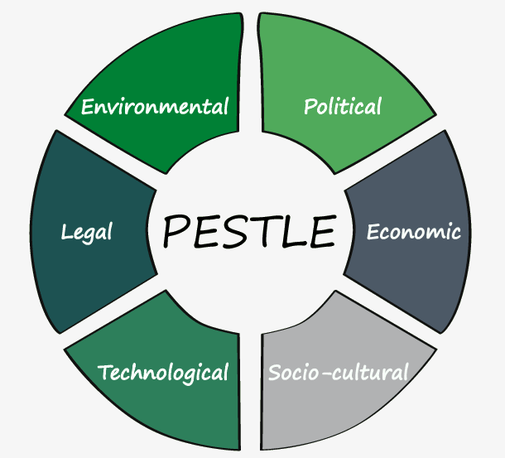

Figure 3: PESTLE Analysis
Source: (Coffman, 2016)
Political Factors:
A country's arrangements straightforwardly sway organisations working on its edges. A PESTEL study of the car area shows what political issues can do to the company.
- To protect the security of travellers, most state-run administrations have set guidelines overseeing the creation of car parts. Assuming a partnership neglects to meet these circumstances, its permit might be renounced (Coffman, 2016). Besides, Bentley should commit huge chances to test before send-off, which can be expensive.
- Organisations are similarly quick to restrict the inescapable utilisation of petroleum products, adding to expanded contamination. Carmakers should hold discharges under a particular cutoff to remain in business.
- A nation's car area is likewise dependent on the public authority's approaches to commodity and import. An organisation's net revenue can improve if it can import top-notch parts at a lower cost.
Economic Factors:
A country's economy impacts individuals' ways of life. Accordingly, it might affect the vehicle area. Here are a few financial elements that might influence the vehicle business:
- Individuals' earnings in both stable and are ascending to develop economic zones. Therefore, it is expanding to spending power. It is the motivation behind why the interest in vehicles is increasing.
- Numerous legislatures have forced charges on extravagant things, raising their costs, and thus, a specific fragment of buyers might decide not to buy one. It might prompt an abatement sought after for luxurious vehicles in certain countries (Guy, 2017). Be that as it may, assuming many organisations send off relatively minimal expense vehicles, they might draw in a considerable number of buyers.
- Assuming the expense of auto parts rises, so will the cost of the vehicles. It very well may be one reason behind the drop famous of automobiles.
Social Factors:
The socio-social elements of land affect its endeavours. Social improvements altogether affect auto fabricating. The PESTEL assessment of the auto area can distinguish humanistic elements that can unleash devastation on the business-
- Vehicles are something beyond transportation; they are likewise design proclamations. Accordingly, while growing new vehicles, companies should consider their clients' inclinations (Conklin, 2018). Any other way, it might become undesirable and neglected to sell.
- The conveyance of a country's populace impacts vehicle deals too. A state with a thick public and various families will sell numerous colossal vehicles, like SUVs.
- The way of life and propensities of networks sway the auto business also. Nations with comprehensive associated transport frameworks, for instance, may encounter a decline in the number of individuals claiming vehicles. Created nations likewise inclined to argue at least one car.
Technological Factors:
The state of advancement basically influences the arrangements of vehicle firms. The following are a couple of particular concerns that can impact the vehicle's business:
- The vehicle business is seriously subject to cutting edge advancement to get people's prosperity. Associations ought to work on their advances to make their vehicles as safeguarded as conceivable.
- Associations ought to focus on cutting down their carbon impression. They can utilize cutting edge development to screen the outpouring rate.
- Self-driving vehicles are, at this point, open and accessible. In like manner, they could defy prominence later on (Morrison, 2019). The organization ought to announce self-driving vehicles and destroyed vehicles to win more clients.
Legal Factors:
The regulations and guidelines of nations can impact the vehicle business. Laws administering vehicle firms are standard in many countries. A few legitimate issues might affect the car area, including:
- Numerous nations have carried out close limitations to restrict the number of autos out and about to diminish air contamination.
- At the point when occurrence criminology uncovers an issue with a vehicle's defective gear or airbags, the maker might be expected to take responsibility.
- A vehicle maker should consent to the nearby expense and natural guidelines to carry on with work globally (Whittington, 2017). If they don't, the organisation may be banished from working in the country.
Environmental Factors:
Natural disasters can have a big impact on the car business. As people become more aware of the contamination, their businesses might be affected. The PESTEL investigation of the area where cars are parked can show environmental problems that could hurt the industry:
- Tree-lovers and the public authority are worried about cars dumping their waste into the air. Organisations can use the most up-to-date technology to make battery-controlled or electric vehicles that are less likely to pollute the air.
- The nations' state-run administrations are more prepared to execute natural regulations to diminish contamination levels, and carmakers should keep the rules (Kelly, 2016). It can bring down net revenues for automakers.
- Car organisations' examination divisions should be thorough in their testing. If they can breeze through the severe contamination assessments, they ought to put a unit available.

Porter’s Five Forces
The Porter Five (5) Forces Analysis is a strategic management tool used to examine the industry and determine the underlying profitability.
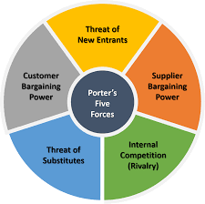

Figure 4: Porter’s Five Forces
Source: (Michaux, Cadiat and Probert, 2016)
Threats of New Entry
In the automobile industry, there are very few new players or entrepreneurs who can get in there. Since newcomers face high obstacles to the entrance, this market is unlikely to see many threats from this group. A newcomer must build up a strong enough reputation over time to compete in the industry (Michaux, Cadiat and Probert, 2016). Consequently, introducing new car manufacturers on a global or domestic scale poses no real threat to Bentley.
Competition from substitutes
Bentley, on the other hand, is threatened with replacements. Rising gas prices have made some drivers in cities switch to public transportation instead. Most people think that the convenience of owning a car outweighs the rise in gas prices (Roy, 2017). If this trend continues, this threat will get worse. Automakers can't come up with a more cost-effective solution.
Bargaining Power of Suppliers
Even though there are a lot of different companies in this market, the costs of switching are high because developing part designs and specifications takes a lot of money at the start. On the other hand, these providers aren't likely to work together in the future. Automobile manufacturers require labour, raw materials, and services. The cost of these inputs can significantly impact profitability. Bentley depends on a diverse range of vendors for a variety of purposes (Lipczynski, 2018). However, it quickly ran into problems with the equipment's quality and compatibility with parts supplied by other manufacturers, which proved prohibitively expensive compared to purchasing from vendors.
Bargaining Power of Buyers
"Buyer power" refers to a customer's ability to get a price that works for the seller. People, businesses, and the government are the main buyers of cars. In most cases, people who buy something they don't like can walk away from it and buy something else from someone else. It doesn't matter if that person is a dealer for that same company (Baron, 2018). However, individual buyers have little power over manufacturers and can only change prices at a single dealership. At a low cost, customers can move to another car dealership and stay there for a long time.
Rivalry among Competitors
With the rise of international competitors, the automotive sector has seen a dramatic increase in competition. Competitive pressure began to build in the 1990s as a flood of new automobiles and concepts appeared on the market. Many companies are offering varying incentives to entice clients into acquiring their vehicles.

Value Chain Analysis
The value chain is creating a product through all of its stages. It comprises all of the phases involved in manufacturing and is primarily used to boost a company's efficiency (Walters, 2018). The goal is to provide the most value for the least amount of money while not sacrificing product quality.
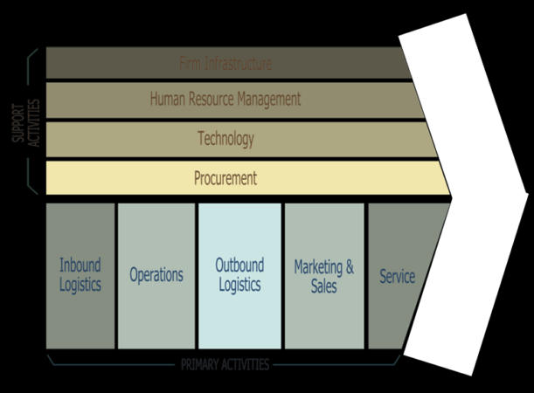

Figure 5: Value Chain Model
Source: (Walters and Rainbird, 2018)
Primary Activities
Inbound Logistics: A company's raw material suppliers and their production method. A good supplier relationship is necessary to get the best costs.
Operations: This step involves changing raw materials into the final product. Many firms have global operations for cheaper and faster shipment.
Outbound Logistics: A car's outbound logistics entail picking up, storing, and delivering things. This helps the company's management (Reese, 2018). All the while respecting consumer and company values, because this is a great way to add value, the delivery must be structured.
Promotion & Sales: Clients are attracted by marketing and sales. Advertising, customer relationship management, distribution, and sales management can help. The goal is to educate the right audience and enhance sales.
Service: The company provides post-sale customer service and product maintenance throughout the automotive value chain. This boosts brand image and customer retention. Customer service is a company's face.
Support Activities
Automotive Industry Support Services The Value Chain comprises activities that support primary occupations.
Infrastructure: It manages the company's culture and structure. To increase earnings, it is critical to know who is in charge of each department and to manage the company's finances efficiently.
HRM: It is a critical part of the firm as motivated, and well-managed personnel are vital to the brand's success (Reese, Waage, Gerwin and Koch, 2018). Controlling performance, recruiting and developing human resources are all part of this segment.
Technology Growth: Technology permeates the automotive value chain, from design to production. Technology development attempts to improve vehicle design, passenger safety, and emission control, a rising business and global concern.
Procurement: Procurement management attempts to lower supplier costs of raw materials and maintain prices low across the company's value chain (Walters and Rainbird, 2018). It also promotes customer reliability since they know what quality and efficiency to expect when buying a product from the company.

Conclusion:
In a business setting, many things can impact the organisation. Political, economic, social, technological, legal, and environmental factors can all impact how an organisation runs and how well it can make choices. All of these factors affect how the organisation runs and makes decisions. Many things about the business, like the company's weaknesses and strengths, possibilities, and risks, affect the business that is bad for the business and its efforts. Bentley will be better able to deal with the problems they will face in their international trading operations if they pay attention to the general environment.

References
Baron, D., 2018. Business and its environment. 4th ed. Boston: Pearson.
Bentleymotors.com. 2022. Official Bentley Motors website | Powerful, handcrafted luxury cars. [online] Available at: <https://www.bentleymotors.com/en.html> [Accessed 16 April 2022].
Coffman, P., 2016. Automobile industry. 14th ed. New York: Poor's Pub. Co.
Conklin, D., 2018. The global environment of business. 5th ed. Thousand Oaks, Calif: Sage.
Guy, F., 2017. The global environment of business. 4th ed. Oxford: Oxford University Press.
Kelly, P. and Ashwin, A., 2016. The business environment. 2nd ed. Andover: Cengage Learning.
Lipczynski, J., 2018. Business. 5th ed. Chicago: Chicago Review Press.
Michaux, S., Cadiat, A. and Probert, C., 2016. Porter's five forces. Uk: 50Minutes.
Morrison, J., 2019. The global busines environment. 6th ed. Hampshire: Palgrave Macmillan.
Reese, J., Waage, M., Gerwin, K. and Koch, S., 2018. Value Chain Analysis. 3rd ed. Germany: Nomos Verlagsgesellschaft.
Roy, D., 2017. Strategic foresight and Porter's five forces. 4th ed. München: GRIN.
Seth, C. and Probert, C., 2018. SWOT analysis. 3rd ed. Uk: 50minutes.com.
Walters, D. and Rainbird, M., 2018. The value chain. 5th ed. [Bradford, England]: Emerald Group Pub.
Whittington, R., Regner, P., Angwin, D., Johnson, G. and Scholes, K., 2017. Exploring strategy. 11th ed. Pearson Education.
Worthington, I., Britton, C. and Thompson, E., 2018. The Business Environment. Harlow, United Kingdom: Pearson Education Canada.

