8/27/2024
The role of social media tools such as LinkedIn and Facebook in staff’s recruitment
Report

Module Name: Digital Skills
Module Code: LCLM 4002
Student’s Name: Radian Cismaru
Student’s ID: 2335156
Group: Weekend
Lecturer’s Name: Koushik Modak

University of Wales Trinity Saint David (London Campus)
Table of Contents
Introduction 3
Advantages of the social media tools of Facebook in staff recruitment 3
Better scope for multiplying access to qualified candidates compared to job boards 3
Cost-effective 3
Disadvantages of using Facebook in staff recruitment 4
Heavy information overload 4
Privacy and Data Protection Concerns 5
Advantages of the social media tools of LinkedIn in Staff Recruitment 5
Most reputed professional social media job site 5
Save time with increased messaging capabilities 5
Disadvantages of the social media tools of LinkedIn 5
Premium cost incurred for premium recruiting service 5
High Risk of identity theft 6
Conclusion 6
Reference List 7

Introduction
According to Allal Cherif et al. (2021), social media enables and supports real-time interactive communication and open interaction between job recruiters and deserving candidates searching for jobs or job changes. Social media applications and its various tools like Facebook and LinkedIn help organizational recruiters to access and spread information about new job openings by positing in multiple social media platform. The various social media tools help both organisations and candidates to come under a common interactive and real-time communication platform for every passive and active candidate. The report will outline the Advantages and disadvantages of the social media tools of Facebook and LinkedIn in recruiting and selection procedures based on evaluating multiple and relevant literature studies.

Advantages of the social media tools of Facebook in staff recruitment

Better scope for multiplying access to qualified candidates compared to job boards
The prime advantage of using the social media tools of Facebook in staff recruitment helps the organizational Human resource management department to have better accessibility to a multiplied number of skilled and qualified candidates compared to job boards. For instance, 91% of the UK corporate firm’s head hunters rely on the social media tools of Facebook to have real-time recruitment and staffing solutions (Shoo Social Media, 2024). This has helped the HR manager of UK firms to reach potential professionals suiting the right job role and streamlining the entire staffing and recruitment networks. Moreover, the companies can reach the most skilled and qualified candidates' networks and can scrutinize their past job experiences and calibre.

Cost-effective
As suggested by Georgiou and Nikolaou (2020), traditional recruiting methods like newspaper ads, registering with various job portals, and media job advertisements are getting expensive day by day, affecting the operational cost of corporate business firms. Modern organisations HR managers and recruiters explore the social media tools of Facebook information sources as Facebook possesses a strong social networking platform people accumulation.
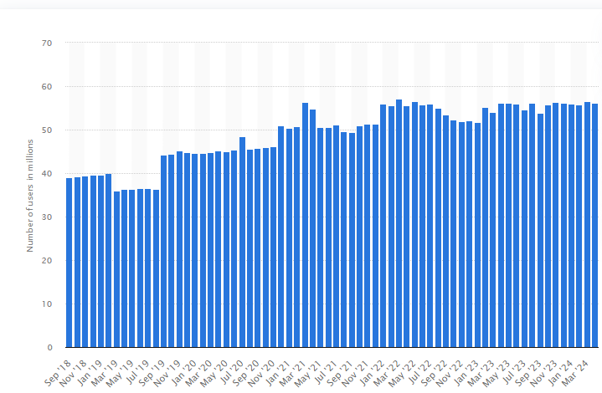
Figure 1: Growing Numbers of Number of Facebook users in the UK from September 2018 to April 2024
(Sourced: Statista, 2024)
For instance, 44% of the UK population is active in Facebook, accounting for 56 million of the UK population are Facebook users and it is still growing in numbers (Statista, 2024). The companies can experience lower cost structure per hiring of candidates starting from identifying the candidate by using social media a tool of Facebook, thus embracing a cost-effective quick and digital recruitment strategy (Synowiec, 2021).

Disadvantages of using Facebook in staff recruitment

Heavy information overload
As opined by Weilandt et al. (2021), one of the prime disadvantages of using Facebook in staff recruitment is heavy information overload resulting in perplexity and wrong choice of candidates by the recruiters. The recruiters need to sort countless profiles and resumes which can be a hugely time-consuming process and important details of the right and deserving candidates can be overlooked.

Privacy and Data Protection Concerns
Organizational recruiters need to abide by the compliance of the data protection rules and regulations along with ensuring the safe handling of candidates' sensitive information securely leading to data breaches. The recruiters can face major legal consequences or huge penalties if the candidates complain in a court of law about the recruiter's unethical use of personal information.

Advantages of the social media tools of LinkedIn in Staff Recruitment

Most reputed professional social media job site
LinkedIn is the modern-day best social media platform and tool used by global business and organizational recruiters offering the best-valued recruitment and staffing solution for corporate firms. For instance, LinkedIn is used by 40 million people every week to fulfil the purpose of a real-time job search platform (Shoo Social Media, 2024). In the UK, 94% of organisational recruiters rely on the social media tool the LinkedIn platform, and approximately three people are hired in a single minute. LinkedIn has been considered as the most effective way of attracting new and skilled talent from multiple locations. On the other hand, 90% of job-seekers in the UK use LinkedIn social media tools to reach their desired organisational job advertisements (Shoo Social Media, 2024).

Save time with increased messaging capabilities
Scholars like McCarthy (2021), identify that LinkedIn helps to empower real-time two-way interactive communication sharing job details and collecting candidates' academic and professional information under a single platform. LinkedIn provides exchanging of bulk messages between recruiters and candidates saving both time and money for both the sender and receiver within a corporate job network. LinkedIn helps the recruiters to gain past job experiences and company details for the identified candidates who has been shortlisted for interview.

Disadvantages of the social media tools of LinkedIn

Premium cost incurred for premium recruiting service
All the recruiting and staffing processes of LinkedIn is not free to access, as premium costs are incurred for premium recruiting services. The LinkedIn premium recruitment packages are super expensive such as mid-sized career and job programs. For any start-up business operators or entrepreneurs, it can be cost cost-challenging factor to bear such high-valued premium packages through LinkedIn. In UK, the complete cost of the full LinkedIn Recruiter license cost is £5,000 a year which is not affordable for a new start-up firm looking to hire new candidates (Davidsongray.co.uk, 2024).

High Risk of identity theft
Social media recruiting and staffing processes of LinkedIn can have a high risk of identity theft of the candidates due to the amount of personal information exposed on the social media tools. If there is any technical glitch, then all the personal information of the candidates and organization can be at stake due to third-party intervention.

Conclusion
The report concludes by shedding light on the concept of two important social media recruiting and staffing stools Facebook and LinkedIn and its overall influence and impact on the global job world. The report provides in-depth evidence and literature-based analysis to understand the role of the two major social media recruiting tools, Facebook and LinkedIn, explaining the advantages and disadvantages of the two platforms. The study also highlights the role of traditional recruiting methods, such as media advertisements, capable of identifying active candidates and not passive candidates.
Reference List
Allal-Chérif, O., Aránega, A.Y. and Sánchez, R.C. (2021) Intelligent recruitment: How to identify, select, and retain talents from around the world using artificial intelligence. Technological Forecasting and Social Change, 169. Available at: https://www.sciencedirect.com/science/article/pii/S0040162521002547
(Accessed: 22.07.2024)
Davidsongray.co.uk (2021) How Much Does LinkedIn Recruiter Cost? Available at: https://www.davidsongray.co.uk/a-guide-to-using-linkedin-recruiter/
(Accessed: 24.07.2024)
Georgiou, K. and Nikolaou, I. (2020) Are applicants in favor of traditional or gamified assessment methods? Exploring applicant reactions towards a gamified selection method. Computers in Human Behavior, 109. Available at:
https://www.sciencedirect.com/science/article/pii/S0747563220301096
(Accessed: 23.07.2024)
Macarthy, A. (2021) 500 social media marketing tips: essential advice, hints and strategy for business: facebook, twitter, pinterest, Google+, YouTube, instagram, LinkedIn, and more.
Shoo Social Media (2024) Does social media really work for recruitment?. Available at:
https://www.shoosocialmedia.co.uk/does-social-media-really-work-for-recruitment
Statista (2024) Number of Facebook users in the United Kingdom from September 2018 to April 2024. Available at:
https://www.statista.com/statistics/1012080/uk-monthly-numbers-facebook-users/#:~:text=In%20April%202024%2C%20the%20United,audience%20size%20in%20four%20years
(Accessed: 26.07.2024)
Synowiec, A. (2021) Virtual identity in social media as a source of information in the recruitment process. Соціальні комунікації: теорія і практика, 13(2), pp.184-193. Available at:
http://new.comteka.com.ua/index.php/journal/article/view/120
Weilandt, J., Jonson, C.O. and Prytz, E. (2021) Information overload in Swedish emergency response command and control functions. Linköping University Electronic Press.

