3/24/2025
University of Wales Trinity Saint David
London campus
E-Portfolio Link: Do not forget to share your e-portfolio (Wix) link here
Module Name: Learning In the Digital Era
Module Code: ACCA 4025

Student Name:
Student ID:
Group: 1

Lecturer’s Name: Koushik Modak

LDE Assignment 1
E-Portfolio
Table of Contents
Introduction 2
Main Body 2
Task 1: Essential Academic and Employment Skills for the future career Path 2
Task 1 (a): Report on Essential Academic and Employment Skills 2
Task 1 (b): AI Assistant Tools 2
Task 1 (c): Evaluation of Task 1 (a) based on Similarity report 3
Task 2: Collaborative Mind Map and Individual Poster 3
Mind Map (Collaborative) 3
Poster (Individual) 3
Task 3: Virtual Collaboration and RefWorks 3
Report on Virtual Collaboration 3
Step-by-step process of using RefWorks with visuals 3
Task 4: E-Portfolio Creation and Evaluation 3
Task 4 (a): E-Portfolio Creation 3
Task 4 (b): Illustrative Review of E-Portfolio tool Selection 4
Conclusion 4
References 4
Task 1 References: 4
Task 3 References: 4

Introduction
In this portfolio we will explores the essential academic and employment skills needed for a future career in cybersecurity. It explores how critical thinking, research, communication, time management and digital knowledge support successful university studies. It also looks at the technical and professional skills needed to protect computer systems, networks and your sensitive information from cyberattacks. On top of that, the portfolio evaluates popular artificial intelligence assistants and how they can support you in the cybersecurity learning, researching and problem-solving. Building these skills and learning to use digital tools, I want to strengthen my academic performance and prepare for future opportunities in the cybersecurity industry.

Main Body

Task 1: Essential Academic and Employment Skills for the future career Path

Task 1 (a): Report on Essential Academic and Employment Skills
A careful method is needed when studying cybersecurity. Critical thinking enables students to examine the technical details, find any errors and assess whether the information is reliable. When it comes to research, students should look at a cyberattack or a new security tool and it is essential to refer to official studies, books and established cybersecurity advices. It is dangerous to rely on unverified websites. Proper referencing is also of great importance since citing the author shows respect and allows others to verify the facts. Time management is of great significance as students have to plan their assignments, complete their work and prepare for exams without becoming rushed.
Digital literacy helps students in moving around learning platforms and in programming spaces. For example, when a student is studying a cyberattack they have to find out how the attack works, reliable evidence and then explain the correct steps for preventing it. These academic skills form a foundation for more in-depth cybersecurity learning and aid independent study.
To work in cybersecurity a person needs both knowledge and strong personal skills. Technical skills include understanding computer networks, operating systems, programming and how to find weaknesses in computer systems [1] . The National Institute of Standards and Technology says that the exact skills needed can differ based on the job within cybersecurity [1]. Problem-solving and analytical thinking are also key. Cybersecurity professionals often need to investigate suspicious activity and figure out how to stop cyberattacks before they cause damage. Clear communication is important too. It helps when explaining security risks to team members or managers who may not understand details [1]. Working well in a team is also essential during security incidents when quick and coordinated action is needed. The World Economic Forum points out that networks and cybersecurity skills will keep growing in importance as technology changes. Professionals in this field must also be responsible to pay attention to details and keep learning [2]. New threats show up all the time so staying updated is a must. Having both technical know-how and personal strengths like communication and teamwork can make a difference, in finding a job and moving forward in a cybersecurity career [1] [2].

Task 1 (b): AI Assistant Tools
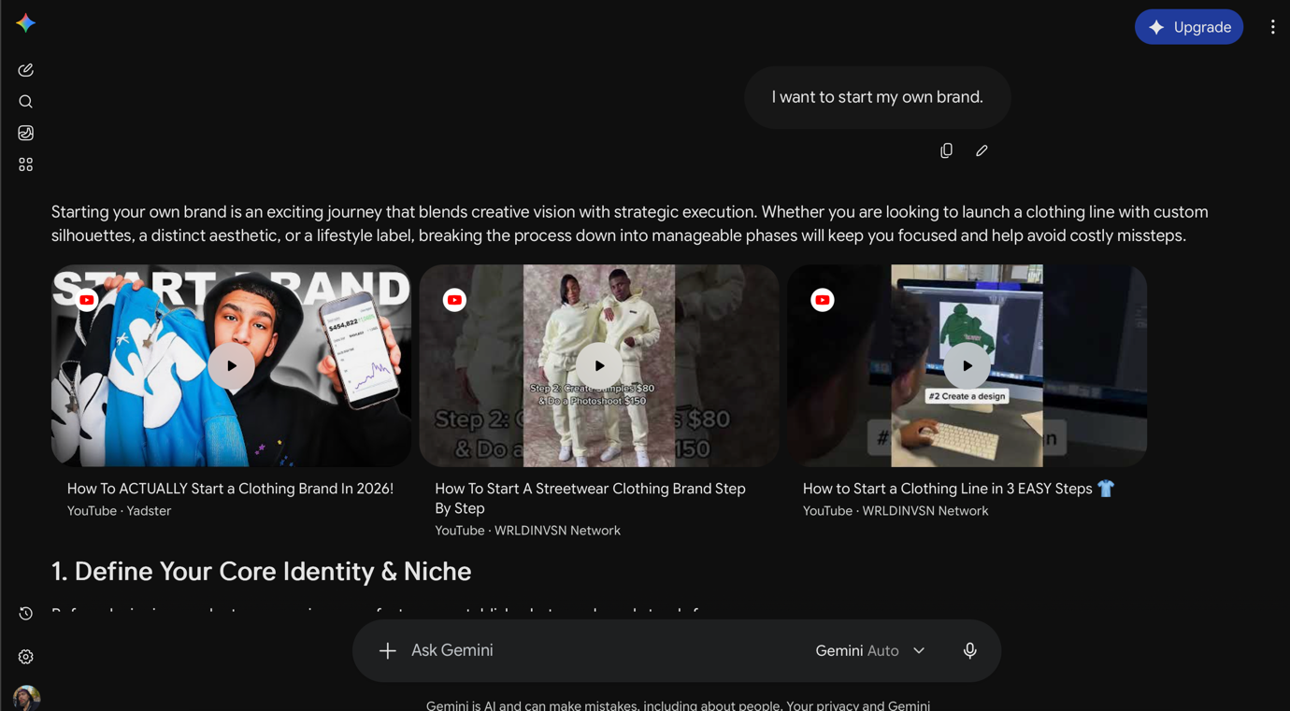
(1)
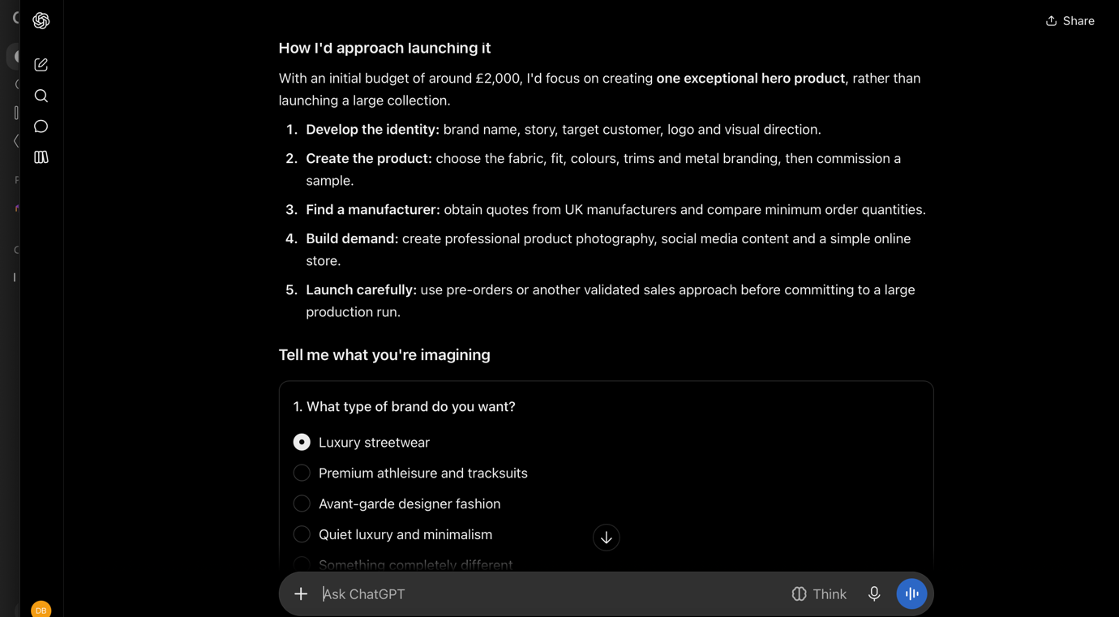
(2)
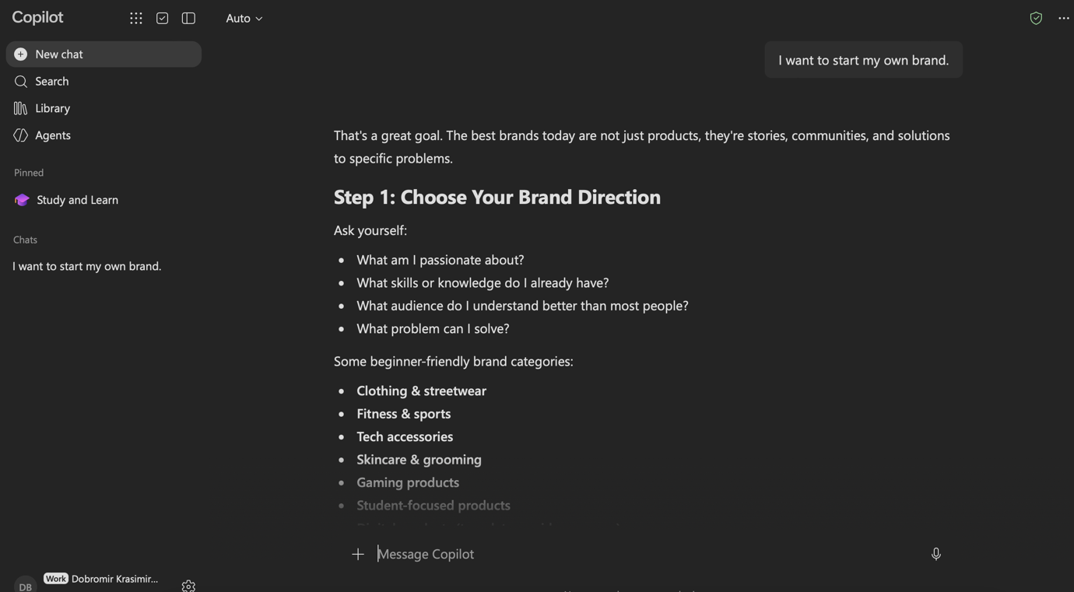
(3)
Image (1) We can see that Gemini provided an introduction to starting a brand and suggested defining the brand's identity and the audience that needs to be the target. It also included video recommendations, which could help beginners find practical advice and understand what will be the process.
As shown in Image (2) ChatGBT gave a more detailed step-by-step plan. It suggested starting with one main product, creating a sample, finding a manufacturer, promoting the brand online and testing the interest levels before investing in large quantities. This response is very useful because it presented the process in an organised and practical way.
Image(3) Copilot on the other hand focused on choosing a brand direction. It suggested me to consider my personal interests, existing skills, target audience and possible product options. This could help someone decide which type of business to start before investing money.
However, as I have experience in the topic, I have given them and have firsthand knowledge regarding some of the information they provided, I noticed a couple of practical errors so people must check important facts with reliable sources before using them in the academic or business area.

Criteria | ChatGPT | Copilot | Gemini
Generating answers | Excellent | Excellent | Excellent
Creative work, code/diagram generation | Good | Good | Very good
Data analysis | Very good
Problem-solving | Medium | Very good | Good

Identify a course available in LinkedIn which talks about AI assistance. (Remove this part after completing)

Task 1 (c): Evaluation of Task 1 (a) based on Similarity report
Submit the document prepared in Task 1 (a) to Turnitin and generate the similarity report and take a screenshot of your similarity report and paste it here. Please evaluate your similarity percentage. (200 words) – self-evaluation (approx. 200 words and 2 paragraphs where the first paragraph is about your similarity index and your areas of improvement. Then the second paragraph is about how much mark you deserve on your work with an appropriate justification-Remove this part after completing).

Task 2: Collaborative Mind Map and Individual Poster

Mind Map (Collaborative)
(approx. 450 words where 3 persons in one group and the contribution from each person should be 150 words approx..).

Poster (Individual)
No word limit. Mind Map must be inserted in the Poster

Task 3: Virtual Collaboration and RefWorks

Report on Virtual Collaboration
(approx. 350 words and 4-5 sources-Remove this part after completing).
Put your Chosen topic here and write a summary of that topic with IEEE referencing using RefWorks-Remove this part after completing.

Step-by-step process of using RefWorks with visuals
Put screenshots with appropriate discussion explaining what has been demonstrated in that screenshot-Remove this part after completing (100-150 words)

Task 4: E-Portfolio Creation and Evaluation

Task 4 (a): E-Portfolio Creation
Explain how you have created your e-portfolio with screenshots as evidence-Remove this part after completing.

Task 4 (b): Illustrative Review of E-Portfolio tool Selection
(approx. 100-150 words and 1-2 sources (if used)-Remove this part after completing).

Conclusion
(approx. 100 words -Remove this part after completing).

References

Bibliography

[1] | R. Petersen, D. Santos, M. Smith and G. Witte, “Workforce Framework for Cybersecurity,” NIST Special Publication, Gaithersburg, 2020.
[2] | W. E. Forum, “The Future of Jobs Report 2025,” World Economics Forum, Geneva, 2025.

Task 3 References:

