  Component One:  What are the key skills required when working in the housekeeping team? 750 words (+/- 10%)  Contribution to Overall Module Assessment: 25% | Student No: | 2207923
 | Module Title: | Hotel placement Operating Hotel Facilities
 | Module Code: | BMIH4006
 | Lecturer:
It takes a diverse set of skills to maintain the cleanliness and organisation of the housekeeping crew. According to research done by Hurrell (2016), in order for housekeeping employees to be effective in their jobs, they need to have strong communication and managerial skills, as well as excellent attention to detail, physical stamina, and the ability to solve problems.
The ability to communicate clearly and concisely is an essential component of housekeeping. In order to provide excellent service and understand their customers' requirements, housekeepers need to have strong communication skills with their customers, their co-workers, and management. It is essential, as stated by Kansakar et al. (2019), for housekeeping personnel and visitors to effectively communicate with one another in order to satisfactorily meet the requirements of guests in a timely manner.
The ability to manage one's time well is another one of the fundamental skills for housekeeping. Housekeepers are responsible for successfully managing their time in order to complete their work within the time limits that are imposed on them as a result of cleaning multiple rooms on a predetermined schedule. According to Prais et al. (2019), individuals who work in housekeeping need to be skilled in time management in order to ensure that all areas are cleaned thoroughly and in a timely manner.
The cleaning process demands careful attention to every detail. It is necessary for housekeepers to pay close attention to detail in their work in order to guarantee that each room is meticulously cleaned and that all possessions are stored in the appropriate manner. According to McMunn et al. (2020), it is essential for housekeepers to pay attention to even the smallest things, such as ensuring that the drapes are straight and placing the pillows on the bed.
Employees in the cleaning industry need to be able to demonstrate a high level of physical endurance. Housekeepers are need to stand for extended amounts of time due to the physically demanding nature of their work, which includes tasks like as lifting heavy things and stooping to clean lower regions of the home. According to Whiting and Symon (2020), housekeeping staff members need to have a certain level of physical fitness in order to successfully complete their occupations, which include tasks such as cleaning and transporting heavy products.
Housekeeping personnel must also have great problem-solving skills. Because they may confront tough customers or severe stains that require effective remedies, housekeepers need to be quick thinkers who are able to handle problems. According to Edgell et al. (2015), problem-solving skills are necessary for housekeeping employees in order to address any issues that may arise in the workplace.
In addition to these skills, staff in the housekeeping department are required to have a pleasant attitude and have a strong work ethic. The position of housekeeper is one that requires a high level of physical fitness and calls on workers to put in long hours while being motivated throughout their shift. Housekeepers should have a positive attitude and be willing to go above and beyond to ensure that guests have a nice and delightful experience, according to Knox et al. (2015). This will ensure that guests receive the best possible service.
To summarise, the members of the housekeeping team need to possess a number of skills, including the ability to communicate well, manage their time effectively, be fastidious, have physical endurance, and be able to solve problems. It is important for personnel working in housekeeping to have a positive attitude and a strong work ethic in order to provide outstanding service to visitors and guarantee that they have a pleasant and enjoyable stay. By acquiring these skills, individuals working in housekeeping can improve their performance in their roles and make more significant contributions to the businesses for which they work.

Word Count | 628

Component Two:
Contribution to Overall Module Assessment: 25%
In this scenario – You have just been promoted to team leader for a floor within the hotel. A guest complains that on their arrival, their room had not been properly cleaned. Create an action plan and answer the following questions.

Problem | Why did it happen? | What are you going to do? | How will you prevent this from happening in the future? | What measures would you introduce to improve team effectiveness?
Room not properly cleaned | Housekeeper may have missed some areas during cleaning, or was not thorough enough. | Apologise to the guest and offer to have the room recleaned immediately. Offer compensation or a discount for the inconvenience caused. | Conduct regular quality checks and inspections of rooms to ensure all areas are properly cleaned. Provide additional training to housekeepers if necessary. | Implement a system for accountability and follow-up to ensure any issues are addressed in a timely manner. Encourage open communication among team members to identify and address any concerns or challenges.
Lack of communication among team members | Miscommunication or lack of communication may lead to incomplete tasks or missed deadlines. | Foster open communication among team members, encourage regular team meetings and updates, and ensure that everyone is aware of their roles and responsibilities. | Implement a system for tracking and monitoring tasks and deadlines to ensure everyone is on the same page. Provide additional training on effective communication if necessary. | Encourage collaboration and teamwork among team members, and reward and recognise individuals for their contributions and achievements.
Inadequate training or skills | New team members may not be properly trained or have the necessary skills to perform their duties effectively. | Provide comprehensive training and onboarding for new team members, and offer ongoing training and development opportunities to improve skills and knowledge. | Regularly evaluate team members' skills and performance, and provide feedback and coaching to help them improve. Encourage team members to share their knowledge and expertise with each other. | Offer incentives or rewards for individuals who participate in training and development activities, and recognise and promote individuals who demonstrate exceptional skills and performance.
Lack of motivation or engagement | Team members may become disengaged or unmotivated, leading to decreased productivity and quality of work. | Offer opportunities for team members to provide feedback and suggestions on ways to improve their work environment or processes. Provide recognition and rewards for exceptional performance, and encourage team members to set personal and professional goals. | Foster a positive and supportive work culture, and encourage team members to take ownership of their work and contribute to the team's success. Offer opportunities for team building and social activities to promote engagement and collaboration. | Encourage open communication and feedback, and regularly evaluate team members' job satisfaction and engagement. Address any concerns or issues promptly and proactively. Offer opportunities for career growth and advancement within the organisation.

Component Three:
Contribution to Overall Module Assessment: 50%
Your task is to create and prepare a presentation following the detailed scenario provided below.

As the floor housekeeping manager and given the recent guest complaints you need to put together a basic training presentation for your colleagues within the housekeeping team to get the best out of them, ensure that brand standard is being achieved and that Health and Safety procedures are also being followed.

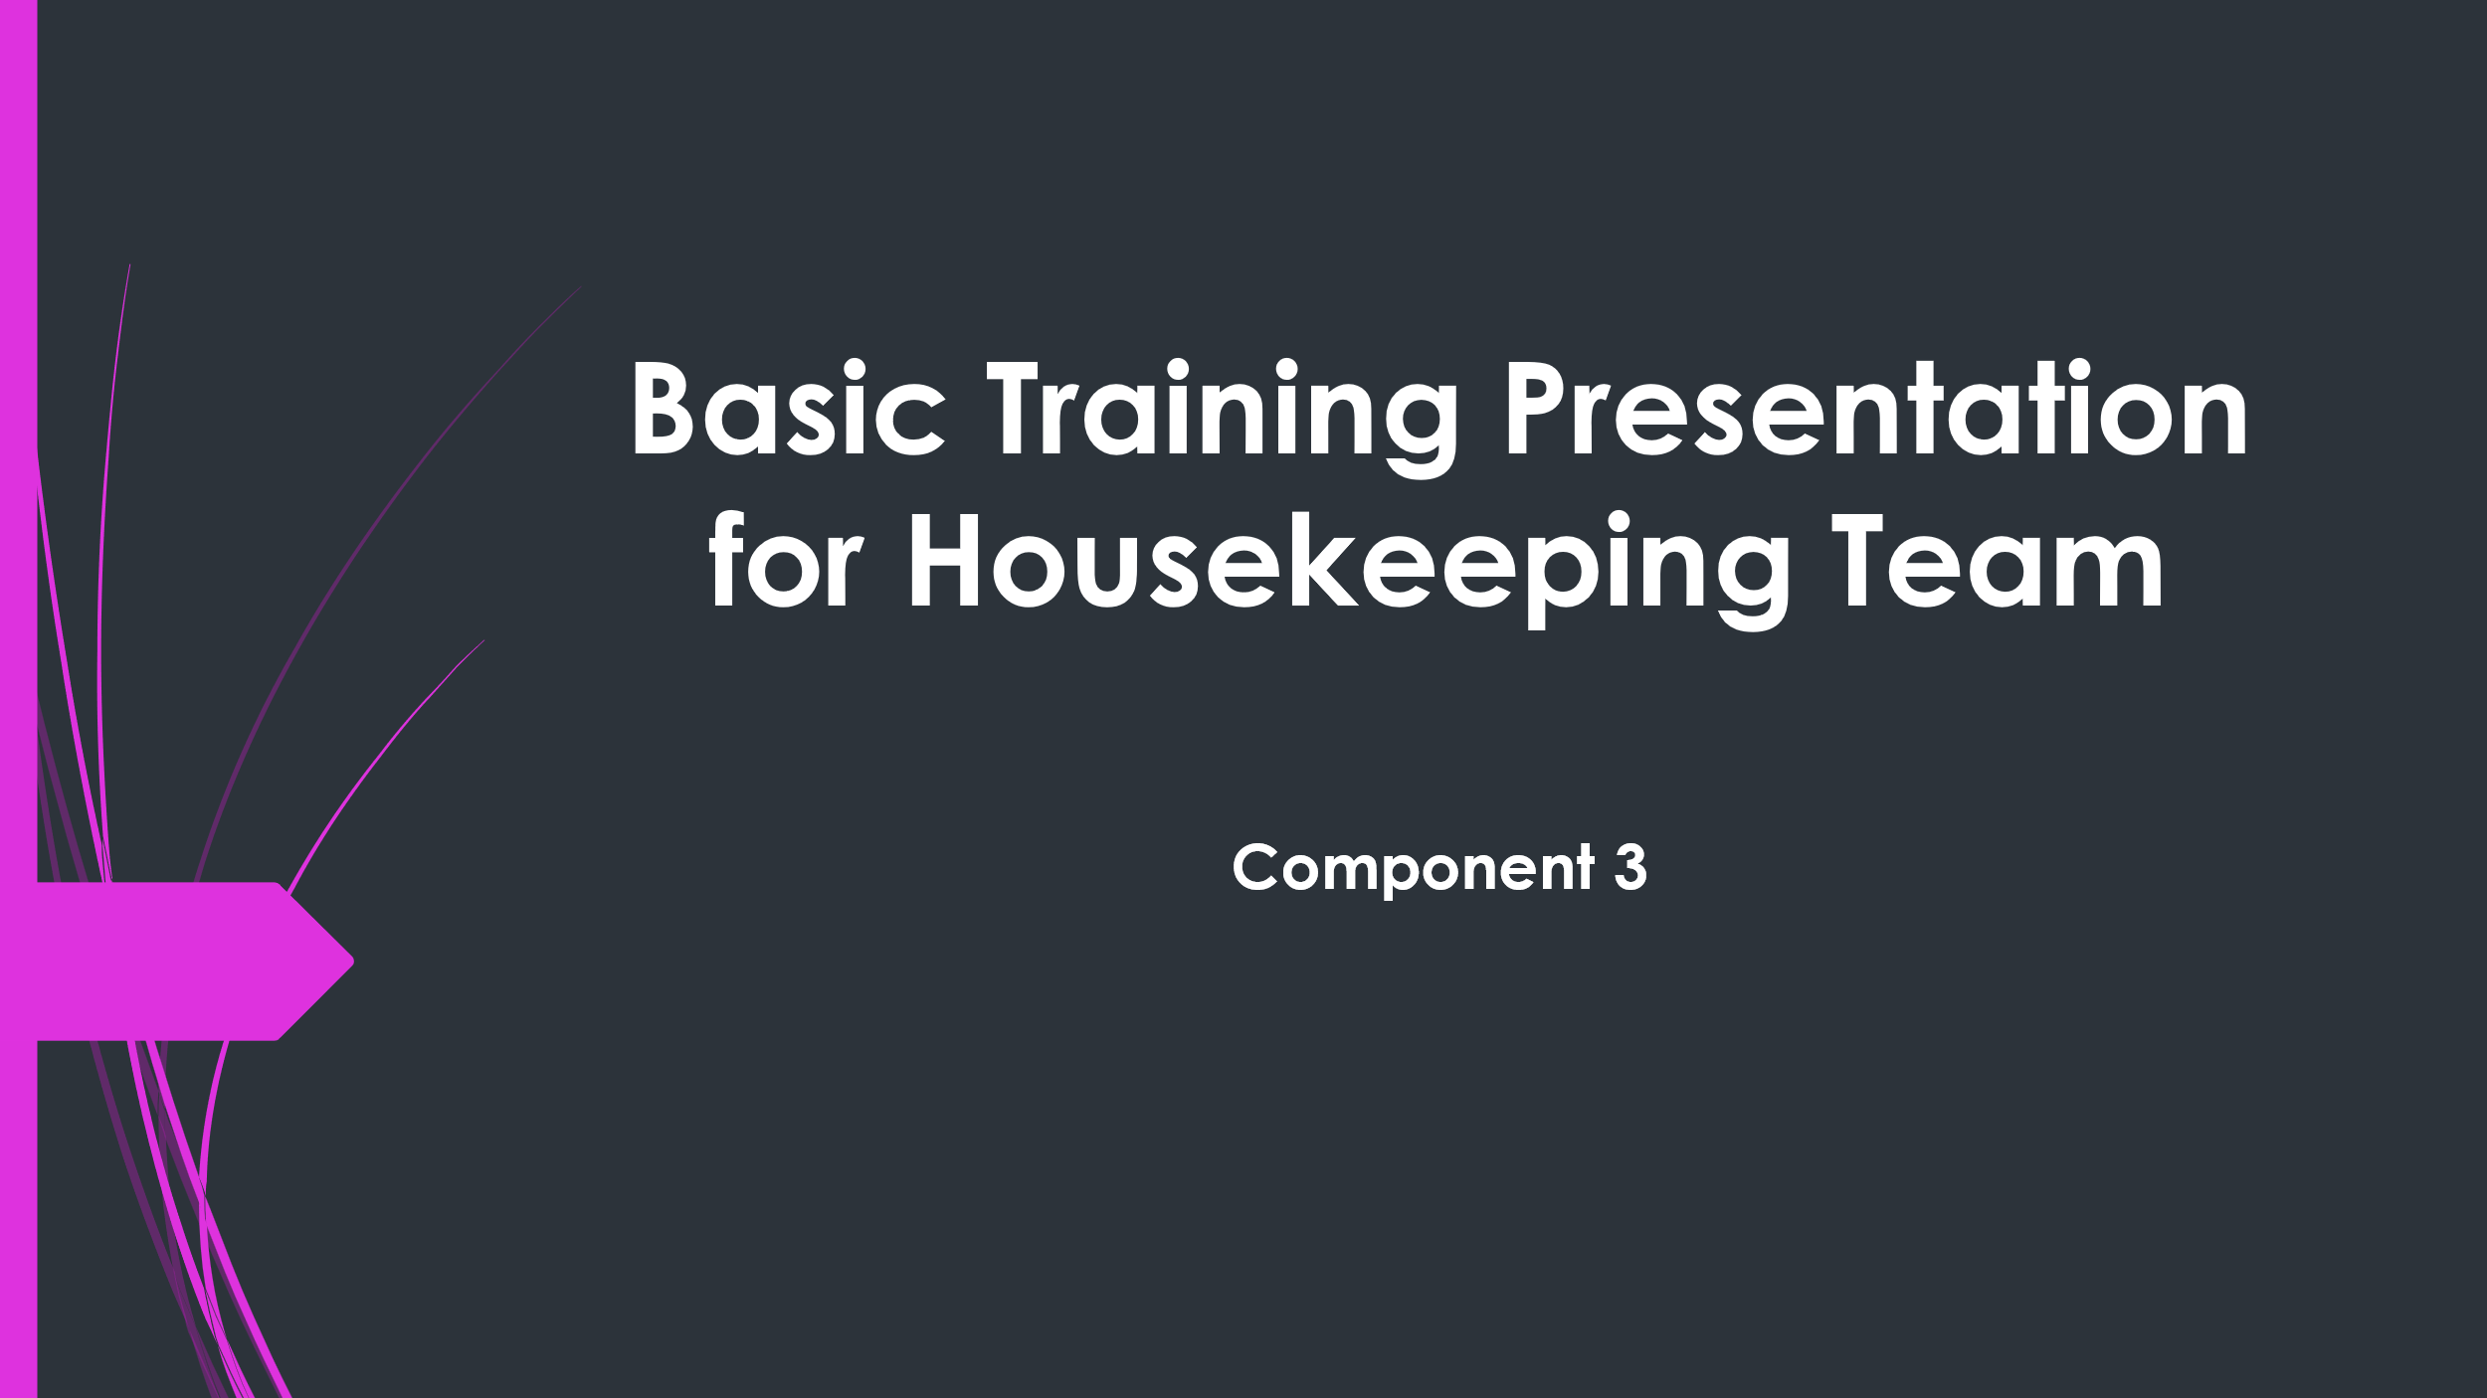

Training Notes:
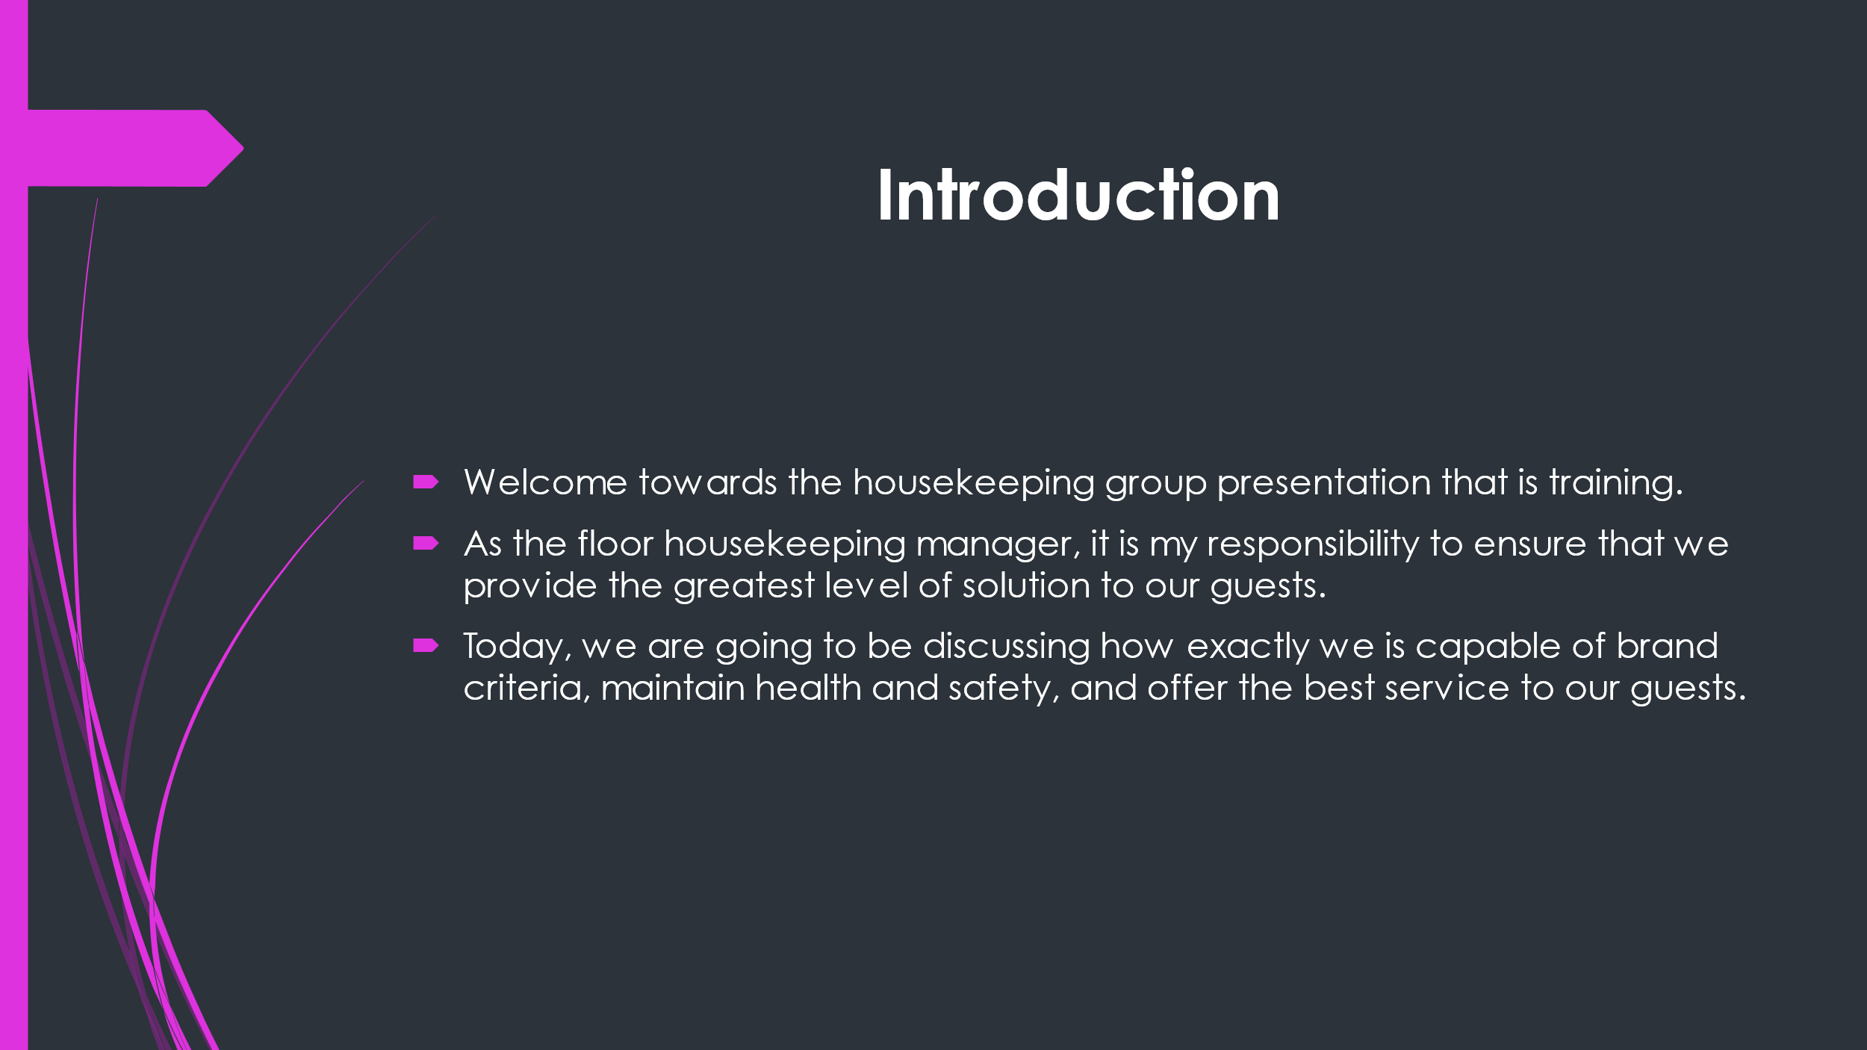

Training Notes:
- Welcome everyone to the housekeeping team presentation that is training.
- Introduce myself and explain why this training is essential. For instance, recent guest complaints might have prompted the necessity for training.
- stress the value of keeping high standards and providing solution that is excellent guests.
- Let my team know very well what they are able to expect to discover during the presentation.

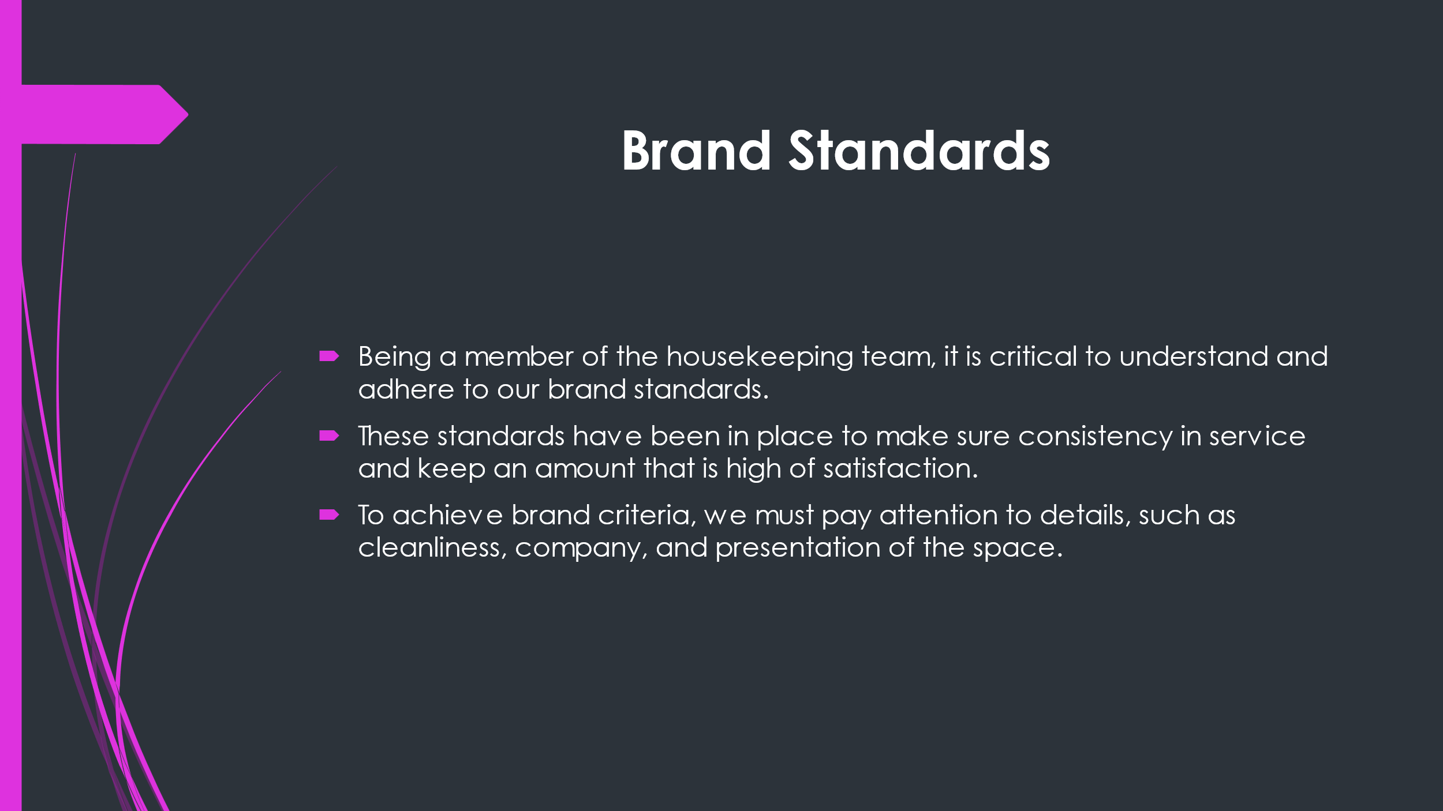

Training Notes:
- Explain just what brand standards are and why they truly are important. Brand name standards are guidelines for how the resort wants to be identified by guests. They include sets from how the available room should be arranged to the amenities that ought to be provided.
- Provide specific examples of brand standards, such as just how beds ought to be made, how the bathroom should really be cleaned, and what amenities should really be supplied.
- Explain the value of staying with brand name requirements, such as ensuring consistency in service and keeping high levels of visitor satisfaction.

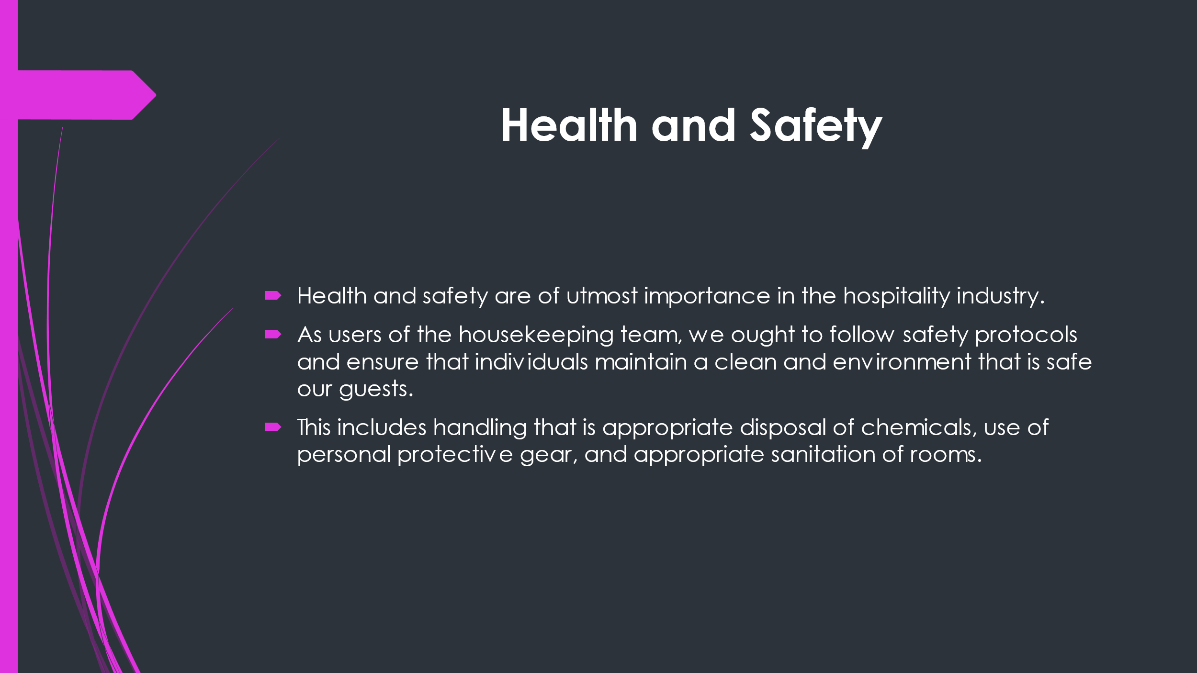

Training Notes:
- Discuss the importance of safety and health into the hospitality industry. This includes making certain the hotel is a safe and environment that is clean guests and staff.
- Explain the risks associated with perhaps not health that is following security protocols, such as for example injuries, accidents, and illness.
- Provide specific examples of health and safety protocols that the housekeeping team should follow, such as for instance how to handle and dispose of chemical substances, utilising personal gear that is protective and how to properly sanitize rooms.

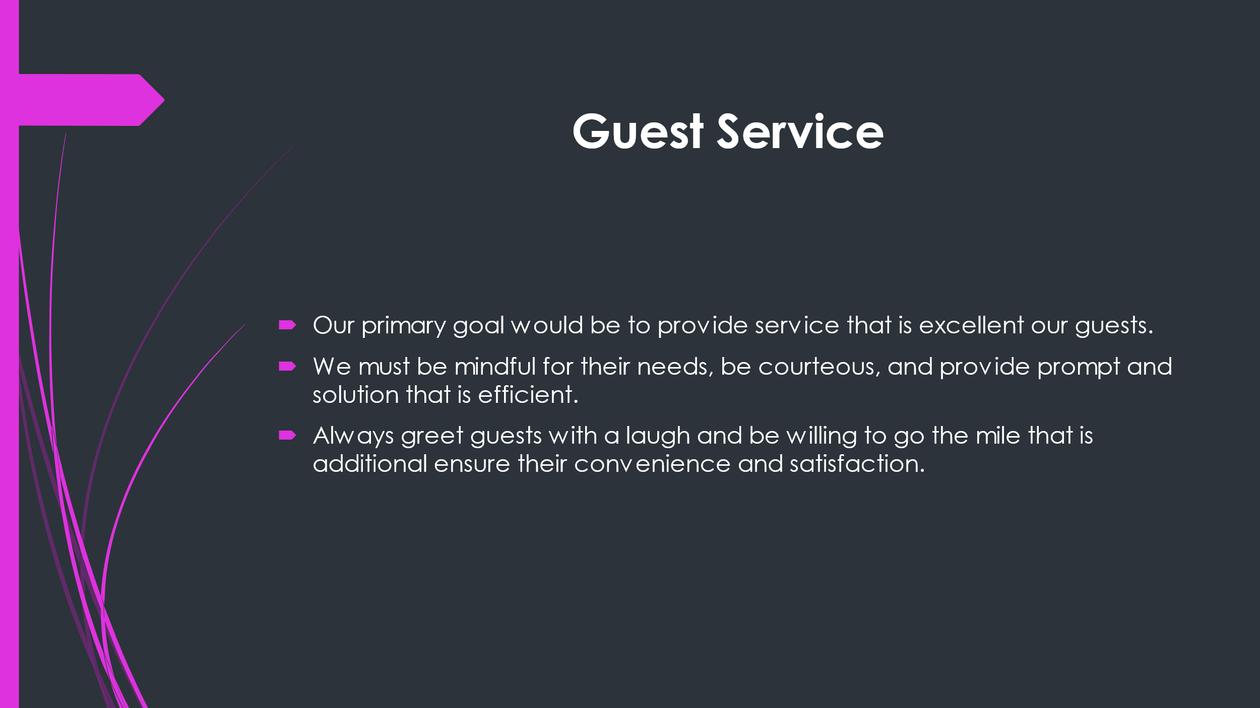

Training Notes:
- Emphasise the value of providing service that is excellent visitors. This includes being attentive to their requirements, being courteous, and supplying prompt and service that is efficient.
- Provide specific examples of how to give service that is very good such as for instance greeting guests with a laugh, offering to help with their luggage, and ensuring their room is neat and comfortable.
- Explain how providing service that is very good result in increased visitor satisfaction and repeat business.

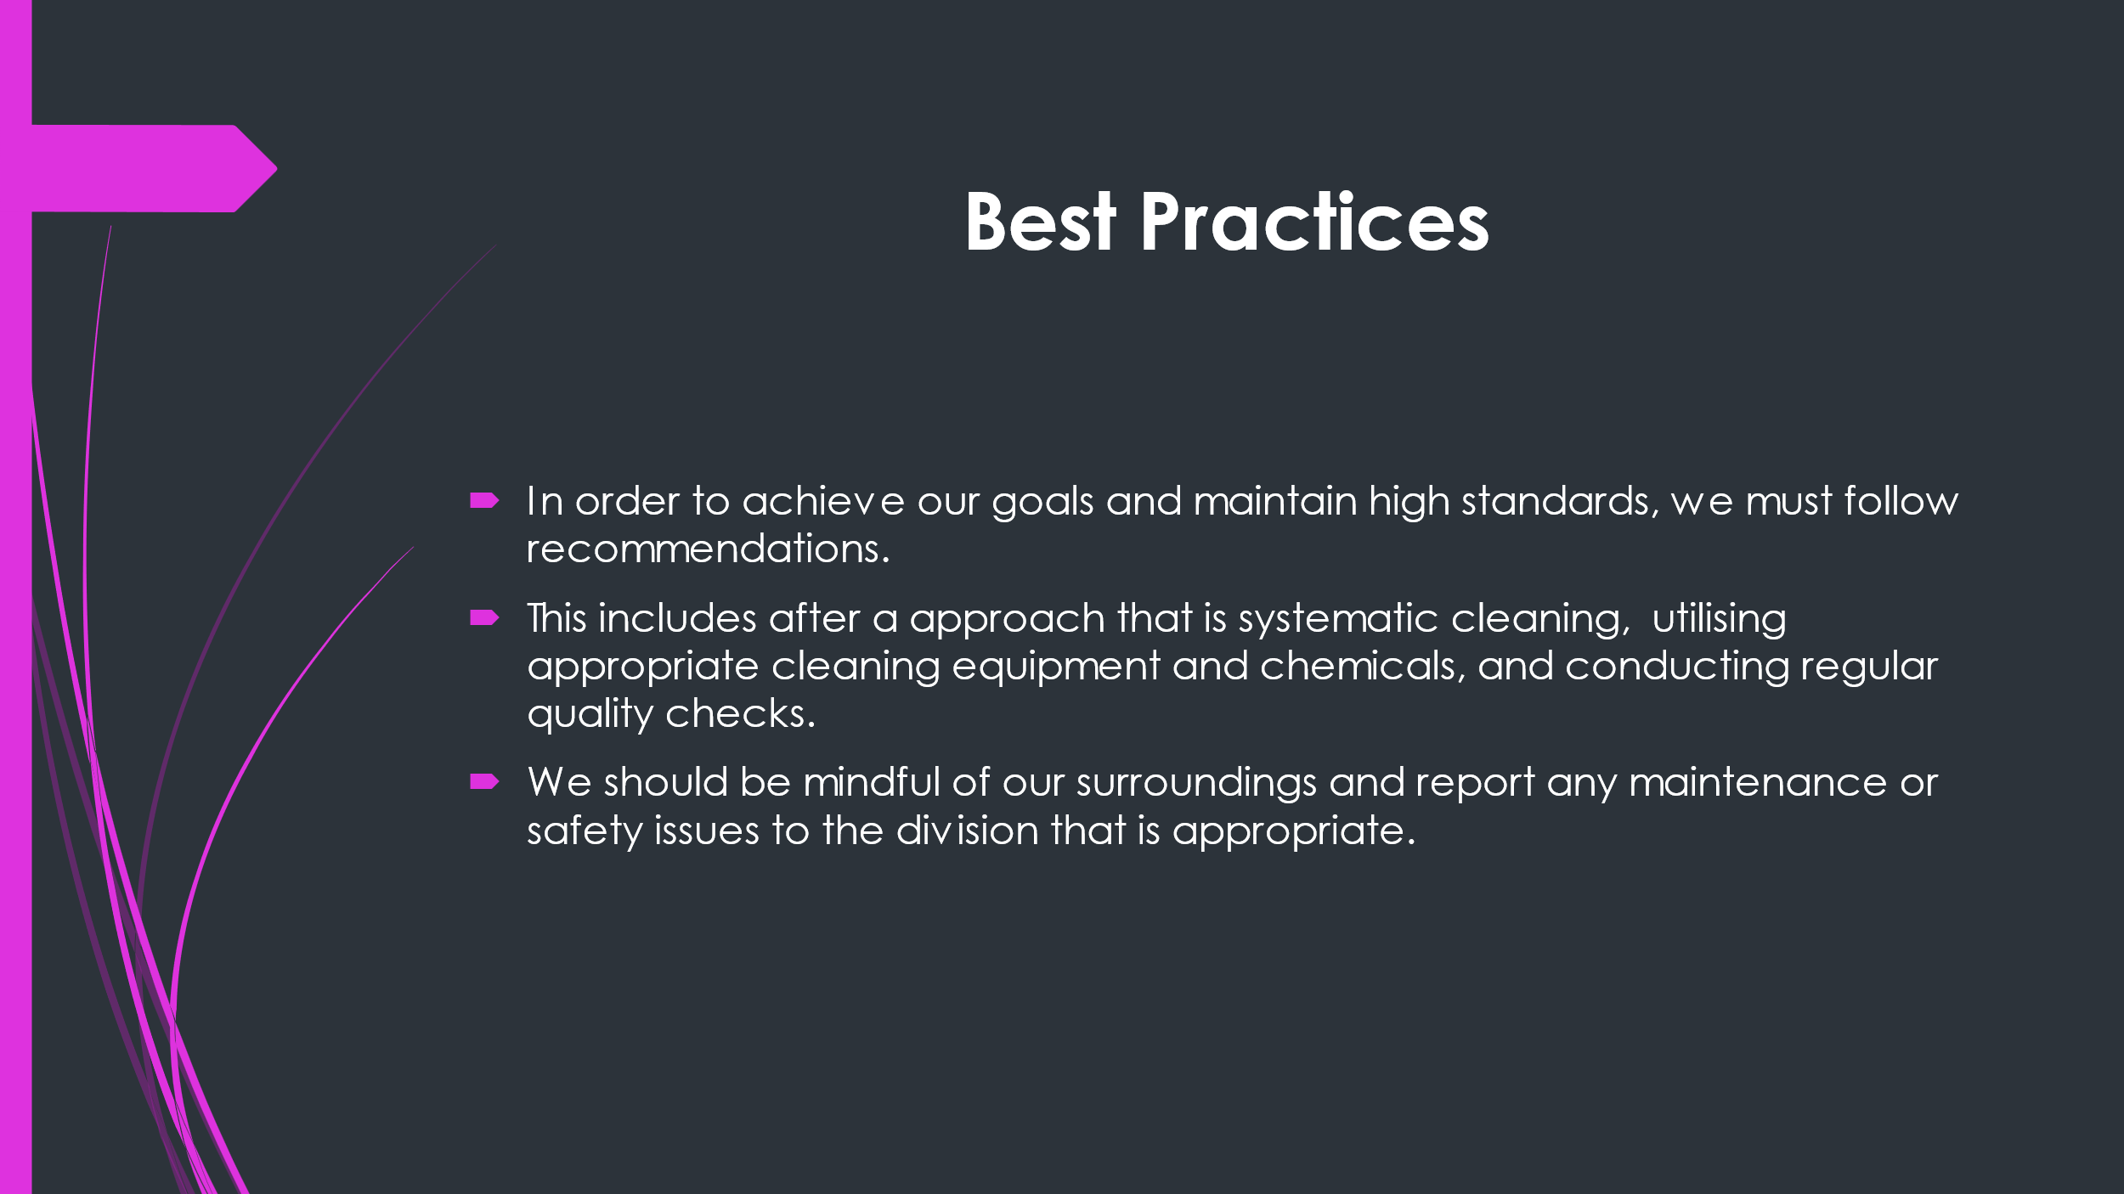

Training Notes:
- Discuss the importance of following guidelines in housekeeping. This includes carrying out a approach that is systematic cleaning, using appropriate cleaning equipment and chemicals, and performing regular quality checks.
- Provide specific examples of best practices, such as beginning from the top associated with room and working downwards, utilising microfiber cloths to reduce the usage of chemical substances, and checking for cleanliness and functionality of all items into the room.
- Explain how following best practices can lead to effectiveness that is improved better quality work, and increased guest satisfaction.

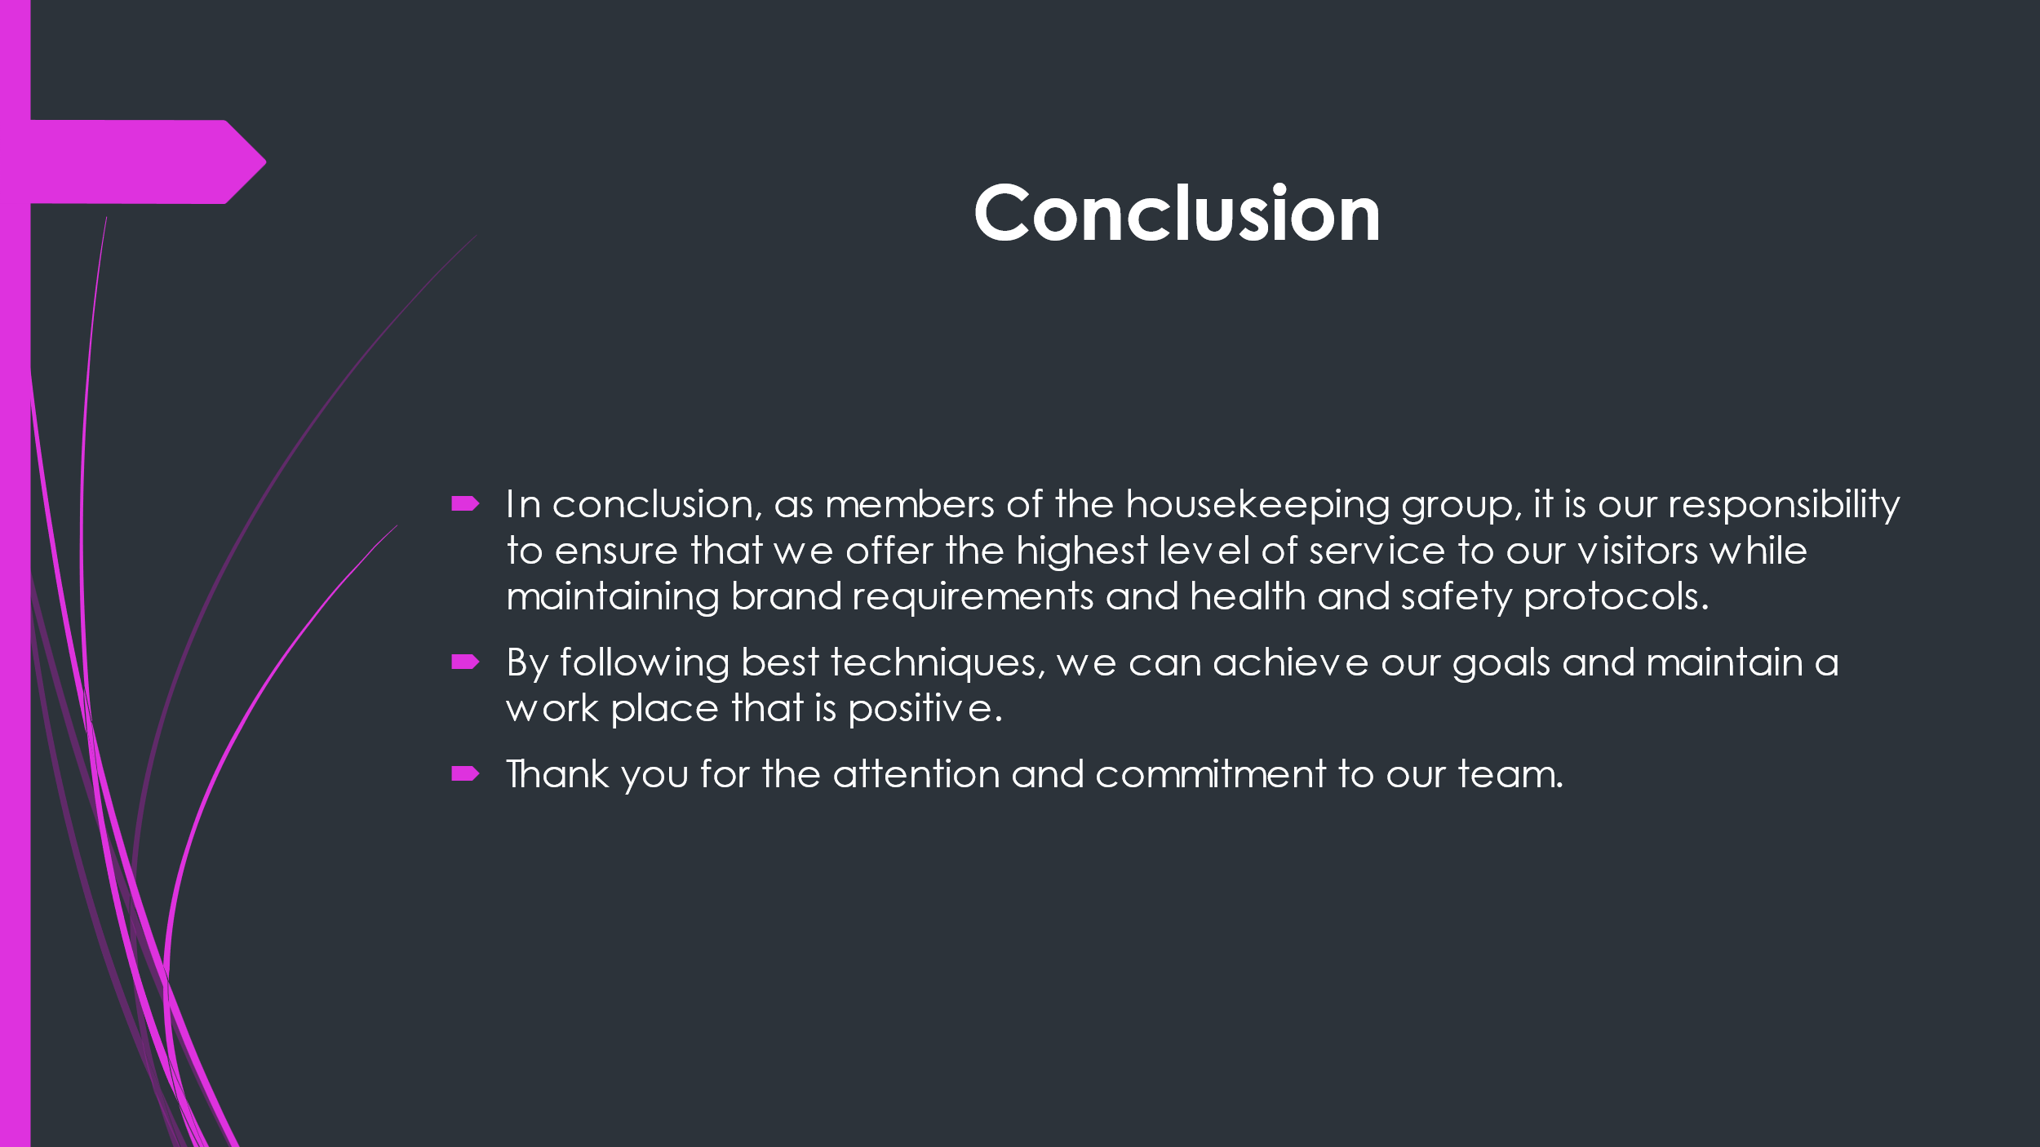

Training Notes:
- Summarise the points that are key the presentation, such as the significance of brand standards, safe practices, guest service, and guidelines.
- Emphasise that by after these instructions, the housekeeping team provides service that is excellent guests and maintain high levels of visitor satisfaction.
- Thank my team for their attention and dedication to their work, and encourage them to continue to shoot for excellence.

References
Edgell, S., Gottfried, H. and Granter, E. eds., 2015. The SAGE handbook of the sociology of work and employment.
Hurrell, S.A., 2016. Rethinking the soft skills deficit blame game: Employers, skills withdrawal and the reporting of soft skills gaps. Human relations, 69(3), pp.605-628.
Kansakar, P., Munir, A. and Shabani, N., 2019. Technology in the hospitality industry: Prospects and challenges. IEEE Consumer Electronics Magazine, 8(3), pp.60-65.
Knox, A., Warhurst, C., Nickson, D. and Dutton, E., 2015. More than a feeling: Using hotel room attendants to improve understanding of job quality. The International Journal of Human Resource Management, 26(12), pp.1547-1567.
McMunn, A., Bird, L., Webb, E. and Sacker, A., 2020. Gender divisions of paid and unpaid work in contemporary UK couples. Work, Employment and Society, 34(2), pp.155-173.
Prais, S.J., Jarvis, V. and Wagner, K., 2019. Productivity and vocational skills in services in Britain and Germany: Hotels. In International comparisons of vocational education and training for intermediate skills (pp. 119-145). Routledge.
Whiting, R. and Symon, G., 2020. Digi-housekeeping: the invisible work of flexibility. Work, employment and society, 34(6), pp.1079-1096.

