Web Development

Molner Thomas
1804565
ACCC5004
Assignment 2 (50%)

Suneth Fernando
Terry Walcott

Student Management

Table of Contents
Student Management 4
Website concept and implementation 4
Database Normalization 5
First normal form or 1NF: 5
Second Normal Form or 2NF: 5
Third Normal Form 3NF: 5
XAMPP 5
PHP 5
Error in PHP 6
Conclusion 8
Reference: 9
Appendices: 10

Student Management

The student management project is about the report on the website of the University with more courses, which was been created by me. Here you will find my report based on the Student Management website which supports all my idea and you will see step by step and the concept I implemented for creating this website. For your summary I was working with HTML and XAMPP, I explain one by one what are exactly and the process. I create this website from scratch, and I was working with Structured Query Language SQL also, so that includes data query, data manipulation and data definition.
The most important rule of formatting a web developer summary statement is to lead with the most important information, such as education or training in a niche the company is focused organized and focused on details.

Website concept and implementation

You will during my report all step you need to follow to complete and create a website from scratch, you can open this internet pages on Safari, Chrome and any browser would you like.
This website it has been design by me, and you can find multiple commands and tags as body, title, header, new line, hyperlink and another basic commands.

I will explain my front page which was written in HTML, and you can see all my courses as per “Figure nr 1”.
I will talk about my front page, where you can see my logo up on the left side, and on the right side you can see all my pages, you can have access on all of them, I will also explain one by one why are there and what are they doing.
On the second point I will explain you my menu from the right side where you have access to “ Home ” if you click on it always it is going to the main page, “ About ” you can see our evolution from our campus, “ Courses ” you will have access to our five Moodle, “ Events ” on this page it is posted our event every Monday for next week or month, “ Gallery ” at this section you will see photo with our staff or student and the last one is “ Contract ” this is the most important page, you will see all our contact form, our phone number, our address.
In our Student & Admin Registration as in “Figure number 2” attached below you can see in the first column they are asking for “ First name ”, “ Last name ”, and for “ User type ” you have two option “ Admin “ and “ Student ”, if you are “ Admin ” you can select “ Admin” and if not you have an option for “ Student “, to continue without form you have to complete with your details such as “ Address ”, “ City “, “ Country “, and at the section “ Course ” you will have to select your course from this University, which are “ Computer Science “, “ Business Studies ”, “ Media and Journalism “, “ Arts and Humanities “, “ Medical Science “, and two more columns you will have to fill up, and they are “ Email ID ” and at the last DOB this is coming from Date of birth.

I will explain something important from Date of Birth DOB, I connected from the database, if you are from under 18 years old you can submit your registrations, if you are under the 18 years old you will have an error.

Database Normalization

The database normalization or I can say simple normalization it will help with the process of reorganizing data in a database the tables or columns so I can minimize data redundancy.
The database is very important for beginners like me because it makes me understand the terminology and how to precondition a table into a small table so we cannot lose important information.
So, I have three type of normalization, I will explain in particular one by one.

First normal form or 1NF:
It will help into defined the column and the row with only one values, and they need to be in an individual unit.

Second Normal Form or 2NF:
In the second normal form, I will say each attribute, need to be part of a prime attribute or non-prime attribute. The difference between this two is, the prime attribute is a part of prime-key and the non-prime attribute is not part of the prime-key. In this case, the non-prime attribute must be dependent on a prime key attribute.

Third Normal Form 3NF:
In the last normal form, I will inform you that I can see the relation between the First Normal Form and Second Normal Form.
In my database from PhpMyAdmin which I create 3 queries, one it will be with the user, module, columns.

XAMPP

I will use XAMPP to write the code and I will explain in a few words what it is, XAMPP is the title used for a
compilation of free software. The initial X is coming from the operating system, A is the software packet which contains the web server Apache this is the most used server, M is coming from MySQL/Maria DB and this will help with the relational database management system, I will go further with the next letter which is it P coming from Pearl from the scripting language and is it used in system administration, web development and network programming, and the last P is coming from PHP the Hypertext preprocessor.

PHP
The PHP had become an important field this day and in the modern world, and it is used in any organization, that is why I used to create this website and could have.
The PHP to print/display Echo is used
◦Syntax:
echo “your message goes here”;
Example
<? Php
echo “Hello, this is my first PHP script”;
?>
This will display the output as follows on the webpage:

localhost:port/filename
In case the port assigned is not the default which normally gets assigned to the server.

Error in PHP
The most important rule of formatting or creating a website from scrach is to be careful at the writing code in PHP and as beginner as me, also after this experience I learn from my mistake as I had few errors, and they are 4 type of error.
- Warning error
This error it will let you run the code, but for the future it will cause big issues.

Example:

<?php
echo “Warning error”’;
include (“external_file.php”);
?>

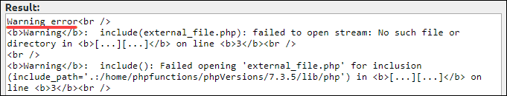

- Notice error
This type or error is minor almost similar with previous one as they let you keep run the code but you can see the difference.

Example:

<?php
$a=”Defined error”;
echo “Notice error”;
echo $b;
?>

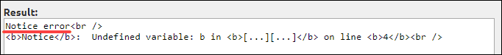

- Parse Error
This error can show you if a symbol is it missing or in the wrong syntax. The compiler will catch all the error and they will terminate the script.
I will write few examples for parse error, can be missing unclosed brackets or quotes, missing the semicolons or misspelling. You can see the example

Example:

<?php
echo “White”;
echo “Black”;
echo “Gray”
?>

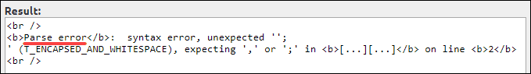

- Fatal Error
The last error it will stop your program from running and this error is a critical error. This can happen only if the system can’t run the code, when the programmer is trying to run and the code stop working completely.

Example:

<?php
function sub()
{
$sub=6-1;
echo “The sub= “.$sub;
}
div();
?>

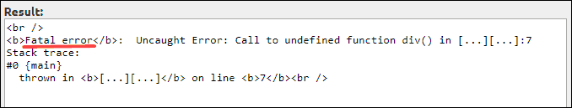

Conclusion

As a conclusion of this report which help a lot to improve my skills as a web development or website development. The most important rule of formatting a web developer summary statement is to lead with the most important information, such as education or training in a niche the company is focused organized and focused on details.

Reference:

HTML, Computer Hope., (11/13/2018) HTML. Computer Hope.
Available on:https://www.computerhope.com/jargon/h/html.htm

How To Create a Registration Form in HTML From Scratch, Vrinda Singh (28/05/2019) Real Life Wins, Paper form
Available on:https://paperform.co/blog/registration-form-in-html

Using an Access Database with PHP, By David Francis (07/05/2010) Sitepoint
Available on:https://www.sitepoint.com/using-an-access-database-with-php

4 Different types of errors in PHP by Sofija Simic ( August 6, 2019)
Available on : https://phoenixnap.com/kb/php-error-types

Appendices:


Figure number 1: Frontpage

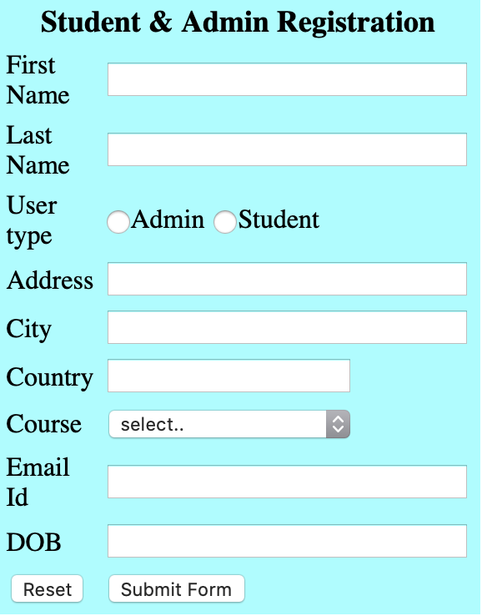
Figure number 2: Login & Registration details

University Logo


Menu bar


University Courses

