CAE and Stress Analysis
The following e-books are recommended for this module
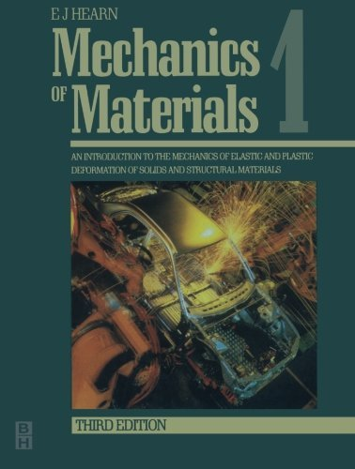
https://www-dawsonera-com.ezproxy.uwtsd.ac.uk/abstract/9780080523996

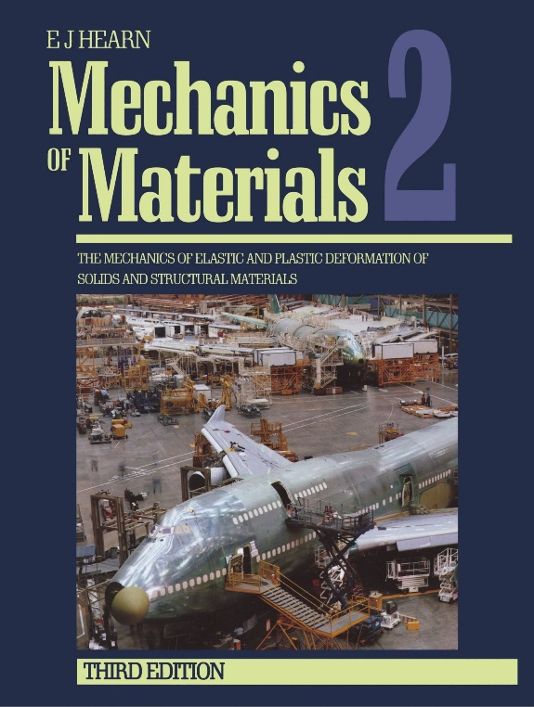
https://www-dawsonera-com.ezproxy.uwtsd.ac.uk/abstract/9780080524009

