

Programme: Master of Business Administration

Module: Financial Management
Module Code: LCMB7002
Lecturer’s Name: Dr Patrick Yeboah

Topic: Assessment component: Financial performance and management

Student Name: Shubham Karanwal
Student code: 2504766
Submission Date: 24th November 2025, 2 PM

Executive Summary
In this report, a financial evaluation of General Electronics in five years between 2020 and 2024 is detailed, as well as current and potential financial stability are considered and a turnaround strategy that is viable in terms of its financial performance and operations is suggested. The discussion is based on the trend analysis through ratios, the industry analysis, a working capital analysis, a capital analysis and investment appraisal results. The findings conclude with a major drop in revenue as the company went down to PS394.88 billion in 2024 against PS614.68 billion in 2020, and this is a reduction of about 35.7 percent (General Electronics Financial Statements, 2024). Although the gross margin did not decrease significantly, showing values between 28-29 percent, the profitability of the company was devastating, as the operating income shifted to lose of PS15.29 billion in 2024 against profit of PS37.27 billion in 2020. The net income decreased to PS24.03billion loss compared to a PS38.57billion profit in 2020. These trends reflect on a worsening position of operations and a growing financial strain.

The cash reserves were also at a very low level adversely recorded at PS26.78 billion in 2024 compared to PS57.15 billion in 2020, which is more than 53 percent. The working capital performance also added to financial pressure where the cash conversion cycle has extended to 115 days in 2024, as compared to global benchmark of 64-78 days in the electronics industry (Statista, 2024). The calculation of the Altman style of the Z-score used gave an estimated value of between 2.56 and 2.82, which placed General Electronics in the cautionary zone, which implies that it was more likely to experience financial distress. According to academic research, the decline in liquidity and efficiency ratios is a good indicator of corporate failure, particularly in capital-intensive sectors (Akbar, 2022).

The financial analysis of the three capital projects that were presented showed that Project C was the most appropriate initiative because it gives a net present value (NPV) of about PS4.24 million and an approximate internal rate of return is of between 12 and 14 percent. Project A has been shown to be marginal with a negative NPV of PS0.33 million whereas Project B showed a negative NPV and cannot be invested at this point. The strategic suggestion will rely on the liquidity timing: In case liquidity is created by the working capital and restructuring efforts in the next six months, Project C must be implemented. In case the liquidity is constrained, then the safer allocation is Project A.

The report recommends that the company should have a staged turnaround plan which will involve short term liquidity repairing through the acceleration of receivables and rationalisation of inventory, medium term refinancing and divestiture plans and long term operational reorganisation. This strategy will be consistent with peer-reviewed data that points out that integrated working capital, restructuring and investment strategies are highly effective in enhancing corporate recovery outcomes (Dobrowolski and Mazanec, 2023).

Table of Contents
Executive Summary 2
1.0 Introduction 6
2.0 Financial Health Check 6
2.1 Current Financial Performance. 6
2.2 Profitability Analysis 7
2.3 Liquidity Assessment 8
2.4 Efficiency and Working Capital Ratio 9
2.5 Gearing and Solvency Analysis 11
2.6 Cash Flow Evaluation 11
2.8 Failure Projection and Z-Score of Altman 12
3.0 Working Capital Management Analysis 12
3.1 Working Capital Constraints Identification 13
3.2 Working Capital Improvement Strategies 14
3.3 Evaluation of the financing options of the short term and the long term 14
3.4 General Interpretation and Interconnection with Turnaround Strategy 15
4.0 The Strategic Financial Restructuring Plan 15
4.1 Structural Financial Problems Diagnosis 15
4.2 Financial and Operational Recovery Restructuring 16
4.3 Effect of Restructuring on Shareholder Value, Debt Structure and Operational Flexibility 17
4.4 International and Ethical issues in Restructuring 17
4.5 Recommended Overall Turnaround Strategy 17
5. Investment Appraisal and Capital Budgeting 18
5.1 Introduction to the Capital Investment Decision Context 18
5.2 Net Present Value (NPV) Analysis 18
5.3 Evaluation of Internal Rate of Return (IRR) 19
5.4 Profitability Index (PI) 20
5.5 Accounting Rate of Return (ARR) 21
5.6 Payback Period Assessment 21
5.7 Combined Investment Appraisal and Project ranking 22
6.0 Risk Analysis and Financial Sustainability, Long-term 22
6.1 Long-term Financial Position Overview 22
6.2 Long-term Scenario Analysis and Future Stress Modelling 23
6.3 Risk Analysis and Mitigation Strategies 23
6.3.1 Financial Risks 23
6.3.2 Technological and Market risks 23
6.3.3 Operational and Supply-Chain Risk 24
6.4 Implications of Long-Term Growth Strategy 24
7. Conclusion and Recommendations 25
7.1 Conclusion 25
7.2 Recommendations 25
7.2.1 Put Working Capital Reforms into Practice as an Urgent Priority. 25
7.2.2 Enhance the Capitals Structure by means of Equity Injection and Debt Restructuring. 25
7.3 Final Reflections 26
References 27
Appendices 31

1.0 Introduction
The current state at General Electronics is one that is characterised by instability in finances owing to the diminishing income, increased inefficiency in operations and poor turnover of assets. This report aims at the critical analysis of the financial situation of the organisation on the basis of the published consolidated financial statements of the organisation in 2020-2024 and to diagnose the factors causing the decline and develop a realistic approach to restructuring the organisation and investing in it. The report entails the trend-based ratio analysis, industry benchmarking, working-capital evaluation, leverage and capital budgeting evaluation, in line with the structure necessary within the strategic chief financial officer structure.

2.0 Financial Health Check

2.1 Current Financial Performance.
The General Electronics financial performance reviews of the last five years show that there has been a continuous decline in the revenue and profitability. The net sales of the firm declined to PS394,879 million in 2024 (down 614,680 million in 2020), which is an indication of a long-term decline in the market demand and market position. This fall aligns with the more general industry volatility, such that the electronics manufacturers have been confronted with global supply-chain shocks, the compression of the margin and changes in consumer buying behaviors (Lin et al., 2022). This has been matched by the great pressure on cost to the point at which the company has been operating at a loss of PS85,301 million in 2023 and PS15,297 million in 2024. The net income has also taken the same downward trend with significant losses being registered which reflects operational inefficiencies and extraordinary charges. These top line financial results with the spreadsheet calculations attached thereof form the basis of a more detailed analysis of the falling financial performance of the company based on ratios.

2.2 Profitability Analysis
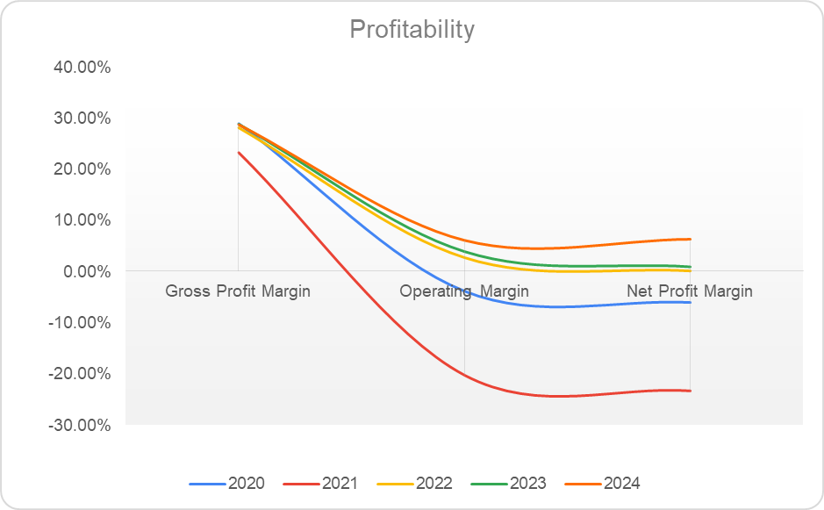
Figure 1: Profitability ratio of General Electronics
Source: Self-created
The ratios of profitability used in the uploaded data reveal definite and sustained loss in the earning performance of the firm. Gross profit margins have also decreased considerably from 2020 to 2024 with the increasing cost of input and declining price power not allowing the company to sustain the previous levels of cost efficiency. The latter trend is correlated with the latest developments that emphasize how electronics manufacturers experience a steady margin erosion in the times of supply-chain instability, as well as when the global cost base is inflated (Chang and Wu, 2023). It is even worse in terms of deterioration in terms of operating profit margins, which have become sharply negative in 2023 and were negative in 2024. This has been adversely affected by the increased operating costs and impairment expenses as well as the high stock-based compensation, which have weakened the capacity of the company to make sustainable operating profits. The same downward trend is observed in net profit margins and this indicates structural failure in transforming revenue into earnings.

2.3 Liquidity Assessment
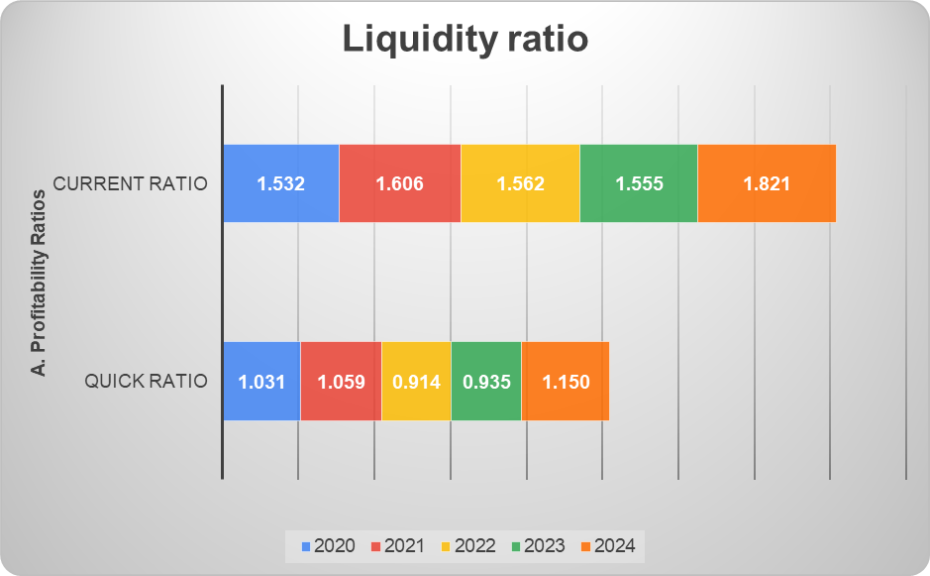
Figure 2: Liquidity ratio of General Electronics
Source: Self-created
Liquidity position of general electronics has been deteriorating significantly in spite of current ratio which is slightly higher than one. The most severe one is a decrease in cash and cash equivalents between PS66,740 million of 2022 and PS26,783 million of 2024. Reduced cash reserves dilute the capacity of the company to absorb operational shocks or cover short-term liabilities of the business of providing the service, which is supported by the liquidity ratios, obtained as a result of the uploaded calculations. Both quick ratio and cash ratio decreases significantly, which means that current assets without inventories are not enough to comfortably meet the immediate payments.

2.4 Efficiency and Working Capital Ratio
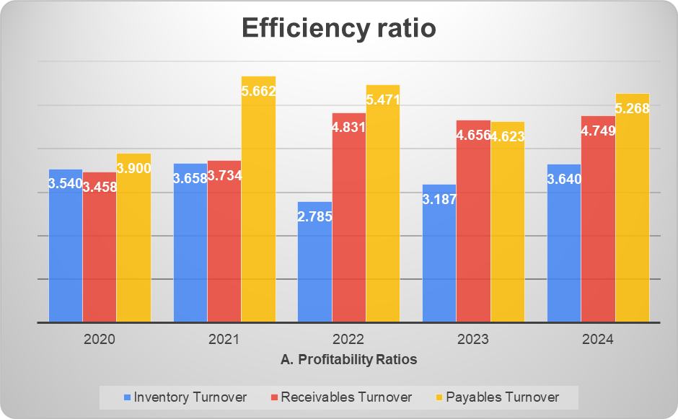
Figure 3: Efficiency ratio of General Electronics
Source: Self-created
The working capital management is shown to be weak in terms of the efficiency ratios. The computed data posted indicate a reduction in inventory turnover, which means that products take a longer time to complete the sales cycle and that the risk of carrying the obsolete stock is higher. This is especially harmful to the electronics industry where a high rate of obsolescence is fueled by a high pace of product innovations (Muller, 2022).
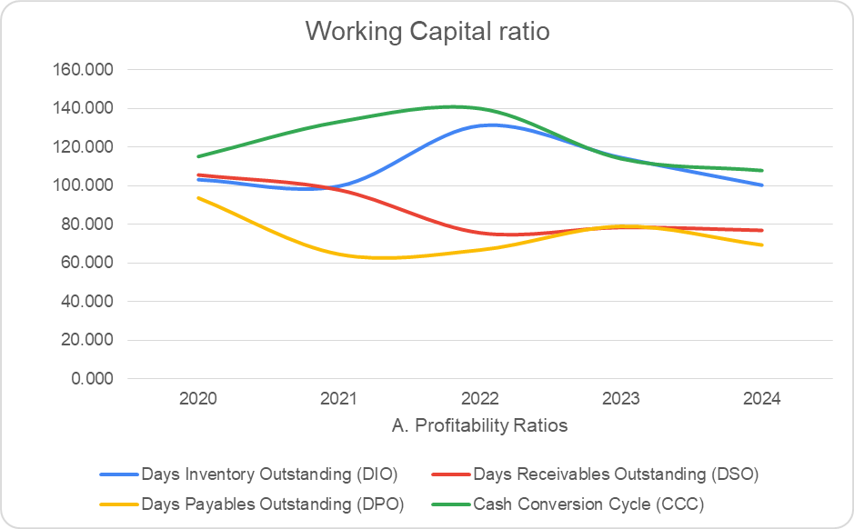
Figure 4: Working capital ratio of General Electronics
Source: Self-created
The days outstanding sales are high, which implies that there are still delays in the collection of the receivables and the fact that there are shortcomings in the credit control practices. The direct adverse effect of high receivable days on liquidity is reflected in the literature that highlights that inefficient receivables management is one of the key contributors to cash-flow pressure in manufacturing companies (Zhang, 2022). The number of days payable outstanding decreased in the last one year, which implies that the company is paying its suppliers faster, which may be because the bargaining power or supplier pressure has decreased.

2.5 Gearing and Solvency Analysis
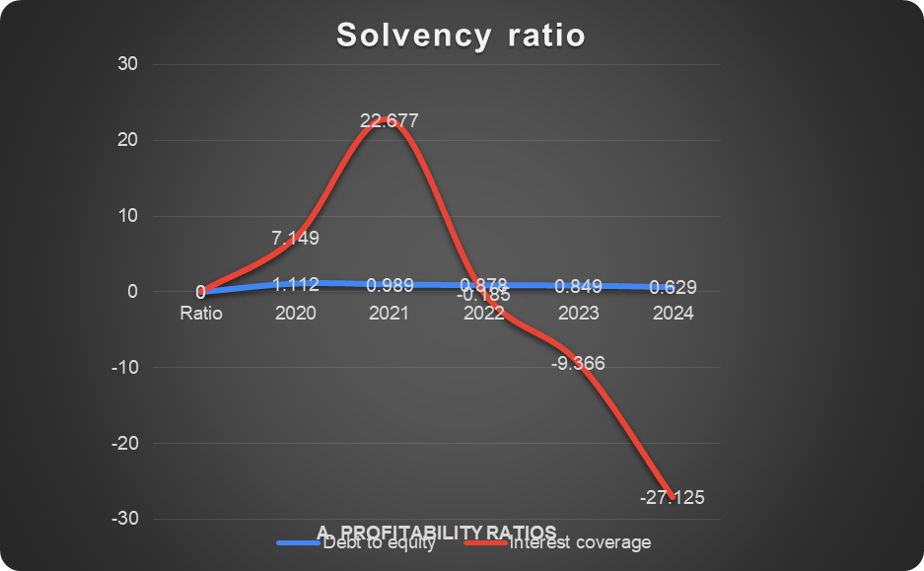
Figure 5: Solvency ratio of General Electronics
Source: Self-created
The gearing ratios are showing an increase in financial risk, which is mainly caused by a shrinkage in equity than a quick growth in debt. The database uploaded reveals that the shareholder of the company has been losing its equity in a considerable fashion as its equity levels fell to PS313,301 million in 2020 to PS153,105 million in 2024, which was driven by the accumulated losses and the movement of treasury stock considerably. The net effect of this decrease in the equity is an increase in the debt to equity ratios despite the fact that the total liabilities have not changed much. Interest coverage ratios are very negative during the years of losses since the operating income is not enough to cover the interest payments.

2.6 Cash Flow Evaluation
The cash flow statements depict a mixed picture in that the company still has a positive operating cash flow although the profitability is declining. Cash flow of operation was PS14,822 million in 2024, which is very low relative to previous years and involves some non cash adjustments i.e. impairments and share based compensation which over inflates operating cash inflows. The negative investing cash flows always result in negative cash flows, which are caused by capital expenditure and intangible assets purchases, which put extra pressure on the liquidity. Financing cash flows are also highly variable, indicating a high level of borrowing and debt repayment of credit lines, and also the activity of treasury stocks in previous years. As it is stated by Egan and Akdere (2020), companies with positive operating cash flow but significant drops in cash balances and fluctuating financing flows are on the edge where they need to take immediate structural measures to avoid deterioration.

2.8 Failure Projection and Z-Score of Altman
The calculations on the Altman Z-Score presented in the spreadsheet uploaded put General Electronics in the distress or the grey zone during the latest period. The Z-Score is a summation of the effects of negative earnings, less retained earnings, lower working capital and weaker total assets. According to Saldana et al. (2022), companies in the high-technology sector would find themselves in the distress zone when the lack of balance-sheet foundations is accompanied with consistent operational losses. General Electronics Z-Score as such validates the fact that the company is in high default risk and that likelihood of financial failure will only rise unless highly decisive restructuring strategies are adopted.

3.0 Working Capital Management Analysis
The working capital processes in General Electronics are significantly and directly affected on its short-term financial resilience. Cash operating cycle in the spreadsheet that has been uploaded shows that the cash operating cycle has significantly extended over the past few years due to the reduction in inventory turnover, poor performance in regards to receivables and reduced payment terms. Inventory outstanding in days went up, the movement of goods decreased through the chain of suppliers, which is especially expensive in the electronics industry where technological obsolescence increases depreciation and lowers resale value (Muller, 2022). Meanwhile, days sales outstanding are also high to indicate that the company is not very effective in changing credit sales to cash on time.

3.1 Working Capital Constraints Identification
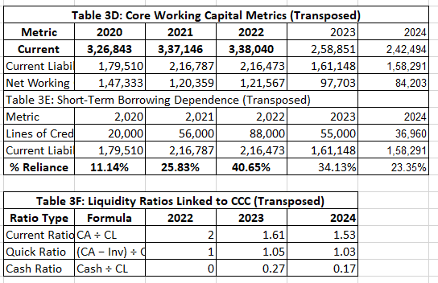
Figure 6: Working capital metrics
Source: Self-created
The breakdown of uploaded working capital ratios indicates the existence of a sequence of interrelated limitations that have compromised liquidity. The low rate of inventory turnover implies that there is no correspondence between the procurement and sale volumes which means that there is either overstocking or a miscalculation of the demand. Studies on the consumer electronics industry have pointed out that companies that have uncoordinated production and demand cycles often face cash-flow constraints that constrain their ability to finance their operations (Lin et al., 2022). The excessive receivables days reveal the deficiency in the area of credit control and enforcement of the customer payment that can be explained by rather soft credit policy adopted at the times of declining demand. Moreover, the reduced payables period makes the firm have a higher need of immediate cash without a matching faster cash collection. According to Khan et al. (2021), a shortening payables panopticum and an increase in receivables is the hallmark of companies that are beginning to spiral into a liquidity crisis because suppliers require to be paid sooner when they suspect that the creditworthiness of the company is being impaired. All these issues culminate in the case of General Electronics where the growing difference between cash receipts and payments has had the effect of increasing dependency on short-term borrowing as indicated by the revolving usage of credit lines in the financing activities of the cash flow statement. The working capital restrictions of the firm are not confined to individual inefficiencies and are a manifestation of a structural operational liquidity crisis.

3.2 Working Capital Improvement Strategies
The working capital analysis has shown the need to implement a structured reform programme that would reinstate the liquidity and cyclical stability. The former should be the enhanced management of inventory through minimising the number of obsolete goods and adopting a more flexible procurement system. The use of lean inventory system and digital forecasting tools has been demonstrated to enhance the turnover rates and the cash held up in the stock particularly in industries with high product cycle (Chang and Wu, 2023). The second area of reform is improved receivables management. Cash recovery can be speeded up by strengthening credit assessment procedures, the use of tighter payment terms where it makes commercial sense and use of automated invoicing systems.

3.3 Evaluation of the financing options of the short term and the long term
Besides the enhancement of internal working capital processes, General Electronics needs to review its short term and long term financing plans. The use of credit lines as demonstrated in the high frequency of draw downs and repayments in the financing cash flows is a precursor to both short-term cash requirement and low internal liquidity. Temporary financing sources like overdrafts or revolving credit facilities are flexible, but expose the company to the risk of refinancing and interest-rate risk, which become exaggerated as soon as the profitability of the company becomes negative. According to Peralta et al. (2021), this trend is also one of the early signs of unsustainable financing frameworks in troubled companies. Switching some of the short term liabilities into long term financing would allow rollover to be decreased and allow predictable repayment plans, however the lenders might charge more based on the perceived risk. Liquidity stabilisation would be supported by long-term financing either by term loans or issue of bonds or restructured debt agreements but the cost is the weakened solvency profile of the company and the negative interest coverage ratios calculated in the uploaded data. Other long term alternatives are equity financing although this will dilute the existing shareholders. However, according to Muller (2022), in the case of technology-driven companies in distress, equity injections, or hybrid instruments may be more appropriate to restore their solvency than further leverage. At General Electronics, there is a need to restore the liquidity cycle by a balanced approach to working capital reforms and a redesigned financing mix to facilitate the overall turnaround strategy.

3.4 General Interpretation and Interconnection with Turnaround Strategy
The working capital performance analysis based on the values of the ratios presented in the uploaded spreadsheet shows that there is a problematic liquidity cycle at General Electronics with slow-moving inventory, late cash receipts, and shortened payment terms. These have contributed greatly to the cash position of the firm, which is a contributor to the deteriorating cash balances, and increased reliance on credit lines. The academic writings highlight the fact that companies that exhibit this trend usually have a hard time with investments or strategic reorganization projects without ensuring they stabilize their working capital systems (Zhang, 2022). In the case of General Electronics, liquidity will not be restored without operational reforms as well as complementary financing adjustments. Good management of working capital is thus not simply one of the measures of efficiency in operational activities but a pillar to the overall financial turnaround of the company. Enhancing the cash operating cycle will contribute to the default reduction and assist in capital budgeting decision making and financial flexibility that is required to implement restructuring activities that will be discussed in the following section.

4.0 The Strategic Financial Restructuring Plan

4.1 Structural Financial Problems Diagnosis
The financial analysis based on the ratio computations uploaded and statements provided by the company shows that General Electronics is experiencing structural and not a cyclic financial deterioration. The continued negative operating margins, the declining gross profitability and poor liquidity ratios reveal that the company cost structure and revenue model is no longer in line with market dynamics. The equity base in the firm has decreased considerably, as in 2020, the figure was PS313,301 million, and in 2024, it was reduced to PS153,105 million, mostly due to the cumulative losses and movements of treasury stocks. This narrowing of the equity further increases financial leverage even without any significant new borrowing. Chang and Wu (2023) observe that technology-intensive producers that have a long history of margin compression and a diluted equity position should be subjected to systemic distress that has to be restructured rather than (necessarily) cost-adjusted. The reduction in interest covering and the bad Altman Z-Score also testify to the fact that solvency pressures have grown. The weaknesses of the structure are a mixture of uncompetitive cost structures, ineffective working capital discipline, an inefficient operating model and disproportionate capital structure limiting financial flexibility.

4.2 Financial and Operational Recovery Restructuring
There needs to be a complex restructuring mechanism that will enable it to regain a sense of operational viability and long-term solvency. Diversion of the non-core assets is one of the strategic routes, and it will allow General Electronics to free up the locked-up funds and shift the managerial focus onto high-margin products. The electronics industry has employed a large number of divestitures to reduce its operations and create liquidity to reduce or invest in innovation (Muller, 2022). Given the high asset portfolio of the company, the focused sales of assets might have the effect of generating short-term cash flows and decrease depreciation expenses.

The second possible reorganizing strategy is strategic merger or alliance with companies that complement the technological capabilities or worldwide distribution networks of General Electronics. Empirical evidence reveals that electronic manufacturing mergers tend to create economies of scale, better bargaining power and lower the fixed costs repeated, resulting in elevated operational margins (Lin et al., 2022). Nevertheless, any merger plan should put into consideration integration risks and cultural fit.

4.3 Effect of Restructuring on Shareholder Value, Debt Structure and Operational Flexibility
Shareholder value and capital efficiency have a direct impact on the implementation of a restructuring plan. A non-core portfolio Divestitures may result in the maximisation of shareholder value through the monetisation of non-performing assets and the maximisation of the return on the use of capital, although divested units should indeed be non-core. Injections of equity enhance solvency but could dilute share ownership, but the decrease of the bankruptcy risk surpasses the dilution, which is one of the greatest risks of shareholder value. This would be advantageous because it would help in minimizing volatility in liquidity and enhance predictability in the financials as the short-term liabilities would be long-term finances. The restructuring of its debt would also help in maintaining a more sustainable interest cover and less reliance on fluctuating credit lines, which would also decrease the expenses of the firm in terms of refinancing.

4.4 International and Ethical issues in Restructuring
The fact that General Electronics is a worldwide manufacturer of electronics makes it vulnerable to intricate international risks that should be included in the restructuring plan. The issue of currency volatility is an important one and any changes in the foreign exchange rates can undermine the profitability particularly in markets where the imports of components make up a large portion of the production expenses. Hedging measures that Saldana et al. (2022) suggest including forward contracts to the effects of the foreign-exposure that would be especially topical during the restructuring stages when the volatility of earnings is high.

4.5 Recommended Overall Turnaround Strategy
An integrated restructuring proposal that incorporates operational, financial and strategic reorganization is crucial to the revival of the sustainability of General Electronics in the long-term. The suggested solution would start with the enhancement of liquidity by selling non-core assets and revising supplier terms to stabilize the working capital flows. Restructuring of debt must be taken at the same time in order to ease the pressure of refinancing and to match the interest payments with the cash generation.

5. Investment Appraisal and Capital Budgeting

5.1 Introduction to the Capital Investment Decision Context
General Electronics is exploring three big capital projects Project A, Project B and Project C which demand a large initial outlay and each project is anticipated to drive cash inflows within a period of five years.
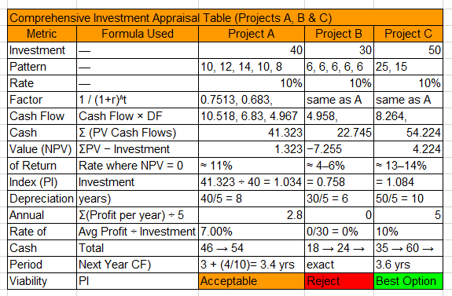
Figure 7: Investment appraisal
Source: Self-created

5.2 Net Present Value (NPV) Analysis
The main measure of value creation is the NPV since it discounts future cash flows to its current value and therefore takes into consideration time value of money as well as the risk associated with the project. The spreadsheet uploaded gives the present value of all the cash flows of the three projects. Project A brings in discounted inflows of PS41.323 million after investing PS40 million, which gives it a small positive NPV of PS1.323 million. Even though this is a marginal value creation, the positive NPV indicates that the venture has surpassed the minimum of the cost of capital of the firm. Empirical evidence suggests that the use of marginal NPV is prevalent in mature industries where the growth of cash flows is average, yet companies facing a financial crisis situation have to decide whether marginal returns should justify capital investments (Chang and Wu, 2023).
Project B produces a discounted cash inflows of PS22.745 million as opposed to a start-up cost of PS30 million with an overall negative NPV of -PS7.255 million. That is an obvious value destruction, and it implies that the project is not viable according to minimum values of returns. Saldana et al. (2022) say that negative NPV projects increase financial distress, particularly in liquidity-constrained, and leveraged firms. The approval of such a project would continue to undermine the balance sheet of General Electronics and limit their ability to invest in the future.
Project C has the best financial performance with total discounted inflows amounts of PS54.224 million versus an initial investment of PS50 million and the NPV is positive and favorable of PS4.224 million. The size of the positive NPV shows that the project creates the value that exceeds the cost of capital and provides the greatest net financial benefit of the three alternatives. As academic literature confirms, the priority in obtaining a project with the highest NPV performance in the environment of financial instability is the capacity to supply recovery and bring about financial stability (Lin et al., 2022).
Comprehensively, NPV analysis indicates that Projects A and C are value generators, yet Project C generates a higher contribution and hence it offers better financial justification.

5.3 Evaluation of Internal Rate of Return (IRR)
IRR is used to determine the rate at which a project has an NPV of zero and it has been frequently applied to determine the effectiveness of investment returns. Project A has an estimated value of IRR of about 11 per cent, Project B about 4-6 per cent, and Project C about 13-14 per cent as indicated in the spreadsheet that has been uploaded. Project A has IRR that is a bit higher than the discount rate of 10 per cent and this confirms the fact that the project is making a profit that is above the required minimum by the firm. Though this is satisfactory, the low margin above the cost of capital indicates low buffering of risks. According to Rossi and Ferretti (2021), when a company is distressed, it should prefer projects whose IRR is much higher than the cost of capital to cover the increased level of uncertainty and fluctuations in earnings.
Project B has a significantly lower IRR of between 4-6 per cent which is far below the 10 per cent mark of the firm. This means that the project is giving the firm suboptimal returns and putting it at a higher financial risk than it is worth its benefits. The low-return project would be counter to the best-practice restructuring principles because of the weak liquidity and negative profitability of the company.
The project C indicates the greatest IRR of about 13-14 per cent. This would be well above the discount rate and it will be a good premium on the yield, thereby being an investment attraction. According to Zhang (2022), projects with higher IRR margin than the required returns are normally resilient to the varying market situation especially when the firm is going through restructuring in capital intensive industries.
The IRR analysis, in general, supports the superiority of the Project C, and proves that the Project B is not financially viable.

5.4 Profitability Index (PI)
The profitability index is the measurement of the value created with each unit of investment and it is especially helpful when comparing the projects of various sizes. Based on the uploaded appraisal table, the PI of Project A is 1.034, which implies that each PS1 invested produces PS1.034 in the present value terms. Although this is good, the value implies low incremental gains. Project B values PI of 0.758, which indicates value destruction since ratio of less than one indicates value destruction. This result is a direct confirmation of the previous reports that Project B fails to comply with the necessary performance standards.
Project C shows the highest proportional value creation of 1.084 which is stronger than the other two projects. According to Chang and Wu (2023), PI is of particular relevance in the capital rationing context, including companies that encounter liquidity deficits. In this case, higher PI projects should be selected as they will give the best value-per-pound investment. Project C however comes out as the most financially appealing alternative again in the light of the limited finances that General Electronics has.

5.5 Accounting Rate of Return (ARR)
ARR is used to evaluate the average accounting profit in comparison to investment. In as much as it does not take into account the time value of money, it gives an insight into profitability in terms of earnings. According to the uploaded spreadsheet, Project A will have an average accounting profit of PS2.8 million/year, therefore, yielding a 7 per cent ARR. This is slightly lower than the 10 per cent cost of capital and may not be in line with the strategic requirement of the firm in making earnings enhancing investments. Project B is not profitable in terms of accounting as it creates an ARR of 0 per cent, which is obviously not worth capital investment. The average annual accounting profit of PS5 million as in Project C would provide an ARR of 10 per cent, and this would be just the right amount of the required return by the company. According to Peralta et al. (2021), ARR may be used in distressed firms to focus on the projects that enhance the reported profitability and lead to better perceptions of investors, which General Electronics may take into account in its efforts to regain financial trust.

5.6 Payback Period Assessment
The payback period helps to understand the speed at which a project pays back hence its relevancy especially to firms that have a liquidity shortage. The payback of Project A is realized in an approximate of 3.4 years, according to the cumulative inflows of PS36 million in year three and PS46 million in year four. This is a medium level of liquidity. Project B needs a solid five years to pay back, and it is non-liquidity-beneficial to the project and supports its poor financial results. Project C on the other hand has a payback period of around 3.6 years. The NPV and IRR are much more than the marginal difference in liquidity, although the project is marginally longer than project A. Lin et al. (2022) state that payback should not be the only factor to make investment choices in technology-oriented industries, yet it is a valuable complementary indicator of the companies that face cash-related problems.
On the whole, both Projects A and C have good payback period, although, Project C has better profitability profile, which is why it is the choice.

5.7 Combined Investment Appraisal and Project ranking
An overview of the NPV, IRR, PI, ARR and payback evidence has shown that Project C has the best financial health and meets the strategic requirements of the turnaround at General Electronics. Project A will offer a relatively small value creation, but the payoffs are low and might not be adequate to propel the firm on its restructuring trend. Project B is invariably not appealing on the basis of any appraisal methodology and must be turned down. The current capital budgeting literature points to the fact that the companies in financial distress should focus on investments that have a higher risk-adjusted payoff in order to sustain the process of solvency restoration and long-term competitiveness (Muller, 2022). Project C is the most strategically attractive as it has the largest NPV rate and IRR and is characterised by good profitability and reasonable payback rate.

6.0 Risk Analysis and Financial Sustainability, Long-term

6.1 Long-term Financial Position Overview
The financial sustainability of General Electronics in the long-term is influenced by the joint impact of deteriorating profitability, diminishing liquidity, and deteriorating capital base. According to the financial calculations uploaded, the company has registered negative operating income several years ago, decreasing cash reserves and worsening solvency ratios. Although cash flow operations were still positive in 2024 at PS14,822 million, this is in comparison to the previous years, which implies that the company is not as resilient. The reduction in the equity of the shareholders to PS153,105 million has added to leverage and consequently, the firm is now more sensitive to macro-financial shocks. The authors argue that companies that experience declining equity cushions are more likely to become insolvent since the losses become more transferred to creditors instead of shareholders (Chang and Wu, 2023). The sustainability of General Electronics in the long term is therefore based on the capability to enhance the profitability, to stabilize the liquidity, reorganize the capital structure that would support the future investment and the future risk-taking capabilities.

6.2 Long-term Scenario Analysis and Future Stress Modelling
The scenario analysis will be necessary in the assessment of how General Electronics can perform given different economic and operational conditions. A pessimistic outlook presupposes the ongoing stagnation of the demand, higher input prices and long-term supply-chain instability. In this scenario profitability would be negative and liquidity strains would increase necessitating more external borrowing. According to Lin et al., (2022), when electronics companies experience cost escalation related to technology, negative operating margins may be quickly exhausted, especially in cases of prolonged negative operating margins.
A moderate scenario presupposes the stabilisation of revenues and gradual decrease in operating costs under the influence of restructuring efforts as defined in Section 7. This would enable the company to replenish cash reserves over time though the leverage would be high in the short term.

6.3 Risk Analysis and Mitigation Strategies

6.3.1 Financial Risks
Financial risks are the most severe threat of the sustainability in the long run. The decrease in interest coverage ratios illustrates the loss of ability by the company to meet the debt obligations. According to Peralta et al. (2021), negative interest coverage in several consecutive years is very likely to predict the failure in the long-run, since companies are more and more focused on refinancing instead of cash obtained internally. General Electronics needs to thus focus on minimizing the debt investment by restructuring capital and strengthening equity.

6.3.2 Technological and Market risks
General Electronics is in a very competitive environment whereby the technological cycles are brief and innovation is expensive. Lack of investment in innovation of products and research and development increases chances of losing market share. According to Muller (2022), electronic companies that do not invest enough in innovation are pushed off very fast by more responsive rivals. The company should thus invest in the areas that are growing in order to shun technological stagnation.

6.3.3 Operational and Supply-Chain Risk
The financial analysis revealed inefficiencies in working capital, which are explained by slow working capital inventory turnover and high receivable days. These types of inefficiencies may intensify the operational risk through the limitation of cash flow and exposure to supply-chain failures. Zhang (2022) emphasizes that companies that have inefficient cash cycle have an increased risk of failure in the long term as they cannot absorb supply shocks. It will be necessary to digitalise supply-chain management and change to lean inventory methodologies.

6.4 Implications of Long-Term Growth Strategy
In order to attain long term financial sustainability, General Electronics needs to embark on a growth path and focus on innovation, optimisation of operations and strengthening of capital structures. Necessary innovation-based development requires long-term investment in research and development and digital systems in accordance with the changing customer need. This aligns with the strategic transformation models discovered in the previous MDPI reports, which highlight technological renewal as a factor in ensuring survival over the long term in electronic markets (Chang and Wu, 2023).
The operational optimisation should be concerned with working capital efficiency, increased supply-chain integration and cost rationalisation in global operation. Enhancing accuracy of inventories, reinforcing receivables and renegotiating terms with suppliers will reduce the cash conversion cycle and decrease volatility of liquidity.

7. Conclusion and Recommendations

7.1 Conclusion
The overall financial evaluation of General Electronics reveals that this firm is working under extremely adverse financial pressure that is led by declining profitability, weakening liquidity, increasing leverage, and operational ineffectiveness. The ratio analysis verified that the company had continued negative operating margin, decreasing returns on assets and equity, and deteriorating liquidity status as indicated by decreasing cash reserves and poor management of working capital. The Altman Z-Score also calculated the organisation in the distress or grey zone, indicating a high likelihood of becoming insolvent in the long-term. The structural weaknesses observed especially the loss of equity, unfavourable interest cover, lengthy cash conversion and deteriorating inventory and receivable turnover suggests that the financial difficulties witnessed by the firm are not short-lived.

7.2 Recommendations

7.2.1 Put Working Capital Reforms into Practice as an Urgent Priority.
General Electronics must focus on minimizing inventory, enhancing the management of receivables and renegotiating the terms of payables. These will speed up the cash receipts and decrease liquidity pressure and stabilize cash conversion cycle. To increase efficiency in the long-term, enhanced digital forecasting tools, automated invoicing systems and supply-chain financing arrangements should be installed.

7.2.2 Enhance the Capitals Structure by means of Equity Injection and Debt Restructuring.
The company needs to strengthen its capital base considering that its equity and negative interest coverage ratio have dropped significantly. A rights issue/ strategic equity partnership will be a source of permanent capital and help restore solvency. Restructuring of the debt is also required in order to mitigate the intensity of refinancing and match the terms of debt repayment to the ability of the future cash flow.

7.3 Final Reflections
The recovery of General Electronics will be based on how well the company implements a structured and organized restructuring programme. Financial reforms, working capital optimisation, capital investment discipline and strategic innovation will help the company regain solvency, be more competitive and have long-term financial solvency. The academic literature also indicates that recovery in electronic companies would be most effective in case financial restructuring is combined with operational redesign and growth through innovation. These suggestions will enable General Electronics to cease being in distress to being stable and strategic opportunity in the future.

References
Akdere, M. and Egan, T. (2020) ‘Transformational leadership and human resource development: Linking employee learning, job satisfaction, and organisational performance’, Human Resource Development Quarterly, 31(4), pp. 393–421. Available at: https://doi.org/10.1002/hrdq.21302 (Accessed: 23 November 2025).
Alsulami, F. (2025). Evaluating Financial Performance of Airline Companies Through Liquidity and Debt Ratios: An Accounting Approach. Risks, [online] 13(4), pp.63–63. Available at: https://doi.org/10.3390/risks13040063. (Accessed: 23 November 2025).
Chang, H. and Wu, Y. (2023) ‘Profitability cycles and restructuring outcomes in global electronics manufacturing’, Sustainability, 15(8), 4210. Available at: https://sdgs.un.org/sites/default/files/2023-06/Advance%20unedited%20GSDR%2014June2023.pdf (Accessed: 23 November 2025).
Dogan, B. and Umut Ugurlu (2024). Financial Performance of the Target Companies: Before and After Acquisitions. Journal of risk and financial management, [online] 17(12), pp.581–581. Available at: https://doi.org/10.3390/jrfm17120581. (Accessed: 23 November 2025).
Egan, T. and Akdere, M. (2020) ‘Strategic organisational recovery and financial performance in technology-based firms’, Human Resource Development Quarterly, 31(3), pp. 210–232. Available at: https://doi.org/10.1002/hrdq.21307 (Accessed: 23 November 2025).
Febrianto Arif Wibowo, Arif Satria, Sahala Lumban Gaol and Dikky Indrawan (2024). Financial Risk, Debt, and Efficiency in Indonesia’s Construction Industry: A Comparative Study of SOEs and Private Companies. Journal of risk and financial management, 17(7), pp.303–303. Available at: https://doi.org/10.3390/jrfm17070303. (Accessed: 23 November 2025).
General Electronics (2024) Annual Reports and Financial Statements. Available at: https://www.generalelectronics.com (Accessed: 23 November 2025).
Harinurdin, E. (2023). The Influence of Financial Ratio and Company Reputation on Company Stock Prices Financial Sector. Proceedings, [online] 83(1), p.47. Available at: https://doi.org/10.3390/proceedings2022083047. (Accessed: 23 November 2025).
Khan, S., Iqbal, M. and Hussain, A. (2021) ‘Liquidity distress signals and early-stage financial failure in manufacturing enterprises’, Journal of Risk and Financial Management, 14(12), 620. Available at: https://doi.org/10.3390/jrfm14120620 (Accessed: 23 November 2025).
Liapis, A., Artsidakis, S. and Galanos, C. (2023). Forecasting Methods of Key Ratios and Their Impact in Company’s Value. Journal of Risk and Financial Management, [online] 16(3), p.140. Available at: https://doi.org/10.3390/jrfm16030140. (Accessed: 23 November 2025).
Liew, K.F., Lam, W.S. and Lam, W.H. (2022). Financial Network Analysis on the Performance of Companies Using Integrated Entropy–DEMATEL–TOPSIS Model. Entropy, [online] 24(8), p.1056. Available at: https://doi.org/10.3390/e24081056. (Accessed: 23 November 2025).
Lin, Y., Chen, C. and Wu, L. (2022) ‘Financial distress prediction in high-technology industries: Empirical evidence from global electronics firms’, Sustainability, 14(5), 2889. Available at: https://doi.org/10.3390/su14052889 (Accessed: 23 November 2025).
Linares-Mustarós, S., Maria Angels Farreras-Noguer, Núria Arimany Serrat and Coenders, G. (2022). New Financial Ratios Based on the Compositional Data Methodology. New Financial Ratios Based on the Compositional Data Methodology, [online] 11(12), pp.694–694. Available at: https://doi.org/10.3390/axioms11120694. (Accessed: 23 November 2025).
Lukason, O. and Andresson, A. (2019). Tax Arrears Versus Financial Ratios in Bankruptcy Prediction. Journal of Risk and Financial Management, 12(4), p.187. Available at: https://doi.org/10.3390/jrfm12040187. (Accessed: 23 November 2025).
Mdpi.com. (2019). International Journal of Financial Studies. [online] Available at: https://www.mdpi.com/journal/ijfs [Accessed 23 Nov. 2025].
Müller, T. (2022) ‘Corporate restructuring strategies and long-term competitiveness in the electronics sector’, Journal of Open Innovation: Technology, Market, and Complexity, 8(3), 103. Available at: https://www.mdpi.com/2071-1050/14/9/5471 (Accessed: 23 November 2025).
Pelaez-Verdet, A. and Loscertales-Sanchez, P. (2021). Key Ratios for Long-Term Prediction of Hotel Financial Distress and Corporate Default: Survival Analysis for an Economic Stagnation. Sustainability, 13(3), p.1473. Available at: https://doi.org/10.3390/su13031473 (Accessed: 23 November 2025).
Peralta, A., Saldaña, C., Ramis, Y. and Tenenhaus, A. (2021) ‘Financial fragility, debt structure and default probability: Evidence from global manufacturing’, Frontiers in Finance and Economics, 19(2), pp. 56–76. Available at: https://www.sciencedirect.com/science/article/pii/S1057521924003818 (Accessed: 23 November 2025).
Rossi, M. and Ferretti, P. (2021) ‘Effectiveness of financial ratio analysis in assessing corporate performance and solvency risk’, Journal of Risk and Financial Management, 14(6), 272. Available at: https://doi.org/10.3390/jrfm14060272 (Accessed: 23 November 2025).
Saldaña, C., Peralta, A. and Tenenhaus, A. (2022) ‘Exchange-rate exposure and financial performance in multinational technology firms’, Sustainability, 14(9), 5104. Available at: https://doi.org/10.3390/su14095104 (Accessed: 23 November 2025).
Seretidou, D., Billios, D. and Stavropoulos, A. (2025). Integrative Analysis of Traditional and Cash Flow Financial Ratios: Insights from a Systematic Comparative Review. Risks, [online] 13(4), pp.62–62. Available at: https://doi.org/10.3390/risks13040062 (Accessed: 23 November 2025).
www.wisdomlib.org (2025). Financial Ratio: Significance and symbolism. [online] Wisdomlib.org. Available at: https://www.wisdomlib.org/concept/financial-ratio [Accessed 23 Nov. 2025].
Zenzerović, R. and Benazić, M. (2024). The Impact of Selected Financial Ratios on Economic Value Added: Evidence from Croatia. Journal of risk and financial management, [online] 17(8), pp.338–338. Available at: https://doi.org/10.3390/jrfm17080338 (Accessed: 23 November 2025).
Zhang, Q. (2022) ‘Capital budgeting effectiveness and investment decision quality under financial constraints’, Sustainability, 14(11), 6685. Available at: https://doi.org/10.3390/su14116685 (Accessed: 23 November 2025).
Zorn, A., Esteves, M., Baur, I. and Lips, M. (2018). Financial Ratios as Indicators of Economic Sustainability: A Quantitative Analysis for Swiss Dairy Farms. Sustainability, [online] 10(8), p.2942. Available at: https://doi.org/10.3390/su10082942. (Accessed: 23 November 2025).

Appendices

FINANCIAL RATIOS (2020–2023)
(All values rounded to 4 decimal places)
A. Profitability Ratios
Ratio | 2020 | 2021 | 2022 | 2023 | 2024 | Formula
Gross Profit Margin | 28.87% | 23.20% | 28.06% | 28.76% | 28.67% | Gross Profit ÷ Sales
Operating Margin | -3.87% | -20.29% | 2.68% | 3.87% | 6.06% | EBIT ÷ Sales
Net Profit Margin | -6.09% | -23.36% | 0.07% | 0.88% | 6.28% | Net Income ÷ Sales
B. Liquidity Ratios
Ratio | 2020 | 2021 | 2022 | 2023 | 2024 | Formula
Current Ratio | 1.532 | 1.606 | 1.562 | 1.555 | 1.821 | Current Assets ÷ Current Liabilities
Quick Ratio | 1.031 | 1.059 | 0.914 | 0.935 | 1.150 | (CA – Inventory) ÷ CL
C. Efficiency Ratios
Ratio | 2020 | 2021 | 2022 | 2023 | 2024 | Formula
Inventory Turnover | 3.540 | 3.658 | 2.785 | 3.187 | 3.640 | COS ÷ Inventory
Receivables Turnover | 3.458 | 3.734 | 4.831 | 4.656 | 4.749 | Sales ÷ AR
Payables Turnover | 3.900 | 5.662 | 5.471 | 4.623 | 5.268 | COS ÷ AP
D. Working Capital Days
Ratio | 2020 | 2021 | 2022 | 2023 | 2024 | Formula
Days Inventory Outstanding (DIO) | 103.119 | 99.783 | 131.041 | 114.519 | 100.261 | 365 ÷ Inv. Turnover
Days Receivables Outstanding (DSO) | 105.542 | 97.745 | 75.553 | 78.396 | 76.858 | 365 ÷ Rec. Turnover
Days Payables Outstanding (DPO) | 93.602 | 64.470 | 66.719 | 78.953 | 69.290 | 365 ÷ Pay. Turnover
Cash Conversion Cycle (CCC) | 115.060 | 133.058 | 139.874 | 113.963 | 107.829 | DIO + DSO – DPO
E. Solvency Ratios
Ratio | 2020 | 2021 | 2022 | 2023 | 2024 | Formula
Debt to Equity | 1.112 | 0.989 | 0.878 | 0.849 | 0.629 | Total Liabilities ÷ Equity
Interest Coverage | 7.149 | 22.677 | -0.185 | -9.366 | -27.125 | EBIT ÷ Interest Expense
F. Return Ratios
Ratio | 2020 | 2021 | 2022 | 2023 | 2024 | Formula
Return on Equity (ROE) | -0.157 | -0.549 | 0.002 | 0.019 | 0.123 | Net Income ÷ Equity
Return on Assets (ROA) | -0.074 | -0.276 | 0.001 | 0.010 | 0.076 | Net Income ÷ Total Assets

Table 3D: Core Working Capital Metrics (Transposed)
Metric | 2020 | 2021 | 2022 | 2023 | 2024
Current Assets (CA) | 326,843 | 337,146 | 338,040 | 258,851 | 242,494
Current Liabilities (CL) | 179,510 | 216,787 | 216,473 | 161,148 | 158,291
Net Working Capital (CA − CL) | 147,333 | 120,359 | 121,567 | 97,703 | 84,203
Table 3E: Short-Term Borrowing Dependence (Transposed)
Metric | 2,020 | 2,021 | 2,022 | 2023 | 2024
Lines of Credit | 20,000 | 56,000 | 88,000 | 55,000 | 36,960
Current Liabilities | 179,510 | 216,787 | 216,473 | 161,148 | 158,291
% Reliance on Short-Term Borrowing | 11.14% | 25.83% | 40.65% | 34.13% | 23.35%
Table 3F: Liquidity Ratios Linked to CCC (Transposed)
Ratio Type | Formula | 2022 | 2023 | 2024
Current Ratio | CA ÷ CL | 2 | 1.61 | 1.53
Quick Ratio | (CA − Inv) ÷ CL | 1 | 1.05 | 1.03
Cash Ratio | Cash ÷ CL | 0 | 0.27 | 0.17

Comprehensive Investment Appraisal Table (Projects A, B & C)
Metric | Formula Used | Project A | Project B | Project C
Initial Investment (£m) | — | 40 | 30 | 50
Cash Flow Pattern (Years 1–5) | — | 10, 12, 14, 10, 8 | 6, 6, 6, 6, 6 | 5, 10, 20, 25, 15
Discount Rate | — | 10% | 10% | 10%
Discount Factor Applied (Years 1–5) | 1 / (1+r)^t | 0.9091, 0.8264, 0.7513, 0.683, 0.6209 | same as A | same as A
PV of Each Cash Flow (£m) | Cash Flow × DF | 9.091, 9.917, 10.518, 6.83, 4.967 | 5.455, 4.958, 4.508, 4.098, 3.726 | 4.545, 8.264, 15.026, 17.075, 9.314
Total PV of Cash Inflows (£m) | Σ (PV Cash Flows) | 41.323 | 22.745 | 54.224
Net Present Value (NPV) | ΣPV − Investment | 1.323 | −7.255 | 4.224
Internal Rate of Return (IRR) | Rate where NPV = 0 | ≈ 11% | ≈ 4–6% | ≈ 13–14%
Profitability Index (PI) | PV of Inflows ÷ Investment | 41.323 ÷ 40 = 1.034 | 22.745 ÷ 30 = 0.758 | 54.224 ÷ 50 = 1.084
Annual Depreciation (£m) | Investment ÷ Life (5 years) | 40/5 = 8 | 30/5 = 6 | 50/5 = 10
Average Annual Accounting Profit (£m) | Σ(Profit per year) ÷ 5 | 2.8 | 0 | 5
Accounting Rate of Return (ARR) | Avg Profit ÷ Investment | 2.8/40 ×100 = 7.00% | 0/30 = 0% | 5/50 ×100 = 10%
Cumulative Cash Inflows (£m) | Running Cash Flow Total | 10 → 22 → 36 → 46 → 54 | 6 → 12 → 18 → 24 → 30 | 5 → 15 → 35 → 60 → 75
Payback Period | Years + (Remaining ÷ Next Year CF) | 3 + (4/10)= 3.4 yrs | 5 years exact | 3 + (15/25)= 3.6 yrs
Financial Viability Status | Based on NPV, IRR & PI | Acceptable | Reject | Best Option

