

LOCATION: SWANSEA | LLEOLIAD: ABERTAWE
LEVEL 4 | LEFEL 4
EXAMINATION PERIOD | CYFNOD ARHOLIADAU
2023 | 2023
MODULE CODE: ACCB4017
SOFTWARE DEVELOPMENT
(IN-CLASS TEST – time to BE ARRANGED BY MODULE LECTURER)
TIME: 2 HOURS
answer all questions

Equipment or materials required. Please select from the following:
Adnoddau neu ddefnyddiau sydd eu hangen.

Cyfrifiannell/Calculator ☐
Llyfr Agored/Open Book ☒
Arall/Other ☐

Nodwch/Please Note: Students will answer the questions below using the programming language they have studied during the module. The questions/solutions shown below refer to the Python language, but some groups may be studying the module using other programming languages (such as C). Therefore the paper will be adapted to reflect this if required.

Additionally, at some delivery locations, where the test is delivered via electronic means such as Moodle, questions may be drawn from a random pool, but will be in the style and of a similar difficulty level to those listed below.

ANSWER ALL QUESTIONS

1. a) Which variable type would be most suitable to store each of the following values?

p char

-41 string

Gemma String

2.56 Double

G5 String

34.62 Double

[1 mark each - 6 marks total]

1 b)

What errors are present in the following code for welcoming a user to a program? Line numbers are included for easy reference

1 print(Welcome to my program")
2
3 print("Please enter your name: ")
4 myName = int(input())
5
6 print("Welcome, " myName)
7
8 print("I shall say hello to you 10 times: ")
9
10 for counter in range(0, 11)
11 print("Hello")

[5 marks]

Line 1: There is no start to the quotation

Line 4: The myName is set as an integer and not a string
Line 6: The comma needs to be outside the quotation marks
Line 10: there needs to be a colon between the range and the brackets
Line 10: the 0, 11 makes it show more than 10 times
1 c) How many iterations do the following loops have?

for i in range(2, 6, 1): 3
print("Hello")

for i in range(0, 12, 2): 3
print("Hello")

[4 marks – 2 marks each]

1. d) What is the value of the integer variable total after the following code is executed?

total = 1
for x in range(0, 9, 1):
total = total + x
if x == 5:
total = 0
total = total - 1

20
[3 marks]

1 e) Logic

- Given the following values x=5, y=2, z=15 is the statement below true or false?
x<=y
False

- Given the following values x=5, y=3, z=12 is the statement below true or false?
x == z/y
false

[2 marks total]

[20 marks total for Question 1]

2. Calculating the volume of a cone

The volume of a cone is calculated using the formula shown below:
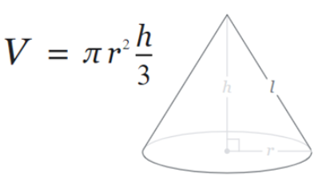

Task:
Write a program to calculate the volume using the above formula.

Allow the user to enter the measurements for r and h. Both r and h should be positive numbers. You can set pi to 3.142

Print the volume on the screen to 2 decimal places
[10 marks total for Question 2]
pi = 3.142
radius1 = input('')
height1 = input('')
radius = radius1*radius1
height = height1/3
volume = pi*radius*height
def Volume_of_cone(Volume):

radius, height = '',''

print (radius1 =' ')
print (height1 = ' ')
radius, height = volume, radius+height
print ("Please enter the radius of the cone")
radius1 = input('')

print("Please enter the height of the cone")
height1 = input('')

print (Volume)

3. Using lists (Python) or arrays (C etc)

Task:
Declare an empty list in your program to hold some measurements, for example:

rainfall = [ ]

1. Prompt the user to enter five (valid) rainfall measurements (in millimetres) and store them in a list. (eg 3.3, 5.0, 2.6 etc)
2. Print each of the entered values on the screen using a loop.
3. Calculate the total rainfall (ie add all five measurements)
4. Also calculate the average rainfall and print it on the screen

Sample output:
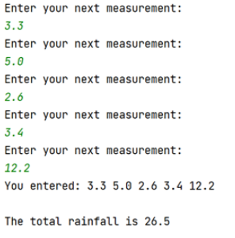
[15 marks total for Question 3]
rainfall=[ ]
measurement1 = input('')
measurement2 = input('')
measurement3 = input('')
measurement4 = input('')
measurement5 = input('')
total = measurement1+measurement2+measurement3+measurement4+measurement5
average = measurement1+measurement2+measurement3+measurement4+measurement5/5

print("please input the first measurement")
measurement1 = input('')
print(measurement1)

print("please input the second measurement")
measurement2 = input('')
print(measurement2)

print("please input the third measurement")
measurement3 = input('')
print(measurement3)

print("please input the fourth measurement")
measurement4 = input('')
print(measurement4)

print("please input the fifth measurement")
measurement5 = input('')
print(measurement5)

print("You entered" , measurement1, measurement2, measurement3, measurement4, measurement5)

rainfall = rainfall + [measurement1, measurement2, measurement3, measurement4, measurement5]

print ("This is your total rainfall", total)
print ("This is your average rainfall", average)

4. Using Functions

Task:
Write a function called entermeasurement() which will allow the user to enter a measurement for one side of a parcel and then return it to the main program. The function should also check that the measurement entered is greater than 0.

From the main program, call your entermeasurement() function 3 times - once for each of the length, width and height measurements, and print the measurements returned on the screen.

Also, calculate and print the volume of the parcel (length * width * height) on the screen.

Sample output:

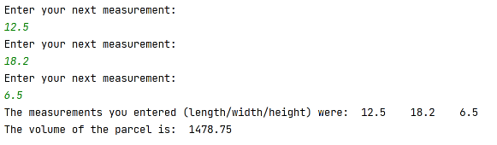
[15 marks total for Question 4]

length = input ('')
height = input ('')
width = input ('')
def f_int(entermeasurement,):
return entermeasurement==length*width*height
entermeasurement = int(input("please input the length of the parcel: "))
length = input('')

entermeasurement = int(input("please input the width of the parcel: "))
width = input('')

entermeasurement = int(input("please input the height of the parcel: "))
height = input('')

print("The measurements you entered (length/width/height) were: ", length. width, height)
print("The volume of the parcel is:", entermeasurement)

Diwedd/End

