Evidence of Learning (E-Portfolio)
Student Name: Nasson Msoni
Student Number:2244265
Table of Contents
Borton’s Reflective Tool 3
What 3
So what 3
Now what 3
A Two-Minute Video Presentation 4
A Mind Map about Personal Identity 5
Importance of Academic Integrity 6
References 8

Borton’s Reflective Tool
As I reflected on my journey to prepare for higher education, Borton's reflective tool helped me understand the process, challenges, and personal growth. Borton's model encourages the exploration of experiences, feelings, and actions, fostering a deeper understanding of the learning journey (Delves-Yates, 2021).

What
Initially, I engaged in thorough research on potential fields of study, universities, and career paths. This involved gathering information on academic programs, admission requirements, and potential challenges. Furthermore, I documented my goals, aspirations, and fears at some stage in this segment, which laid the foundation for self-awareness (Grant et al., 2017).

So what
As I navigated through the complexities of university applications, financial planning, and personal growth, I developed resilience and adaptability. I learned about different institutions that were offering different academic programs and analysed my own strengths and weakness as per the prerequisites of the programs (Collington and Fook, 2019). I attended several seminars and educational expos that connected higher study institutions with their potential new admittance. Overcoming challenges such as balancing academic commitments and extracurricular activities strengthened my time management and organisational skills (Fontaine, 2018). Recognising the transformative energy of these challenges allowed me to adopt the growth and development that occurred during the preparation phase (Delves-Yates, 2021).

Now what
I identified the significance of continued self-reflection and adaptation as I transitioned into higher education. I set SMART goals for my academic performance, personal development, and social integration (Fontaine, 2018). Additionally, I acknowledged the need for a support structure, seeking guidance from mentors, friends, and university resources. It highlighted the multifaceted nature of preparing for higher education, encouraging me to delve into my feelings, thoughts, and actions (Delves-Yates, 2021). Through reflection, I gained a more comprehensive understanding of my achievements and identified specific domains in which I could further improve. It empowered me to recognise the significance of my past, interpret setbacks as opportunities for growth, and establish purposeful objectives for the future (Grant et al., 2017).

A Two-Minute Video Presentation
Digital learning has revolutionised the way of seeking knowledge and skills and has become a vital part of the education system. Digital learning includes the usage of various software, online lectures, and internet research; it must be addressed in the context of career development (Camilleri and Camilleri, 2017). These skills prepare individuals for the dynamic and technologically driven background of modern workplaces and help improve their academic performance (Sousa and Rocha, 2019). One of the primary advantages of digital learning lies in its accessibility. The use of various software and online platforms allows learners to access educational materials from everywhere in the world, breaking down geographical barriers (Bonfield et al., 2020). This accessibility is particularly beneficial for individuals seeking career development because it enables them to pursue additional qualifications or skills without the limitations of region or time. Whether it is far attending virtual lectures, participating in online courses, or using educational software, digital learning facilitates continuous professional development (Blayone et al., 2017).
Proficiency in conducting research utilising the extensive volumes of information accessible on the internet is essential in the knowledge-driven economy of the twenty-first century. Remaining updated on evolving consumer preferences, industry benchmarks, and novel technological advancements is frequently imperative for advancing in an individual’s professional career (Munro, 2018). Proficiency in conducting online research efficiently and effectively is an exceptionally valuable ability, as it enables one to obtain relevant knowledge, recognise trends, and form accurate conclusions. Those who demonstrate this digital proficiency may advance their professional trajectories forward and establish themselves as professionals in their respective domains, poised to effectuate constructive change (Camilleri and Camilleri, 2017). Furthermore, the use of collaborative digital challenges fosters communication and teamwork, which are essential skills in the modern workplace (Sousa and Rocha, 2019). Platforms like Google Workspace, Microsoft Teams, and project management tools enable individuals to collaborate seamlessly, regardless of physical proximity. As many careers involve cross-functional collaboration and diverse teams, proficiency in these tools becomes a key asset. Learning to navigate and leverage such software programs now not only enhances productivity but also demonstrates adaptability, a quality highly valued by employers (Bonfield et al., 2020).
Online learning platforms and virtual classrooms offer flexibility, permitting individuals to tailor their learning experiences to their schedules. This flexibility is particularly advantageous for professionals seeking career advancement. They can pursue further education, up-skill, or reskill without the need to compromise their current employment (Blayone et al., 2017). The capacity to adapt to the requirements of online learning and education is an essential factor in professional development. This ability is crucial for maintaining significance and competitiveness in industries undergoing constant change (Munro, 2018). Digital literacy is an essential skill for professional advancement, encompassing the ability to proficiently utilise digital tools for tasks such as navigation, evaluation, and employment (Camilleri and Camilleri, 2017). Numerous occupations today necessitate proficiency with particular software and technologies. Those who embrace and master digital tools position themselves as valuable assets in their respective fields. As technology continues to advance, the demand for digitally literate professionals will increase, making it vital for individuals to invest in digital learning to stay competitive in the job marketplace (Blayone et al., 2017).

A Mind Map about Personal Identity

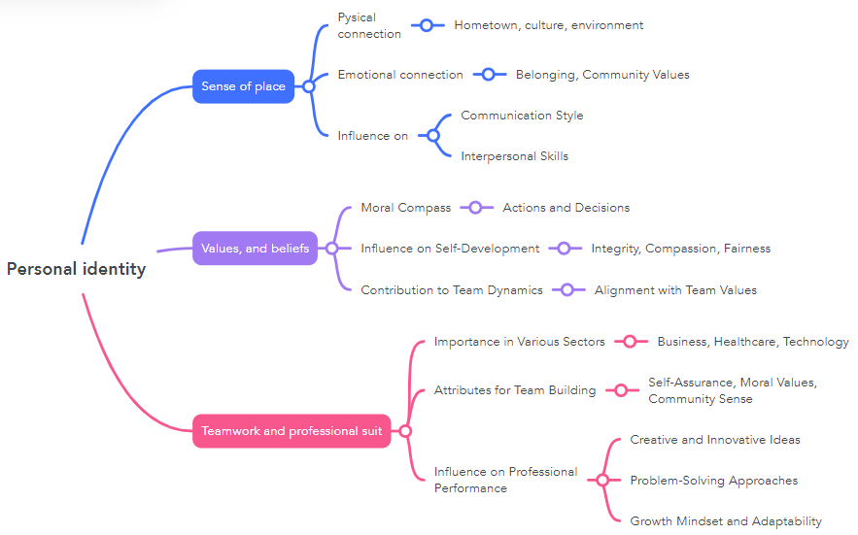
Figure 1, Mid Map
Personal identity is a complex interplay of various factors, including the sense of place, values, and beliefs. These elements collectively shape an individual's understanding of themselves and influence how they navigate the world around them (Grant and Archer, 2019). The concept of personal identity extends beyond individual characteristics and permeates into interpersonal relationships, teamwork, and professional pursuits (Avdagic et al., 2021). A sense of place contributes significantly to personal identity. This encompasses the physical and emotional connection individuals have with their environment, including their hometown, culture, and environment. The geographical context in which one grows up shapes their perspectives, values, and social interactions (Shoemaker and Tobia, 2019). For instance, an individual raised in a close-knit community may develop a strong sense of belonging and community-oriented values, influencing their identification as a team member. This connection to a specific place can also have an impact on an individual’s communication style and interpersonal skills, contributing clearly to collaborative efforts (Leeds et al., 2019). The beliefs and ideals of an individual serve as their moral compass, determining their actions and decisions. Individuals' sense of self-development and interpersonal connections are both influenced by these enduring norms (Grant and Archer, 2019). Team members who possess strong character characteristics such as integrity, compassion, and fairness are typically the most valuable (Avdagic et al., 2021). These principles establish the foundation for truthful communication, collaboration, and recognition within a group workplace. Moreover, individuals who align their values with those of their team are much more likely to make a contribution to the overall team dynamic (Shoemaker and Tobia, 2019).

Video:

The influence of personal identity on teamwork extends to the professional realm, where it becomes a crucial asset for career development. Proficiency in collaborative teamwork is an asset in numerous sectors, including but not limited to business, healthcare, and technology (Leeds et al., 2019). An individual who possesses self-assurance, dedicated moral values by which they conduct themselves, and a deep sense of communal belonging can effectively utilise these attributes to build a unified and fruitful team (Leeds et al., 2019). Team members are more inclined to generate creative and innovative ideas, in addition to novel problem-solving approaches, when they possess an awareness of and regard for the distinct perspectives that result from recognising each individual (Shoemaker and Tobia, 2019). An individual's professional performance is likewise influenced by their sense of self-belief, which subsequently shapes their approach to challenges and opportunities. For instance, an individual with a resilient identity, entrenched in their values and sense of place, may approach setbacks with a growth mindset (Avdagic et al., 2021). This adaptability is a valuable trait in the professional world, permitting individuals to navigate complicated situations, learn from experiences, and continuously improve their skills (Grant and Archer, 2019).

Importance of Academic Integrity
Plagiarism must be strictly avoided in professional and academic environments in order to maintain the integrity and novelty of the work being done. Plagiarism is an act that inappropriately adopts the ideas, words, or work of another individual and presents it as its work, thereby undermining the academic method and creative contributions (Morris, 2018). This is critical as it undermines confidence in establishments, undermines the credibility of those involved, and diminishes the standard of education for all. Academic dishonesty may result in expulsion from the institution, academic sanctions, or harm to one's reputation within the academic sphere (Bertram Gallant, 2017). Such conduct undermines the credibility and learning capacity of students; therefore, academic integrity is vital. It can safeguard the integrity and honour that an individual student represents, which is vital for the betterment of society at large (Mahmud, 2024). At the same time, the student's academic performance may be adversely affected by their breeches. Acknowledging the assistance provided by experts to students with academic writing is an essential component of upholding academic integrity (Park, 2017). In the academic community, academic dishonesty is met with severe consequences at every level. It is manifested in academic dishonesty and plagiarism (Morris, 2018). The academic community embraces and provides mutual support for all members' research endeavours. Academic dishonesty that eludes public detection has the potential to undermine endeavours aimed at ensuring the safety of students. Demonstrating academic integrity entails generating original concepts and appropriately attributing them to an individual’s work (Bertram Gallant, 2017).
Students should prioritise the development of their academic abilities due to the critical nature of this endeavour in upholding their academic integrity. Students can find multiple tools and resources that help students to produce original works. Students use the Central libraries to consult with a vast array of specialists for assistance with their academic assignments (Mahmud, 2024). An extensive assortment of scholarly materials, including citations, academic papers, notes, and readings, are accessible through the online platforms of the Student Learning Center (Park, 2017). Additionally, students should seek out liaison librarians, as they can serve as an invaluable asset in locating academic materials of superior quality. Perform research on any subject at any time and in any location by utilising advanced search guides. In addition, it generates a sense of accomplishment and enables the author to establish a positive reputation within the academic community (Morris, 2018).

References
Avdagic, E., May, F., McClean, T., Shackleton, F., Wade, C. and Healy, K., 2021. Mind Mapping as a Pragmatic Solution for Evaluation: A Critical Reflection through Two Case Studies. Practical Assessment, Research & Evaluation, 26, p.5.
Bertram Gallant, T., 2017. Academic integrity as a teaching & learning issue: From theory to practice. Theory Into Practice, 56(2), pp.88-94.
Blayone, T.J., vanOostveen, R., Barber, W., DiGiuseppe, M. and Childs, E., 2017. Democratising digital learning: theorising the fully online learning community model. International Journal of Educational Technology in Higher Education, 14, pp.1-16.
Bonfield, C.A., Salter, M., Longmuir, A., Benson, M. and Adachi, C., 2020. Transformation or evolution?: Education 4.0, teaching and learning in the digital age. Higher education pedagogies, 5(1), pp.223-246.
Camilleri, M.A. and Camilleri, A.C., 2017. Digital learning resources and ubiquitous technologies in education. Technology, Knowledge and Learning, 22, pp.65-82.
Collington, V. and Fook, J., 2019. Reflection and intuitive practice. Myles Professional Studies for Midwifery Education and Practice: Concepts and Challenges, p.71.
Delves-Yates, C., 2021. 1 What is Reflection?. Beginner′ s Guide to Reflective Practice in Nursing, p.5.
Fontaine, S.J., 2018. The role of reflective practice in professional development. The Veterinary Nurse, 9(7), pp.340-347.
Grant, A., McKimm, J. and Murphy, F., 2017. Developing reflective practice: a guide for medical students, doctors and teachers. John Wiley & Sons.
Grant, T. and Archer, A., 2019. Multimodal mapping: Using mind maps to negotiate emerging professional communication practices and identity in higher education. South African Journal of Higher Education, 33(1), pp.74-91.
Leeds, A.J., Kudrowitz, B. and Kwon, J., 2019. Mapping associations: exploring divergent thinking
Mahmud, S. ed., 2024. Academic Integrity in the Age of Artificial Intelligence. IGI Global.
Morris, E.J., 2018. Academic integrity matters: five considerations for addressing contract cheating. International journal for educational integrity, 14(1), p.15.
Munro, M., 2018. The complicity of digital technologies in the marketisation of UK higher education: exploring the implications of a critical discourse analysis of thirteen national digital teaching and learning strategies. International Journal of Educational Technology in Higher Education, 15(1), pp.1-20.
Park, C., 2017. In other (people's) words: plagiarism by university students—literature and lessons. Academic ethics, pp.525-542.
Shoemaker, D. and Tobia, K., 2019. P
Sousa, M.J. and Rocha, Á., 2019. Digital learning: Developing skills for digital transformation of organisations. Future Generation Computer Systems, 91, pp.327-334.

