


Engine Dynamometer/ Engine Performance Characteristics
Vehicle Technology, M4X00394
University of Wales Trinity Saint David
School of Engineering
Dan Morris
1900912@student.uwtsd.ac.uk
Student Number:1900912
Date: 10//12/19
Table of Contents
1 Introduction ii
1.1 Aims ii
1.2 What is an Engine Dynamometer? And how does it work? ii
2 Methodology iii
2.1 Equipment used iii
2.2 Method iii
3 Results v
3.1 Collected Data v
3.2 Calculated Data vi
4 Graphical Results vii
4.1 Torque against RPM vii
4.2 Power against RPM viii
4.3 SFC against RPM ix
5 Evaluation xi

Introduction

In this experiment, we are using the on-site engine dynamometer to execute an engine performance test and analysis on the Honda B16A engine.

Aims

- Carry out an engine dynamometer test on the B16A, including a step test and a sweep test at different throttle positions. We will only be extracting the data from the 100% throttle sweep test.
- Collate all raw data in an excel spreadsheet in order to find the calculated values we are analysing. (Corrected Power, Torque, BMEP, SFC, and Overall Thermal Efficiency).
- Using the given equations, find all of the above data sets and graph the wanted results.
Table 1 - Graphs to be plotted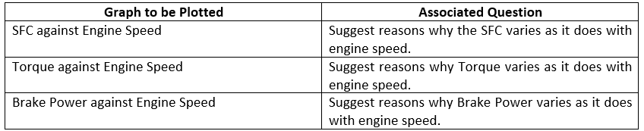
- To be able to find expected relationships between the data sets and to be able to explain why the graphs vary like they do.
- Analyse how I think I performed during the experiment.

What is an Engine Dynamometer? And how does it work?

An engine dynamometer is a device used to test and log an engines different outputs, such as power and torque. As the engine rotates its crankshaft, the crank is attached to an impeller that will spin at the same RPM as the crankshaft. As the impeller spins, it is resisted by water inside the impeller housing, causing a resistance against motion. This heats up the water and puts a large load on the impeller housing, and a force transducer measures the rotational strength and converts it into figures we know like torque and power. Some of the water from the tank will be used to regulate engine temperature. Before it can be used, it needs to be calibrated. So we hung a mass on an arm on the impeller housing and compared it to the reading on the dyno software. If it matches, then the device is ready to use. On the software, we can set the reader to collate data at different RPM steps, different time intervals, or sweep across an RPM range. For our test, we used a sweep test, which lets the engine run across a given RPM range, and the reader will take data from each given RPM increment. It is from this test, we can use the data collected to find our different relationships. (Williamson, 2019). The dyno we used was an eddy-current dyno, which works slightly differently. The brake moment is achieved by having an excited coil creating a magnetic field across a stator housing and the internal rotor. As the primary rotor (engine) spins the internal rotor, the internal rotor cuts off the field lines resulting in eddy currents being induced, acting as a reverse force on the internal rotor, attempting to slow it down (braking). As the RPM of the engine increases, the rate of change of magnetic flux increases, making the eddy currents larger, and the braking effect larger, resulting in a higher torque from the primary rotor in order to maintain the same speed.

Methodology

Equipment used

- W230 Engine Dynamometer
- Engine Dynamometer data acquisition software
- Torque Arm
- Weight
- Microsoft Excel and Word

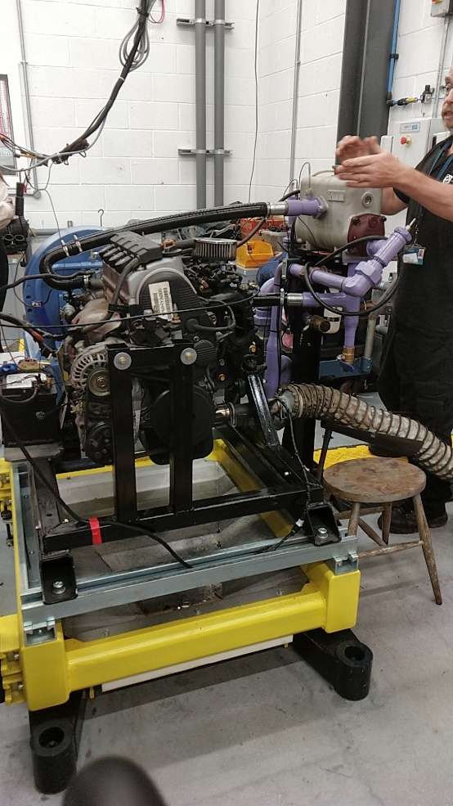
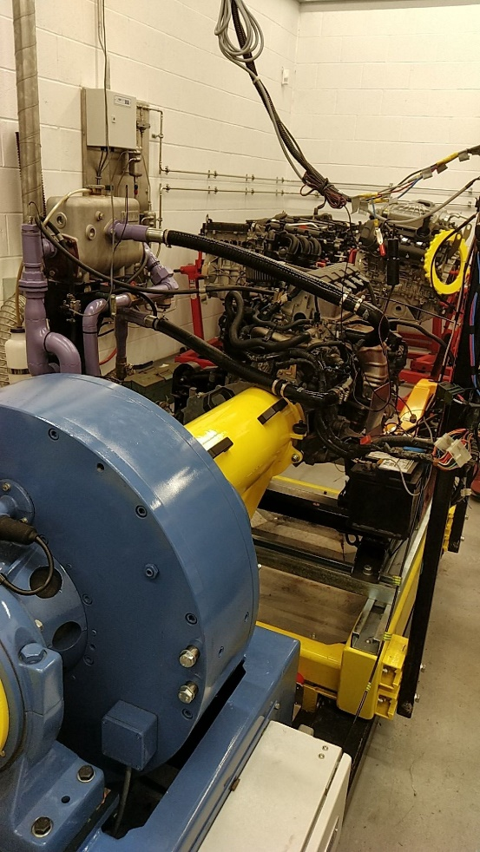
Figure 1-B16A hooked up to engine dynamometer

Figure 2-B16A engine

Method

- Hook up the engine to the dyno. See Figure 1;2.
- Calibrate the dyno using a torque arm and a weight (looking for correlation between the software and our results) see Figure 3.
- Carry out 2-3 sweep test runs on 100% throttle opening to ensure the equipment is running effectively and we get a true representation from our final run.
- Perform our final run and check if the data is feasible (compare data from final run with data collected from the test runs).
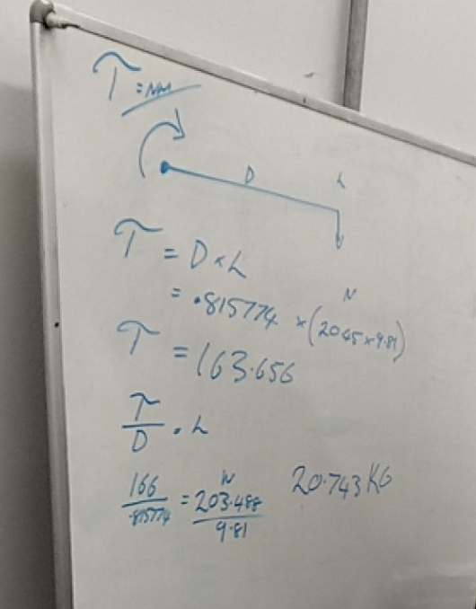
Test run parameters:
- 1000-5500 RPM sweep
- 100% throttle
- Log every 50 RPM

- Log the collected data onto an excel worksheet.
- Graph the data sets we want to investigate and analyse the results.

Figure 3- Calibration process on our whiteboard

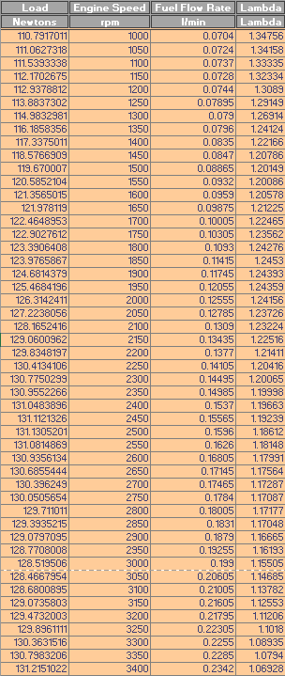
Results
Table 2- Raw data from final dyno run

Collected Data

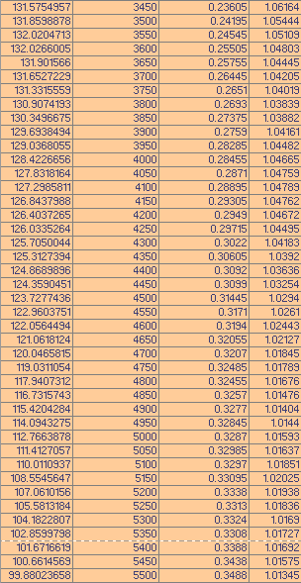

Calculated Data
Table 4-Power table
Table 5-SFC table
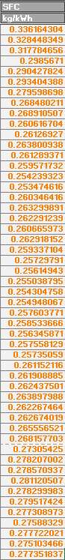
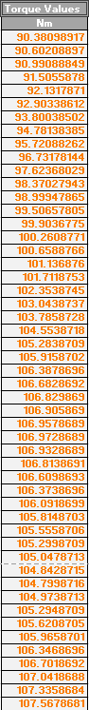
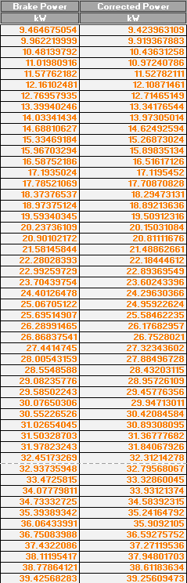
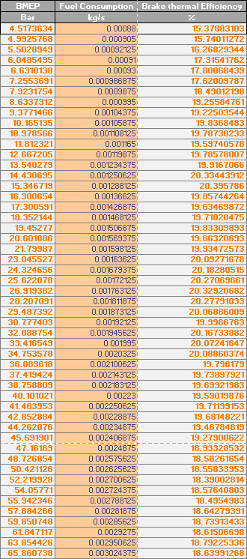
Table 3-Torque table
Table 6-Final BMEP, FC and BTE table

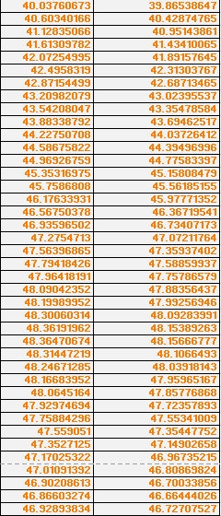
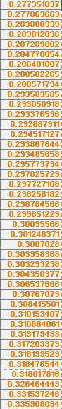
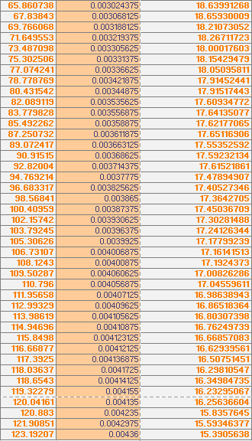
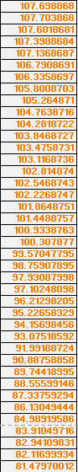

Graphical Results

Torque against RPM
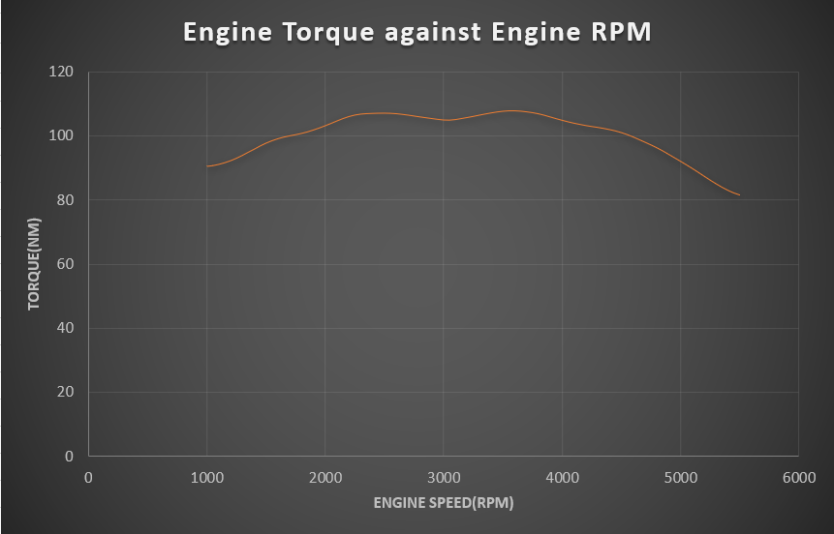
Figure 4- Torque against RPM
Torque is a twisting force created when a force is applied at a length from an axis of rotation/pivot. Within the engine, the combustion within the cylinder is supplying a reciprocating force pressing downwards on the piston, which is then pressing down on the rod bearing journal. The rod bearing journal is part of the crankshaft, but the journal is offset from the crankshafts axis of rotation. This results in a force acting at a distance from an axis of rotation, which is torque.
Our torque figures are taken by multiplying the varying load on the internal rotor and the torque arm distance. An expected torque curve is a gradual increase of torque with RPM, but we can see this isn’t the case. The torque peaks at around 3600 RPM and starts to decrease. The increase of torque between 1000:3600 RPM is expected, but the torque decrease after 3600 RPM shouldn’t theoretically happen, as a higher load should be exhorted at a higher RPM. The reason for this decrease is the decrease in volumetric efficiency. The airflow within the engine gets restricted due to the higher piston speeds, resulting in a reduction of air/fuel mixture into the chamber, and less downwards force as a result. This effect gets enhanced as the RPM increases past a certain point, this case 3600 RPM. Also, as mechanical friction within the engine will increase with engine speed, resulting in lower overall mechanical efficiency at higher RPM’s.

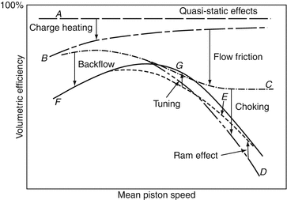
Figure 5- Graph to show how volumetric efficiency varies with RPM
(Jacobs, 2012)

Power against RPM

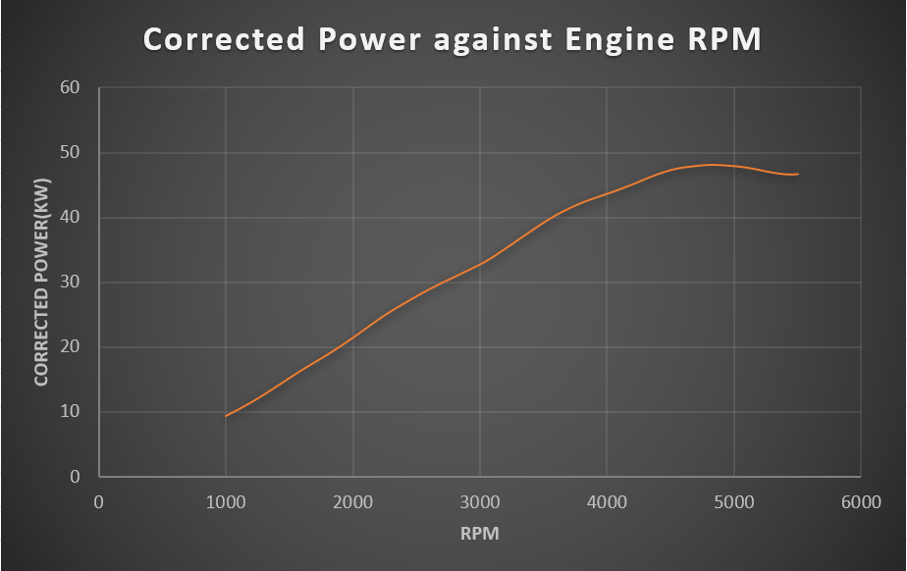
Figure 6- Graph of Power against RPM
Equation 1-Engine power is a function of torque and RPM.
Power is the rate that work(torque) is done.
$$P=\frac{2πNT}{60}$$
N= RPM
T= Torque
The graph is what we would expect from this relationship. From the data, we have an ever increasing value of RPM and an increasing value of torque, up to 3600 RPM when it starts to decline. This decline in torque is miniscule compared to the increase in RPM, up to a certain point of max power.
Equation 2- Proportionality
Taking $P∝NT$ and two sets of our data:
Equation 3
$\frac{2π×5200×87.338}{60}=47.553$kW
Equation 4
$$\frac{2π×5250×86.136}{60}=47.354kW$$
Even as RPM increases and torque decreases, the larger decrease in torque results in a smaller power figure. This is the reason why our graph drops off at the later RPM stages.
Data taken from Table 2,3 and 4.

SFC against RPM
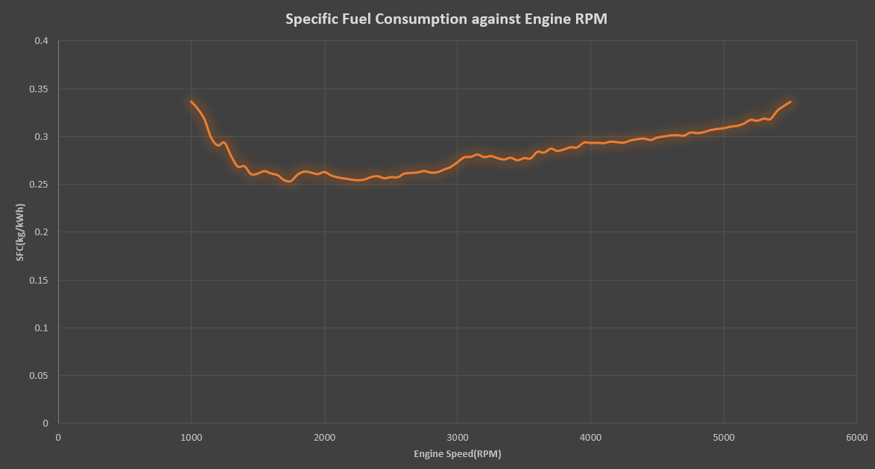
Figure 7- Graph of SFC against RPM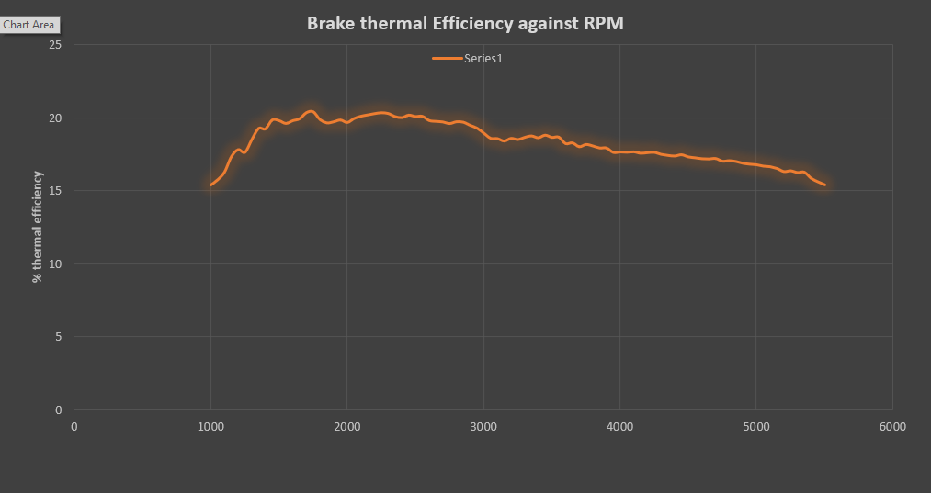
Figure 8-BTE against RPM
Figure 9-BTE against RPM flipped
Looking at Figure 7 and 9, we can see that the graphs are identical. Meaning that the plot of SFC against RPM is a mirror of the BTE against RPM graph. This is because the only variables in both SFC and BTE equations is power and fuel flow rate and SFC is directly determined by the brake thermal efficiency of the system. In the data we collected, our value for lambda decreases. This means the fuel/air mix is getting richer because of the restricted air flow mentioned in chapter 4.1 and also for cooling reasons. Ultimately, this results in a lower thermal efficiency past a certain RPM, as a richer fuel/air mix results in incomplete combustion. The SFC curve decreases between a rev range. This is because the engine has been optimised to be as thermally efficient as possible within the most likely RPM that it will be used for. The B16A engine wasn’t made for the track, but for city and motorway driving. We can see that in the graph. The optimal rev range is 1300:3000, which is what most drivers would use around the city or on the motorway. Reasons for this optimum rev range also means that the running costs of the vehicle would be less if the SFC was less in the frequently used RPM ranges. The SFC increase past 3000 RPM will be due to increased mechanical frictional losses like piston, pumping and valvetrain losses which all increase with RPM naturally. This area of low SFC is roughly similar in all spark ignited engines. If we were going to investigate a diesel truck SFC graph, the diesel would be lower SFC values all round. This is due to diesel being a denser mix, resulting in less fuel needed to be burnt to produce the same amount of energy. Diesel engines also have a higher compression ratio, resulting in better fuel consumption. The range of the lower SFC band would be at a lower RPM than a petrol engine, due to a diesel engines longer stroke, and higher torque figures at lower RPM’s.

Evaluation

I believe the tests were a success, as all of our data and graphical results came out to be as expected. I’ve enjoyed using the engine dyno and collecting data, and I don’t believe there was much we could have done to improve how the investigation went. In the future, I would have changed the rev increments to take readings. We used each 50 RPM to take a reading. Ideally, we would have done it every 1 rpm increase, but we didn’t have the time to do that.

Bibliography
Dr Scott J. I. Walker, D. A. (2018). DS4,UOS. Retrieved from University of Southampton: http://uosdesign.org/designshow2018/project/line-launcher/
Jacobs, T. J. (2012). Internal Combustion Engines, Developments in. New York. doi:https://doi.org/10.1007/978-1-4419-0851-3
Williamson, B. (2019, 4 3). How An Engine Dyno Works. Retrieved from Power Nation: https://www.powernationtv.com/post/how-an-engine-dyno-works

Figure 1-B16A hooked up to engine dynamometer iii
Figure 2-B16A engine iii
Figure 3- Calibration process on our whiteboard iv
Figure 4- Torque against RPM vii
Figure 5- Graph to show how volumetric efficiency varies with RPM viii
Figure 6- Graph of Power against RPM viii
Figure 7- Graph of SFC against RPM ix
Figure 8-BTE against RPM ix
Figure 9-BTE against RPM flipped x

