Module Assignment Submission
Cover Page

Student Name: | Nadean Kennedy
Student Number: | 1815021
Module No: | BMSK 6001
Module Title: | Emergent leadership skills for the workplace.

Date submitted: | 09/07/2023
Time submitted: | 23:59
Statement of Confirmation of Authenticity
By the act of making this submission, the student declares that this is the work of the student named above. Where materials have been used from other sources it has been properly acknowledged. If this statement is untrue, the student acknowledges that an assessment offence has been committed. Proven incidents of plagiarism, collusion or cheating can result in a learner being withdrawn from a
qualification.
Attention is drawn to the Plagiarism, Collusion and Cheating Policy and Unfair Practice policies of the University and ILM.
Permission for ILM to use this script
ILM uses learners’ submissions – on an anonymous basis – for assessment standardisation. By submitting, both the centre and the learner agree that ILM may use this script on condition that identifying information is removed. However, if you are unwilling to allow ILM to use this script, please refuse by ticking the box: □

Contents
- Introduction 4
- Critically assess a recognised leadership model or theory in relation to its ability to impact on individual’s workplace performance. 5
2.2 What is situational leadership? 6
- Evaluate own ability to use a range of leadership styles, in different situations and with different types of people, to fulfil the leadership role. 9
- Assess your own ability to set direction, motivate, delegate and empower others to bring about a workplace change. 11
4.1 Setting direction 11
4.2 Delegating 12
4.3 Motivating 12
4.4 Empowerment 12
- Conclusion 13
- References 14
- Appendix A 15
- Appendix B 19
- Appendix C 20
- Appendix D 21
- Appendix E 22
- Appendix F 25
- Appendix G 25
- Appendix H 26

Introduction

This report is going to critically assess a recognised leadership model or theory and how it would have an impact on an individual’s workplace performance. The organisation chosen are Admiral Insurance and will asses if the chosen style of leadership would be affective compare to the organisations goals and expectations as one of the UK’s leading insurance providers. Some famous political leaders commonly use methods of leadership to gain votes from the public and eventually gain enough votes to become leaders.
"May I stress the need for courageous, intelligent, and dedicated leadership... Leaders of sound integrity. Leaders not in love with publicity, but in love with justice. Leaders not in love with money, but in love with humanity. Leaders who can subject their particular egos to the greatness of the cause." ~ Martin Luther King, Jr.
"Power is like being a lady... if you have to tell people you are, you aren't." ~ Margaret Thatcher
"You have to think anyway, so why not think big?" ~ Donald Trump
The report will also look into the students own abilities to use a range of leadership styles and how it will affect the leadership role within an organisation, including self-assessment questionnaires an competency test. The report will also take into account the students abilities to set direction, delegate, motivate and empower individuals within a leadership role. This report should allow the student to identify strengths and weaknesses of their own abilities and brining awareness to areas that may need improvement to be able to fulfil a leadership role in the future.

Critically assess a recognised leadership model or theory in relation to its ability to impact on individual’s workplace performance.

In this section of the report will be where situational leadership is going to be looked at in more detail. However, it is ideal to understand what a leader is and the key dimensions of being a leader. Carol, B., Ford, J., & Taylor, S. (2019) note that there a difference between a manager and a leader. A manager would be planning ways to improve their team for example. Were as a leader would be looking at were the company is , in regard to competition and the organisations place in the market, and how the organisation holds up against peer. A leader is there to offer guidance and inspire the members of the organisation to follow the same goals and visions.
There are many different types of leadership styles such as:
- Transactional
- Transformational
- Autocratic
- Bureaucratic
- Charismatic
- Democratic
- Laissez Faire
- Task Orientated
Kouzes, J., & Posner, B. (2012) Mention in their book five practices of exemplary leadership. They are listed as follows:
- Models the way – This is more to do with behaviour than title because one does not need to have a title within and organisation to be a good leader. The behaviour of the leader is what helps earn the respect of others. The book also mentions in this section that self-awareness is also especially important, as a good leader would need to understand what their own core values and principles are, and also understand that being a leader means understanding that others have different values and principles.

- Inspires a shared vision - The vision of the organisation is also a detrimental part of being a great leader. Having a personal belief in the organisations vision will transcend through their leadership. A great leader will have already envisioned the further development and possibilities. A clear goal and vision is needed however to be able to share the vision with others “You cannot command commitment; you have to inspire it.” Kouzes, J., & Posner, B. (2012)

- Challenges the process – When a leader is at their best, they will challenge the status quo, and keeping things the same does not allow an organization to progress and keep up with the market and its peers. As mentioned, a leader does not have to have a title within the organisation but something as small as fighting for free tea/coffee, or free sanitary products can make a huge difference to morale of an organisation. It can also be dealing withing such as changes as an innovative new product or piece of technology, targeting a wider range of the market because innovation and change involve taking risks and challenging current processes and procedures.

- Enables others to act – an organisation Is made up of so many different branches, and within it many people. Being able to delegate task for example allows not only the staff member to gain an insight into what is needed in relation to skills etc to progress, it also builds trust and empowerment. By being open to all ideas and giving the opportunity to voice opinions encourages more trust in a leader.

- Encourage the heart – Part of a leader’s job is to be encouraging and appreciating individuals achievements, which in turn helps people feel genuinely cared about and part of a team. This can help build the culture and a sense of community.
There are many different leadership styles that have been created over the years noted previously in this section of the report that can be adapted in a leadership role within an organisation. Within an organisation, it is going to be made of up of all kinds of individuals that have different needs. Being able to adapt and adjust leadership styles to an individual and their needs is an example of great leadership. There is not a one size fits all, as everyone is different. The next section of this report will look at situational leadership, which does just that.

2.2 What is situational leadership?

Dr Paul Hersey is the founder of situational leadership and believes that leadership equals influence. Situational leadership is about the leader being able to identify and match their behaviour to the performance needs of the individuals within the organization or group. The centre of leadership studies. (2015) quotes a few definitions from Dr Hersey giving a little more insight into leadership and situational leadership “If you’re looking for a single formula…, There is no magic solution for leaders” meaning there is no one shoe fits all type of leadership when dealing with individuals. The leadership style must change depending on the goal and the individual combined. The best way to influence individuals as a leader is through the leader’s behaviour. “Affective leadership depends upon what behaviour one uses, in a particular situation”.
Simpson, S. (2012). Discuss what situational leadership is and mentions different leadership models based around this. These theories a based on the premise that an individual’s behaviour is determined and influenced by the situation they find themselves in within the organisation.
- Bolman & Deals 4 Frame Model
- Hersey and Blanchard’s Situational Leadership Model
- Kurt Lewin’s 3 Styles Model
- Path-Goal Theory
- Tannenbaum and Schmidt’s leadership behaviour Continuum Model
- The Fiedler’s Contingency Model
- Vroom-Yetton Leadership Model
Looking specifically at the Heresy and Blanchard model it focuses on three sections. Style of learning, maturity level, and development level. The first section looks at the style of leadership (s). This is broken down into four sections of progression.
- Telling - S1 This leadership style will be highly directive and low supportive behaviour. The leader would define the roles and instruct and be based on a one-way system of communication. This type of leadership may be used for a new employee for example or an individual taking on a new task within an organisation were the leadership style may need to be more directive.

- Selling - S2 The leadership style here is still very much directive but also high supportive behaviour. The communication is more of a two may exchange but the leader will still be providing direction. The leader will be also offering emotional support, building a bond.

- Participating/Supporting – S3 A high supportive and low directive behaviour would be demonstrated within this section of the cycle. This leadership style allows for shared decision making and would provide a less instructive role around tasks.

- Delegating – S4 A low supportive and low directive behavioural approach is adapted here. This leadership would be allowed for individuals or groups to take responsibility for processes, although the leader may still be involved and monitor progress
Maturity levels = M, Development levels = D. Refer to appendix for explanations of each. Looking at situational leadership within this report has allowed me to draw a link between this and the phases of Tuckman’s four stages of team development. Jones, A. (2019) give an overview of Tuckman’s four stages of building a team. A team can be made up of two or more people and as a leader, especially when trying to build new relationships with an individual or group will most likely go through these stages of building a team, which part of the leadership role is building good relationships. The four stages of the Tuckman theory include Forming, Norming, Storming, and Performing. The forming stage would be were the leader would take the lead, and making sure they are highly visible. The leader will be giving instruction, ,establishing expectations. This falls in line with the telling stage of situational leadership. The next stage of Tuckman’s model would be would still require the leader to provide direction but will be at a stage of normalising behaviours, requesting and encouraging feedback and building trust. This phase of the Tuckman theory falls in line with S2 stage of situational leadership. The norming stage of the model is were purpose and goals are now established and understood and confidence has grown for the individual or group meaning the leader can take a less directive approach, S3 stage of situational leadership align here. The final stage of Tuckman’s model would be performing. The group or individual will be highly motivated, and performing consistently. Trust has been established and the leader can take a more guidance approach and allowing lower supportive and directive needs from the group or individuals and encourages decision making and problem solving. Again this falls in line with the S4 level of situational leadership
Situational leadership can mean a leader has to move from a democratic approach but them may find it necessary to change to an autocratic approach when an individual or group show unacceptable behaviour that goes against the organisations core values for example.
Kurt Lewin’s three styles model of leadership styles. Crosby, G. (2020) noted in their article the three areas as:
- Autocratic Leadership requires the leader to make all the decisions, has short term increases in productivity but has a negative impact on long term engagement, motivation and creativity of the individual or group. This style of leadership will get results but only whilst the leader is watching so would require a lot of supervision and micro managing
- Democratic Leadership would involve all individuals participating in decision making, strategy decisions, encourages strong engagement from all, and can sustain productivity and reach goals even when the leader is not there
- Laissez faire leadership is a completely hands off approach where all the decision making is done by the team. Generally this style works well with a highly skilled individual or team and requires self-motivation but it does mention that this style van be detrimental to productivity at times
With situational leadership it is sometimes necessary to have to switch to a more autocratic leadership style. But it is not a style the leader would want to stay in. Ideally a delegating or laissez faire leadership style allows both leader and individual or group conduct task affectively whilst still feeling valued, trusted and motivated.
Admiral insurance being a very large organisation has to deal with many different individuals and groups within the UK and abroad. Within the sales department it is currently piloting it’s0 first sales team based in an Indian call centre in Deli. This is a new project, and the training is being conducted by UK trainers, via teams. This is not only a new way of training staff as usually staff will be trained within the office, it is also the first call centre outside of the UK for the sales department that have no previous training within the organisation. An established team has been running for many years within customer service from the Deli call centre but no for sales. Situational leadership would be very useful within this situation especially due to the new starters at the deli call centre not only being new and having no previous experience within the organisation but also having to learn the processes via team will mean the leader at the begging of training will need to be very directive and give instruction. It will be a one way method of communication and the new starters will have no input in any processes or procedures. They will get clear outlines of expectations and goals. There will be a six month probation period but staff will then have the same opportunities as all other staff to progress and or take on addition tasks and responsibilities.
Looking at other leadership styles in comparison such as transactional and transformational leadership. The difference in this style of leadership is that situational leadership can tend to be best used in isolated instances or scenarios. Were as transformational leadership for example, is to create or change the whole culture of an organisation, group.
Bass, B.M., & Riggio, R.E., (2016) Describe transactional leadership as some sort of exchange. For example First minister of Wales, Mark Drakeford, or UK Prime minister Rishi Sunak would use transactional leadership by making promises of change in taxes or reductions in energy prices, reducing student debt to gain the trust and votes of the public. It is an exchange of one thing for another. Within an organisation, transactional leadership would be offering performance rewards such as bonuses and pay rises but hen denying those rewards or bonus for under performance. Transformational leadership looks more at stimulating and inspiring individuals into wanting to achieve better outcomes of performance. Transformational leaders motivate and encourage individuals to go above and challenge expectations resulting in higher performance being achieved. Transformational leaders offer empowerment to individuals leading to higher satisfaction and commitment of the individual. Transformational leadership makes the effort to take care of the individuals development needs and eventually develop the individuals own leadership potentials.
In looking at these different styles of leadership, it seems that although situational leadership is an affective style of leadership, it is a short team style. Within and organisational setting this style can be very handy in dealing with day-to-day leadership. Within Admiral insurance situational leadership would be the best method for a team leader/ manager dealing with a group of individuals with many different personalities and development needs whilst also helping build a relationship with the group to meet tasks. Transformational leadership within Admiral insurance would be more of and organisational change, than focusing on a small area or group within the organisation. Transformational leadership can also be used to bring improvements within a department such as the sales department, or customer service department rather than the teams or individuals within that department. Transformational leadership could be used if the organisation want to change the whole culture of the organisation or move to a different end of the market the organisation trades in.

Evaluate own ability to use a range of leadership styles, in different situations and with different types of people, to fulfil the leadership role.

To evaluate the student’s own ability to use a range of leadership style, a number of leaders ship style questionnaires were completed, and results then evaluated.
The first questionnaire completed was a leadership style questionnaire. Refer to appendix A:
This questionnaire looks four different styles of leadership. Authoritative, Democratic, facilitative, and situational. Frome the survey it was found the students most dominant or highest scoring style of leadership was democratic. As the student works within a call centre, within the sales department of Admiral insurance, this style of leadership can be very affective as groups are usually of around 15 individuals and as the democratic style of leadership is based on including all group members in the decision making processes on how the group should operate and will help build trust in the leader, resulting in meeting team objectives and productivity. It gives a sense of team and working as a unit and giving all members equal opportunities. The lowest scoring area was authoritative leadership. This seems logical as is the opposite of a democratic leadership style. Interestingly situational and facilitative leadership come out equal in score for the student. Looking at the overall score of this questionnaire, at Admiral Insurance, the organisation the student works at shows the students leadership style would fit in well with the organisational culture and how the department functions. Admiral insurance philosophy: “People who like what they do, do it better. Ou culture is honest, open, and whole heartedly focused on four key areas: Communication, Equality, reward and recognition, and Fun.” Admiral (2021)
The next questionnaire completed by the student was specifically around Hersey and Blanchard’s situational leadership model previously mentioned in section 2. Refer to appendix E.
The results of this questionnaire showed the student scoring high in the S2 and S3 are of the situational leadership model. This refers to the selling/coaching style of leadership and the participating/facilitating style of leadership. This would fall in line with the results of the previous questionnaire of having a democratic leadership style which give all members of the team or group the opportunity to participate and contribute to ideas and decision making. However the student scored lowest in the S1 and S4 section of the survey. S1 would be telling and directing. The student suggests scoring low in this section could be due to a lack of confidence or wanting to avoid confrontation. Within an organisation telling\directing may not necessarily be a negative or confrontational scenario. I may mean setting goals and objectives that are clear for the group or individual to understand avoiding a situation where the learner or group become un happy or struggle to lack of direction and not knowing what is actually required of them. Laker, B., & Pereira, V. (2022) mention in the business Harvard review, four main triggers that cause conflict within a team or group. These would include:
- Not establishing clear channels of communication
- Not being transparent about performance expectation
- Not managing time expectations
- Not clarifying task and role expectations
This suggests that the student scoring really low in the telling and directing style of leadership may result in conflicts within the team or group and adding pressure and stress to their leadership. There is also a link to the Lencioni, P. (2002) theory: The Five Dysfunctions of a Team:
- Absence of Trust
- Fear of Conflict
- Lack of Commitment
- Avoidance of Accountability
- Inattention to results
Lack of communication and fear of conflict can result in the absence of trust from a team meaning the student would benefit from trying to find ways of improving their skills surrounding lack of confidence and not wanting to cause conflict or confrontation by setting direction or giving clear instruction to their team or group. Coaching may be a way of the student being able to unlock what is holding them back or lowering their confidence when approaching a certain scenario that involves giving orders and direction.
The other low scoring section was delegating and observing. This scoring was not as low as S1 The student suggested this may be due to the thought process of not wanting any mistakes so would prefer to do tasks themselves or due to lack of time to allow a less experience individual complete tasks or fearing peers repercussion if there are any errors that may cause detriment.
It is important to see delegation as a method of learning and progression rather than an inconvenience or an exercise to of load tasks. The ability to be able to delegate tasks is an important part of being an effective leader.
Maxwell, J. (2013) believes that there are five levels of leadership:
- Position
- Permission
- Production
- People Development
- Pinnacle
Level four is people development within this model and Maxwell believes that the goal of a leader is to identify and develop as many leaders within the organisation as possible. Maxwell explains that for a leader to excel it is imperative to make investing in leaders a priority. The more leaders within the organisation will lead to more of the organisation’s objectives being meet. A mentoring relationship develops, and the organisation is then filled leaders aiming for the same goal.
Although situational leadership is about being able to adapt to the different style the student would need to be able to recognise the areas that they would need to look at improving their skills to be able to give balance to all areas of situational leadership.

Assess your own ability to set direction, motivate, delegate and empower others to bring about a workplace change.

This part of the report will now look at the student own abilities and management style when it comes to setting direction, delegating, motivating and empowering individuals within an organisation. The organisation will be looking at will again be Admiral Insurance, that is a leading insurance provider in the UK and abroad.
- Setting direction

Just one of the pinnacle parts of displaying great leadership. In a Forbes article regarding the importance of setting direction, Gawley, C. (2021) a co-founder and CEO of a digital growth agency and say’s “ Good leaders give directions; great leaders give direction!” the difference between the two meaning is that giving directions are the steps needing to take to get to the end goal of were the company is being directed. Looking back at the students result from their situational leadership questionnaire in section 3, the students lowest score was S1/Telling and setting direction. A great leader needs to set the direction for which they want the company to go and allow its employees to then find ways to reach that goal. Setting direction for a leader is the first steps of forming a good relationship with the individuals of the team or organisation as everyone is aware of the goals and expectations. It also allows the individuals to complete tasks and goals confidently as hey have an understanding of what is required. The student would need to work on over coming what hold them back from giving direction affectively and confidently as being a leader in some situations will require the student to have to give firm, precise, and clear instructions and deadlines and be able to monitor the progress of those actions. This will in turn allow the individuals to proceed with tasks confidently. Admiral insurance are clear with their mission statement in making all its staff feel included and part of the wider team. As a leader the student needs to b e able to make their whole team feel included by making sure directions and direction is clear.
“At Admiral, we care deeply about our colleagues, our customers and the impact we make on the world, and strive to do the right thing at every turn. We believe that happy colleagues mean better outcomes for our customers, colleagues and communities. This is why we work hard to ensure that we foster an inclusive workplace and cultivate a can-do approach.” Admiral Group PLC (2022)

4.2 Delegating

As part of his 7 habits of a highly affective people. Covey, S. (2008) mentions delegation and the importance of it as part of habit 3 of the seven habits he mentions. Covey says that delegating and doing it effectively can be one of the most powerful activities that can be undertaken and mentions two styles of delegating. Gofer delegation which is more instructive in telling the individuals what is wanted, how to do it and the leader being kept up to date with all progress and decision making. And is more of a micro-management style of leadership. Stewardship delegation focuses more on the results rather than the method in which a task is complete allowing the individual to take responsibility. Delegation allows for individuals to feel trusted and leads to the next sections, meaning individuals feel motivated and empowered. Referring back to the students results from their situational leadership questionnaire, the student scored low in this section also. The student mentioned this could be down to not wanting any mistakes being made not having enough time for a task to be delegated to a less experienced individual as it would take more time for said task to be completed. Habit two of coveys seven habits includes the four quadrans of time management. Urgent, Not Urgent, Important, and Not Important. which could help the student manage time better and therefore enabling delegation to be enforced and sufficient time to allow less experienced individuals time to learn. Refer to Appendix F

4.3 Motivating

Motivation can come in two different types. There is intrinsic and extrinsic motivation. Extrinsic motivations are influences from external factors such as a reward for completing tasks and goals. This can range from things such as promotion, money, trophies, certificates, recognition. Intrinsic motivation is from within the individual and a lot harder to tap into that extrinsic motivation. Intrinsic motivation is about the individuals inner drive to want to succeed and progress. Takin the student as an example. They have worked at Admiral insurance for many years and is very familiar on how tasks are needing to be completed and expectation. Because of this the student is finding it difficult to stay motivated whilst in work although they have been completing required tasks they have stated being bored of the job. From the Leaders point f view it would be beneficial to try and tap into the students intrinsic motivations. This can be down as mentioned about by delegating task and giving the student more responsibilities on the team. Thus giving a sense of purpose, pride and the want to go above and beyond standard requirements, also leading into the next section which is empowerment.
"Goals may cause systematic problems for organizations due to narrowed focus, unethical behaviour, increased risk taking, decreased cooperation, and decreased intrinsic motivation. Use care when applying goals in your organization." ~ Daniel H. Pink
"The will to win, the desire to succeed, the urge to reach your full potential... these are the keys that will unlock the door to personal excellence." ~ Confucius
"Most people aren't anywhere near to realizing their creative potential, in part because they're labouring in environments that impede intrinsic motivation." ~ Teresa Amabile

4.4 Empowerment

The Cambridge dictionary definition of empowerment is ‘The process of giving a group or individual more freedom or rights.
As mentioned previously in this report a leader providing effective delegation tasks to an individual not only is a great learning tool but gives the induvial a sense of feeling trusted. This will also help tap into the individuals’ intrinsic motivations. Looking a Maslow’s Hierarchy of needs McCleod, S. (2020). Refer to Appendix G. From an organisational point of view by a leader providing an individual delegative tasks to complete, it builds that individuals sense of worth and belonging. A side from the beginning stage of Maslow’s hierarchy, which is physical needs, each part of the other needs can be met though great leadership. Safety needs are met through job security, which is the second stage. A sense of love and belonging need will be met through using a democratic style of leadership meaning the team and its individuals all feel included and valued. Esteem needs again gained through delegation, recognition, freedom, trust. And the pinnacle of Maslow’s hierarchy is self-actualisation which can also be referred to as empowerment and the desire to be the most that one can be. Huq, R. (2010) Mentions that Power sharing, participative decision making, devolution of responsibility, and a people orientated leadership style to reach empowerment within an individual in an organisational setting

Conclusion.

During this report it has looked at leadership and its different styles and theories surrounding leadership. The main leadership style that was looked at was situational leadership. The report showed that situational leadership is an effective method or style of leadership but requires the leader to be able to switch methods depending on the task or goal to be completed. The report suggested that the student would need to focus on some areas of situational leadership to be able to implement it successfully. Although situational leadership would be an affective stye within the students organisation Admiral Insurance, It is more of a short term style of leadership that may work better within a department such as the sales department that the student currently works. As an organisation as a whole though the evidence suggests that a democratic style of leadership approach is taken by the high members of the organisation looking at the companies mission statements and goals. This report also took a look at the students own ability to use a range of leadership styles and how it would help the student fulfil a leadership role. The student completed self-assessment questionnaires and the results gave an insight into the student capabilities and what areas they may want to work on in the future to be able to fulfil a leadership role. The report has also taken a look into the student ability within a leadership role to be able to set direction, delegate, motivate, and empower individuals again giving an insight into what is required from the student if the were in a leadership role within an organisation. The report has shown leadership consist of many different elements and can be detrimental in the success of an organisation and how it reaches its goals. Organisations are run by people and being able to lead individuals successfully can be lead to more commitment from its individuals, built a great culture and work ethic amongst individuals and align all individuals to want and believe in reaching the same goal.

References

Admiral. (2021). Our Culture. Admiral Jobs. https://www.admiraljobs.co.uk/our-culture
Admiral Group Plc. (2022). Our purpose | Admiral Group Plc. Admiral Group Plc. https://admiralgroup.co.uk/who-we-are/our-purpose
AZ Quotes. (2010). TOP 15 INTRINSIC MOTIVATION QUOTES | A-Z Quotes. A-Z Quotes. https://www.azquotes.com/quotes/topics/intrinsic-motivation.html
Bass, B. M., & Riggio, R. E. (2006). Transformational Leadership. In Google Books. Psychology Press. https://books.google.co.uk/books?hl=en&lr=&id=2WsJSw6wa6cC&oi=fnd&pg=PT5&dq=transformational+leadership+theory&ots=I7b1jTJQCJ&sig=ORFhxCrqmmKCpqYW1cYl6vtZTy8&redir_esc=y#v=onepage&q=transformational%20leadership%20theory&f=false
BBC. (2023). Motivation - intrinsic and extrinsic - Mental preparation - Eduqas - GCSE Physical Education Revision - Eduqas. BBC Bitesize. https://www.bbc.co.uk/bitesize/guides/zgntfrd/revision/3
Cambridge Dictionary. (2019). EMPOWERMENT | meaning in the Cambridge English Dictionary. Cambridge.org. https://dictionary.cambridge.org/dictionary/english/empowerment
Carol, B., Ford, J., & Taylor, S. (2019). Leadership, contemporary critical perspectives (Second). SAGE. (Original work published 2015)
Covey, S. (2008). Habit 2: Begin With the End in Mind Habit 3: Put First Things First Habit 4: Think Win/Win Habit 6: Synergize Habit 7: Sharpen the Saw The Seven Habits of Highly Effective People THE SUMMARY IN BRIEF. https://www.cbmcexecutiveforums.com/wp-content/uploads/2019/12/2019...The-Seven-Habits-of-Highly-Effective-People.pdf
Crosby, G. (2020). Lewin’s Democratic Style of Situational Leadership: A Fresh Look at a Powerful OD Model. The Journal of Applied Behavioural Science, 57(3), 002188632097981. Sagepub. https://doi.org/10.1177/0021886320979810
Gawley, C. (2021). Council Post: Good Leaders Give Directions; Great Leaders Give Direction. Forbes. https://www.forbes.com/sites/forbesagencycouncil/2021/04/09/good-leaders-give-directions-great-leaders-give-direction/?sh=7185312127e9
Huq, R. (2010). Employee Empowerment. In Google Books. Triarchy Press. https://books.google.co.uk/books?hl=en&lr=&id=Lf8lDwAAQBAJ&oi=fnd&pg=PT5&dq=what+is+empowerment+theory+in+organisations&ots=eLPd8cal32&sig=Z7uKSDcSuHmYp8g9WiNQ6SJakD4&redir_esc=y#v=onepage&q=what%20is%20empowerment%20theory%20in%20organisations&f=false (Original work published 2023)
Jones, A. (2019). The Tuckman’s Model Implementation, Effect, and Analysis & the New Development of Jones LSI Model on a Small Group. Papers.ssrn.com. https://papers.ssrn.com/sol3/papers.cfm?abstract_id=3525281
Kouzes, J., & Posner, B. (2012). The leadership challenge. how to make extraordinary things happen in organisations. (Fifth). The Leadership Challenge a Willey Brand.
Laker, B., & Pereira, V. (2022). 4 Triggers Cause the Majority of Team Conflicts. Harvard Business Review. https://hbr.org/2022/05/conflict-is-not-always-bad-but-you-should-know-how-to-manage-it
Lencioni, P. (2002). The Five Dysfunctions of a Team. https://meridiancoaching.ca/wp-content/uploads/2018/08/Definition-and-Lencioni-Teams-.pdf
Lindberg, C. (2021). Kurt Lewin Leadership Styles. Leadership Ahoy! https://www.leadershipahoy.com/kurt-lewin-leadership-styles/
Maxwell, J. (2016). The 5 Levels of Leadership. John Maxwell. https://www.johnmaxwell.com/blog/the-5-levels-of-leadership1/
Mcleod, S. (2020). [Maslow’s Hierarchy of Needs]. Www.simplypsychology.org. https://www.simplypsychology.org/maslow.html?ez_vid=2cae626a2fe896279da43d587baa3eb663083817
Riegel, D. G. (2019). 8 Ways Leaders Delegate Successfully. Harvard Business Review. https://hbr.org/2019/08/8-ways-leaders-delegate-successfully?autocomplete=true
Simpson, S. (2012). The style, Models, and Philosophy of leadership. Bookboom.com. https://moodle.uwtsd.ac.uk/mod/folder/view.php?id=96246#
Teaching the Essential Elements of Excellence for work and life! (2015). https://e3professionaltrainers.com/wp-content/uploads/2015/04/Situational-Transformational-Overview.pdf
The Centre for Leadership Studies. (2015). Situational Leadership® Overview with Dr. Paul Hersey. In YouTube. https://www.youtube.com/watch?v=5qD_6yIKXbo

Appendix A

Leadership Styles Questionnaires
There are different leadership styles, each of which can be appropriate and effective in different situations. Most of us, if we find ourselves in a leadership role, have a preference for a particular style. This questionnaire is designed to help you think about your preferences. Please read each statement and tick the appropriate box, indicating what you think is true for you.
 |  | Exactly like me  (3) | Much  like me  (2) | A bit like me  (1) | Not me at all  (0) | Score
1 | I believe teams work best when everyone is involved in taking decisions
2 | I am good at bringing out the best in other people
3 | I can take on leadership role when needed, but do not consider myself as a ‘leader’
4 | I am happy to act as the spokesperson for our group
5 | I am good at adapting to different situations
6 | I am determined to push projects forward and get results
7 | I think people should be allowed to make mistakes in order to learn
8 | I enjoy working on committees (different groups/teams)
9 | I think the most important thing for a team is the wellbeing of its members
10 | I can see situations from many different perspectives
11 | I do not mind how long discussions last, so long as we consider every angle
12 | I am good at organising other people
13 | I think all team members should abide by formal decisions, so long as we follow proper procedures
14 | I set myself high standards and expect others to do the same for themselves
15 | I enjoy role playing exercises
16 | I love helping other people to develop
Once you have ticked one box for each of the statements, please note the score for each question in the right-hand column
In the table below, add scores for listed combinations of questions and total this for your Leadership Style Preference.

Question Numbers | Scores  (List your score for e question) |  |  | ach | Total | Leadership Style Preference
4, 6, 12, 14 | 3 | 2 | 2 | 0 | 7 | Authoritative
1, 8, 11, 13 | 3 | 2 | 3 | 3 | 11 | Democratic
2, 7, 9, 16 | 2 | 3 | 3 | 2 | 9 | Facilitative
3, 5, 10, 15 | 2 | 2 | 3 | 2 | 9 | Situational

Leadership is exercised in different ways by different people in different situations. The following are examples of different leadership styles. None is the ‘right’ way; each has their strengths and weaknesses, and each would be ‘right’ for certain people at certain times.

Authoritative |  | Democratic
This style is based on the idea that leaders should assume personal responsibility for decisions. The  authoritative style is attractive to people who are.  restless, action-oriented, and have a strong personal vision of what’s needed. While the authoritative leader may sometimes ‘consult’ group members  before taking decisions, their favoured approach is to take the decisions first and then ‘tell’ or ‘sell’ them to the rest of the group. |  | The leader is determined to include all group members in decisions about how the group should operate. The democratic style is based on a belief.  that groups cannot be effective unless all members have an opportunity to participate fully. The democratic leader’s role is largely one of  establishing a structure and ground-rules for the group, protecting these, and enabling group activity
Strengths | Weaknesses | Strengths | Weaknesses
Team members know where they stand Decisions can be taken rapidly, which is good in  a crisis  Team members can concentrate on  ‘operational’ tasks, without having to worry about ‘strategic issues’ | Unlikely to win full commitment from all group members.  Can lead to un-informed and shallow decisions. Does not allow team members any space to develop | Gives power to team members.  Energises and motivates team members to achieve their tasks Builds individual  responsibility amongst  members | May slow down tasks, encouraging talk not action  Can frustrate members who like clear direction Inappropriate when rapid decisions are needed •The most popular decisions are not always the best
Facilitative |  | Situational
The facilitative style is concerned with offering suggestions which group members may or may not take up. Structure, content and operation of the  group are left to group members to determine. While facilitative leaders may have their own clear opinions  about the best courses of action, they are not willing to influence the group unduly with their personal  ideas. They believe that group activity should be a  constant learning process, and that it is OK to make  mistakes so long as people learn from them. The journey is seen as more important than the  destination |  | Situational leadership is an approach in which the leader attempts to adapt how they behave  according to the needs of each situation. The  situational leader will vary their style so that it is  appropriate for the particular group (for example, their current levels of skill and confidence), and for the particular task in hand.
Strengths | Weaknesses | Strengths | Weaknesses
Gives plenty of space for creative ideas to emerge and be explored Enables individual learning  Can be empowering in the right circumstances | Can allow the group to become aimless and chaotic  The leadership ‘gap’ can get filled by other people, who have to operate as ‘informal’ leaders | Allows groups to change over the time. Adapts to urgent and nonurgent situations | Difficult to carry off effectively – group members never know what to expect, and may resist changes in style.

Leadership is exercised in different ways by different people in different situations. The following are examples of different leadership styles. None is the ‘right’ way; each has their strengths and weaknesses, and each would be ‘right’ for certain people at certain times.

AUTHORITATIVE
This style is based on the idea that leaders should assume personal responsibility for decisions. The authoritative style is attractive to people who are restless, action-oriented, and have a strong personal vision of what’s needed. While the authoritative leader may sometimes ‘consult’ group members before taking decisions, their favoured approach is to take the decisions first and then ‘tell’ or ‘sell’ them to the rest of the group.
Strengths | Weaknesses
Team members know where they stand  Decisions can be taken rapidly, which is good in a crisis  Team members can concentrate on ‘operational’ tasks, without having to worry about ‘strategic issues’ | Unlikely to win full commitment from all group members  Can lead to un-informed and shallow decisions.  Does not allow team members any space to develop
DEMOCRATIC
The leader is determined to include all group members in decisions about how the group should operate. The democratic style is based on a belief that groups cannot be effective unless all members have an opportunity to participate fully. The democratic leader’s role is largely one of establishing a structure and ground-rules for the group, protecting these, and enabling group activity
Strengths | Weaknesses
Gives power to team members  Energises and motivates team members to achieve their tasks  Builds individual responsibility amongst members | May slow down tasks, encouraging talk not action  Can frustrate members who like clear direction  Inappropriate when rapid decisions are needed  The most popular decisions are not always the best
FACILITATIVE
The facilitative style is concerned with offering suggestions which group members may or may not take up. Structure, content and operation of the group are left to group members to determine. While facilitative leaders may have their own clear opinions about the best courses of action, they are not willing to influence the group unduly with their personal ideas. They believe that group activity should be a constant learning process, and that it is OK to make mistakes so long as people learn from them. The journey is seen as more important than the destination
Strengths | Weaknesses
Gives plenty of space for creative ideas to  emerge and be explored  Enables individual learning  Can be empowering in the right circumstances | Can allow the group to become aimless and chaotic The leadership ‘gap’ can get filled by other people, who have to operate as ‘informal’ leaders
SITUATIONAL
Situational leadership is an approach in which the leader attempts to adapt how they behave according to the needs of each situation. The situational leader will vary their style so that it is appropriate for the particular group (for example, their current levels of skill and confidence), and for the particular task in hand.
Strengths | Weaknesses
Allows groups to change over the time.  Adapts to urgent and nonurgent situations | Difficult to carry off effectively – group members never know what to expect, and may resist changes in style.

Appendix B

Hersey an Blanchard’s Situational leadership Model.
Sourced: hersey and blanchard situational leadership - Bing

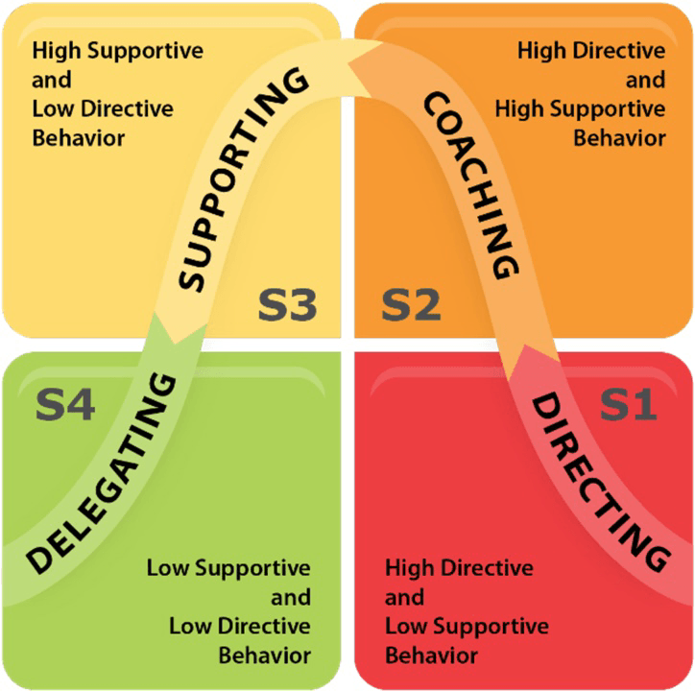

Appendix C

Maturity level of Hersey and Blanchard’s Leadership Model
Sourced: Situational Theories of Leadership | Principles of Management (lumenlearning.com)
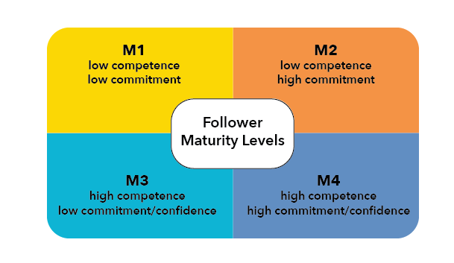

Appendix D

Development levels of the Hersey and Blanchards Situational Leadership model.
Sourced: New Insights into Situational Leadership & Organisation Maturity — ODTI (orgcmf.com)
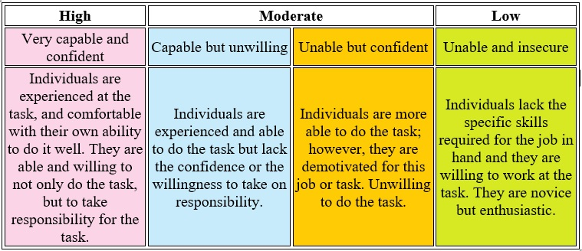

Appendix E
Situational Leadership Self-assessment questions: Read through the Situation questions and then choose the response (only one) from the corresponding Alternative Action statements that most appeals to you or that you feel seems the most characteristic of you. In some cases none of the responses may be appealing or characteristic of you. Nonetheless, please select the statement that you prefer or feel suits you best.

Situation | Alternative Action
1. Your group is not responding lately to your friendly conversation and obvious concern for their welfare. Their performance is declining rapidly. | - Emphasize the use of uniform procedures and the necessity for task accomplishment.  - Make yourself available for discussion but do not push your involvement.  - Talk with them and then set goals.  - Intentionally do not intervene.
2. The observable performance of your group is increasing. You have been making sure that all members were aware of their responsibilities and expected standards of performance. | - Engage in friendly interaction, but continue to make sure that all members are aware of their responsibilities and expected standards of performance.  - Take no definite action.  - Do what you can to make the group feel important and involved.  - Emphasize the importance of deadlines and tasks.
3. Members of your group are unable to solve a problem themselves. You have normally left them alone. Group performance and interpersonal relations have been good. | - Work with the group and together engage in program solving.  - Let the group work it out.  - Act quickly and firmly to correct and redirect.  - Encourage the group to work on the problem and be supportive of their efforts.
4. You are considering a change. Your group has a fine record of accomplishment. They respect the need for change. | - Allow group involvement in developing the change, but do not be too directive.  - Announce changes and them implement with close supervision.  - Allow the group to formulate its own directive.  - Incorporate group recommendations, but you direct the change.
5. The performance of your group has been dropping during the last few months. Members have been unconcerned with meeting objectives. Redefining roles and responsibilities has helped it in the past. They have continually needed reminding to have their tasks done on  time. | - Allow the group to formulate its own direction.  - Incorporate group recommendations, but see that objectives are met.  - Redefine roles and responsibilities and supervise carefully.  - Allow group involvement in determining roles and responsibilities but do not be too directive.
6. You stepped into an efficiently run group. The previous leader tightly controlled the situation. You want to maintain a productive situation, but would like to begin having more time building interpersonal relationships among members. | - Do what you can do to make the group feel important and involved.  - Emphasize the importance of deadlines and tasks.  - Intentionally do not intervene.  - Get the group involved in decision-making, but see that objectives are met.
7. You are considering changing to a structure that will be new to your group. Members of the group have made suggestions about needed change. The group has been productive and demonstrated flexibility. | - Define the change and supervise carefully.  - Participate with the group in developing the change but allow members to organize the implementation.  - Be willing to make changes as recommended, but maintain control of the implementation.  - Be supportive in discussing the situation with the group but not too directive.

Situation | Alternative Action
8. Group performance and interpersonal relations are good. You feel somewhat unsure about your lack of direction in the group. | - Leave the group alone.  - Discuss the situation with the group and then you initiate necessary changes.  - Redefine goals and supervise carefully.  - Allow group involvement in setting goal, but don’t push.
9. You have been appointed to give leadership to a study group that is far overdue in making requested recommendations for change. The group is not clear on its goals. Attendance at sessions has been poor. Their meetings have turned into social gatherings. Potentially they  have the talent necessary to help. | - Let the group work out its problems.  - Incorporate group recommendations, but see that objectives are met.  - Redefine goals and supervise carefully.  - Allow group involvement in setting goals, but do not push.
10. Your group, usually able to take responsibility, is not responding to your recent redefining of job responsibilities as a result of one member leaving the city. | - Allow group involvement in redefining standards but don’t take control.  - Redefine standards and supervise carefully.  - Avoid confrontation by not applying pressure, leave situation alone.  - Incorporate group recommendations, but see that new job responsibilities are met.
11. You have been promoted to a leadership position. The previous leader was involved in the affairs of the group. The group has adequately handled its tasks and direction. Interpersonal relationships in the group are good. | - Take steps to direct the group towards working in a well-defined manner.  - Involve the group in decision-making and reinforce good contributions.  - Discuss past performance with the group and then you examine the need for new practice.  - Continue to leave the group alone.
12. Recent information indicates some internal difficulties among group members. The group has a remarkable record of accomplishment. Members have effectively maintained long- range goals. The have worked in harmony for the past year. All are well qualified for the  tasks. | - Try out your solution with the group and examine the need for new procedures.  - Allow group members to work it out themselves.  - Act quickly and firmly to correct and redirect.  - Participate in problem discussion while providing support for group members.

Scoring your self-assessment: Circle the responses from your self-assessment Situation questions on the scoring sheet below. Add up each column to determine your preferred leadership style according to the Hersey and Blanchard model.

SITUATIONS | ALTERNATIVE ACTIONS
SITUATIONS | 1 | A | C | B | D
SITUATIONS | 2 | D | A | C | B
SITUATIONS | 3 | C | A | D | B
SITUATIONS | 4 | B | D | A | C
SITUATIONS | 5 | C | B | D | A
SITUATIONS | 6 | B | D | A | C
SITUATIONS | 7 | A | C | B | D
SITUATIONS | 8 | C | B | D | A
SITUATIONS | 9 | C | B | D | A
SITUATIONS | 10 | B | D | A | C
SITUATIONS | 11 | A | C | B | D
SITUATIONS | 12 | C | A | D | B
 | TOTAL | 1 | 5 | 4 | 2
 | LEADERSHIP STYLE | TELLING (DIRECTING) | SELLING (COACHING) | PARTICIPATING (FACILITATIING) | DELEGATING (OBSERVING)

Appendix F

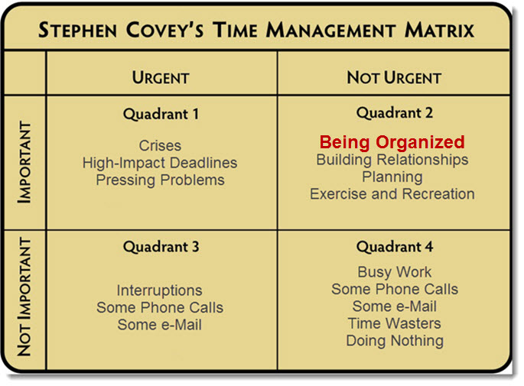
Sourced: Stephen-Covey-Time-Management-Matrix-1B.jpg (685×505) (acleanvision.com)

Appendix G

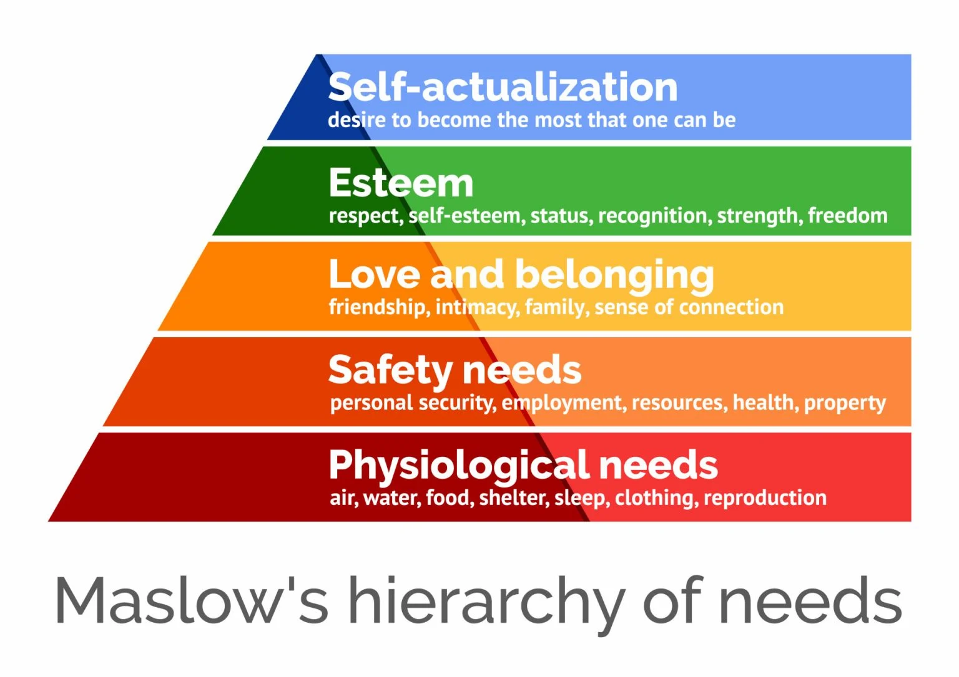
Sourse: Maslow's Hierarchy of Needs (simplypsychology.org)

