Program: BA Business Management
Module: Management Economics
Module code: LCBB5003
Assignment Title: Assessment 1

Student Name: Sava Mantchev
Student ID:2028706
Lecturer Name: Taye Osadiya

Table of Contents
Introduction 1
The business model and products of McDonald’s 1
Factors affecting demand and market equilibrium of McDonald’s 2
Factors influencing the price elasticity of demand 6
Conclusion 10
References 12

Introduction
The fast-food industry has been evolving due to the increasing demand for these products. The fast-food market is growing at a 6.05% rate and due to this, the fast-food chains are also growing at a 17% rate (Aigner-Walder, 2015). Due to this growth, this industry has become the topic of demand function and elasticity as the various functions of this industry use economic functions such as demand models, supply models, and so on. However, the report aims to analyze different economic concepts such as supply and demand, price elasticity, cost analysis, and so on. The main product of McDonald’s and its business model will be part of the overall discussion. The effect of demand and supply equilibrium and the price elasticity of demand on the main product of McDonald’s will be delineated in the report.

The business model and products of McDonald’s

Figure 1: The logo of McDonald’s.
Source: (Mcdonalds.com, 2022).
McDonald’s, one of the largest food chains in the world was established in 1940. This company was founded by Richard and Maurice McDonald but was purchased by Ray Kroc in 1961. The company has its headquarters in Chicago, USA and this company has more than 35,000 outlets in over 100 countries (Mcdonalds.com, 2022). The company belongs to the restaurant industry providing quick services and the company has a variety of food products such as breakfast items, burgers, sandwiches, nuggets, beverages, and so on. The company has adopted the franchising strategy to enter the global market and currently, the company has a 22% market share in the global market (Bagwell, 2005). More than 70 million customers are provided with food and beverage service at McDonald’s. However, the company has its main market in the USA with a 36.92% share and the company has recorded around 7.55 million US dollars as revenue in the global market (Baker, 2003). However, the company is listed on NYSE as MCD and operates in a highly competitive market in which Burger King, Starbucks, KFC, Subway, and so on are major competitors of this company. The business model and its pricing strategy have helped the company in getting a more competitive edge. However, the key product of this company is burgers and having adequate knowledge of the food chain and demand for burgers in the UK market, this product of McDonald’s has been chosen. Besides, determining the demand and market equilibrium the McDonald’s burgers against the competitors will be easy with this product. Besides, this product of McDonald’s has many substitutes available in the market and which will help in assessing the impact of supply and demand equilibrium and price elasticity for this product (Ellickson, 2013).

Factors affecting demand and market equilibrium of McDonald’s
The factors affecting the demand and market equilibrium of McDonald’s are as follows:
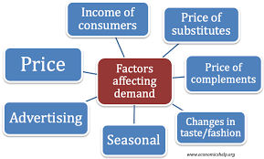
Figure 2: Factors of demand and market equilibrium.
Source: (Ellickson, 2013).
Price of substitutes
Substitute products are the products that consumers can consume as an alternative to the main products. When the price of substitute products increases, the demand for the main product also increased. The substitute product of Burger is Pizza. The substitute product’s price is decreasing, because of the decrease in the price of ingredients (Ruiz Estrada, 2019). When the price of substitute products decreases, the demand for main products is decrease. For example, people eat burgers when the people like them and the price is also within their budget. When they find that the price of burgers is high than the price of a pizza, they try to consume fast food at a low cost and choose pizza to satisfy their needs. So, the price decrease of pizza will reduce the demand for burgers, because pizza also can satisfy the needs of fast food of customers.
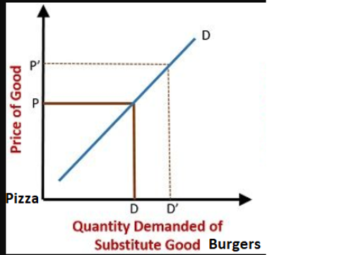
Figure 3: Substitute price and demand for main products.
Source: (Choi, 2018).
Price of complements
The compliment product is the product that is needed for the main products. When the price of complementary products is increasing, the demand for the main product decreases and vice versa. The complementary products of burgers are ketchup and cheese (Ruiz Estrada, 2019). The price of cheese is increased because of the huge demand in the market. When the price of ketchup and cheese increases the demand for the burger will be decreased. Burgers need cheese and ketchup to make the burger tastier, or without cheese and ketchup burgers cannot be proper. So, if the price of cheese and ketchup increases, ultimately the price of consuming burgers will also increase. A high price means low demand. So, the demand for burgers will be decreased. Thus, the price of complementary products influences the demand for the products.
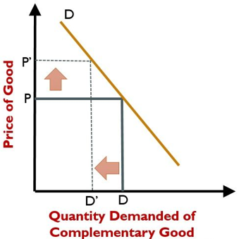
Figure 4: Complement product price and demand of main products.
Source: (Tsai, 2018).
Consumer Income
Consumers’ income has a great influence on the demand for any products and services. When customers’ income increases, their disposable income also increases, so the demand for products also increases. But when the income of the customers decreased the demand for the product also decreased. The consumer’s income is decreased, and because of inflation, the purchasing power of the customer decreases (Choi, 2018). So, it indicates that the income of the customers decreased. When the income of the customers decreased, the purchasing power of the customers also decreased. Customers need to focus on basic needs. When the customer’s income reduces, the customers only buy the necessary products. The customers also focus on buying the basic products, rather than buying frequently. Burgers are not a basic need for customers, so when customers will think to buy a burger, they will think about the product price (Ruiz Estrada, 2019). The consumer will buy a burger when the basic need of the customer will be fulfilled. So, the income decrease reduces the demand for a burger. The income of customers impacts the demand drastically.
Consumer tastes and preferences
Consumers’ tastes and preferences refer to the customer’s satisfaction from purchasing the products (Andreyeva, Long and Brownell, 2010). Customers make their buying decisions based on their buying experience, the service of the company, the relativity of the products against the quantity, and so on. Besides, the availability of substitutes from competing companies can influence the presence of customers. In the case of McDonald’s burgers, the customers prefer to take burgers of the company than the competitor’s which impacts the business positively. But along with customers’ preferences, the demand for burgers gets increased changes customers’ preferences. Besides, as customers are moving to healthy food habits, it is negatively impacting the demand for burgers despite no changes in the pricing strategy.

Figure 5: Last six years’ revenue of McDonald’s.
Source: (Foot and Gomez, 2006).
This is quite evident that customers’ preferences are changing due to the increasing competition in the fast-food market through which the revenue of McDonald’s from burgers is fluctuating.
Customer expectation of price
Customers’ expectation refers to the price of the products anticipated by the consumers and this largely affects their buying decisions (Syrovatka and Lechanova, 2019). As the products in the fast-food industry are perishable, this factor is less dominant. The company offers burgers to lower to middle-class customers at low prices. However, if the customers assume the price of the burgers will increase in the future, the current demand for the product may increase. As the company is intending to launch expensive burgers to be a luxury brand, the demand for burgers is increasing currently.
Demographics
Demographics refers to the targeted population of a company that affects the demand for the products (Griffith, 2003). As the target customers of McDonald’s burgers are lower to middle-class people of different ages, they are more likely to take the product than the substitutes which indicates the high demand for the products.
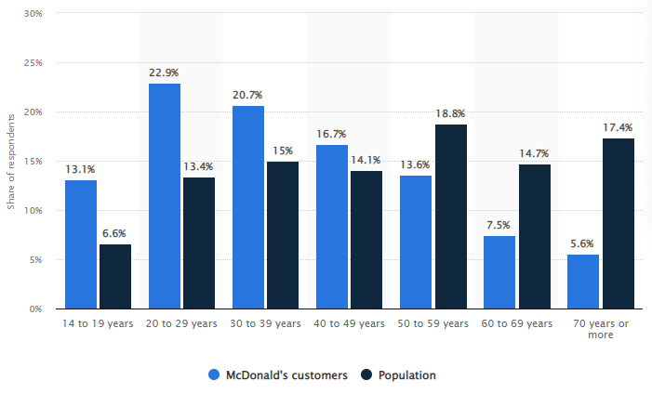
Figure 6: Demographics of McDonald’s by age.
Source: (Rauch and Schleicher, 2015).
The company has numerous outlets in different regions of the world but the demand depends on the number of target customers. Most of the customers of McDonald's burgers are adolescents to middle age in most countries such as UK, USA, Germany, and so on and so the demand for burgers is increasing in these countries. On the contrary, China has a high population in the world but the number of aged people is high here. And so, the demand for McDonald’s burgers is decreasing in this country due to a healthy lifestyle.

Factors influencing the price elasticity of demand
Price elasticity of demand refers to the changes in demand and consumption of products according to the changes in price (Cigliano, 1980). In terms of economics, if the price elasticity is higher than 1, it indicates the elasticity of the product. But if the price elasticity of the product is 0, it indicates the inelasticity of the products. However, the availability of substitutes for particular products influences the elasticity of the products. The factors that influence the price elasticity of demand are delineated below:

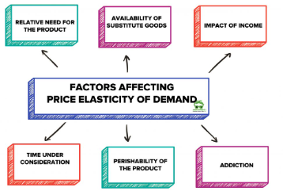

Figure 7: Factors of price elasticity of demand.
Source: (Cigliano, 1980).
Availability of substitutes
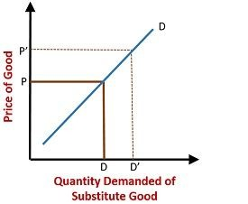
Figure 8: Price elasticity of demand for availability of substitutes.
Source: (Rauch and Schleicher, 2015).
The price elasticity of demand gets influenced by the availability of substitutes to a great extent if the price of the goods rises by a small amount, it influences the customers to move to the substitutes available in the market (Helen and Pompelli, 1989). So, it is evident that the availability of substitutes influences the prices of the products and shows high price elasticity for the product. As there are many substitutes for McDonald’s burgers available in the market, such as pizza and other products of the competitors, consumers can easily switch to the substitutes in case of any changes in the price level. So, there is a high price elasticity of demand for McDonald’s burgers.
Price levels
The fast-food industry gets influenced by the constant fluctuations in price due to increasing competition in the market. In the food industry, the price elasticity for products is acceptable between 0.7 to 0.8 (Griffith, 2003). As this market is sensitive to price changes, price and demand are elastic. If this market increases its price of products even by 1%, it will result in a decreasing demand for the products and the ratio will remain between 0.7 to 0.7 (Cigliano, 1980). The same applies to McDonald’s also as if the company increases the price of burgers, it will result in decreasing demand for this product and the company may lose many potential customers. But the demand for burgers will remain the same in case of constant price. So, it is evident that the price of burgers has high elasticity with demand in the market.
Nature of products and services
The nature of the products and services affects the elasticity of demand as different types of products can be necessary goods, comfort goods, or luxury goods for different people (Aigner-Walder, 2015). So, the nature of products has high relativity to the price elasticity of demand. The main product of McDonald’s is neither a product of necessity nor luxury as this product is not highly required for human survival. Rather this product is a comfort good as its consumption can be delayed for a certain period. The demand for the burger is relatively elastic as changes in price due to the company’s decision on tax and other policies can impact the fluctuations in demand for a short time.
Income levels
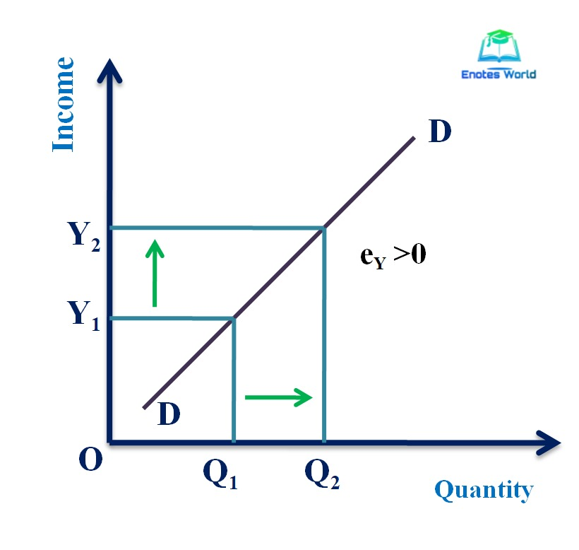
Figure 9: Price elasticity of demand for income level.
Source: (Choi, 2018).
Society includes different social classes based on the lifestyle and incomes of the people. The price elasticity of demand affects the people of higher income groups less but the lower-class people get highly influenced due to the changes in the price of the commodity. The demand and supply curve of McDonald’s burgers follow the market conventions as the price and supply go hand in hand but eh demand remains almost the same (Bagwell, 2005). Consumers increase their consumption of McDonald’s burgers when they have high disposable incomes which indicates the price elasticity of the product. On the other hand, when consumers experience harsh economic conditions and lack of disposable income, their demand for a product gets lessened and they focus to buy only the necessary goods. As burgers are comfort goods, it shows the inelasticity of the product as consumers’ income can increase the consumption of burgers.
Period
Price elasticity of demand depends on the times that are taken by the consumers to make adjustments to the changed price of the products (Baker, 2003). If the changed price stays longer, it shows high price elasticity for the demand for the products as the customers get much time to adjust to the increased price. On the other hand, inelasticity of demand is seen if the price changes for a short time. If McDonald’s increases its price level and keeps it the same for a long time, the consumers will adjust their expenses and consumption to buy the products. On the other hand, a decrease in the price of the products can result in increasing demand for the products. So, there exists price elasticity for the demand for burgers at McDonald’s. However, the changes in the pricing strategy, quality assurance, and marketing strategy can lead the company to higher elasticity in the market than the competing companies.
Addiction or habit
The price elasticity remains inelastic if people are habitual to buy any product despite price changes. As the burgers of McDonald’s are not a product of necessary goods, people are less habitual to the burgers and it indicates price elasticity for the McDonald’s burgers (Foot and Gomez, 2006). On the other hand, if the targeted customers are more likely to consume burgers or are habituated to buying burgers in their daily life, it will indicate the price inelasticity of the demand for burgers for that particular section of consumers.
Analysis of pricing strategy and recommendation
The core concept of pricing elasticity of demand presents that, the elasticity of demand indicates the lower price of the product. Again, the inelasticity of the product results in the high price of the product. From the overall analysis of the pricing elasticity of the demand, most of the factors of pricing elasticity of demand indicate the elasticity of the burgers and so the price of the burgers is low (Baker, 2003). With this low price, the company can sell its product along with ensured profits but can reduce the demand for the individual product in the long run. As the company is operating its business in a competitive oligopoly market, the company should adopt the competitive pricing strategy as it will help the company in attracting more customers (Griffith, 2003). The company should increase the price of burgers a little bit in comparison to the competitors. But to apply this strategy, the company will have to watch the price of the competitors to gain highly competitive advantages with demand and price.

Conclusion
Demand and supply are interrelated and price changes can influence the demand for the products. Several factors influence the demand for McDonald’s burgers out of many products such as the price of the substitutes, complements, income, and so on. Most of the factors of price elasticity of demand show high elasticity of the demand of the burgers against prices. As the company applies bundle pricing and psychological pricing, it leads the company towards decreasing revenue due to the demand for individual products. So, to gain more competitive advantages, the company should adopt a competitive pricing strategy which will help the company reduce the fluctuation of the company’s revenue.

References
Aigner-Walder, B. (2015) Effects of the Demographic Changes on Private Consumption: An Almost Ideal Demand System Analysis for Austria. Journal of Economic and Social Studies, 5, 1, 33-57
Andreyeva, T., Long, M. and Brownell, K. (2010) The Impact of Food Prices on Consumption: A Systematic Review of Research on the Price Elasticity of Demand for Food. American Journal of Public Health, 100, 2, 216-222.
Bagwell, K. (2005) The Economic Analysis of Advertising. Columbia University Discussion Papers No: 0506-01
Baker, J. (2003) Competitive Price Discrimination: The Exercise of Market Power Without Anticompetitive Effects (Comment on Klein and Wiley). Articles in Law Reviews & Other Academic Journals. Paper 278.
Choi, H. (2018) Disproving Market Demand and Market Supply. SSRN Electronic Journal.
Cigliano, J. (1980) Price and Income Elasticities for Airline Travel: The North Atlantic Market, Business Economics, pp. 17–21.
Ellickson, P. (2013) Market Structure and Performance. International Encyclopedia of the Social & Behavioral Sciences, Forthcoming; Simon School Working Paper No. 13-21
Foot, D. and Gomez, R. (2006) Population aging and sectorial growth: the case study of the UK, 2006- 2026. OJBE, 5:1
Griffith, G. (2003) The Impact of Supermarkets on Farm Suppliers. The Australian Economic Review, 37, 3, 329–336
Heien, D. and Pompelli, G. (1989) The Demand for Alcoholic Beverages: Economic and Demographic Effects, Southern Economic Journal, pp. 759–769.
Mcdonalds.com (2022) McDonald’s UK: Burgers, Fries, Salads & More. Quality Ingredients. [online] Mcdonalds.com. Available at: http://www.mcdonalds.com.
OECD (2015) GENERAL ASSESSMENT OF THE MACROECONOMIC SITUATION. OECD Economic Outlook Volume 2015/1
OECD (2015), OECD Employment Outlook 2015, OECD Publishing, Paris. Available at: http://ifuturo.org/documentacion/Employment%20outlook%202015.pdf
Rauch, D. and Schleicher, D. (2015) Like Uber, But for Local Governmental Policy: The Future of Local Regulation of the 'Sharing Economy’. George Mason Law & Economics Research Paper No. 15-01. Available at: http://ssrn.com/abstract=2549919
Ruiz Estrada, M.A. (2019) Market Equilibrium Vs. Market Imbalance. SSRN Electronic Journal.
Shapiro, M. (1987) Measuring Market Power in U.S. Industry, NBER Working Paper, No. 2212.
Syrovatka, P. and Lechanova, I. (2019) Price transmission and estimations of price elasticity of secondary demand functions: application on commodity market for food grains. Agricultural Economics (Zemedelska ekonomika), 51(No. 7), pp.293–303.
Tsai, I-Chun. (2018) Supply, Demand, and Price. Economic Journal, 26(4), pp.381–396.

