
Ghazala Firdous (2243660)

STUDENT ID: 2243660 Student name: GHAZALA FIRDOUS Programme: BSc Applied Computing Module: Usability Engineering Module code: ACCB6017 Lecturer: Fahad Ahmed DUE DATE:17-Aug-2026

Contents
1. Introduction 0
Aim 0
Objectives 0
2. Full-Colour Storyboard Design 0
storyboard screenshots 0
Login Screen 0
2: Full-colour Home Screen 0
3 Game Lobby 0
4 Role Selection 0
5 Campus Map 0
6 Infection Alert Screen 0
7 Treat Infection Screen 0
8 Resource Sharing Screen 0
.9 Research Cure Screen 0
10 Discussion and Team Chat 0
Mission Complete 0
3. Prototype Feedback and Usability Testing: 0
5. Reflection: Usability and User Experience 0
Usability and UX 0
6. Conclusion 0
References 0
APPENDIX 0

Introduction

In the cooperative strategy game Pandemic, players collaborate to manage disease outbreaks and find treatments before infections get out of control. This initiative, which is located at the University of Wales Trinity Saint David (UWTSD), transforms the cooperative idea into a mobile game. Players work together to prevent a fake illness from spreading throughout university buildings and facilities rather than defending towns all over the world. The roles of a student, lecturer, librarian, IT technician, security officer, and campus health adviser are represented by up to six players.
The previous low-fidelity work is developed into an interactive prototype, a storyboard, a navigation-flow diagram, and a full set of full-color interface panels in this assignment. The entire process from account access and game setup to active gameplay and a successful or unsuccessful mission outcome must be shown in the design. Written analysis outlining each screen's purpose, design modifications made following evaluation, and the connection between usability and user experience will support the practical work.
The report will be guided by a user centred design approach. Consistent navigation, understandable font, large touch targets, identifiable icons, and colour-coded status information will all be features of the interface. Red will convey danger and infection, blue will help navigation and information, yellow will show cautions, and green will stand for safe regions and successful acts. These options are designed to facilitate quick system comprehension and effective cooperative work completion for users with varying degrees of technical confidence. [1]

Aim
The goal is to create and assess a user-friendly, entertaining mobile interface that enables UWTSD participants to work together to manage a hypothetical campus outbreak, share resources, and coordinate activities. [2]

Objectives
Create twelve consistent mobile interface screens covering the complete game journey.
Produce low-fidelity wireframes before adding colour and detailed visual styling.
Show the relationship between screens using a clear navigation-flow diagram.
Create an interactive Canva prototype with working screen-to-screen links.
Evaluate the design with representative users and record evidence of their feedback.
Improve the interface using the findings from usability testing.
Reflect critically on usability, accessibility and the wider user experience. [3] [4]
Intended Users
The intended users include UWTSD students and staff with mixed levels of mobile-gaming experience, technical ability and familiarity with cooperative games. The prototype therefore needs to support experienced players while remaining understandable to casual, international and mature students.
2. Practical Design Requirements
The practical portfolio will contain six connected outputs. These outputs must use the same screen names, visual language and navigation logic so that the evidence appears as one coherent design process.
1 Login Screen
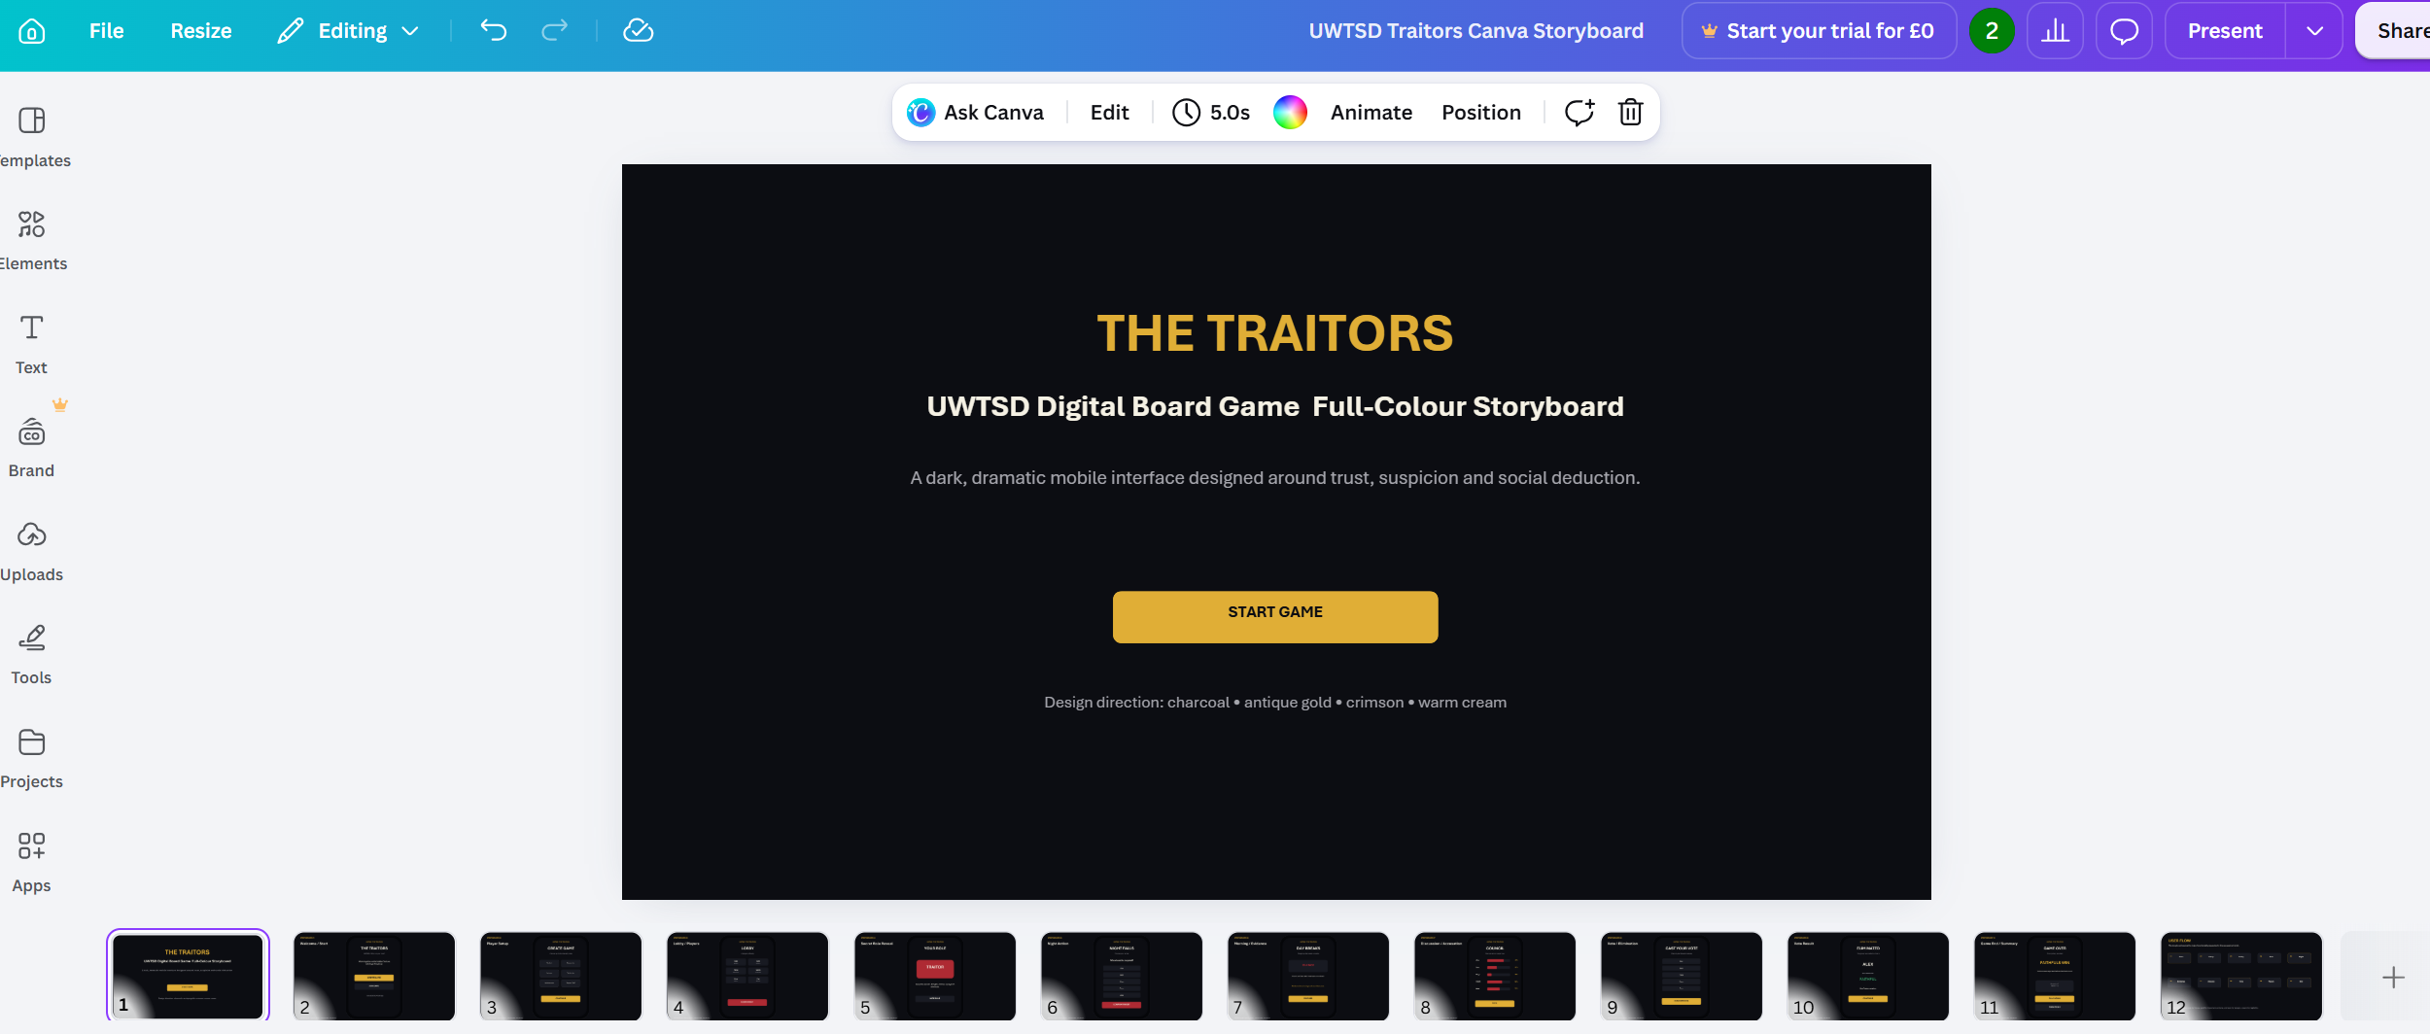
The title screen introduces the UWTSD Traitors game and its dramatic visual theme. The Start Game button begins the user journey.
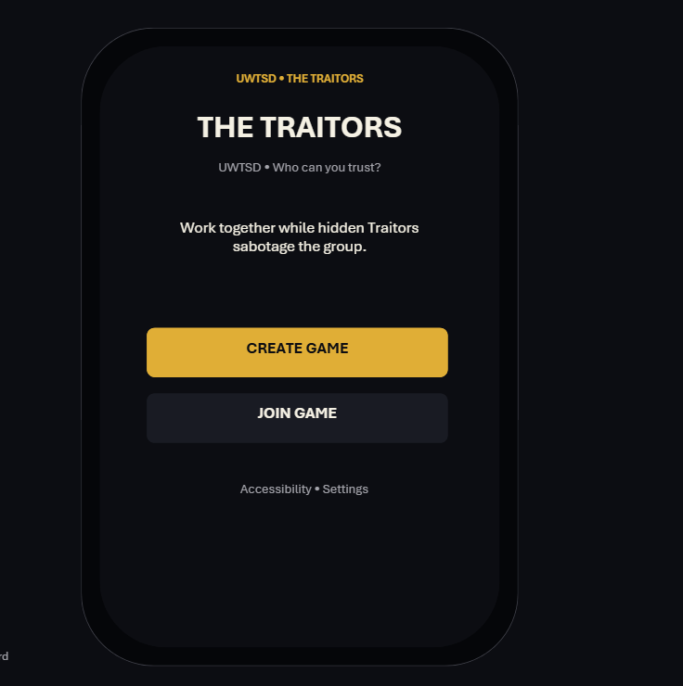
Players can create a new game or join an existing session. Accessibility and settings options are also available.
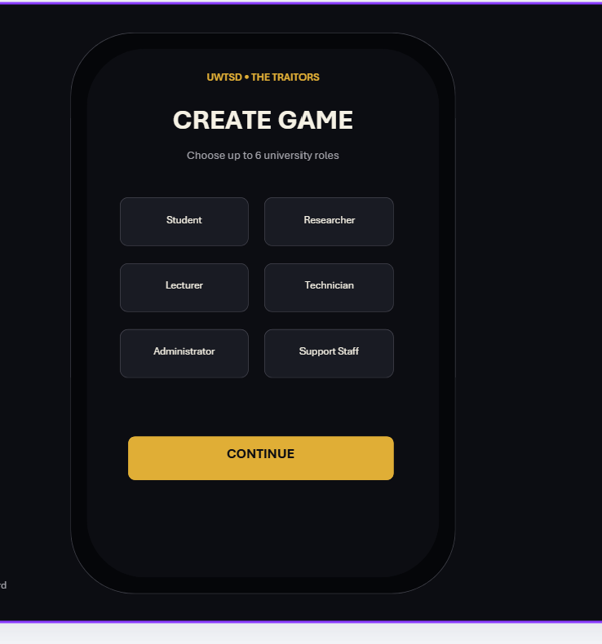

The lobby displays all participants, their selected roles and readiness status. The game begins when all players are ready.

Game Lobby Screen
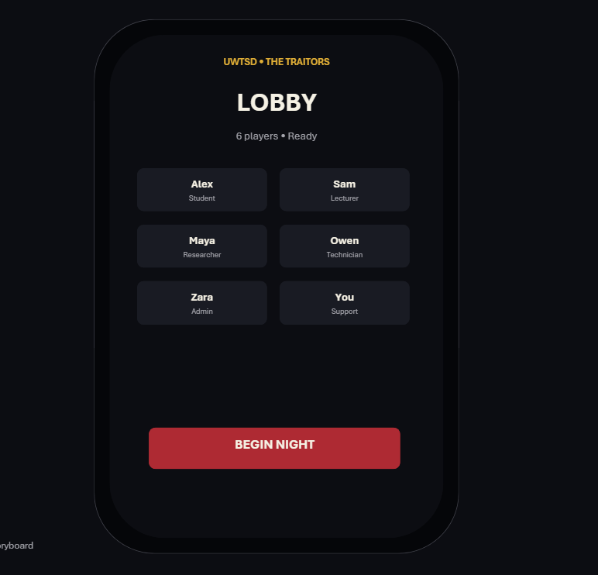
Game Lobby screen helps the user to prepare up to six players. Identify the main controls (Invite / Ready / Start Game), describe relevant accessibility choices, and state one improvement made after usability feedback.

Pandemic is a cooperative strategy board game in which players work together to control disease outbreaks and discover cures before infections spread beyond control. This project adapts the main concept of Pandemic into a mobile computer game based at the University of Wales Trinity Saint David (UWTSD). Instead of protecting cities around the world, players collaborate to stop a fictional epidemic spreading across university buildings and facilities. The game may include up to six players who represent different university roles, such as a student, lecturer, librarian, IT technician, security officer and campus health adviser.
This assignment develops the initial wireframes created during the first stage of the project into a complete set of full-colour storyboard prototypes. The storyboards demonstrate the appearance of the interface, the major game functions and the way users move between screens. Important design decisions include the use of clear navigation, large touch controls, recognisable icons, readable text and consistent colours. These features are intended to make the game accessible to users with different levels of technical ability and gaming experience. [5]
The design process follows a user-centred approach. Feedback collected from potential users is used to identify usability problems and improve the interface. The report discusses the final storyboard designs, changes made after wireframe testing, feedback gathered from users, future data collection and the relationship between usability and user experience.

2. Full-Colour Storyboard Design
The Assignment 1 wireframes were developed into full-colour mobile storyboards using Canva. The redesign aimed to create a modern and accessible interface that supports teamwork, communication and quick decision-making. User feedback informed improvements to navigation, readability, button size and screen layout.[6]
A consistent colour scheme helps users recognise information quickly. Green represents safe areas and successful actions, red indicates danger, yellow communicates warnings, and blue supports navigation. Grey is used for backgrounds and inactive controls. Flat graphics, rounded icons, readable typography and large touch-friendly buttons improve mobile accessibility.
Consistent screen layouts allow users to locate controls easily and reduce the learning required by first-time players. The following storyboard screens demonstrate the application’s main functions and navigation.[7]
https://canva.link/gw9g11uya4iigyq

storyboard screenshots

- Login Screen
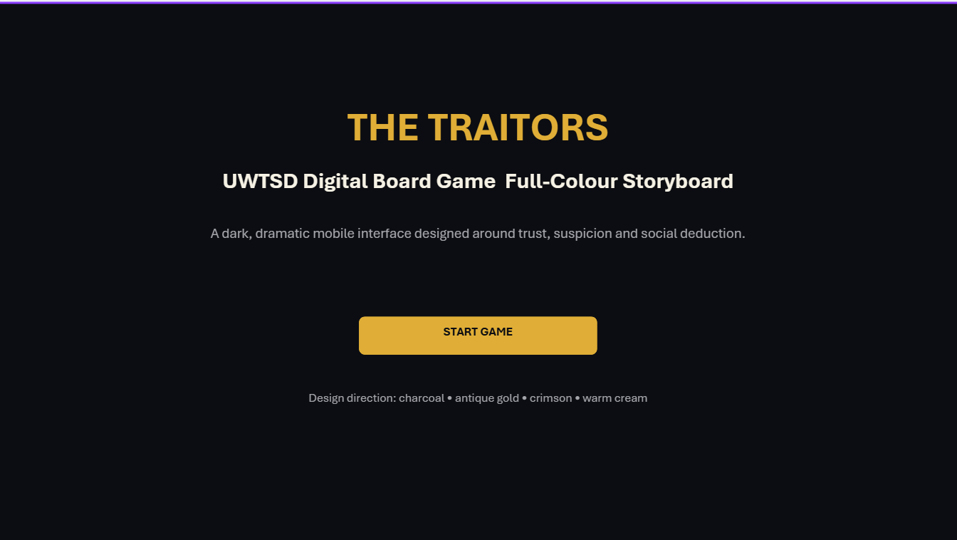

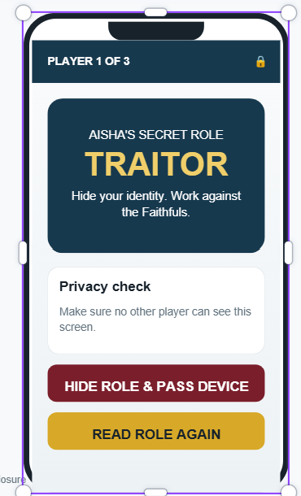
- Campus Map
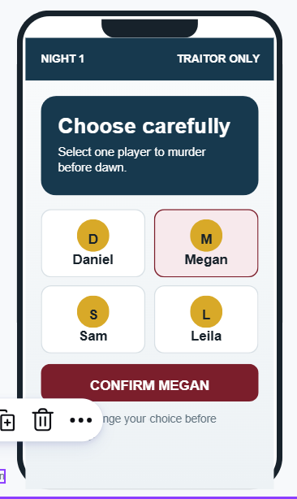
Rest storyboard screens are in appendix

Login Screen
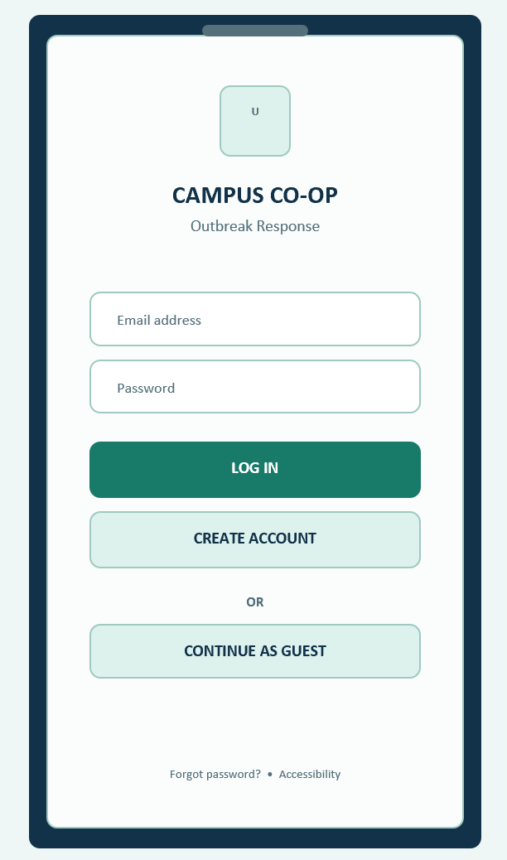
The Login Screen is the first screen users see when opening the application. It provides a simple and welcoming interface that allows players to sign in quickly before joining a game

2: Full-colour Home Screen
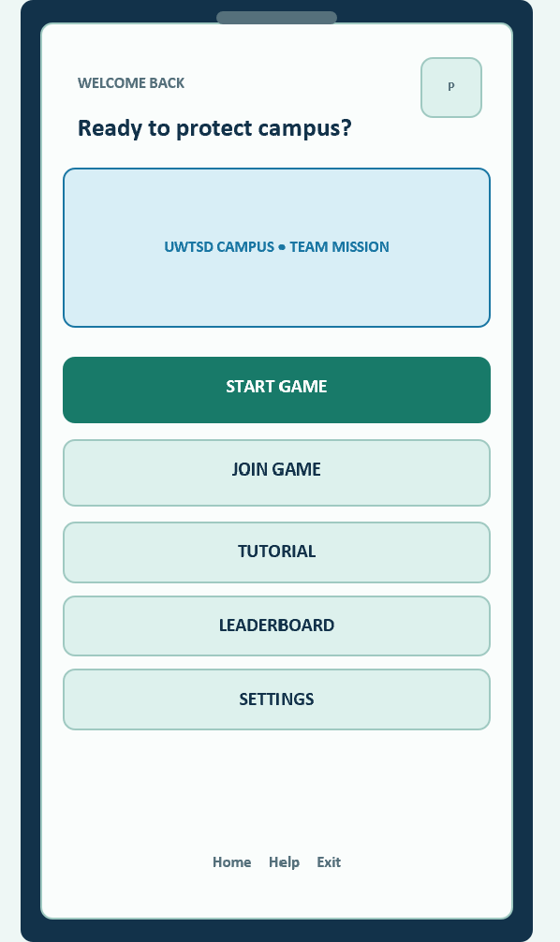

The Home Screen acts as the main navigation hub of the application. After logging in, players are presented with a simple menu that allows them to access the main features of the game. The screen includes the options Start Game, Join Game, Tutorial, Leaderboard, Settings, and Exit. Each option is displayed using a large button with a clear icon to help users quickly recognise its purpose.l8]
- UWTSD logo

3 Game Lobby
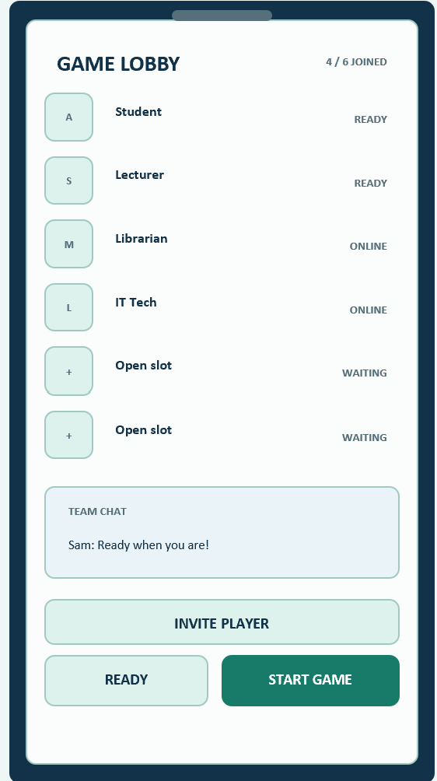
The Game Lobby allows players to prepare before starting the mission. This screen displays the list of connected players, their chosen avatars and their assigned university roles. A maximum of six players can join the game,

4 Role Selection
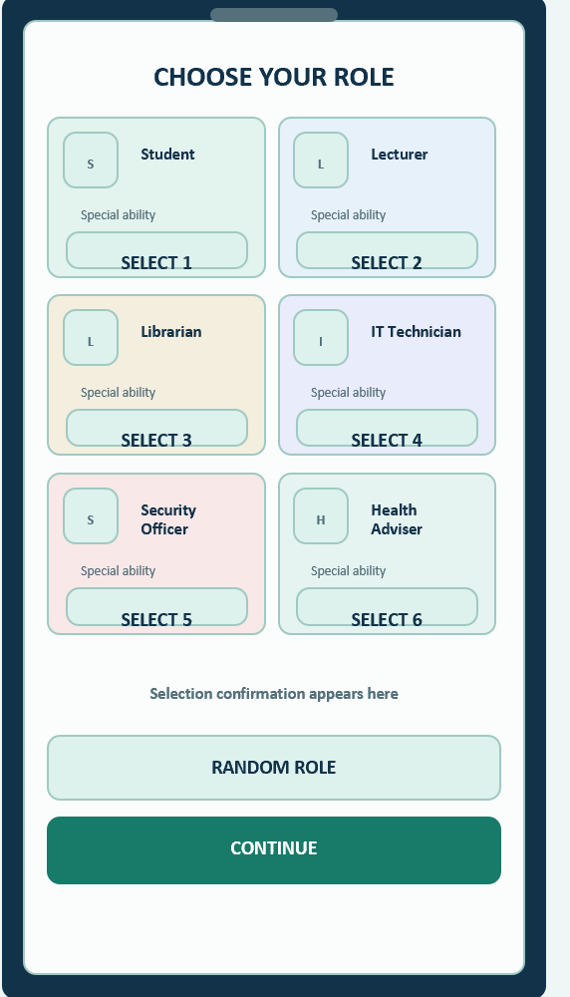
The Role Selection screen allows each player to choose or receive a specialist role before the mission begins. Each role has unique skills that encourage teamwork and strategic decision-making. The six available roles are Student, Lecturer, Librarian, IT Technician, Security Officer and Campus Health Adviser. Players must work together by combining their individual abilities to control the outbreak and complete the mission successfully.[9]

5 Campus Map
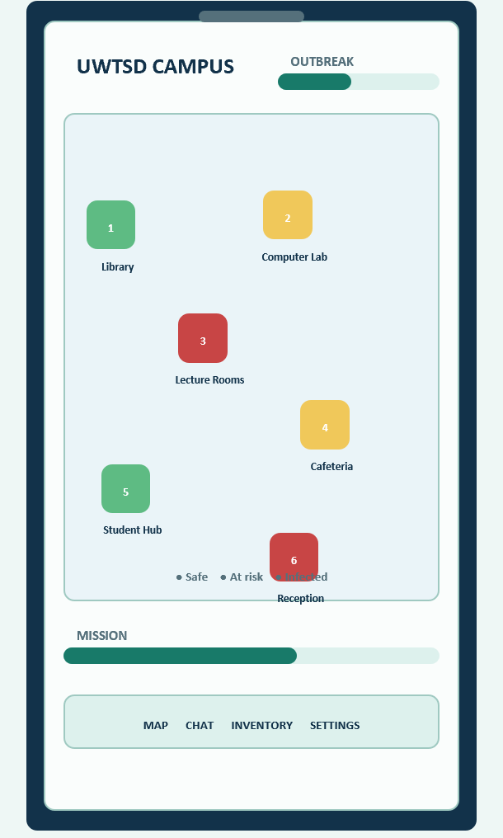
The Campus Map is the main gameplay screen where players monitor the spread of the outbreak and work together to protect the university. The map is based on the UWTSD London Campus and displays key locations such as the Library, Lecture Rooms, Computer Lab, Student Hub, Cafeteria and Reception. Each location is represented by a clear icon, allowing players to identify buildings quickly and move between them with ease.

6 Infection Alert Screen
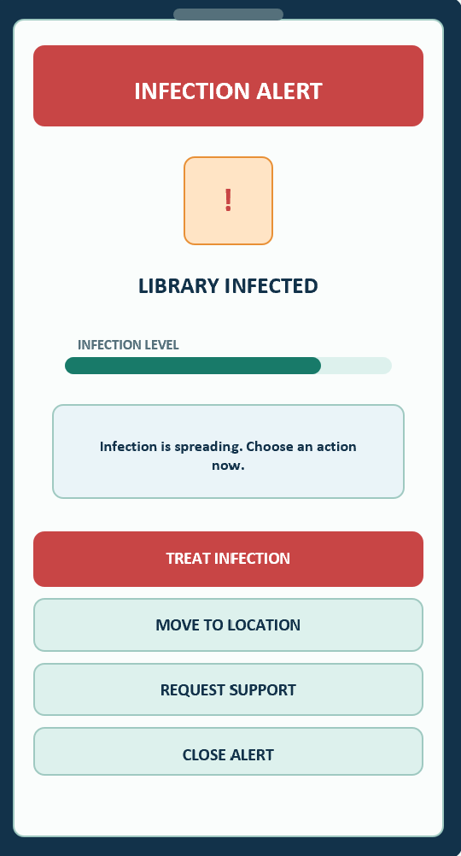
The Infection Alert screen appears whenever a new outbreak is detected on the UWTSD campus. Its purpose is to immediately inform players about the location and severity of the infection so they can work together to prevent it from spreading further. The screen displays the affected building, the current infection level and a short warning message explaining the situation. Players must quickly decide how to respond by treating the infection, travelling to the affected area or supporting other team members.

7 Treat Infection Screen
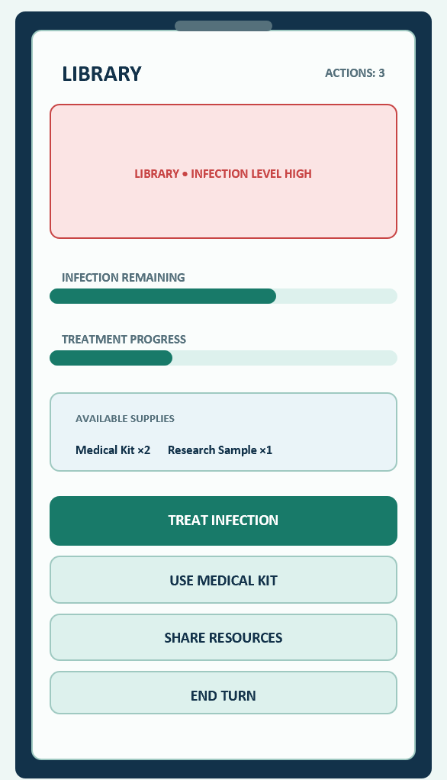
The Treat Infection screen allows players to carry out actions that reduce the spread of the disease within the university. After arriving at an infected location, players can use their available action points to treat the infection, apply medical resources and work with teammates to protect the affected building. Successful treatment lowers the infection level and helps prevent further outbreaks across the campus.

8 Resource Sharing Screen
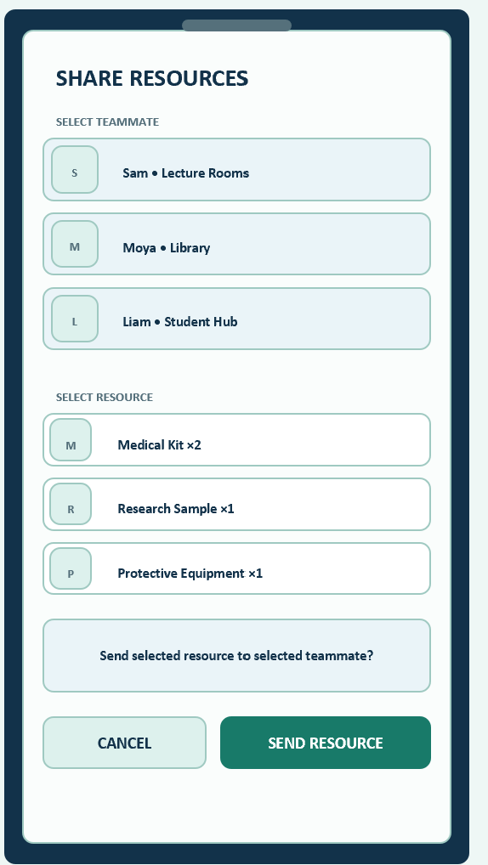
The Resource Sharing screen enables players to cooperate by exchanging supplies and equipment needed to control the outbreak. As Pandemic is a cooperative game, effective teamwork is essential for completing objectives and preventing the infection from spreading across the UWTSD campus. This screen allows players to transfer medical kits, research samples and protective equipment to teammates who require additional resources.

.9 Research Cure Screen
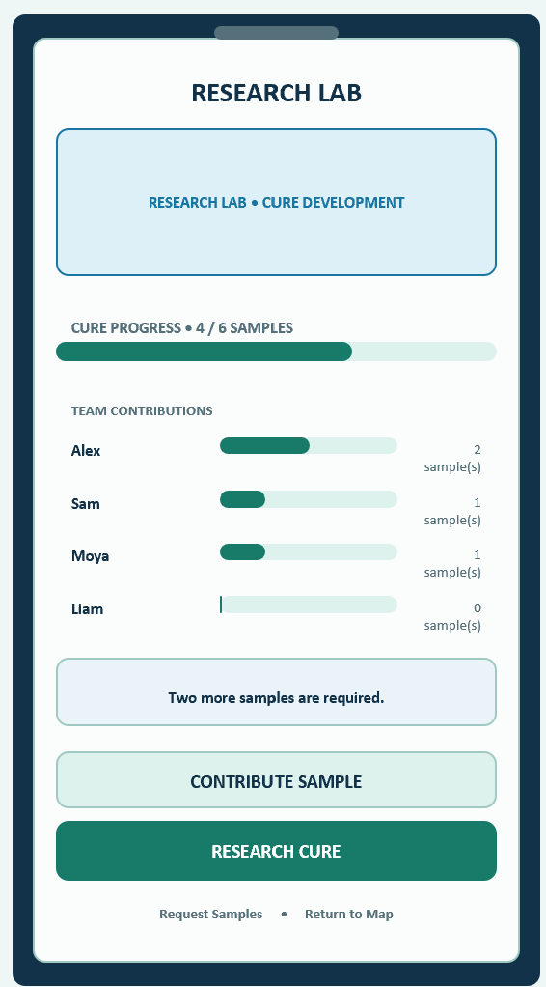
The Research Cure screen allows players to work together to discover a cure for the campus outbreak. This is one of the main objectives of the game, as players must collect enough research samples and combine their resources to develop a cure before the infection spreads across the university. Cooperation and careful planning are essential because no single player can complete this objective alone.

10 Discussion and Team Chat
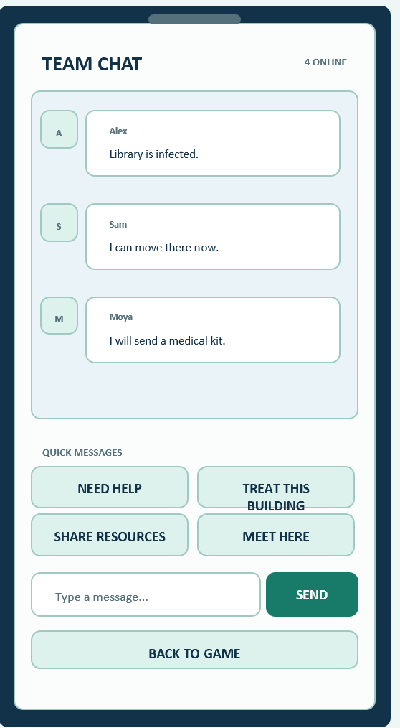
The Discussion and Team Chat screen provides players with a dedicated space to communicate, share information and coordinate strategies throughout the game. Since the UWTSD Pandemic game is based on cooperation, effective communication is essential for deciding which buildings should be protected, how resources should be shared and which player should respond to new outbreaks. This screen encourages teamwork and helps players make informed decisions before taking their next action.[10]
The interface includes a real-time chat window where players can send text messages to teammates. Quick communication buttons

Mission Complete
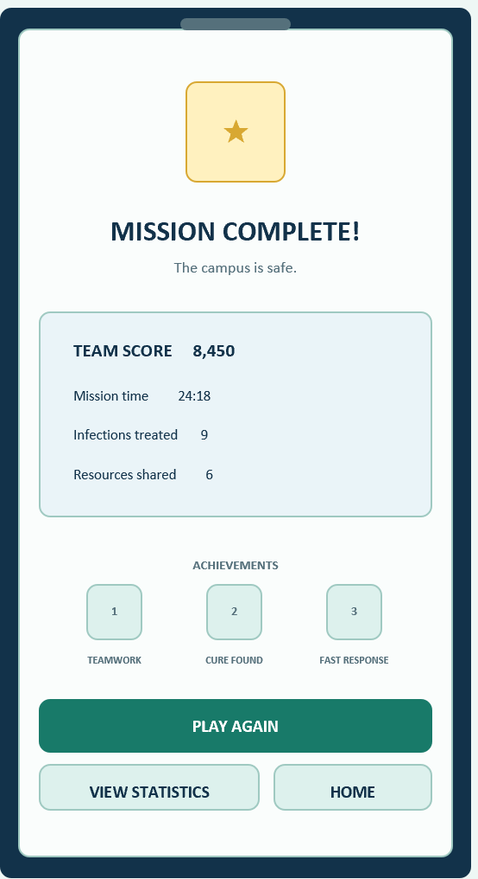
The Mission Complete screen celebrates success and displays team statistics, individual contributions and achievement badges. Green and gold colours reinforce accomplishment, while buttons provide options to play again, view statistics or return home. These features reward teamwork and encourage replayability.
Game Over
The Game Over screen explains why the mission failed and provides statistics and improvement tips. Red highlights communicate danger, while options to retry, view statistics or return home encourage learning and replay.

3. Prototype Feedback and Usability Testing:
A usability evaluation was carried out to assess the effectiveness of the final storyboard prototype before implementation. The aim of the testing was to determine whether users could navigate the interface easily, understand the game mechanics and complete common tasks without confusion. The evaluation also explored users' emotional responses to the interface, including whether they found the game enjoyable, engaging and visually appealing.
Six volunteers participated in the usability testing. The participants represented the range of personas identified during Assignment 1, including experienced mobile gamers, casual players, international students and mature students. This ensured that feedback reflected different levels of technical ability, gaming experience and accessibility needs. Before beginning the evaluation, each participant received a short explanation of the game and was asked to complete a series of realistic tasks using the storyboard prototype.[11]
The participants were needed to complete the following tasks:
- Log into the application.
- Start or join a multiplayer game.
- Select a specialist role.
- Navigate the campus map.
- Respond to an infection alert.
- Treat an infected building.
- Share resources with another player.
- Contribute towards discovering a cure.
- Communicate with teammates using the chat feature.
- Complete the mission and review the results screen.
During the evaluation, participants were encouraged to think aloud while interacting with the prototype. Their comments were recorded and written notes were taken throughout the session. After completing the tasks, each participant completed a short questionnaire containing both Likert-scale and open-ended questions. This combination of observation and questionnaires provided both quantitative and qualitative feedback about the usability and overall user experience of the design.
Participant Profiles
Participant | Persona | Gaming Experience | Technical Ability
P1 | Computing Student | High | High
P2 | Business Student | Moderate | Moderate
P3 | International Student | Casual | Moderate
P4 | Mature Student | Low | Moderate
P5 | Engineering Student | High | High
P6 | Health Student | Casual | Moderate

Usability Testing Session

3. Feedback Analysis
Participants found the prototype attractive, easy to navigate and enjoyable. They praised the clear colours, large buttons, understandable icons, campus map and teamwork features. Suggested improvements included a larger chat window, map zoom controls, clearer role descriptions and optional hints. Overall, the testing showed that the design met its main usability objectives.
Summary of User Feedback
Positive feedback | Suggested improvements
Easy navigation | Larger chat window
Clear colours | Map zoom controls
Large buttons | Clearer role descriptions
Helpful tutorial | Optional beginner hints
User Satisfaction Results
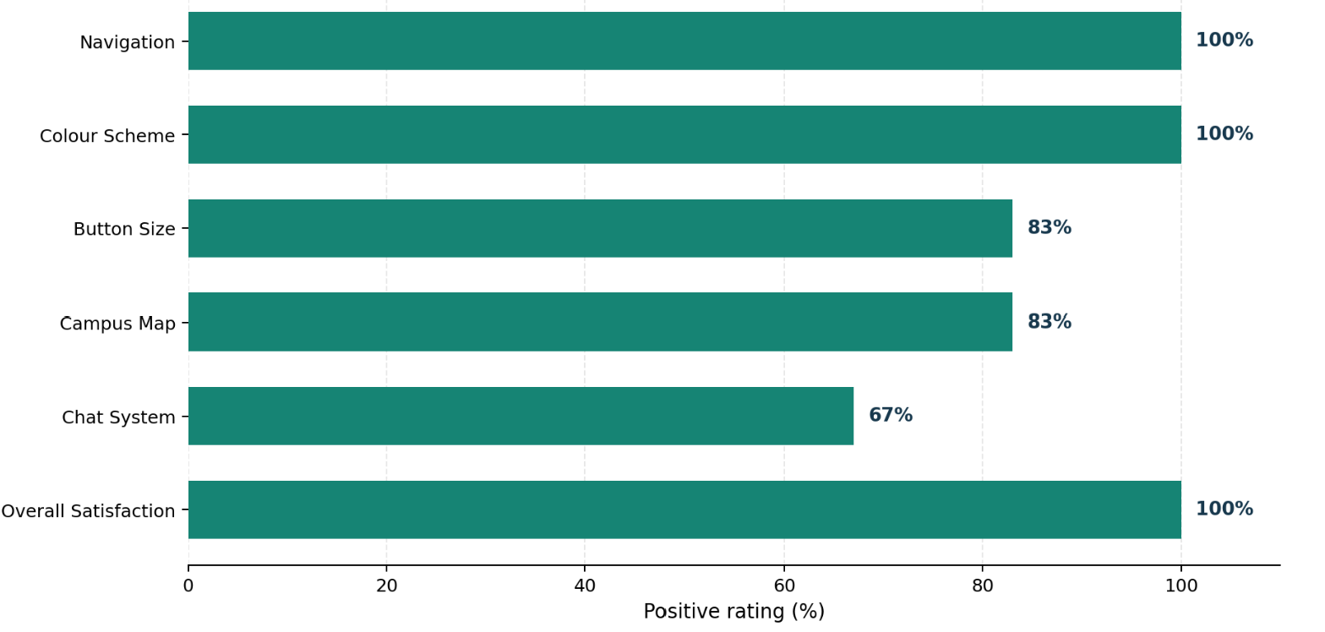
Design Improvements
Testing feedback led to larger buttons, clearer map labels, colour-coded locations and improved role descriptions. Confirmation messages and progress bars were also added to provide immediate feedback. These changes improved navigation, accessibility and user confidence.
Design Changes After Testing
Feedback | Change | Benefit
Small buttons | Enlarged buttons | Easier interaction
Unclear map | Added labels and legend | Better navigation
Small chat area | Enlarged chat window | Improved communication
Confusing roles | Added role descriptions | Easier selection
Limited feedback | Added confirmations | Greater confidence
Simple appearance | Added colours and icons | Better visual appeal
4. Data Collection for the Working Version
If the UWTSD Traitors game became a working application, user data would help developers improve its usability, gameplay and accessibility. Automatically collected information could include login frequency, session length, completed games, selected roles, navigation routes and voting outcomes. These statistics would identify unpopular features, confusing screens and potential problems with game balance.18]
Analytics cannot fully explain how players feel. Questionnaires, interviews and feedback forms would therefore collect opinions about enjoyment, difficulty and accessibility. Combining behavioural data with direct feedback would support evidence-based improvements. Data collection must follow UK GDPR requirements, including transparency, consent, data minimisation and secure storage.[12]
Table 4.1 – Data Collection Plan
Data | Method | Purpose
Session length | Analytics | Measure engagement
Navigation routes | Analytics | Identify difficulties
Voting outcomes | Analytics | Balance gameplay
Satisfaction | Survey | Evaluate experience
Suggestions | Feedback form | Plan improvements

5. Reflection: Usability and User Experience
The design balanced usability with an engaging Traitors-themed experience. Consistent navigation, large buttons, readable text and clear labels made the interface easier to operate. Status indicators and confirmation messages also helped players understand game progress and reduced errors.
User experience was supported through a charcoal, gold, crimson and cream colour scheme, creating suspense while maintaining readability. Some decorative features could have distracted users or slowed interaction, so visual elements were kept purposeful.
Feedback from potential users resulted in larger controls, clearer role descriptions and improved navigation. This demonstrated the value of user-centred and iterative design. Overall, the final storyboard aimed to be accessible, efficient and emotionally engaging.[13]

Usability and UX
Usability | UX | Solution
Clear controls | Attractive design | Coloured buttons
Fast navigation | Engaging play | Consistent icons
Readable text | Traitors theme | High contrast
Error prevention | Confidence | Confirmations

6. Conclusion
This report presented the final full-colour storyboard design for the UWTSD Traitors mobile game. The original wireframes were improved using feedback collected from six participants during usability testing. Important changes included larger buttons, clearer role descriptions, improved navigation and more effective confirmation messages. These improvements made the interface more accessible, understandable and suitable for users with different levels of gaming experience.[14]
The report also considered how analytics, questionnaires and feedback forms could support future development. Combining usage statistics with players’ emotional responses would help identify usability problems and improve the overall experience. In conclusion, applying HCI principles and involving users throughout the design process created a consistent, engaging and user-friendly prototype.16]

References

[1] | Satish Anamalamudi , Dennis Opoku Boadu , “Advancing human-computer interaction research through structural equation modelling,” https://www.frontiersin.org/, vol. 8, 22026.
[2] | L. H. Mjema, “MOBILE-BASED APPLICATION FOR ASSESSING AND REPORTING SOCIAL-ENGINEERING VULNERABILITIES IN HIGHER LEARNING INSTITUTIONS: A TANZANIAN MULTI-INSTITUTIONAL,” 2025.
[3] | de Almeida, João Carlos Cambaia Gomes, “A Gamified Mobile App for Promoting Campus-Community Engagement: The Case of Iscte-IUL’s 50thAnniversary,” /openview/, 2023.
[4] | Dlungwana, Ignatia Thobeka. , “Assessing the Effectiveness of Campus Management Teams in Managing Online Learning at Durban TVET College Campuses,” /openview/e, 2025.
[5] | L. Au, andfo30nline.com/, vol. 30, no. 4, pp. 598-602 , 2021.
[6] | L. Au, “The Board Game Pandemic: Cooperative Sociotechnical Imaginaries Obscuring Power Relations,” . , vol. 30, no. 4, 2021.

7 Y, H. Sharp, and J. Preece, Interaction Design: Beyond Human–Computer Interaction, 6th ed. Hoboken, NJ, USA: Wiley, 2023. Publisher | Google Scholar
[8]. Hartson and P. S. Pyla, The UX Book: Agile UX Design for a Quality User Experience, 3rd ed. Cambridge, MA, USA: Academic Press, 2025. Publisher | Google Scholar
[9]Lazar, J. H. Feng, and H. Hochheiser, Research Methods in Human–Computer Interaction, 2nd ed. Cambridge, MA, USA: Morgan Kaufmann, 2017. Publisher | Google Scholar
[10] J. Sauro and J. R. Lewis, Quantifying the User Experience: Practical Statistics for User Research, 2nd ed. Cambridge, MA, USA: Morgan Kaufmann, 2016. Publisher | Google Scholar
[11] A. Drachen, P. Mirza-Babaei, and L. E. Nacke, Eds., Games User Research. Oxford, UK: Oxford University Press, 2018. Publisher | Google Scholar
[13] R. Bernhaupt, Ed., Evaluating User Experience in Games: Concepts and Methods. London, UK: Springer, 2010. Publisher | Google Scholar
[15] M. Jeon, Ed., Emotions and Affect in Human Factors and Human–Computer Interaction. Cambridge, MA, USA: Academic Press, 2017. Publisher | Google Scholar
[16 ] International Organization for Standardization, Ergonomics of Human-System Interaction—Part 11: Usability: Definitions and Concepts, ISO 9241-11:2018, Geneva, Switzerland, 2018. [Online]. Available: ISO
[17] International Organization for Standardization, Ergonomics of Human-System Interaction—Part 210: Human-Centred Design for Interactive Systems, ISO 9241-210:2019, Geneva, Switzerland, 2019. [Online]. Available: ISO
[18] Information Commissioner’s Office, “When is consent appropriate?” UK GDPR Guidance. [Online]. Available: ICO. [Accessed: Aug. 16, 2026].

APPENDIX
storyboard screens
│
▼
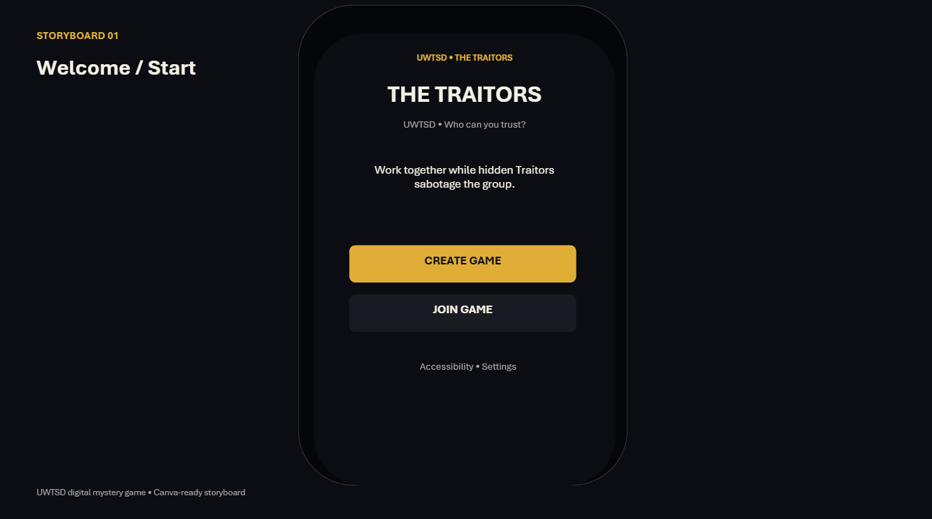
│
▼
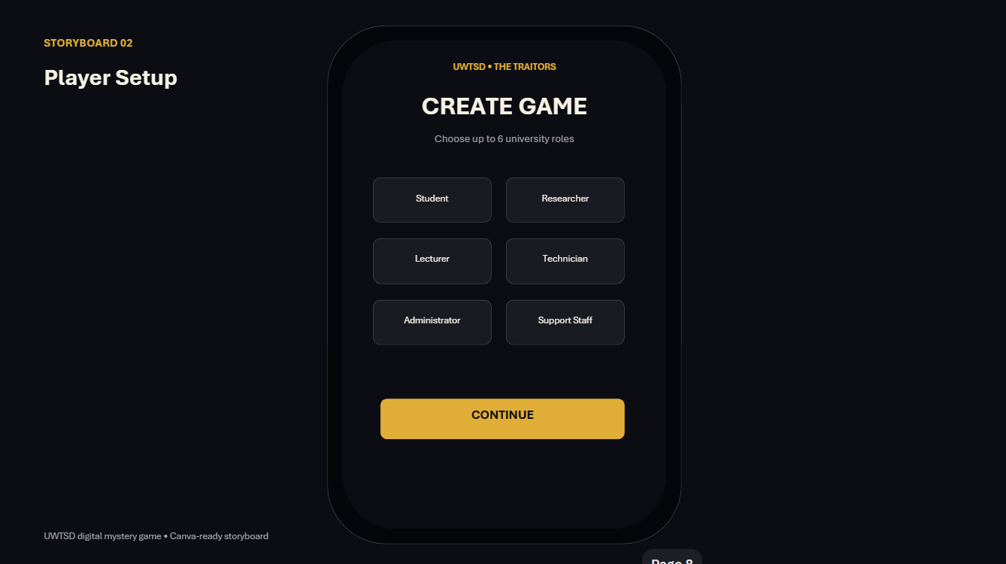
│
▼
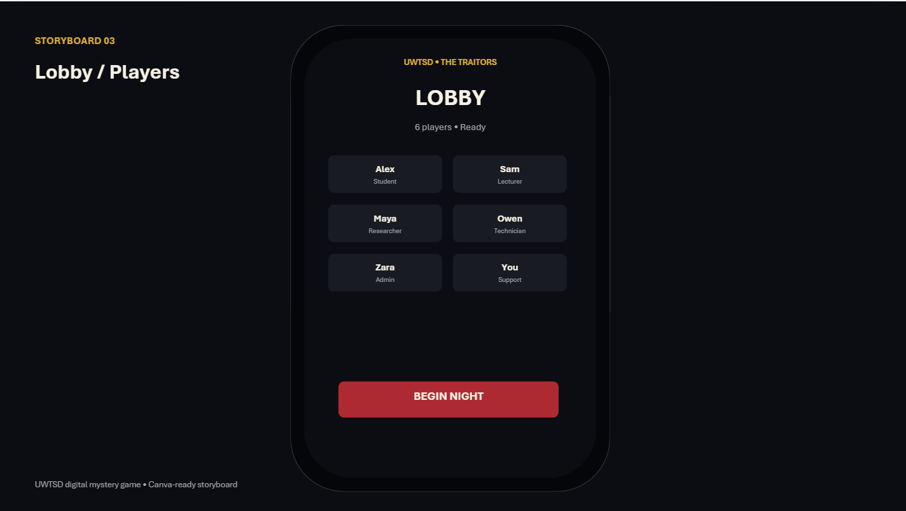
│
▼
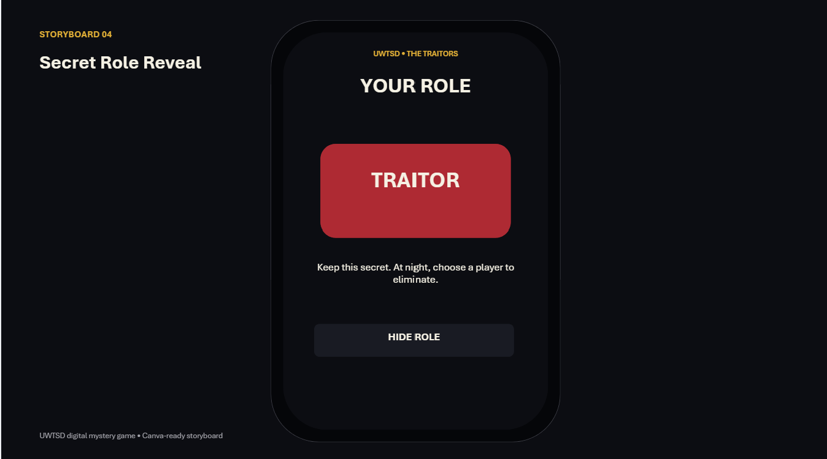
│
▼
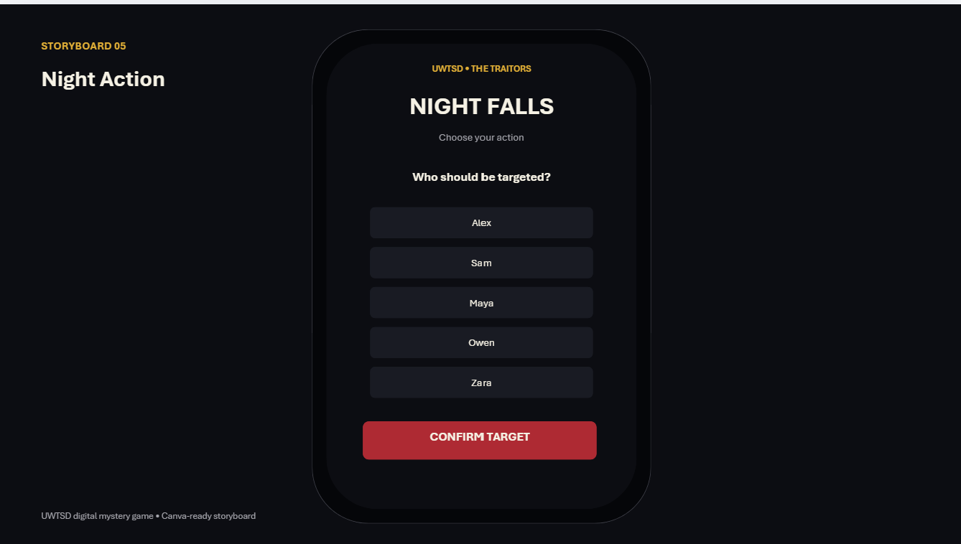
│
▼
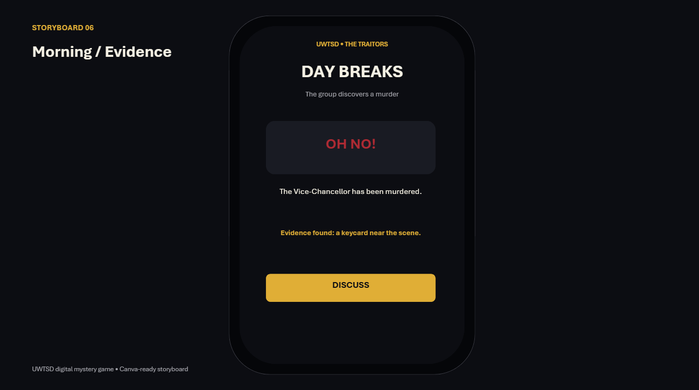
│
▼
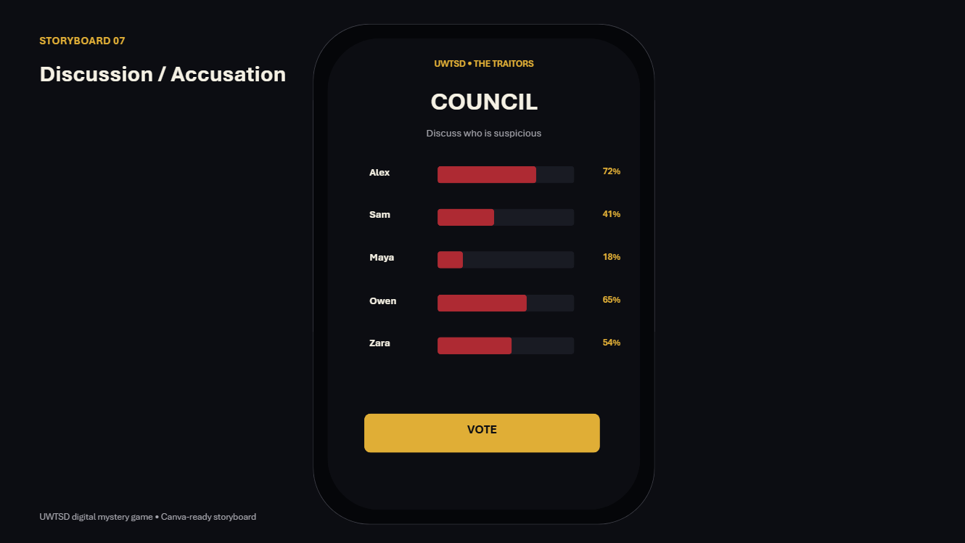
│
▼
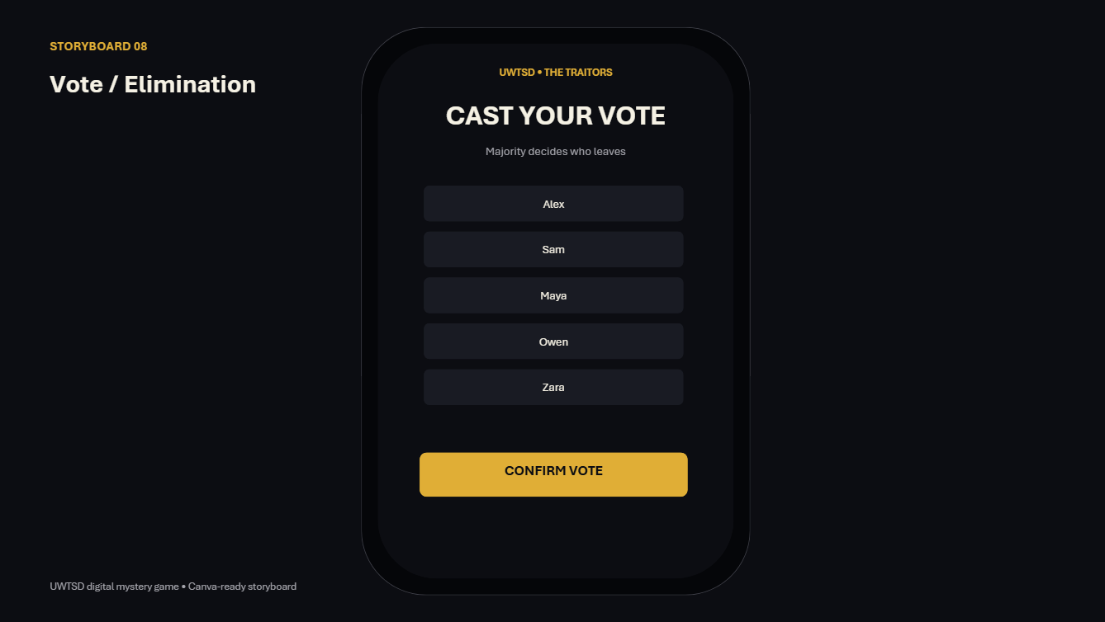
│
▼
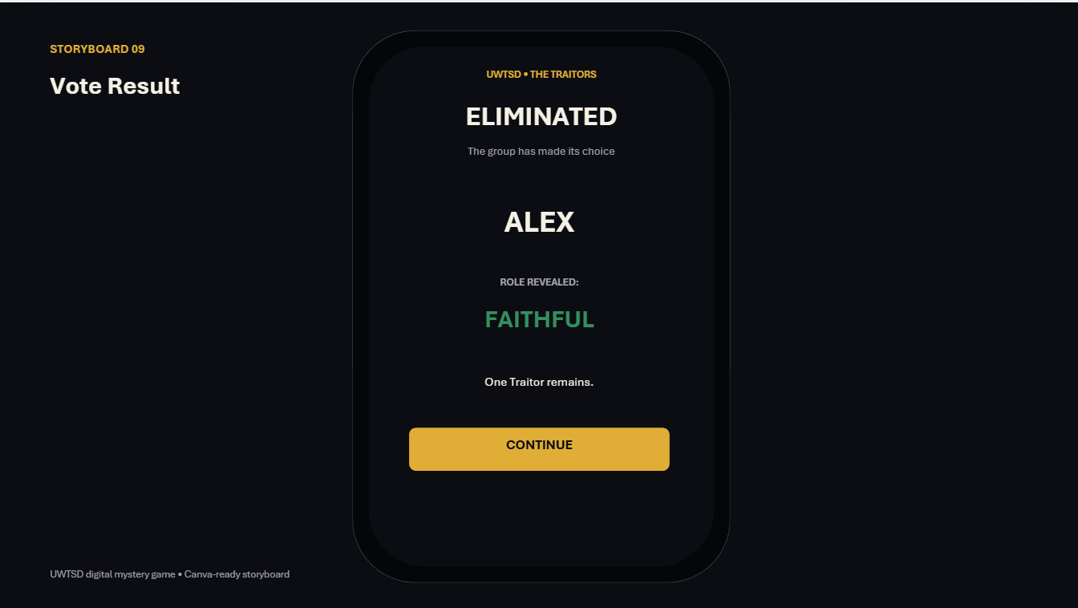
│
▼
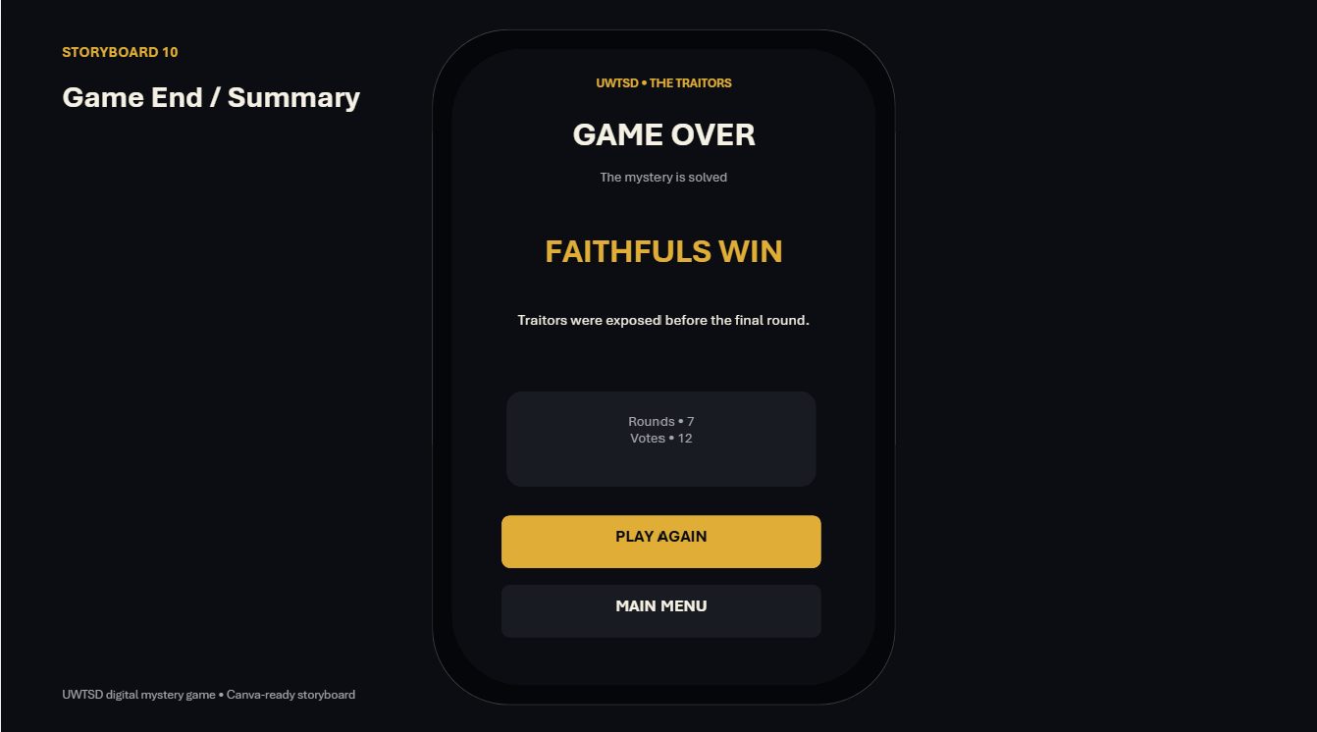
│
▼
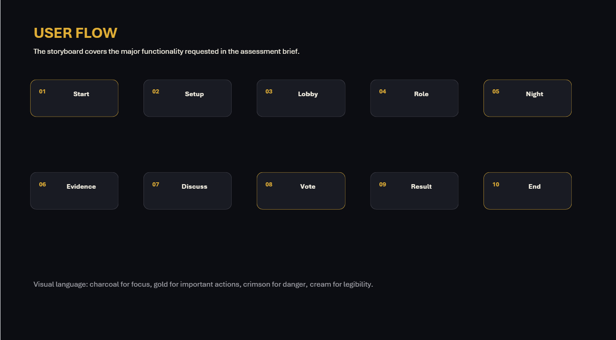

Interview Questions



