Programme: Certificate in Higher Education Business Skills for the Workplace
Module: Enterprise and Entrepreneurship
Module Code: LCLM4006
Assignment Title: Business Plan for Chrome Cards
Lecturer: Mucahit Ozden
Student Name: Saba Iftikhar Ali
Student ID: 2505347

Executive Summary
Chrome Cards is a UK based company specialising in personalised metal debit and credit cards, designed to transform ordinary bank cards into premium lifestyle accessories. Founded by Saba Iftikhar Ali, the business aims to meet the rising consumer demand for customised, luxury products by offering durable and environmentally friendly metal cards that can be personalised with logos and bespoke artwork. The company’s main objective is to place Chrome Cards as a leading brand within the luxury accessories market whilst also promoting sustainability.
The target market includes young people, entrepreneurs, luxury consumers and individuals interested in personal branding. Market research suggests strong social trends leaning toward individuality and premium customisation. Competitor companies such as Ridge Wallet also offer premium accessories however very few competitors provide personalised metal payment cards. This lack of concentration in the market gives Chrome Cards a strong competitive advantage and reflects on its premium pricing.
Chrome Cards’ marketing and sales strategy focuses on various social medias, including TikTok, Instagram and YouTube, assisted by influencer partnerships and content marketing. The company will sell primarily through its website, reaching nationwide and globally while maintaining low overheads.
Expanding product lines in future will also help growth. This can be done via several methods including: introducing limited editions, offering corporate branded cards and developing membership packages. Financial forecasts suggest strong revenue potential, with projected monthly sales of £16,000 based on 200 units at £80 each and annual revenues of £192,000 before expansion. The key benchmarks that are being used include customer obtaining targets, production efficiency, online engagement and sales growth.
To achieve its objectives, Chrome Cards requires £100,000 in investment, towards marketing (£30,000), production equipment (£25,000), website development, inventory and capital. The company’s management structure includes a Managing Director, Operations Manager, Marketing Manager and Customer Service Team, each contributing their expertise in strategic decision making, production, branding and customer satisfaction.
Overall, Chrome Cards presents a compelling business opportunity driven by innovation, personalisation and sustainability. With a clear competitive advantage and a scalable business model, the company is well positioned for long term growth and presents an attractive investment proposition.

Table of Contents
Overview of the Business Idea 3
Market Research 4
Marketing Communications 5
Financials 6
Conclusion 7
Reference List 7

Overview of the Business Idea
Introduction--
Chrome Cards is an inventive company based in the UK which makes metal payment cards customized to the buyer. The company was established by businesswoman Saba Iftikhar Ali. It seeks to turn regular debit and credit cards issued by banks into premium lifestyle items through personalization. While regular debit and credit cards are issued by banks and made of plastic material, Chrome Cards enables its customers to have their metal payment card personalized with logos, photos and any other desired design.
Chrome Cards was developed because of the growing trend of consumers desiring individualized and luxurious products. Consumers are becoming more demanding in terms of purchasing products that offer them uniqueness. Studies have shown that product customization can increase satisfaction among consumers because customers feel that personalized products have more value compared to conventional products (Kotler et al., 2022). This makes Chrome Cards a suitable product because it is both a fashion accessory and status symbol.
The primary goods offered by Chrome Cards include custom metal debit cards, custom credit cards, high-end card holders and luxurious accessories. Customers can create their own products using a web interface that allows for uploading images, logos and other forms of artwork and then viewing a design preview. This approach makes the design process more customer-centric and contributes to making the purchase experience more engaging for customers. Moreover, it is possible that the company will offer its range of products to expand in the future to include limited editions, corporate branded cards and membership packages.
The main features of the Chrome Cards business model include sustainability. The environmental aspect has become very important for customers as well as for investors. Annually, millions of plastic credit cards are made worldwide, resulting in significant pollution through the dumping of old plastic cards. Thanks to the long lasting nature of metal cards, Chrome Cards helps to cut down plastic pollution.
The business will operate as a private limited company (Ltd). This legal structure provides several benefits including limited liability protection, improved credibility and greater opportunities to attract investment. Investors generally prefer limited companies because ownership can be clearly defined through shares and the business can continue operating independently of its founders. As the company grows, this structure will support expansion and potential international development.

Managing Director | Operations Manager | Marketing Manager | Customer Service Team
make strategic decisions that will lead to the growth of the organization | managing the production process, supplier management and stock control | marketing campaign creation and manages the online reputation of the company, | ensuring customer satisfaction
The structure of Chrome Cards

Overall, Chrome Cards represents a strong business opportunity because it combines innovation, personalisation, sustainability and premium branding. These factors position the company to meet changing consumer demands while generating long-term competitive advantages within the marketplace.

Market Research
A thorough market analysis is essential to determine whether Chrome Cards can achieve long-term success. One of the most widely used tools for evaluating the external business environment is PESTEL analysis. This framework examines the political, economic, social, technological, environmental and legal factors that may influence business performance.
 |  |  | PESTLE ANALYSIS
Political | Economic | Social |  | Technological |  |  | Legal |  | Environmental
Government  Support grants | Cost of living pressure | Demand for personalised products |  | E commerce engraving technology |  |  | GDPR laws data protection requirements |  | Sustainable packaging
Support for entrepreneurship and innovation | Reduced disposable income may affect spending | Consumers use products to express individuality |  |  | E commerce platforms allow online ordering and customisation |  | Consumer rights act compliance | Demand on recyclable packaging

In competitor analysis, we have identified the opportunity as well as the threat for our business venture. Our direct competitors will include companies dealing in custom payment cards and high-end accessories. Premium products from companies like Ridge Wallet target similar customers and have developed a good reputation among them. However, in comparison, our main competitive advantage is that we offer personalized payment cards in ways that our competitors do not provide. Traditional banks are some of our indirect competitors because they provide free-of-charge payment cards to their customers.
The company's competitive advantage is based on product differentiation. Customers are not simply purchasing a payment card; they are purchasing a personalised luxury accessory that reflects their identity. This emotional connection creates additional value and reduces direct price competition. Consequently, Chrome Cards occupies a unique position within the market that supports premium pricing and long-term growth potential.

Marketing Communications
Effective marketing communications will play a critical role in the success of Chrome Cards. As a relatively new business operating within a niche market, the company must build brand awareness while communicating the unique benefits of its products. The primary target market consists of young professionals, entrepreneurs, content creators, luxury consumers and individuals interested in personal branding.
The company plans on adopting the marketing mix, which consists of product, price, place, and promotion. In relation to product, the focus will be on the delivery of high-quality customized metal cards by combining luxury and functionality. Quality is expected to form one of the key differentiation factors since customers of luxurious goods expect excellence from them. Product development and releases in small quantities will add up to customer attraction and retention.
The pricing strategy will involve the use of premium pricing. The use of premium pricing means that the cost of goods sold will be higher than in the case of regular products. This is aimed at enhancing the brand image and profitability as well. Premium pricing will increase profits to support future growth. Consumers of the target market are usually willing to pay more for their benefit.
In terms of the distribution strategy, online selling will be the top priority. Online sales will reduce overhead expenses and enable selling throughout the country and globally. Selling on the company's website will help achieve the objective in addition to serving as a branding tool. This is because customers can enjoy the design and the shopping experience on the website.
Promotion will be heavily focused on digital marketing. Social media platforms such as TikTok, Instagram and YouTube will be used to showcase customer designs, product demonstrations and behind-the-scenes content. Influencer marketing will be particularly effective because consumers often trust recommendations from content creators they follow. Collaborating with entrepreneurs, lifestyle influencers and business personalities can significantly increase brand visibility.
Content marketing will also form an important part of the communication strategy. Blog articles, videos and educational content can improve search engine rankings while providing value to potential customers. Public relations activities will further enhance brand awareness. This exposure provides a strong credibility advantage compared with many competing startups.

Financials
To support future expansion, Chrome Cards requires an investment of £100,000. This funding will be used to increase production capacity, strengthen marketing activities, improve website functionality and provide working capital.
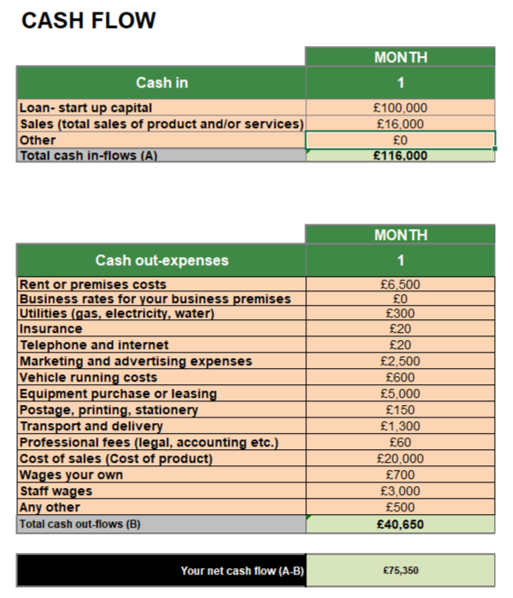
Firstly, budget allocation prioritises marketing expenditure, which reflects the importance of acquiring customers as part of the growth strategy. It is anticipated that about £30,000 will go towards social media marketing, influencers, and content creation. In addition, around £25,000 will go towards purchasing equipment and improving production technologies for efficient processes and maintenance of the quality of products. Moreover, supplementary funding will cover expenses associated with procurement of inventory, personnel costs and website development.
The total cost of starting operations within the first month is expected to be approximately £31,000. The costs involve website development, marketing campaigns, equipment acquisition, inventory, insurance, office expenses and employee compensation. Although the start-up cost is relatively high, it is essential for building a reputable and scalable company.
As far as sales revenue forecasts are concerned, there are significant opportunities for growing revenues. If 200 custom cards per month can be sold at an average price of £80, then sales per month would amount to £16,000, while annual sales revenues without further expansion would make up to £192,000. Furthermore, as awareness grows due to marketing and word of mouth referrals, sales figures will improve significantly.
Financial forecast for Chrome Cards appears to be positive, considering the combination of high prices, high margins, and growing consumer demands for personalised products. Despite the risks involved in running a company, such as competition and uncertainties of the market, Chrome Cards enjoys numerous strengths.

Conclusion
Chrome Cards represents an innovative and commercially viable business opportunity within the growing personalisation market. The company benefits from strong consumer trends, premium branding, technological innovation and sustainability initiatives. Market research demonstrates significant demand for customised products, while the company's unique value proposition differentiates it from traditional competitors. Through effective marketing communications, strategic investment and careful financial management, Chrome Cards has the potential to become a leading brand within the personalised luxury accessories market. The proposed investment of £100,000 will provide the resources necessary to support growth and maximise future opportunities. Consequently, Chrome Cards represents an attractive proposition for investors seeking both financial returns and sustainable business development.

Reference List
CB Insights. (2021). Haze. [online] Available at: https://www.cbinsights.com/company/haze [Accessed 1 Jun. 2026].
Dickinson, M. (2021). Myles Dickinson - CEO at Product Customizer by Haze | The Org. [online] THE ORG. Available at: https://www.theorg.com/org/product-customizer-by-haze/org-chart/myles-dickinson [Accessed 6 Jun. 2026].
Available at: https://www.thestudentpocketguide.com/2023/02/entertainment/tv/myles-dickinson-dragons-den-investment/ [Accessed 4 Jun. 2026].
West, P. (n.d.). Dragon’s Den star, Myles Dickinson, pivots to SaaS company. [online] Startups Magazine. Available at: https://startupsmagazine.co.uk/article-dragons-den-star-myles-dickinson-pivots-saas-company.

